ONLINE APPENDIX: The Effect of Racial and Ethnic Attitudes on Asian Identity in the U.S

Data
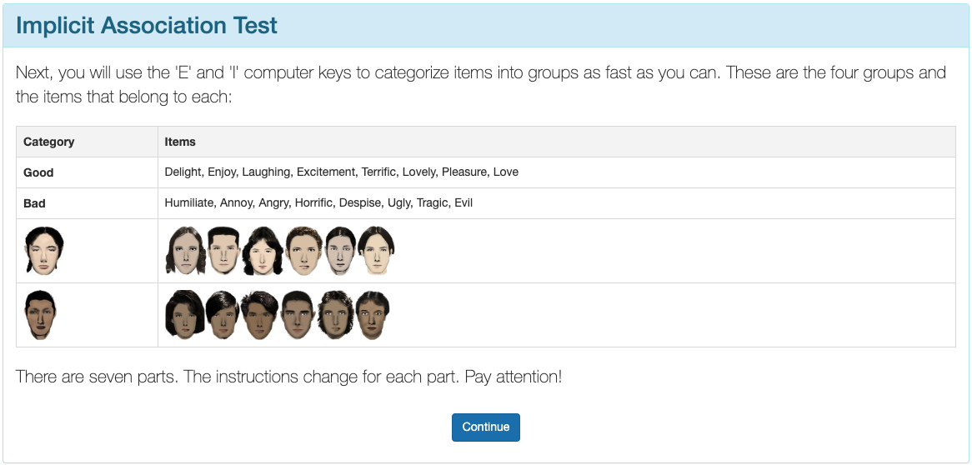 | 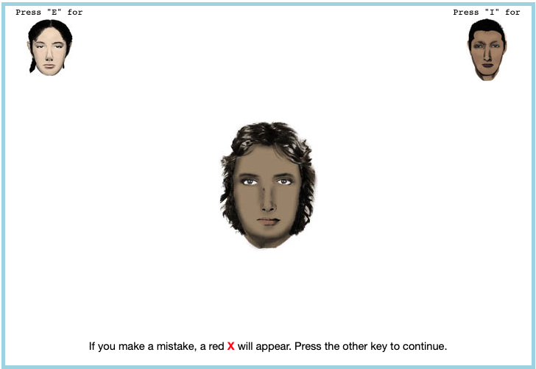 |  |  |  | Here are a few examples of what a respondent would see on an implicit association test.
Examples of an Implicit Association Test

Tables
Subjective Asian Identity and Asian Bias
 | (1) $A_{i}$ | (2) $A_{i}$ | (3) $A_{i}$ | (4) $A_{i}$ | (5) $A_{i}$ | (6) $A_{i}$ | (7) $A_{i}$ | (8) $A_{i}$
Bias | $−0.04$*** | $−0.14$*** | $−0.02$*** | $−0.02$ | $−0.03$*** | $−0.07$** | $−0.10$*** | $−0.04$
 | ($0.01$) | ($0.04$) | ($0.01$) | ($0.03$) | ($0.01$) | ($0.03$) | ($0.03$) | ($0.03$)
Female | $−0.01$** | $−0.01$** | $−0.01$** | $−0.01$* | $−0.01$** | $−0.01$* | $−0.01$* | $−0.01$*
 | ($0.00$) | ($0.00$) | ($0.00$) | ($0.00$) | ($0.00$) | ($0.00$) | ($0.00$) | ($0.00$)
College Graduate: Mother | $0.01$ | $0.01$ | $0.01$ | $0.01$ | $0.01$ | $0.01$ | $0.01$ | $0.01$
 | ($0.01$) | ($0.01$) | ($0.01$) | ($0.01$) | ($0.01$) | ($0.01$) | ($0.01$) | ($0.01$)
College Graduate: Father | $0.01$** | $0.01$* | $0.01$** | $0.01$** | $0.01$** | $0.01$** | $0.01$** | $0.01$**
 | ($0.01$) | ($0.01$) | ($0.01$) | ($0.01$) | ($0.01$) | ($0.01$) | ($0.01$) | ($0.01$)
Both parents Asian | $0.63$*** | $0.63$*** | $0.62$*** | $0.62$*** | $0.63$*** | $0.63$*** | $0.63$*** | $0.62$***
 | ($0.03$) | ($0.03$) | ($0.03$) | ($0.03$) | ($0.03$) | ($0.03$) | ($0.03$) | ($0.03$)
First Gen | $0.01$ | $0.02$ | $0.02$* | $0.02$** | $0.02$* | $0.02$** | $0.02$* | $0.02$**
 | ($0.01$) | ($0.01$) | ($0.01$) | ($0.01$) | ($0.01$) | ($0.01$) | ($0.01$) | ($0.01$)
Second Gen | $0.02$ | $0.02$ | $0.01$ | $0.02$ | $0.02$ | $0.02$ | $0.02$ | $0.02$
 | ($0.01$) | ($0.01$) | ($0.01$) | ($0.02$) | ($0.02$) | ($0.02$) | ($0.02$) | ($0.02$)
N | $129078$ | $129078$ | $129078$ | $129078$ | $129078$ | $129078$ | $129078$ | $129078$
Region FE |  |  |  |  | X | X
Year FE |  | X |  | X |  | X
State FE |  |  | X | X |  |  |  | X
Year-Region FE |  |  |  |  |  |  | X | X
* p $<$ 0.1, ** p $<$ 0.05, *** p $<$ 0.01
1. I include controls for sex, quartic age, and parental education.
2. Standard errors are clustered on the state level.
Logistic Regression Analysis of Bias and Interracial Marriages
 |  | Asian Men | Asian Women
 | (1) Interethnic | (2) Interethnic | (3) Interethnic
Bias | $0.38$*** | $−0.19$ | $0.33$**
 | ($0.11$) | ($0.16$) | ($0.14$)
College Graduate: Wife | $0.35$*** | $0.44$*** | $0.56$***
 | ($0.04$) | ($0.06$) | ($0.05$)
College Graduate: Husband | $−0.06$ | $−0.03$ | $−0.15$***
 | ($0.04$) | ($0.06$) | ($0.05$)
Observations | $69,800$ | $52,032$ | $60,171$
Year $×$ Region FE | X | X | X
* p $<$ 0.1, ** p $<$ 0.05, *** p $<$ 0.01
1. Each column estimates a logistic regression: $Pr\left(interracial_{ist}=1\right)=Λ\left(β_{1}AntiAsianBias_{st}+X_{ist}π+γ_{rt}\right)$, where $interracial_{ist}$ indicates an interracial couple (Asian husband–White wife or White husband–Asian wife), $AntiAsianBias_{st}$ is average anti-Asian bias in state $s$ at time $t$, and $X_{ist}$ includes partner-specific controls (sex, age, education, and years since immigrating to the United States). Coefficients are exponentiated and should be interpreted as odds ratios. Standard errors are clustered on the household level.
3. Data source is the 2004-2020 Current Population Survey Data.
Between-Model Tests of Average Marginal Effects: Second-Generation AW vs. WA
 | Asian Only | White Only | Asian & White
Panel A: AW vs. WA
Anti-Asian Bias | $−0.024$ | $0.106$** | $−0.082$
 | ($0.055$) | ($0.044$) | ($0.062$)
Female | $−0.056$* | $−0.044$ | $0.097$***
 | ($0.031$) | ($0.029$) | ($0.028$)
College Graduate: Mother | $0.084$** | $−0.106$** | $0.021$
 | ($0.036$) | ($0.050$) | ($0.048$)
College Graduate: Father | $−0.061$** | $0.069$** | $−0.002$
 | ($0.027$) | ($0.031$) | ($0.037$)
* p $<$ 0.1, ** p $<$ 0.05, *** p $<$ 0.01
1. Each cell reports the difference in average marginal effects (AME) between the Asian father–White mother (AW) and White father–Asian mother (WA) models, estimated from equation (4) using multinomial logit. The difference is computed as ${\hat{\text{AME}}}_{\text{AW}}−{\hat{\text{AME}}}_{\text{WA}}$.
2. Standard errors of the difference are computed from the bootstrap distributions of the two models. $z$-statistics test the null hypothesis that the marginal effects are equal across models.
3. I include region $×$ year fixed effects with controls for quartic age and local Asian population share. Each estimate is the median across 1,000 bootstrap resamples, with 95% percentile confidence intervals.
1. Each cell reports the difference in average marginal effects (AME) between the indicated models, estimated from equation (4) using multinomial logit. The difference is computed as ${\hat{\text{AME}}}_{\text{Model A}}−{\hat{\text{AME}}}_{\text{Model B}}$.
2. Standard errors of the difference are computed from the bootstrap distributions of the two models. $z$-statistics test the null hypothesis that the marginal effects are equal across models.
3. I include region $×$ year fixed effects with controls for quartic age and local Asian population share. Each estimate is the median across 1,000 bootstrap resamples, with 95% percentile confidence intervals.
4. GP = Grandparent(s). Third-generation individuals are native-born with at least one grandparent born in an Asian country.
Between-Model Tests of Average Marginal Effects: Third-Generation by Asian Grandparent Count
 | Asian Only | White Only | Asian & White
Table A. – continued from previous page
 | Asian Only | White Only | Asian & White
Continued on next page
Anti-Asian Bias | $0.102$* | $−0.059$ | $−0.047$
 | ($0.059$) | ($0.077$) | ($0.084$)
Female | $−0.010$ | $−0.073$ | $0.088$*
 | ($0.031$) | ($0.048$) | ($0.050$)
College Graduate: Mother | $−0.048$ | $−0.106$** | $0.160$***
 | ($0.032$) | ($0.048$) | ($0.052$)
College Graduate: Father | $−0.021$ | $0.060$ | $−0.041$
 | ($0.031$) | ($0.058$) | ($0.061$)
Panel B: One Asian GP vs. Three Asian GP
Anti-Asian Bias | $0.201$ | $−0.203$*** | $−0.028$
 | ($0.152$) | ($0.071$) | ($0.149$)
Female | $0.031$ | $−0.118$*** | $0.087$**
 | ($0.031$) | ($0.043$) | ($0.040$)
College Graduate: Mother | $−0.318$*** | $0.198$*** | $0.122$**
 | ($0.046$) | ($0.047$) | ($0.051$)
College Graduate: Father | $0.293$*** | $−0.345$*** | $0.057$
 | ($0.049$) | ($0.065$) | ($0.062$)
Panel C: Two Asian GP vs. Three Asian GP
Anti-Asian Bias | $0.098$ | $−0.145$*** | $0.019$
 | ($0.156$) | ($0.054$) | ($0.142$)
Female | $0.042$ | $−0.045$ | $−0.000$
 | ($0.041$) | ($0.047$) | ($0.045$)
College Graduate: Mother | $−0.270$*** | $0.304$*** | $−0.039$
 | ($0.054$) | ($0.055$) | ($0.059$)
College Graduate: Father | $0.314$*** | $−0.405$*** | $0.098$
 | ($0.056$) | ($0.060$) | ($0.067$)

Figures
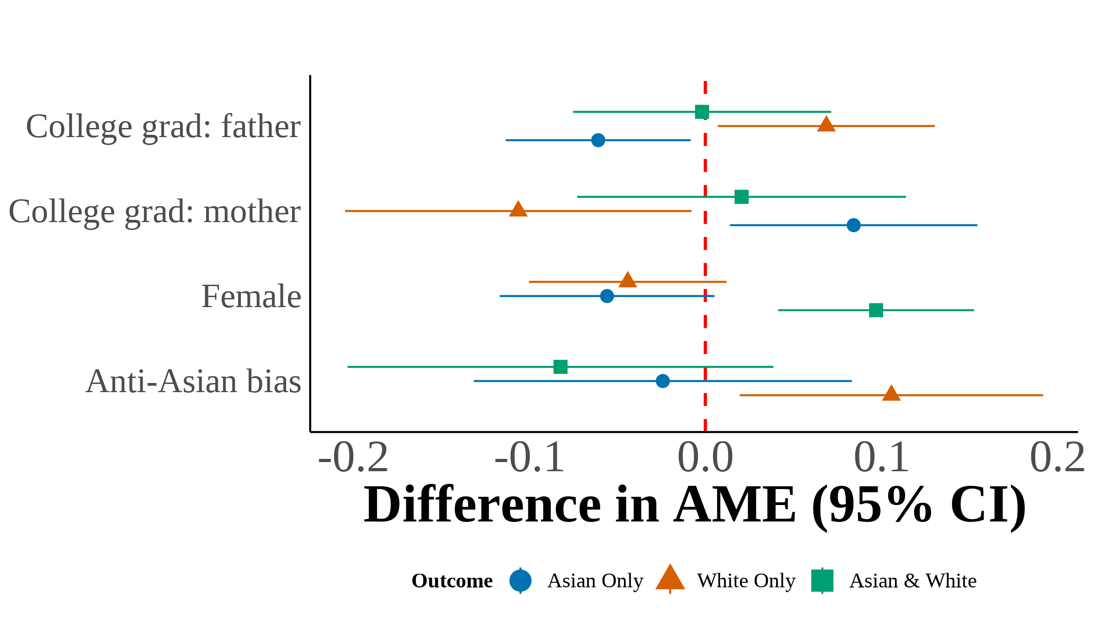 | This figure plots the difference in average marginal effects (AME) between the Asian father–White mother (AW) and White father–Asian mother (WA) multinomial logit models, estimated from equation (4). Each point represents ${\hat{\text{AME}}}_{\text{AW}}−{\hat{\text{AME}}}_{\text{WA}}$ for a given covariate and racial identity outcome. Filled markers indicate statistical significance at the 5% level. Error bars show 95% confidence intervals constructed from the bootstrap standard errors of the difference. I include region $×$ year fixed effects with controls for quartic age and local Asian population share. Each estimate is the median across 1,000 bootstrap resamples.
Between-Model Differences in Average Marginal Effects: Second-Generation AW vs. WA
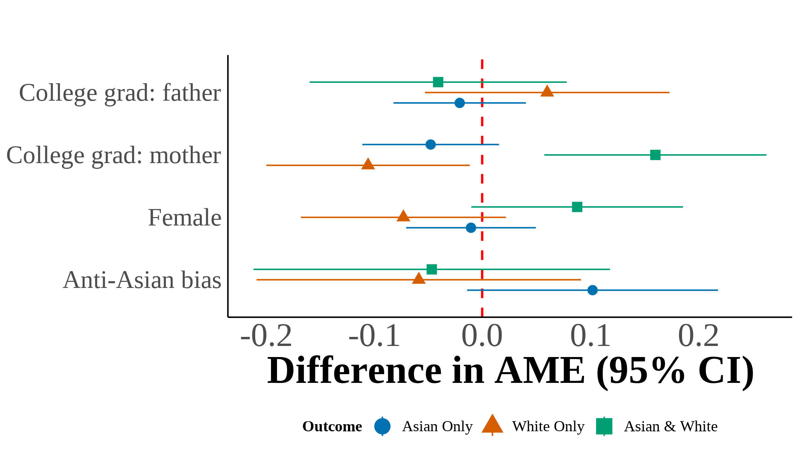 | 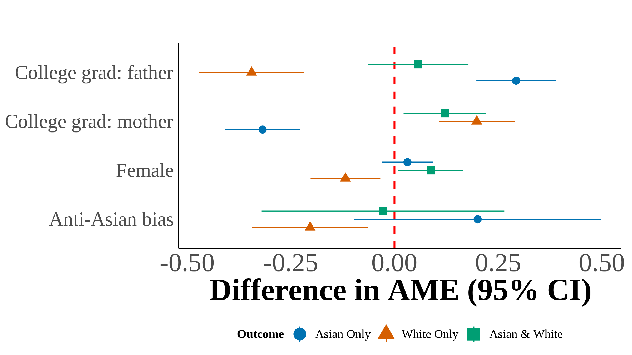 | 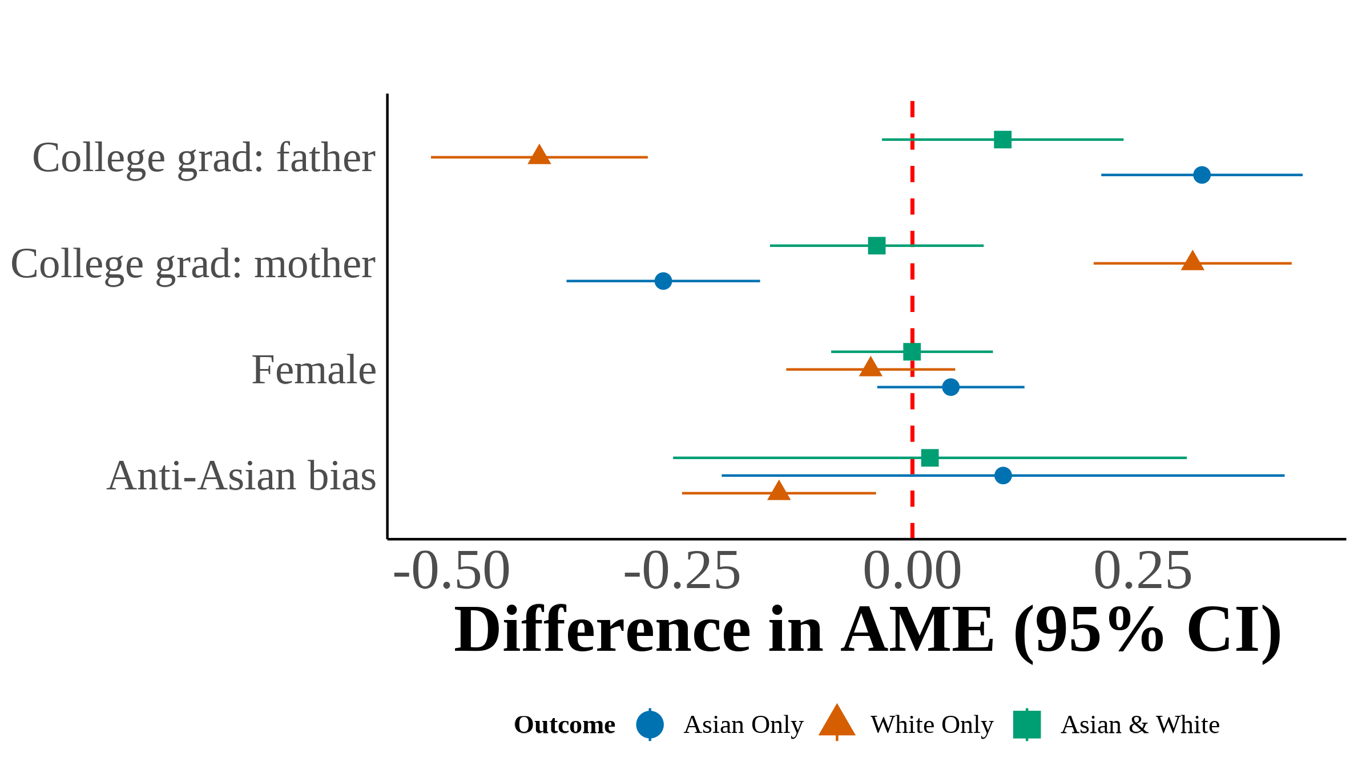 | This figure plots the difference in average marginal effects (AME) between third-generation multinomial logit models estimated on samples defined by the number of Asian grandparents. Each point represents the difference in AME between the indicated models for a given covariate and racial identity outcome. Filled markers indicate statistical significance at the 5% level. Error bars show 95% confidence intervals constructed from the bootstrap standard errors of the difference. I include region $×$ year fixed effects with controls for quartic age and local Asian population share. Each estimate is the median across 1,000 bootstrap resamples.
Two vs. Three Asian Grandparents
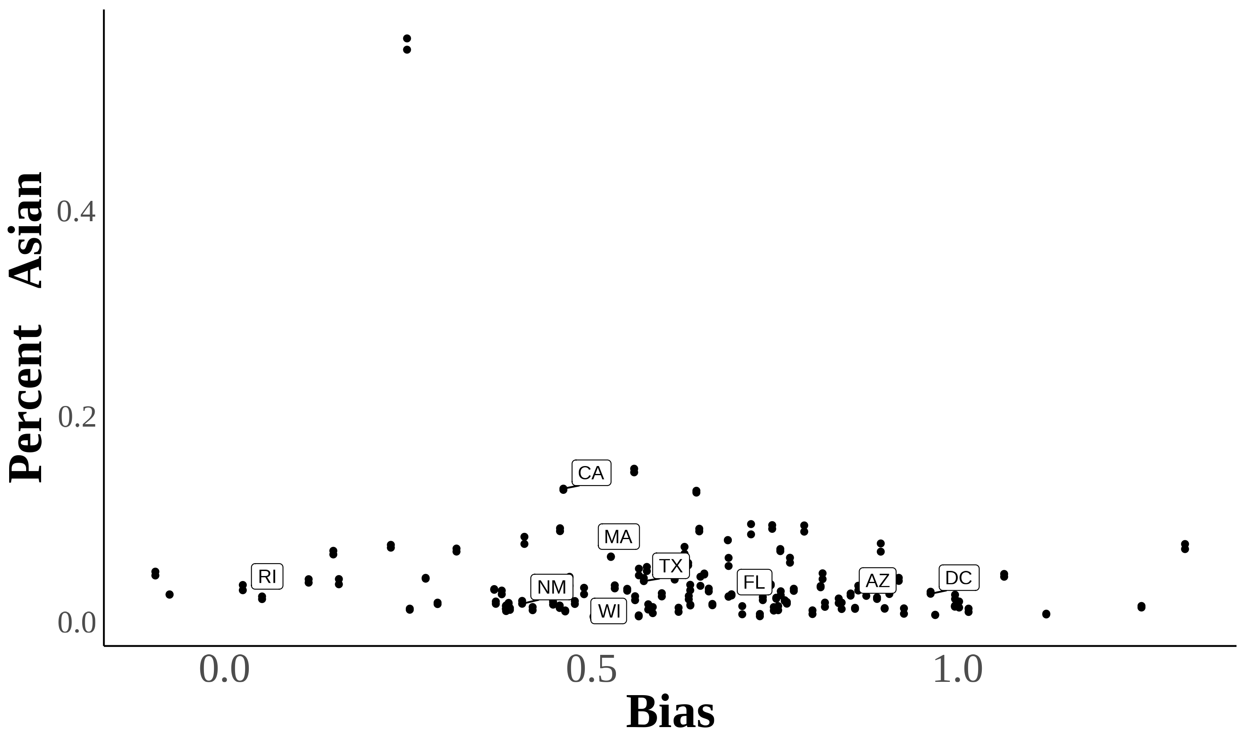 | 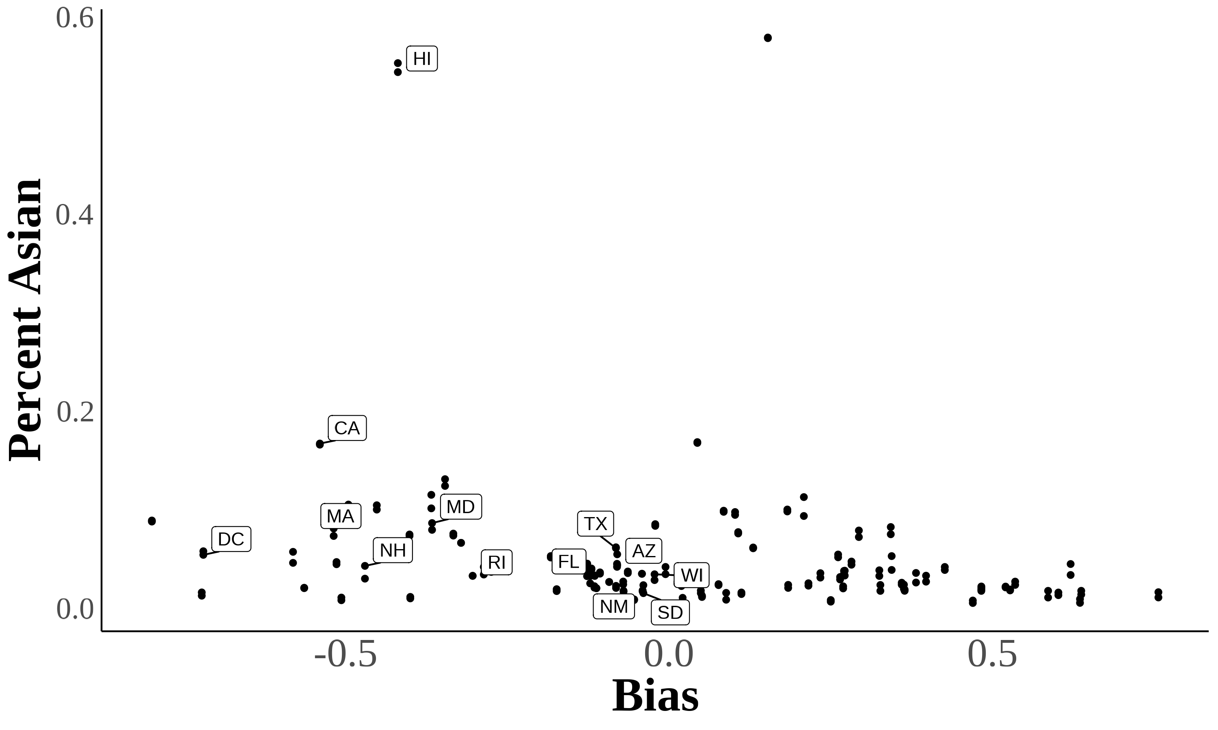 | Here are two scatter plots showing the relationship between bias and subjective Asian population in a state. Each dot represents a state in a certain year. Percent subjectively Asian = $\frac{\#\text{Asian}}{\text{Population}}$  Source. 2004–2021 Current Population Survey.
Year $≥$ 2015

Using Lubotsky & Wittenberg (2006) to Construct Bias Index
In Lubotsky & Wittenberg (2006), the authors propose a method to reduce measurement error in proxies by constructing a composite index. The Lubotsky-Wittenberg (henceforth LW) consider a model where a covariate is unobserved. Therefore, they use two proxies in its place, which will have measurement error. Thus, the LW method allows researchers to use two proxies that are error-ridden.
LW consider a setup with the following model:
$$\begin{matrix}y & =α+βx^{*}+ϵ \\ x_{1} & =x^{*}+μ_{1} \\ x_{2} & =x^{*}+μ_{2}\end{matrix}$$
Where $x_{i}^{*}$ is the unobserved covariate, $x_{1i}$ and $x_{2i}$ are the proxies, and the measurement errors $μ_{1}$ and $μ_{2}$ are assumed to be classical and allowed to covary. The covariance matrix of the errors is given by:
$$Σ=\left[\begin{matrix}σ_{1}^{2} & σ_{12} \\ σ_{12} & σ_{2}^{2}\end{matrix}\right]$$
Replacing the unobserved $x^{*}$ with $x_{1}$ or $x_{2}$ yields the following expectations of the OLS estimates:
$$E\left[{\hat{β}}_{1}\right]=β\frac{σ_{x^{*}}^{2}}{σ_{x^{*}}^{2}+σ_{1}^{2}} ; E\left[{\hat{β}}_{2}\right]=β\frac{σ_{x^{*}}^{2}}{σ_{x^{*}}^{2}+σ_{2}^{2}}$$
Both estimates are biased; the one with the smaller variance of the measurement error being less biased.
LW then propose defining a new proxy $x_{3}$ as a weighted average of $x_{1}$ and $x_{2}$:
$$x_{3}=λx_{1}+\left(1−λ\right)x_{2}$$
To minimize the attenuation bias in the OLS estimate of $β$, they solve for the optimal value of $λ$:
$$λ^{*}=\frac{σ_{2}^{2}−σ_{12}}{σ_{1}^{2}+σ_{2}^{2}−2σ_{12}}$$
This optimal value of $λ$ is not directly useful because the variances of the measurement errors and their covariance are unobserved. However, if you estimate a bivariate regression using OLS (i.e., regress $y$ on $x_{1}$ and $x_{2}$), then the expectation of the sum of the two coefficient estimates is identical to the expectation of the OLS coefficient estimate on $x_{3}$ in a univariate regression using the optimal choice of $λ$:
$$E\left[{\hat{β}}_{1}+{\hat{β}}_{2}\right]=E\left[{\hat{β}}_{x_{3}}\right]$$
Thus, OLS produces an estimate of $β$ with the least bias by optimally combining the information in $x_{1}$ and $x_{2}$.

References for Online Appendix
Lubotsky, D., & Wittenberg, M. (2006). Interpretation of Regressions with Multiple Proxies. The Review of Economics and Statistics, 88(3), 549–562. http://doi.org/10.1162/rest.88.3.549

