MANUSCRIPT TEXT

Introduction
Asian Americans represent the fastest-growing racial group in the United States, yet their experiences with discrimination and identity formation remain underexplored in economic research. Unlike other minority groups, Asian Americans occupy a distinctive position in America’s racial hierarchy—simultaneously experiencing discrimination and being labeled as “perpetual foreigners” while also being characterized through the “model minority” stereotype (Fouka, Mazumder, & Tabellini, 2022). This dual status creates complex incentives around racial identity choices that fundamentally differ from other groups’ experiences. Understanding how both anti-Asian bias and socioeconomic status influence racial identity decisions is crucial, as the selection could systematically distort the true enumeration of the Asian population in the US, the empirical assessments of Asian American outcomes and the true extent of discrimination they face.
An extensive literature has documented how Asians and Whites compare across multiple outcomes, yet the role of identity selection in shaping the Asian-White gaps remains understudied (Arabsheibani & Wang, 2010; Chiswick, 1983; Duleep & Sanders, 2012; Hilger, 2016). The challenge lies in defining and measuring racial identity, particularly when individuals possess agency in how they racially self-identify. If reporting Asian racial identity represents a strategic choice influenced by local discrimination, measured gaps may systematically vary across geographic contexts in ways that previous research has not fully explored.
Various contextual factors, including anti-Asian sentiment and stereotypes, can influence how individuals navigate their racial identity choices. The COVID-19 pandemic has brought renewed attention to how external hostility shapes Asian American experiences (Gover, Harper, & Langton, 2020). In this paper, I examine the determinants of Asian racial identity reporting and analyze how Asian Americans strategically select between Asian and White racial identities. Specifically, I investigate how anti-Asian bias, education, and family income shape decisions to identify racially as Asian American. I also break down the analysis by generation and family structure (interracial versus endogamous parents) and examine what racial identities individuals with objective Asian ancestry report (Asian only, White only, multiracial, etc.).
I explore how individual characteristics and societal attitudes toward Asian Americans influence racial identity reporting. I use identity and ancestry data from the Current Population Survey (CPS) combined with measures of anti-Asian bias derived from Harvard’s Project Implicit Association Test (IAT), the American National Election Studies (ANES), and hate crimes targeting Asian Americans. I ground my analysis in the theoretical framework of Akerlof & Kranton (2000), explicitly modeling how external prejudice creates differential utility from identity choices and establishing conditions under which individuals strategically modify their racial self-presentation. I also use CPS data to study the effect of education (parental and individual) and family income on Asian racial identity reporting.
Measuring identity choices outside of lab settings is challenging, requiring both objective ancestry indicators and subjective identity measures. I leverage birthplace and ancestry data to construct objective Asian ancestry measures, then analyze deviations between objective ancestry and subjective racial identity. I find that racial identity reporting responds to both individual characteristics and environmental factors reflecting local discrimination levels.
I find substantial Asian racial identity attrition across generations, driven primarily by interracial family structures. While children of endogamous Asian parents report Asian identity at rates above 90%, only about a third of second-generation children with one Asian and one White parent do the same. Using multinomial logit models, I show that anti-Asian bias shifts identity choices away from “Asian only” and toward “White only,” with effects that are larger in families where the father is Asian and that scale with the number of Asian grandparents among the third generation. On average, parental education increases the probability of Asian identification. However, this relationship reverses in high-bias states, where individuals with higher parental education are less likely to identify as Asian than those with lower parental education under the same levels of bias. Because of this shifting composition, the Asian-identified population has a lower average socioeconomic status in high-bias areas. Consequently, conventional analyses overestimate Asian–White disparities in areas where prejudice is strongest.
This research contributes to several bodies of literature. First, it extends the economics of identity framework (Akerlof & Kranton, 2000) and stratification economics (Darity, 2022; Darity, Mason, & Stewart, 2006) by examining how racial stereotypes—both positive and negative—influence identity choices among Asian Americans, who face a unique utility landscape where identity can simultaneously signal competence and foreignness (Atkin, Colson-Sihra, & Shayo, 2021; Charness & Chen, 2020; Diette, Goldsmith, Hamilton, & Darity, 2015; Goldsmith, Hamilton, & Darity, 2007; Hamilton, Goldsmith, & Darity, 2009). Qualitative research documents how individuals strategically adapt racial presentations across contexts (Cornell & Hartmann, 2006; Telles & Ortiz, 2008; Waters, 1990; Zhou, 1997); this paper quantifies those choices by comparing objective ancestry with subjective identification across varying bias environments.
Second, it extends research on discrimination (Bertrand & Mullainathan, 2004; Bordalo, Coffman, Gennaioli, & Shleifer, 2016; Bursztyn, Chaney, Hassan, & Rao, 2022; Charles & Guryan, 2008) by examining how prejudice influences racial self-identification itself. Within immigration research, the paper builds on studies of assimilation (Abramitzky, Boustan, & Eriksson, 2014, 2016), but unlike European immigrant groups, Asian Americans face persistent “perpetual foreigner” stereotypes that complicate integration regardless of generational status (Fouka et al., 2022), and the model minority myth means Asian racial identity may carry both benefits and costs depending on context (Meng & Gregory, 2005).
This paper most closely relates to recent economic research on racial identity fluidity (F. Antman & Duncan, 2015, 2021; F. Antman, Duncan, & Trejo, 2016; Hadah, 2024). While previous work focused primarily on Hispanic ethnic attrition, Asian American identity choices operate through different mechanisms due to distinct stereotypes, discrimination patterns, and socioeconomic profiles.

Theoretical Framework
I develop a theoretical framework for understanding racial identity choice that extends Akerlof & Kranton (2000) to incorporate stereotype-specific costs and benefits. Unlike generic minority identification models, this framework recognizes that Asian Americans face unique utility trade-offs where racial identity can signal both positive attributes (academic achievement, work ethic) and negative characteristics (foreignness, social exclusion).
Formally, individual $i$ belongs to racial group $r_{i}∈\{A,W\}$, where $A$ represents Asian and $W$ represents White. Agent $i$’s utility depends on their actions and how those actions interact with their chosen racial identity $I_{i}$:
$$U_{i}=U_{i}\left(a_{i},a_{−i},I_{i}\right)$$
Individual identity $I_{i}$ reflects personal actions, others’ behaviors toward them, and societal expectations associated with their racial group:
$$I_{i}=I_{i}\left(a_{i},a_{−i};S_{r_{i}}\right)$$
where $a_{i}$ represents individual $i$’s actions, $a_{−i}$ captures others’ actions affecting $i$’s identity (including anti-Asian bias), and $S_{r_{i}}$ denotes societal stereotypes and expectations associated with racial group membership.
The key insight is that $S_{A}$ includes both positive stereotypes (academic excellence) and negative ones (perpetual foreigner status). Thus creating context-dependent utility from Asian racial identification.
Individual $i$ selects actions $a_{i}$ to maximize utility given their racial group $r_{i}$, associated stereotypes $S_{r_{i}}$, and others’ actions $a_{−i}$. The first-order condition becomes:
$$\frac{∂U_{i}}{∂a_{i}}+\frac{∂U_{i}}{∂I_{i}}⋅\frac{dI_{i}}{da_{i}}=0$$
The solution $a_{i}^{⋆}$ yields utility $U_{i}^{⋆}$. Now suppose individuals can strategically choose their racial identity at cost $c$. They will switch identities when ${\tilde{U_{i}}}^{⋆}≥U_{i}^{⋆}+c$, where ${\tilde{U_{i}}}^{⋆}$ represents utility under the alternative racial identity.
Identity switching occurs when benefits ${\tilde{U_{i}}}^{⋆}−U_{i}^{⋆}$ exceed costs $c$. These net benefits are non-zero only when $\frac{dI_{i}}{da_{i}}≠0$ and $\frac{∂U_{i}}{∂I_{i}}≠0$. This framework suggests empirical analysis should focus on: (1) individual characteristics affecting optimal actions under different racial identities, (2) contextual factors (anti-Asian bias) creating differential treatment by racial group, (3) populations with low switching costs $c$, and (4) groups whose utility significantly depends on racial identity.
The model predicts that anti-Asian bias increases the utility differential between White and Asian racial identity, making identity switching more attractive. Mixed-race individuals face lower switching costs due to phenotypic ambiguity, while later-generation Asian Americans may find identity switching more feasible due to cultural assimilation.

Data Sources and Measurement Strategy
In this section, I describe the datasets I use in the analysis. To examine relationships between social attitudes and Asian racial identity reporting, I need both subjective and objective Asian identity measures for identifying appropriate Asian American subgroups. I use the Integrated Public Use Microdata Series (IPUMS) Current Population Survey (CPS) (Flood, King, et al., 2021) with ancestry information through the places of birth of individuals, their parents, and grandparents to construct objective identity measures. I develop composite anti-Asian bias measures using Lubotsky & Wittenberg (2006)’s multiple proxy regression method to reduce attenuation bias.

Measuring Asian Racial Identity
I measure Asian racial identity using CPS data from 2004–2021. Following (F. M. Antman, Duncan, & Trejo, 2020; F. Antman et al.; 2016), I utilize birthplace information for individuals, parents, and grandparents to create objective Asian ancestry indicators for minors under age 17 living with parents. The methodology allows for the identification of first-, second-, and third-generation Asian Americans (see Figure 1 for visual representation). I also use a CPS sample of adults aged 18+ to examine whether their racial identity reporting patterns differ from minors; for the adult sample, I can only identify first- and second-generation.
The objective ancestry measure—distinct from subjective racial identification where respondents select “Asian” as their race—depends on birthplaces across three generations. The three identifiable generations include: 1) first-generation immigrants born in Asian countries with both parents also born in Asian countries, 2) second-generation individuals who are US-born citizens with at least one parent born in an Asian country, and 3) third-generation Asian Americans who are US-born citizens with two US-born parents and at least one grandparent born in an Asian country.
While the ancestry measure provides an objective assessment of Asian heritage, it may not capture all nuances of racial identity. For instance, White individuals with Asian ancestry born to non-Asian parents in Asia, such as on American military bases, may be classified as Asian in the data. To avoid potential misclassification, I remove individuals who report that they were born abroad of American parents. The final sample includes Asian Americans, first-, second-, and third-generation immigrants aged 17 and younger living with parents between 2004 and 2021. I present the summary statistics in Table (1). The adult sample includes first- and second-generation Asian American immigrants aged 18 and older between 2004 and 2021. I show the summary statistics for the adult sample in Table (2).
CPS relies on household respondents (parents or caregivers) to report children’s racial identity. Asian identity reporting rates are consistent regardless of whether mother (72%), father (72%), or child/other caregiver (87%) serves as respondent (Table 3), and attrition patterns among adults align with those observed in children (Tables 4 and 5). I address proxy reporting concerns more fully in Section 6.1.
The overall sample comprises 49% females, with 65% self-reporting Asian racial identity—answering affirmatively to “what is your race.” Average age is 8.4 years. Approximately 52% of mothers and 52% of fathers hold college degrees. Additional summary statistics for the overall sample and each generation appear in Table (1).
Using parental and grandparental birthplaces, I objectively identify ethnic ancestry and categorize different family types. For second-generation children, parental birthplaces create three objective categories: Objectively Asian-father-Asian-mother (AA), Objectively Asian-father-White-mother (AW), and Objectively White-father-Asian-mother (WA)
Similarly, grandparental birthplaces create 15 objective categories for third-generation children: (1) objectively Asian paternal grandfather-Asian paternal grandmother-Asian maternal grandfather-Asian maternal grandmother (AAAA); (2) objectively White paternal grandfather-Asian paternal grandmother-Asian maternal grandfather-Asian maternal grandmother (WAAA); (3) objectively Asian paternal grandfather-White paternal grandmother-Asian maternal grandfather-Asian maternal grandmother (AWAA), etc.
My analysis employs a subsample of the US population; Tables 4 and 2 demonstrate sufficient observations across generations for both adults and children. Consistent with literature on ethnic and racial identity fluidity among Asian and Hispanic Americans, I document significant attrition among third-generation Asian Americans.

Measuring Anti-Asian Sentiment
I construct anti-Asian sentiment measures using implicit association tests, American National Election Studies, and hate crimes targeting Asian Americans from 2004–2021.
The implicit association test measures conceptual associations—for example, linking Asian Americans with negative stereotypes—and evaluative responses. Respondents rapidly categorize words into screen-displayed categories. Figure (A.1) shows examples from Harvard’s Project Implicit skin tone test.
I employ Asian-focused IAT data to construct anti-Asian prejudice proxies (Greenwald et al., 1998). The IAT measures bias direction and magnitude while capturing unconscious biases individuals may be unwilling to report, and previous research demonstrates the difficulty of manipulating IAT scores (Egloff & Schmukle, 2002). A meta-analysis by Greenwald et al. (1998) finds significantly higher predictive validity for IAT compared to self-report measures.
However, some research questions IAT predictive validity claims. Implicit Association Tests may not reliably measure or predict implicit prejudice or biased behaviors. Research shows implicit biases experience minor, temporary intervention-induced changes. Additionally, implicit bias fails to predict dictator game contributions or social pressure susceptibility, highlighting distinctions between implicit bias and biased actions (Arkes & Tetlock, 2004; Forscher et al., 2019; Lee, 2018). Therefore, I supplement IAT with explicit bias measures from American National Election Studies (ANES) and hate crimes against Asian individuals to construct a composite bias measure.
I develop a second proxy from the American National Election Studies (ANES), averaging responses across several 2004–2020 questions measuring racial animus (American National Election Studies, 2021). While the ANES racial animus questions primarily focus on attitudes toward Black Americans, research demonstrates that racial prejudices are highly correlated across different minority groups, with individuals who express bias toward one racial minority typically holding similar attitudes toward others (Almasalkhi, 2023; Mora & Paschel, 2020). These measures therefore capture broader patterns of racial animus that extend beyond anti-Black sentiment specifically. When combined with the Asian-focused IAT measures and hate crimes against Asian Americans in my composite index, this multi-proxy approach weights the bias measure more heavily toward Asian-specific prejudice while still capturing the general racial climate. Finally, I incorporate Uniform Crime Reports (UCR) data quantifying hate crimes against Asian Americans (Bureau of Justice Statistics, 2023).
To reduce attenuation bias and measurement error, I follow Lubotsky & Wittenberg (2006) in constructing composite bias measures using IAT, ANES racial animus measures, and hate crimes against Asian Americans. Figure (2a) graphically represents bias measures over time in the most and least biased locations. Figure (2b) shows Asian racial identity reporting in the two most and least biased locations. Lower scores indicate less bias; higher scores indicate greater racial animus. One standard deviation bias increase is equivalent to moving from Washington, DC, or Vermont to North Dakota in 2020. State-level average bias over time appears in Figure (3), with overall 2004–2021 averages in Figure (4).

From the Data: Asian Racial Identity and Attrition
Table (4) displays racial attrition patterns across generations. Among first-generation Asian Americans, 96% self-report Asian racial identity. This drops to 73% among second-generation and 31% among third-generation Asian Americans. Attrition is driven primarily by children from interracial families. Among second-generation children, those with two Asian parents report 97% Asian racial identity, while those with one Asian and one White parent report only 33%. Similarly, among third-generation children, 94% of those with four Asian grandparents report Asian racial identity compared to 25% overall. Adult samples show similar patterns (Table 5). Among second-generation adults, those with two Asian parents report 95% Asian racial identity, while those with one Asian and one White parent report 37%.
Figures 5–8 display racial identity choices among objectively Asian children by generation and family structure. Among all objectively Asian children (Figure 5), 64% report Asian only identity, 16% White only, and 16% Asian and White/Pacific Islander. First-generation children overwhelmingly report Asian only identity (94%, Figure 6). Among second-generation interracial families, rates differ by parental composition: 36% report Asian only in Asian father–White mother families versus 29% in White father–Asian mother families (Figure 7).
Third-generation patterns reveal increasing identity fluidity (Figure 8). White only identity becomes most common overall (35%), followed by Asian only (29%), Asian and White/Pacific Islander (26%), and other multiracial identities (7%). The number of Asian grandparents strongly predicts choices: those with one Asian grandparent report 54% White only, while those with four Asian grandparents report 92% Asian only.
These patterns demonstrate that racial identity becomes increasingly fluid across generations, with endogamous Asian families maintaining high rates of Asian racial identity while interracial family structures significantly increase not-Asian-only identity choices.

Empirical Approach
To understand associations between Asian racial self-identification and anti-Asian bias, I estimate a multinomial logit model in which the dependent variable $Y_{ist}^{g}$ captures categorical racial identity choices: (1) Asian only, (2) White only, (3) Asian and White/Pacific Islander:
$$\begin{matrix}log\left(\frac{P\left(Y_{ist}^{g}=j\right)}{P\left(Y_{ist}^{g}=\text{Asian only}\right)}\right) & =β_{1j}^{g}AntiAsianBias_{st}+β_{2j}^{g}DadCollegeGrad_{ist} \\ & +β_{3j}^{g}MomCollegeGrad_{ist}+β_{4j}^{g}Female_{ist}+X_{ist}^{g}π_{j} \\ & +γ_{rtj}+ε_{istj}; j∈\{\text{White only},\text{Asian and White}\}\end{matrix}$$
where $Y_{ist}$ represents the categorical racial identity of person $i$ in state $s$ at interview time $t$, $j$ indexes the identity categories, with “Asian only” as the reference category, $P\left(Y_{ist}^{g}=j\right)$ denotes the probability of person $i$ in state $s$ at time $t$ choosing identity $j$, $X_{ist}^{g}$ represents the vector of controls that include quartic age, Asian population fraction, parent types, grandparent types, and generation dummies, $β_{j}^{g}$ denotes the coefficient vector for outcome $j$ and generation $g$, and $J$ indexes the three identity categories. Finally, $γ_{rtj}$ represents region-time fixed effects that would control for region $×$ year specific shocks affecting identity choice $j$, and $ε_{istj}$ is the error term.
The model specification allows the effects of anti-Asian bias and other covariates to vary across identity choices. For instance, $β_{1,\text{White only}}^{g}$ captures how anti-Asian bias affects the log-odds of choosing “White only” versus “Asian only” identity, while $β_{1,\text{Asian and White}}^{g}$ measures the bias effect on choosing “Asian and White” versus “Asian only.” This framework enables analysis of how bias, sex, and parental education differentially influence various identity strategies available to individuals with Asian ancestry.
The coefficients of interest are $β_{1j}^{g}$, $β_{2j}^{g}$, $β_{3j}^{g}$, and $β_{4j}^{g}$, which capture how anti-Asian bias, parental education, and sex influence the likelihood of selecting each identity category relative to “Asian only.” I estimate separate models for each generation $g∈\{1,2,3\}$ to assess whether these relationships differ across generational status.
The multinomial specification is appropriate because choosing “White only” identity represents a fundamentally different strategy than selecting “Asian and White” multiracial identity, a distinction particularly important for mixed-ancestry individuals who may strategically choose between complete ethnic distancing and maintaining partial ethnic connection.
Since log odds coefficients from multinomial logit models are difficult to interpret directly, I compute the predicted probabilities of each identity choice at different anti-Asian bias levels, holding other covariates constant and summarizing results with the median across 1,000 bootstrap resamples (with percentile-based 95% confidence intervals). This approach provides more intuitive insights into how bias influences the likelihood of selecting each identity category.

Results and Robustness Checks
I present average marginal effects from the multinomial logit analysis in Figures 9–13, focusing on mixed-race Asian Americans where effects are most pronounced.
Second-Generation Subsample. Among children of mixed-race parents (Figure 9), a one standard deviation increase in anti-Asian bias increases “White only” identity by 12 percentage points (pp) and decreases “Asian only” by 10 pp. Maternal college education increases “Asian only” ($+$5 pp) and decreases “White only” ($−$6 pp). Paternal college education increases “Asian and White” ($+$5 pp) and decreases “White only” ($−$4 pp). Results among second-generation adults are directionally similar (Figure 11).
I also estimate the model separately by parental composition—Asian father–White mother (AW) versus White father–Asian mother (WA) families (Figure 10 and Table A.3). Point estimates suggest that bias effects on “White only” identity may be larger in AW families ($+$20 pp) than WA families ($+$10 pp), and that maternal college education effects may differ in direction and magnitude across the two family types.
I conduct a between-model tests of cross-group differences in average marginal effects (Figure A.2 and Table A.3). I find that the AW–WA difference in bias effects on “White only” identity is statistically significant. Consequently, the effect of bias is stronger among AW families (when the father is Asian), pushing children toward “White-only” racial identity. Maternal and paternal college education effects also differ significantly across family types for “Asian only” and “White only” outcomes. However, I find that the remaining AW–WA differences are not statistically distinguishable.
Third-Generation Subsample. Among pooled third-generation children, bias effects on identity are not statistically significant; the one exception is paternal college education, which increases “Asian and White” identification by 8 pp. Because bias and parental education should matter most for those with the strongest ancestral ties, I split the sample by number of Asian grandparents (Figure 13). Both sets of effects grow with Asian ancestry: the effect of bias on “White only” identity is negligible among children with one Asian grandparent but reaches $+$19 pp among those with three, and the effect of maternal college education on “Asian only” grows to $+$32 pp over the same gradient. The between-model tests I conduct (Figure A.3 and Table A.4) confirm that these differences are statistically significant: comparing one versus three Asian grandparents, the bias effect on “White only” and both parents’ college effects on “Asian only” and “White only” differ significantly. Maternal college effects differ between one and two grandparents, and bias and parental education effects differ between two and three. Gender effects never differ across groups.
The effects of bias and parental education on identity are heterogeneous across ancestry types: even where cross-group differences fall short of statistical significance, point estimates increase steadily with the number of Asian grandparents. Consistent with the theoretical framework, individuals with lower switching costs—those with fewer Asian grandparents and greater racial ambiguity—show smaller marginal effects of bias because they can switch identities even at low levels of bias, while those with more Asian ancestry require stronger incentives to overcome higher switching costs.

The interaction between state-level bias and socioeconomic status
To assess whether bias and socioeconomic status jointly affect Asian identification, I estimate linear probability models interacting demeaned state-level bias with parental education (own education for adults), family income (own income for adults), and gender. Results appear in Figures 14–16.
I find that education amplifies the negative effect of bias on Asian identification. Among second-generation AW children (Figure 14), the interaction between bias and maternal-college is negative and significant (approximately $−$0.20); in high-bias states, children of college-educated mothers are substantially less likely to report “Asian only” identity. AW adults show the same pattern with own college education (approximately $−$0.07; Figure 15). Among WA families, no interaction terms are significant in either the children or adult samples. In the pooled second-generation sample, the bias-by-maternal-college interaction is negative and marginally significant (approximately $−$0.04). Among third-generation respondents (Figure 16), point estimates follow the same direction—negative bias-by-maternal-college interactions that grow larger with more Asian grandparents—but are imprecisely estimated. The pooled third-generation bias-by-maternal-college interaction is significant (approximately $−$0.05).
These results imply that higher-educated individuals of Asian ancestry are disproportionately likely to exit Asian identification in high-bias states. The remaining Asian-identified population is therefore negatively selected on education and socioeconomic status, implying that conventional analyses could overestimate Asian–White gaps in states where anti-Asian prejudice is strongest.

Robustness Checks
I examine three potential threats to identification: endogenous interracial marriage, selective migration, and proxy reporting. If anti-Asian bias influences interracial marriage rates, it could affect the composition of the mixed-race sample. I regress interracial couple status on state-level bias with partner-specific controls (Table 7). A one standard deviation increase in bias raises interracial parent probabilities by 4 pp, driven by a 3 pp increase in Asian wife–White husband couples and a 1 pp decrease in Asian husband–White wife couples.
Using 2004–2021 Census data (Flood, Ronald, Megan, & Matthew, 2021), I test whether anti-Asian bias predicts interstate migration among second-generation Asian Americans with two Asian-born parents (Table 6). I find no significant correlation between bias and migration decisions. Among movers, Asian-identifying individuals live in states with 0.06 standard deviations greater bias than their birth states, suggesting that if anything my estimates understate the effect of bias on identity switching.
In the CPS, a household respondent reports racial identity for all members, raising the concern that proxy responses may not reflect children’s own identities. Two pieces of evidence mitigate this concern. First, B. Duncan & Trejo (2011) show that reported Hispanic identity does not vary with respondent identity, and Table 3 shows a similar pattern for Asian identity. Second, I find similar patterns of ethnic attrition and bias effects among adult Asian Americans who self-report their own identity (Table 5).
Moreover, the results are also robust to fixed state characteristics. Appendix Table A.1 re-estimates the linear probability model adding region, state, year, and year-by-region fixed effects in all combinations. With state fixed effects—identifying only from within-state variation in bias—the coefficient remains negative and statistically significant, and point estimates remain negative and comparable in magnitude to the baseline across all eight specifications.
Larger Asian American populations could themselves affect state-level bias. Figure A.4 shows no correlation between state Asian American population shares and average anti-Asian bias.

Conclusion
As American society becomes increasingly multiracial, racial identity choices will significantly influence political representation, resource allocation, and social cohesion. Understanding the determinants of identity is particularly important for researchers studying discrimination’s role in racial economic gaps. This paper demonstrates how individual characteristics and anti-Asian sentiment influence racial identity reporting among Asian Americans.
Using multinomial logit analysis, I show that anti-Asian bias fundamentally reshapes racial identity choices, with effects that vary significantly across family structures and generational distance from immigration. Among pooled second-generation children of mixed-race parents, a one standard deviation increase in bias raises “White only” reporting by 12 percentage points and reduces “Asian only” by 10 pp. The effects differ markedly by parental composition: in AW families, the same increase in bias reduces “Asian only” by 13 pp and increases “White only” by 20 pp, while in WA families, “Asian only” decreases by 12 pp and “White only” increases by 10 pp. Between-model tests confirm that the bias effect on “White only” identity is significantly larger in AW families (10.6 pp). Among third-generation respondents, bias effects scale with the number of Asian grandparents: those with three Asian grandparents show the largest shifts ($+$19 pp “White only”), while those with one grandparent show small, imprecise effects.
Parental education shapes identity choices in ways that also differ significantly across family structures. In AW families, maternal college education increases “Asian only” by 10 pp and decreases “White only” by 12 pp, while in WA families maternal education produces no significant change—a difference confirmed by formal between-model tests on both outcomes. Among the third generation, parental education effects increases with ancestry concentration: maternal college raises “Asian only” by 32 pp for those with three Asian grandparents versus 7 pp for those with two, differences that are statistically significant. However, the relationship between maternal education and identification varies by environment. For Asian-White (AW) families, the interaction between state-level bias and maternal college education is $−$0.20, indicating that the negative relationship between bias and Asian identification is more pronounced among individuals with higher maternal education.
These results have important consequences for the measurement of racial disparities. Because the combination of higher education and higher bias is associated with less—not more—Asian identification, the Asian-identified population in high-bias states is negatively selected on education and socioeconomic status. Conventional analyses relying on self-reported race therefore overestimate Asian–White gaps in the most prejudiced areas. More broadly, identity decisions likely profoundly affect people’s choices, investments, and well-being, and the strategic nature of these decisions means that studies relying on self-reported racial identity may overstate Asian American socioeconomic success and understate assimilation speed.
This study encourages further research into relationships between bias and self-reported identities for other groups, including other ethnic and racial minorities and sexual minorities. Scholars could examine how recent anti-Asian violence following the COVID-19 pandemic has influenced identity patterns, providing natural experiments in bias effects. Researchers might also explore identity choices in specific institutional contexts like college admissions or workplace advancement, where model minority stereotypes create complex incentive structures, or extend the analysis to subgroups facing distinct stereotypes and discrimination patterns. More granular geographic analysis at the county or zip-code level could provide more precise measures of local bias, though data limitations prevent this in the current analysis. Understanding strategic racial identification among Asian Americans is essential for designing effective anti-discrimination policies and accurately measuring racial equity progress.

References for Manuscript
CPS Summary Statistics
 | Overall | By Generation
Characteristic
N = 318,404
N=40,033
N=199,294
N=79,077
Female | 0.49 | 0.53 | 0.49 | 0.49
Asian | 0.65 | 0.96 | 0.73 | 0.31
Age | 8.4 (5.1) | 10.9 (4.5) | 8.3 (5.1) | 7.7 (5.0)
College Graduate: Father | 0.52 | 0.59 | 0.52 | 0.50
College Graduate: Mother | 0.52 | 0.56 | 0.51 | 0.52
Total Family Income (1999 dollars) | 87,031 (84,797) | 75,815 (74,489) | 88,295 (88,411) | 89,436 (80,051)
1. The samples include children ages 17 and below who live in intact families. First-generation Asian immigrant children that were born in a Asian country. Native-born second-generation Asian immigrant children with at least one parent born in a Asian country. Finally, native-born third generation Asian immigrant children with native-born parents and at least one grand parent born in a Asian country.
2. Data source is the 2004-2021 Current Population Survey.
Current Population Survey (CPS) Summary Statistics
 | Overall | By Generation
Characteristic
N = 48,153
N=35,728
N=12,425
Female | 0.56 | 0.58 | 0.50
Asian | 0.90 | 0.96 | 0.73
Age | 46 (17) | 49 (16) | 38 (17)
Years of Education | 14.0 (3.5) | 13.9 (3.8) | 14.5 (2.5)
Total Family Income (1999 dollars) | 68,121 (71,266) | 66,093 (70,444) | 73,950 (73,269)
1. The samples include people of Asian ancestry ages 18 and above. First-generation Asian immigrants were born in a Asian country. Native-born second-generation Asian immigrants have at least one parent born in a Asian country.
2. Data source is the 2004-2021 Current Population Survey.
Main Effect of Proxy on Second-Generation’s Asian Self-identification
Parents Type | All | Asian-Asian | Asian-White | White-Asian
Proxy:
Mother | 0.72 | 0.97 | 0.37 | 0.3
Father | 0.72 | 0.97 | 0.39 | 0.29
Self | 0.87 | 0.97 | 0.23 | 0.31
Others | 0.88 | 0.96 | 0.6 | 0.54
1. The samples include children ages 17 and below who live in intact families. A proxy is the person that answered the Current Population Survey questionnaire.
2. Data source is the 1994-2021 Current Population Survey.
Asian Self-identification by Generation
 | Self-identify as Asian | Self-identify as not-only-Asian | % Self-identify as Asian | % Self-identify as not-only-Asian
1st Gen. | 14,811 | 688 | 0.96 | 0.04
2nd Gen. | 58,756 | 21,381 | 0.73 | 0.27
Asian on:
Both Sides | 49,118 | 1,717 | 0.97 | 0.03
One Side | 9,638 | 19,664 | 0.33 | 0.67
3rd Gen. | 10,394 | 23,048 | 0.31 | 0.69
Asian on:
Both Sides | 5,428 | 316 | 0.94 | 0.06
One Side | 3,030 | 9,213 | 0.25 | 0.75
1. The samples include children ages 17 and below who live in intact families. First-generation Asian immigrant children that were born in a Asian country. Native-born second-generation Asian immigrant children with at least one parent born in a Asian country. Finally, native-born third-generation Asian immigrant children with native-born parents and at least one grandparent born in a Asian country.
2. Data source is the 2004-2021 Current Population Survey.
Asian Self-identification by Generation
 | Self-identify as Asian | Self-identify as not-only-Asian | % Self-identify as Asian | % Self-identify as not-only-Asian
1st Gen. | 275,516 | 11,037 | 0.96 | 0.04
2nd Gen. | 74,345 | 28,027 | 0.73 | 0.27
Asian on:
Both Sides | 59,880 | 2,935 | 0.95 | 0.05
One Side | 14,465 | 25,092 | 0.37 | 0.63
1. The samples include people of Asian ancestry ages 18 and above. First-generation Asian immigrants were born in a Asian country. Native-born second-generation Asian immigrants have at least one parent born in a Asian country.
2. Data source is the 2004-2021 Current Population Survey.
Relationship Between Bias and Migration
 | (1) Migrated from Birth Place | (2) Migrated from Birth Place | (3) $Bias_{ist}−Bias_{ilb}$
$Bias_{st}$ | 0.13*
 | (0.07)
$Bias_{lb}$ |  | -0.03
 |  | (0.17)
Asian |  |  | 0.02
 |  |  | (0.04)
Female | 0.00 | -0.01 | 0.00
 | (0.00) | (0.00) | (0.02)
College Graduate: Mother | 0.01*** | 0.00 | -0.01
 | (0.00) | (0.01) | (0.03)
College Graduate: Father | -0.03*** | -0.03*** | 0.03
 | (0.01) | (0.01) | (0.02)
Observations | 73,563 | 41,641 | 2,075
Mean | 0.15 | 0.15 | -0.1
Year $×$ Region FE | X
Birthyear $×$ Birth Region FE |  | X
* p $<$ 0.1, ** p $<$ 0.05, *** p $<$ 0.01
1. Columns (1) and (2) estimate: $BirthPlaceMigration_{i}=β_{1}AntiAsianBias+X_{i}π+γ+ε_{i}$, where $BirthPlaceMigration$ indicates whether person $i$ lives in a state different from their birth state. Column (1) uses bias in the current state at survey time; column (2) uses bias in the birth state at birth year. Column (3) estimates: $Y_{i}=β_{0}+β_{1}Asian_{i}+X_{i}π+ε_{i}$, where $Y_{i}≡AntiAsianBias_{ist}−AntiAsianBias_{ilb}$ is the difference between bias in the current state and bias in the birth state, and $Asian_{i}$ is self-reported Asian identity. I include controls for sex, quartic age, parental education, fraction of Asians in a state, and region $×$ year fixed effects (column 1) or birthyear $×$ birth region fixed effects (column 2). Standard errors are clustered on the state level.
3. The samples include children ages 17 and below who live in intact families. Native-born second-generation Asian immigrant children with both parents born in a Asian country. The sample in the column (3) regression is further restricted to only those that migrated from their birth state.
4. Data source is the 2004-2021 Census Data.
Relationship Between Bias and Interracial Marriages
 |  | Asian Men | Asian Women
 | (1) Interracial | (2) Interracial | (3) Interracial
Bias | $0.04$*** | $−0.01$ | $0.03$**
 | ($0.01$) | ($0.01$) | ($0.01$)
College Graduate: Wife | $0.04$*** | $0.04$*** | $0.05$***
 | ($0.00$) | ($0.01$) | ($0.00$)
College Graduate: Husband | $−0.01$* | $−0.01$ | $−0.02$***
 | ($0.00$) | ($0.01$) | ($0.00$)
Observations | $69,800$ | $52,103$ | $60,214$
Year $×$ Region FE | X | X | X
* p $<$ 0.1, ** p $<$ 0.05, *** p $<$ 0.01
1. Each column estimates the following linear probability model: $interracial_{ist}=β_{1}AntiAsianBias_{st}+X_{ist}π+γ_{rt}+ε_{ist}$, where $interracial_{ist}$ indicates an interracial couple (Asian husband–White wife or White husband–Asian wife), $AntiAsianBias_{st}$ is average anti-Asian bias in state $s$ at time $t$, and $X_{ist}$ includes partner-specific controls (sex, age, education, and years since immigrating to the United States). Standard errors are clustered on the household level.
3. Data source is the 2004-2020 Current Population Survey Data.
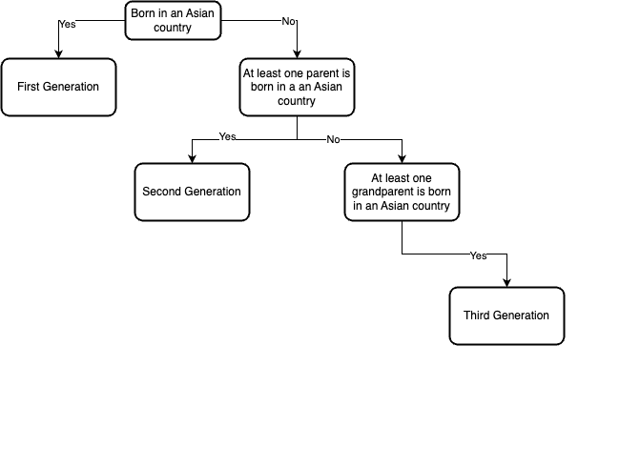
Diagram of the Three Different Generations of Asian Immigrants.
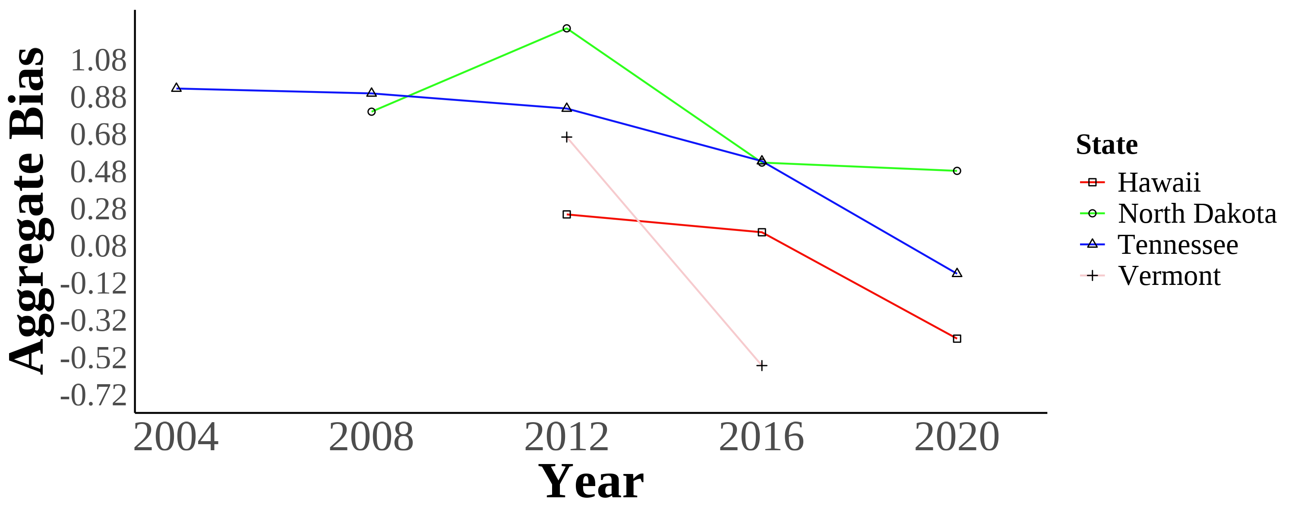 | 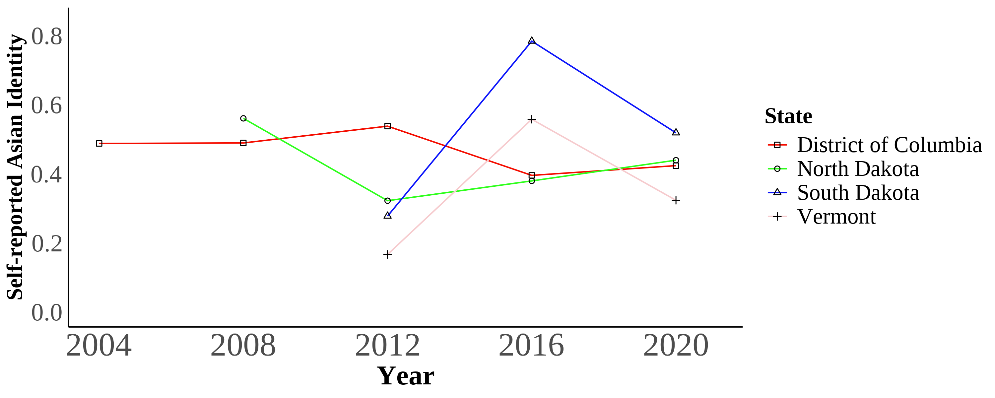 | These two panels show the trends in bias (panel a) and self-reported Asian identity among Asian immigrants (panel b) of the least and most biased places in the data. The District of Colombia is the least biased geographical area, and North Dakota is the most biased. The bias units are in standard deviations. Self-reported Asian identity is among first, second, and third-generation Asian immigrants aged 17 and younger still living in intact families.  Bias data is from the 2004–2021 Harvard’s Project Implicit Association Test scores, American National Election Studies (ANES), and state-level hate crimes against Asians. Identity data is from the 2004–2021 Current Population Survey (CPS).
Self-reported Asian Identity Over Time
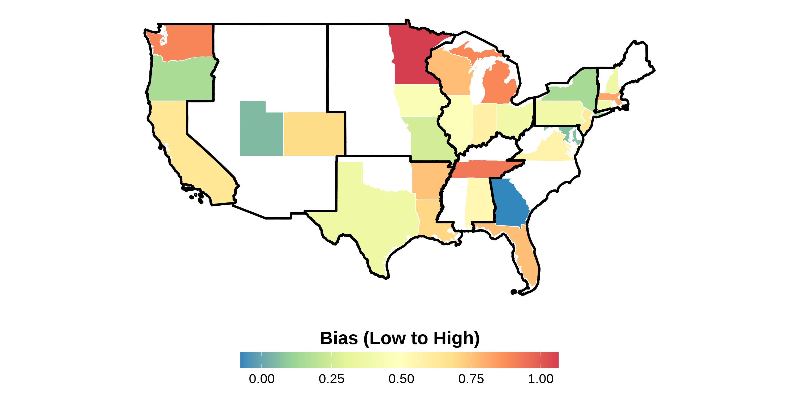 | 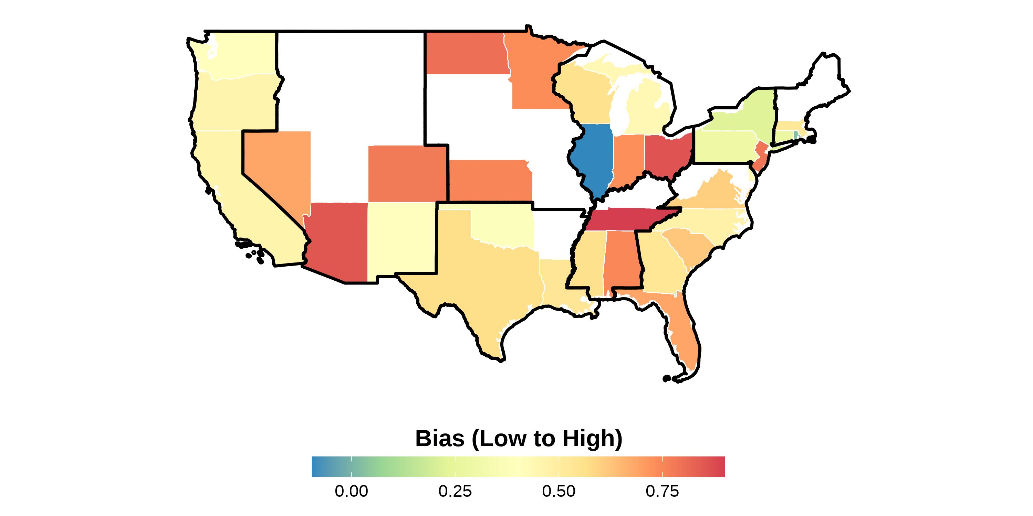 | 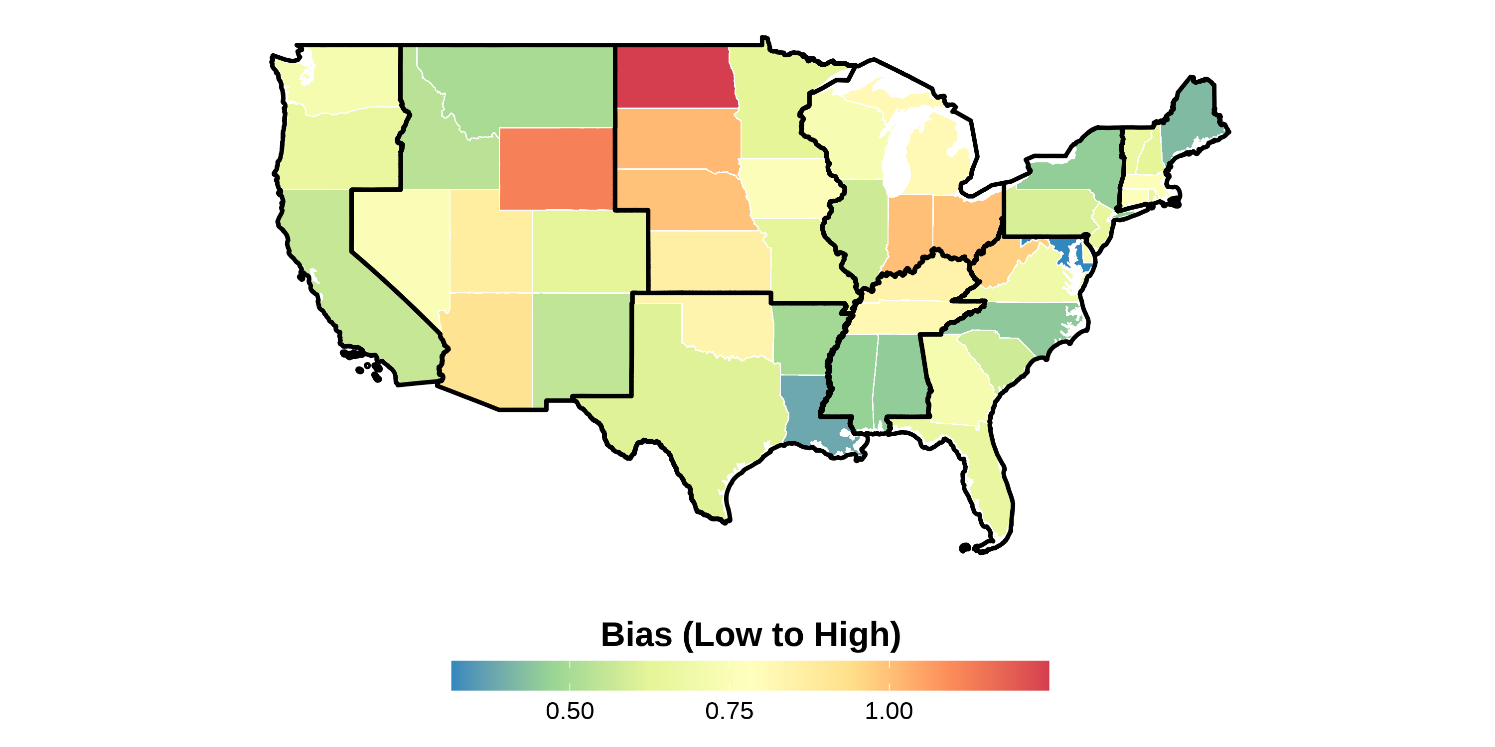 | 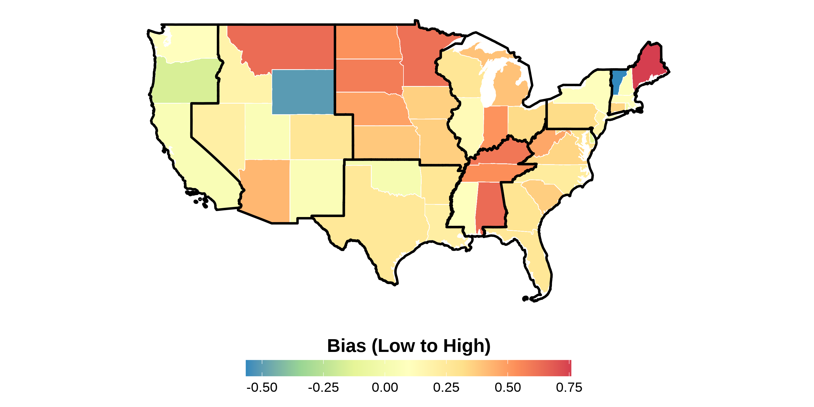 | This figure shows the state-level bias index in different years in the sample. The bias units are in standard deviations and ranges from low to high bias. Bias index is constructed following Lubotsky & Wittenberg (2006). The data is from the 2004–2021 Harvard’s Project Implicit Association Test scores, American National Election Studies (ANES), and state-level hate crimes against Asians. Each panel presents state-level bias during a certain year. The boundaries in black represent the different Census divisions in the United States. Notice how there is a variation across states within a region.
State-level Bias in 2016
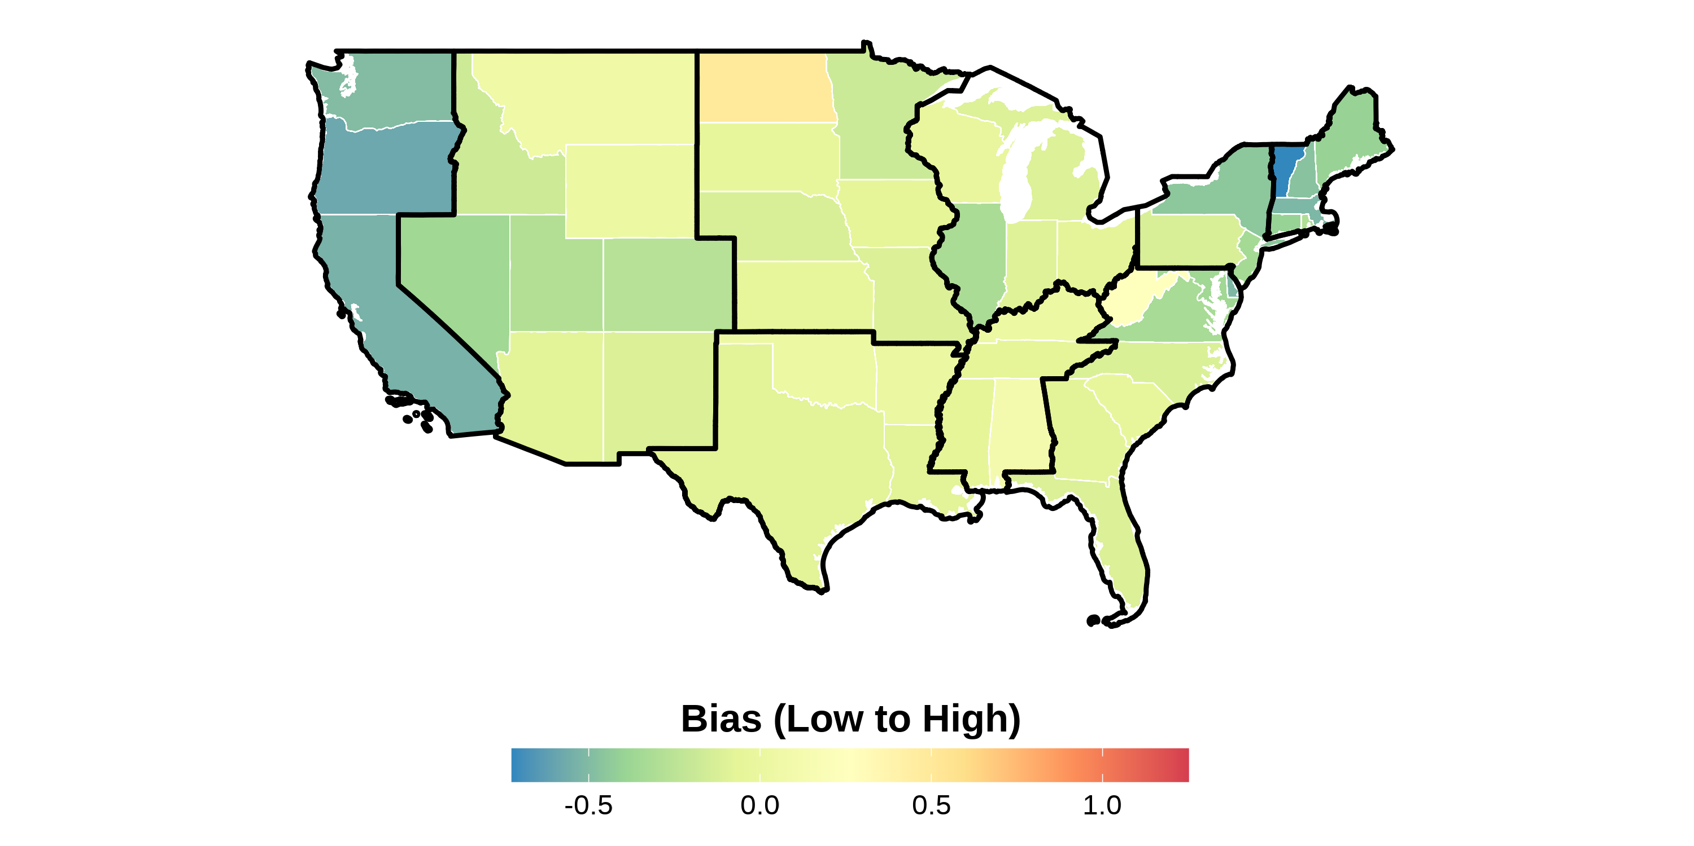 | This figure shows the state-level bias index in the sample from 2004 to 2021. The bias units are in standard deviations and ranges from low to high bias. Bias index is constructed following Lubotsky & Wittenberg (2006). The data is from the 2004–2021 Harvard’s Project Implicit Association Test scores, American National Election Studies (ANES), and state-level hate crimes against Asians. The boundaries in black represent the different Census divisions in the United States. Notice how there is a variation across states within a region.
Maps of State-level Bias 2004–2021 Measure with Census Division Regional Boundaries
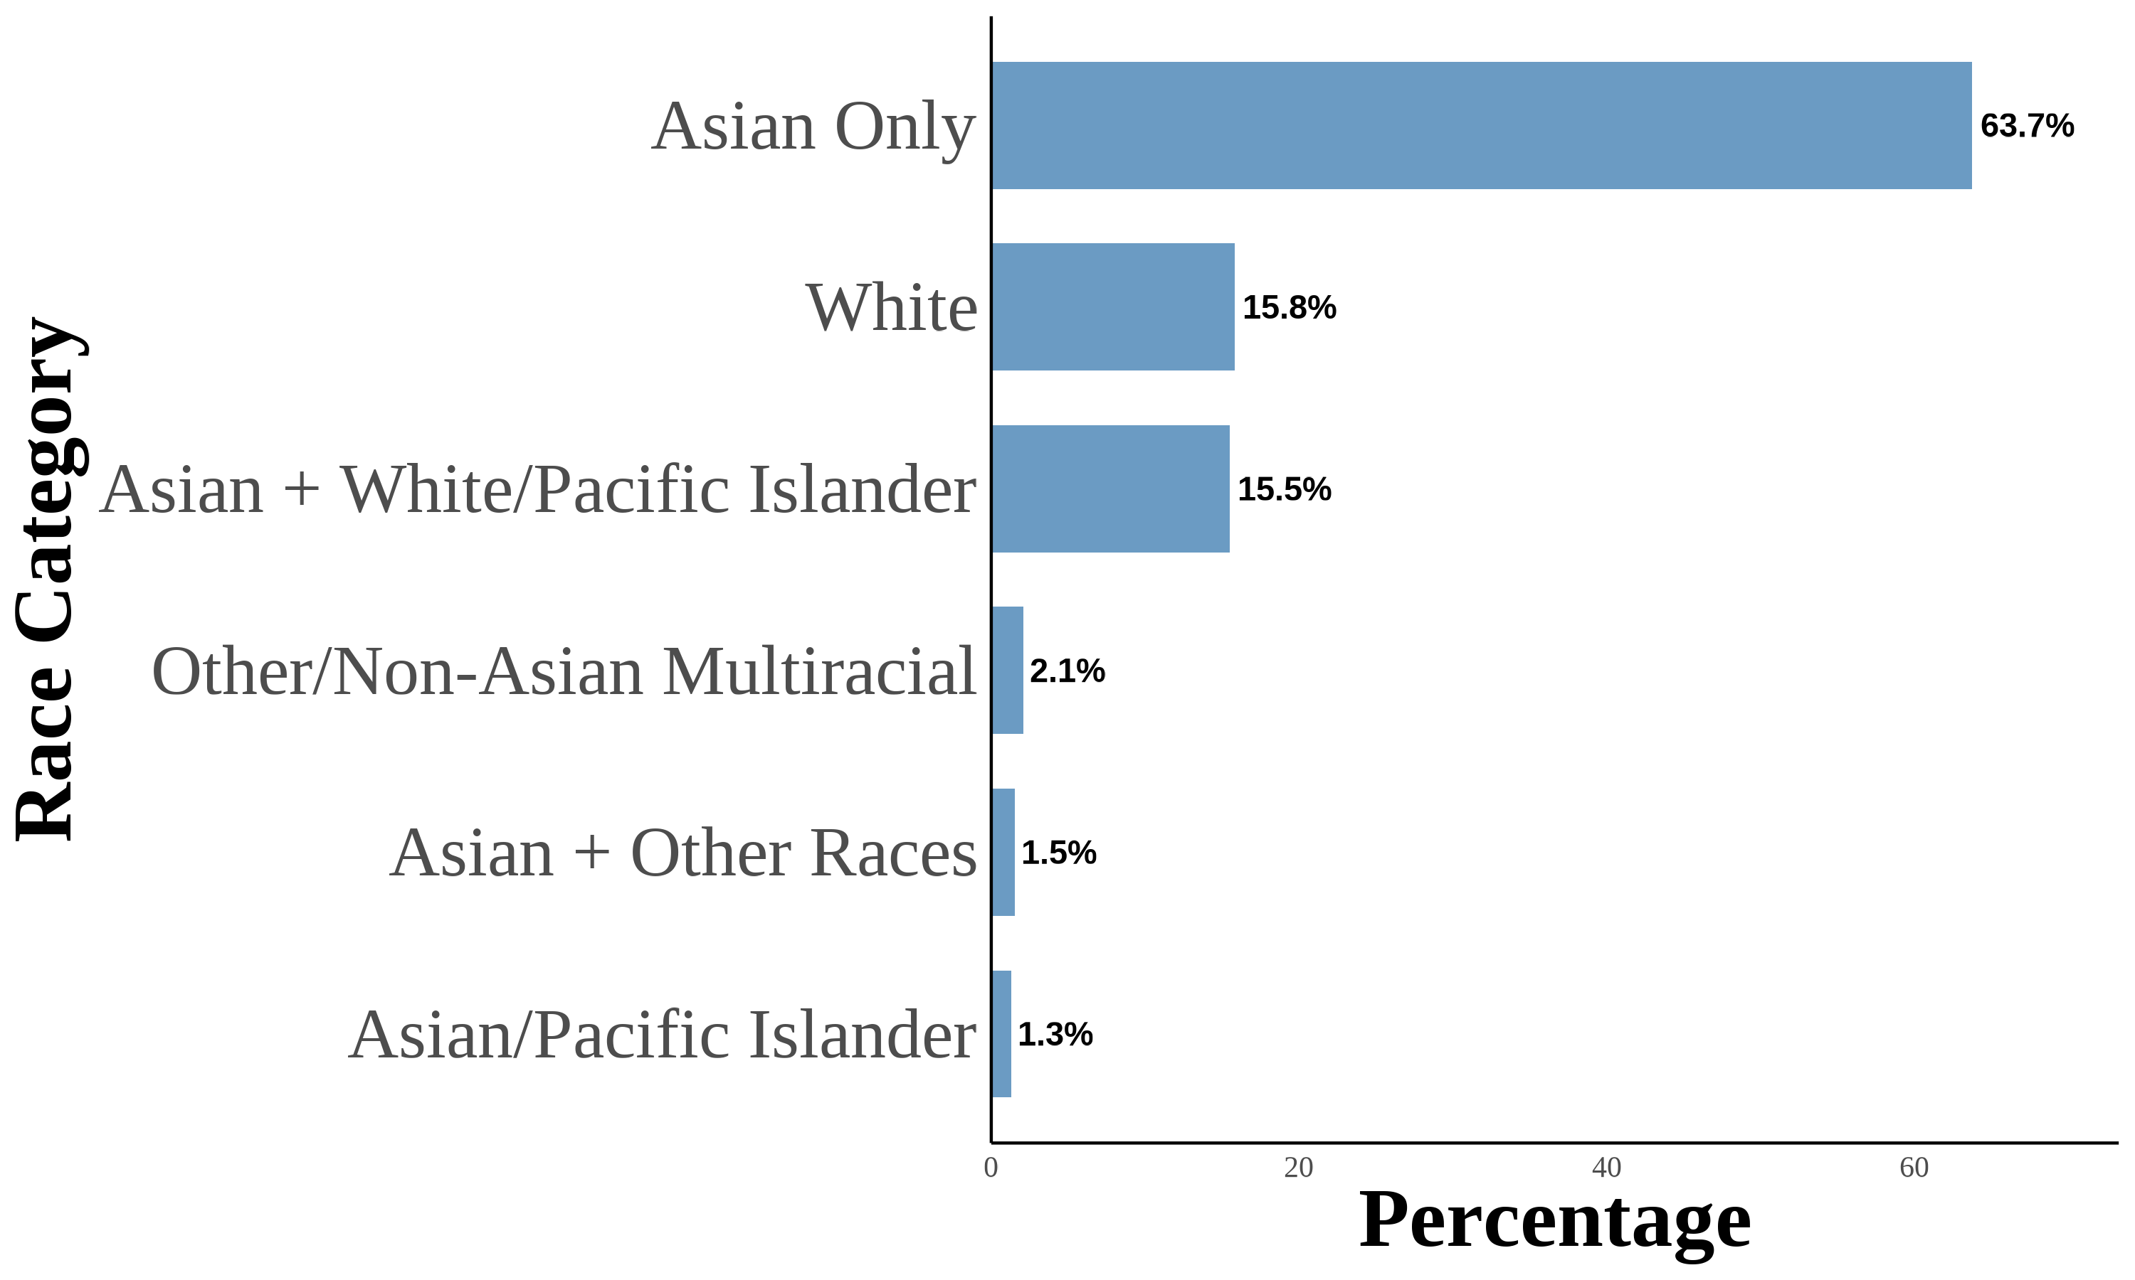 | This figure shows the distribution of Asian racial identity among respondents. The data is aggregated from the 2004–2021 Current Population Survey (CPS). The sample includes first-, second-, and third-generation objectively Asian Americans. Following (F. M. Antman et al., 2020; F. Antman et al.; 2016), I utilize birthplace information for individuals, parents, and grandparents to create objective Asian ancestry indicators.
Asian Racial Identity
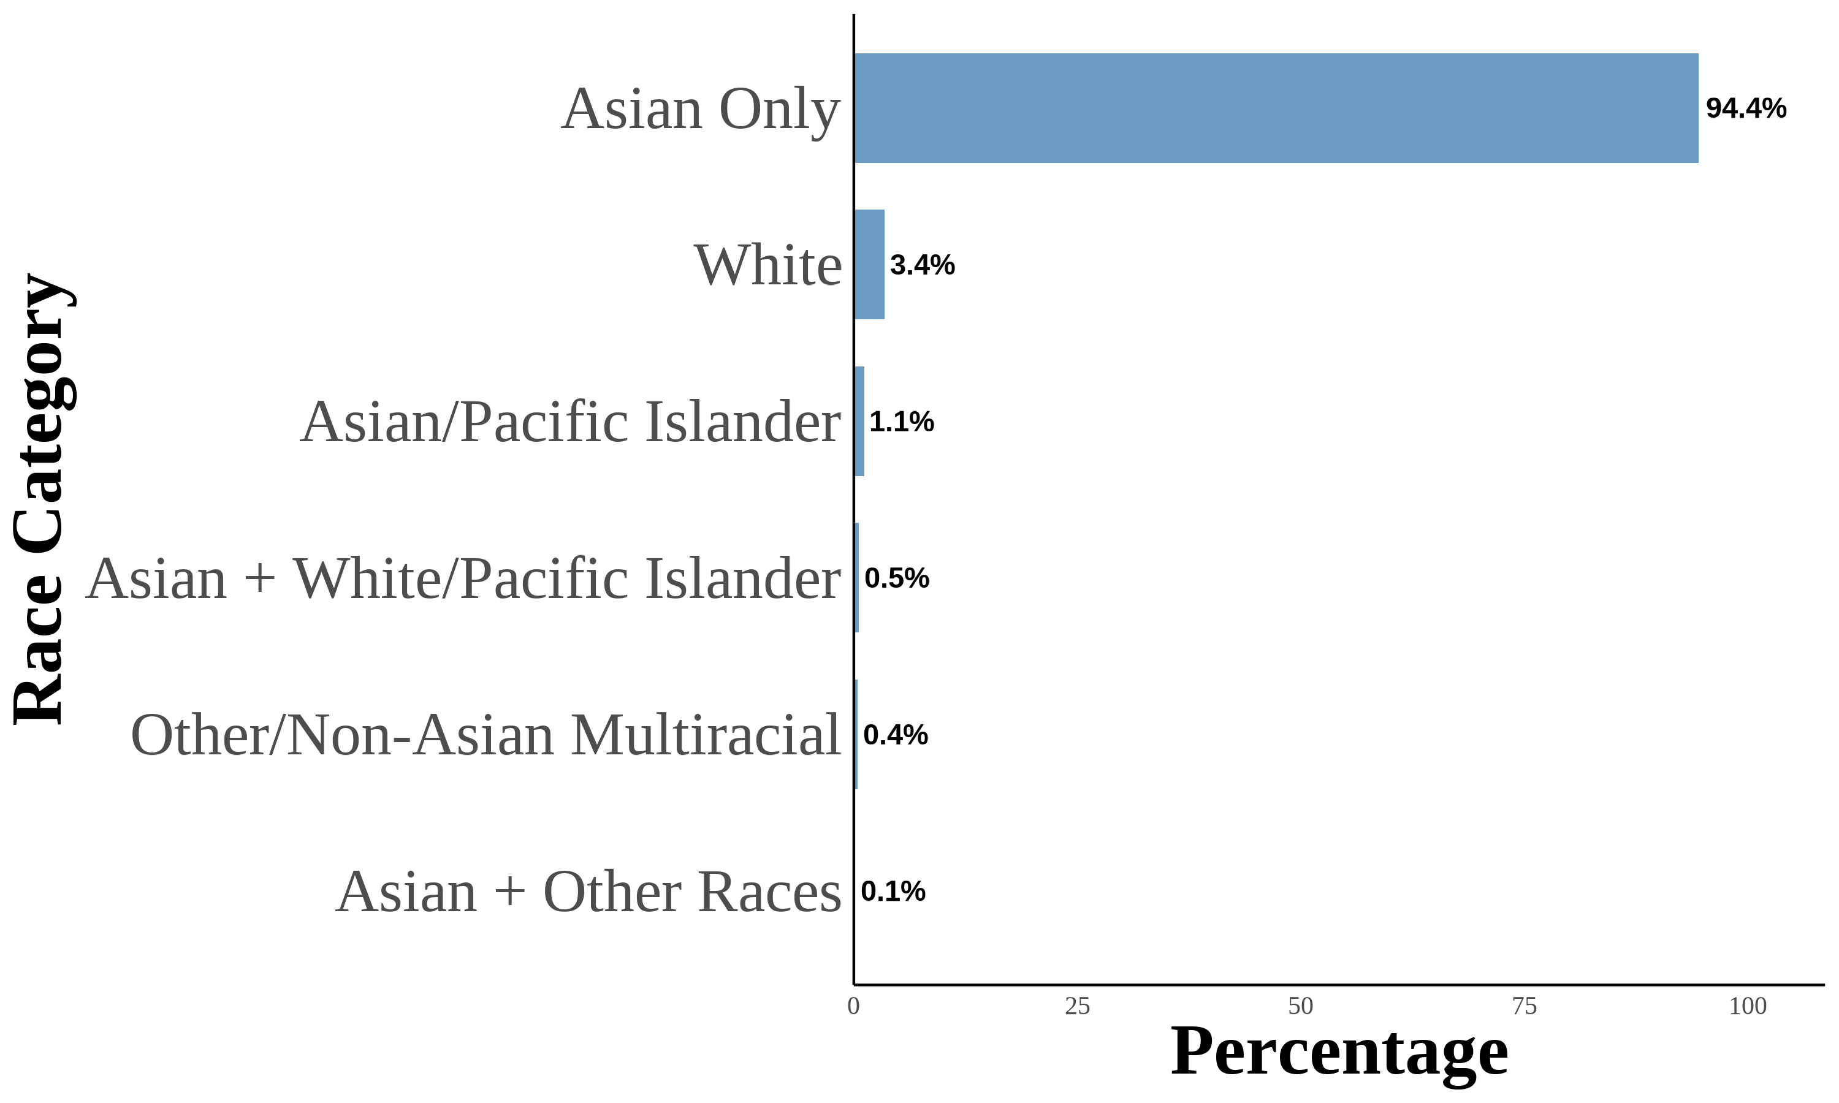 | This figure shows the distribution of Asian racial identity among respondents. The data is aggregated from the 2004–2021 Current Population Survey (CPS). The sample includes first-generation objectively Asian Americans. Following (F. M. Antman et al., 2020; F. Antman et al.; 2016), I utilize birthplace information for individuals, parents, and grandparents to create objective Asian ancestry indicators. A first-generation Asian American is defined as an individual born in an Asian country and is not a US citizen born to US citizen parents abroad.
Asian Racial Identity: First Generation
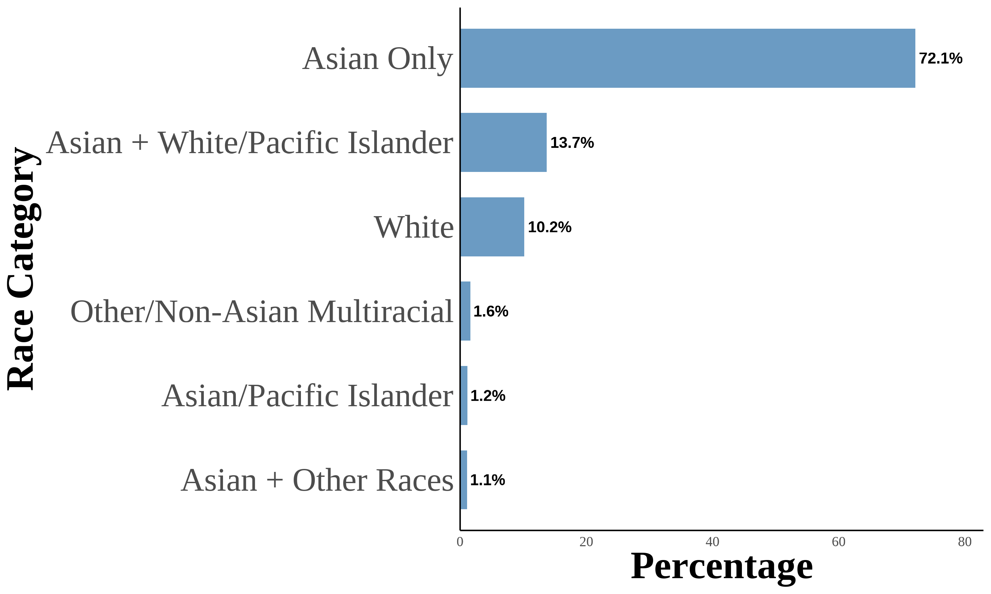 | 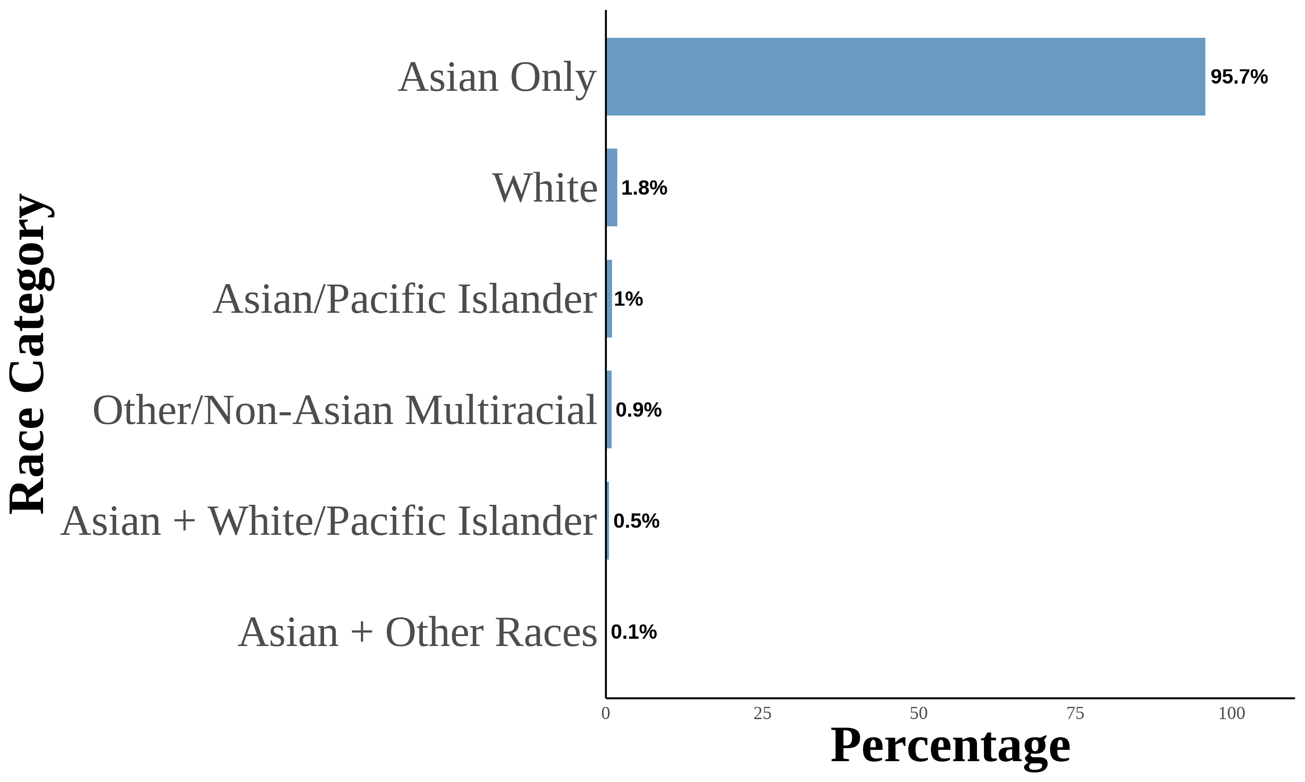 | 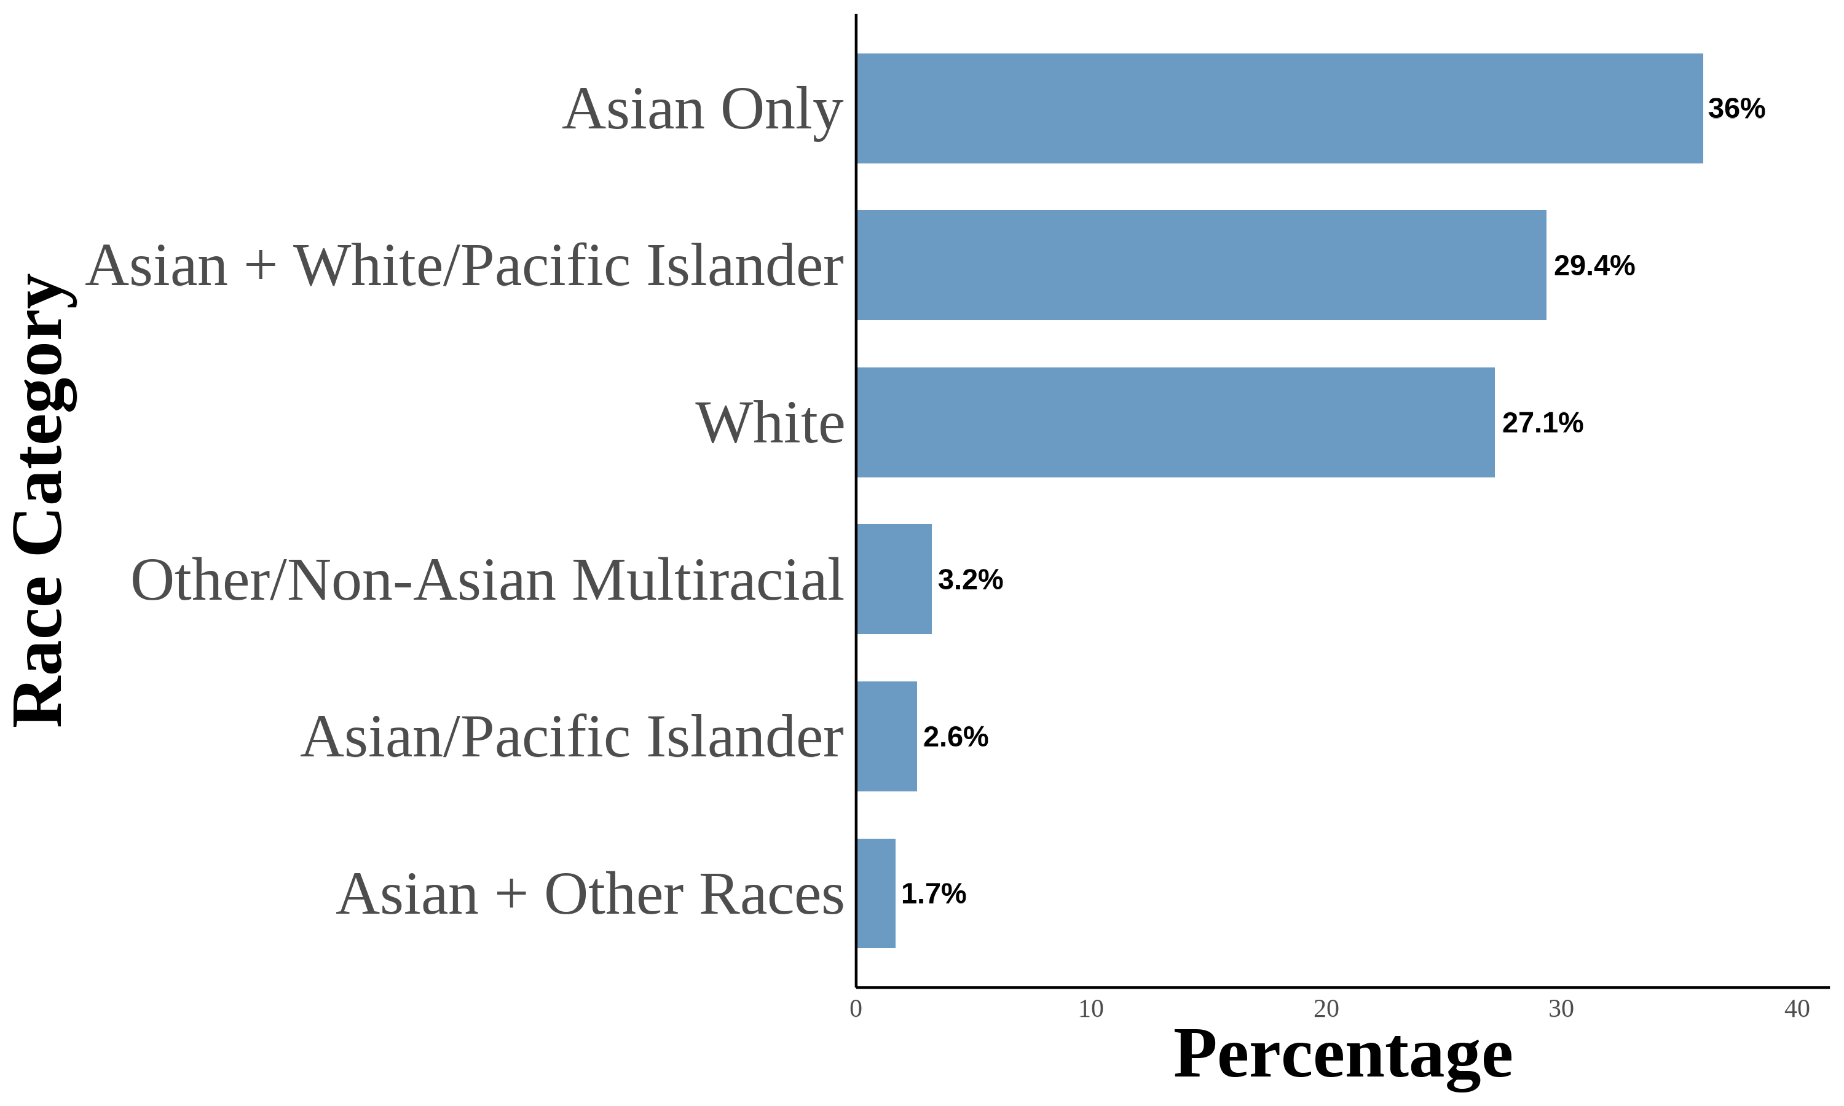 | 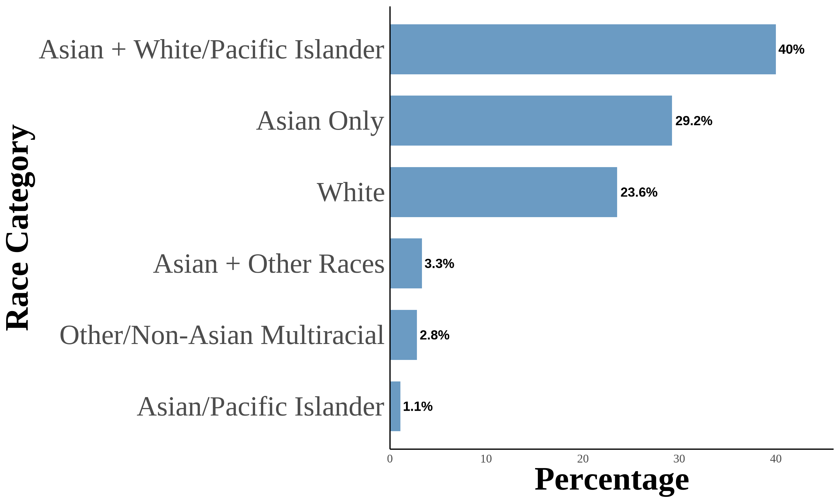 | This figure shows the distribution of Asian racial identity among respondents. The data is aggregated from the 2004–2021 Current Population Survey (CPS). The sample includes second-generation objectively Asian Americans. Following (F. M. Antman et al., 2020; F. Antman et al.; 2016), I utilize birthplace information for individuals, parents, and grandparents to create objective Asian ancestry indicators. A second-generation Asian American is defined as a native-born individual with at least one parent born in an Asian country. The first panel is for second-generation Asian Americans. The second panel is for second-generation Asian Americans with both parents born in an Asian country. The third panel is for second-generation Asian Americans with an Asian father and a White mother. The fourth panel is for second-generation Asian Americans with a White father and an Asian mother.
Second Generation: White Fathers-Asian Mothers
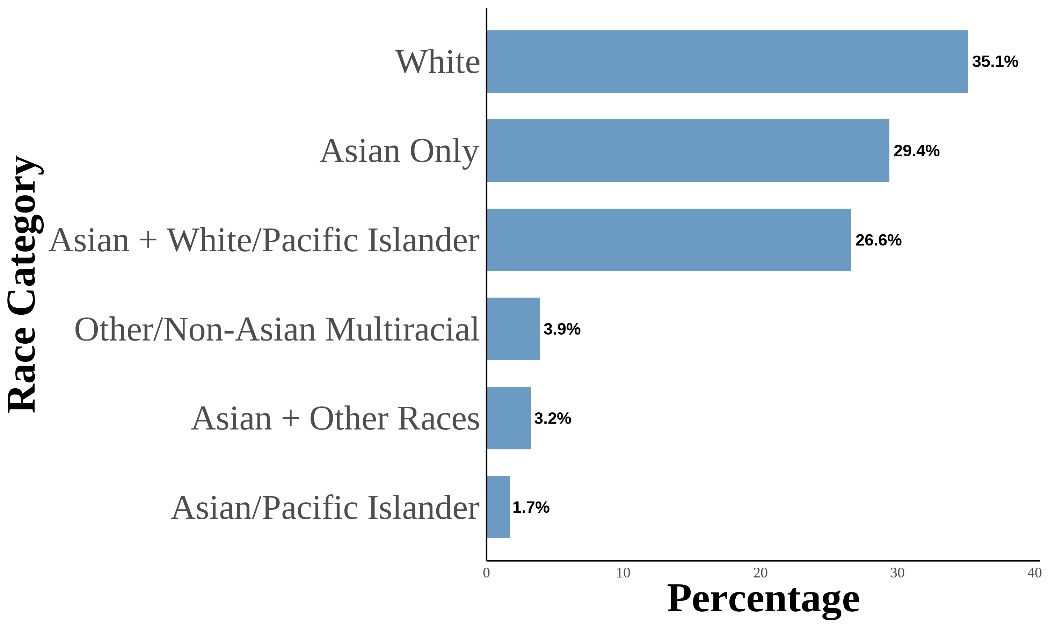 | 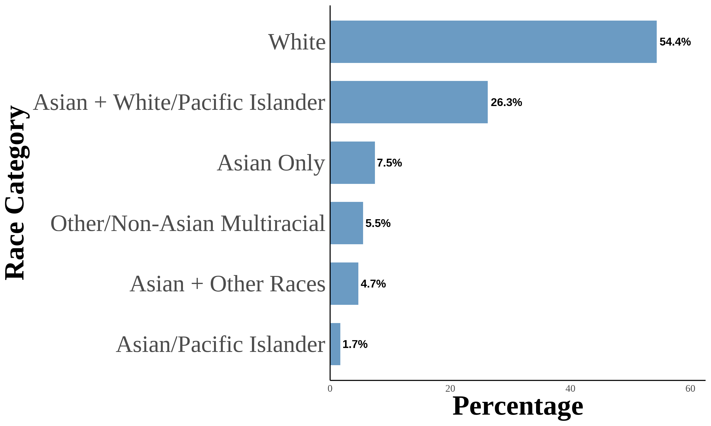 | 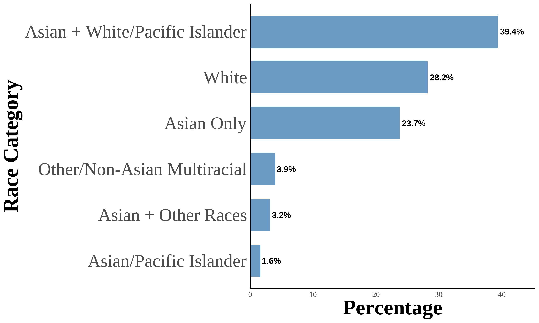 | 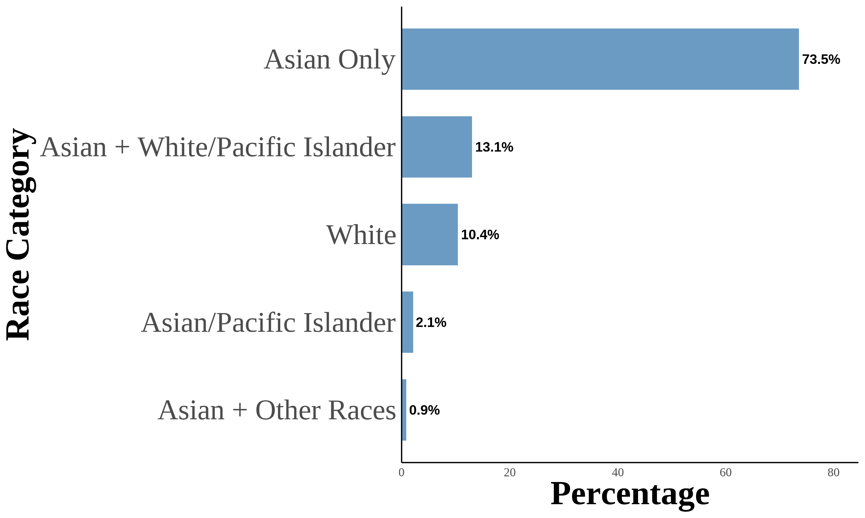 | 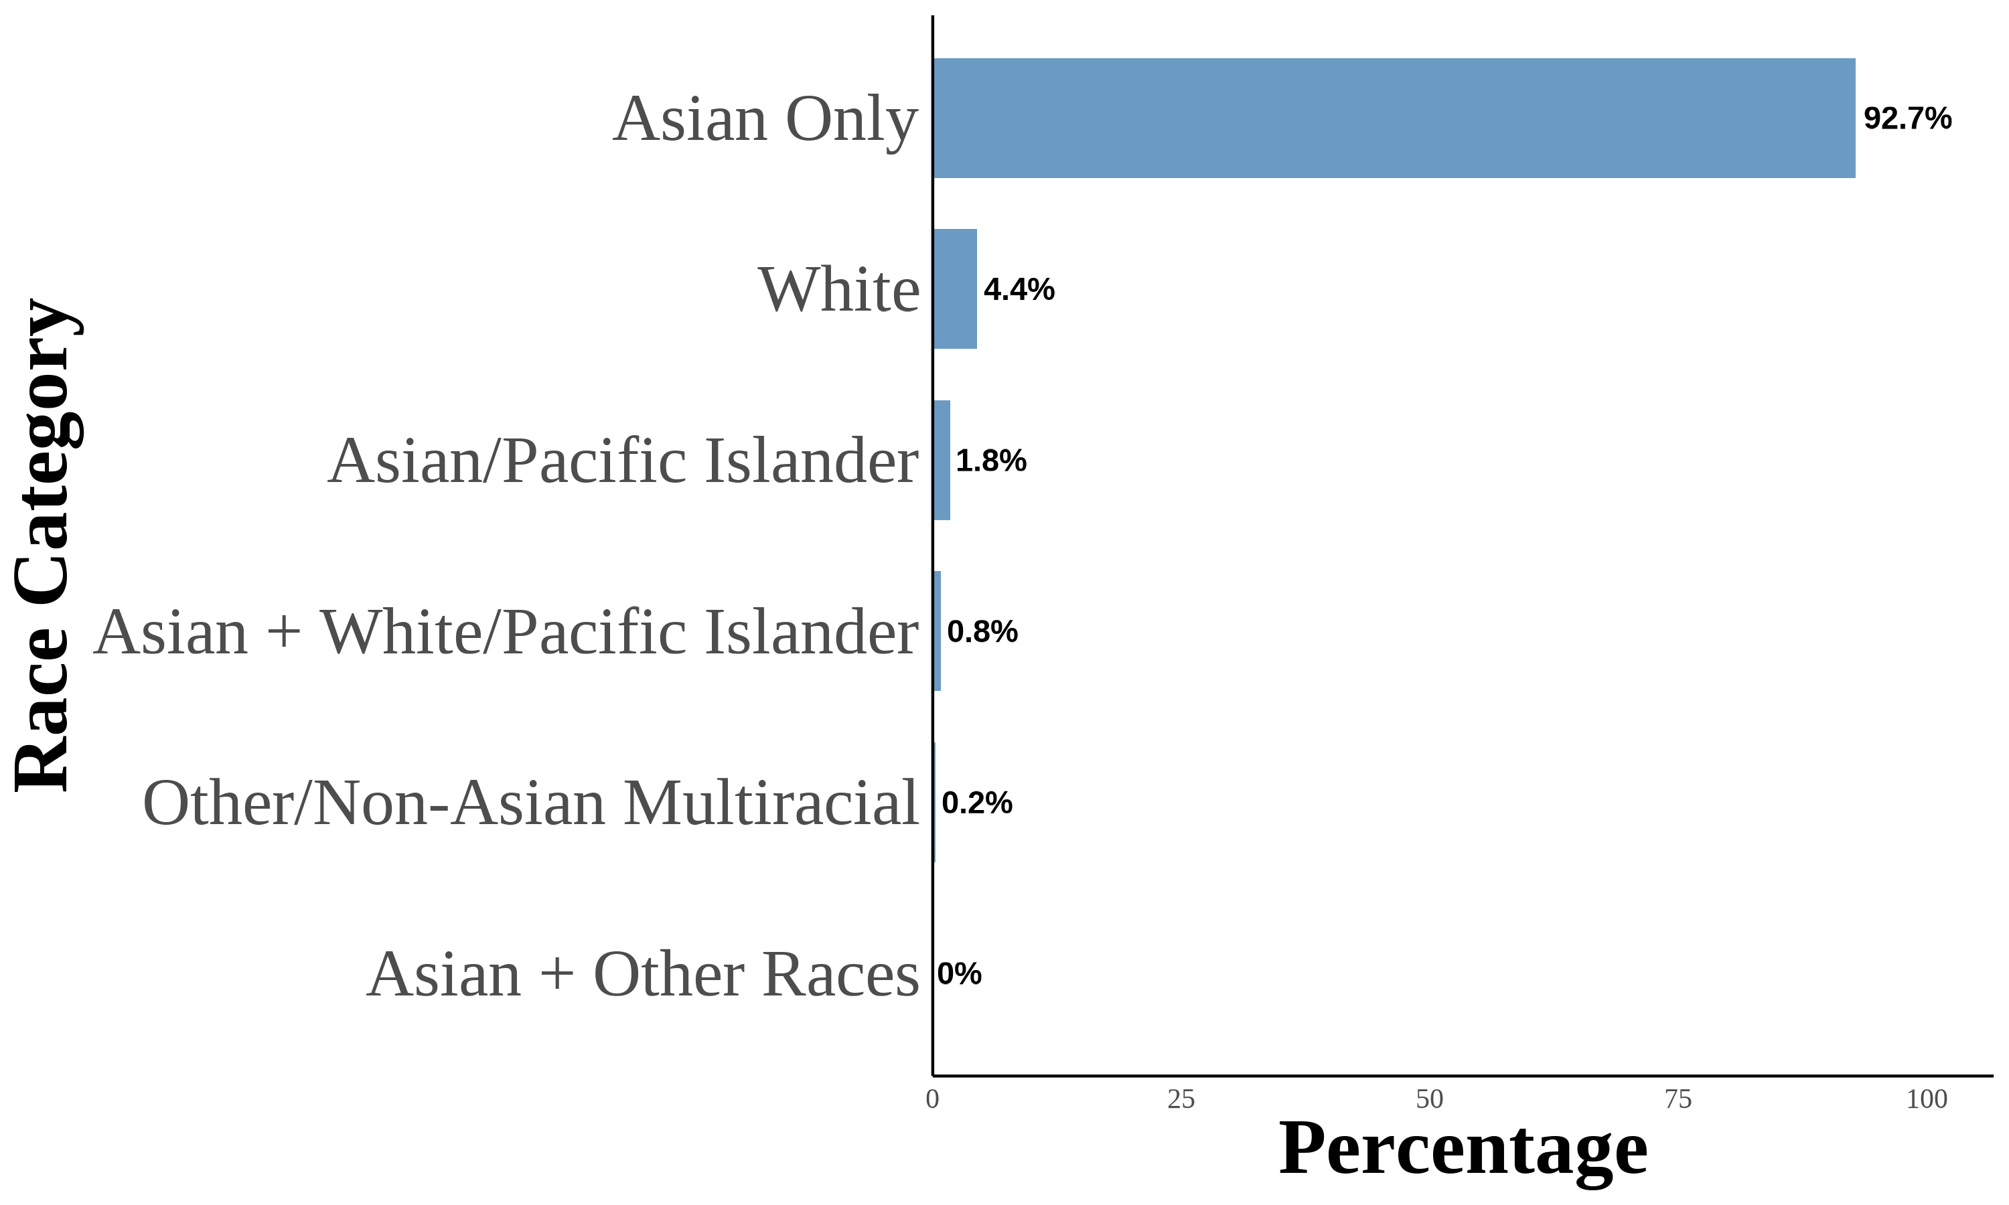 | This figure shows the distribution of Asian racial identity among respondents. The data is aggregated from the 2004–2021 Current Population Survey (CPS). The sample includes second-generation objectively Asian Americans. Following (F. M. Antman et al., 2020; F. Antman et al.; 2016), I utilize birthplace information for individuals, parents, and grandparents to create objective Asian ancestry indicators. A third-generation Asian American is defined as a native-born individual with native-born parents and at least one grandparent born in an Asian country. The first panel is for third-generation Asian Americans. The second panel is for third-generation Asian Americans with one grandparent born in an Asian country. The third panel is for third-generation Asian Americans with two grandparents born in an Asian country. The fourth panel is for third-generation Asian Americans with three grandparents born in an Asian country. The fifth panel is for third-generation Asian Americans with four grandparents born in an Asian country.
Third Generation: Four Asian Grandparents
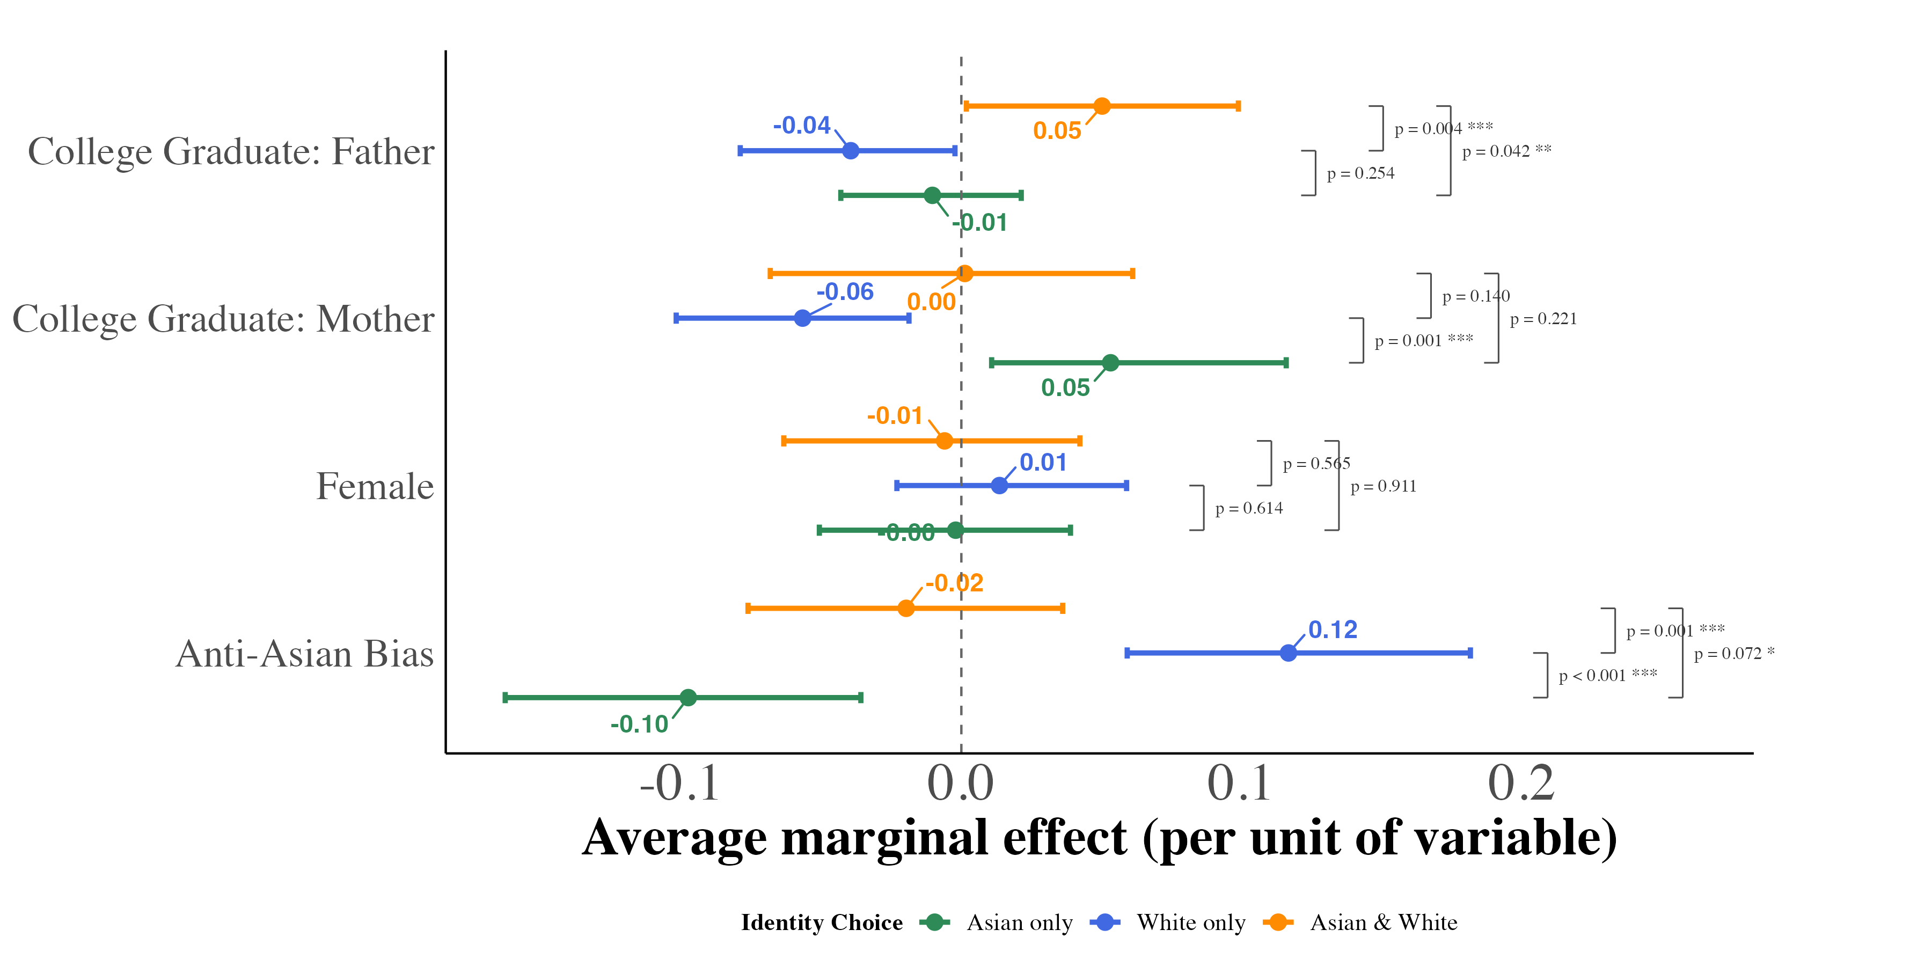 This figure displays the marginal effects of key covariates on the probability of each racial identification outcome, estimated from equation (4) using multinomial logit models for all pooled mixed-race second-generation Asian Americans. Marginal effects represent the change in predicted probability for a one-unit increase in the covariate (or discrete change from 0 to 1 for binary variables), holding other variables at their sample means. I include region $×$ year fixed effects with controls for quartic age and local Asian population share. Each point corresponds to the median marginal effect across 1,000 bootstrap resamples, with 95% percentile confidence intervals. Second-generation Asian Americans are native-born individuals with at least one Asian-born parent.
Marginal Effects of Key Covariates on Racial Identity Choice (Pooled Mixed-Race Second-Generation Asian Americans)
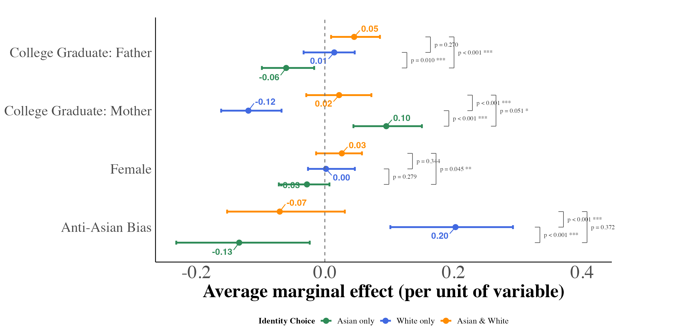 | 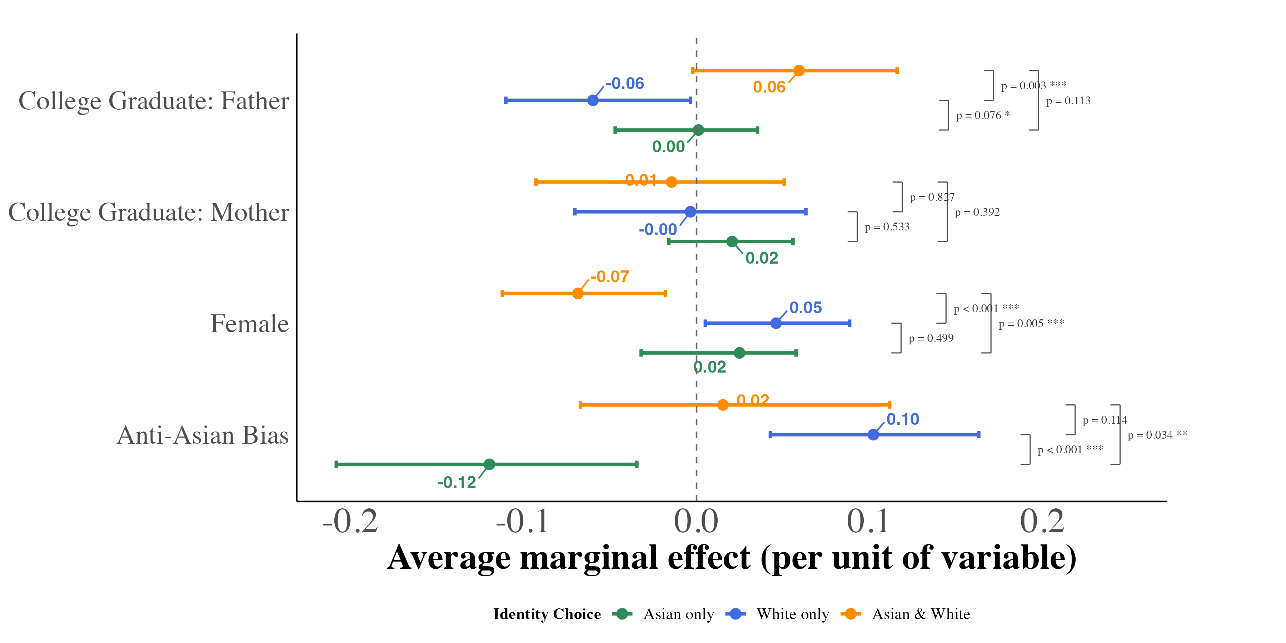 | This figure displays the marginal effects of key covariates on the probability of each racial identification outcome, estimated from equation (4) using multinomial logit models for second-generation Asian Americans by parental ancestry configuration. Marginal effects represent the change in predicted probability for a one-unit increase in the covariate (or discrete change from 0 to 1 for binary variables), holding other variables at their sample means. I include region $×$ year fixed effects with controls for quartic age and local Asian population share. Each point corresponds to the median marginal effect across 1,000 bootstrap resamples, with 95% percentile confidence intervals. Second-generation Asian Americans are native-born individuals with at least one Asian-born parent.
White Father-Asian Mother (WA)
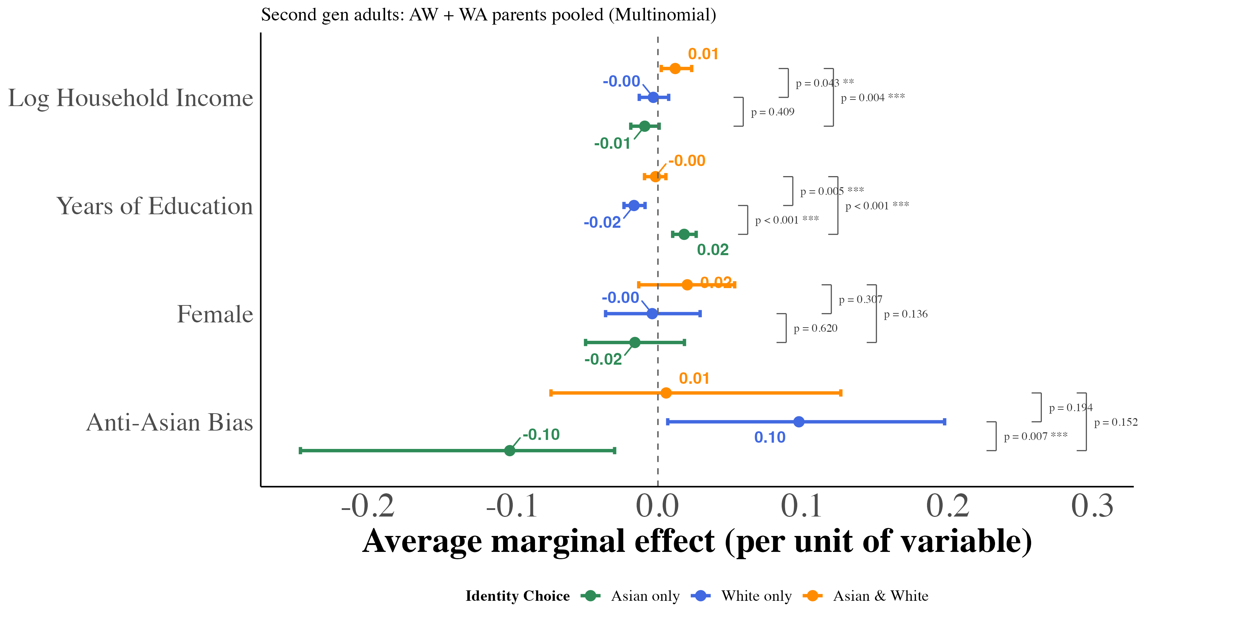 This figure displays the marginal effects of key covariates on the probability of each racial identification outcome, estimated from equation (4) using multinomial logit models for all pooled mixed-race adult second-generation Asian Americans. Marginal effects represent the change in predicted probability for a one-unit increase in the covariate (or discrete change from 0 to 1 for binary variables), holding other variables at their sample means. I include region $×$ year fixed effects with controls for quartic age and local Asian population share. Each point corresponds to the median marginal effect across 1,000 bootstrap resamples, with 95% percentile confidence intervals. Second-generation Asian Americans are native-born individuals with at least one Asian-born parent.
Marginal Effects of Key Covariates on Racial Identity Choice (Pooled Mixed-Race Adult Second-Generation Asian Americans)
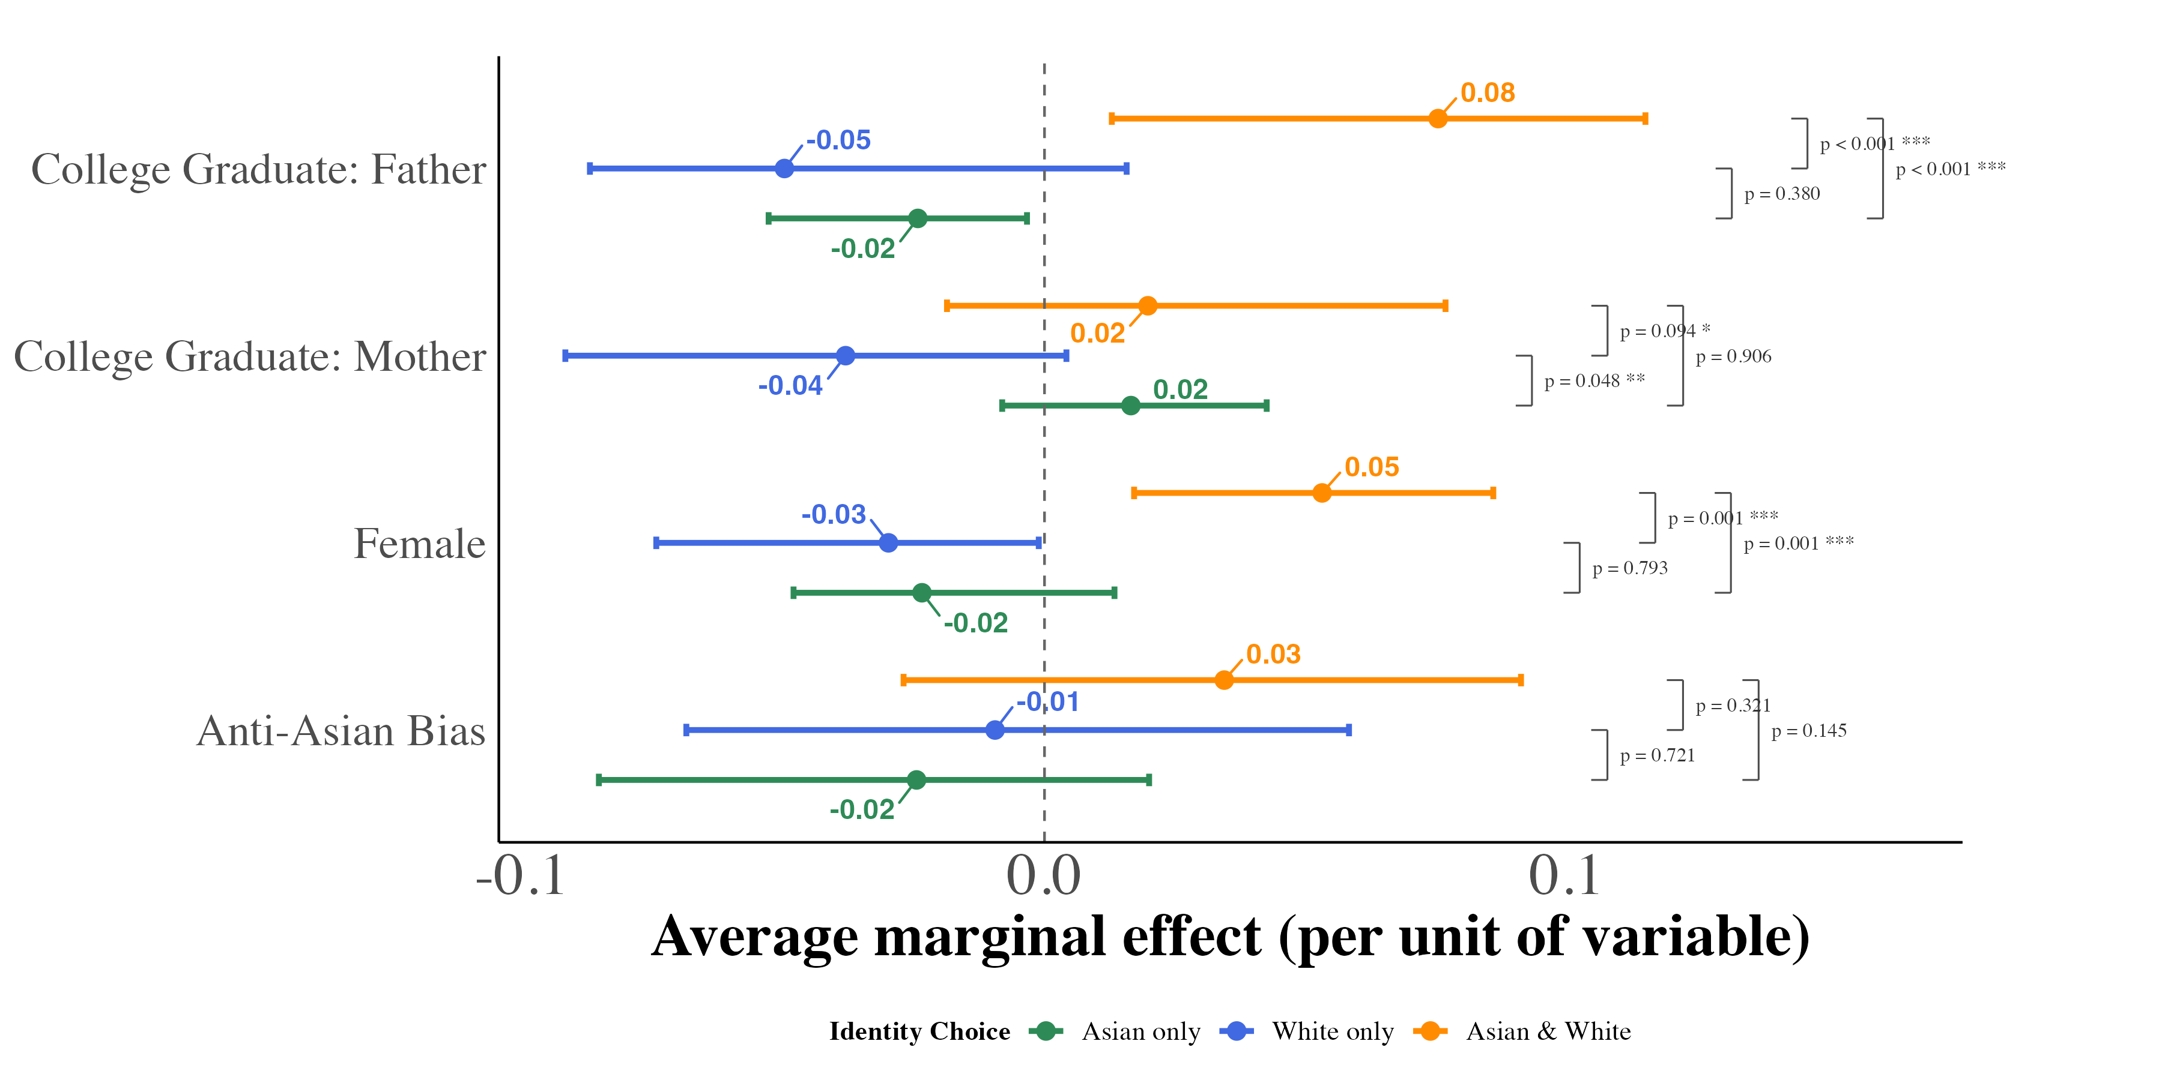 This figure displays the marginal effects of key covariates on the probability of each racial identification outcome, estimated from equation (4) using multinomial logit models for all pooled third-generation Asian Americans. Marginal effects represent the change in predicted probability for a one-unit increase in the covariate (or discrete change from 0 to 1 for binary variables), holding other variables at their sample means. I include region $×$ year fixed effects with controls for quartic age and local Asian population share. Each estimate is the median across 1,000 bootstrap resamples, and 95% percentile confidence intervals accompany every point.
Marginal Effects of Key Covariates on Racial Identity Choice (Pooled Third-Generation Asian Americans)
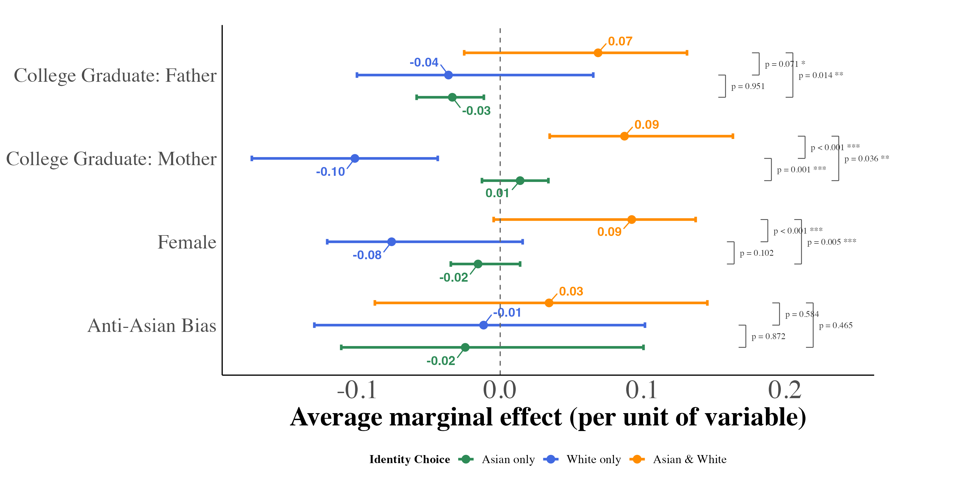 | 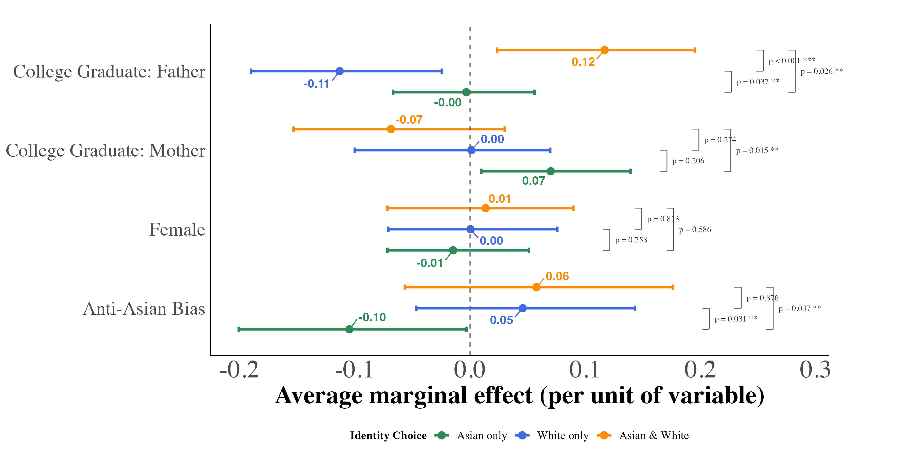 | 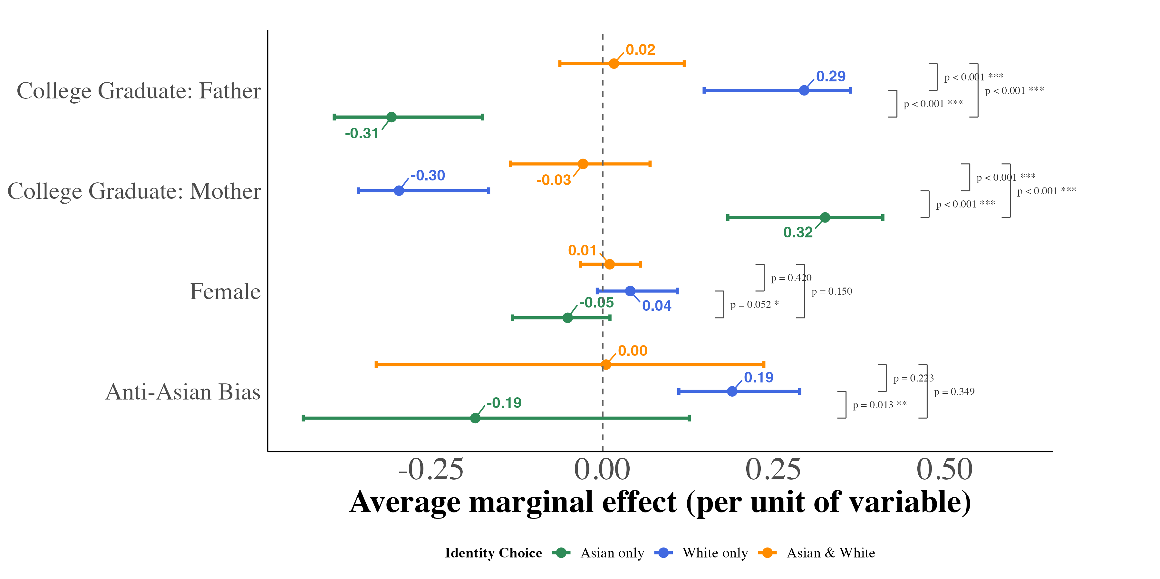 | This figure displays the marginal effects of key covariates on the probability of each racial identification outcome, estimated from equation (4) using multinomial logit models for third-generation Asian Americans by number of Asian grandparents. Marginal effects represent the change in predicted probability for a one-unit increase in the covariate (or discrete change from 0 to 1 for binary variables), holding other variables at their sample means. I include region $×$ year fixed effects with controls for quartic age and local Asian population share. Each estimate is the median across 1,000 bootstrap resamples, and 95% percentile confidence intervals accompany every point.
Three Asian Grandparents
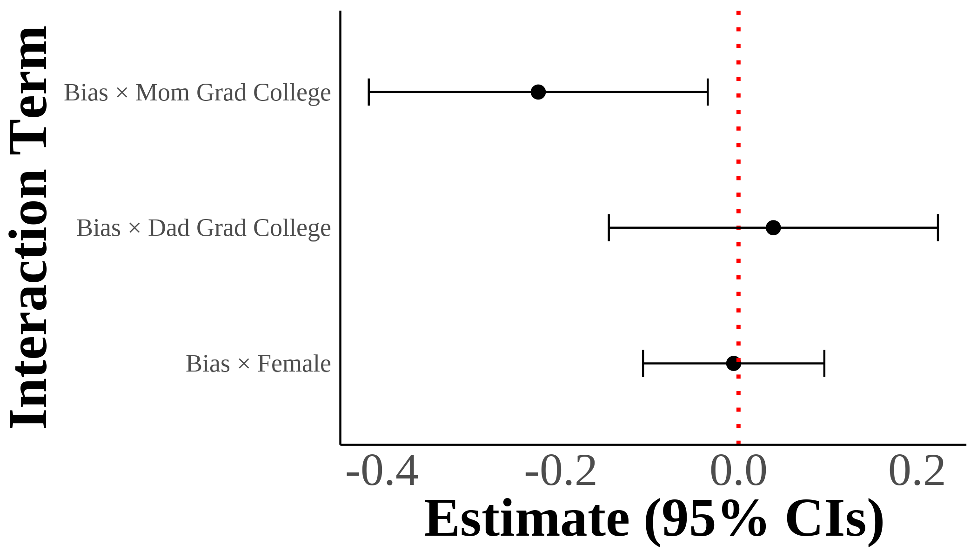 | 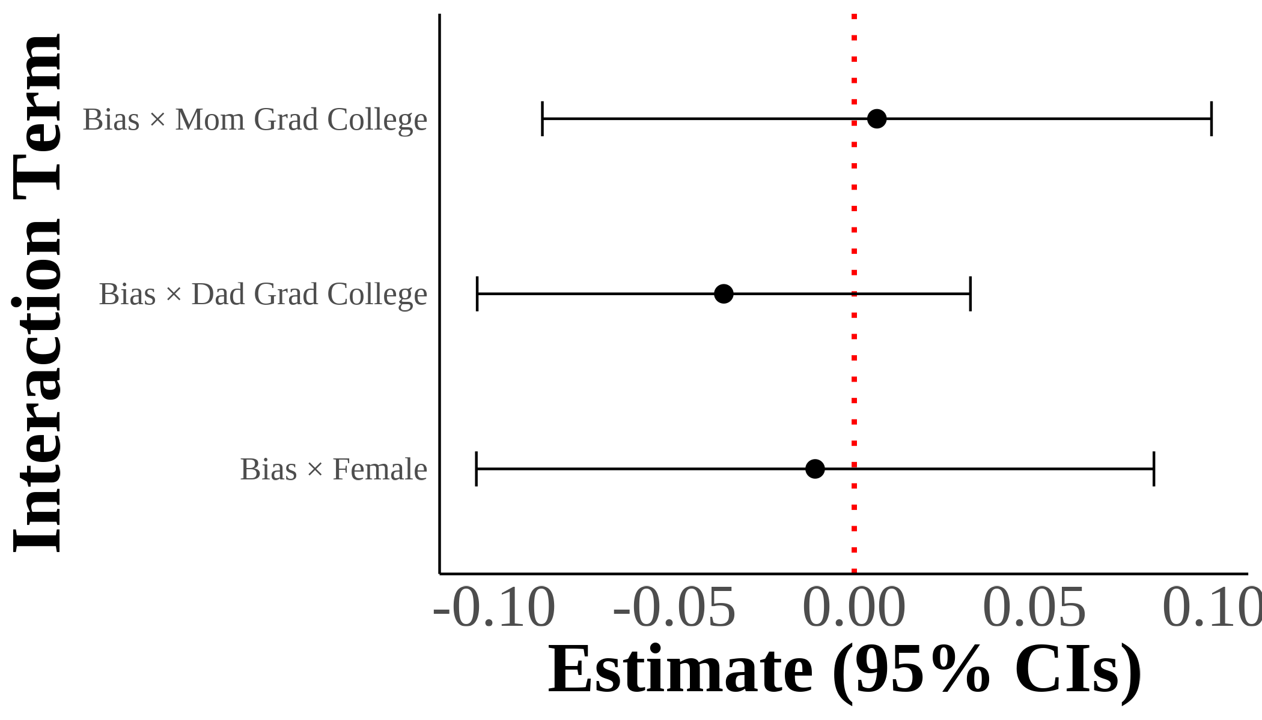 | 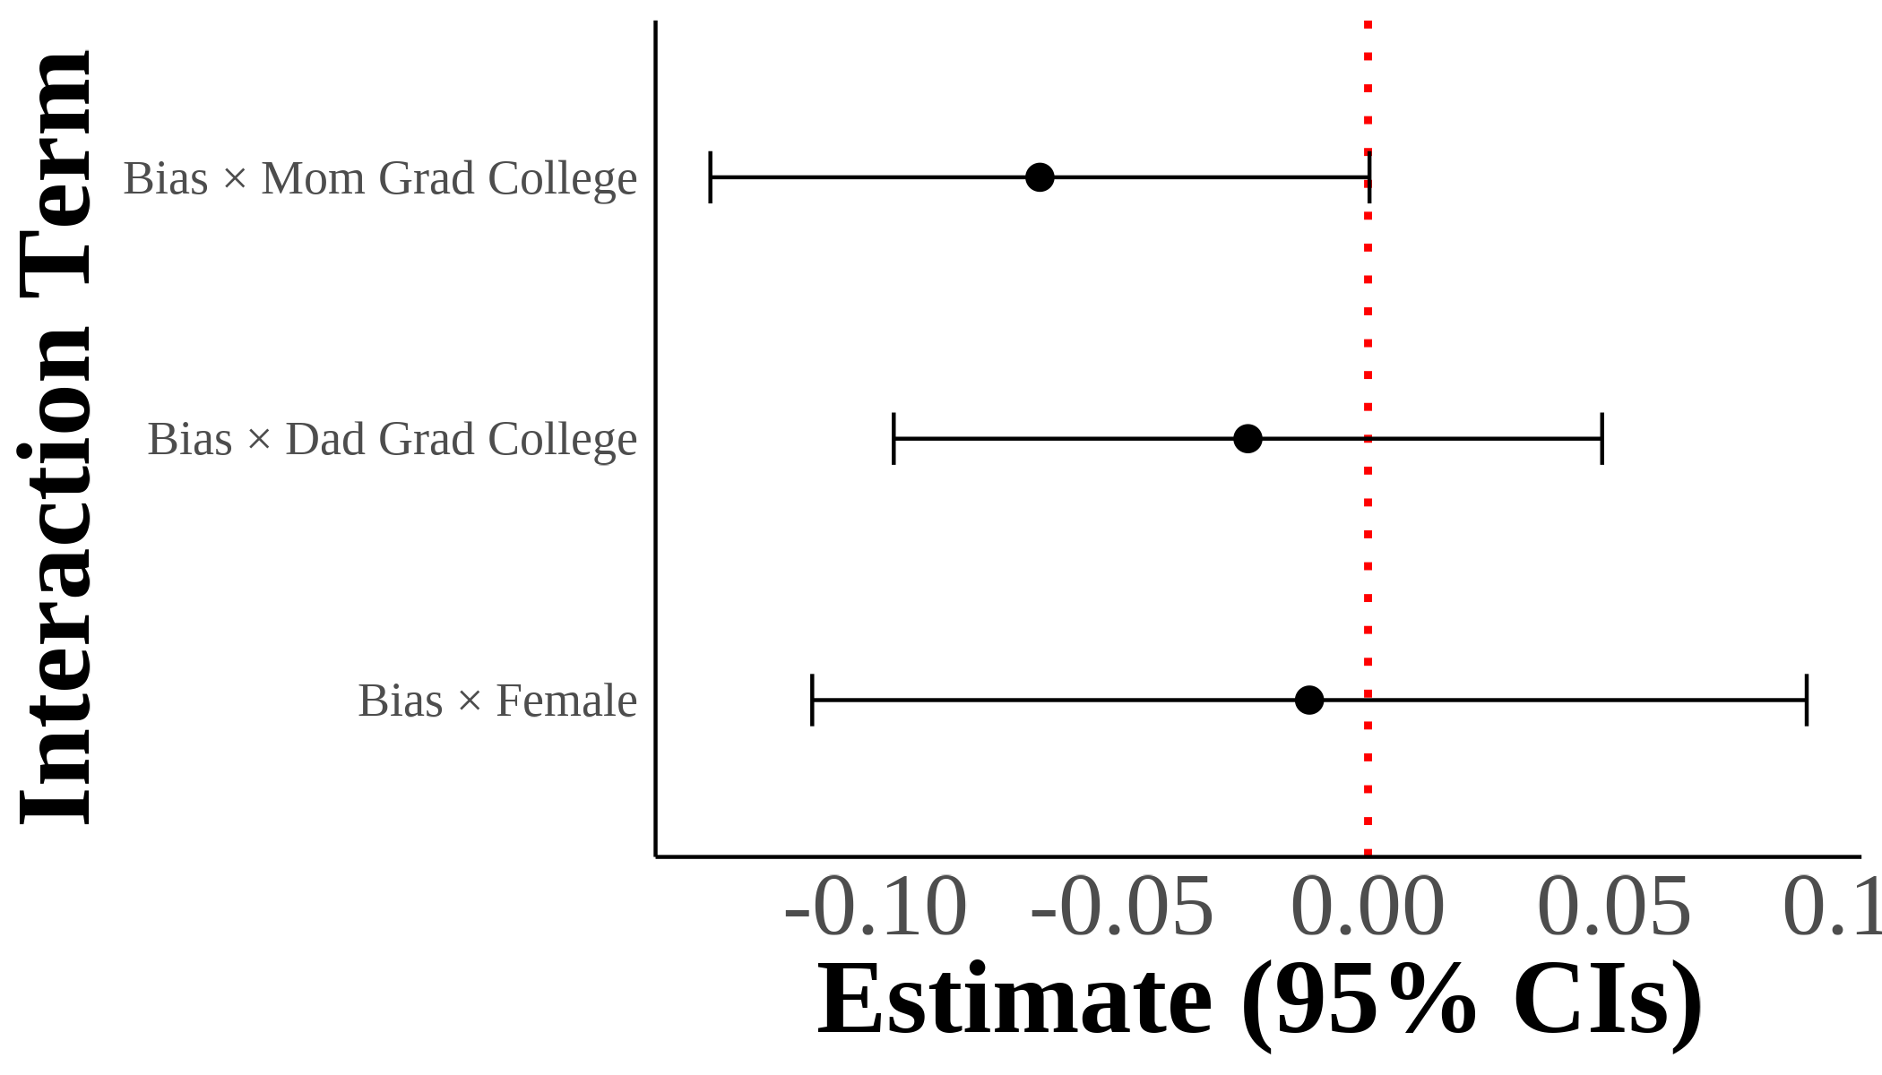 | I show interaction coefficients from estimating $A_{ist}^{g}=β_{1}^{g}AntiAsianBias_{st}+X_{ist}^{g}π+γ_{rt}+ε_{ist}$ with interaction terms for gender and parental education. I include region $×$ year fixed effects with controls for sex, quartic age, years of education, and the inverse hyperbolic sine of income. The dependent variable is self-reported Asian identity and the independent variables include demeaned state-level bias interacted with gender and parental education indicators. Each panel results from separate regressions on different samples divided by mixed parental types. Standard errors are clustered on the state level. The samples include second-generation Asian individuals with mixed-race parentage. Native-born second-generation Asian immigrant individuals with one parent born in an Asian country and one parent born outside of Asia.
Pooled: All Mixed-Race
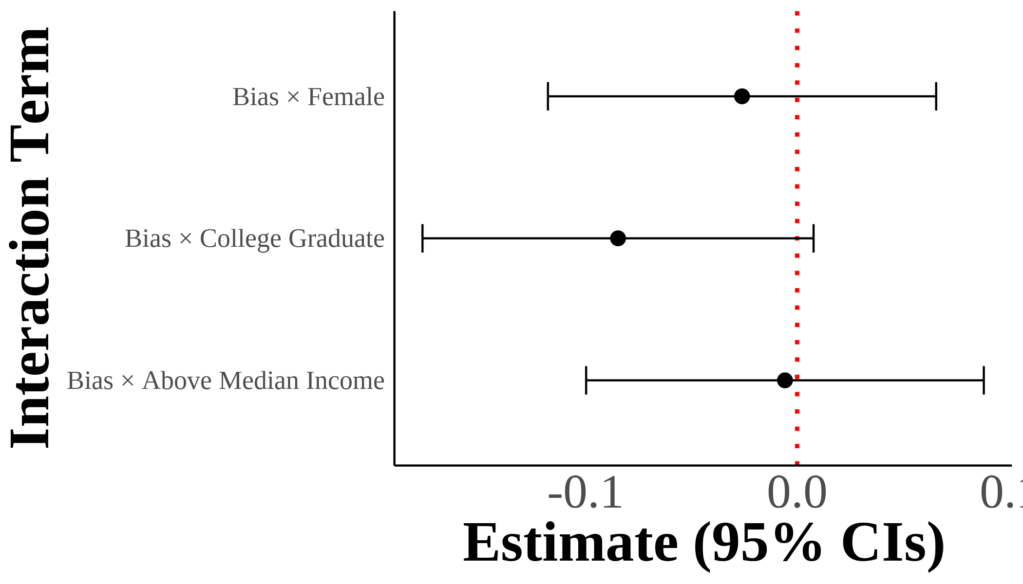 | 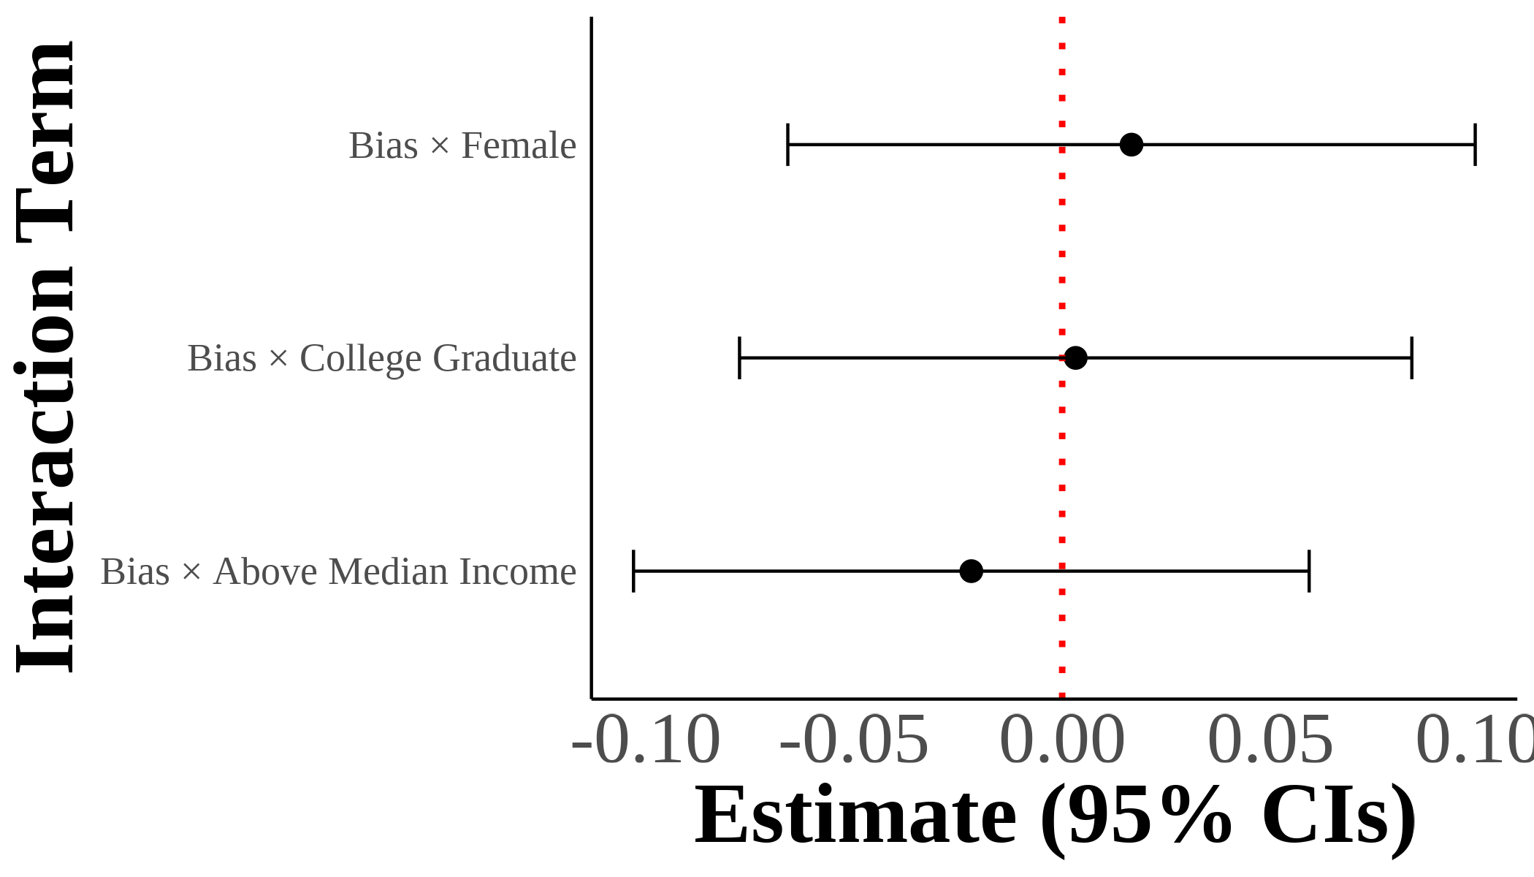 | I show interaction coefficients from estimating $A_{ist}^{g}=β_{1}^{g}AntiAsianBias_{st}+X_{ist}^{g}π+γ_{rt}+ε_{ist}$ with interaction terms for gender and parental education. I include region $×$ year fixed effects with controls for sex, quartic age, years of education, and the inverse hyperbolic sine of income. The dependent variable is self-reported Asian identity and the independent variables include demeaned state-level bias interacted with gender and parental education indicators. Each panel results from separate regressions on different samples divided by mixed parental types. Standard errors are clustered on the state level. The samples include second-generation Asian individuals ages 18 and above with mixed-race parentage. Native-born second-generation Asian immigrant individuals with one parent born in an Asian country and one parent born outside of Asia.
White Fathers-Asian Mothers
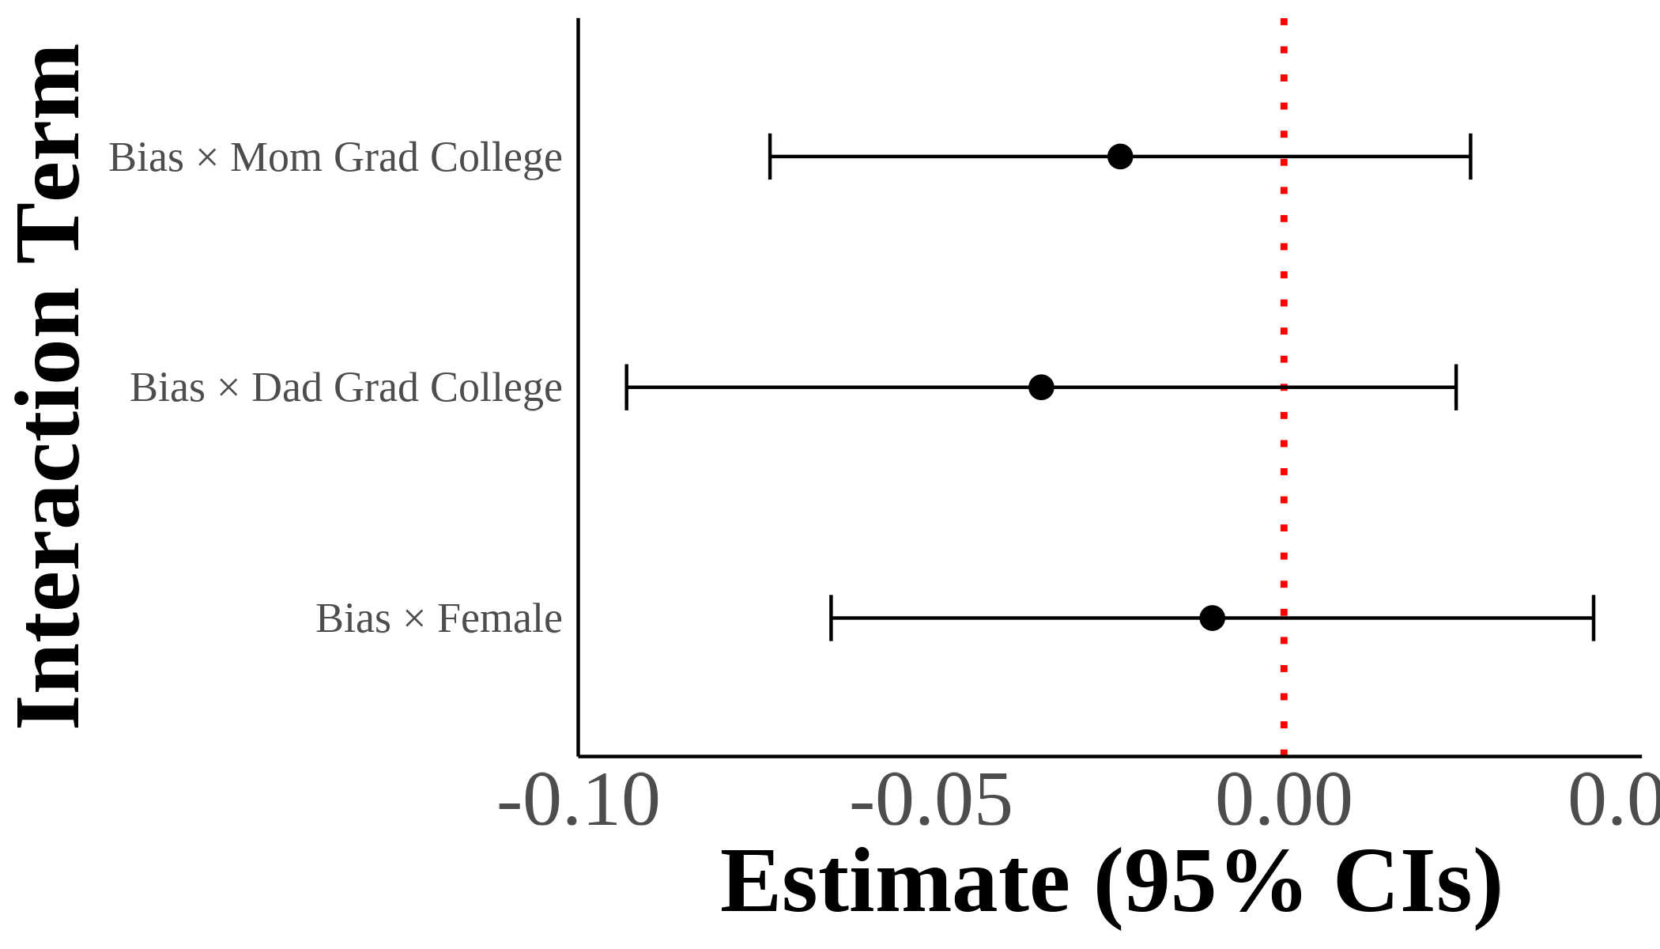 | 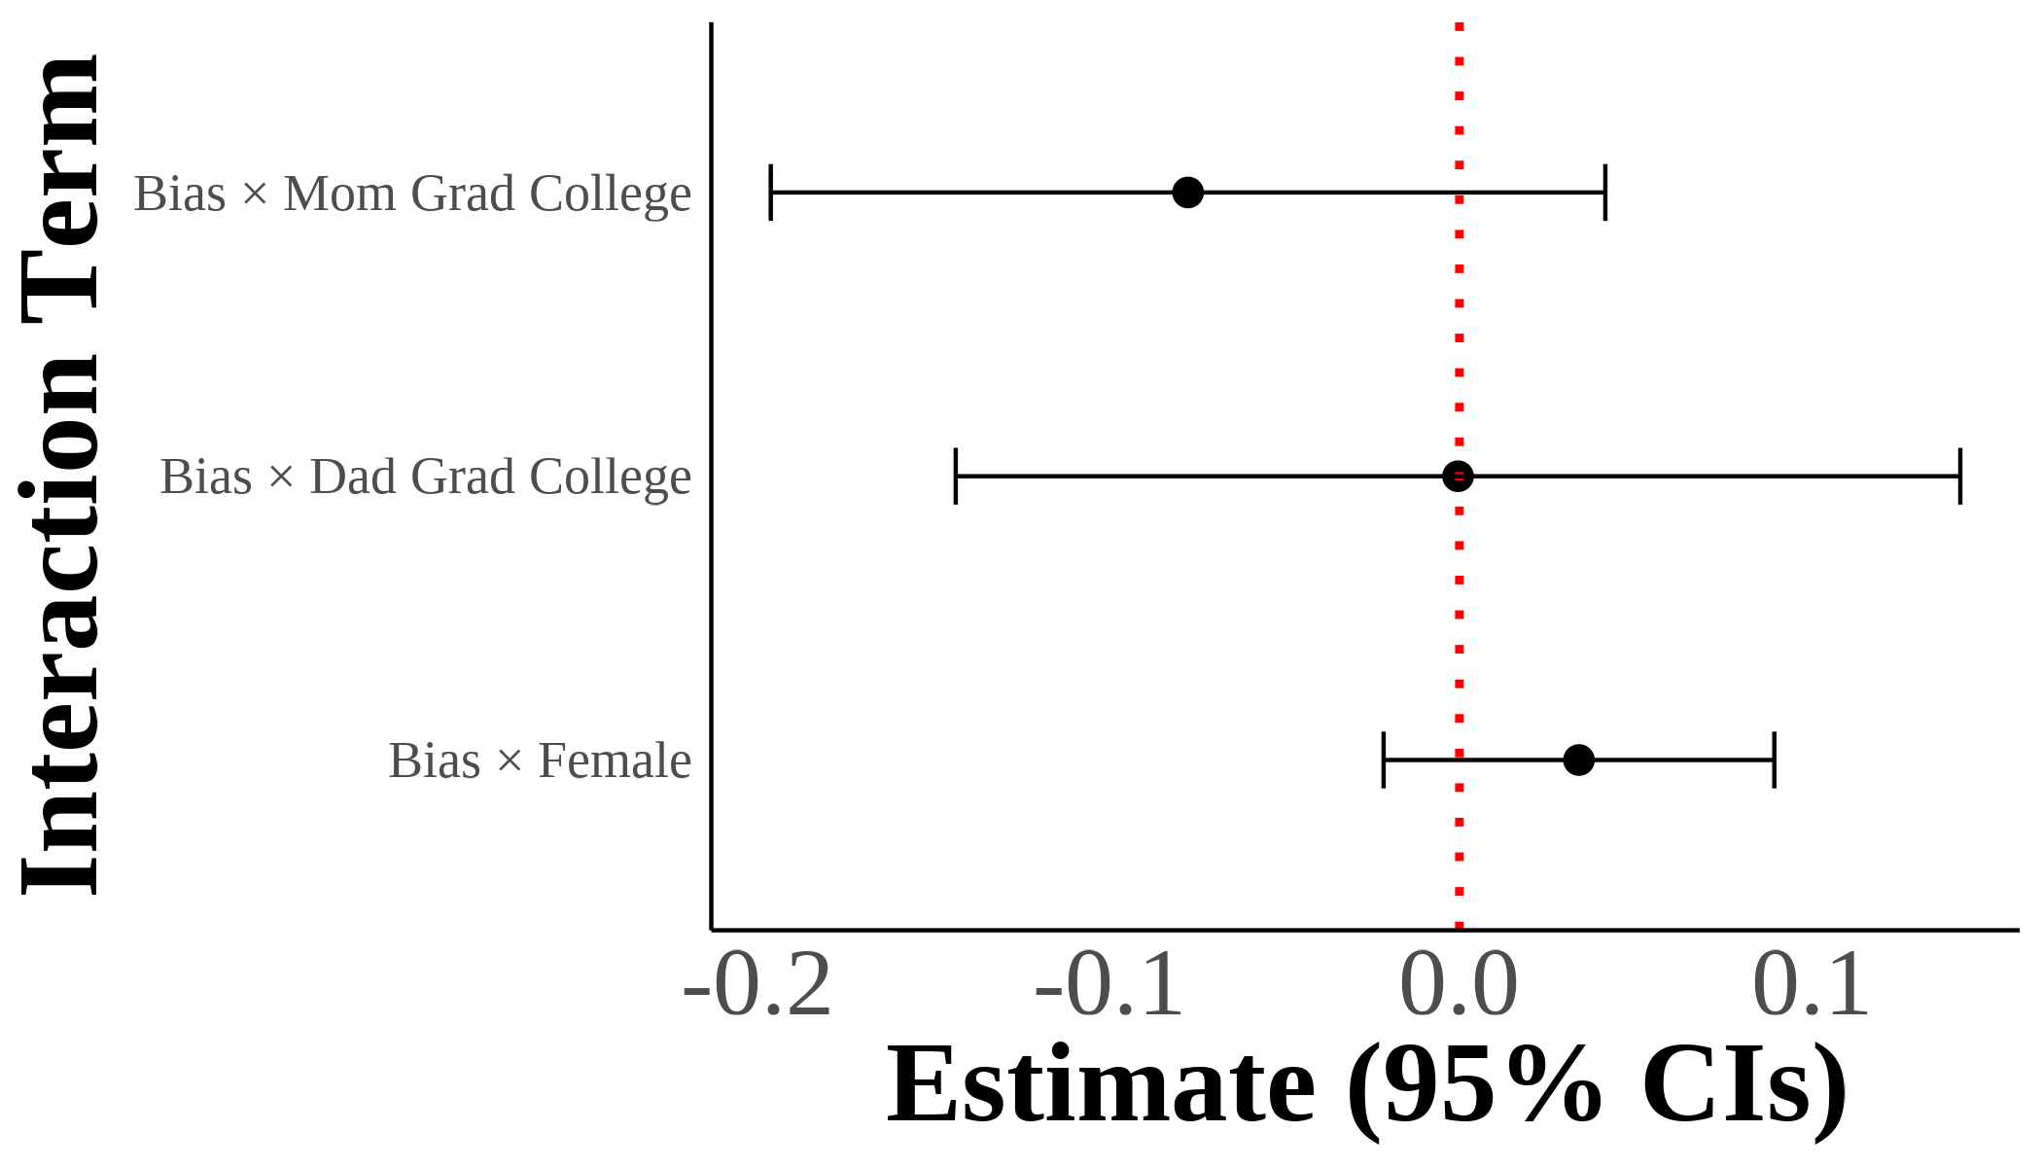 | 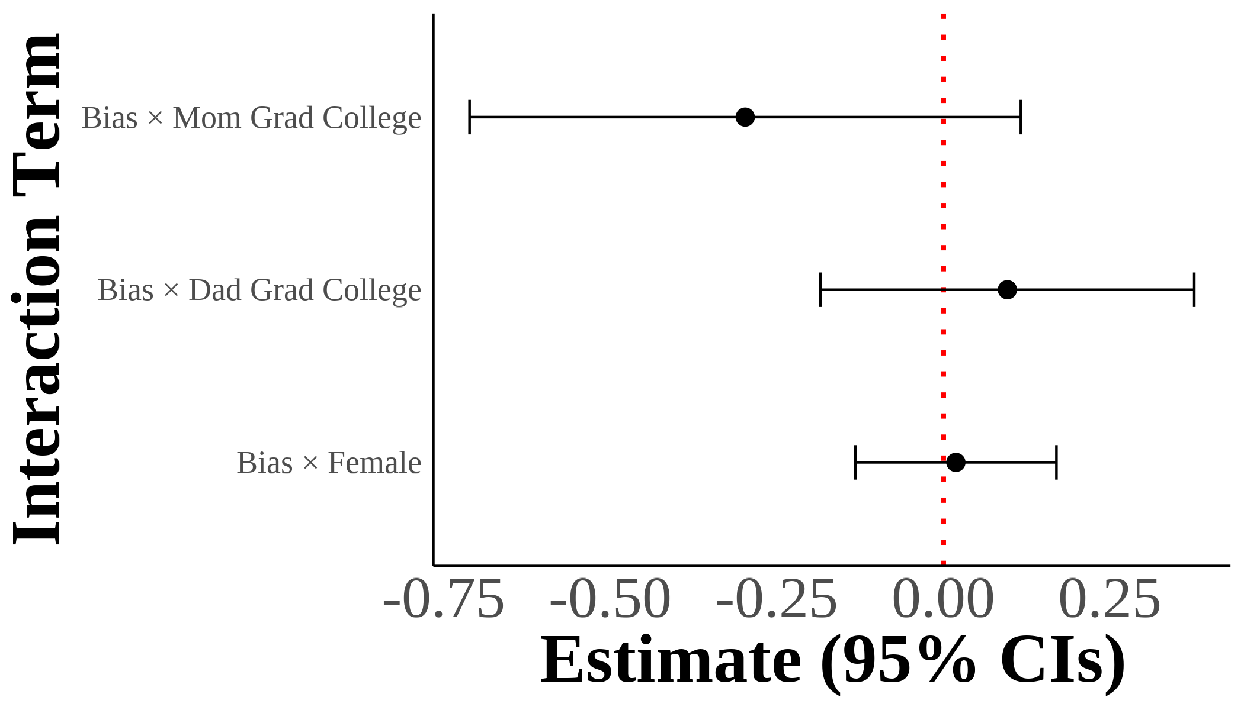 | 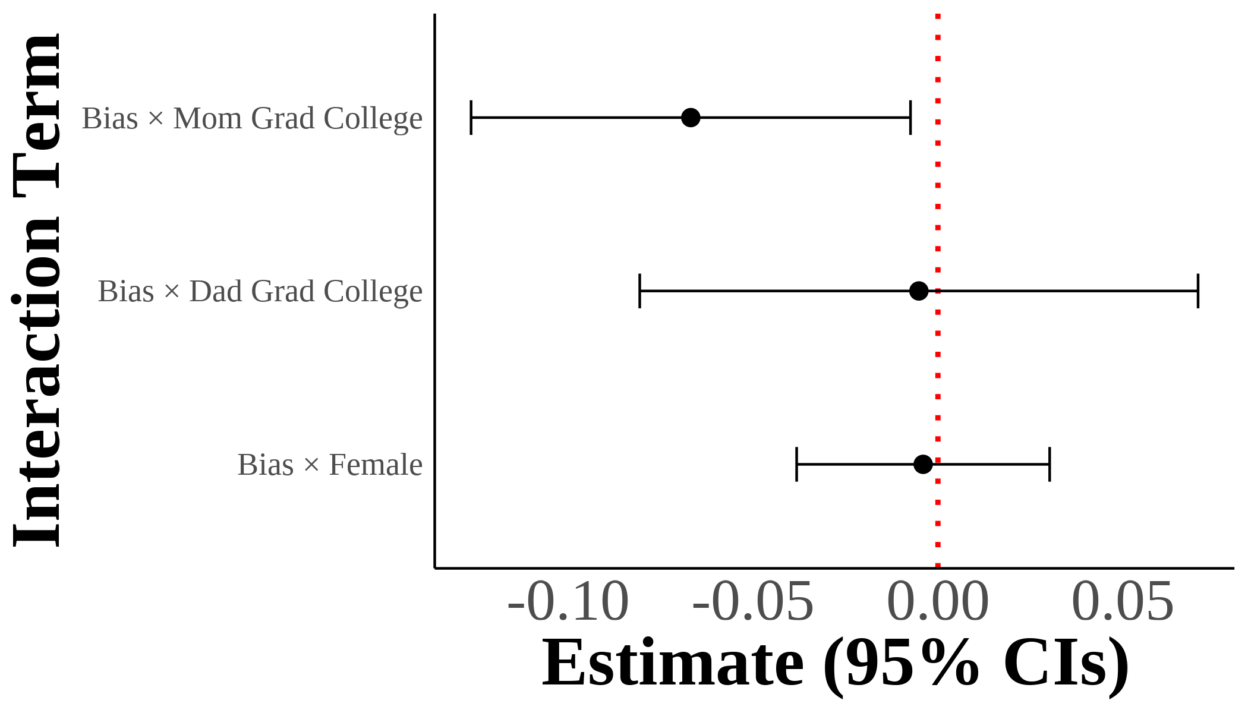 | I show interaction coefficients from estimating $A_{ist}^{g}=β_{1}^{g}AntiAsianBias_{st}+X_{ist}^{g}π+γ_{rt}+ε_{ist}$ with interaction terms for gender and parental education on third-generation samples. I include region $×$ year fixed effects with controls for sex, quartic age, years of education, and the inverse hyperbolic sine of income. The dependent variable is self-reported Asian identity and the independent variables include demeaned state-level bias interacted with gender and parental education indicators. Each panel results from separate regressions on different samples divided by the number of Asian grandparents. Standard errors are clustered on the state level. The samples include third-generation Asian individuals with varying degrees of Asian ancestry through grandparents. Native-born third-generation individuals with at least one grandparent born in an Asian country.
Pooled: All Third Generation
Abramitzky, R., Boustan, L. P., & Eriksson, K. (2014). A Nation of Immigrants: Assimilation and Economic Outcomes in the Age of Mass Migration. Journal of Political Economy, 122(3), 467–506. http://doi.org/10.1086/675805
Abramitzky, R., Boustan, L. P., & Eriksson, K. (2016, July). Cultural Assimilation during the Age of Mass Migration [Working Paper]. http://doi.org/10.3386/w22381
Akerlof, G. A., & Kranton, R. E. (2000). Economics and Identity. Quarterly Journal of Economics, 115(3), 715–753. http://doi.org/10.1162/003355300554881
Almasalkhi, N. (2023). Links between anti-immigrant bias and racial prejudice in california.
American National Election Studies. (2021). ANES 2020 time series study full release [dataset and documentation]. Retrieved from https://www.electionstudies.org
Antman, F. M., Duncan, B., & Trejo, S. J. (2020). Ethnic attrition, assimilation, and the measured health outcomes of Mexican Americans. Journal of Population Economics, 33(4), 1499–1522. http://doi.org/https://doi-org.ezproxy.lib.uh.edu/10.1007/s00148-020-00772-8
Antman, F., & Duncan, B. (2015). Incentives to Identify: Racial Identity in the Age of Affirmative Action. Review of Economics & Statistics, 97(3), 710–713. http://doi.org/10.1162/REST_a_00527
Antman, F., & Duncan, B. (2021). American Indian Casinos and Native American Self‐Identification.
Antman, F., Duncan, B., & Trejo, S. J. (2016). Ethnic Attrition and the Observed Health of Later-Generation Mexican Americans. The American Economic Review, 106(5), 467–471. Retrieved from http://www.jstor.org/stable/43861065
Arabsheibani, G. R., & Wang, J. (2010). Asian-white male wage differentials in the united states. Applied Economics Letters, 17(1), 37–43.
Arkes, H. R., & Tetlock, P. E. (2004). Attributions of Implicit Prejudice, or "Would Jesse Jackson ’Fail’ the Implicit Association Test?". Psychological Inquiry, 15(4), 257–278. http://doi.org/10.1207/s15327965pli1504_01
Atkin, D., Colson-Sihra, E., & Shayo, M. (2021). How Do We Choose Our Identity? A Revealed Preference Approach Using Food Consumption. Journal of Political Economy, 129(4), 1193–1251. http://doi.org/10.1086/712761
Bertrand, M., & Mullainathan, S. (2004). Are Emily and Greg More Employable Than Lakisha and Jamal? A Field Experiment on Labor Market Discrimination. American Economic Review, 94(4), 991–1013. http://doi.org/10.1257/0002828042002561
Bordalo, P., Coffman, K., Gennaioli, N., & Shleifer, A. (2016). Stereotypes*. The Quarterly Journal of Economics, 131(4), 1753–1794. http://doi.org/10.1093/qje/qjw029
Bureau of Justice Statistics. (2023). Uniform crime reporting program data series [dataset]. Retrieved from https://catalog.data.gov/dataset/uniform-crime-reporting-program-data-series-16edb
Bursztyn, L., Chaney, T., Hassan, T. A., & Rao, A. (2022, March 31). The Immigrant Next Door: Long-Term Contact, Generosity, and Prejudice [SSRN Scholarly Paper]. http://doi.org/10.2139/ssrn.3781974
Charles, K. K., & Guryan, J. (2008). Prejudice and Wages: An Empirical Assessment of Becker’s The Economics of Discrimination. Journal of Political Economy, 116(5), 773–809. http://doi.org/10.1086/593073
Charness, G., & Chen, Y. (2020). Social Identity, Group Behavior, and Teams. Annual Review of Economics, 12(1), 691–713. http://doi.org/10.1146/annurev-economics-091619-032800
Chetty, R., Hendren, N., Jones, M. R., & Porter, S. R. (2020). Race and Economic Opportunity in the United States: An Intergenerational Perspective*. The Quarterly Journal of Economics, 135(2), 711–783. http://doi.org/10.1093/qje/qjz042
Chiswick, B. R. (1983). An analysis of the earnings and employment of asian-american men. Journal of Labor Economics, 1(2), 197–214.
Cornell, S., & Hartmann, D. (2006). Ethnicity and race: Making identities in a changing world. Sage Publications.
Darity, W. A. (2022). Position and Possessions: Stratification Economics and Intergroup Inequality. Journal of Economic Literature, 60(2), 400–426. http://doi.org/10.1257/jel.20211690
Darity, W. A., Mason, P. L., & Stewart, J. B. (2006). The economics of identity: The origin and persistence of racial identity norms. Journal of Economic Behavior & Organization, 60(3), 283–305. http://doi.org/10.1016/j.jebo.2004.09.005
Diette, T. M., Goldsmith, A. H., Hamilton, D., & Darity, W. (2015). Skin Shade Stratification and the Psychological Cost of Unemployment: Is there a Gradient for Black Females? The Review of Black Political Economy, 42(1-2), 155–177. http://doi.org/10.1007/s12114-014-9192-z
Duleep, H. O., & Sanders, S. G. (2012). The economic status of asian americans before and after the civil rights act.
Duncan, B., & Trejo, S. J. (2011). Intermarriage and the intergenerational transmission of ethnic identity and human Capital for Mexican Americans. J Labor Econ, 29.
Duncan, Brian, & Trejo, S. J. (2018a). Identifying the Later-Generation Descendants of U.S. Immigrants: Issues Arising from Selective Ethnic Attrition. The ANNALS of the American Academy of Political and Social Science, 677(1), 131–138. http://doi.org/10.1177/0002716218763293
Duncan, Brian, & Trejo, S. J. (2018b). Socioeconomic Integration of U.S. Immigrant Groups over the Long Term: The Second Generation and Beyond (Working Paper No. 24394). National Bureau of Economic Research. Retrieved from http://www.nber.org/papers/w24394
Egloff, B., & Schmukle, S. C. (2002). Predictive validity of an implicit association test for assessing anxiety. Journal of Personality and Social Psychology, 83, 1441–1455. http://doi.org/10.1037/0022-3514.83.6.1441
Flood, S., King, M., Rodgers, R., Ruggles, S., Warren, J. R., & Westberry, M. (2021). Integrated Public Use Microdata Series, Current Population Survey: Version 9.0 (Version 9.0) [Data set]. Minneapolis, MN: IPUMS. http://doi.org/10.18128/D030.V9.0
Flood, S., Ronald, G., Megan, S., & Matthew, S. (2021). Integrated Public Use Microdata Series, USA: Version 12.0 (Version 9.0) [Data set]. Minneapolis, MN: IPUMS. http://doi.org/10.18128/D030.V9.0
Forscher, P. S., Lai, C. K., Axt, J. R., Ebersole, C. R., Herman, M., Devine, P. G., & Nosek, B. A. (2019). A meta-analysis of procedures to change implicit measures. Journal of Personality and Social Psychology, 117(3), 522–559. http://doi.org/10.1037/pspa0000160
Fouka, V., Mazumder, S., & Tabellini, M. (2022). From Immigrants to Americans: Race and Assimilation during the Great Migration. The Review of Economic Studies, 89(2), 811–842. http://doi.org/10.1093/restud/rdab038
Friese, M., Bluemke, M., & Wänke, M. (2007). Predicting voting behavior with implicit attitude measures: The 2002 German parliamentary election. Experimental Psychology, 54(4), 247–255. http://doi.org/10.1027/1618-3169.54.4.247
Glover, D., Pallais, A., & Pariente, W. (2017). Discrimination as a Self-Fulfilling Prophecy: Evidence from French Grocery Stores. Quarterly Journal of Economics, 132(3), 1219–1260. http://doi.org/10.1093/qje/qjx006
Goldsmith, A. H., Hamilton, D., & Darity, W. (2007). From Dark to Light: Skin Color and Wages among African-Americans. The Journal of Human Resources, 42(4), 701–738. Retrieved from https://www.jstor.org/stable/40057327
Gover, A. R., Harper, S. B., & Langton, L. (2020). Anti-asian hate crime during the COVID-19 pandemic: Exploring the reproduction of inequality. American Journal of Criminal Justice, 45(4), 647–667.
Greenwald, A. G., McGhee, D. E., & Schwartz, J. L. K. (1998). Measuring individual differences in implicit cognition: The implicit association test. Journal of Personality and Social Psychology, 74(6), 1464–1480. http://doi.org/10.1037/0022-3514.74.6.1464
Hadah, H. (2024). The effect of racial and ethnic attitudes on hispanic identity in the united states. Southern Economic Journal.
Hamilton, D., Goldsmith, A. H., & Darity, W. (2009). Shedding “light” on marriage: The influence of skin shade on marriage for black females. Journal of Economic Behavior & Organization, 72(1), 30–50. http://doi.org/10.1016/j.jebo.2009.05.024
Hilger, N. (2016). Upward mobility and discrimination: The case of asian americans. National Bureau of Economic Research.
Lee, D. J. (2018). Does Implicit Bias Predict Dictator Giving? Games, 9(4, 4), 73. http://doi.org/10.3390/g9040073
Leitner, J. B., Hehman, E., Ayduk, O., & Mendoza-Denton, R. (2016). Racial bias is associated with ingroup death rate for Blacks and Whites: Insights from Project Implicit. Social Science & Medicine, 170, 220–227. http://doi.org/10.1016/j.socscimed.2016.10.007
Lubotsky, D., & Wittenberg, M. (2006). Interpretation of Regressions with Multiple Proxies. The Review of Economics and Statistics, 88(3), 549–562. http://doi.org/10.1162/rest.88.3.549
Meng, X., & Gregory, R. G. (2005). Intermarriage and the Economic Assimilation of Immigrants. Journal of Labor Economics, 23(1), 135–174. http://doi.org/10.1086/425436
Mora, G. C., & Paschel, T. S. (2020). Antiblackness as a logic for anti-immigrant resentment: Evidence from california. In Sociological forum (Vol. 35, pp. 918–940). Wiley Online Library.
Telles, E. E., & Ortiz, V. (2008). Generations of exclusion: Mexican-americans, assimilation, and race. Russell Sage Foundation.
Waters, M. C. (1990). Ethnic options: Choosing identities in america.
Zhou, M. (1997). Segmented assimilation: Issues, controversies, and recent research on the new second generation. International Migration Review, 31(4), 975–1008.

The 2020 Census counted more than 20 million Asian Americans—6.4 percent of the population—nearly double the number counted two decades earlier. The Asian American population numbers are based on the author’s calculations from the Current Population Survey and US Census data (Flood, King, et al., 2021).
The IAT data comes from Harvard’s Project Implicit (Greenwald, McGhee, & Schwartz, 1998). Implicit bias measures have gained prominence in economics, with IAT scores correlating with economic outcomes (Chetty, Hendren, Jones, & Porter, 2020; Glover, Pallais, & Pariente, 2017), voting patterns (Friese, Bluemke, & Wänke, 2007), and health disparities (Leitner, Hehman, Ayduk, & Mendoza-Denton, 2016).
This extends Akerlof & Kranton (2000)’s prescription concept to encompass both negative stereotypes and positive model minority expectations.
This approach parallels previous research but focuses on racial rather than ethnic categorization.
Since adults still living with parents might not be representative of the overall adult population and is a rare occurrence, I do not link adults to their parents.
For this analysis, Asian countries comprise East Asian and Southeast Asian nations, including China, Hong Kong, Taiwan, Japan, Korea, Mongolia, Cambodia, Indonesia, Laos, Malaysia, Philippines, Singapore, Thailand, and Vietnam, but exclude South Asian and Middle Eastern countries, consistent with standard demographic classifications.
(F. M. Antman et al., 2020; F. Antman et al., 2016; Brian Duncan & Trejo; 2018a, 2018b) document substantial identity attrition among various groups.
IAT participation is voluntary, potentially creating selection bias. However, IAT-reflected bias serves as a proxy for prejudiced attitudes (Chetty et al., 2020).
Questions parallel those used by Charles & Guryan (2008): (1) “Conditions Make it Difficult for Blacks to Succeed”, (2) “Blacks Should Not Have Special Favors to Succeed”, (3) “Blacks Must Try Harder to Succeed”, (4) “Blacks Gotten Less than They Deserve Over the Past Few Years”, and (5) “Feeling Thermometer Toward Asians.”
Additional methodological details appear in the Data Online Appendix, Section 7.
Beginning in 2003, the CPS allowed respondents to report multiple racial identities. I categorize responses into six classifications: (1) Asian only, (2) White only, (3) Asian and White/Pacific Islander, (4) other non-Asian multiracial combinations, (5) Asian combined with other races, and (6) Asian/Pacific Islander.
Hadah (2024) finds similar effects on third-generation Hispanic immigrants.
According to CPS guidelines, household respondents must be at least 15 years old with sufficient household knowledge. When the proxy is “self,” respondents range from 15 to 17 years old.

