The Effect of Racial and Ethnic Attitudes on Asian Identity in the U.S
Hussain Hadah

Abstract
I study the determinants of racial self-identification among Asian Americans, combining Current Population Survey ancestry data with a composite anti-Asian bias measure drawn from Implicit Association Tests, the American National Election Studies, and hate crimes. I document substantial identity attrition across generations, driven by interracial family structures: while children of endogamous Asian parents report Asian identity at rates above 90%, only about a third of second-generation children with one Asian and one White parent do the same. Using multinomial logit models, I show that anti-Asian bias shifts identity choices away from “Asian only” toward “White only,” with effects that are significantly larger when the father is Asian. In the third generation, the effects grow with the number of Asian grandparents in tests that do not account for dependence within states. Higher parental education increases the probability of Asian identification on average. Among children of an Asian father and a White mother, the interaction between state-level bias and maternal college education is negative and statistically significant, so bias lowers Asian identification more among children of college-educated mothers; I find no such interaction when the mother is Asian. This selection leaves the remaining Asian-identified children of these families with lower socioeconomic status in high-bias areas. It implies that outcomes measured on self-reported race understate the outcomes of people of Asian ancestry in areas with high levels of prejudice, biasing conventional estimates of Asian–White disparities there. Because the bias coefficient in a linear probability model shrinks and loses statistical significance when state fixed effects are added, confounding by fixed state characteristics cannot be ruled out.
Keywords: Economics of Minorities, Race, and Immigrants; Discrimination and Prejudice; Stratification Economics

1. Introduction
Asian Americans represent the fastest-growing racial group in the United States, yet their experiences with discrimination and identity formation remain underexplored in economic research.¹ Unlike other minority groups, Asian Americans occupy a distinctive position in America’s racial hierarchy—simultaneously experiencing discrimination and being labeled as “perpetual foreigners” while also being characterized through the “model minority” stereotype (Fouka, Mazumder, & Tabellini, 2022). This dual status creates incentives around racial identity choices that differ from other groups’ experiences. Whether those choices respond to local prejudice is a question with direct consequences for policy, because the statistics that count Asian Americans and measure their outcomes classify people by self-reported race. The federal standards for collecting data on race and ethnicity, revised in 2024, govern the statistics used to enforce civil rights law, allocate federal funds, and track disparities (Office of Management and Budget, 2024), and the COVID-19 Hate Crimes Act of 2021 directed federal and state agencies to improve the reporting of anti-Asian hate crimes (United States Congress, 2021). Hate-crime statistics classify an incident by evidence of the offender’s bias against a perceived group, not by the victim’s self-reported race, but a victimization rate divides those incidents by a population count that does rest on self-identification. If people of Asian ancestry are less likely to identify as Asian where prejudice is stronger, then the population counts and outcome gaps that these policies rely on, including the denominators of victimization rates, are measured with an error that is itself a function of prejudice.
An extensive literature has documented how Asians and Whites compare across multiple outcomes, yet the role of identity selection in shaping the Asian-White gaps remains understudied (Arabsheibani & Wang, 2010; Chiswick, 1983; Duleep & Sanders, 2012; Hilger, 2016). The challenge lies in defining and measuring racial identity, particularly when individuals possess agency in how they racially self-identify. If reporting Asian racial identity represents a strategic choice influenced by local discrimination, measured gaps may systematically vary across geographic contexts in ways that previous research has not fully explored.
Various contextual factors, including anti-Asian sentiment and stereotypes, can influence how individuals navigate their racial identity choices. The COVID-19 pandemic has brought renewed attention to how external hostility shapes Asian American experiences (Gover, Harper, & Langton, 2020). In this paper, I examine the determinants of Asian racial identity reporting and analyze how Asian Americans strategically select between Asian and White racial identities. Specifically, I investigate how anti-Asian bias, education, and family income shape decisions to identify racially as Asian American. I also break down the analysis by generation and family structure (interracial versus endogamous parents) and examine what racial identities individuals with objective Asian ancestry report (Asian only, White only, multiracial, etc.).
I explore how individual characteristics and societal attitudes toward Asian Americans influence racial identity reporting. I use identity and ancestry data from the Current Population Survey (CPS) combined with measures of anti-Asian bias derived from Harvard’s Project Implicit Association Test (IAT), the American National Election Studies (ANES), and hate crimes targeting Asian Americans.² I ground my analysis in the theoretical framework of Akerlof & Kranton (2000), explicitly modeling how external prejudice creates differential utility from identity choices and establishing conditions under which individuals strategically modify their racial self-presentation. I also use CPS data to study the effect of education (parental and individual) and family income on Asian racial identity reporting.
Measuring identity choices outside of lab settings is challenging, requiring both objective ancestry indicators and subjective identity measures. I leverage birthplace and ancestry data to construct objective Asian ancestry measures, then analyze deviations between objective ancestry and subjective racial identity. I find that racial identity reporting responds to both individual characteristics and environmental factors reflecting local discrimination levels.
I find substantial Asian racial identity attrition across generations, driven primarily by interracial family structures. While children of endogamous Asian parents report Asian identity at rates above 90%, only about a third of second-generation children with one Asian and one White parent do the same. Using multinomial logit models, I show that anti-Asian bias shifts identity choices away from “Asian only” and toward “White only,” with effects that are larger in families where the father is Asian. Among the third generation, the effects grow with the number of Asian grandparents, although that gradient is statistically significant only under an individual-level bootstrap that does not account for dependence among children in the same state. On average, parental education increases the probability of Asian identification. In families with an Asian father, however, the relationship weakens as bias rises: per one-unit increase in the bias index, the probability of Asian identification falls 23 percentage points more for children of college-educated mothers than for children of mothers without a degree. In families with an Asian mother, I find no such interaction. Because of this shifting composition, the Asian-identified children of Asian fathers have lower average parental education in high-bias areas. Consequently, outcomes measured on self-reported race understate the outcomes of people of Asian ancestry where prejudice is strongest, and conventional estimates of Asian–White disparities are biased there.
The policy stakes follow from the direction of this selection. First, the Asian population that official statistics count falls short of the population of Asian ancestry by the most where anti-Asian prejudice is strongest, so the number of people exposed to that prejudice is understated where protection matters most. Second, in families with an Asian father, children of college-educated mothers are the ones more likely to stop identifying as Asian in high-bias states, so the Asian-identified population from these families has lower socioeconomic status than the population of Asian ancestry. Outcomes measured on self-reported race therefore understate the outcomes of people of Asian ancestry in high-bias states, and the comparisons of Asian and White outcomes that guide civil rights enforcement, the targeting of programs by race, and the assessment of immigrant integration are distorted in a way that varies systematically with prejudice. Brian Duncan & Trejo (2018a) show that selective ethnic attrition of this kind biases measures of intergenerational progress for Hispanics, and the National Academies raised the same concern for integration statistics generally (National Academies of Sciences, Engineering, and Medicine, 2015); the estimates in this paper put magnitudes on the mechanism for Asian Americans and show which families drive it. These implications hold only if the estimates reflect bias rather than fixed characteristics of high-bias states. When state fixed effects are added to a linear probability version of the model, the bias coefficient falls by more than half and is no longer statistically distinguishable from zero (Section 6.1), so that alternative cannot be ruled out.
This research contributes to several bodies of literature. First, it extends the economics of identity framework (Akerlof & Kranton, 2000) and stratification economics (Darity, 2022; Darity, Mason, & Stewart, 2006) by examining how racial stereotypes—both positive and negative—influence identity choices among Asian Americans, who face a unique utility landscape where identity can simultaneously signal competence and foreignness (Atkin, Colson-Sihra, & Shayo, 2021; Charness & Chen, 2020; Diette, Goldsmith, Hamilton, & Darity, 2015; Goldsmith, Hamilton, & Darity, 2007; Hamilton, Goldsmith, & Darity, 2009). Qualitative research documents how individuals strategically adapt racial presentations across contexts (Cornell & Hartmann, 2006; Telles & Ortiz, 2008; Waters, 1990; Zhou, 1997); this paper quantifies those choices by comparing objective ancestry with subjective identification across varying bias environments.
Second, it extends research on discrimination (Bertrand & Mullainathan, 2004; Bordalo, Coffman, Gennaioli, & Shleifer, 2016; Bursztyn, Chaney, Hassan, & Rao, 2022; Charles & Guryan, 2008) by examining how prejudice influences racial self-identification itself. Within immigration research, the paper builds on studies of assimilation (Abramitzky, Boustan, & Eriksson, 2014, 2016), but unlike European immigrant groups, Asian Americans face persistent “perpetual foreigner” stereotypes that complicate integration regardless of generational status (Fouka et al., 2022), and the model minority myth means Asian racial identity may carry both benefits and costs depending on context (Meng & Gregory, 2005).
This paper most closely relates to recent economic research on racial identity fluidity (F. Antman & Duncan, 2015, 2021; F. Antman, Duncan, & Trejo, 2016; Hadah, 2024). While previous work focused primarily on Hispanic ethnic attrition, Asian American identity choices operate through different mechanisms due to distinct stereotypes, discrimination patterns, and socioeconomic profiles.

2. Theoretical Framework
I develop a theoretical framework for understanding racial identity choice that extends Akerlof & Kranton (2000) to incorporate stereotype-specific costs and benefits. Unlike generic minority identification models, this framework recognizes that Asian Americans face unique utility trade-offs where racial identity can signal both positive attributes (academic achievement, work ethic) and negative characteristics (foreignness, social exclusion).
Formally, individual belongs to racial group 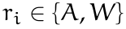, where represents Asian and represents White. Agent ’s utility depends on their actions and how those actions interact with their chosen racial identity :
Individual identity reflects personal actions, others’ behaviors toward them, and societal expectations associated with their racial group:
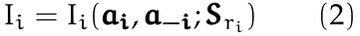
where represents individual ’s actions, captures others’ actions affecting ’s identity (including anti-Asian bias), and 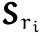 denotes societal stereotypes and expectations associated with racial group membership.³
The key insight is that 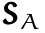 includes both positive stereotypes (academic excellence) and negative ones (perpetual foreigner status). Thus creating context-dependent utility from Asian racial identification.
Individual selects actions to maximize utility given their racial group , associated stereotypes , and others’ actions . The first-order condition becomes:
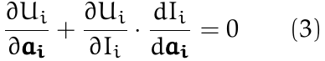
The solution 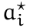 yields utility 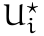. Now suppose individuals can strategically choose their racial identity at cost . They will switch identities when 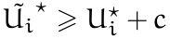, where 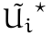 represents utility under the alternative racial identity.
Identity switching occurs when benefits 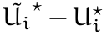 exceed costs . These net benefits are non-zero only when 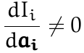 and 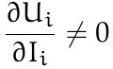. This framework suggests empirical analysis should focus on: (1) individual characteristics affecting optimal actions under different racial identities, (2) contextual factors (anti-Asian bias) creating differential treatment by racial group, (3) populations with low switching costs , and (4) groups whose utility significantly depends on racial identity.
The model predicts that anti-Asian bias increases the utility differential between White and Asian racial identity, making identity switching more attractive. Mixed-race individuals face lower switching costs due to phenotypic ambiguity, while later-generation Asian Americans may find identity switching more feasible due to cultural assimilation.

3. Data Sources and Measurement Strategy
In this section, I describe the datasets I use in the analysis. To examine relationships between social attitudes and Asian racial identity reporting, I need both subjective and objective Asian identity measures for identifying appropriate Asian American subgroups. I use the Integrated Public Use Microdata Series (IPUMS) Current Population Survey (CPS) (Flood, King, et al., 2021) with ancestry information through the places of birth of individuals, their parents, and grandparents to construct objective identity measures. I develop composite anti-Asian bias measures using Lubotsky & Wittenberg (2006)’s multiple proxy regression method to reduce attenuation bias.

Measuring Asian Racial Identity
I measure Asian racial identity using CPS data from 2004–2021. Following (F. M. Antman, Duncan, & Trejo, 2020; F. Antman et al.; 2016), I utilize birthplace information for individuals, parents, and grandparents to create objective Asian ancestry indicators for minors under age 17 living with parents.⁴ The methodology allows for the identification of first-, second-, and third-generation Asian Americans (see Figure 1 for visual representation). I also use a CPS sample of adults aged 18+ to examine whether their racial identity reporting patterns differ from minors; for the adult sample, I can only identify first- and second-generation.⁵
The objective ancestry measure—distinct from subjective racial identification where respondents select “Asian” as their race—depends on birthplaces across three generations.⁶ The three identifiable generations include: 1) first-generation immigrants born in Asian countries with both parents also born in Asian countries, 2) second-generation individuals who are US-born citizens with at least one parent born in an Asian country, and 3) third-generation Asian Americans who are US-born citizens with two US-born parents and at least one grandparent born in an Asian country.
While the ancestry measure provides an objective assessment of Asian heritage, it may not capture all nuances of racial identity. For instance, White individuals with Asian ancestry born to non-Asian parents in Asia, such as on American military bases, may be classified as Asian in the data. To avoid potential misclassification, I remove individuals who report that they were born abroad of American parents. The final sample includes Asian Americans, first-, second-, and third-generation immigrants aged 17 and younger living with parents between 2004 and 2021. I present the summary statistics in Table (1). The adult sample includes first- and second-generation Asian American immigrants aged 18 and older between 2004 and 2021. I show the summary statistics for the adult sample in Table (2).
CPS relies on household respondents (parents or caregivers) to report children’s racial identity. Asian identity reporting rates are consistent regardless of whether mother (72%), father (72%), or child/other caregiver (87%) serves as respondent (Table 3), and attrition patterns among adults align with those observed in children (Tables 4 and 5). I address proxy reporting concerns more fully in Section 6.1.
The overall sample comprises 49% females, with 65% self-reporting Asian racial identity—answering affirmatively to “what is your race.” Average age is 8.4 years. Approximately 52% of mothers and 52% of fathers hold college degrees. Additional summary statistics for the overall sample and each generation appear in Table (1).
Using parental and grandparental birthplaces, I objectively identify ethnic ancestry and categorize different family types. For second-generation children, parental birthplaces create three objective categories: Objectively Asian-father-Asian-mother (AA), Objectively Asian-father-White-mother (AW), and Objectively White-father-Asian-mother (WA)
Similarly, grandparental birthplaces create 15 objective categories for third-generation children: (1) objectively Asian paternal grandfather-Asian paternal grandmother-Asian maternal grandfather-Asian maternal grandmother (AAAA); (2) objectively White paternal grandfather-Asian paternal grandmother-Asian maternal grandfather-Asian maternal grandmother (WAAA); (3) objectively Asian paternal grandfather-White paternal grandmother-Asian maternal grandfather-Asian maternal grandmother (AWAA), etc.
My analysis employs a subsample of the US population; Tables 4 and 2 demonstrate sufficient observations across generations for both adults and children. Consistent with literature on ethnic and racial identity fluidity among Asian and Hispanic Americans, I document significant attrition among third-generation Asian Americans.⁷

Measuring Anti-Asian Sentiment
I construct anti-Asian sentiment measures using implicit association tests, American National Election Studies, and hate crimes targeting Asian Americans from 2004–2021.
The implicit association test measures conceptual associations—for example, linking Asian Americans with negative stereotypes—and evaluative responses. Respondents rapidly categorize words into screen-displayed categories. Figure (A.1) shows examples from Harvard’s Project Implicit skin tone test.
I employ Asian-focused IAT data to construct anti-Asian prejudice proxies (Greenwald, McGhee, & Schwartz, 1998). The IAT measures bias direction and magnitude while capturing unconscious biases individuals may be unwilling to report, and previous research demonstrates the difficulty of manipulating IAT scores (Egloff & Schmukle, 2002). A meta-analysis by Greenwald et al. (1998) finds significantly higher predictive validity for IAT compared to self-report measures.⁸
However, some research questions IAT predictive validity claims. Implicit Association Tests may not reliably measure or predict implicit prejudice or biased behaviors. Research shows implicit biases experience minor, temporary intervention-induced changes. Additionally, implicit bias fails to predict dictator game contributions or social pressure susceptibility, highlighting distinctions between implicit bias and biased actions (Arkes & Tetlock, 2004; Forscher et al., 2019; Lee, 2018). Therefore, I supplement IAT with explicit bias measures from American National Election Studies (ANES) and hate crimes against Asian individuals to construct a composite bias measure.
I develop a second proxy from the American National Election Studies (ANES), averaging responses across several 2004–2020 questions measuring racial animus (American National Election Studies, 2021).⁹ While the ANES racial animus questions primarily focus on attitudes toward Black Americans, research demonstrates that racial prejudices are highly correlated across different minority groups, with individuals who express bias toward one racial minority typically holding similar attitudes toward others (Almasalkhi, 2023; Mora & Paschel, 2020). These measures therefore capture broader patterns of racial animus that extend beyond anti-Black sentiment specifically. When combined with the Asian-focused IAT measures and hate crimes against Asian Americans in my composite index, this multi-proxy approach weights the bias measure more heavily toward Asian-specific prejudice while still capturing the general racial climate. Finally, I incorporate Uniform Crime Reports (UCR) data quantifying hate crimes against Asian Americans (Bureau of Justice Statistics, 2023).
To reduce attenuation bias and measurement error, I follow Lubotsky & Wittenberg (2006) in constructing composite bias measures using IAT, ANES racial animus measures, and hate crimes against Asian Americans.¹⁰ Figure 2a plots bias over time in selected places, and Figure 2b plots Asian racial identity reporting. The panels contain different sets of places, as listed in the caption, rather than a matched-state comparison. Lower scores indicate less bias; higher scores indicate greater racial animus. The composite is scaled in the units of the IAT score, a standardized difference in response latencies, and throughout the paper I express effects per one-unit increase in the bias index. A unit of the index is not a standard deviation of the bias observed in the data. Relative to that variation, one unit is a large change. The index is measured in two-year blocks (2004–05, 2008–09, 2012–13, 2016–17, and 2020–21), so each state contributes at most five distinct values, and the panel is unbalanced: 29 states enter in 2004, 11 in 2008, and 11 in 2012. Across the 432 state-year cells with a bias measure, the index has a standard deviation of 0.42, of which the between-state component (the standard deviation of state means) is 0.18 and the within-state component over time is 0.39; within a given year, the standard deviation across states averages 0.26. A one-unit increase, the unit used in the tables and figures, is therefore about 2.4 standard deviations of the state-year distribution, or the gap between the least biased places (Washington, DC, and Vermont) and the most biased (North Dakota) in 2020. Appendix Figures A.2 and A.3 map the index by year and averaged over 2004–2021.

4. From the Data: Asian Racial Identity and Attrition
Table 4 reports the distribution of self-reported racial identity among children of Asian ancestry by generation and ancestry, using the three categories that the multinomial logit models below distinguish (“Asian only,” “White only,” and “Asian and White”) plus a residual category.¹¹ Among first-generation children, 94% report “Asian only.” The share falls to 72% in the second generation and 29% in the third. Attrition is concentrated in interracial families. Among second-generation children with two Asian-born parents, 96% report “Asian only,” compared with 31% of children with one Asian-born parent and one parent born outside Asia (86% of whom are US-born); the rest of the latter group split between “White only” (25%) and “Asian and White” (37%). The split differs by which parent is Asian: 36% of children of an Asian father and a White mother report “Asian only” versus 29% of children of a White father and an Asian mother, who more often report “Asian and White” (40% versus 29%).
Among third-generation children, the number of Asian-born grandparents predicts identity almost completely. Children with four Asian grandparents report “Asian only” at 93%; with three, 74%; with two, 24%; and with one, 7%, at which point “White only” is the modal response (54%). Adults show the same pattern (Table 5): 93% of second-generation adults with two Asian-born parents report “Asian only” against 33% of those with one Asian-born parent, and among the latter “White only” (34%) is as common as “Asian only.”
These patterns show that racial identity becomes more fluid across generations. Endogamous Asian families maintain high rates of Asian identification, while interracial family structures leave most children choosing between a multiracial and a White-only identity, which is the margin on which bias and family background can operate.

5. Empirical Approach
To understand associations between Asian racial self-identification and anti-Asian bias, I estimate a multinomial logit model in which the dependent variable 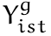 captures categorical racial identity choices: (1) Asian only, (2) White only, (3) Asian and White, the pooled multiracial category defined in Section 4:
where 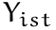 represents the categorical racial identity of person in state at interview time , indexes the identity categories, with “Asian only” as the reference category, 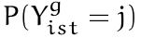 denotes the probability of person in state at time choosing identity , 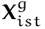 represents the vector of controls that include quartic age, Asian population fraction, parent types, grandparent types, and generation dummies, 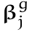 denotes the coefficient vector for outcome and generation , and indexes the three identity categories. Finally, represents region-time fixed effects that would control for region year specific shocks affecting identity choice , and is the error term.
The model specification allows the effects of anti-Asian bias and other covariates to vary across identity choices. For instance, 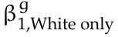 captures how anti-Asian bias affects the log-odds of choosing “White only” versus “Asian only” identity, while 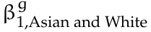 measures the bias effect on choosing “Asian and White” versus “Asian only.” This framework enables analysis of how bias, sex, and parental education differentially influence various identity strategies available to individuals with Asian ancestry.
The coefficients of interest are 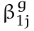, 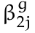, 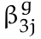, and 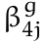, which capture how anti-Asian bias, parental education, and sex influence the likelihood of selecting each identity category relative to “Asian only.” I estimate separate models for each generation 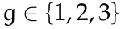 to assess whether these relationships differ across generational status.
The multinomial specification is appropriate because choosing “White only” identity represents a fundamentally different strategy than selecting “Asian and White” multiracial identity, a distinction particularly important for mixed-ancestry individuals who may strategically choose between complete ethnic distancing and maintaining partial ethnic connection.
Because multinomial logit coefficients are log-odds ratios relative to the “Asian only” category, I report average marginal effects on the probability of each identity. For anti-Asian bias, the marginal effect for each child is the derivative of the predicted probability of an outcome with respect to the bias index, evaluated at that child’s own covariate values; I average these derivatives, without weights, over the estimation sample. The reported number is therefore an average slope expressed per index unit. Because one unit is large relative to the observed variation in bias (Section 3.2), it should not be read as the exact change in probability that a one-unit shift in bias would produce.¹² For the binary covariates (female, mother college graduate, father college graduate), the marginal effect is the average over the sample of the change in predicted probability from switching the indicator from 0 to 1. For inference, I draw 1,000 bootstrap samples of children with replacement, stratified by region year cell, re-estimate the model in each, and recompute the sample-average marginal effects. The point estimates I report are the medians of these 1,000 sample averages, not medians across children, and the confidence intervals are their 2.5th and 97.5th percentiles. Because the bootstrap resamples children rather than states, these intervals reflect sampling variation in the individual data and do not account for dependence among children in the same state. I therefore use the state-clustered pooled model of Appendix Table A.5 for inference about the pooled bias effect and the AW–WA contrast, and report it alongside the bootstrap estimates.

6. Results and Robustness Checks
Figure 3 presents average marginal effects from the multinomial logit models for the pooled mixed-race second-generation sample (panel a) and the pooled third-generation sample (panel b), the groups for which identity is fluid. Appendix Figures A.8, A.9, and A.10 report the same estimates separately by parental configuration, for adults, and by number of Asian grandparents.
Second-Generation Subsample. Among children of mixed-race parents (Figure 3a), the average marginal effect of anti-Asian bias is 12 percentage points (pp) per index unit on “White only” identity and 10 pp on “Asian only.” A pooled model with a common bias effect and standard errors clustered at the state level (Appendix Table A.5, Panel B) gives a similar magnitude, 14.6 pp (standard error 5.7) for “White only,” with the offsetting decline falling almost entirely on “Asian only” (12.3 pp) rather than “Asian and White” (2.4 pp), so the result does not depend on the individual-level bootstrap. Maternal college education increases “Asian only” (5 pp) and decreases “White only” (6 pp). Paternal college education increases “Asian and White” (5 pp) and decreases “White only” (4 pp). Results among second-generation adults are directionally similar (Appendix Figure A.9).
I also estimate the model separately by parental composition—Asian father–White mother (AW) versus White father–Asian mother (WA) families (Appendix Figure A.8). Point estimates suggest that bias effects on “White only” identity are larger in AW families (20 pp) than in WA families (10 pp), and that maternal college education effects differ in direction and magnitude across the two family types.
Comparing these two sets of estimates requires care, because they come from separately estimated models. A difference in average marginal effects reflects differences in coefficients but also differences in the two groups’ covariate distributions, and the coefficients themselves are not comparable across multinomial logits whose error scales are normalized separately. I therefore test the AW–WA difference in two ways. Appendix Table A.3 and Appendix Figure A.11 report between-model tests of the differences in average marginal effects, with bootstrap standard errors for each difference. Appendix Table A.5 instead pools the two groups in a single multinomial logit that constrains every coefficient to be equal across AW and WA families except an interaction between bias and an AW indicator, and computes the average marginal effect of bias for both groups over the same pooled sample, so that the comparison holds the covariate distribution fixed. Both approaches agree on the main difference. In the pooled model, the bias AW interaction in the “White only” equation is 0.89 (standard error 0.32), and a Wald test with state-clustered standard errors rejects equal bias effects in the two equations (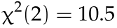, 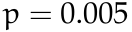); the average marginal effect of bias on “White only” identification is 24.9 pp per index unit in AW families and 9.9 pp in WA families, a difference of 15.1 pp (standard error 4.2). The corresponding difference for “Asian only” is 10.5 pp (standard error 6.4, 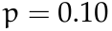), and for “Asian and White” it is not distinguishable from zero.¹³ The effect of bias is therefore stronger when the father is Asian, pushing children toward a “White only” identity. The between-model tests also find that maternal and paternal college education effects differ across family types for “Asian only” and “White only.” Among the sex effects, the female effect on “Asian and White” identification is 9.7 pp larger in AW than in WA families (standard error 2.8); the remaining AW–WA differences are not statistically significant at the five percent level. The between-model tests rest on the individual-level bootstrap and inherit the caveat from Section 5: their standard errors do not account for dependence among children in the same state, so differences that are significant only by that criterion, including the education and sex differences, should be read as suggestive. The AW–WA difference in the bias effect is the one that survives state-clustered inference.
Third-Generation Subsample. Among pooled third-generation children (Figure 3b), bias effects on identity are not statistically significant; the one exception is paternal college education, which increases “Asian and White” identification by 8 pp. Because bias and parental education should matter most for those with the strongest ancestral ties, I split the sample by number of Asian grandparents (Appendix Figure A.10). Both sets of effects grow with Asian ancestry: the effect of bias on “White only” identity is negligible among children with one Asian grandparent but reaches 19 pp per index unit among those with three, and the effect of maternal college education on “Asian only” grows to 32 pp over the same gradient. The between-model tests I conduct (Appendix Figure A.12 and Appendix Table A.4) find these differences statistically significant by the bootstrap criterion, subject to the same caveat: comparing one versus three Asian grandparents, the bias effect on “White only” and both parents’ college effects on “Asian only” and “White only” differ significantly. Maternal college effects differ between one and two grandparents, and bias and parental education effects differ between two and three. By the same criterion, the female effect also differs between one and three Asian grandparents: the one-minus-three difference is 11.8 pp on “White only” (standard error 4.3) and 8.7 pp on “Asian and White” (standard error 4.0). No other sex difference across grandparent groups is statistically significant at the five percent level. None of these third-generation comparisons has been tested with state-clustered inference.
The effects of bias and parental education on identity are heterogeneous across ancestry types: even where cross-group differences fall short of statistical significance, point estimates increase steadily with the number of Asian grandparents. Consistent with the theoretical framework, individuals with lower switching costs—those with fewer Asian grandparents and greater racial ambiguity—show smaller marginal effects of bias because they can switch identities even at low levels of bias, while those with more Asian ancestry require stronger incentives to overcome higher switching costs.¹⁴

The interaction between state-level bias and socioeconomic status
To assess whether bias and socioeconomic status jointly affect Asian identification, I estimate linear probability models that interact demeaned state-level bias with sex and with parental education (own education and family income for adults). Table 8 reports the interaction coefficients for mixed-race second-generation children (Panel A), mixed-race second-generation adults (Panel B), and third-generation children by number of Asian grandparents (Panel C), separately by family type and pooled.
Education amplifies the negative effect of bias on Asian identification, and the pattern is concentrated in families with an Asian father. Among second-generation AW children, the interaction between bias and maternal college education is 0.23 (standard error 0.10): per one-unit increase in the bias index, the probability of Asian identification falls 23 percentage points more for children of college-educated mothers than for children of mothers without a degree. AW adults show the same pattern with their own college education (0.08, standard error 0.05, significant at the ten percent level). In WA families no interaction is distinguishable from zero in either the children or the adult sample. Pooling AW and WA families, the bias-by-maternal-college interaction is 0.07 (standard error 0.03) among children, significant only at the ten percent level, and not distinguishable from zero among adults. Among third-generation children, the point estimates are negative and grow with the number of Asian grandparents (0.02, 0.08, and 0.30 for one, two, and three grandparents), but the subsamples are small and none is precisely estimated; the pooled third-generation interaction is 0.07 (standard error 0.03). Interactions with sex, with paternal education, and with family income are not distinguishable from zero in any panel.
These results imply that, in families with an Asian father, children of college-educated mothers and college-educated adults are disproportionately likely to exit Asian identification in high-bias states. The remaining Asian-identified population from these families is therefore negatively selected on education and socioeconomic status, so outcomes measured on self-reported race understate the outcomes of people of Asian ancestry in states where anti-Asian prejudice is strongest. The data do not show the same selection in families with an Asian mother.

Robustness Checks
I examine four potential threats to identification: endogenous interracial marriage, selective migration, proxy reporting, and fixed state characteristics. If anti-Asian bias influences interracial marriage rates, it could affect the composition of the mixed-race sample. I regress an indicator for an interracial couple on state-level bias with partner-specific controls among the parents of second-generation children (Table 7). The point estimates are small. A one-unit increase in the bias index is associated with a 4 pp higher probability that a child’s parents are an interracial couple (standard error 3 pp), a 3 pp increase among children of Asian-born mothers, and a 1 pp decrease among children of Asian-born fathers, and none of the three is statistically distinguishable from zero with standard errors clustered at the state level.¹⁵ The opposite signs for Asian-born mothers and fathers deserve comment, because in a closed marriage market every Asian woman who marries a White man is matched by an Asian man who does not marry an Asian woman. This sample is not a closed market. It conditions on a co-resident child and at least one Asian-born parent, and it includes both Asian–Asian and mixed-parentage couples. Among mixed-parentage families, an Asian-born mother is far more common than an Asian-born father: in the descriptive sample in Table 4, 20,247 children have a White father and an Asian mother, compared with 9,055 with an Asian father and a White mother. A bias-induced change in whether Asian men marry at all, or in whether they form a family with a co-resident child, would appear as a difference between the two columns rather than as an interracial marriage. The estimates are therefore consistent with bias affecting marriage itself for Asian men, not only partner choice, although their imprecision means the data do not settle this.
Using 2004–2021 American Community Survey data (Flood, Ronald, Megan, & Matthew, 2021), I test whether anti-Asian bias predicts interstate migration among second-generation Asian Americans with two Asian-born parents (Table 6). I find no significant correlation between bias and migration decisions. Among movers, self-identified Asians live in states with 0.02 index units more bias than their birth states (standard error 0.04), a difference not distinguishable from zero; the positive sign means that selective migration, if anything, works against finding an effect of bias on identity switching.
In the CPS, a household respondent reports racial identity for all members, raising the concern that proxy responses may not reflect children’s own identities. Two pieces of evidence mitigate this concern. First, B. Duncan & Trejo (2011) show that reported Hispanic identity does not vary with respondent identity, and Table 3 shows a similar pattern for Asian identity.¹⁶ Second, I find similar patterns of ethnic attrition and bias effects among adult Asian Americans who self-report their own identity (Table 5).
Finally, the main specification includes region year fixed effects and identifies the effect of bias from differences across states within a region and year and from changes within states over time. It does not include state fixed effects, and this is a limitation. Appendix Table A.1 does not re-estimate the mixed-race multinomial logit. It reports a linear probability model for Asian identification on the all-generation sample of 129,078 children, including children of endogamous Asian parents, with indicators for generation and for endogamous parentage, estimated with region, state, year, and region year fixed effects in every combination. Adding state fixed effects to the region year specification (column 8) moves the bias coefficient from 0.10 (column 7) to 0.04. The rounded standard error is 0.03 in both columns, so the estimate loses statistical significance because the point estimate falls, not because the standard error rises. The specification with state and year fixed effects (column 4) gives 0.02 with the same standard error. Neither estimate is statistically distinguishable from zero. The 95 percent confidence interval in column 8, roughly 0.10 to 0.02, reaches the baseline estimate, while the interval in column 4, roughly 0.08 to 0.04, excludes it; the point estimates are less than half and about a fifth of the baseline. The loss of significance does not come from a lack of within-state variation (the residual standard deviation of the index after state and region year effects is 0.18, against 0.22 after region year effects alone, and each state contributes at most five distinct values of the index); it is the point estimate itself that falls once state effects are included. Two explanations are consistent with that pattern and the data do not distinguish them: a fixed characteristic of states with high anti-Asian bias, rather than the bias itself, could lower Asian identification; or measurement error in the proxy-based index, which is proportionally larger for changes within a state than for differences between states, could attenuate the within-state estimate. A specification with state fixed effects and no time controls (column 3) yields a precise 0.02, but it attributes to bias any common time trend in identification and is not the baseline model with state effects added. Because this check pools all generations and uses a linear model, it is not a state-fixed-effects version of the mixed-race multinomial logit behind the main estimates. The within-state estimates are therefore uninformative rather than reassuring, and the results in this paper should be read with the possibility of confounding by fixed state characteristics left open.
Larger Asian American populations could themselves affect state-level bias. Figure A.13 shows no correlation between state Asian American population shares and average anti-Asian bias.

7. Conclusion
As American society becomes increasingly multiracial, racial identity choices will shape political representation, resource allocation, and social cohesion, and the statistics that policy relies on will continue to count people by the race they report. Understanding the determinants of identity is therefore important both for researchers studying discrimination’s role in racial economic gaps and for the agencies that enforce civil rights law and monitor disparities with self-reported data. This paper shows how individual characteristics and anti-Asian sentiment influence racial identity reporting among Asian Americans.
Using multinomial logit analysis, I show that anti-Asian bias reshapes racial identity choices, with effects that vary across family structures and generational distance from immigration. Among pooled second-generation children of mixed-race parents, the average marginal effect of bias is 12 percentage points per index unit on “White only” reporting and 10 pp on “Asian only.” The effects differ by parental composition: in AW families, the corresponding effects are 13 pp on “Asian only” and 20 pp on “White only,” while in WA families they are 12 pp and 10 pp. Both between-model tests and a pooled model that interacts bias with an AW indicator confirm that the bias effect on “White only” identity is larger in AW families (by 10.6 pp in the between-model comparison and 15.1 pp in the pooled model, whose standard errors are clustered by state). Among third-generation respondents, bias effects grow with the number of Asian grandparents: those with three Asian grandparents show the largest shifts (19 pp “White only”), while those with one grandparent show small, imprecise effects. That gradient is statistically significant only under the individual-level bootstrap, which does not account for dependence within states.
Parental education shapes identity choices in ways that also differ across family structures. In AW families, maternal college education increases “Asian only” by 10 pp and decreases “White only” by 12 pp, while in WA families maternal education produces no significant change—a difference the between-model tests find significant on both outcomes, although those tests do not account for state-level dependence. Among the third generation, parental education effects increase with ancestry concentration: maternal college raises “Asian only” by 32 pp for those with three Asian grandparents versus 7 pp for those with two, differences that are statistically significant by the same bootstrap criterion and subject to the same caveat. However, the relationship between maternal education and identification varies by environment. For children of an Asian father and a White mother (AW), the interaction between state-level bias and maternal college education is 0.23 (state-clustered standard error 0.10), indicating that the negative relationship between bias and Asian identification is more pronounced among children of college-educated mothers. The interaction is indistinguishable from zero in WA families, and pooling the two family types gives an estimate significant only at the ten percent level.
These results have consequences for the measurement of racial disparities and for the policies that depend on it. In families with an Asian father, the combination of higher education and higher bias is associated with less, not more, Asian identification, so the Asian-identified population from these families in high-bias states is negatively selected on education and socioeconomic status. Outcomes measured on self-reported race therefore understate the outcomes of people of Asian ancestry in the most prejudiced areas, and comparisons of Asian and White outcomes there are biased in a direction that depends on which group is ahead: where Asian Americans trail, the gap is overstated, and where they lead, the lead is understated. Federal race and ethnicity statistics and the disparity measures used to target and evaluate programs rest on self-identification (Office of Management and Budget, 2024), so these distortions are not confined to academic estimates. Hate-crime statistics are different, because they classify incidents by evidence of the offender’s bias rather than by the victim’s self-reported race; but the anti-Asian victimization rates built from them, whose reporting the COVID-19 Hate Crimes Act sought to improve (United States Congress, 2021), divide those incidents by population counts that do rest on self-identification. More broadly, the strategic nature of identity decisions means that studies relying on self-reported racial identity may understate Asian American socioeconomic success in high-bias areas and understate the group’s progress across generations.
One limitation qualifies these conclusions. The estimates rely on variation in bias across states within a region and year and on changes within states over time. When state fixed effects are added to an all-generation linear probability version of the baseline specification, the bias coefficient falls from 0.10 to 0.04 and is no longer statistically distinguishable from zero, although its rounded standard error stays at 0.03. The possibility that fixed characteristics of high-bias states, rather than bias itself, lower Asian identification among children of mixed ancestry therefore cannot be ruled out with these data.
This study encourages further research into relationships between bias and self-reported identities for other groups, including other ethnic and racial minorities and sexual minorities. Scholars could examine how recent anti-Asian violence following the COVID-19 pandemic has influenced identity patterns, providing natural experiments in bias effects. Researchers might also explore identity choices in specific institutional contexts like college admissions or workplace advancement, where model minority stereotypes create complex incentive structures, or extend the analysis to subgroups facing distinct stereotypes and discrimination patterns. More granular geographic analysis at the county or zip-code level could provide more precise measures of local bias, though data limitations prevent this in the current analysis. Understanding strategic racial identification among Asian Americans is essential for designing effective anti-discrimination policies and accurately measuring racial equity progress.

Table 1. CPS Summary Statistics
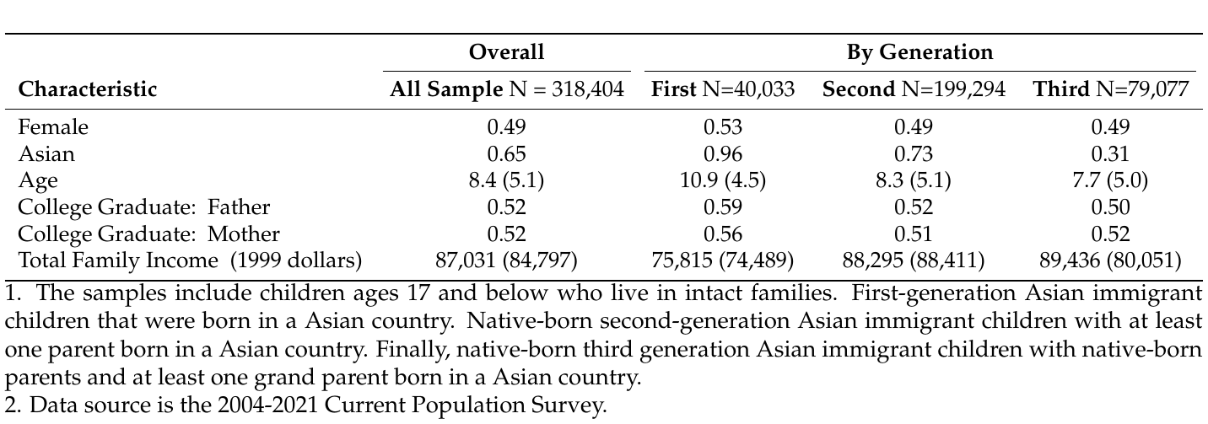

Table 2. Current Population Survey (CPS) Summary Statistics
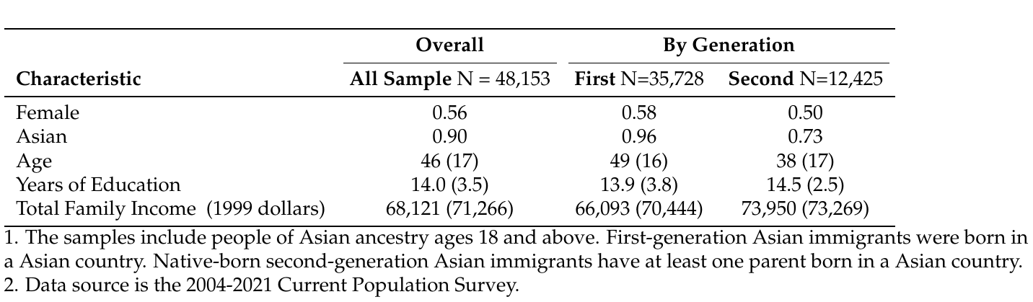

Table 3. Main Effect of Proxy on Second-Generation’s Asian Self-identification
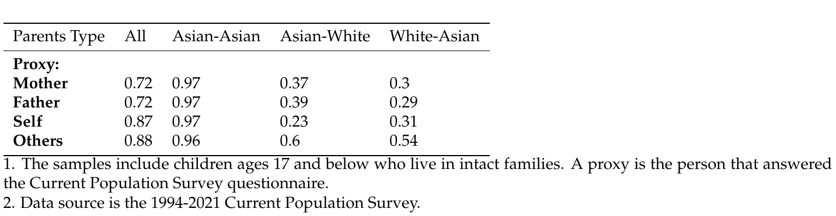

Table 4. Self-Reported Racial Identity of Children of Asian Ancestry by Generation
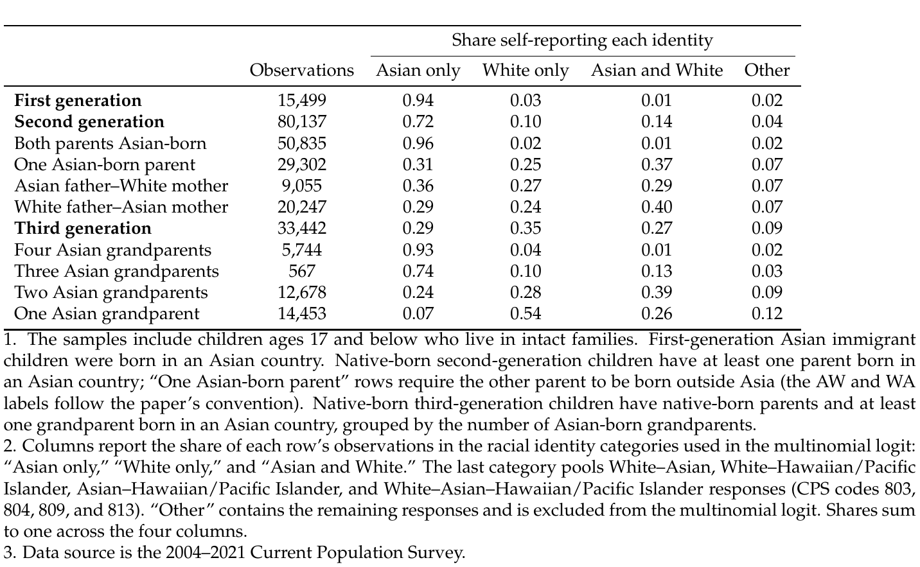

Table 5. Self-Reported Racial Identity of Adults of Asian Ancestry by Generation
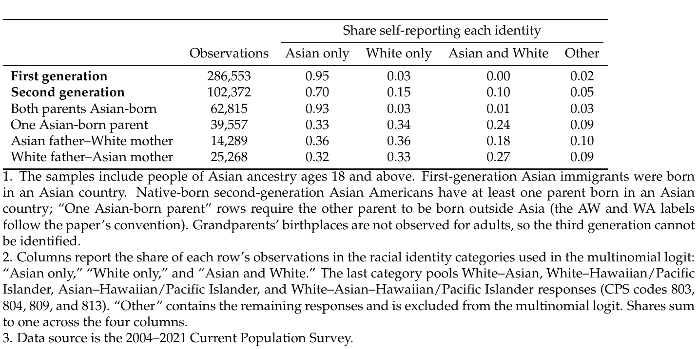

Table 6. Relationship Between Bias and Migration
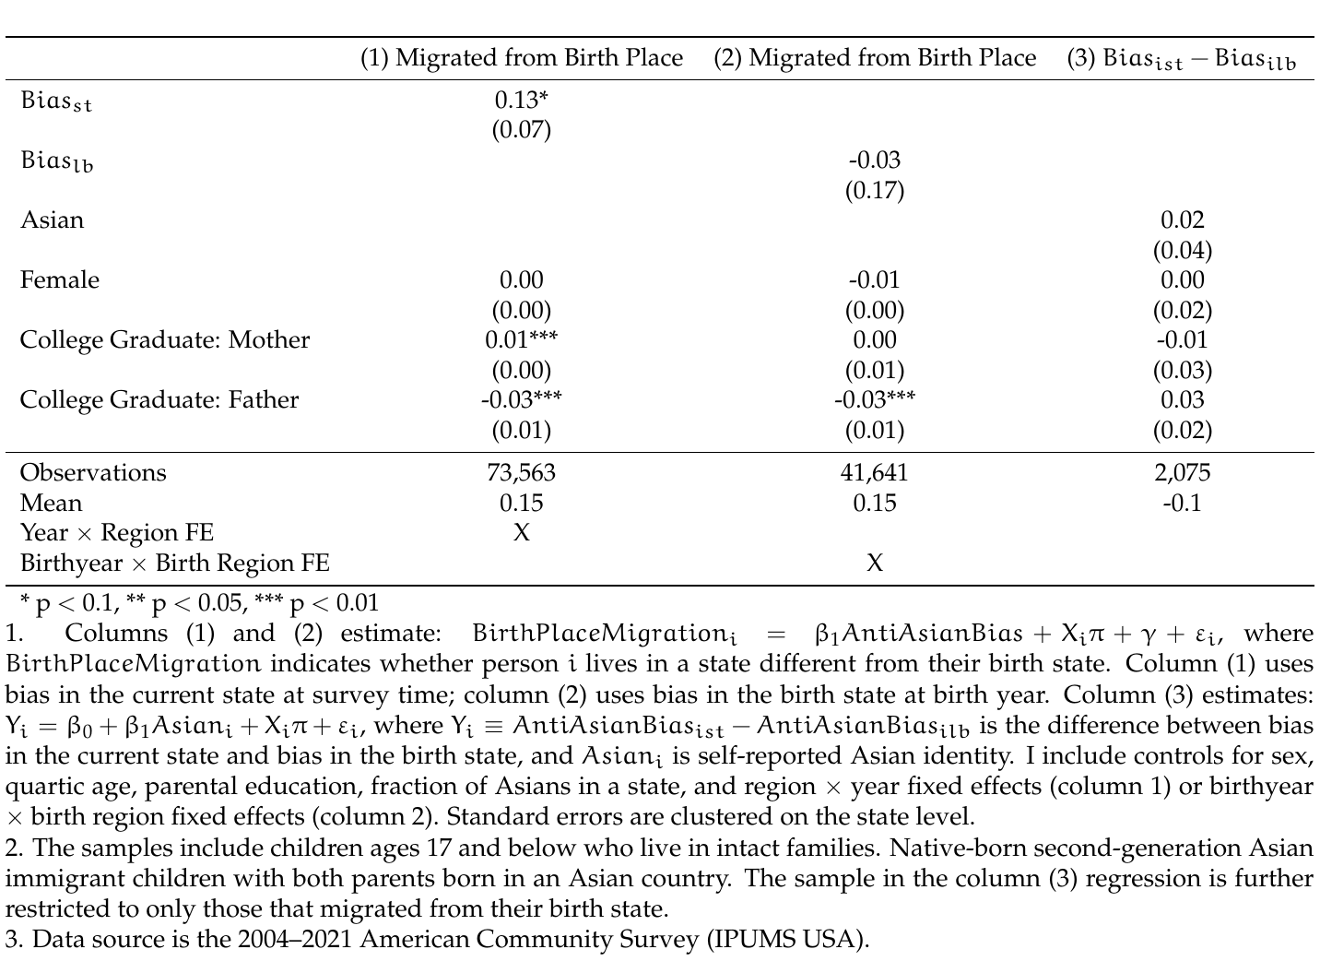

Table 7. Relationship Between Bias and Interracial Marriages
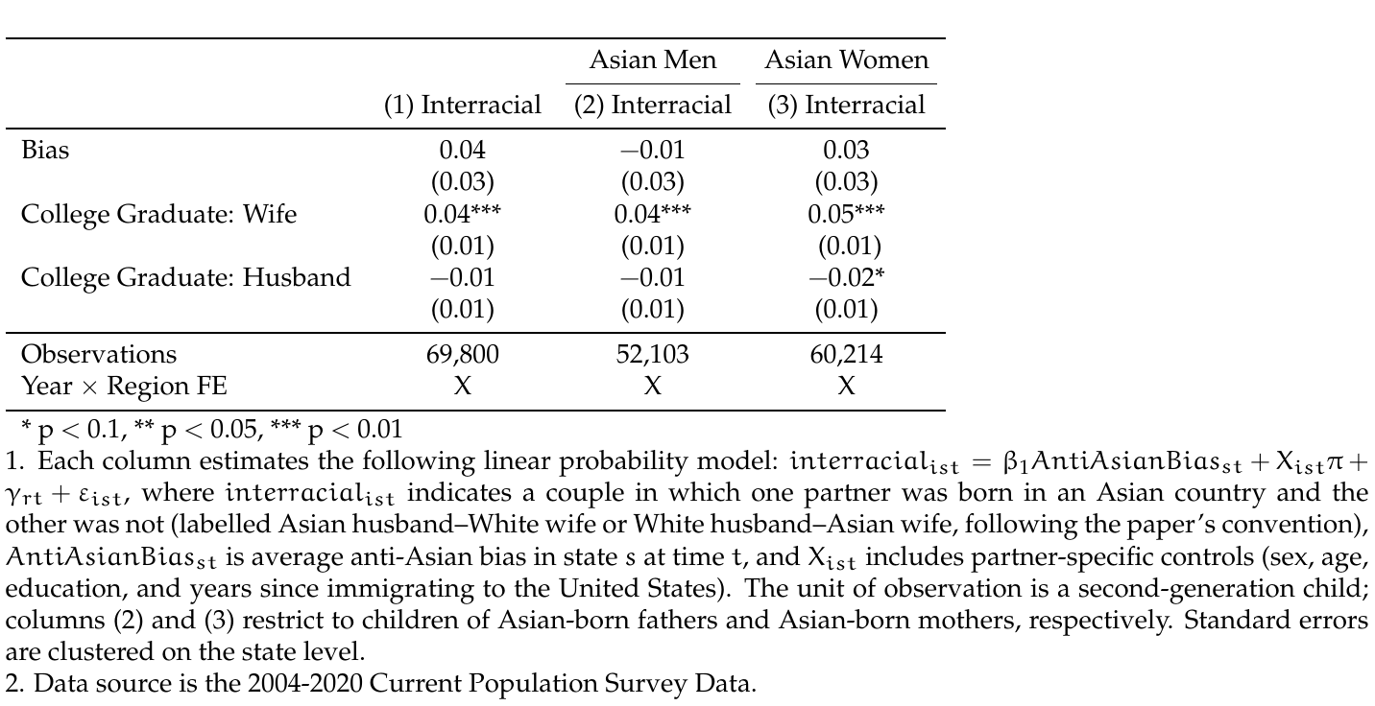

Table 8. Heterogeneity in the Effect of Anti-Asian Bias on Asian Identification
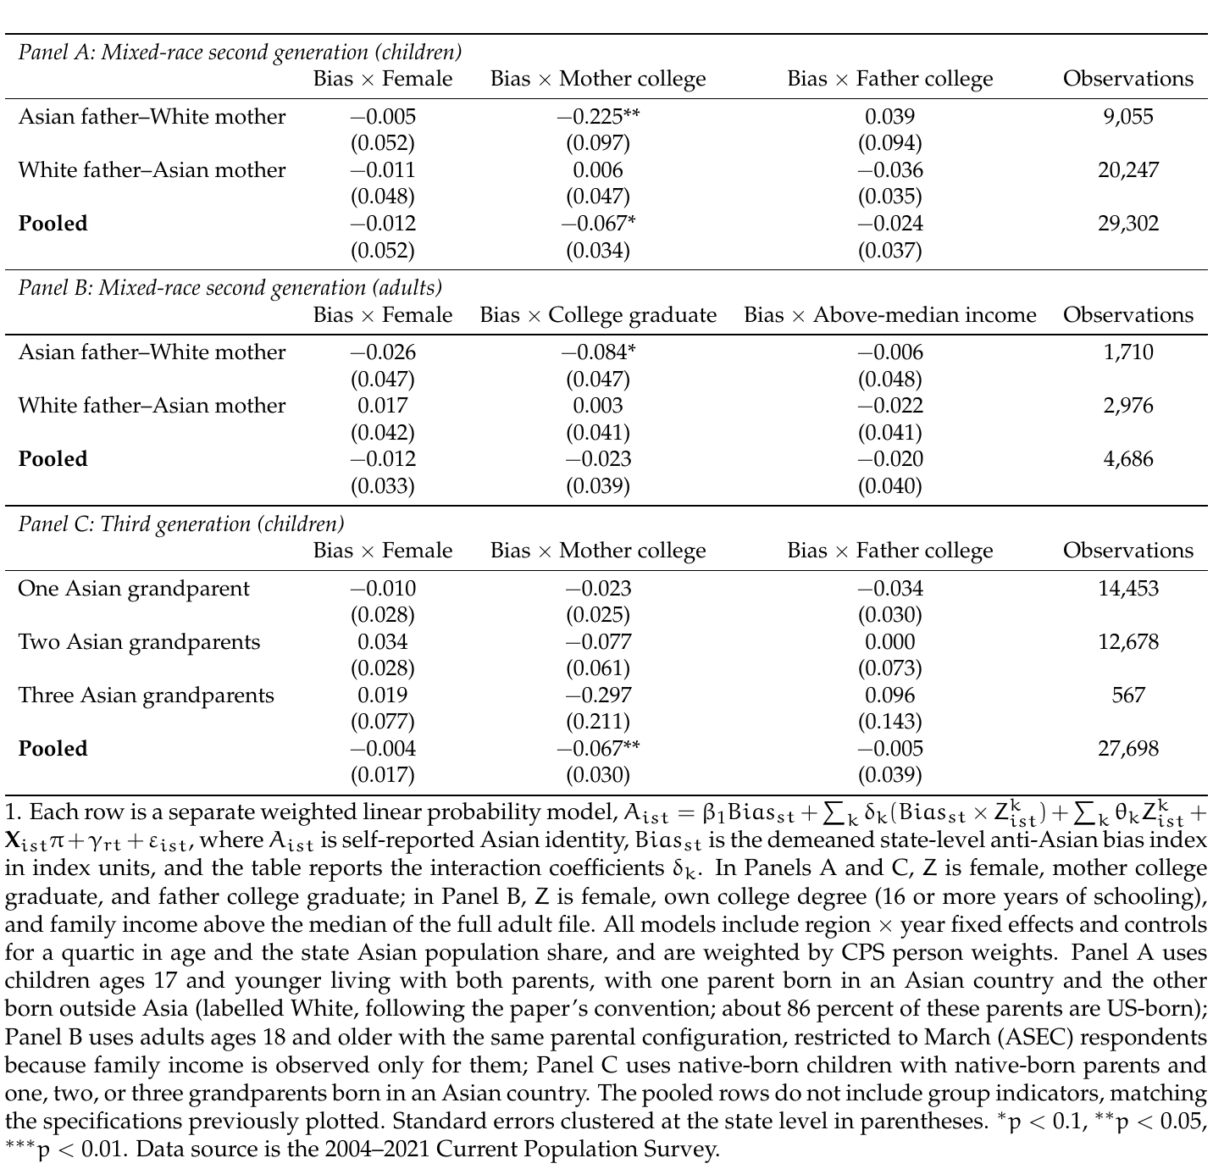

Figure 1. Diagram of the Three Different Generations of Asian Immigrants.
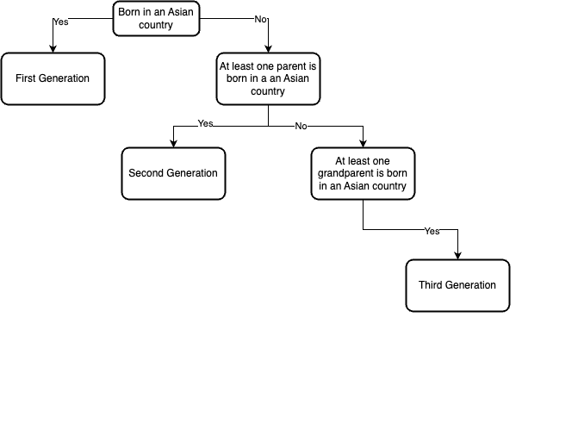

Figure 2. Bias and Self-reported Asian Identity in Selected Places
(a) Bias Over Time
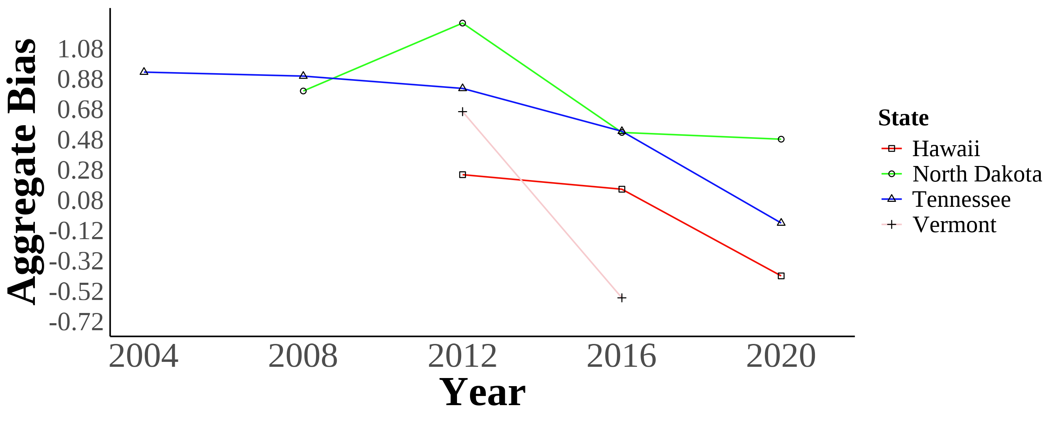
(b) Self-reported Asian Identity Over Time
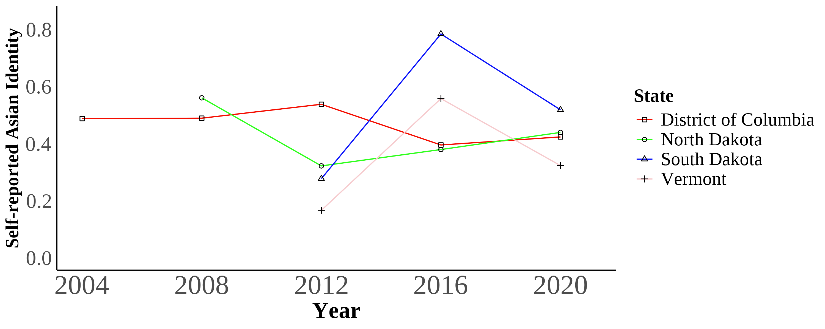
Panel a plots bias in Hawaii, North Dakota, Tennessee, and Vermont. Panel b plots self-reported Asian identity in the District of Columbia, North Dakota, South Dakota, and Vermont. The panels show different sets of places and are not a matched-state comparison. Bias is measured in units of the composite index, which is scaled in IAT -score units; one index unit is about 2.4 standard deviations of the state-year distribution of the index. Self-reported Asian identity is among first, second, and third-generation Asian immigrants aged 17 and younger still living in intact families.
Bias data is from the 2004–2021 Harvard’s Project Implicit Association Test scores, American National Election Studies (ANES), and state-level hate crimes against Asians. Identity data is from the 2004–2021 Current Population Survey (CPS).

Figure 3. Marginal Effects of Key Covariates on Racial Identity Choice
(a) Mixed-Race Second-Generation Asian Americans
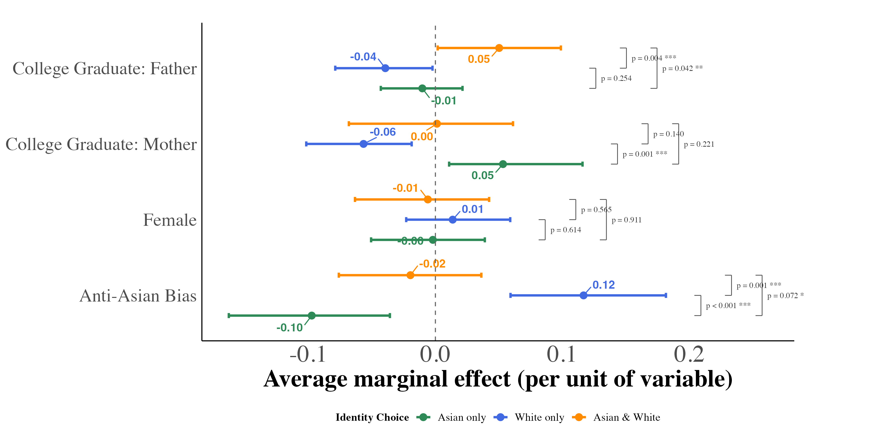
(b) Third-Generation Asian Americans
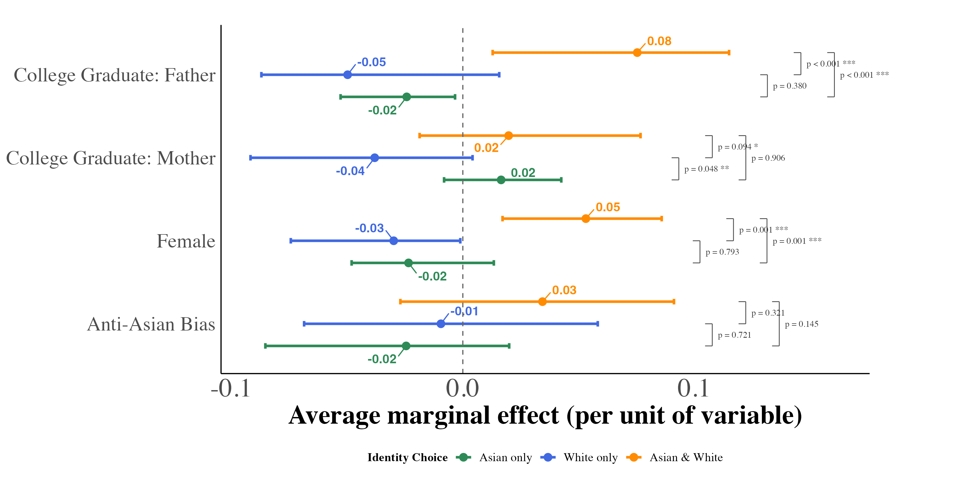
This figure displays average marginal effects of key covariates on the probability of each racial identity outcome, estimated from equation (4). Panel (a) pools second-generation children with one parent born in an Asian country and one parent born outside Asia; panel (b) pools third-generation children with one, two, or three Asian-born grandparents. For anti-Asian bias, the marginal effect is the derivative of each predicted probability with respect to the bias index, evaluated for every child at that child’s own covariate values and averaged over the estimation sample. It is an average slope expressed per one-unit increase in the bias index, not the exact probability change from a one-unit shift; one index unit is about 2.4 standard deviations of the state-year distribution of the index. For the binary covariates, it is the average change in predicted probability from switching the indicator from 0 to 1 for every child. Models include region year fixed effects and controls for a quartic in age and the state Asian population share, and are weighted by CPS person weights. Each point is the median, across 1,000 bootstrap resamples of children drawn with replacement within region year cells, of the sample-average marginal effect; the bars span the 2.5th and 97.5th percentiles of the same resamples. Because children rather than states are resampled, the intervals do not account for dependence among children in the same state.

Notes
1. The 2020 Census counted more than 20 million Asian Americans—6.4 percent of the population—nearly double the number counted two decades earlier. The Asian American population numbers are based on the author’s calculations from the Current Population Survey and US Census data (Flood, King, et al., 2021).
2. The IAT data comes from Harvard’s Project Implicit (Greenwald et al., 1998). Implicit bias measures have gained prominence in economics, with IAT scores correlating with economic outcomes (Chetty, Hendren, Jones, & Porter, 2020; Glover, Pallais, & Pariente, 2017), voting patterns (Friese, Bluemke, & Wänke, 2007), and health disparities (Leitner, Hehman, Ayduk, & Mendoza-Denton, 2016).
3. This extends Akerlof & Kranton (2000)’s prescription concept to encompass both negative stereotypes and positive model minority expectations.
4. This approach parallels previous research but focuses on racial rather than ethnic categorization.
5. Since adults still living with parents might not be representative of the overall adult population and is a rare occurrence, I do not link adults to their parents.
6. For this analysis, Asian countries comprise East Asian and Southeast Asian nations, including China, Hong Kong, Taiwan, Japan, Korea, Mongolia, Cambodia, Indonesia, Laos, Malaysia, Philippines, Singapore, Thailand, and Vietnam, but exclude South Asian and Middle Eastern countries, consistent with standard demographic classifications.
7. (F. M. Antman et al., 2020; F. Antman et al., 2016; Brian Duncan & Trejo; 2018a, 2018b) document substantial identity attrition among various groups.
8. IAT participation is voluntary, potentially creating selection bias. However, IAT-reflected bias serves as a proxy for prejudiced attitudes (Chetty et al., 2020).
9. Questions parallel those used by Charles & Guryan (2008): (1) “Conditions Make it Difficult for Blacks to Succeed”, (2) “Blacks Should Not Have Special Favors to Succeed”, (3) “Blacks Must Try Harder to Succeed”, (4) “Blacks Gotten Less than They Deserve Over the Past Few Years”, and (5) “Feeling Thermometer Toward Asians.”
10. Additional methodological details appear in the Online Appendix.
11. Beginning in 2003, the CPS allowed respondents to report multiple racial identities. The category labelled “Asian and White” pools White–Asian, White–Hawaiian/Pacific Islander, Asian–Hawaiian/Pacific Islander, and White–Asian–Hawaiian/Pacific Islander responses (CPS race codes 803, 804, 809, and 813). “Other” contains the remaining responses and is excluded from the multinomial model. Appendix Figures A.4–A.7 show a finer breakdown of the responses.
12. The derivative is computed numerically as a central difference with a step of one-tenth of the standard deviation of the index across children in the estimation sample, not one-tenth of an index unit; the perturbation is truncated at the sample range of the index, which pulls the derivatives for children in the most and least biased cells slightly toward zero.
13. A linear probability model for the binary Asian indicator with the same pooled specification gives a bias AW interaction of 0.08 (standard error 0.06). The estimate has the same sign as the multinomial contrast but is statistically inconclusive.
14. Hadah (2024) finds similar effects on third-generation Hispanic immigrants.
15. The previous version of this table clustered standard errors at the household level, which treats the state-year bias measure as if it varied across households and understated the standard errors by a factor of about three; the point estimates are unchanged.
16. According to CPS guidelines, household respondents must be at least 15 years old with sufficient household knowledge. When the proxy is “self,” respondents range from 15 to 17 years old.

References
Abramitzky, R., Boustan, L. P., & Eriksson, K. (2014). A Nation of Immigrants: Assimilation and Economic Outcomes in the Age of Mass Migration. Journal of Political Economy, 122(3), 467–506. http://doi.org/10.1086/675805
Abramitzky, R., Boustan, L. P., & Eriksson, K. (2016, July). Cultural Assimilation during the Age of Mass Migration [Working Paper]. http://doi.org/10.3386/w22381
Akerlof, G. A., & Kranton, R. E. (2000). Economics and Identity. Quarterly Journal of Economics, 115(3), 715–753. http://doi.org/10.1162/003355300554881
Almasalkhi, N. (2023). Links between anti-immigrant bias and racial prejudice in california.
American National Election Studies. (2021). ANES 2020 time series study full release [dataset and documentation]. Retrieved from https://www.electionstudies.org
Antman, F. M., Duncan, B., & Trejo, S. J. (2020). Ethnic attrition, assimilation, and the measured health outcomes of Mexican Americans. Journal of Population Economics, 33(4), 1499–1522. http://doi.org/https://doi-org.ezproxy.lib.uh.edu/10.1007/s00148-020-00772-8
Antman, F., & Duncan, B. (2015). Incentives to Identify: Racial Identity in the Age of Affirmative Action. Review of Economics & Statistics, 97(3), 710–713. http://doi.org/10.1162/REST_a_00527
Antman, F., & Duncan, B. (2021). American Indian Casinos and Native American Self‐Identification.
Antman, F., Duncan, B., & Trejo, S. J. (2016). Ethnic Attrition and the Observed Health of Later-Generation Mexican Americans. The American Economic Review, 106(5), 467–471. Retrieved from http://www.jstor.org/stable/43861065
Arabsheibani, G. R., & Wang, J. (2010). Asian-white male wage differentials in the united states. Applied Economics Letters, 17(1), 37–43.
Arkes, H. R., & Tetlock, P. E. (2004). Attributions of Implicit Prejudice, or "Would Jesse Jackson ’Fail’ the Implicit Association Test?". Psychological Inquiry, 15(4), 257–278. http://doi.org/10.1207/s15327965pli1504_01
Atkin, D., Colson-Sihra, E., & Shayo, M. (2021). How Do We Choose Our Identity? A Revealed Preference Approach Using Food Consumption. Journal of Political Economy, 129(4), 1193–1251. http://doi.org/10.1086/712761
Bertrand, M., & Mullainathan, S. (2004). Are Emily and Greg More Employable Than Lakisha and Jamal? A Field Experiment on Labor Market Discrimination. American Economic Review, 94(4), 991–1013. http://doi.org/10.1257/0002828042002561
Bordalo, P., Coffman, K., Gennaioli, N., & Shleifer, A. (2016). Stereotypes*. The Quarterly Journal of Economics, 131(4), 1753–1794. http://doi.org/10.1093/qje/qjw029
Bureau of Justice Statistics. (2023). Uniform crime reporting program data series [dataset]. Retrieved from https://catalog.data.gov/dataset/uniform-crime-reporting-program-data-series-16edb
Bursztyn, L., Chaney, T., Hassan, T. A., & Rao, A. (2022, March 31). The Immigrant Next Door: Long-Term Contact, Generosity, and Prejudice [SSRN Scholarly Paper]. http://doi.org/10.2139/ssrn.3781974
Charles, K. K., & Guryan, J. (2008). Prejudice and Wages: An Empirical Assessment of Becker’s The Economics of Discrimination. Journal of Political Economy, 116(5), 773–809. http://doi.org/10.1086/593073
Charness, G., & Chen, Y. (2020). Social Identity, Group Behavior, and Teams. Annual Review of Economics, 12(1), 691–713. http://doi.org/10.1146/annurev-economics-091619-032800
Chetty, R., Hendren, N., Jones, M. R., & Porter, S. R. (2020). Race and Economic Opportunity in the United States: An Intergenerational Perspective*. The Quarterly Journal of Economics, 135(2), 711–783. http://doi.org/10.1093/qje/qjz042
Chiswick, B. R. (1983). An analysis of the earnings and employment of asian-american men. Journal of Labor Economics, 1(2), 197–214.
Cornell, S., & Hartmann, D. (2006). Ethnicity and race: Making identities in a changing world. Sage Publications.
Darity, W. A. (2022). Position and Possessions: Stratification Economics and Intergroup Inequality. Journal of Economic Literature, 60(2), 400–426. http://doi.org/10.1257/jel.20211690
Darity, W. A., Mason, P. L., & Stewart, J. B. (2006). The economics of identity: The origin and persistence of racial identity norms. Journal of Economic Behavior & Organization, 60(3), 283–305. http://doi.org/10.1016/j.jebo.2004.09.005
Diette, T. M., Goldsmith, A. H., Hamilton, D., & Darity, W. (2015). Skin Shade Stratification and the Psychological Cost of Unemployment: Is there a Gradient for Black Females? The Review of Black Political Economy, 42(1-2), 155–177. http://doi.org/10.1007/s12114-014-9192-z
Duleep, H. O., & Sanders, S. G. (2012). The economic status of asian americans before and after the civil rights act.
Duncan, B., & Trejo, S. J. (2011). Intermarriage and the intergenerational transmission of ethnic identity and human Capital for Mexican Americans. J Labor Econ, 29.
Duncan, Brian, & Trejo, S. J. (2018a). Identifying the Later-Generation Descendants of U.S. Immigrants: Issues Arising from Selective Ethnic Attrition. The ANNALS of the American Academy of Political and Social Science, 677(1), 131–138. http://doi.org/10.1177/0002716218763293
Duncan, Brian, & Trejo, S. J. (2018b). Socioeconomic Integration of U.S. Immigrant Groups over the Long Term: The Second Generation and Beyond (Working Paper No. 24394). National Bureau of Economic Research. Retrieved from http://www.nber.org/papers/w24394
Egloff, B., & Schmukle, S. C. (2002). Predictive validity of an implicit association test for assessing anxiety. Journal of Personality and Social Psychology, 83, 1441–1455. http://doi.org/10.1037/0022-3514.83.6.1441
Flood, S., King, M., Rodgers, R., Ruggles, S., Warren, J. R., & Westberry, M. (2021). Integrated Public Use Microdata Series, Current Population Survey: Version 9.0 (Version 9.0) [Data set]. Minneapolis, MN: IPUMS. http://doi.org/10.18128/D030.V9.0
Flood, S., Ronald, G., Megan, S., & Matthew, S. (2021). Integrated Public Use Microdata Series, USA: Version 12.0 (Version 9.0) [Data set]. Minneapolis, MN: IPUMS. http://doi.org/10.18128/D030.V9.0
Forscher, P. S., Lai, C. K., Axt, J. R., Ebersole, C. R., Herman, M., Devine, P. G., & Nosek, B. A. (2019). A meta-analysis of procedures to change implicit measures. Journal of Personality and Social Psychology, 117(3), 522–559. http://doi.org/10.1037/pspa0000160
Fouka, V., Mazumder, S., & Tabellini, M. (2022). From Immigrants to Americans: Race and Assimilation during the Great Migration. The Review of Economic Studies, 89(2), 811–842. http://doi.org/10.1093/restud/rdab038
Friese, M., Bluemke, M., & Wänke, M. (2007). Predicting voting behavior with implicit attitude measures: The 2002 German parliamentary election. Experimental Psychology, 54(4), 247–255. http://doi.org/10.1027/1618-3169.54.4.247
Glover, D., Pallais, A., & Pariente, W. (2017). Discrimination as a Self-Fulfilling Prophecy: Evidence from French Grocery Stores. Quarterly Journal of Economics, 132(3), 1219–1260. http://doi.org/10.1093/qje/qjx006
Goldsmith, A. H., Hamilton, D., & Darity, W. (2007). From Dark to Light: Skin Color and Wages among African-Americans. The Journal of Human Resources, 42(4), 701–738. Retrieved from https://www.jstor.org/stable/40057327
Gover, A. R., Harper, S. B., & Langton, L. (2020). Anti-asian hate crime during the COVID-19 pandemic: Exploring the reproduction of inequality. American Journal of Criminal Justice, 45(4), 647–667.
Greenwald, A. G., McGhee, D. E., & Schwartz, J. L. K. (1998). Measuring individual differences in implicit cognition: The implicit association test. Journal of Personality and Social Psychology, 74(6), 1464–1480. http://doi.org/10.1037/0022-3514.74.6.1464
Hadah, H. (2024). The effect of racial and ethnic attitudes on hispanic identity in the united states. Southern Economic Journal.
Hamilton, D., Goldsmith, A. H., & Darity, W. (2009). Shedding “light” on marriage: The influence of skin shade on marriage for black females. Journal of Economic Behavior & Organization, 72(1), 30–50. http://doi.org/10.1016/j.jebo.2009.05.024
Hilger, N. (2016). Upward mobility and discrimination: The case of asian americans. National Bureau of Economic Research.
Lee, D. J. (2018). Does Implicit Bias Predict Dictator Giving? Games, 9(4, 4), 73. http://doi.org/10.3390/g9040073
Leitner, J. B., Hehman, E., Ayduk, O., & Mendoza-Denton, R. (2016). Racial bias is associated with ingroup death rate for Blacks and Whites: Insights from Project Implicit. Social Science & Medicine, 170, 220–227. http://doi.org/10.1016/j.socscimed.2016.10.007
Lubotsky, D., & Wittenberg, M. (2006). Interpretation of Regressions with Multiple Proxies. The Review of Economics and Statistics, 88(3), 549–562. http://doi.org/10.1162/rest.88.3.549
Meng, X., & Gregory, R. G. (2005). Intermarriage and the Economic Assimilation of Immigrants. Journal of Labor Economics, 23(1), 135–174. http://doi.org/10.1086/425436
Mora, G. C., & Paschel, T. S. (2020). Antiblackness as a logic for anti-immigrant resentment: Evidence from california. In Sociological forum (Vol. 35, pp. 918–940). Wiley Online Library.
National Academies of Sciences, Engineering, and Medicine. (2015). The Integration of Immigrants into American Society. (M. C. Waters & M. G. Pineau, Eds.). Washington, DC: The National Academies Press. http://doi.org/10.17226/21746
Office of Management and Budget. (2024). Revisions to OMB’s Statistical Policy Directive No. 15: Standards for Maintaining, Collecting, and Presenting Federal Data on Race and Ethnicity (Notice of decision No. 89 FR 22182, Document 2024-06469). Federal Register. Retrieved from https://www.federalregister.gov/documents/2024/03/29/2024-06469/revisions-to-ombs-statistical-policy-directive-no-15-standards-for-maintaining-collecting-and
Telles, E. E., & Ortiz, V. (2008). Generations of exclusion: Mexican-americans, assimilation, and race. Russell Sage Foundation.
United States Congress. COVID-19 Hate Crimes Act, Pub. L. No. Public Law 117-13, 135 Stat. 265 (2021). Retrieved from https://www.govinfo.gov/app/details/PLAW-117publ13
Waters, M. C. (1990). Ethnic options: Choosing identities in america.
Zhou, M. (1997). Segmented assimilation: Issues, controversies, and recent research on the new second generation. International Migration Review, 31(4), 975–1008.

