Children’s Hospital Los Angeles
Phone: 323-491-8257 │ Email: pharmacogenomics@chla.usc.edu

Pharmacogenomics Test Result Summary
Patient name: | {{patient_name}} | Laboratory: | OneOme
Date of birth: | {{date_of_birth}} | Date of test: | {{report_date}}
 |  | Date of interpretation: | {{report_date}}
PURPOSE
The laboratory has looked at your DNA to help predict how certain medications are expected to work in your body. These results can help your doctors and other healthcare professionals make decisions about medication selection and dosage.

LIMITATIONS
There are limitations to pharmacogenomic testing. Genetics is one piece of the puzzle when it comes to medication response. Other clinical factors (e.g., age, weight, kidney function, other medications you are taking), and other genetic factors that are not yet well understood, can also influence whether you benefit from a certain medication or experience side effects. In addition, a “*1” or “normal” result means that you do not have any of the genetic variants that were included on the test. There is a possibility that you have a rare, or not yet discovered, genetic variant that may affect medication response.

TYPES OF PHARMACOGENOMIC RESULTS
Metabolizer Genes
These genes can determine how fast or slow medications are broken down (turned off) or activated (turned on) in the body by proteins called enzymes. Everyone processes medications at different rates.
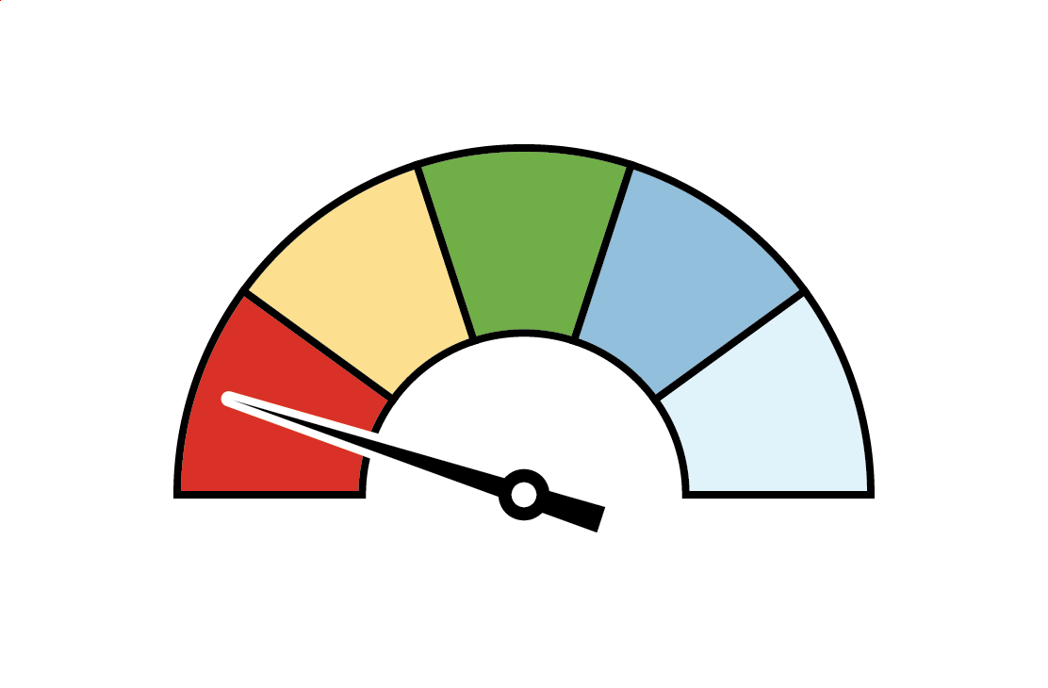  Poor  Metabolizer |  | 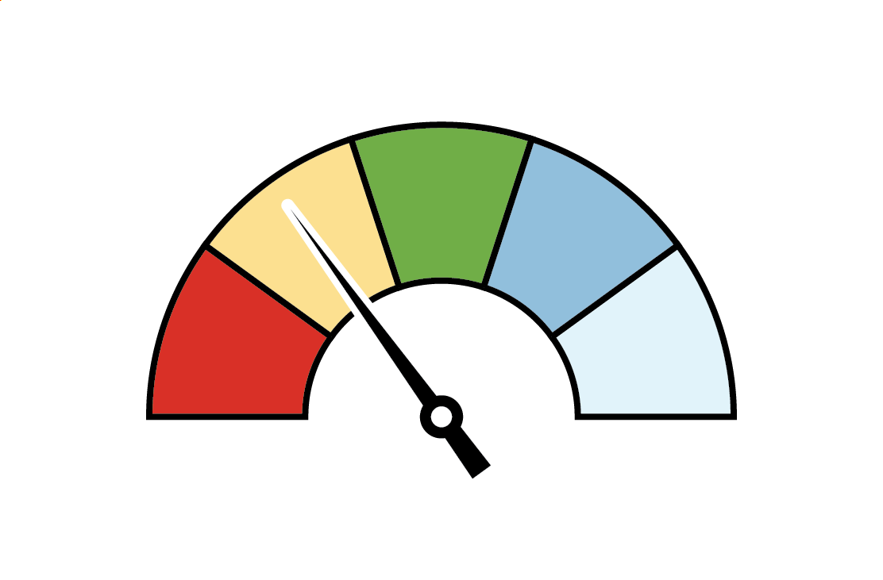  Intermediate  Metabolizer |  |  | 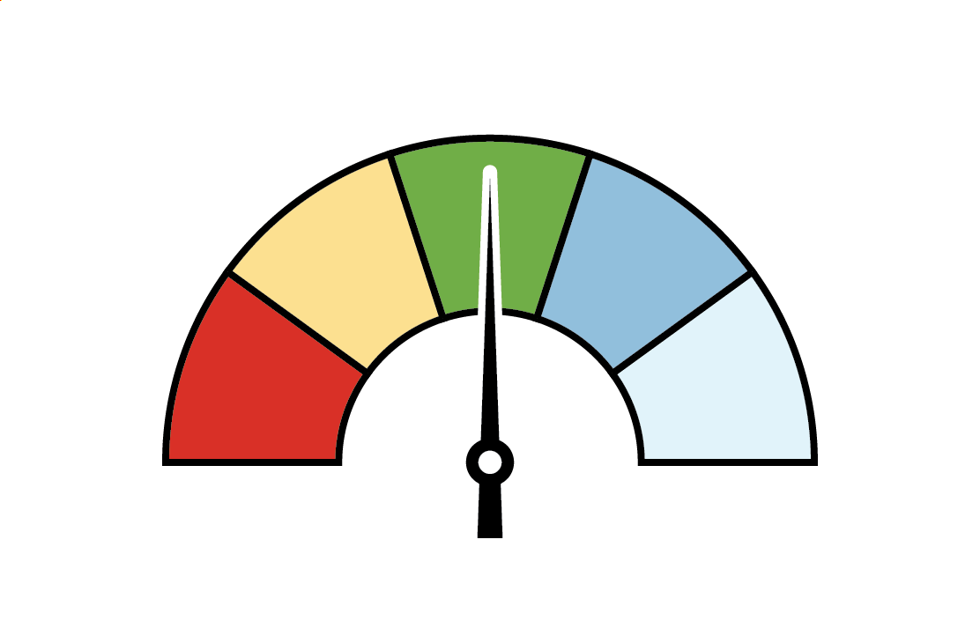  Normal  Metabolizer |  | 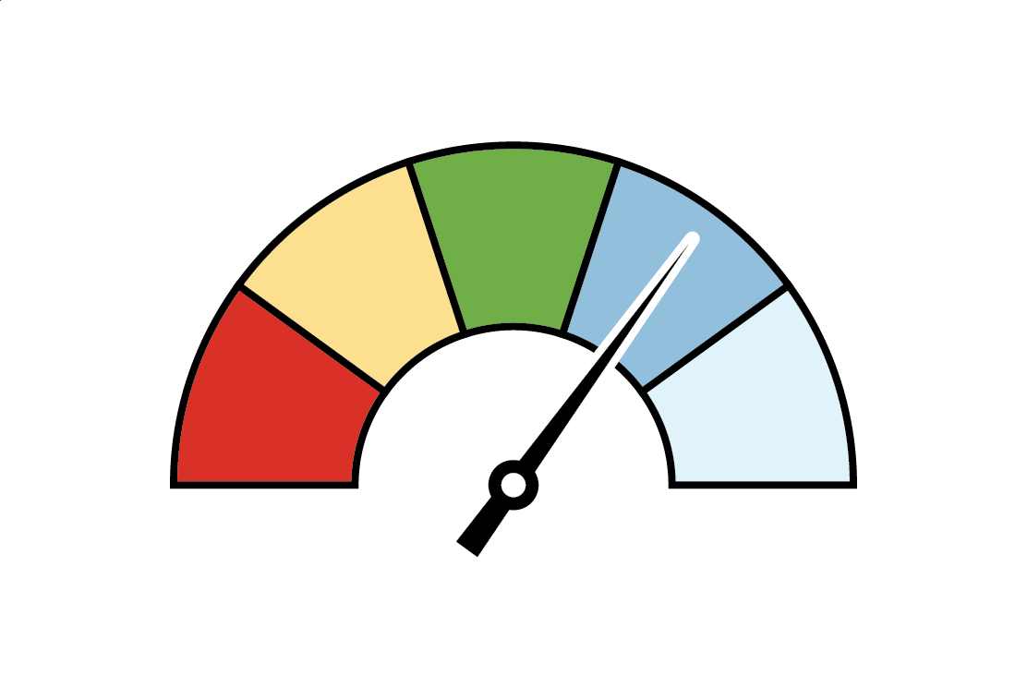  Rapid  Metabolizer | 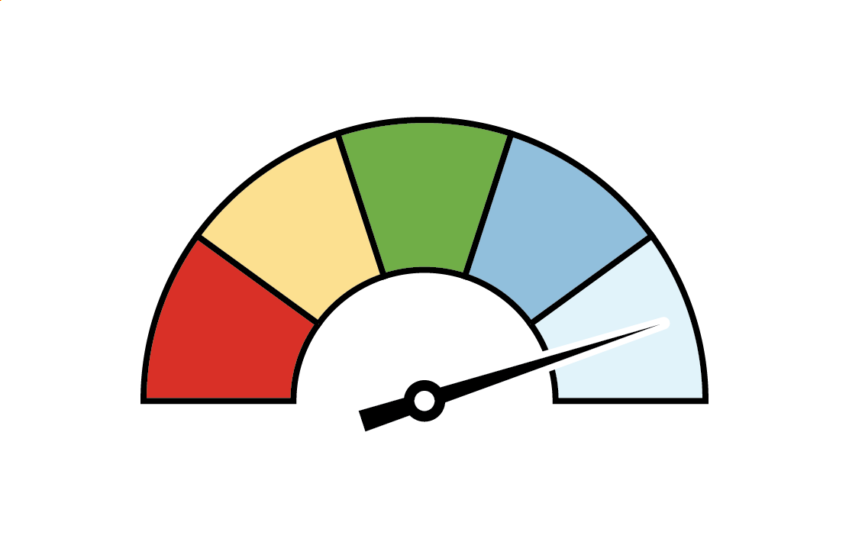  Ultrarapid  Metabolizer
Medications are broken down or activated very slowly |  | Medications are broken down or activated slower than expected |  |  | Medications are broken down or activated at the expected rate |  | Medications are broken down or activated faster than expected | Medications are broken down or activated very quickly
Transporter Genes |  |  |  |  |  | Immune Reaction Genes
These genes can determine how effectively medications move through proteins called transporters. Transporters work like pumps, moving drugs into and out of our cells. Everyone’s transporters (pumps) work a little differently. |  |  |  |  |  | These genes can determine if we are at risk for a severe allergic reaction to certain medications. A positive result for one of these genes means you have a higher risk of a reaction. A negative result means you have a standard risk of a reaction.
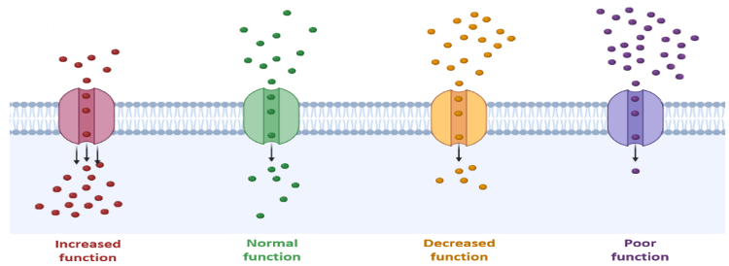 |  |  |  |  |  | 
Increased  Function | Normal  Function |  | Decreased  Function | Poor  Function

GENETIC RESULTS THAT MAY IMPACT MEDICATION PRESCRIBING
You were tested for 16 genes that can affect medication response: CYP2B6, CYP2C9, CYP2C19, CYP2C cluster, CYP2D6, CYP3A5, CYP4F2, DPYD, HLA-A, HLA-B, IFNL4, NUDT15, SLCO1B1, TPMT, UGT1A1, VKORC1. For a complete list of all of your pharmacogenomic test results, please refer to the OneOme lab report or Table 2 on this document.

These are your pharmacogenomic test results that have corresponding medication recommendations that differ from standard prescribing at this time. Medications included in the table are ones to either avoid, use with caution, or that may need dose adjustments based on genetics. For specific pharmacogenomics-guided medication recommendations, healthcare professionals can refer to the following sources identified next to the relevant medications in the table below: Clinical Pharmacogenetics Implementation Consortium (CPIC) guidelines¹, FDA Table of Pharmacogenetic Associations (Section 1 only)², and/or the Dutch Pharmacogenetics Working Group (DPWG) guidelines³ (links for these sources are provided below). The DPWG guidelines are only included for medications for which there are no current CPIC or FDA recommendations based on genetics.

The information provided on this report may become out of date as new research and guidelines are developed; therefore, healthcare professionals should always consult the updated pharmacogenomics resources to assess which medications may be impacted by your pharmacogenomic test results and the associated clinical recommendations. For assistance with interpreting and applying your pharmacogenomic test results, your doctors or other prescribing healthcare professionals may request assistance from the Children’s Hospital Los Angeles Genetic Test Assistance and Counseling (GTAC) team at 323-361-5536 or GTAC@chla.usc.edu.

 | For medication guidance based on your unique pharmacogenomic results, healthcare professionals can refer to QR code on the left or this link. This link is to an external resource that our clinical team does not manage, so healthcare professionals should verify all medication recommendations with the original guideline sources before making medical decisions. The link also doesn’t support all of the results from your test. Do not stop, start, or change the way you take any medications based on your pharmacogenomic test results without first consulting your doctor or other healthcare professional. Genetics is just one factor to consider with medication prescribing and should not be used as the sole means of treatment decision making

TABLE 1. GENETIC RESULTS THAT MAY IMPACT MEDICATION PRESCRIBING
Gene | Genotype | Phenotype | Examples of Affected Medications
{%tr for gene in high_risk_genes %}
{{gene.gene}} | {{gene.genotype}} | {{gene.phenotype}} | {{gene.medications}}
{%tr endfor %}

Footnote to add if “likely” results (delete if not needed):
¥Although the FDA does not provide explicit guidance for “likely” results (i.e., CYP2C19 Likely Intermediate Metabolizer and CYP2C19 Likely Poor Metabolizer), patients with these results can be treated clinically as if they had the definitive result (i.e., CYP2C19 Intermediate Metabolizer and CYP2C19 Poor Metabolizer).
Sources of Pharmacogenomics-Guided Medication Recommendations:
- Clinical Pharmacogenetics Implementation Consortium (CPIC) guidelines. www.cpicpgx.org/guidelines.
- U.S. Food and Drug Administration (FDA) Table of Pharmacogenetic Associations (Section 1). https://www.fda.gov/medical-devices/precision-medicine/table-pharmacogenetic-associations.
- Dutch Pharmacogenetics Working Group (DPWG) guidelines. https://www.pharmgkb.org/page/dpwg

TABLE 2. PHARMACOGENOMIC TEST RESULTS
Gene | Genotype | Phenotype
{%tr for gene in all_genes %}
{{gene.gene}} | {{gene.genotype}} | {{gene.phenotype}}
{%tr endfor %}

TABLE 3. GENERAL LIST OF MEDICATIONS WITH PHARMACOGENOMIC ASSOCIATIONS AND GUIDANCE
This is a list of medications and their relevant gene associations. This list is not comprehensive as pharmacogenomics is a fast-growing area, and new medications might be added as time goes by. For the most updated list of medications with pharmacogenomics guidance, please refer to the resources mentioned above.
  Medications | Genes
  BEHAVIORAL HEALTH
  Amitriptyline (Elavil®) | CYP2C19, CYP2D6
  Amphetamine (Evekeo®) | CYP2D6
  Aripiprazole (Abilify®) | CYP2D6
  Atomoxetine (Strattera®) | CYP2D6
  Brexpiprazole (Rexulti®) | CYP2D6
  Citalopram (Celexa®) | CYP2C19
  Clomipramine (Anafranil®) | CYP2C19, CYP2D6
  Clozapine (Clozaril®) | CYP2D6
  Desipramine (Norpramin®) | CYP2D6
  Doxepin (Silenor®) | CYP2C19, CYP2D6
  Escitalopram (Lexapro®) | CYP2C19
  Fluvoxamine (Luvox®) | CYP2D6
  Haloperidol (Haldol®) | CYP2D6
  Iloperidone (Fanapt®) | CYP2D6
  Imipramine (Tofranil®) | CYP2C19, CYP2D6
  Nortriptyline (Pamelor®) | CYP2D6
  Paroxetine (Paxil®) | CYP2D6
  Risperidone (Risperdal®) | CYP2D6
  Sertraline (Zoloft®) | CYP2C19, CYP2B6
  Thioridazine (Mellaril®) | CYP2D6
  Trimipramine (Surmontil®) | CYP2C19, CYP2D6
  Valbenazine (Ingrezza®) | CYP2D6
  Venlafaxine (Effexor®) | CYP2D6
  Vortioxetine (Trintellix®) | CYP2D6
  CARDIOLOGY
  Atorvastatin (Lipitor®) | SLCO1B1
  Clopidogrel (Plavix®) | CYP2C19
  Flecainide (Tambocor®) | CYP2D6
  Fluvastatin (Lescol®) | CYP2C9, SLCO1B1
  Lovastatin (Altoprev®) | SLCO1B1
  Metoprolol (Lopressor®) | CYP2D6
  Pitavastatin (Livalo®) | SLCO1B1
  Pravastatin (Pravachol®) | SLCO1B1
  Propafenone (Rythmol®) | CYP2D6
  Rosuvastatin (Crestor®) | SLCO1B1
  Simvastatin (Zocor®) | SLCO1B1
  Warfarin (Coumadin®) | CYP2C9, CYP2C cluster, CYP4F2, VKORC1
  DERMATOLOGY
  Abrocitinib (Cibinqo®) | CYP2C19
  ENDOCRINOLOGY
  Nateglinide (Starlix®) | CYP2C9
  Medications | Genes
  GASTROENTEROLOGY
  Dexlansoprazole (Dexilant®) | CYP2C19
  Dronabinol (Marinol®) | CYP2C9
  Lansoprazole (Prevacid®) | CYP2C19
  Meclizine (Antivert®) | CYP2D6
  Metoclopramide (Reglan®) | CYP2D6
  Omeprazole (Prilosec®) | CYP2C19
  Ondansetron (Zofran®) | CYP2D6
  Pantoprazole (Protonix®) | CYP2C19
  GENETIC DISORDERS
  Eliglustat (Cerdelga®) | CYP2D6
  IMMUNOSUPPRESSION
  Azathioprine (Imuran®) | TPMT, NUDT15
  Tacrolimus (Prograf®) | CYP3A5
  INFECTIOUS DISEASES
  Abacavir (Ziagen®) | HLA-B*57:01
  Atazanavir (Reyataz®) | UGT1A1
  Efavirenz (Sustiva®) | CYP2B6
  Flucytosine (Ancobon®) | DPYD
  Peginterferon alfa-based regimens | IFNL4
  Voriconazole (Vfend®) | CYP2C19
  MISCELLANEOUS
  Lofexidine (Lucemyra®) | CYP2D6
  NEUROLOGY
  Brivaracetam (Briviact®) | CYP2C19
  Carbamazepine (Tegretol®) | HLA-A*31:01, HLA-B*15:02
  Clobazam (Onfi®) | CYP2C19
  Deutetrabenazine (Austedo®) | CYP2D6
  Fosphenytoin (Cerebyx®) | CYP2C9, HLA-B*15:02
  Lamotrigine (Lamictal®) | HLA-B*15:02
  Oxcarbazepine (Trileptal®) | HLA-B*15:02
  Phenytoin (Dilantin®) | CYP2C9, HLA-B*15:02
  Pimozide (Orap®) | CYP2D6
  Pitolisant (Wakix®) | CYP2D6
  Siponimod (Mayzent®) | CYP2C9
  Tetrabenazine (Xenazine®) | CYP2D6
  ONCOLOGY
  Belinostat (Beleodaq®) | UGT1A1
  Belzutifan (Welireg®) | CYP2C19
  Capecitabine (Xeloda®) | DPYD
  Erdafitinib (Balversa®) | CYP2C9
  Fluorouracil | DPYD
ONCOLOGY
Gefitinib (Iressa®) | CYP2D6
Irinotecan (Camptosar®) | UGT1A1
Mercaptopurine (Purixan®) | TPMT, NUDT15
Sacituzumab govitecan-hziy (Trodelvy®) | UGT1A1
Tamoxifen (Soltamox®) | CYP2D6
Thioguanine (Tabloid®) | TPMT, NUDT15
PAIN MANAGEMENT
Celecoxib (Celebrex®) | CYP2C9
Codeine | CYP2D6
Hydrocodone (Hysingla®) | CYP2D6
Flurbiprofen (Ansaid®) | CYP2C9
Ibuprofen (Advil®) | CYP2C9
Meloxicam (Mobic®) | CYP2C9
Oliceridine (Olinvyk®) | CYP2D6
Piroxicam (Feldene®) | CYP2C9
Tramadol (Ultram®) | CYP2D6
RHEUMATOLOGY
Allopurinol (Zyloprim®) | HLA-B*58:01
WOMEN’S HEALTH
Flibanserin (Addyi®) | CYP2C19

