Year | Number of cells towed | Number of cells crab ≥ 65 mmCL found | Mean Biomass(t) of ≥ 65 mmCL | Total Biomass(t) of ≥ 65 mmCL | Std. Dev. Biomass (t) of ≥ 65 mmCL | Coeff. Var. Biomass | Remarks
1985 | 144 | 65 | 246 | 33211 | 5327 | 0.16
1986 | 147 | 62 | 288 | 38896 | 7403 | 0.19 | 2 (E11,E13,G9)1, 3(E8,E12,G7),4 (F9), 5 (F7,F8,G8) tows
1987 | 150 | 76 | 476 | 64324 | 13218 | 0.21 | 2(F14, J13), 3 (E13) tows
1988 | 139 | 72 | 346 | 46736 | 9982 | 0.21 | 2 (D10,E11,E12,J13), 3(F13), 5(D8), 27(C8) tows
1989 | 150 | 81 | 417 | 56280 | 11742 | 0.21 | 2(C7,E12,E13), 3(F13), 4(D11), 20 (C8) tows
1990 | 150 | 66 | 374 | 50594 | 11301 | 0.21 | 2(E10,F8,F9) tows
1991 | 146 | 59 | 351 | 47334 | 9341 | 0.20 | 2(G6), 4(F7) tows
1992 | 145 | 57 | 257 | 34745 | 6044 | 0.17
1993 | 138 | 49 | 371 | 50144 | 8691 | 0.17 | 4(F08) tows
1994 | 136 | 45 | 235 | 31774 | 5505 | 0.17
1995 | 138 | 49 | 321 | 43334 | 9384 | 0.22 | 4 tows in 20 stations
1996 | 136 | 49 | 320 | 43143 | 8726 | 0.20
1997 | 138 | 54 | 585 | 78928 | 20714 | 0.26
1998 | 138 | 57 | 605 | 81690 | 14788 | 0.18
1999 | 135 | 59 | 462 | 62387 | 9568 | 0.15 | double tows in 31 stations
2000 | 137 | 62 | 483 | 65229 | 10253 | 0.16 | double tows in 23 stations
2001 | 137 | 59 | 358 | 48389 | 8664 | 0.18
2002 | 137 | 57 | 527 | 71149 | 14246 | 0.20
2003 | 139 | 68 | 700 | 94510 | 15521 | 0.16 | 5(H09) tows
2004 | 140 | 59 | 722 | 97461 | 15858 | 0.16 | 5(G7, H9) tows
2005 | 137 | 62 | 736 | 99296 | 17222 | 0.17
2006 | 137 | 68 | 659 | 89026 | 11562 | 0.13 | double tows in 31 stations
2007 | 137 | 66 | 747 | 100815 | 13458 | 0.13 | double tows in 32 stations, male averaged for the repeat tow cell, female second tow value was taken

Estimation formula:

Number of cells towed in Bristol Bay area in year t = n_{t}
Estimated combined sexes biomass in a cell i = B_{cell i}

Where
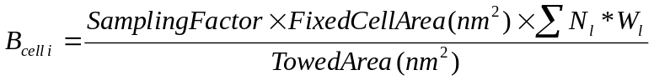

(Fixed cell area = 400nm².)

Mean biomass per cell in year t,

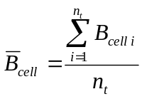

Total biomass in year t,

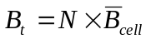

Where, N is a fixed number of cells for Bristol Bay, set to 135 cells.

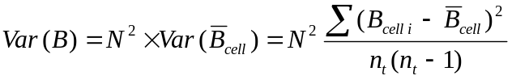

For stratified samples (two and above repeated tows in a cell), following simple formulas are used:

Total biomass in year t,

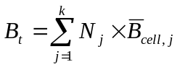

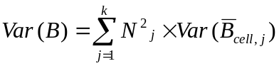

Where k is the number of strata, and
