Yukon River Fall Chum Salmon Inseason Mixed Stock Analysis

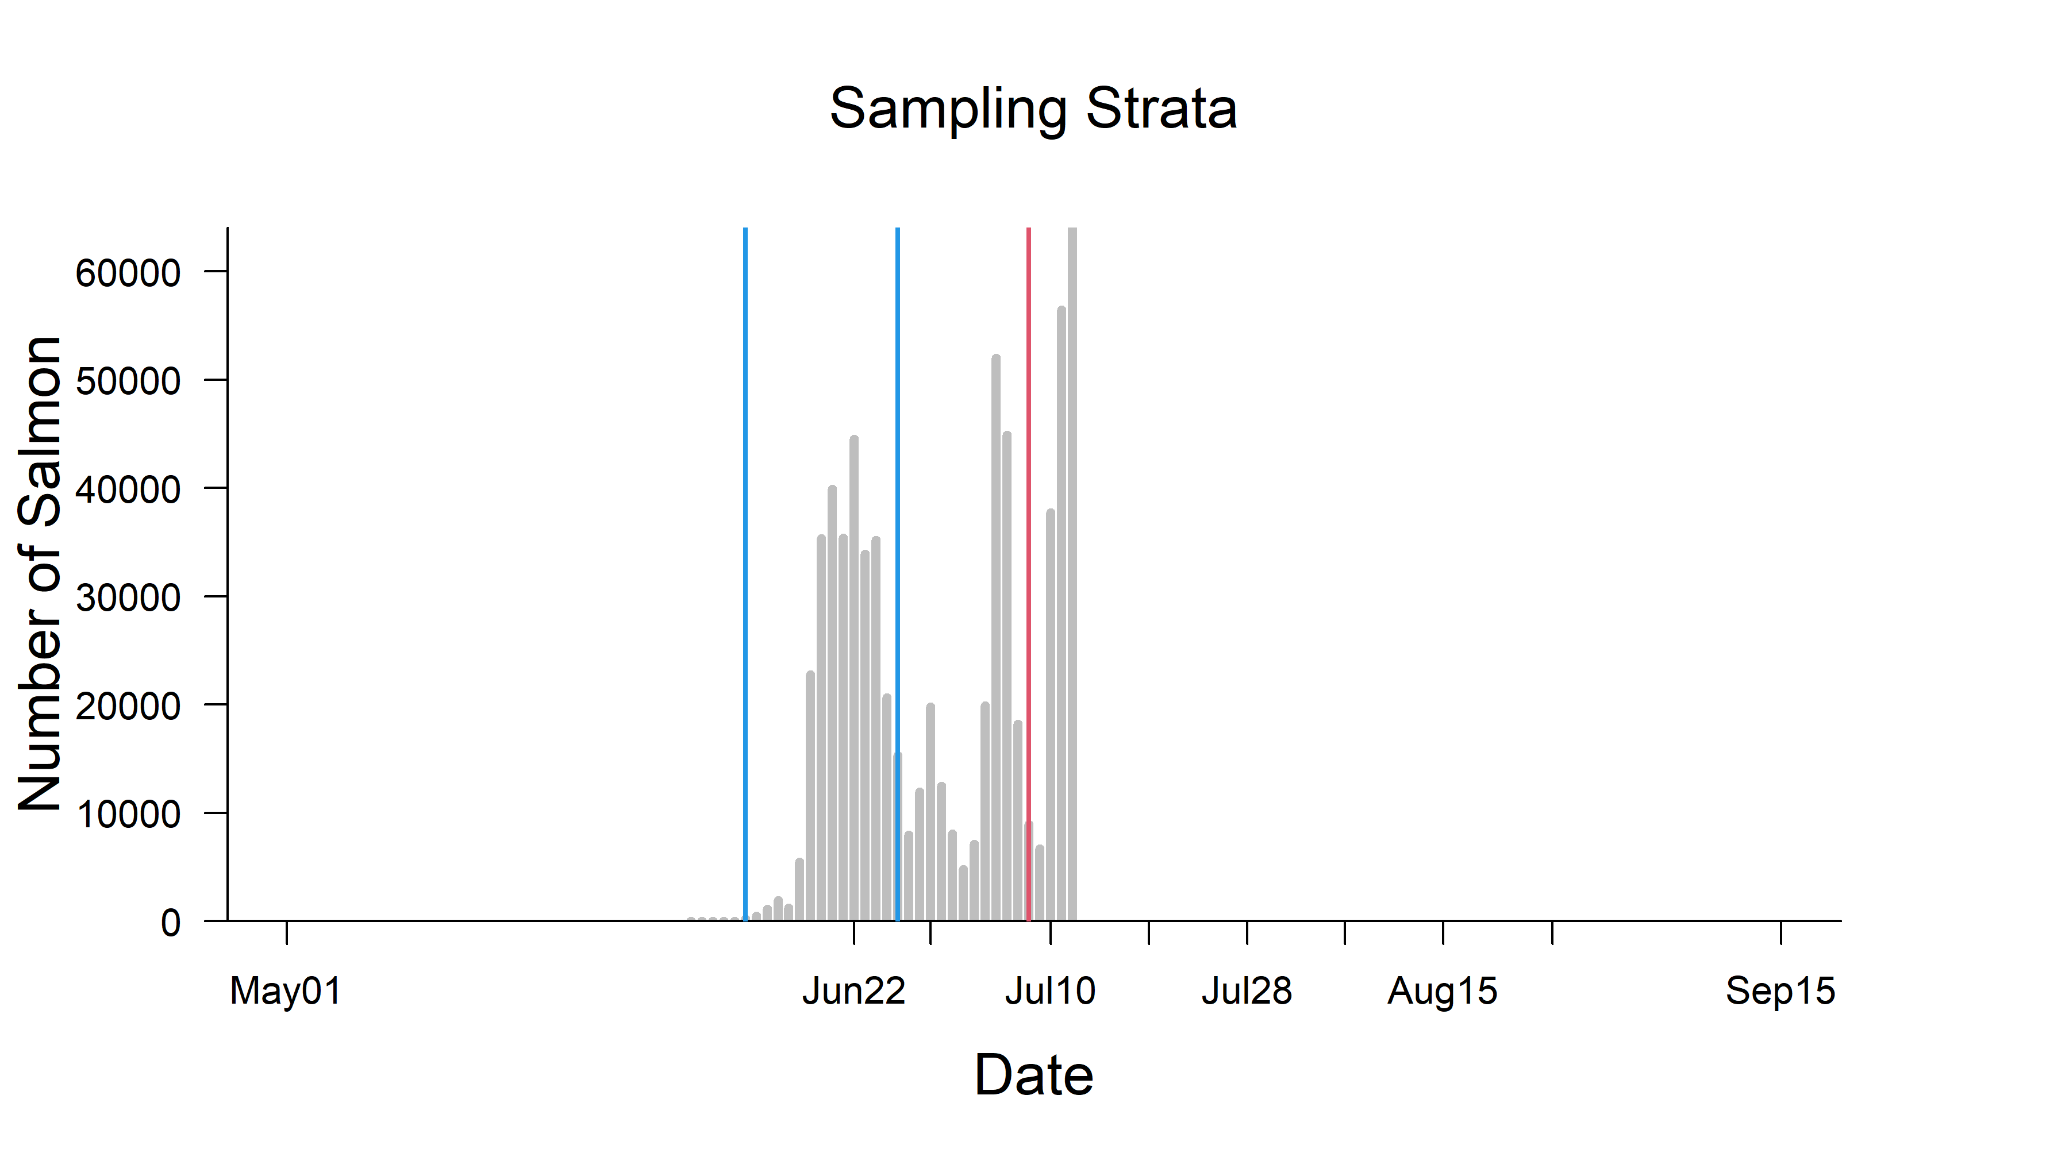 Figure 1. Daily sonar counts attributed to chum salmon (bars) showing genetic sampling time frames (droplines), project operated near Pilot Station, Yukon Area, 2023.

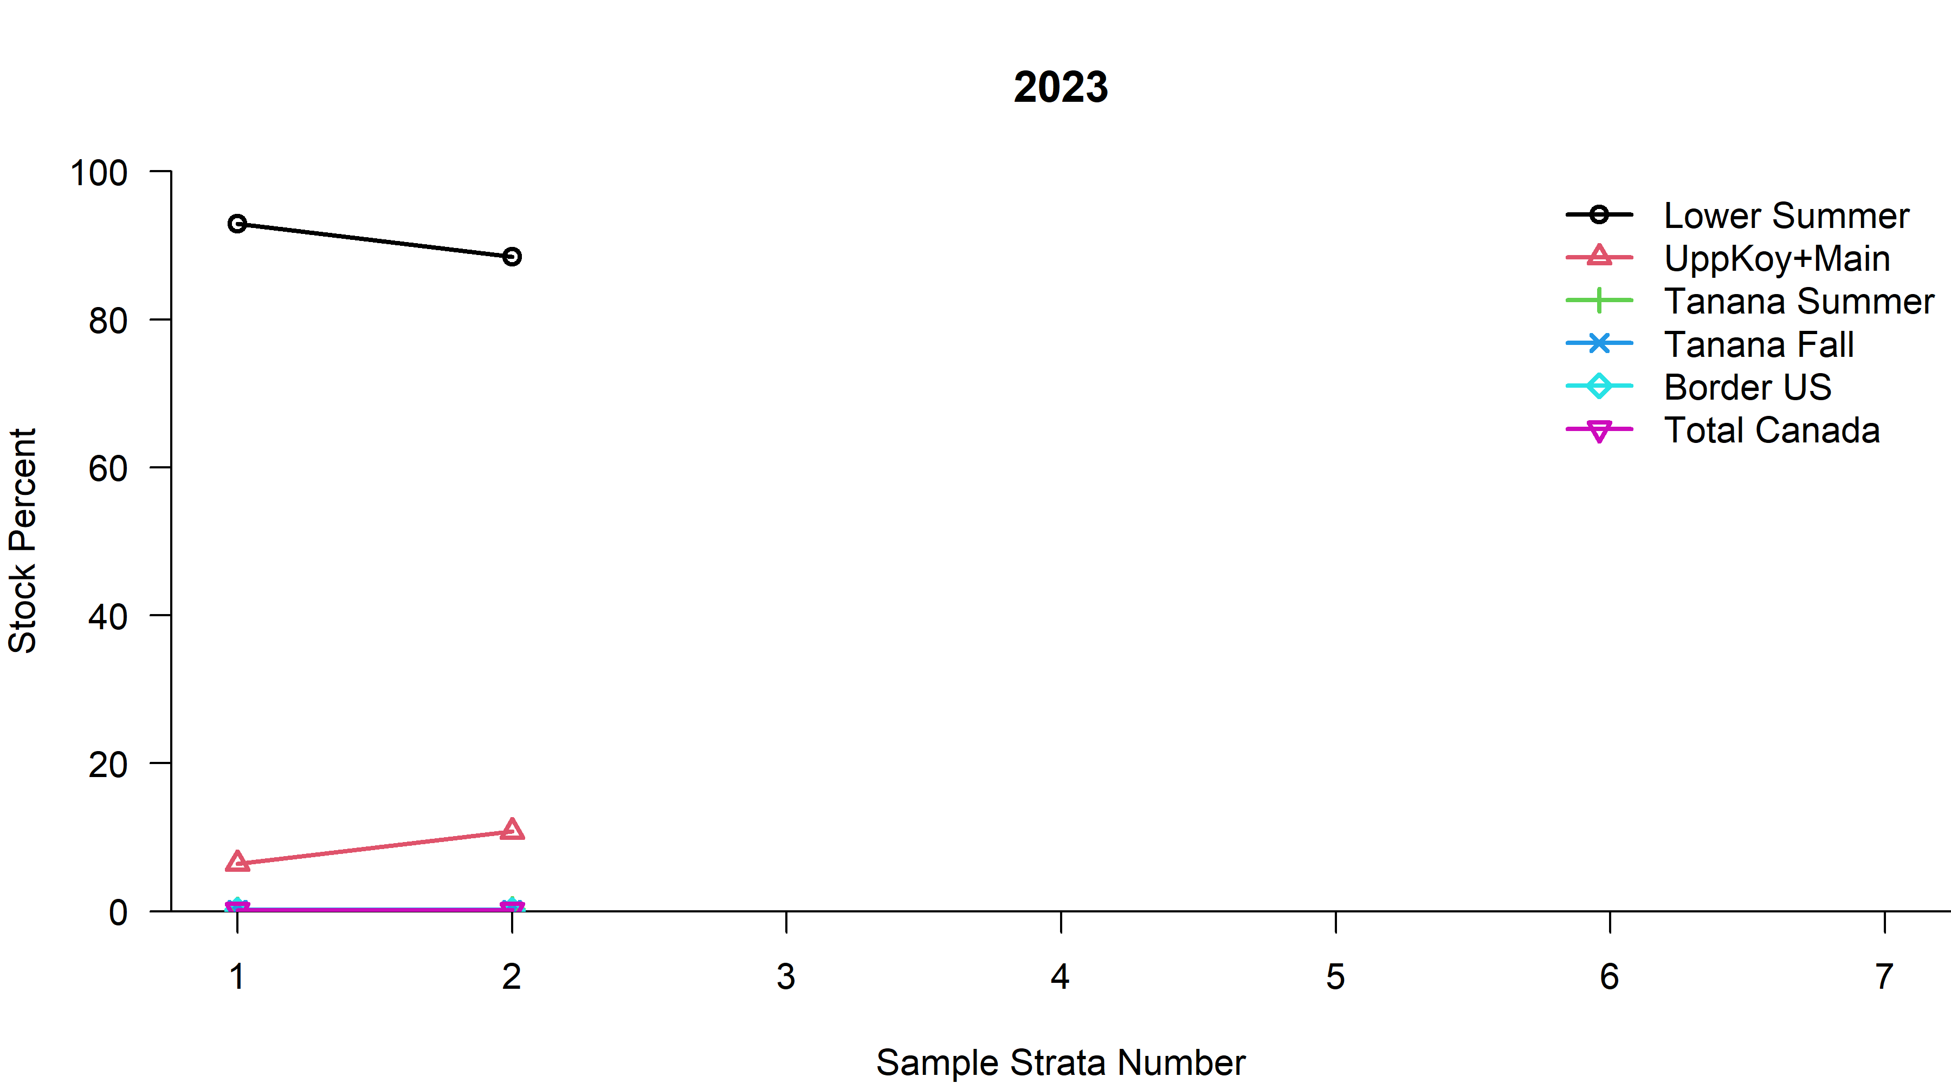 Figure 2. Mean proportion of chum salmon stock groups by sampling strata, Yukon Area, 2023.

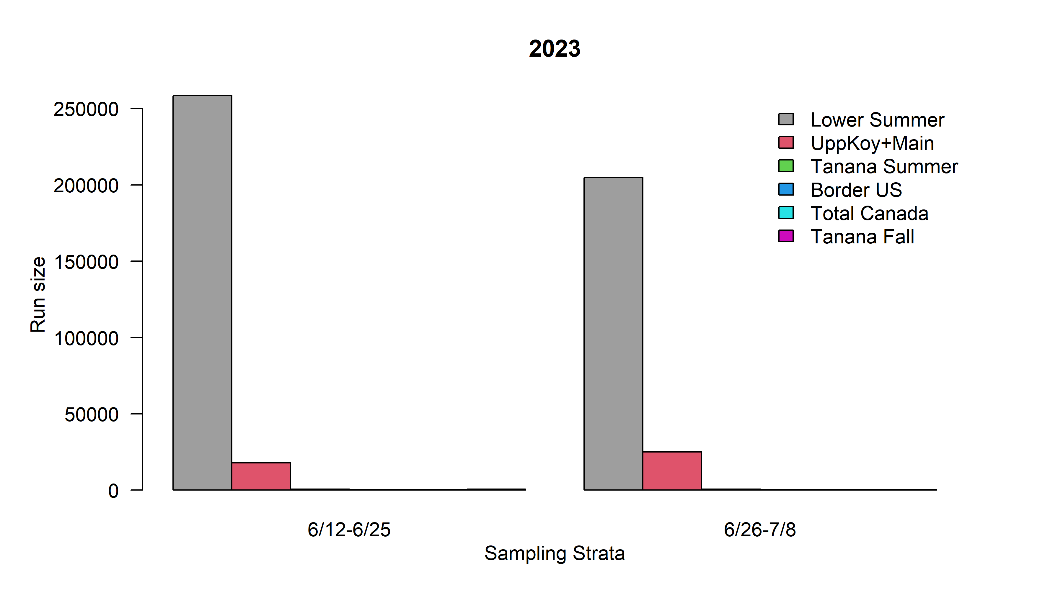 Figure 2.5 Mean proportion of chum salmon stock groups by sampling strata, Yukon Area, 2023.

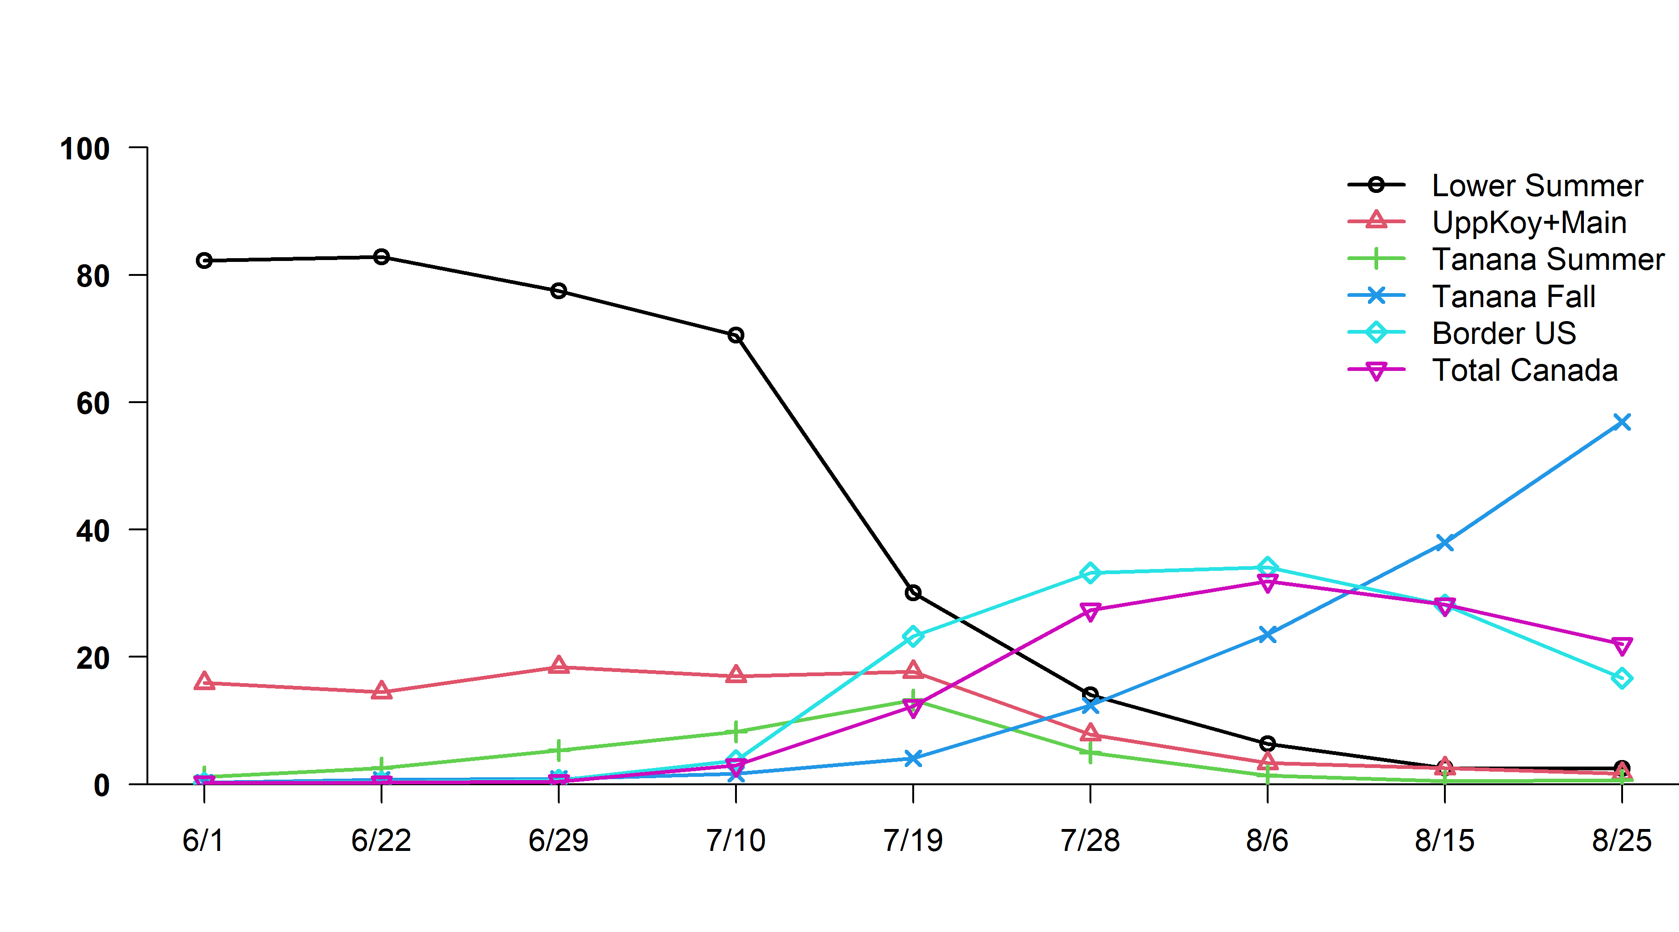 Figure 3. Mean proportion of chum salmon stock groups by standard sampling strata, Yukon Area, 2004-2022. 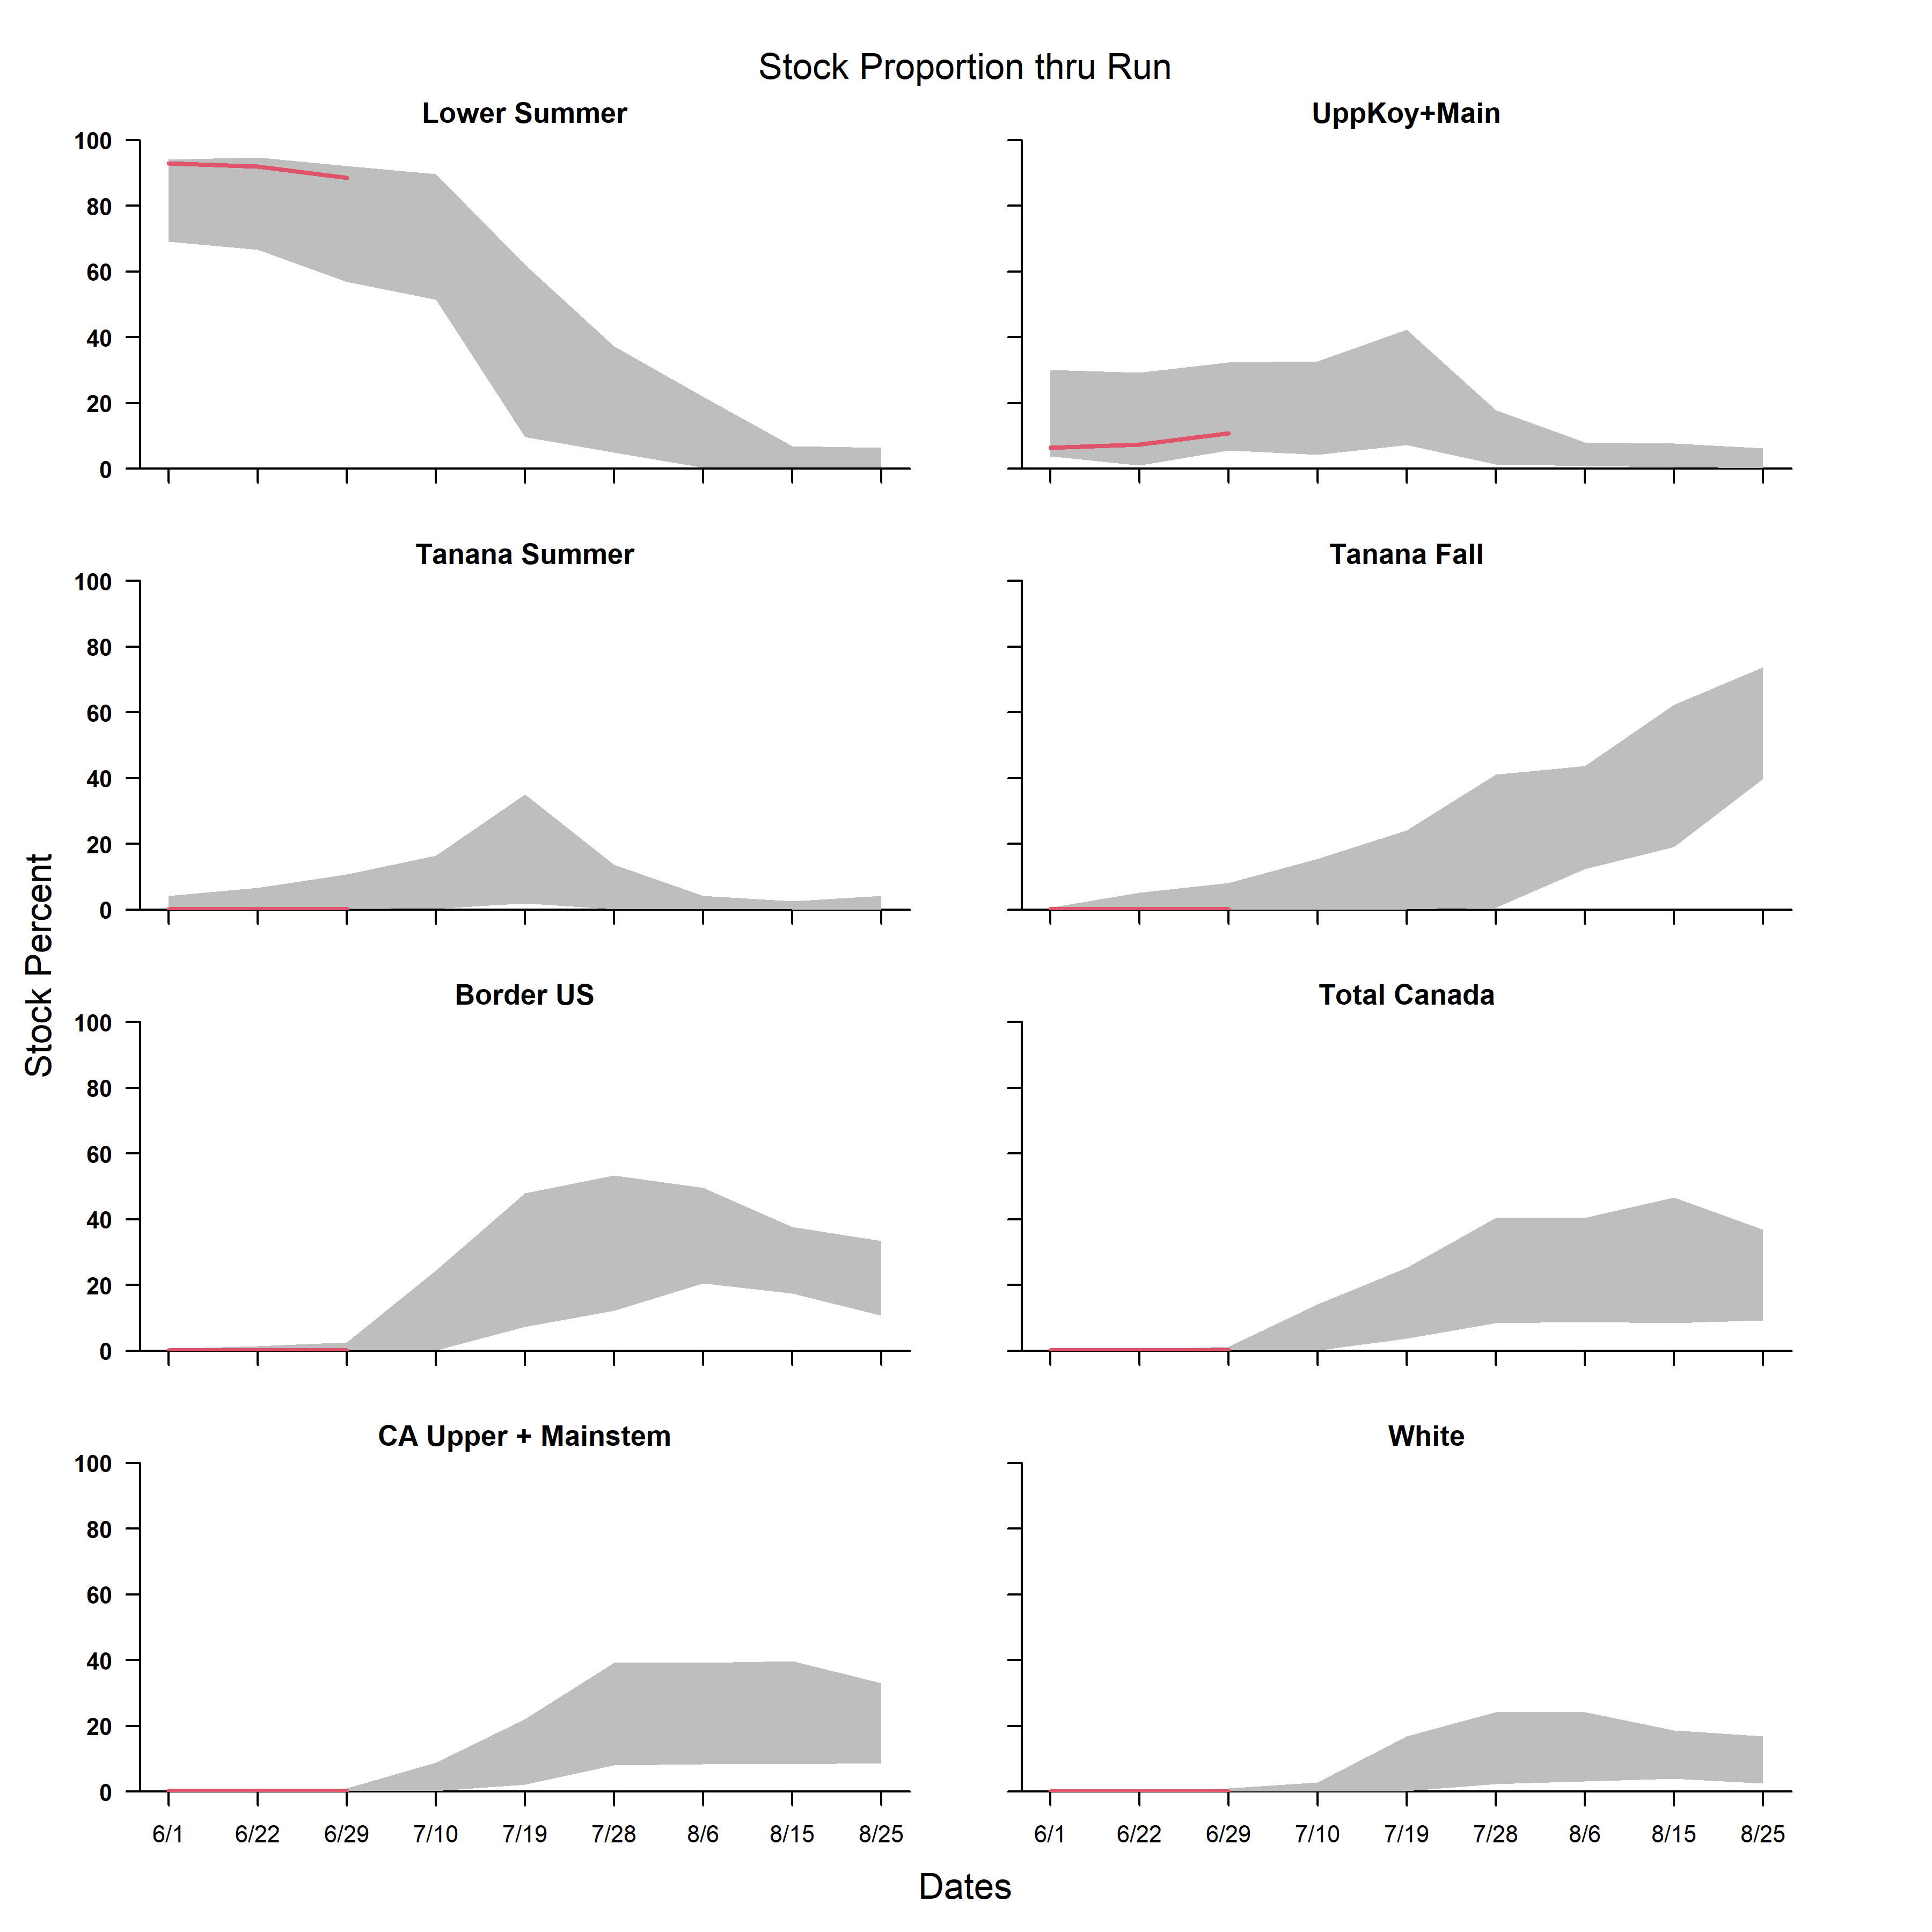 Figure 4. Minimum and maximum (2004-2022) and 2023 mean stock proportion by standard sampling strata, comparing the major chum salmon components, Yukon Area. 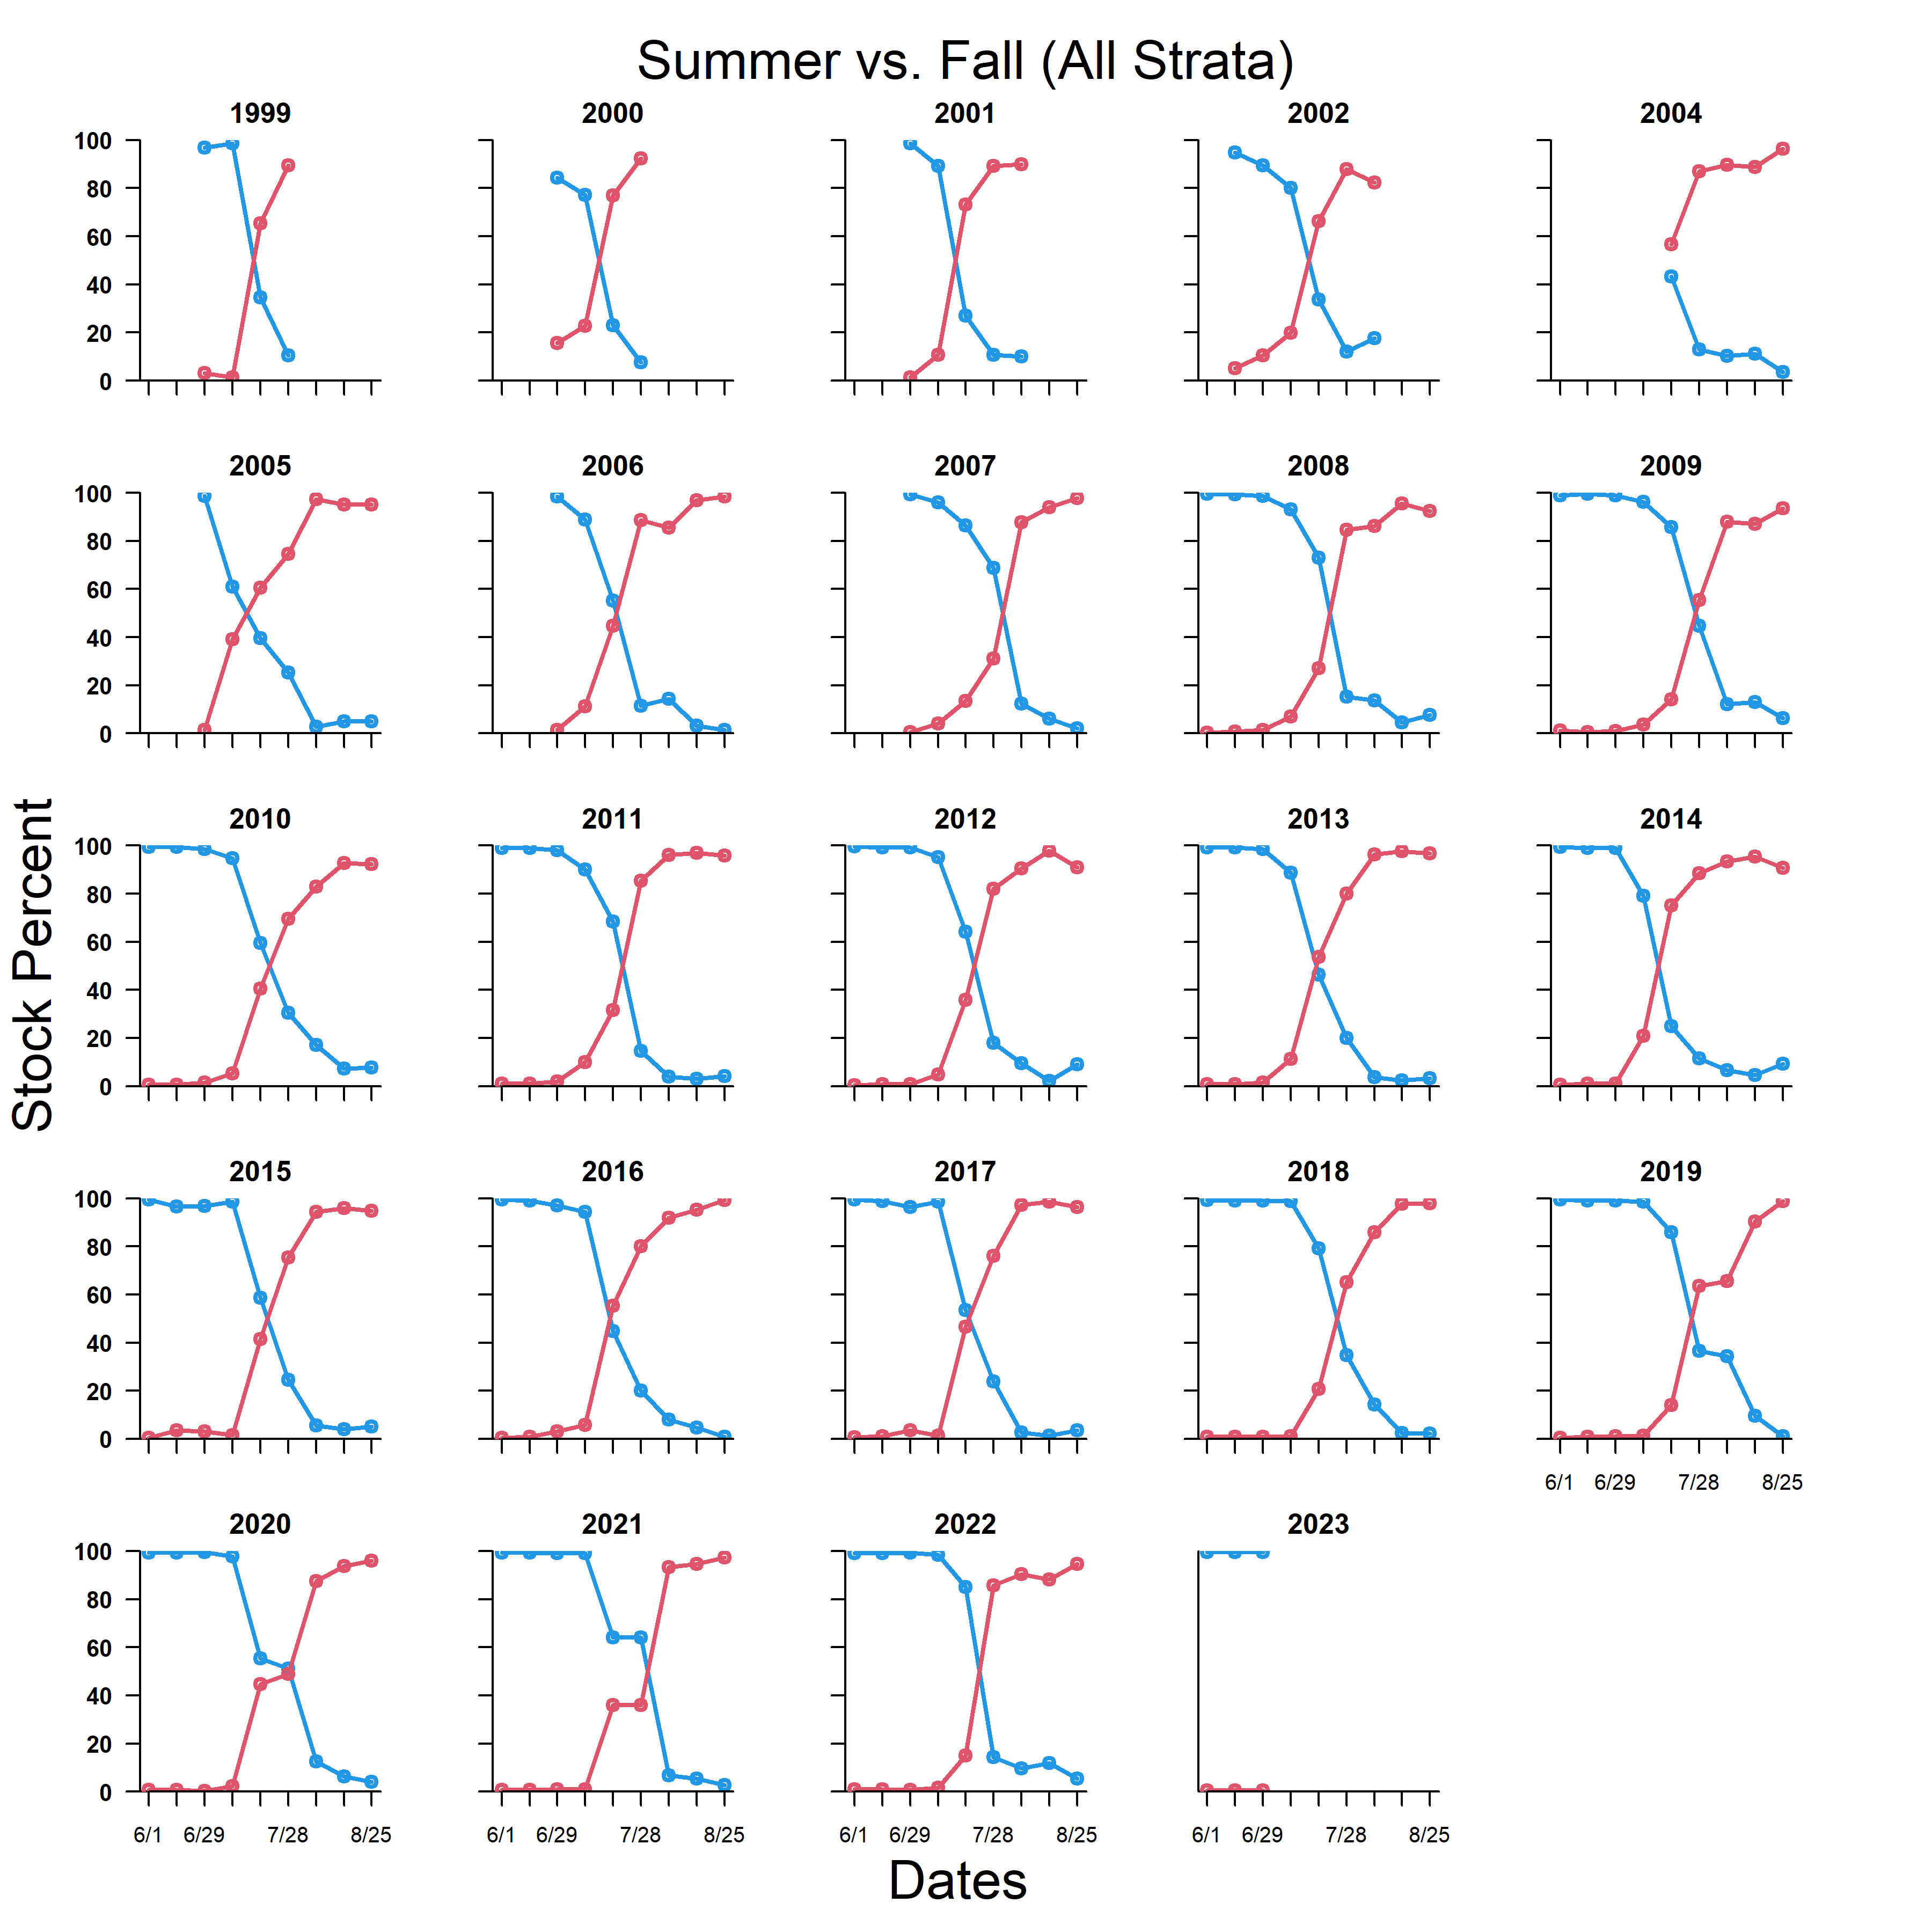 Figure 5. Crossover of summer and fall chum salmon based on genetic stock analysis (standard sampling strata), Yukon Area, 1999-2002 using allozymes and 2004-2023 using microsatellites. 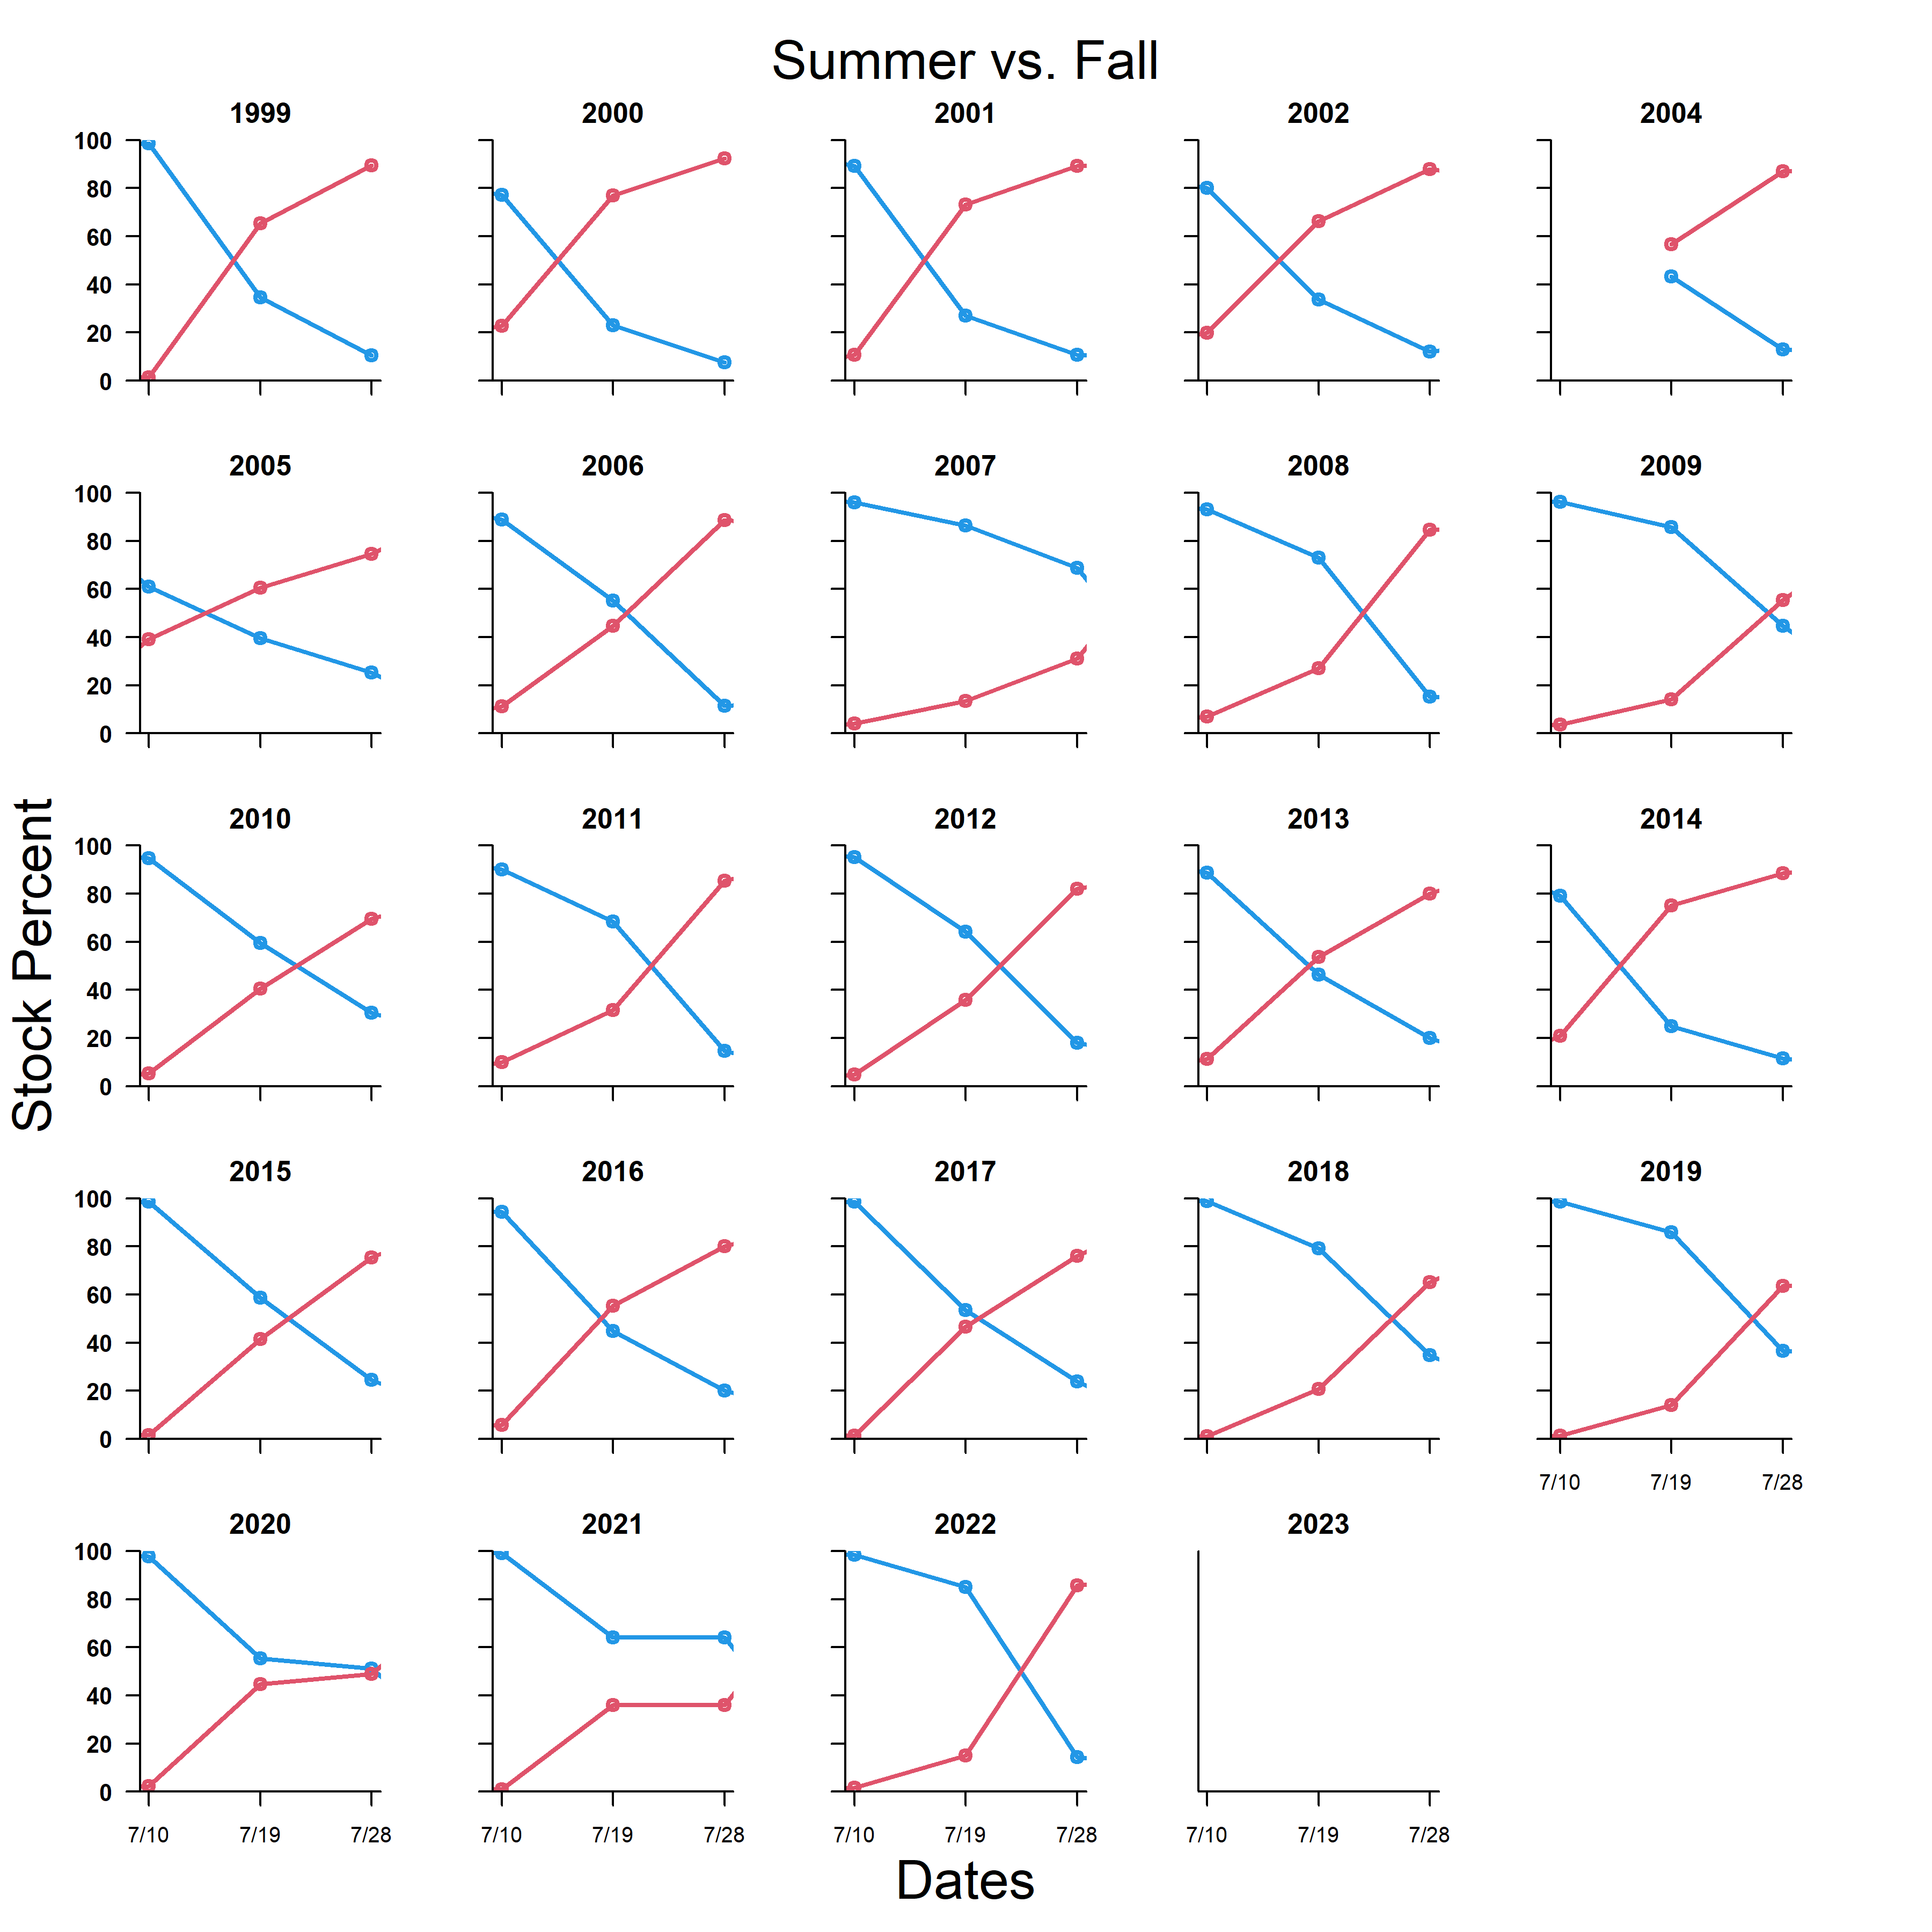 Figure 6. Crossover of summer and fall chum salmon (3 periods) based on genetic stock analysis (standard sampling strata), Yukon Area, 1999-2002 using allozymes and 2004-2023 using microsatellites.

Figure 7. Contributions of chum salmon based on genetic analysis during the fall season (July 19 to end of season), sampled at the mainstem sonar operated near Pilot Station, Yukon Area, 2023.

Figure 8. Contributions of Fall chum salmon based on genetic analysis during the fall season (July 19 to end of season), sampled at the mainstem sonar operated near Pilot Station, Yukon Area, 2023.