**Name :حمدي محمد عب الشافي احمد عبد الغني**

**B.N: 306**

**Date : 8/6**

**Topic:** **Big data**

**Github link :**

**Github page :**

**Application brief :**

“Big data” is a field that treats ways to analyze, systematically extract information from, or otherwise deal with data sets that are too large or complex to be dealt with by traditional data-processing application software. Data with many cases (rows) offer greater statistical power, while data with higher complexity (more attributes or columns) may lead to a higher false discovery rate. Big data challenges include capturing data, data storage, data analysis, search, sharing, transfer, visualization, querying, updating, information privacy and data source. Big data was originally associated with three key concepts: volume, variety, and velocity. When we handle big data, we may not sample but simply observe and track what happens. Therefore, big data often includes data with sizes that exceed the capacity of traditional usual software to process within an acceptable time and value.

Big data is a term applied to data sets whose size or type is beyond the ability of traditional relational databases to capture, manage and process the data with low latency. Big data has one or more of the following characteristics: high volume, high velocity or high variety. Artificial intelligence (AI), mobile, social and the Internet of Things (IoT) are driving data complexity through new forms and sources of data. For example, big data comes from sensors, devices, video/audio, networks, log files, transactional applications, web, and social media — much of it generated in real time and at a very large scale.

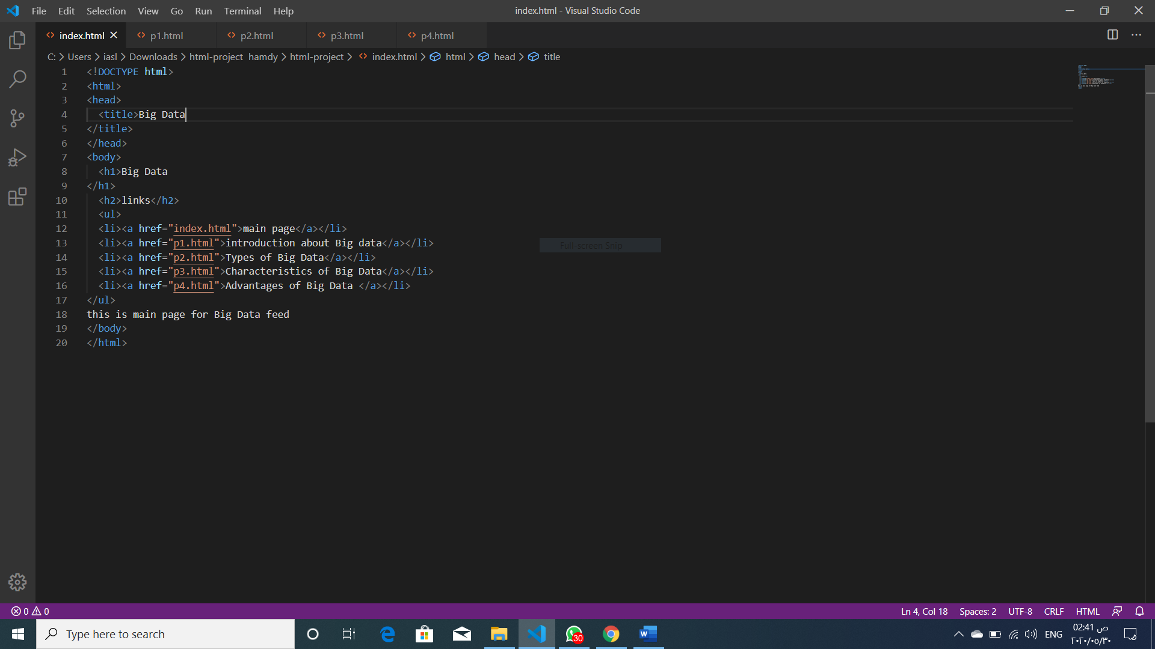**Screeshots :**

