**Project: Employee (Assignment)**

**Main domain: Make a Crud for Employee Basic Information**

**Employee creation use case**

When front end Application is running Following page will be shown as shown in figure below

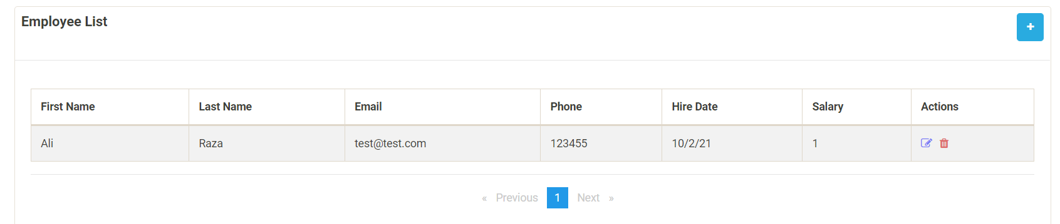

When user click on blue button a new view will be open as below.

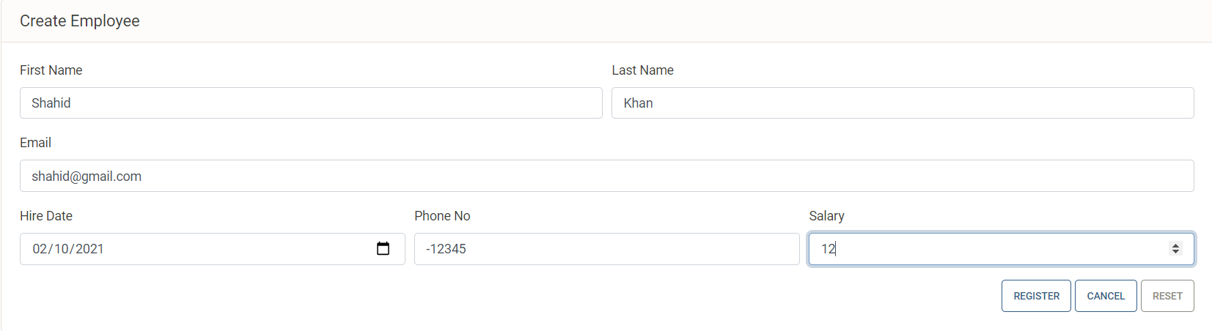

When user enters details on fields after validation data will be saved in database as shown in figure below.

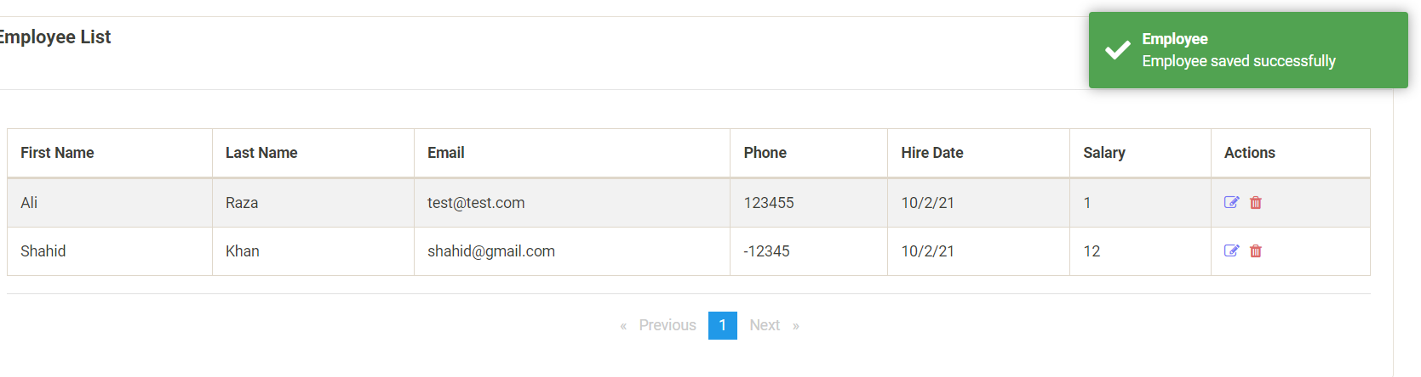

If user does not provide correct data then following screen will be shown.

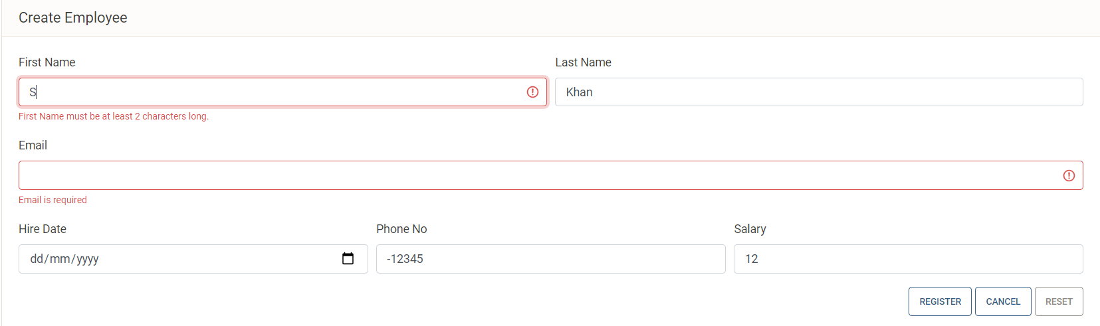

**Employee Read use case**

When user click on employee following screen will be shown that’s is listing page.

