ONLINE BETTING PLATFORM

CME3201 Database Management Systems Project Report

*Authors:*

*Efe Özdemir, 2019510092*

*Sedat Karadağ, 2019510164*

*Shakhobiddin Urinov, 2020510110*

**ABSTRACT**

We prepared a strategic plan to enhance our bet website, a comprehensive online betting platform. Our aim is optimizing the front-end and back-end systems, ensuring a seamless and engaging user experience across various devices. Additionally, we propose a thorough review and potential restructuring of our database architecture for improved efficiency and security. By focusing on scalability, user interface enhancements, and robust security measures, our goal is to elevate the overall quality of the platform, positioning it as a leader in the online betting industry, and providing users with an unparalleled and secure betting experience.

**An Introduction to Online Betting Platforms**

Bet websites, also known as online betting platforms or sportsbooks, are digital platforms that allow users to place bets on various sports events, games, or other activities, often in exchange for the opportunity to win monetary prizes. These platforms facilitate a wide range of betting options, including traditional sports like football, basketball, and horse racing, as well as emerging trends such as esports and virtual sports. Users typically create accounts on these websites, deposit funds, and place bets on different outcomes. Bet websites provide real-time updates, odds, and statistics, offering an interactive and convenient way for individuals to engage in sports wagering from the comfort of their homes or on-the-go. Security and regulatory compliance are crucial aspects of reputable bet websites to ensure the fairness and safety of the betting experience.

**Why Use An Online Betting Platform?**

Choosing to play on online betting platforms provides a host of conveniences and advantages for enthusiasts. The ability to bet from the comfort of one's home or while on the move is a significant draw, eliminating the need for physical visits to traditional bookmakers. The diverse range of betting options, spanning traditional sports, esports, and virtual sports, caters to a wide spectrum of interests. Real-time updates, bonuses, and innovative features such as live streaming enhance the overall betting experience. Security measures ensure the privacy of transactions, and the accessibility of these platforms via mobile devices adds a layer of convenience. With transparent practices, a global market of events, and a sense of community through social features, online betting platforms offer a comprehensive and engaging experience for players.Formun Üstü

**What Do We Offer?**

Our bet website stands out as a premier choice for online betting enthusiasts for several compelling reasons:

* **User-Friendly Interface:** We prioritize a seamless and intuitive user experience, ensuring that navigating through our platform is easy and enjoyable for both seasoned bettors and newcomers.
* **Diverse Betting Options:** Our platform offers an extensive range of betting options across various sports and events, catering to a wide array of interests and preferences.
* **Real-Time Updates:** Stay in the loop with live scores, statistics, and real-time updates, enhancing the excitement and engagement of your betting experience.
* **Security and Trust:** We take the security of your transactions and personal information seriously, implementing robust measures to safeguard your data and instill trust in every aspect of your betting journey.
* **Exclusive Promotions:** Enjoy access to exclusive promotions, bonuses, and loyalty programs that add significant value to your betting activities, providing you with extra incentives and rewards.
* **Community Engagement:** Connect with like-minded individuals through social features, forums, and chat functionality, creating a vibrant community where you can share insights, strategies, and experiences.
* **Innovative Features:** We continually strive to incorporate cutting-edge technology and features to enhance your betting experience, ensuring that you have access to the latest trends and advancements in the world of online betting.
* **Convenience and Accessibility:** Bet on your favorite sports from the comfort of your home or on-the-go with our mobile-friendly platform, offering unmatched convenience and accessibility.
* **Transparent and Fair Practices:** Our commitment to fairness and transparency ensures that you can place your bets with confidence, knowing that you are participating in a secure and trustworthy betting environment.
* **Responsive Customer Support:** Experience dedicated customer support to address any queries or concerns promptly, ensuring that your betting journey is smooth and hassle-free.

**Stakeholders and Their Roles**

In the context of a bet website, various stakeholders play essential roles in ensuring its success and functionality. Here are key stakeholders and their roles:

1. **Users/Bettors:**
   * *Role:* The primary consumers of the bet website, users engage in betting activities, explore features, and contribute to the platform's success through their participation.
2. **Developers and IT Team:**
   * *Role:* Responsible for building and maintaining the website's front-end and back-end systems, developers ensure the platform's functionality, security, and seamless user experience.
3. **Database Administrators:**
   * *Role:* Database administrators manage and optimize the database system, ensuring data integrity, security, and efficient retrieval for the smooth operation of the bet website.
4. **Security Team:**
   * *Role:* Focused on implementing and monitoring security measures, the security team works to protect user data, financial transactions, and the overall integrity of the platform against cyber threats.
5. **Marketing Team:**
   * *Role:* The marketing team is tasked with promoting the bet website, acquiring new users, and retaining existing ones through strategic campaigns, promotions, and community engagement initiatives.
6. **Customer Support:**
   * *Role:* Customer support representatives address user queries, provide assistance, and ensure a positive user experience by promptly resolving issues and offering support.
7. **Regulatory Compliance Team:**
   * *Role:* Responsible for ensuring that the bet website complies with legal and regulatory requirements in the jurisdictions where it operates, mitigating legal risks and maintaining ethical practices.
8. **Management/Leadership Team:**
   * *Role:* The management team provides strategic direction, oversees overall operations, and makes key decisions related to the bet website's growth, financial management, and long-term sustainability.
9. **Financial Team:**
   * *Role:* Managing financial transactions, accounting, and budgeting, the financial team ensures the fiscal health of the bet website and compliance with financial regulations.
10. **Third-Party Service Providers:**
    * *Role:* External service providers, such as payment processors or third-party integrations, contribute to the functionality and features of the bet website, and their reliability is crucial for a smooth user experience.
11. **Government and Regulatory Authorities:**
    * *Role:* These entities oversee and regulate the operation of the bet website, ensuring that it adheres to legal and ethical standards, protecting users and maintaining the integrity of the industry.

Each stakeholder plays a vital role in contributing to the overall success, security, and sustainability of the bet website, emphasizing the importance of collaboration and effective communication among these diverse roles.

**Requirements and Constraints**

**Requirements**

1. **User Authentication and Account Management:**
   * Users should be able to create accounts securely, with password protection and account recovery options.
   * Two-factor authentication for enhanced security.
   * User profiles to manage personal information and betting history.
2. **Betting Interface:**
   * Intuitive and user-friendly interface for placing bets on various sports and events.
   * Real-time odds updates and relevant statistics to aid in decision-making.
   * Support for a diverse range of betting types (e.g., single bets, accumulators).
3. **Payment Integration:**
   * Secure and reliable payment gateways for depositing funds and withdrawing winnings.
   * Multiple payment options, including credit/debit cards, e-wallets, and bank transfers.
4. **Security Measures:**
   * Encryption protocols to secure user data and financial transactions.
   * Monitoring and detection systems for potential fraudulent activities.
   * Regular security audits and updates to address emerging threats.
5. **Database Management:**
   * Efficient and scalable database architecture to handle user data and transaction records.
   * Backup and recovery procedures to ensure data integrity and availability.
6. **Real-Time Updates:**
   * Live scores, event updates, and relevant news to enhance the user experience.
   * Notifications for ongoing and upcoming events based on user preferences.
7. **Community Features:**
   * Social features such as forums, chat functionality, and user-generated content to foster a sense of community.
   * Integration with social media platforms for sharing betting activities.
8. **Mobile Responsiveness:**
   * Responsive design to ensure a seamless experience across various devices, including smartphones and tablets.
9. **Regulatory Compliance:**
   * Adherence to legal and regulatory requirements in all jurisdictions where the platform operates.
   * Age verification mechanisms to ensure compliance with legal age restrictions.

**Constraints**

1. **Regulatory Constraints:**
   * Compliance with varying legal frameworks and regulations in different geographical regions may limit certain features or betting options.
2. **Technology Limitations:**
   * The availability and compatibility of certain features may be constrained by the technology stack chosen for development.
3. **Financial Constraints:**
   * Budgetary limitations may impact the implementation of certain advanced features or marketing initiatives.
4. **Third-Party Dependencies:**
   * Dependencies on third-party services, such as payment processors or data providers, may introduce risks related to service outages or changes in terms.
5. **Data Privacy and Security:**
   * Strict data privacy regulations may limit the extent to which user data can be utilized or shared.
6. **Scalability Challenges:**
   * Ensuring scalability to handle a growing user base may pose challenges in terms of infrastructure and resource requirements.
7. **User Adoption:**
   * Encouraging user adoption and engagement may be constrained by external factors such as market competition or shifts in user preferences.
8. **Cultural and Social Sensitivities:**
   * Sensitivity to cultural norms and preferences is crucial, particularly when implementing social features or marketing strategies.

Navigating these requirements and constraints with careful consideration and planning is essential to the successful development and operation of the bet website.

**ER Diagram**

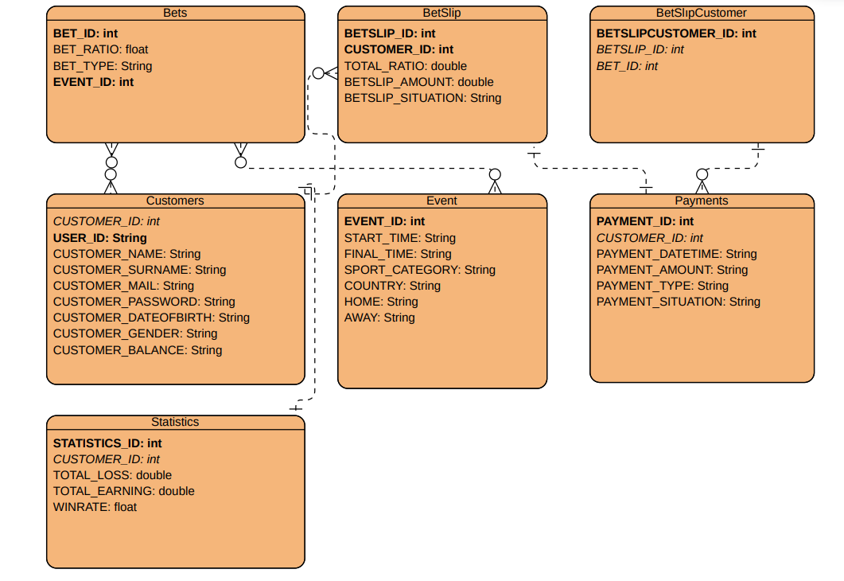

**Use Case Diagram**

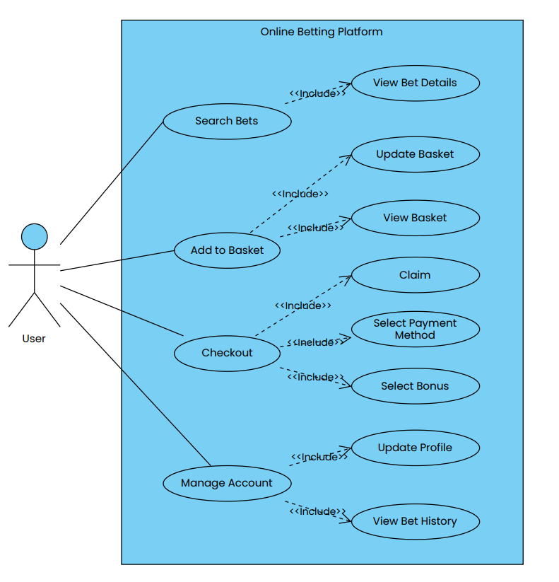

**Sequence Diagram**

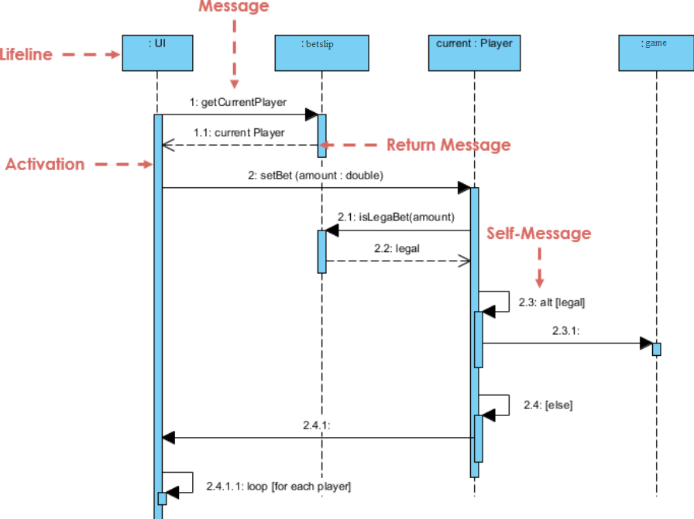

**Activity Diagram**