**HW4 Simulation: Safety Device**

**21900793 한태건**

The machine shown in Figure1 is an overload protection device that release the load when the shear pin S fails. Determine the maximum von Mises stress in the upper part ABE if the pin shears when its shear stress is 40 MPa. Assume the upper part to have a uniform thickness of 6 mm. Assume plane stress conditions for the upper part. The part is made of 6061 aluminum alloy. Is the thickness sufficient to prevent failure based on the maximum distortion energy theory? If not, suggest a better thickness. (Scale all dimensions as needed.)

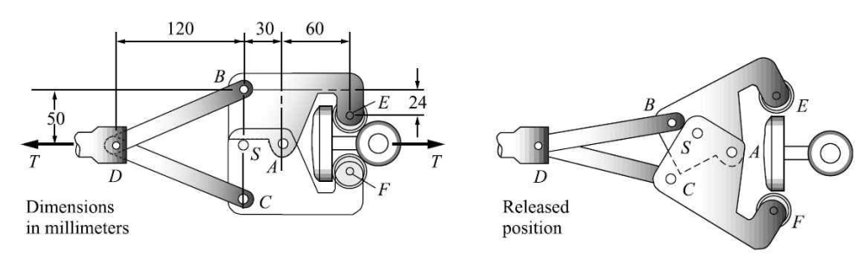

Figure . Overload protection device

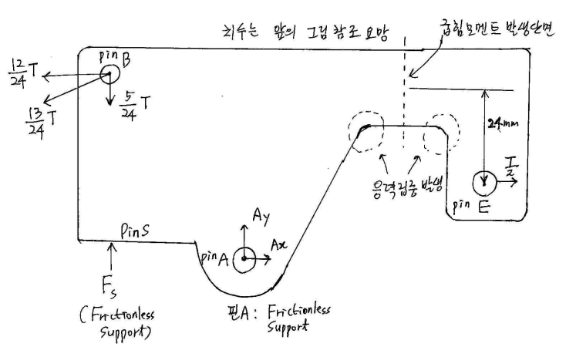

Figure . upper part of the machine

**Validation of the Results**

1. Investigate the support reaction force to see if it is equivalent to the theoretical reaction force (static analysis).

Referring to Figure 2, can be obtained using

, by force balance. Therefore, may be obtained as follows.

|  |  |  |
| --- | --- | --- |
|  | **Simulation** | **Theoretical** |
| **Reaction force of Pin S** |  | -1130.97 N |
| **Reaction force of Pin A** |  | 743.62 N |

It can be seen that the simulation value and the theoretical calculated value are not completely the same, but the direction of the reaction force is the same, and the magnitude of the reaction force is almost similar. The mesh size at this time is 1 mm.

1. The Mesh convergence test examines the convergence of the solution and selects the appropriate element size.

|  |
| --- |
| Mesh Sizing(mm) 🡪 Maximum Stress(MPa) |
| 30mm 🡪 63.143 |
| 10mm 🡪 74.984 |
| 5mm 🡪 92.347 |
| 3mm 🡪 102.62 |
| 2mm 🡪 108.52 |
| 1.5mm 🡪 105.97 |
| 1mm 🡪 106.12 |

The simulation was performed by changing the mesh size. As a result, the maximum stress was 63.143 MPa at 30 mm, 74.984 MPa at 10 mm, 92.347 MPa at 5 mm, 102.62 MPa at 3 mm, 108.52 MPa at 2 mm, 105.97 MPa at 1.5 mm, and 106.12 MPa at 1 mm. Therefore, it was confirmed that the stress value converged between almost 106 and 108 MPa as the mesh became smaller. Therefore, mesh size 1mm was selected as an appropriate element size.

1. Theoretically solve the area where the breakage is expected and compare it with the solution of the simulation.

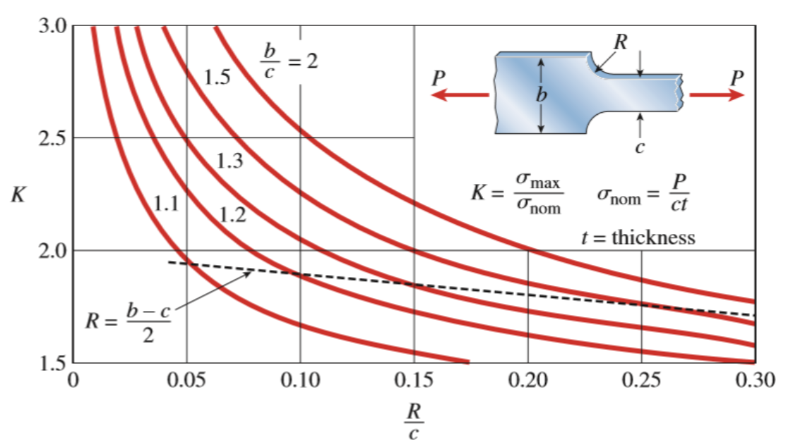

Figure . Stress Concentration Coefficient

Due to the bending stress, the stress of the rounded part around the corner is large, and damage to that part is predicted. The stress values due to bending stress are as follows.

The stress concentration coefficient can be obtained through the following equation and Figure 3.

🡪

Therefore, the stress values of the corners are as follows.

|  |  |  |
| --- | --- | --- |
|  | Theory | Simulation |
|  | 105.83 MPa | 101.49 MPa |

It can be seen that the theoretical value and the simulation value are similar, and the simulation value also shows that the stress value of the rounded corner part is the largest.

1. What is the thickness of the device to secure the yield safety factor of 3?

The conditions given in aluminum 6061-T6 and problems are as follows and the thickness of the device can be obtained using them.

Therefore, the thickness of the device should be at least 6.81 mm.