**HW5 Simulation**

**: Full Model Simulation of The Coal Compression Equipment**

**21900793 한태건**

**5-3. Full Model Simulation**

**- Simulate the full model**

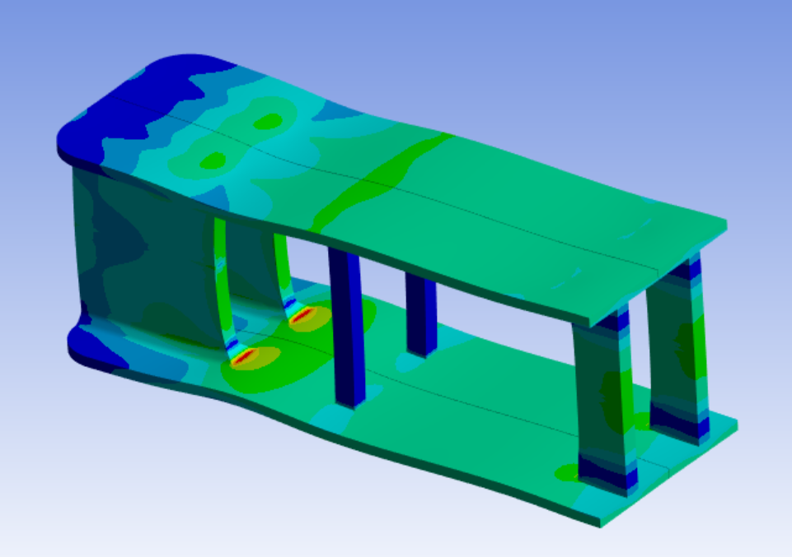

Figure 1. Full Model Simulation

The full model was completed using Symmetry in ANSYS.

**- Check for mesh convergence of your model.(You may need to use standard version of ANSYS installed in PC due to the increased number of meshes)**

Mesh convergence was conducted using a standard version of ANSYS installed on the PC. I changed the mesh size from 3mm to 40mm. The results are represented using MATLAB as shown in Figure 1. It can be seen that the stress values ranged from 73 MPa to about 76 MPa. Therefore, mesh sizing was selected as 5 mm, which is approximately similar to the median value between.

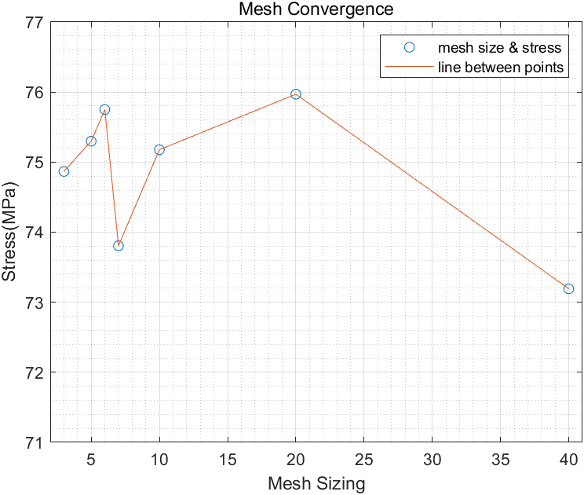 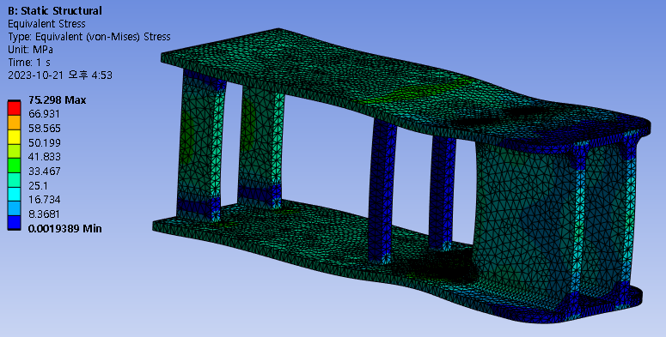

Figure 2. Mesh Convergence

**- Compare the results with those of the quarter mode**

|  |  |  |
| --- | --- | --- |
|  | **Stress(MPa)** | **Total Deformation(mm)** |
| Quarter mode | 76.122 MPa | 0.087669 mm |
| Full mode | 75.298 MPa | 0.087244 mm |

In the same mesh sizing and boundary condition, it can be seen that the quarter mode has higher stress and total deformation than the full mode. Overall, however, the difference between the two modes is not significant. It seems that symmetrical of the quarter mode has made a small difference in the contact surface area. When looking at the two modes, the part where the stress is concentrated was the same.