**LAB1 : Elastic Modulus Estimation**

Name : HanTaegeon

Number : 21900793

**1. PreLAB**

**(1) Strain Gauge**

① Research and describe the gauge factor of the strain gauge.

A strain gauge is a type of sensor that detects minor mechanical changes as changes in electrical resistance. The gauge factor represents how much electrical resistance changes in response to mechanical deformation and responses. In other words, it can be said to indicate the sensitivity of the strain gauge. Equations are as follows.

As can be seen from the equation, the sensitivity of the strain gauge is affected by changes in length and resistivity. Generally, the value of GF is around 2. The gauge factor is an important factor in measuring how effectively mechanical deformation is transformed into an electrical signal.

② Analyze the voltage output equation of the bridge circuit that measures the voltage with the resistance change according to the length change of the strain gauge.

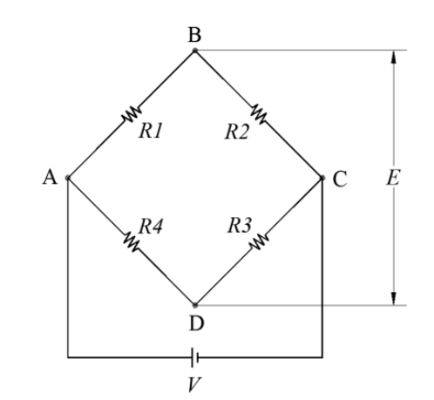

* Fig 1. Bridge Circuit

A voltage applied between nodes A and B and a voltage applied between nodes A and D may be expressed as follows by the voltage division law.

The bridge output voltage E between the nodes B and D is calculated as follows.

The following equations can be obtained through the above equations.

Here, is an output voltage, E is a power supply voltage value of the Bridge circuit, and G is a circuit amplification ratio. ∆R represents the change in resistance of the strain gauge. The length change affects the voltage output because the resistance changes by changing the length of the strain gauge. R represents the initial resistance of the strain gauge. That is, it is a resistance value before the length of the strain gauge changes.

③ Calculate how many volts (V) the output voltage eout will be if a calibration resistor of 100K ohms is connected in parallel to a gauged arm in a bridge circuit (voltage = 5V, arm resistance = 120 ohms) and an amplifying circuit (1500x).

It can be obtained by the following equation.

Using the above equation, it can be calculated as follows.

E = 5V, G = 1500, ,

**(2) Stress and sagging (Fig. 6)**

① Find the weight (Kg) that can be suspended in the center of a stainless steel beam (SUS304) that is 400 mm long from the yield point of view (safety factor 2.5) of the material. The width of the beam is 20 mm and the thickness is 3 mm.

The yield strength of SUS304 is 205 MPa. The area of the cross section is A = 20×3 = 60 . Using these conditions, the weight can be obtained as follows.

② The measurement range of the dial gauge (Fig. 1) capable of measuring the sagging of the center part in the simple support above is 7 mm. Find the weight (kg) that can be suspended in the center.

Aluminum material was used in Fig.1. Therefore, the elastic modulus is 70GPa. The equation for deflection is as follows. The weight can be obtained using the following equation.

**2. Experimental Results**

Record the experimental data in Table 1 and estimate the modulus of elasticity from the slope of the straight line by fitting the approximate straight line passing through the origin in the two methods presented in Section 2-3 respectively.

We can calculate using the following equations.

Bending Moment:

Strain:

Change in Resistance:

Deflection:

The default values for obtaining the values are as follows.

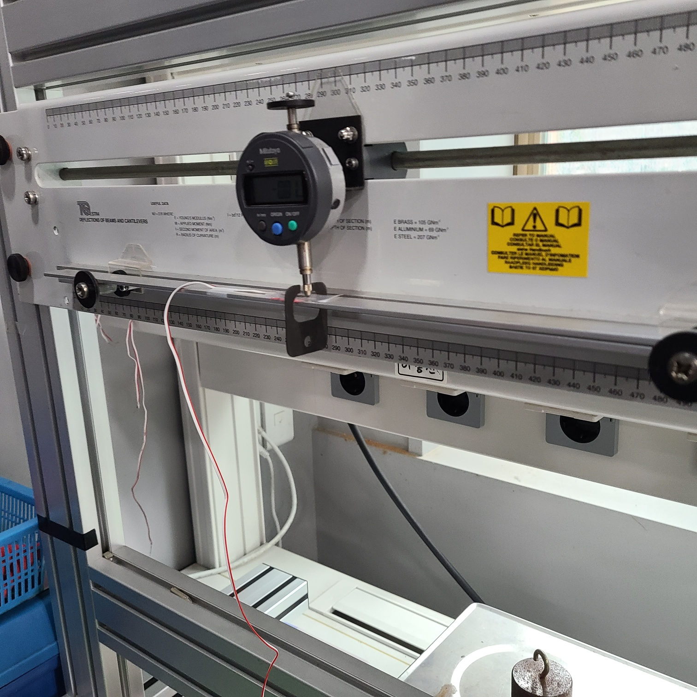

Fig 2. Experiment Picture

We can check the length of beam through the Fig 1

Table 1. Changes in resistance by weight

|  |  |
| --- | --- |
| Weight(Kg) |  |
| 0.2 | 0.023 |
| 0.4 | 0.060 |
| 0.6 | 0.088 |
| 0.8 | 0.118 |
| 1.0 | 0.152 |

Table 2. An experimental record sheet of Simply supported beam

(Length L: 420mm, Width b: 20mm, Height h: 3mm)

|  |  |  |  |  |
| --- | --- | --- | --- | --- |
| Weight(Kg) | Bending Moment(Nm) | Voltage(V) | Strain | Deflection(mm) |
| 0.2 | 0.1962 | 0.36 |  | -1.08 |
| 0.4 | 0.3924 | 0.93 |  | -2.15 |
| 0.6 | 0.5886 | 1.38 |  | -3.21 |
| 0.8 | 0.7848 | 1.85 |  | -4.27 |
| 1.0 | 0.981 | 2.38 |  | -5.31 |

There are two methods to obtain Elastic Modulus.

Deflection Method

Strain Method for simply support beam

The modulus of elasticity according to weight can be calculated through the above equations and tables.

To estimate the modulus of elasticity in the two ways shown above, an approximate straight line passing through the origin is fit

Table 3. Elastic modulus according to weight

|  |  |  |
| --- | --- | --- |
| Weight(Kg) | Pa) | Pa) |
| 0.2 | 62.31 | 75.21 |
| 0.4 | 62.60 | 57.70 |
| 0.6 | 62.89 | 59.03 |
| 0.8 | 63.04 | 58.69 |
| 1.0 | 63.34 | 56.94 |

To estimate the modulus of elasticity in the above two methods, a near line passing through the origin is fitted using MATLAB.

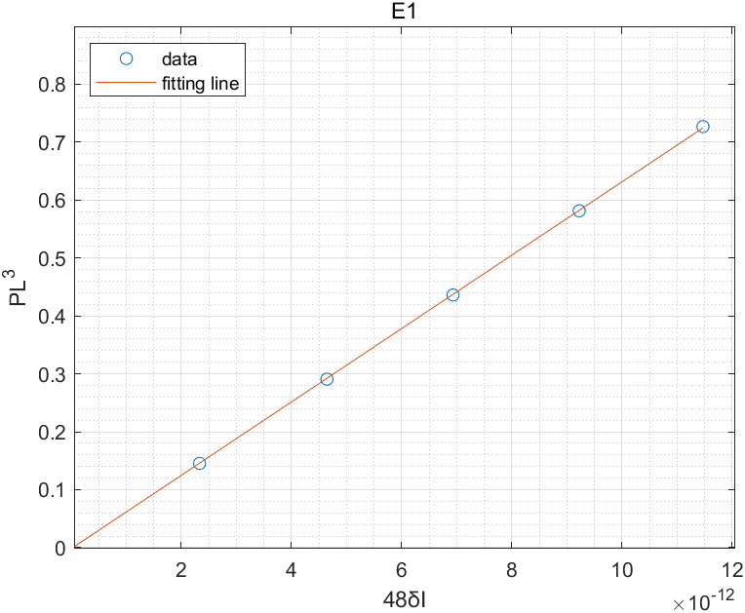 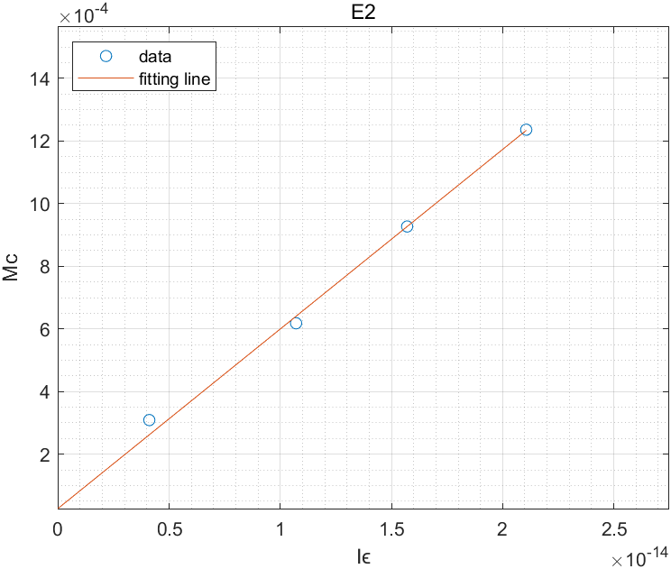

Fig 3. Elastic modulus estimation

Each result is as follows.

**3. Discussions**

(1) Discuss the appropriateness of the maximum load size determined for the group experiment

The purpose of this experiment is to measure the amount of deflection and deformation caused by the bending of the beam to obtain the modulus of elasticity with this value. Aluminum has a yield strength of 276 MPa, safety factor of 2.5 and load of 3.22 kg, as shown in prelab 2-1. Also, the load at prelab 2-2 is 1.69. It is appropriate because the maximum load size determined for the experiment does not exceed the values. The maximum size in the experiment was 1 kg, but accurate experimental values would not have been obtained if the weight was added continuously.

(2) Discuss the noise of the experimental data and discuss the adequacy of the applied filter

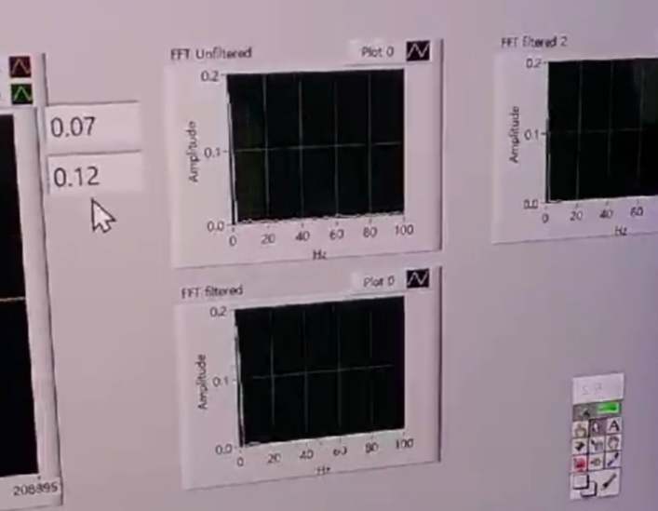

Fig 4. Noise and Filter

In figure4, the upper graph is a noisy FFT graph, and the lower graph is a FFT graph with a filter. Most electronic devices produce noise. This causes errors in the experimental data. Noise can occur for a number of reasons, including environmental conditions and electronic equipment. In particular, the strain gauge measuring the resistance value in this experiment reacts sensitively. Therefore, noise should be minimized by using methods such as filtering. From the picture, it doesn't seem like much noise, but if you zoom in and check the values closely, there is a significant difference.

A low pass filter is applied to remove noise. It is filtered at 10 Hz and adjusted with a DIP switch to block high-frequency signals and pass the desired signal. Noise cannot be identified in filtered FFT graphs, as shown in FIG 4. Therefore, the 10 Hz low-pass filter is suitable for passing the strain gauge signal.

(3) The elastic modulus obtained from the measurement of the sagging amount and the elastic modulus value obtained from the measurement of the strain are compared and discussed with the reference value of the material properties.

There is little difference between the theoretical value obtained using the equation and the simulation value obtained using MATLAB. However, compared to the aluminum elastic coefficient of 70GPa, there seems to be some difference. The one obtained by the Deflection method was closer to the physical property value than the one obtained by the Strain method.  
The exact length of the specimen was not known in this experiment. The length of the specimen is shown, but both ends were fixed to make it a simple support beam, but the length at this time and the L value used in the calculation did not seem to be exactly the same. Also, when measuring the resistance value, there seems to be a slight error. Not only was the noise not completely removed, but there were two voltages, as shown in Fig4, and the number fluctuated rapidly, so the average value was measured with the eyes and used in the equation calculation.

(4) Create an ANSYS simulation model to analyze stress (σ) and sagging (δ) and compare the theoretical values ( ) and the experimental values () at the three load values

It was implemented in ANSYS using the above conditions.

Table 4. Simulation value

|  |  |  |
| --- | --- | --- |
| Weight(Kg) | Stress(MPa) | Deflection(mm) |
| 0.2 | 6.56 | 0.82 |
| 0.6 | 19.68 | 2.46 |
| 1.0 | 32.8 | 4.10 |

Table 5. Theory value

|  |  |  |
| --- | --- | --- |
| Weight(Kg) | Stress(MPa) | Deflection(mm) |
| 0.2 | 6.54 | 0.83 |
| 0.6 | 19.62 | 2.49 |
| 1.0 | 32.70 | 4.15 |

Table 6. Experimental value

|  |  |  |
| --- | --- | --- |
| Weight(Kg) | Stress(MPa) | Deflection(mm) |
| 0.2 | 6.39 | 1.08 |
| 0.6 | 24.43 | 3.21 |
| 1.0 | 42.21 | 5.31 |

As given in the problem, the comparison was made with three loads. The simulation value, the theory value and experimental value were checked and compared to be represented in a table. In comparison, the theoretical value and the simulation value were almost the same as the stress value and deflection value. However, the experimental values of 0.2kg were similar, but as the weight increased, the difference between the experimental values and other values gradually widened.