**LAB2: Combined Stress**

Name/ID: HanTaeGeon 21900793

1. **PreLAB**
2. What is Generalized Hook's Law and present it in a formula.

Hook's law states that when a solid is deformed by applying force, the amount of deformation is proportional to the magnitude of the force unless the force exceeds a certain magnitude. The generalized hook’s law is a fundamental principle explaining the relationship between stress and deformation of materials in the field of continuum mechanics. It also describes a linear relationship between stress and deformation on elastic materials. The generalized hook law can also be used to predict deformation that occurs in a material.

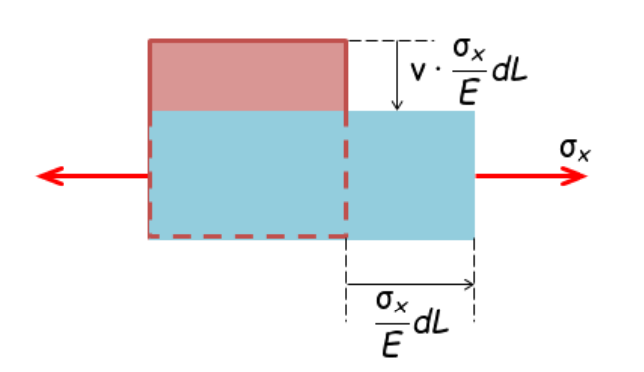

Fig 1. deformation by stress

Referring to Figure 1, the strain and Poisson's ratio in the x-axis direction are as follows.

The above equations can be used to obtain generalized Hook's law. It is written in forms follow.

The stress applied to each axis can be obtained in this form. In the case of Figure 1, it is .

1. When the two-dimensional strain (is measured by attaching a strain gauge rocket (sensor with three strain gauges) to the surface of an object, the two-dimensional stress state () of the surface can be known. Present this procedure as an equation in a 45-degree rojet gauge.

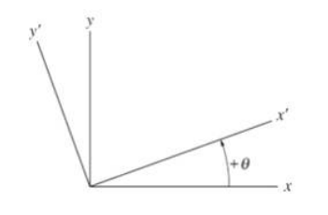

Fig 2. Changes in x and y values depending on the angle

Referring to Fig. 2,

The strain values of is , is and is . Therefore, the strain value of each rojet is obtained as follows.

Accordingly, the two-dimensional strain states() are as follows.

And the two-dimensional stress states (σ_x, σ_y, τ_xy) are calculated by Generalized Hook's Law using the equation in Problem 1 as follows.

1. If you know the two-dimensional stress state of the surface (), investigate how to find the maximum shear stress (), maximum tensile stress (main stress ), and Von-Mises stress ().

The two-dimensional stress state is already known by problem (2). Therefore, we can use this to obtain maximum shear stress, maximum tensile stress (main stress), and Von-Mises stress. Therefore, the stress transformation formula is used as follows.

If the maximum shear stress and maximum tensile stress (main stress) are known, the Von-Mises stress can be obtained.

1. **Experimental Results**

**2-1 Check the gain value of the amplifier**

To check the gain of the amplifier, the calibration (CAL) buttons of the three strain gauge amplifiers are pressed in order and the output voltage values are recorded in Table 1. (Near 2.25V should be available for the gain 1500)

Table 1. Calibration voltage of strain gage amplifier

|  |  |  |  |
| --- | --- | --- | --- |
|  | Gage_a ( | Gage_b ( | Gage_c (- |
|  | 2.20 | 2.23 | 2.30 |

**2-2 Elastic coefficient Estimation Experiment**

The displacement values for loads 1, 2, and 3Kg and the voltage values of strain gauge b (0ﾟgauge) are recorded in Table 2, and the elastic modulus is obtained in two ways based on regression analysis. (Careful attention to the hysteresis of the displacement system)

Table 2. Experiment for estimating Elastic Modulus

|  |  |  |
| --- | --- | --- |
| 하중 | Displacement (mm) | (V) for Gage_b |
| 1 Kg | 2.67 | 0.34 |
| 2 Kg | 5.31 | 0.69 |
| 3 Kg | 8.40 | 1.08 |

**2-3 Stress measurement experiment**

Table 3 shows the three experimental values of the strain-rojet voltage when a load of 3 kg is applied.

Table 3. Voltage output from Strain Rossette circuit for 3Kg load

|  |  |  |  |
| --- | --- | --- | --- |
| 횟수 | for Gage_a | for Gage_b | for Gage_c |
| 1 | 0.82 | 0.95 | - 0.25 |
| 2 | 0.84 | 0.93 | - 0.32 |
| 3 | 0.81 | 0.93 | - 0.19 |
| Average | 0.823 | 0.937 | - 0.253 |

1. **Discussions**
2. Compare and analyze the elastic modulus obtained by the two methods (Deflection Method and Strain Method).

Displacement and used experimental values. The modulus of elasticity was calculated through the following equation.

Table 4. Experimental Values

|  |  |  |  |  |
| --- | --- | --- | --- | --- |
| 하중 | Displacement (mm) |  |  |  |
| 1 Kg | 2.67 | 0.34 | 0.022 | 8.61 |
| 2 Kg | 5.31 | 0.69 | 0.044 | 1.72 |
| 3 Kg | 8.40 | 1.08 | 0.069 | 2.7 |

Using the values in the table above, the modulus of elasticity was calculated in two ways through the following equation. is the elastic modulus value obtained by the strain method. is the elastic modulus value obtained by the deflection method.

Table 5. Elastic Modulus

|  |  |  |  |
| --- | --- | --- | --- |
| 하중 | M(Nm) |  |  |
| 1 Kg | 1.472 | 71.2 | 63.95 |
| 2 Kg | 2.943 | 71.3 | 64.31 |
| 3 Kg | 4.415 | 68.1 | 60.98 |

Overall, the values obtained by the strain method were larger than those obtained by the deflection method. The strain method is closer to 71GPa, the elastic modulus of aluminum alloy.

1. Compare and analyze the experimental and theoretical values of bending stress () and shear stress ().

**Experimental Value**

We can calculate experimental values by using Table 4. The experimental values can be obtained through the equations used in prelab (2). There's a Poisson's ratio in the equation and I set it at 0.3. And the table the table shows them as follows.

Table 6. Values of epsilon

|  |  |  |  |
| --- | --- | --- | --- |
|  | Gage_a | Gage_b | Gage_c |
| 변형률 |  |  |  |
|  |  |  |  |
| value |  |  |  |

We can calculate the value by using the equations as follows.

Table 7. Values of stress

|  |  |  |  |
| --- | --- | --- | --- |
|  |  |  |  |
| value |  | -1.69 | 7.02 |

**Theoretical Value**

1. Compare and analyze experimental and theoretical values and simulation values for main stress (), maximum shear stress (), and Von-Mises stress ().

**Experimental Value**

The experimental value can be obtained by substituting the following equation using the experimental value of the above problem.

**Theoretical Value**

The theoretical value can also be obtained by substituting the following equation using the experimental value of the above problem.

**Simulation Value**

In order to accurately measure a point 150 mm away, a circle with a diameter of 1 was drawn in the design model. And I probed that part.

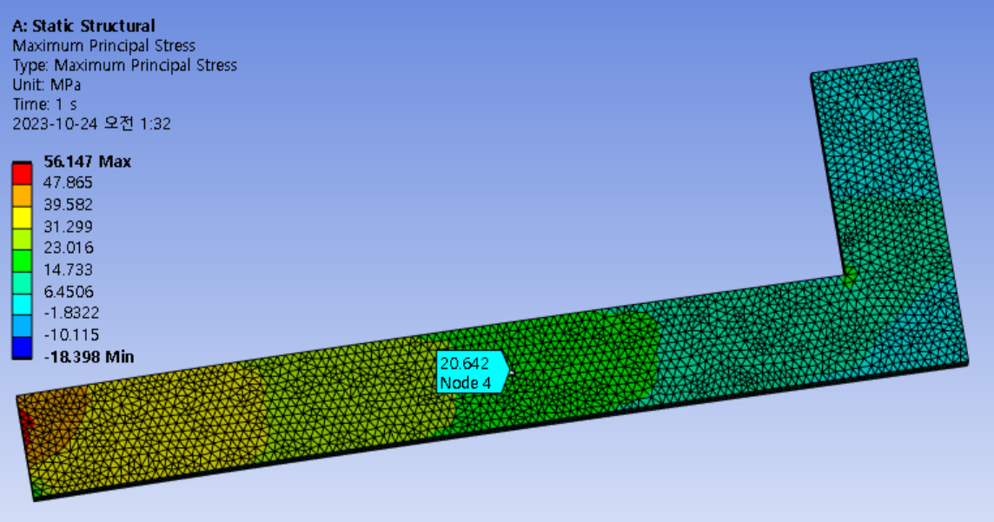 Maximum principal stress(

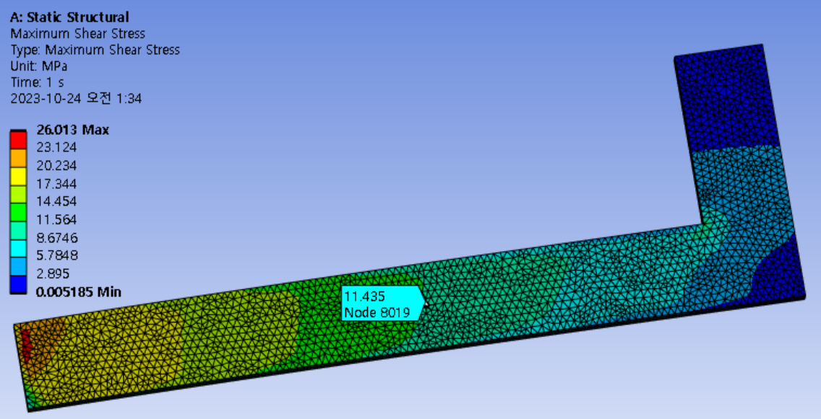 Maximum shear stress(

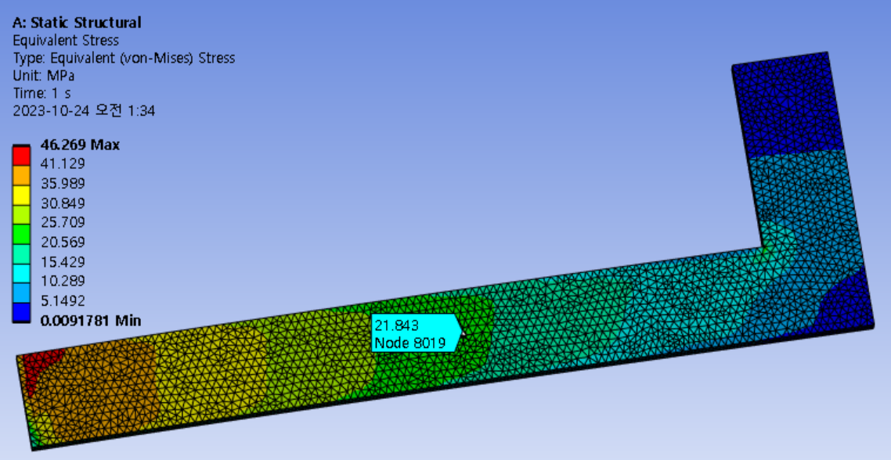 Von-mises stress(

Table 7. Summarizing the values to a table

|  |  |  |  |
| --- | --- | --- | --- |
|  | Experimental value (MPa) | Theoretical value (MPa) | Simulation value (MPa) |
|  | 15.54 | 20.64 | 20.642 |
|  | 8.622 | 11.44 | 11.435 |
|  | 20.46 | 21.85 | 21.843 |

The theoretical value and the simulation value were almost similar. However, the experimental value was smaller than the theoretical value or the simulation value. There is a difference due to the stress in the y-direction.

1. If the safety factor is set to 3, what is the maximum load that can be applied to the L-shaped beam to allow this experiment to continue next year?

Since the maximum yield stress of aluminum alloy is 280 MPa and the safety factor is 3, the maximum load value can be calculated as follows.

1. In addition to the above considerations, discuss what you observed and learned from the experiment.

In the experiment, the zero was set and the gauge was measured, but it was confirmed that the gauge value changed rapidly. Therefore, it is difficult to obtain an accurate gauge value with the desired weight. However, it doesn't matter because the error value is not large. In addition, when measuring the weight, it was measured as 1kg, 2kg, and 3kg, but it is difficult to say that it is actually an accurate kg. Because there were also prime numbers. However, compared to the theoretical value, there is little difference in value, so decimal places are not very important.

I learned how to calculate the three principal strains and, from them, determine the maximum stress values through the stress state. In the process, I was able to apply the equations I had already learned and gain an understanding of how these values are obtained both theoretically and experimentally.