**LAB4: Impact Hammer Test**

Name: HanTaeGeon

ID: 21900793

1. **PreLAB**
2. **Summary of the survey on Impact Hammer Test.**

This is an experiment that measures the natural frequency of a system based on boundary conditions. By adjusting the sampling rate, you can find the desired number of natural frequencies. By applying a brief shock to the system with a hammer, the natural frequency moved by force, the corresponding natural mode, and the degree of attenuation can be found. In other words, the response characteristics of the structure are confirmed through the response signal measured by the hammer impact and accelerometer.

1. **Examine the FFT for the following function and sketch the spectrum in the frequency domain.**

FFT is Fast Fourier Transform. It is a method of quickly calculating only the signals needed for sampling. Select only the required part and apply the expectation for the rest of the signal.

**① Impulse**

Impulse is a function or signal with a very short duration. This is a type of pulse signal with an integral value of 1 from -∞ to the ∞, which can be obtained by converging the width to zero. The Fourier transform of a continuous-time function x(t) can be defined as follows.

We can calculate the FFT of impulse using the above equation. Impulse exists only at t = 0, so we can write like as follows.

The spectrum in the frequency domain was plotted using MATLAB.

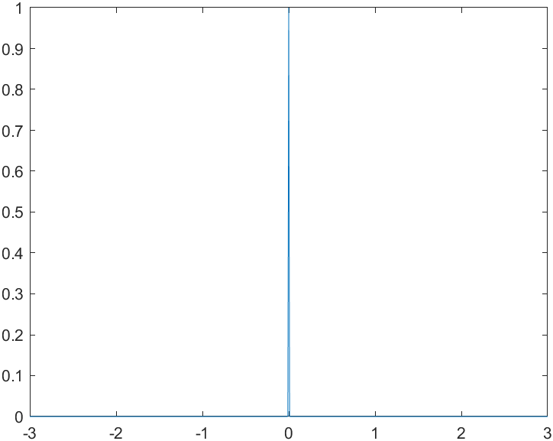 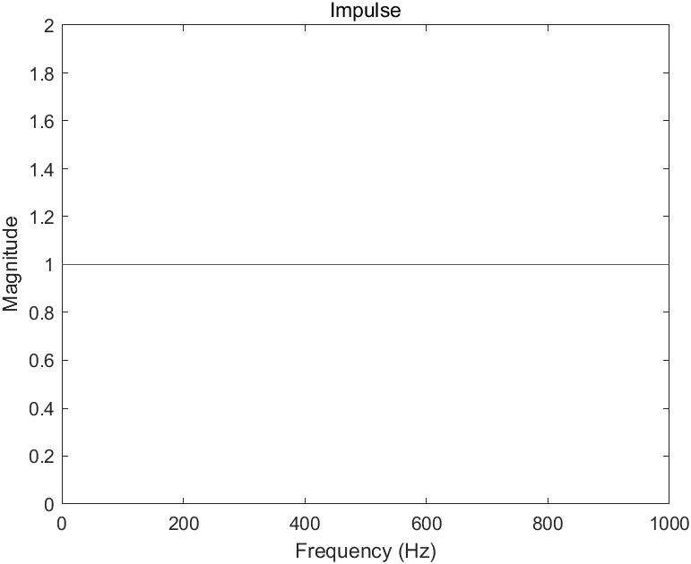

Fig 1. Time domain (impulse) Fig 2. Frequency domain (impulse)

**② Unit Step Function**

The Unit step function is a function that has a value of 0 for real numbers less than 0 and 1/2 for real numbers greater than 0 and 1 for real numbers greater than 0. And Fourier transform of unit step function cannot be found directly. Because the unit step function is not absolutely integrable. So, for find Fourier transform, unit step function is expressed in terms of signum function as follows.

Using the above equation, we can calculate the FFT of unit step function.

Therefore, it can be seen that as the frequency decreases, it increases infinitely, and as the frequency increases, it converges to the value. The spectrum for this is as follows.

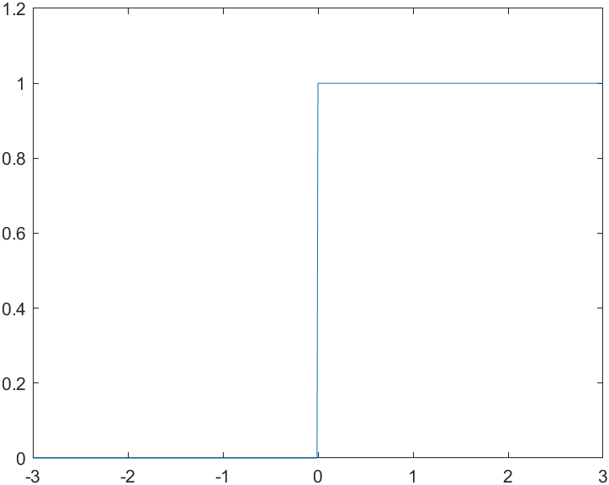 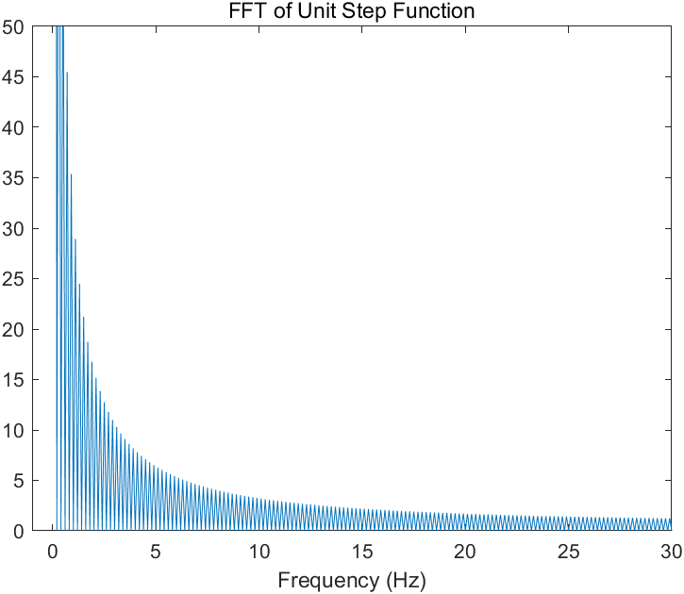

Fig 3. Time domain (Unit step) Fig 4. Frequency domain (Unit step)

**③ Sin(wt)**

In the context of the expression sin(wt), w represents the angular frequency, and t represents time. The sin(wt) function can be obtained using the Euler formula as follows.

The resulting value for this was expressed in the spectrum using MATLAB. It can be seen that the two values were significantly different in the frequency area as follows.

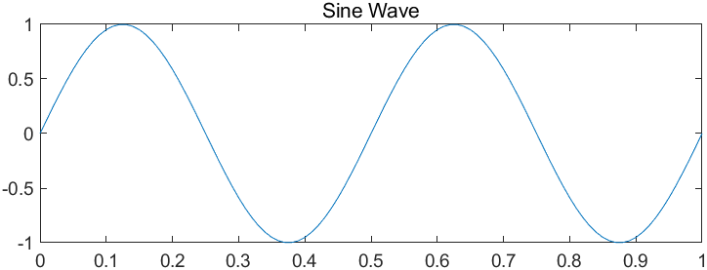 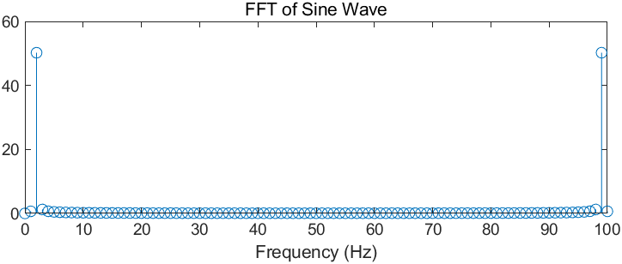

Fig 5. Time domain (sin(wt)) Fig 6. Frequency domain (sin(wt))

1. **Results**

**2-1 Experiments**

Find the natural frequency by performing FFT on the time domain data.

1. Obtain four natural frequencies for vertical transverse vibration of steel, aluminum, and brass cantilever.

|  |  |  |
| --- | --- | --- |
| **Material** | **Experiments Data** | **Value** |
| Steel  cantilever |  |  |
| Aluminum cantilever |  |  |
| Brass  cantilever |  |  |

(2) Obtain four natural frequencies for vertical transverse vibration of steel terminal height information.

|  |  |  |
| --- | --- | --- |
| **Material** | **Experiments Data** | **Value** |
| Steel  Fixed support |  |  |

**2-2 Theory**

1. Find four natural frequencies of the theory of vertical transverse vibration of steel, aluminum, and brass cantilever.

🡪

Here, the is the density, A is the cross-sectional area, I is the moment of inertia, and E is the modulus of elasticity. The value is obtained using the above equation as follows.

1. **Steel**

1. **Aluminum**

1. **Brass**
2. Find four theoretical natural frequencies for vertical transverse vibration of steel terminal height information.

In the above problem, only the boundary condition has been changed from a single blast to information on both ends. Since the value and the total length are changed accordingly, the changed values are applied as follows.

**2-3 Simulation**

1. 3D model is created by measuring the dimensions of steel, aluminum, and brass cantilever, and simulated with ANSYS to obtain a vertical natural frequency and four modes.

|  |  |  |
| --- | --- | --- |
| **Material** | **Experiments Data** | **Value** |
| Steel  cantilever |  |  |
| Aluminum cantilever |  |  |
| Brass  cantilever |  |  |

1. By simulating steel with the information of both ends, the natural frequency in the vertical direction and four modes are obtained.

|  |  |  |
| --- | --- | --- |
| **Material** | **Experiments Data** | **Value** |
| Steel  Fixed support |  |  |

1. **Discussions**

(1) Compare and discuss the differences between experiments, theories, and simulations in each material.

Table 1. Comparison of natural frequencies and mode shapes for steel (Cantilever)

|  |  |  |  |  |
| --- | --- | --- | --- | --- |
|  |  |  |  |  |
| Experiment | 6.33 | 39.22 | 109.30 | 215.16 |
| Theory | 6.70 | 41.86 | 117.21 | 229.69 |
| Simulation | 6.70 | 41.99 | 117.57 | 230.36 |

In steel, the theoretical value and the simulation value were almost similar, and the experimental value was slightly different from the theoretical value and the experimental value. The experimental value was generally lower than the other values. However, their maximum error rate is about 6.5%, so it can be said that the result is almost similar.

Table 2. Comparison of natural frequencies and mode shapes for Aluminum(Cantilever)

|  |  |  |  |  |
| --- | --- | --- | --- | --- |
|  |  |  |  |  |
| Experiment | 5.70 | 38.23 | 107.89 | 213.05 |
| Theory | 6.70 | 41.99 | 117.56 | 230.38 |
| Simulation | 6.73 | 42.15 | 118.02 | 231.25 |

The aluminum beam also showed lower experimental values than other values. The theoretical value and the simulation value were similar. It can be seen that their maximum error rate is about 15%, which is relatively high.

Table 3. Comparison of natural frequencies and mode shapes for Brass (Cantilever)

|  |  |  |  |  |
| --- | --- | --- | --- | --- |
|  |  |  |  |  |
| Experiment | 4.38 | 27.66 | 78.05 | 152.27 |
| Theory | 4.60 | 28.84 | 80.74 | 158.22 |
| Simulation | 4.62 | 28.96 | 81.09 | 158.89 |

Even at this time, the experimental value was lower than the other values. The theoretical value and the simulation value were similar. Their maximum error rate is about 5%, so it can be said to be almost similar.

(2) By simulating steel with the information of both ends, the natural frequency in the vertical direction and four modes are obtained.

Table 4. Comparison of natural frequencies and mode shapes for steel (Both end fixed beam)

|  |  |  |  |  |
| --- | --- | --- | --- | --- |
|  |  |  |  |  |
| Experiment | 41.72 | 115.55 | 225.78 | 366.56 |
| Theory | 46.12 | 127.13 | 249.23 | 411.95 |
| Simulation | 46.43 | 127.94 | 250.77 | 414.44 |

Even at this time, the experimental value was lower than the other values. The theoretical value and the simulation value were similar. Their maximum error rate is about 11.5%, which is different from the experimental value.

Simulation and theoretical values are values in an ideal environment. The beam in the experiment may change the physical property value, and the experimental environment may affect the result value. Also, there were often errors in the sensor in the middle of the experiment. It seems that the result value may also vary depending on the accuracy and performance of the sensor.

(3) Effect of beam material and support conditions (boundary conditions)

- Compare and discuss the effects of beam materials.

Steel was expected to exhibit high natural frequencies due to its strong rigidity. However, the experimental, theoretical, and simulation values showed similar results to the aluminum results. Since aluminum is softer and less rigid than steel, the experimental value shows that the result value of steel is slightly higher than that of aluminum. In addition, brass is the softest and most flexible of the three beams, so it has a low natural frequency. The result value alone shows that it is lower than that of aluminum and steel. When calculating the above values, ANSYS was used because the density value was not accurately known. Due to the difference in density, it is expected that the natural frequencies of aluminum and steel are similar. In terms of theoretical values, when calculating, if the material is changed, only the density and elastic modulus are changed. In conclusion, the result value varies depending on the material of the beam. Of course, the result value comes out differently because the material's physical properties are different.

- Compare and discuss the effect on the support conditions of steel bars.

The experiment was conducted by giving Cantilever and both fixed beam support conditions. The experiment was only a steel beam, but there was definitely a difference in the results. The result showed that the natural frequency of the both fixed beam was much larger. Cantilever is free in one direction, so deformation can occur relatively easily compared to both end fixed beams with both ends, lowering the natural frequency. Since the both end fixed beam fixes both sides, the movement is limited and the beam becomes harder than the Cantilever. This can be seen as an increase in stiffness, which affects increasing the frequency. Therefore, it was found through experiments, theories, and simulations that the both end fixed beam had a higher frequency than the Cantilever.

(4) What is the difference between the FFT result of the vibration measured when the end of the beam is pressed with a hand and suddenly removed and the FFT result of the vibration obtained by slightly hitting it with a hammer?

When pressed by hand, the duration of the pressing is longer, so the vibration lasts longer than the hammer and has a low frequency component. On the other hand, the hammer transmits force quickly, so it has a lower duration than pressing it with your hand, so it has a high frequency component. The amplitude distribution of the FFT results shows a more persistent and longer oscillation when pressed by hand and shows a relatively uniform amplitude. However, when hit with a hammer, a concentrated amplitude occurs. In addition, the area where the hand and hammer contact the beam is different. The hand has a wider contact surface than the hammer, so the force is dispersed. Of course, the hammer can stimulate a specific area more accurately because the force is concentrated at the point where the impact is applied.

(5) Describe the effect of the attachment position of the accelerometer on the experimental results and discuss the precautions for the attachment position of the accelerometer during the experiment

Depending on the location, the amplitude, phase, and frequency response of the recorded acceleration signal may be affected. In particular, since the node is an area with little movement, attaching a sensor around it is likely to produce a very low amplitude response. Therefore, the results may differ depending on the location at which the acceleration sensor is attached, so the location at which the acceleration sensor is attached has a great influence on the experimental results.

Next, be careful about the attachment location. The acceleration sensor must be securely mounted because if it moves during movement, accurate results may not be obtained and errors may appear in the data. Additionally, the direction in which the sensor is measured must be carefully set. It must match the direction of the expected force. Lastly, as mentioned above, you need to be careful about nodes that greatly influence the attachment location. Therefore, you must be careful about the sensor location when attaching it.

**Attenuation ratio experiment**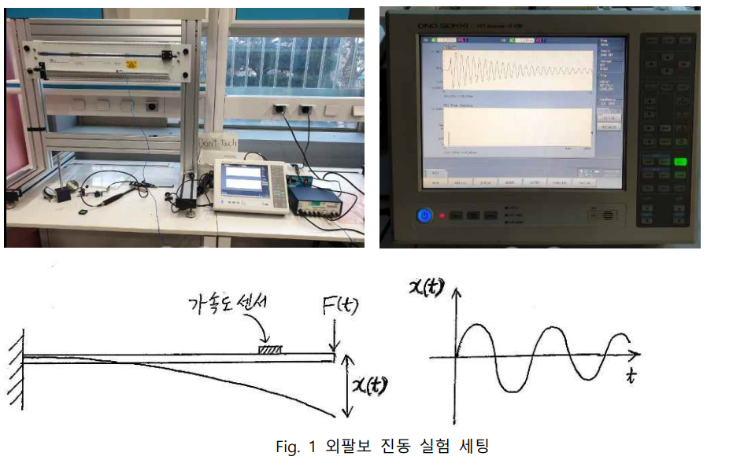

In the experimental setting above, if the end of the cantilever is slightly pressed and released, free vibration due to the initial displacement input can be observed. Find the attenuation factor by measuring the time-domain waveform signal of the acceleration sensor.()

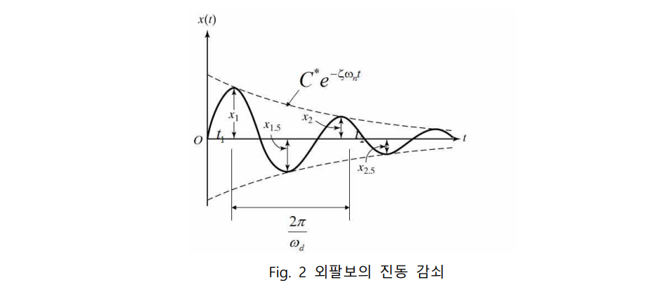

The waveform in Fig. 2 represents the underdamped system (ς <1), and the attenuation ratio can be obtained from the amplitude attenuation ratio over five cycles (n=5) as follows.

Table 1. a table of attenuation ratios on a cantilever

|  |  |
| --- | --- |
| **5-period amplitude ratio (** | **Attenuation ratio (** |
| 0.093 | 0.015 |

We can obtain the 5-period amplitude ratio and the attrition ratio using the following equation.

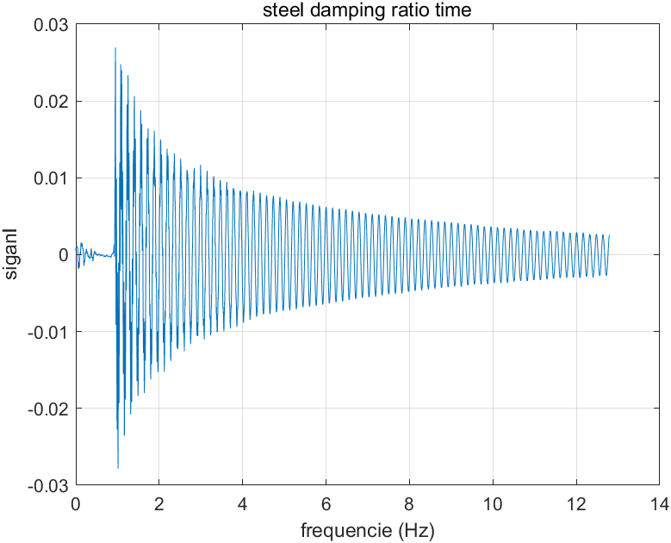 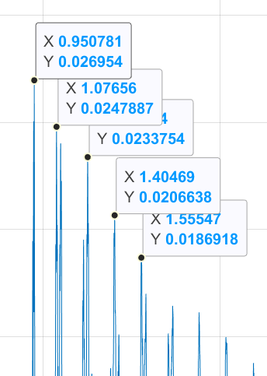

Using the above experimental values, the 5-period amplitude ratio and the attrition ratio are as follows.