Selenium Hybrid Framework
(Python, Selenium, PyTest, Page Object Model, HTML Reports)

Step 1: Create new Project & Install Required Packages/plugins

- Pytest – Python built-in unit test framework (5.4.3 Preferred)
- selenium - selenium libraries
- webdriver-manager – for drivers
- pytest-html – reports
- pytest-xdist - parallel testing
- openpyxl – xl file
- allure-pytest - report

Create requirements.txt file contains all packages and install it.

Step 2: Create Folder Structure

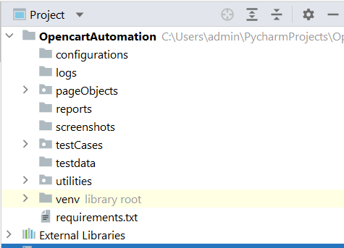

Step 3: Automating Register account test case

3.1: Create page object classes for HomePage & AccountRegistration page under "pageObjects"

3.2: Create conftest.py under "testCases" with driver manager.

3.3: Create AccountRegistration testcase under "testCases"

3.4 Write a utility file to generate random string for email.

Step 4: capture screenshot on failures
4.1. Update AccountRegistration Test case with capture Screenshot under "testCases"

Step 5: Read common values from ini file.

5.1: Add "config.ini" file in "configurations" folder.
5.2: Create "readProperties.py" utility file under utilities package to read common data.
5.3: Replace hard coded values in AccountRegistration testcase.

Step 6: Adding logs to test case

6.1: Add customLogger.py under utilities package.
6.2: Add logs to AccountRegistration test case.

Step 7: Run Tests on Desired Browser(Cross Browser Testing)/Parallel

7.1: update contest.py with required fixtures which will accept command line argument (browser).
7.2: Pass browser name as argument in command line

To Run tests on desired browser
pytest -s -v .\testCases\test_001_AccountRegistration.py --browser edge

To Run tests parallel
pytest -s -v -n=3 .\testCases\test_001_AccountRegistration.py --browser edge

Step 8: Generate pytest HTML Reports

8.1: Update conftest.py with pytest hooks

pytest -s -v --html=reports\report.html --capture=tee-sys .\testCases\test_001_A
ccountRegistration.py --browser chrome

Step 9: Automate Login Test case
9.1: Create page object class LoginPage under "pageObjects"
9.2: Create Login test under "testCases"

Step 10: Automating Data Driven Test Case

10.1: Prepare test data in Excel sheet, place the excel file inside the “testData” folder.
10.2: Create "ExcelUtils.py" utility class under utilities package.
10.3 : Create MyAccount PageObject class
10.3: Create LoginDataDrivenTest under testCases
10.4: Run the test case

Step 11: Grouping Tests
11.1: Grouping markers( Add markers to every test method)
@pytest.mark.sanity
@pytest.mark.regression

11.2: Add Marker entries in pytest.ini file
pytest.ini
--------
[pytest]
markers =
sanity
regression

11.3: Select groups at run time
-m "sanity"
-m "regression"
-m "sanity and regression"
-m "sanity or regression"

Run Command:
pytest -s -v -m "sanity or regression" .\testCases

Step 12: Run Tests in Command Prompt & run.bat file.
12.1: Create requirements.bat file contains packages
pip install pytest==5.4.3
pip install selenium
pip install webdriver-manager
pip install pytest-html
pip install pytest-xdist
pip install pytest-ordering
pip install openpyxl
pip install allure-pytest

12.2 : Create run.bat file
pytest -s -v -m "sanity".\testCases

12.2 Open command prompt as Administrator and then run run.bat file

Step 13: Push the Code to Git & GitHub Repository

Git workflow
1) git init --> Create an Empty git repository(Local repository)

2) git config --global user.name "your name"
got config --global user.email "your email"

3) git status ---> to know the status of the files

4) git add -A ---->add all the files into staging/indexing area
git add filename.java --> add specific file into staging/indexing area
git add *.java

5) git commit -m "user comment"

Github
--------------
1) Create new account (Sign up)
2) Login to github ---> create a new empty remote repository
Remote Repo url:
https://github.com/pavanoltraining/OpencartV11.git

3) Create a token
Reference link: https://docs.github.com/en/github/authenticating-to-github/keeping-your-account-and-data-secure/creating-a-personal-access-token

Create Personal Access Token on Github
---------------
From your Github account, go to Settings => Developer Settings => Personal Access Token => Generate New Token (Give your password) => Fillup the form => click Generate token => Copy the generated Token.

4) push your code into Remote repository

git remote add origin https://github.com/pavanoltraining/OpencartV11.git ---> only once
git push -u origin master

Pull files from remote to local
-------------------------------
git pull origin master

2nd round
---------
add
commit
push
pull
status
Step 14: Run Tests using Jenkins

