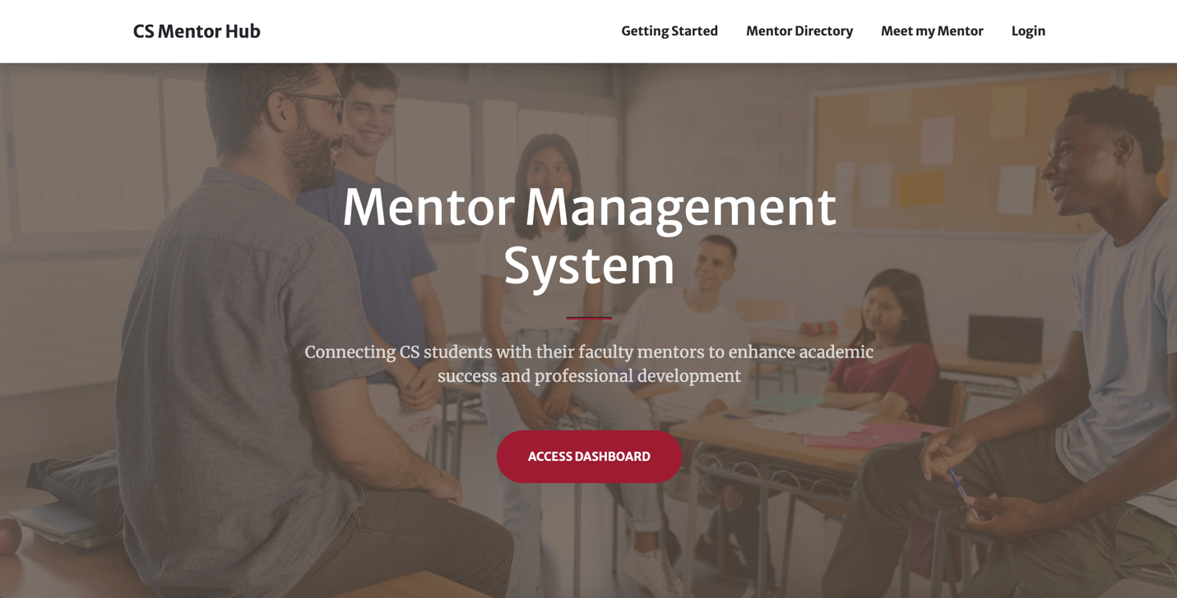

**Sprint Planning Document (Sprint 1)**

**Sprint Goal Backlog (Sprint 1)**

January 23 - February 18, 2025

{Andy Hahn, Hannah Hazelwood, Gregory Nothnagel, Manjila Singh}

**High-level Project Overview**

**Project Mission:**

* The Mentor Management Project aims to support a mentorship program for freshmen in the Computer Science Department. Through this program, students can receive academic, professional, and personal development.

**Problems We Are Solving:**

* There is currently no infrastructure for a mentorship program.
* Materials and information are decentralized, causing a lot of extra work to manually send emails and review form responses.
* There are many students in the department compared to the number of faculty. This means there is a large time burden on those facilitating the mentorship program.
* Freshmen struggle to adjust to college life and need extra support.

**Project Overview (High-Level Features):**

* **Mentor Management Website:**
  + **Sign-in/up:** Users should be able to sign in with crimson email address to Microsoft.
  + **Meet My Mentor:** Page should display a student’s mentor and all necessary information about that mentor.
  + **Mentor Directory:** Users should be able to see a list of all mentors. Students can request to change their mentor.
  + **Home Page:** Home-screen is a landing page with basic information about the application and its features.
  + **Get Started**: This page should give basic instructions to students about the mentorship process.
  + **Interest Forms:** Students should be able to fill out a form with various information about themselves before a meeting. Mentors should be able to see the form responses that their mentees have provided.
  + **Logging a Meeting:** After a meeting, a mentor should be able to add a log for the meeting to track it.
  + **Meeting Scheduler:** A student should be able to schedule a meeting with their mentor. Both students and mentors should be able to see all of their upcoming mentorship meetings.
  + **Tracking Students:** Users should be able to track a student from freshman to senior year. A student should be able to see their meeting history. A mentor should be able to see all of their students’ meeting histories. An admin should be able to see all the students’ meeting histories.
* **Admin Dashboard**
  + CRUD Dashboard for admin and student workers to manage students, mentors and mentorships.
* **Backend Services**
  + **Realtime Database**: Data for students, mentors, mentorships, meetings, interest forms etc.
  + **Hosting:** Host the web app on the cloud. Should be able to deploy and run the project through Docker.
  + **Authentication:** Use OAuth to connect to Microsoft (crimson emails) for authentication.

**Sprint 1 Planning**

**Sprint 1 Goals:**

1. **Research the tools to be used in this project.**
2. **Create a basic frontend and backend.**
3. **Deploy and run the service through Docker.**
4. **Create the database and populate it with sample data.**
5. **Allow a user to sign in with Microsoft using OAuth.**
6. **Allow a student to see their mentor along with information about their mentor.**
7. **Create a view for a mentor to see a list of their mentees/students.**
8. **Create draft of project website.**

**Sprint 1 Deliverables:**

* **Research the tools to be used in this project:**
  + **Assigned:** {Hannah Hazelwood, Manjila Singh, Andy Hahn, Gregory Nothnagel}
  + Research and read through all of the necessary documentation for the tools to be used throughout the project. Discover which tech stack we will need to use.
* **Setup the basic frontend and backend:**
  + **Assigned:** {Manjila Singh, Andy Hahn}
  + Setup a basic backend with the Django framework.
  + Create a basic frontend with node.js using express.js.
* **Deploy and run the service through Docker:**
  + **Assigned:** {Andy Hahn, Gregory Nothnagel, Manjila Singh, Hannah Hazelwood}
  + Create all necessary files needed to run the frontend, backend, and database with a docker-compose command.
  + Ensure README has up to date information on how to run the application using Docker.
* **Create the database and populate it with sample data**
  + **Assigned:** {Hannah Hazelwood, Andy Hahn, Gregory Nothnagel}
  + Use postgreSQL to create the database for the application.
  + Connect this database to the Django Admin Dashboard
  + Create all necessary tables in the projects init.sql file to initialize the database during the build of the Docker container. Tables include students, mentors, mentorships, meetings, and interest forms.
  + Populate the database with some sample data in the init.sql file for testing purposes.
* **Allow a user to sign in with Microsoft using OAuth.**
  + **Assigned:** {Gregory Nothnagel, Manjila Singh}
  + Investigate how OAuth can be used for the login feature.
  + Allow students to log into the application with their crimson email, connecting our application to Microsoft.
* **Allow a student to see their mentor along with information about their mentor**
  + **Assigned:** {Andy Hahn, Manjila Singh, Hannah Hazelwood}
  + Query the database to show an individual student their mentor match.
  + Create the Meet my Mentor Page. This page should showcase information about the mentor, including office hours, contact information, and research interests.
  + Connect to login feature to pull the current logged in student and automatically show the correct mentor.
* **Create a view for a mentor to see a list of their mentees/students**
  + **Assigned:** {Andy Hahn, Manjila Singh, Hannah Hazelwood, Gregory Nothnagel}
  + Query the database to pull all mentees that have a mentorship relationship with a mentor.
  + Create a page to show a list of students.
  + Connect to login feature to pull the current mentor to automatically get the correct list of students.
  + Add roles or a separate view to differentiate a mentor and student as two different users. A student should not see the option to see all mentees and a mentor should not see an option to meet their mentor. This will require some roles being assigned to users.
* **Create Project Website**
  + **Assigned:** {Hannah Hazelwood}
  + Create the first draft of the project website. Include a page for the main goals of the project, an about page for the team, and a page for all sprint deliverables.
  + Host the website with GitHub pages.
  + Update the Project Website with information as sprint deliverables are completed.