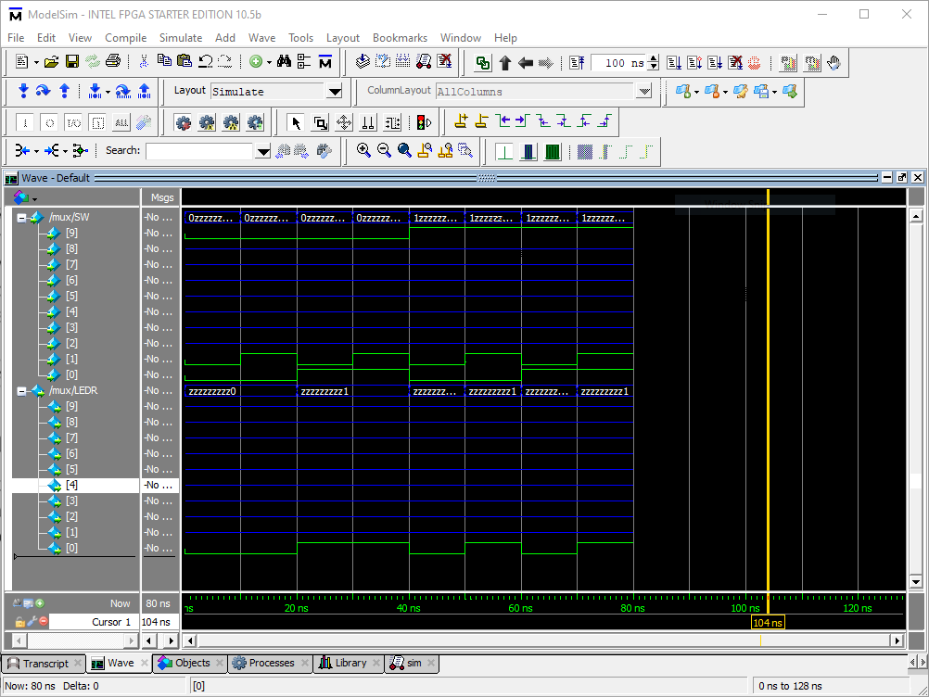

Part I: Input and outputs work as expected.

Part II:

1. There are 4 possible combinations of s1 and s0, along with 16 possible combinations of u, v, w, and x. So multiplied together, there would be 64 rows in the table.
2. 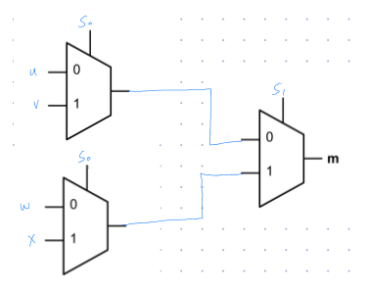

5. 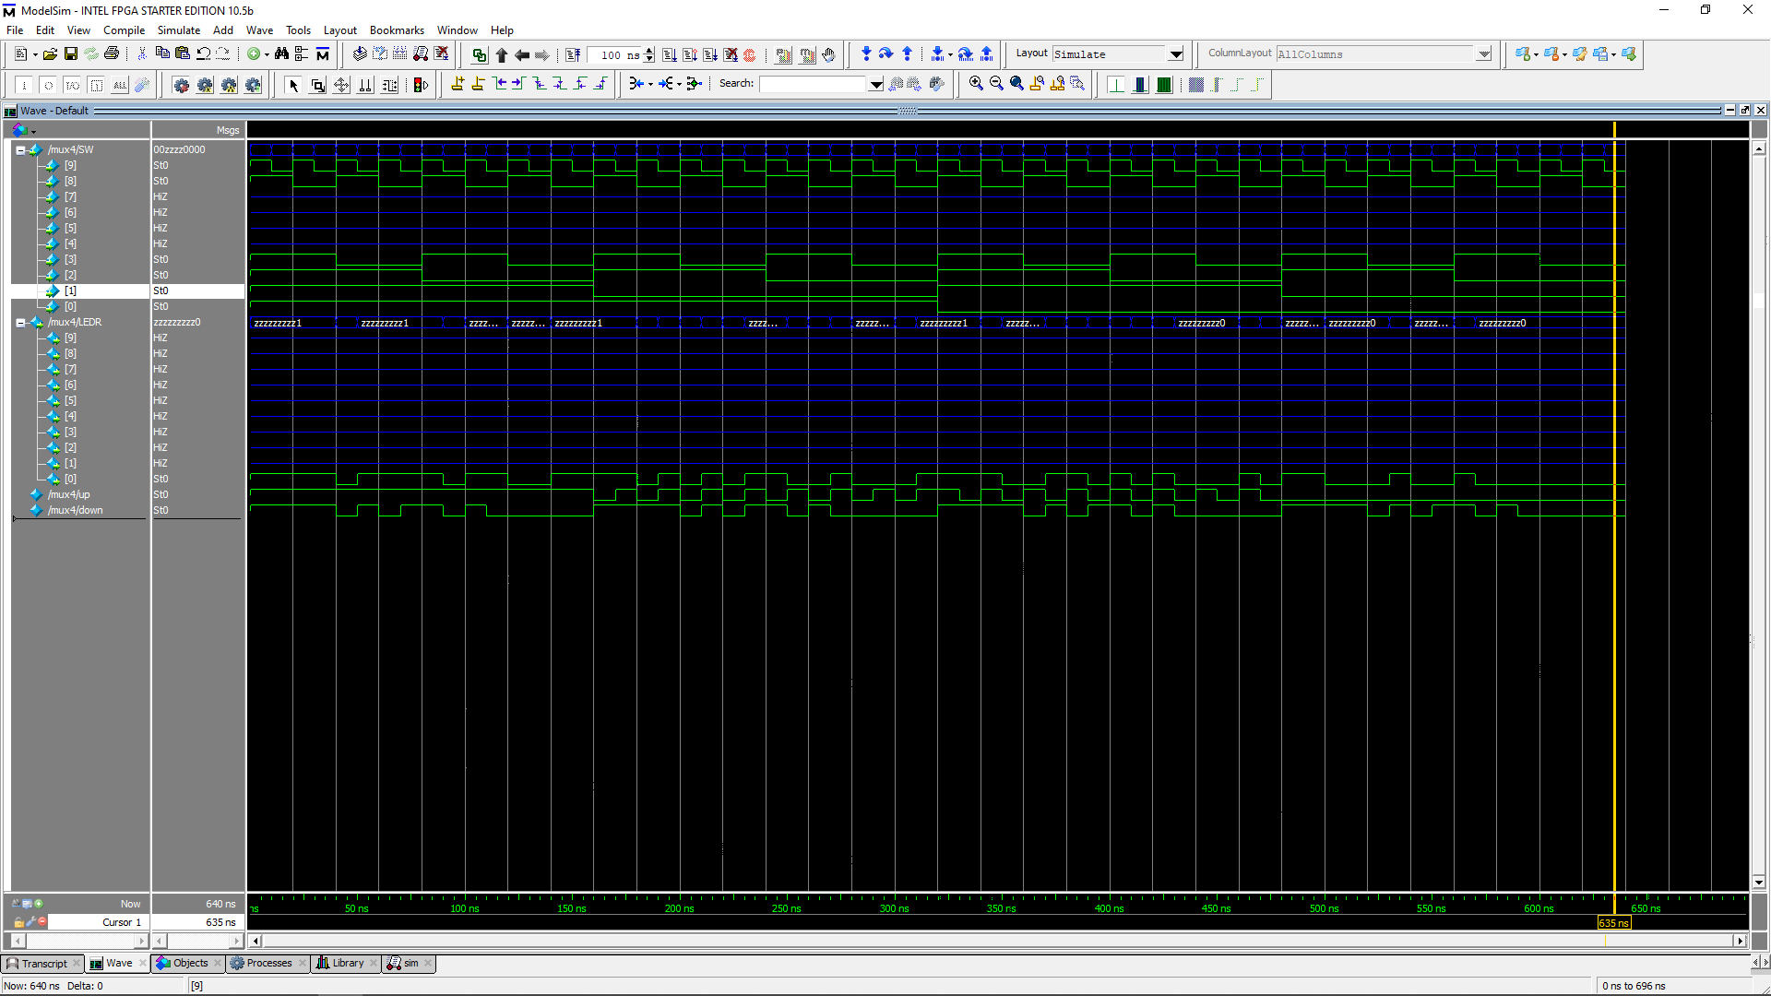

Simulation of 4to1 multiplexer.

Part III:

# 0 1 2 3 4 5 6  
table = {'0000': ['0', '0', '0', '0', '0', '0', '1'], # 0  
 '0001': ['1', '0', '0', '1', '1', '1', '1'], # 1  
 '0010': ['0', '0', '1', '0', '0', '1', '0'], # 2  
 '0011': ['0', '0', '0', '0', '1', '1', '0'], # 3  
 '0100': ['1', '0', '0', '1', '1', '0', '0'], # 4  
 '0101': ['0', '1', '0', '0', '1', '0', '0'], # 5  
 '0110': ['0', '1', '0', '0', '0', '0', '0'], # 6  
 '0111': ['0', '0', '0', '1', '1', '1', '1'], # 7  
 '1000': ['0', '0', '0', '0', '0', '0', '0'], # 8  
 '1001': ['0', '0', '0', '0', '1', '0', '0'], # 9  
 '1010': ['0', '0', '0', '1', '0', '0', '0'], # A  
 '1011': ['1', '1', '0', '0', '0', '0', '0'], # b  
 '1100': ['0', '1', '1', '0', '0', '0', '1'], # C  
 '1101': ['1', '0', '0', '0', '0', '1', '0'], # d  
 '1110': ['0', '1', '1', '0', '0', '0', '0'], # E  
 '1111': ['0', '1', '1', '1', '0', '0', '0']} # F

Truth table for 7 segment display

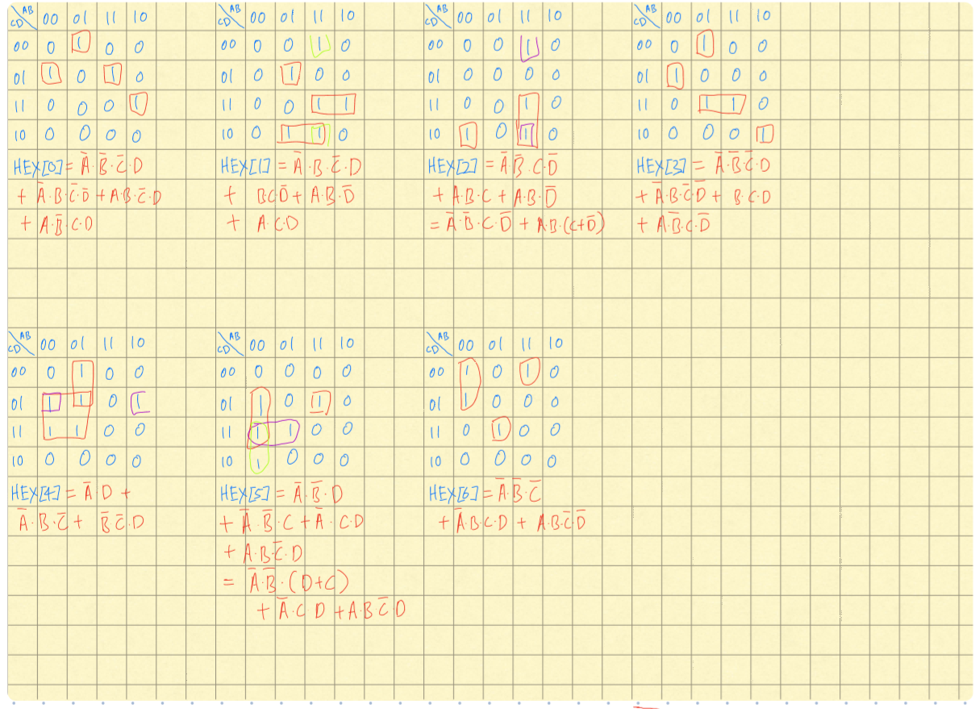

Boolean functions for each HEX node.

Waveforms:

