Part I:

Q1&2: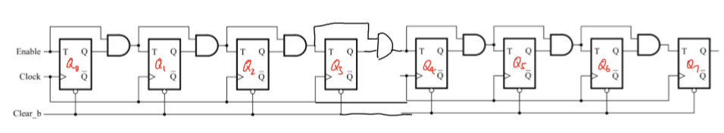

Schematic for 8-bit counter.

3. Verilog code included in final counter.v file. 8bit counter is defined as counter_eight_bit and T flip flop is tflipflop.

4. 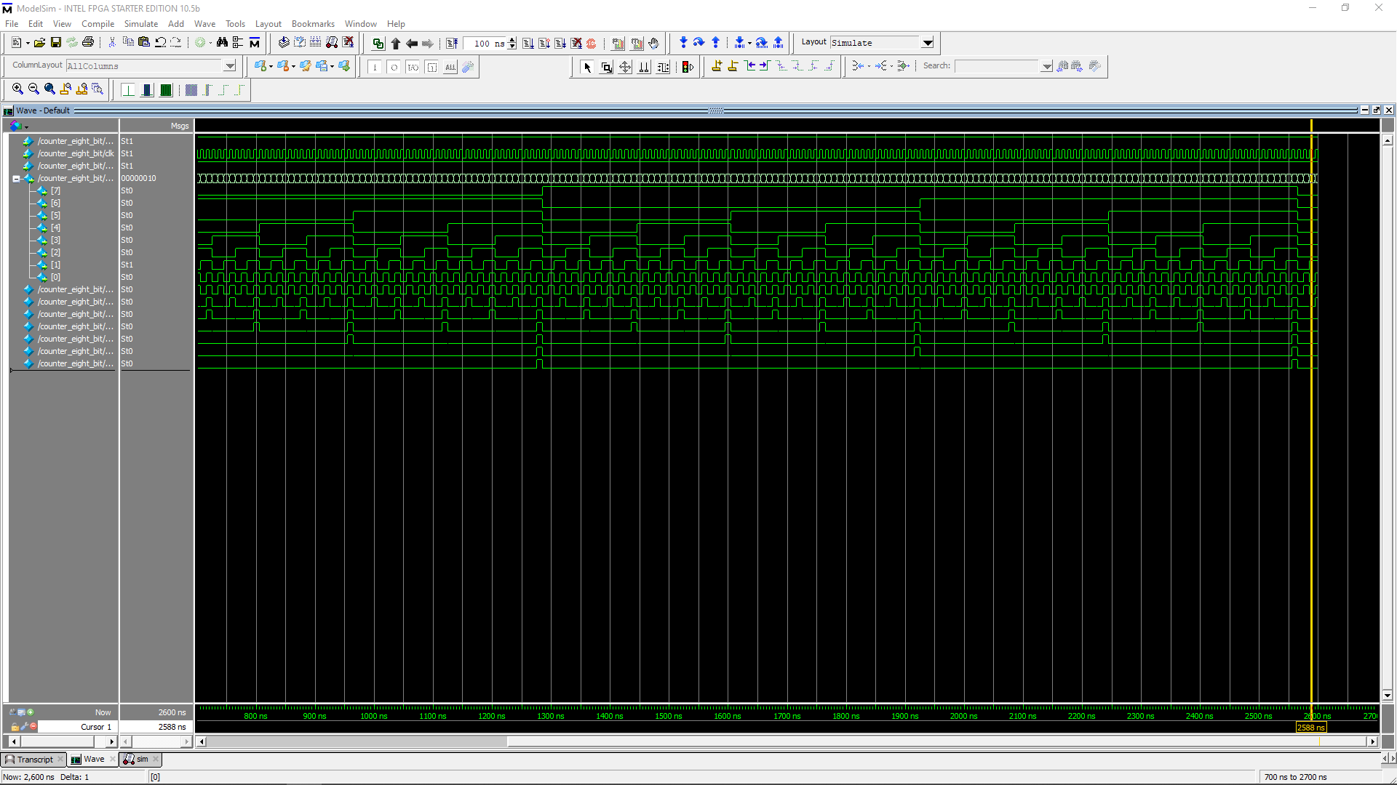

Simulation for the eight bit counter, it counts correctly and resets at the end when number overflows.