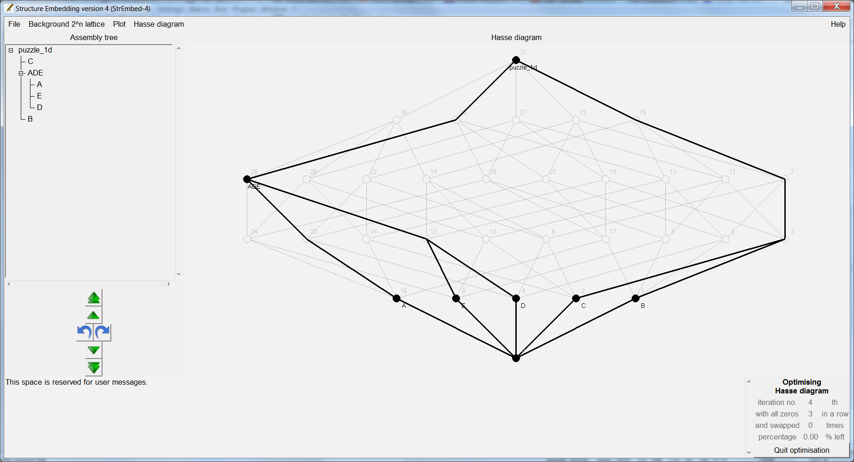

D:\menhhc\StrEmbed-4\StrEmbed-4\bin>perl StrEmbed-4.pl

puzzle_1d [puzzle_1d]

puzzle_1d C [C]

puzzle_1d ADE [ADE]

puzzle_1d ADE A [A]

puzzle_1d ADE E [E]

puzzle_1d ADE D [D]

puzzle_1d B [B]

D:\menhhc\StrEmbed-4\StrEmbed-4\bin>perl StrEmbed-4.pl

puzzle_1d [puzzle_1d]

puzzle_1d ADE [ADE]

puzzle_1d ADE A [A]

puzzle_1d ADE D [D]

puzzle_1d ADE E [E]

puzzle_1d B [B]

puzzle_1d C [C]

0 puzzle_1d

1 ADE

2 A

2 D

2 E

1 B

1 C

0 puzzle_1d

1 ADE

2 A

2 D

2 E

1 B

1 C

0 puzzle_1d [puzzle_1d]

1 puzzle_1d ADE [ADE]

2 puzzle_1d ADE A [A]

2 puzzle_1d ADE D [D]

2 puzzle_1d ADE E [E]

1 puzzle_1d B [B]

1 puzzle_1d C [C]