Vietnamese Sign Language Recognition in Ho Chi Minh City using Convolutional Neural Network
Dung Huy HA^{[1]}, Minh Huu Khoa NGUYEN^{[2]} and Tin Thanh DANG^{[3]}
¹ Bach Khoa University, 268 Ly Thuong Kiet, Ho Chi Minh City, Viet Nam.
² Bach Khoa University, 268 Ly Thuong Kiet, Ho Chi Minh City, Viet Nam.
³ Bach Khoa University, 268 Ly Thuong Kiet, Ho Chi Minh City, Viet Nam.
Email: ¹ 1510551@hcmut.edu.vn
² 1511993@hcmut.edu.vn
³ dttin@hcmut.edu.vn
Abstract. Sign languages are languages that use manual communication to convey meaning. This can include simultaneously employing hand gestures, movement, orientation of the fingers, arms or body, and facial expressions to convey a speaker's ideas. Different sign languages are used in different countries or regions, such as Vietnamese Language (VSL) in Ho Chi Minh City. A real-time sign language translator is an important milestone in facilitating communication between the deaf community and the general public. We hereby present the development and implementation of an VSL fingerspelling translator based on a convolutional neural network. Given the limitations of the datasets and the encouraging results achieved, we are confident that with further research and more data, we can produce a fully generalizable translator for all VSL letters.
Keywords: Convolutional Neural Network, Deep Learning, Sign Language Recognotion, Gesture Regconition.
- Introduction.
Infact, very few people understand sign language. Moreover, contrary to popular belief, it is not an international language. Obviously, this further complicates communication between the Deaf community and the hearing majority. The alternative of written communication is cumbersome, because the Deaf community is generally less skilled in writing a spoken language. The purpose of this work is to contribute to the field of automatic sign language recognition. It help everyone who do not learn sign language to communicate with the deaf as well as control robots, virtual reality.
First of all, we had to study Vietnamese Sign Language (VSL) from the page “tudienngonngukyhieu.com” [1]. There are 28 letters and 8 accents, such as grave accent, acute accent, circumflex accent,… After, we have studied about hand gesture detection based on image processing [2], SVM [3],…Every technique gave us the diffirent results. For example, image processing is less accuracy and incapable to recognize some gesture that are similar to each other, such as letter M-N. Or SVM seem to work very well, but in this paper we want to try a new way to to approach sign language recognition. Convolutional neural networks (CNN) are the current state-of-the-art model architecture for image classification tasks. CNN apply a series of filters to the raw pixel data of an image to extract and learn higher-level features, which the model can then use for classification. CNN are everywhere. It is arguably the most popular deep learning architecture.
We choose CNN because the main advantage of CNN compared to its predecessors is that it automatically detects the important features without any human supervision. For example, given many pictures of cats and dogs it learns distinctive features for each class by itself.
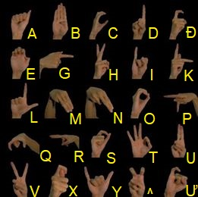

Fig. 1. Static Sign Language
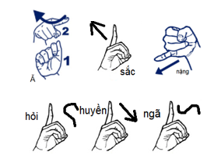
Fig. 2. Non-static Sign Language

Beside CNN, for non-static language recognition, we have chosen an another algorithm. We draw the contour of the hand and find the extreme north, south, east and west coordinates from this draw contour. Moreover, we calculate the transformation of these coordianates to track hand movement. Thankful for this, we can predict non-static sign language.
Sign Language Recognition using only webcam faces many troubles in real life, such as brightness, color, context… So we choose a situation that webcam can work well: a one-color wall behind with brightness of desk lamp, the person in front of the webcam has to wear a dark color shirt.
- Retaled Work
  - Detect skin color
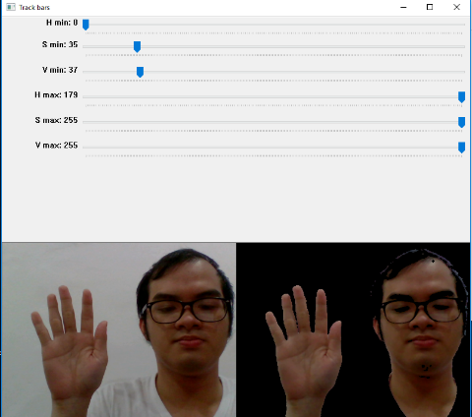
Hue Saturation Value (HSV) [4] model describes color with dominant color (Hue), colourfulness in proportion to the brightness (Saturation), and the volume of luminance (Lightness). The most important characteristic of the model is its explicit discrimination of luminance from chrominance. This makes the model insensitive to brightness at white color and ambient light; the properties that have attracted many researchers to put their skin color detection works on this model. In general, HSV color model has been chosen by many researchers as a favorite skin model for skin tone detection. The recognition of skin color is highly influenced by intensity and saturation of the image, the distribution of intensity, saturation, and hue should be defined for skin detection. Here we chose suitable threshold for hue and saturation which is not efficient for detecting skin regions for more number of people present in a single image.

Fig. 3. Using HSV to detect skin color

  - Get the Region of Interestin (ROI) focus on hand
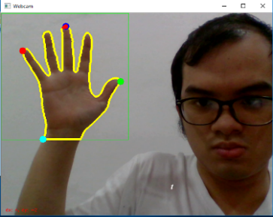
We have set-up a region of the frame which is a rectangle and its coordinates are (0,0), (300,300). The purpose of this work is to focus accurately the hand. After using HSV, the image now has only color of hand. It’s simple to find the contour bounding, then select the contour having the largest area. By using the Green Formula [5], the area of a contour is computed.

Fig. 4. Drawing contour of the hand

  - Convolutional neural network
CNN [6] contains three components:
+ Convolutional layers, which apply a specified number of convolution filters to the image. For each subregion, the layer performs a set of mathematical operations to produce a single value in the output feature map. Convolutional layers then typically apply a ReLU activation function to the output to introduce nonlinearities into the model.
+ Pooling layers, which downsample the image data extracted by the convolutional layers to reduce the dimensionality of the feature map in order to decrease processing time.
+ Dense (fully connected) layers, which perform classification on the features extracted by the convolutional layers and downsampled by the pooling layers. In a dense layer, every node in the layer is connected to every node in the preceding layer.
Typically, a CNN is composed of a stack of convolutional modules that perform feature extraction. Each module consists of a convolutional layer followed by a pooling layer. The last convolutional module is followed by one or more dense layers that perform classification. The final dense layer in a CNN contains a single node for each target class in the model, with a softmax activation function to generate a value between 0–1 for each node. Using a softmax-based classification head allows us to output values akin to probabilities for each VSL letter. This differs from another popular choice: the SVM loss. Using an SVM classification head would result in scores for each VSL letter that would not directly map to probabilities. These probabilities afforded to us by the softmax loss allow us to more intuitively interpret our results and prove useful when running our classifications through a language model.
- Build a program for recognition
  - Train CNN for static sign language recognition
CNN are inspired by the visual cortex of the human brain. The articial neurons in a CNN will connect to a local region of the visual field, called a receptive field. This is accomplished by performing discrete convolutions on the image with filter values as trainable weights. Multiple filters are applied for each channel, and together with the activation functions of the neurons, they form feature maps.
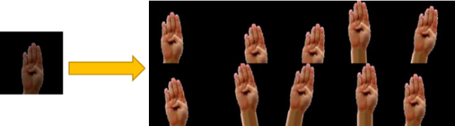
Deep learning uses neural nets with a lot of hidden layers and requires large amounts of training data. The dataset for train includes 2 group: images taken by the webcam and images which we augment from them. What is about to augment data? Data augmentation is another common pre-processing technique involves augmenting the existing data-set with perturbed versions of the existing images. Scaling, rotations and other affine transformations are typical. This is done to expose the neural network to a wide variety of variations. This makes it less likely that the neural network recognizes unwanted characteristics in the data-set. In our project, we used rotation, shift, zoom to augment our data.
Fig. 4. An example of using augmentation data
Our dataset includes: Includes data of 2 users (user 1 and user 2). Training data: 240 images are used for augmention (120 images taken from each user at 4 different light conditions, 3 different distance and 10 hand patterns) and 500 images are not used for augmention (taken from user 1). Testing data: 1000 images taken from user 2.
All CNN models follow a similar architecture. We perform a series convolution and pooling operations, followed by a fully connected layers. If we are performing multiclass classification the output is softmax.
Table 1. Model CNN for training
Layer (type) | Output Shape
Conv2D | (98, 98, 128)
MaxPooling2D | (49, 49, 128)
Dropout | (49, 49, 128)
Conv2D | (47, 47, 64)
MaxPooling2D | (23, 23, 64)
Dropout | (23, 23, 64)
Conv2D | (21, 21, 32)
MaxPooling2D | (10, 10, 32)
Dropout | (10, 10, 32)
Flatten | 3200
Dense | 128
Dense | 26

During training, dropout and data augmentation are used as main approaches to reduce overfitting. This consists of zooming up to 0.15, rotations up to 25 degree, spatial translations up to 0.25. Our model was trained by using Ndivia Tesla K80 provided Google Colab. We have set-up 50 epochs for our training model. The learning rate start with value 0.001 and decrease over time with 0.005 on decay rate [7].
$learning rate= \frac{learning rate}{1+decay rate*epoch}$ (1)
Batch size is size of the subset of examples to use when performing gradient descent during training. We have chosen that batch size is 512. In each batch size the percent of augmented images is 70% and the rest is raw images. Batch size is the number that feed into model for each iteration. Our time training is approximately 1 hours.
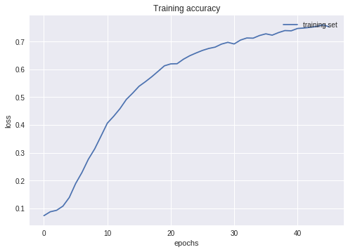
Fig. 5. Training accuracy over epochs
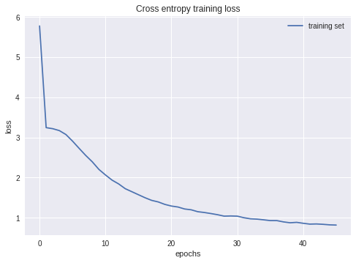
Fig. 6. Training loss over epochs
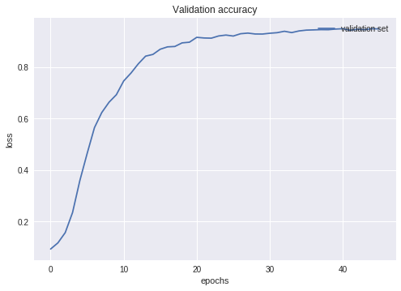
Fig. 7. Validation accuracy over epochs
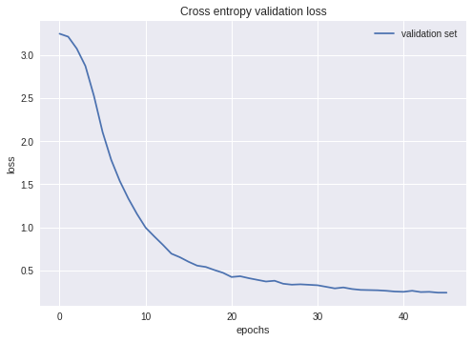
Fig. 8. Validation loss over epochs
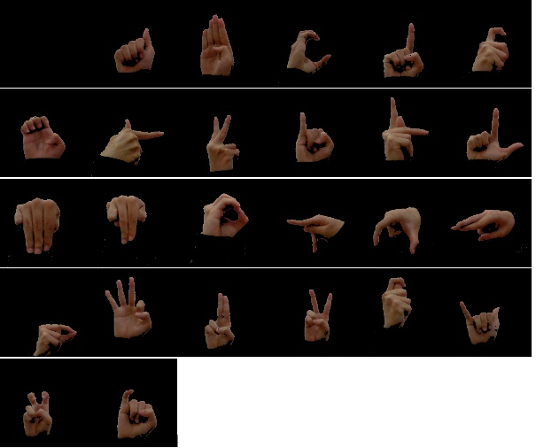
Fig. 9. An example of dataset for training
  - Using transformation of the extreme points of the hand for non-static sign language recognition
First, we need to find the extreme north, south, east and west coordinates from the raw contour [8]. Before we can find extreme points along a contour, it’s important to understand that a contour is simply a NumPy array of (x, y)-coordinates. Therefore, we can leverage NumPy functions to help us find the extreme coordinates.
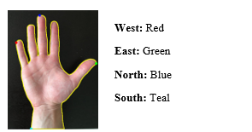
Fig. 10. Finding the extreme points of the hand
After that, we can actually compute the direction of the extreme points which is moving by investigating two previous (x, y)-coordinates [9]. However, it’s important to note that there is a bit of a catch to performing this computation. Unless our hand is moving quickly, the deltas between the (x, y)-coordinates will be very small. If we were to use these deltas to report direction, then our results would be extremely noisy, implying that even small, minuscule changes in trajectory would be considered a direction change. Instead, we compute the deltas between the coordinates of the current frame and a frame farther back in the queue. Performing this operation helps reduce noise and false reports of direction change. In our project, we compared the current frame and ten frames ago to calculate the deltas. And finally, we can use two deltas to determine the directions of our hands. Non-static sign language recognition requires these directions to track the hand movement. It’s essential to note that we used the frame with letter “D” to announce the beginning of our non-static sign language recognition.
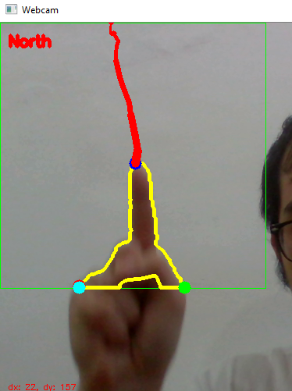
Fig. 11. Determine the direction of the hand

  - A completed program
After training CNN, we will have a .h5 file. Each time we want to use the program, we only need to load this file, do not have to train CNN anymore.
Now, we give the system the video captured by webcam for testing, in real-time. First, we need to use the trackbar to modify HSV values accordingly. The goal of this work is to detect our skin color. After that, we press “S” to save these values in a file skin_value.npy. And finally, we can use our program for vietnamese sign language recognition.
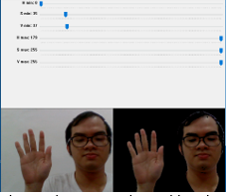
Fig. 12. Trackbars
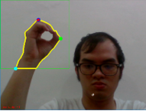

Fig. 13. Webcam on active

Fig.14 . ROI of hand
Fig.15 . Sequence show the context of VSL
- Results
The performance of our model on testing data (1000 images for each character that model has never seen before). These images are in perfect light conditions.
Table 2. Model performance
Character | Right prediction | Probability
A | 982 | 98.2%
B | 992 | 99.2%
C | 944 | 94.4%
D | 985 | 98.5%
Đ | 887 | 88.7%
E | 1000 | 100%
G | 982 | 98.2%
H | 942 | 94.2%
I | 954 | 95.4%
K | 996 | 99.6%
L | 985 | 98.5%
M | 467 | 46.7%
N | 854 | 85.4%
O | 943 | 94.3%
P | 1000 | 1000%
Q | 999 | 99.9%
R | 969 | 96.9%
S | 983 | 98.3%
T | 995 | 99.5%
U | 998 | 99.8%
V | 997 | 99.7%
X | 959 | 95.9%
Y | 1000 | 100%
^ | 999 | 99.9%
Ư | 860 | 86.0%
But when we deploy our model in real time, our model is not good at recognize character X, M and N. These failures may come from the training data or the augment processing or slightly overfitting in our model. For non-static sign language recognition, we haven’t still find a way to recognize the character ”dấu nặng”.
- Conclusion
In this paper, we have studied and applied image processing as well as deep learning techniques.
Although the results are not good as we desired, it is still an other way to approach sign language recognition. Moreover, “dấu nặng” is the only character of non-static sign language that we haven’t figured it how to recognize. We use two chips for running program: chip intel core i5-7200U and chip i5-4200H. The program seems very well, however, CNN requires large amounts of training data, so we have to face the limits of our dataset. If we can diversify our dataset, our VSL recognition will be better more.
In the future, we would like to improve the accuracy of the program, simultaneously we will study CNN 3D to analyse exactly the context of non-static sign language. Furthermore, we think it will be interesting if we combine voices in this program.

References
- tudienngonngukyhieuHomepage,tudienngongukyhieu.com, last access 2018/6/30.
- Siddharth S. Rautaray, Anupam Agrawal, “Real Time Hand Ges-ture Recognition System For Dynamic Applications”, pp. 23-25, International Journal of UbiComp (IJU), Vol.3, No.1, January 2012.
- Nagashree R N, Stafford Michahial, Aishwarya G N, Beebi Hajira Azeez, JayalakshmiM R, R Krupa Rani, “Hand gesture recognition using support vector machine”, pp. 46, The International Journal Of Engineering And Science (IJES).
- Maheswari, Reeba, Korah,
http://www.alliedacademies.org/articles/enhanced-skin-tone-detection-using-heuristic-thresholding.html, last access 2018/6/30.
- George Green, “An Essay on the Application of Mathematical Analysis to the Theories of Electricity and Magnetism”, Nottingham, England: T. Wheelhouse, 1828.
- tensorflowHomepage, https://www.tensorflow.org/, last access 2018/6/30.
- Nikhil Ketkar, “Deep Learning with Python A Hands-on Introduction”, pp. 116-120, Bangalore, Karnataka, India, 2017.
- Adrian Rosebrock,
https://www.pyimagesearch.com/2016/04/11/finding-extreme-points-in-contours-with-opencv/
- Adrian Rosebrock,
https://www.pyimagesearch.com/2015/09/21/opencv-track-object-movement/

