Helen Xu

P6 Analysis

**PercolationDFSFast**

simulation data for 10 trials

grid mean stddev total time

100 0.593 0.019 0.062

200 0.596 0.006 0.065

400 0.592 0.006 0.376

**PercolationBFS**

simulation data for 10 trials

grid mean stddev total time

100 0.593 0.019 0.067

200 0.596 0.006 0.074

400 0.592 0.006 0.528

**PercolationUF**

simulation data for 10 trials

grid mean stddev total time

100 0.593 0.019 0.048

200 0.596 0.006 0.079

400 0.592 0.006 0.281

1. Doubling the grid size has a quadratic effect on the runtime, as seen in the graph with grid size on the x axis and time on the y axis.

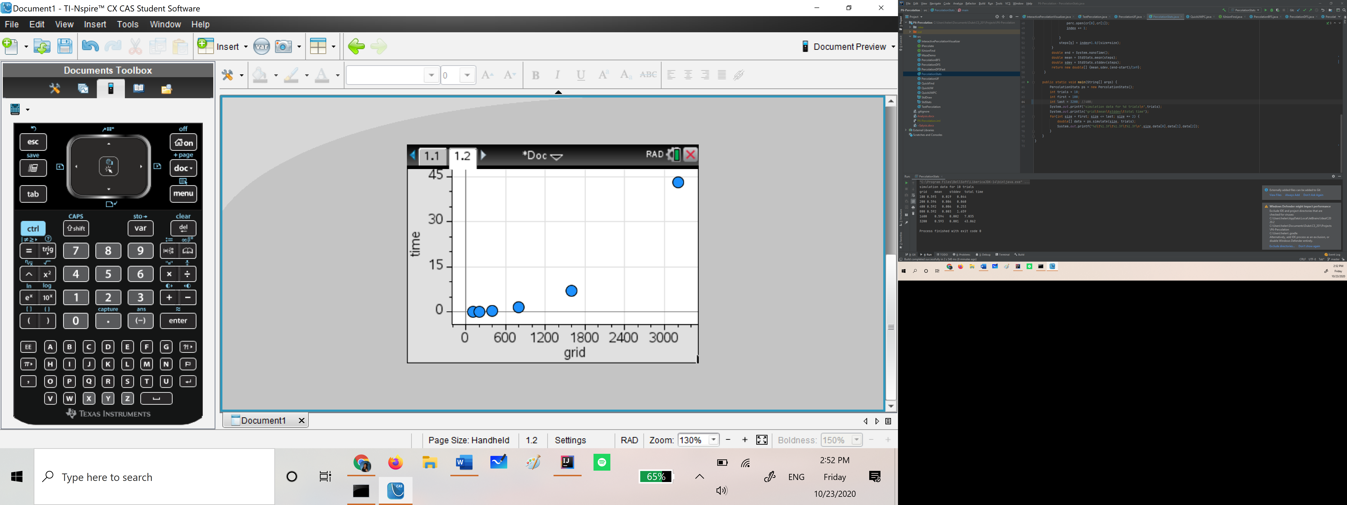

1. Doubling the number of trials approximately doubles the runtime.
2. The largest grid size I can run in 24 hours with 20 trials is about 81500. After plotting the runtimes for 20 trials with grid sizes 100 to 3200, I obtained the quadratic regression line and used that to solve for the maximum size that would finish running in 24 hours (86400 seconds), which turned out to be around 81500.