文法为：

E → T | Eω1T

T → F | Tω2F

F → i | (E)

其中ω1代表+和-，ω2代表*和/。

LL(1)分析法：

对文法消除左递归可得：

E → TE’ ①

E’ → ω1TE’ ② | ε ③

T → FT’ ④

T’ → ω2FT’ ⑤ | ε ⑥

F → i ⑦ | (E) ⑧

select(②) = first(ω1TE’)= { ω1 }

select(③) = first(ε) = Follow(E’) = { ) , # }

select(⑤) = first(ω2FT’) = { ω2 }

select(⑥) = first(ε) = Follow(T’) = { ω1 , ) , # }

select(⑦) = first(i) = { i }

select(⑧) = first(（E）) = { ( }

由于以上三对集合两两互不相交，所以更改后的文法符合LL(1)文法。

LL(1)分析表为：

|  |  |  |  |  |  |  |
| --- | --- | --- | --- | --- | --- | --- |
|  | i | ω1 | ω2 | ( | ) | # |
| E |  |  |  | ① |  |  |
| E’ |  | ② |  |  | ③ | ③ |
| T | ④ |  |  | ④ |  |  |
| T’ |  | ⑥ | ⑤ |  | ⑥ | ⑥ |
| F | ⑦ |  |  | ⑧ |  |  |

待翻译表达式为a*(b+c)

分析表为：

|  |  |  |  |  |
| --- | --- | --- | --- | --- |
| 分析栈 | Top | w | 剩余序列 | 操作 |
| #E | E | a | *(b+c)# | PUSH① |
| #E’T | T | a | *(b+c) # | PUSH④ |
| #E’T’F | F | a | *(b+c) # | PUSH⑦ |
| #E’T’i | i | a | *(b+c) # | Match! |
| #E’T’ | T’ | * | (b+c) # | PUSH⑤ |
| #E’T’F* | * | * | (b+c) # | Match! |
| #E’T’F | F | ( | b+c) # | PUSH⑧ |
| #E’T’)E( | ( | ( | b+c) # | Match! |
| #E’T’)E | E | b | +c) # | PUSH① |
| #E’T’) E’T | T | b | +c) # | PUSH④ |
| #E’T’) E’T’F | F | b | +c) # | PUSH⑦ |
| #E’T’) E’T’i | i | b | +c) # | Match! |
| #E’T’) E’T’ | T’ | + | c) # | PUSH⑥ |
| #E’T’) E’ | E’ | + | c) # | PUSH② |
| #E’T’) E’T+ | + | + | c) # | Match! |
| #E’T’) E’T | T | c | ) # | PUSH④ |
| #E’T’) E’T’F | F | c | ) # | PUSH⑦ |
| #E’T’) E’T’i | i | c | ) # | Match! |
| #E’T’) E’T’ | T’ | ) | # | PUSH⑥ |
| #E’T’) E’ | E’ | ) | # | PUSH③ |
| #E’T’) | ) | ) | # | Match! |
| #E’T’ | T’ | # |  | PUSH⑥ |
| #E’ | E’ | # |  | PUSH③ |
| # | # | # |  | OK |

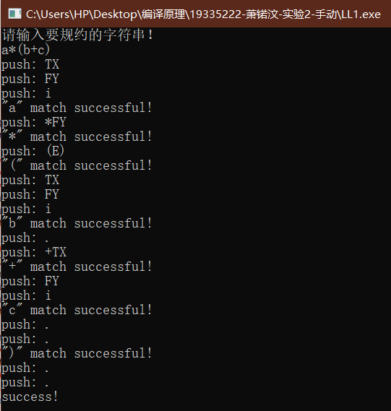结果截图为：

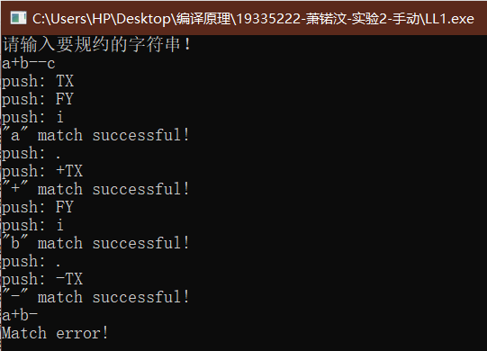错误结果运行截图为：

这代表该表达式不符合语法，导致匹配错误

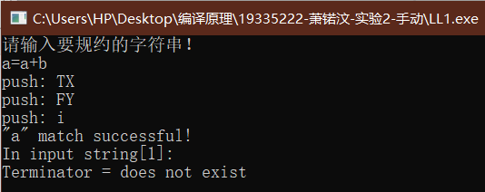

这代表表达式中出现语法以外的符号导致错误

LR(0)分析法：

扩展文法，是文法符号附有位置信息：

E’’→E1（0）

E → T2E’3 （1）

E’ → γ4T5E’6（2）| ε7（3）

T → F8T’9（4）

T’ → α10F11T’12（5）| ε13（6）

F → i14（7）| (15E16)17（8）

其中γ代表+和-，α代表*和/。

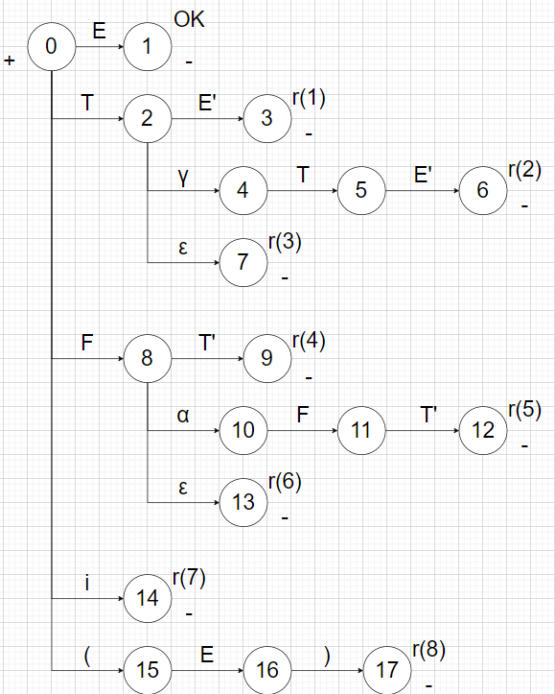构造句柄识别器：

可以看到②和⑧出现规约和移进冲突。

FOLLOW(E’) = {) , #} ∩ {γ} = Ø

FOLLOW(T’) = {γ , ) , #} ∩ {α} = Ø

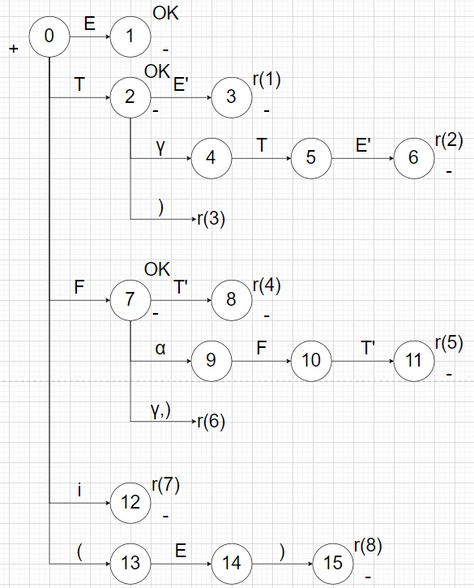所以扩展后的句柄识别器为：

分析表为：

|  |  |  |  |  |  |  |  |  |  |  |  |  |  |
| --- | --- | --- | --- | --- | --- | --- | --- | --- | --- | --- | --- | --- | --- |
|  | γ | α | （ | ） | i | # |  | | E | E’ | T | T’ | F |
| 0 |  |  | (13 |  | i12 |  | |  | E1 |  | T2 |  | F7 |
| 1 |  |  |  |  |  | OK | |  |  |  |  |  |  |
| 2 | γ4 |  |  | r(3) |  | OK | |  |  | E’3 |  |  |  |
| 3 | r(1) | r(1) | r(1) | r(1) | r(1) | r(1) | |  |  |  |  |  |  |
| *4 |  |  | (13 |  | i12 |  | |  |  |  | T5 |  | F7 |
| *5 | γ4 |  |  | r(3) |  | OK | |  |  | E’6 |  |  |  |
| 6 | r(2) | r(2) | r(2) | r(2) | r(2) | r(2) | |  |  |  |  |  |  |
| 7 | r(6) | α9 |  | r(6) |  | OK | |  |  |  |  | T’8 |  |
| 8 | r(4) | r(4) | r(4) | r(4) | r(4) | r(4) | |  |  |  |  |  |  |
| *9 |  |  | (13 |  | i12 |  | |  |  |  |  |  | F10 |
| *10 | r(6) | α9 |  | r(6) |  | OK | |  |  |  |  | T’11 |  |
| 11 | r(5) | r(5) | r(5) | r(5) | r(5) | r(5) | |  |  |  |  |  |  |
| 12 | r(7) | r(7) | r(7) | r(7) | r(7) | r(7) | |  |  |  |  |  |  |
| *13 |  |  | (13 |  | i12 |  | |  | E14 |  | T2 |  | F7 |
| 14 |  |  |  | )15 |  |  | |  |  |  |  |  |  |
| 15 | r(8) | r(8) | r(8) | r(8) | r(8) | r(8) | |  |  |  |  |  |  |

待翻译的表达式为a/(a-b)

分析表为：

|  |  |  |  |  |
| --- | --- | --- | --- | --- |
| 分析栈 | 符号栈 | w | 剩余串 | 操作 |
| #0 | #a | a | /(a-b)# | PUSH(a14),NEXT(w) |
| #014 | #a | / | (a-b)# | REDUCE(7) |
| #08 | #F | / | (a-b)# | PUSH(/10),NEXT(w) |
| #0810 | #F/ | ( | a-b)# | PUSH((13),NEXT(w) |
| #081015 | #F/( | a | -b)# | PUSH(a14),NEXT(w) |
| #08101514 | #F/(a | - | b)# | REDUCE(7) |
| #0810158 | #F/(F | - | b)# | REDUCE(6) |
| #08101589 | #F/(FT’ | - | b)# | REDUCE(4) |
| #0810152 | #F/(T | - | b)# | PUSH(-4),NEXT(w) |
| #08101524 | #F/(T- | b | )# | PUSH(b14),NEXT(w) |
| #0810152414 | #F/(T-b | ) | # | REDUCE(7) |
| #081015248 | #F/(T-F | ) | # | REDUCE(6) |
| #0810152489 | #F/(T-FT’ | ) | # | REDUCE(4) |
| #081015245 | #F/(T-T | ) | # | REDUCE(3) |
| #0810152456 | #F/(T-TE’ | ) | # | REDUCE(2) |
| #08101523 | #F/(TE’ | ) | # | REDUCE(1) |
| #08101516 | #F/(E | ) | # | PUSH()17),NEXT(w) |
| #0810151617 | #F/(E) | # |  | REDUCE(8) |
| #081011 | #F/F | # |  | REDUCE(6) |
| #08101112 | #F/FT’ | # |  | REDUCE(5) |
| #089 | #FT’ | # |  | REDUCE(4) |
| #02 | #T | # |  | REDUCE(3) |
| #023 | #TE’ | # |  | REDUCE(1) |
| #01 | #E | # |  | OK |

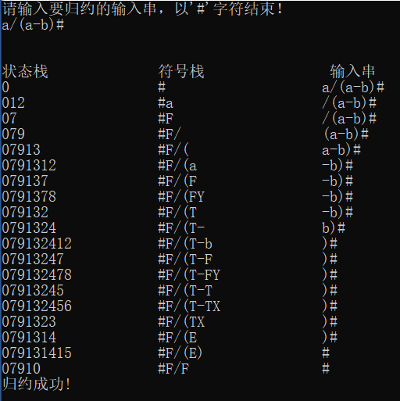运行结果如图：

由于程序用的是SLR(1)分析表，因此结果与上面的LR(0)分析表不同，少了空集的分析部分。

错误结果运行截图为：

