概述
Camera功能就是摄像头（硬件）采集数据，但是我们要在屏幕上看到这些采集到的图像还需要一个东西来显示，在Android中这个功能是是由SurfaceView来完成的。有时我们可能还需要把这些采集到的图像保存起来，也就是录制功能，Android中MediaRecorder来完成这个功能。由此可见，我们可以把Android Camera子系统分为三部分：
- SurfaceView：显示，上层用来显示Camera采集的图像
- Camera：采集，功能的具体实现，负责采集视频信号
- MediaRecorder：录制，通过调用AudioFling和OpenCORE完成音视频的录制

首先看一张图，对整个架构有一个了解：
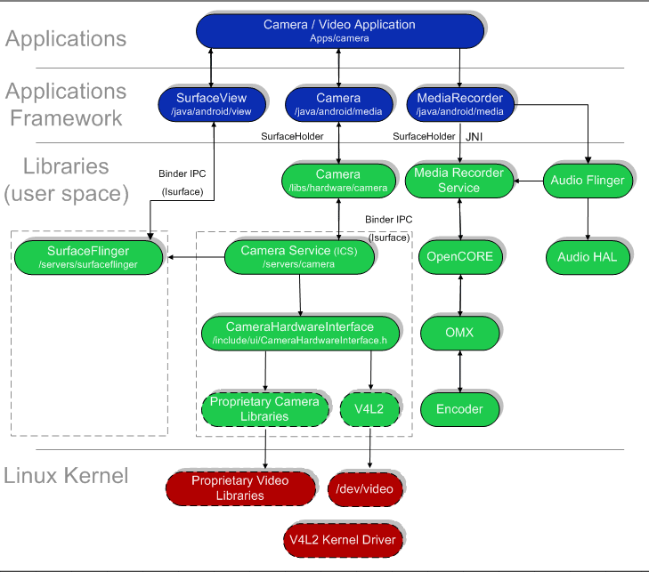
代码结构：
应用：
Camera程序的目录：
packages/apps/Camera
框架：
frameworks/base/core/java/android/view/SurfaceView.java
frameworks/base/core/java/android/hardware/Camera.java
frameworks/base/core/jni/android_hardware_Camera.cpp
frameworks/base/media/java/android/media/MediaRecorder.java
库：
frameworks/base/libs/surfaceflinger/*
frameworks/base/libs/ui/Camera.cpp
frameworks/base/camera/libcameraservice/*
frameworks/base/include/ui/CameraHardwareInterface.h
frameworks/base/media/libmedia/mediarecorder.cpp
frameworks/base/libs/audioflinger/*
驱动：

代码分析
这一部分我们主要去看一些具体的实现，从代码调用的角度来看一下，Camera的具体实现，我们主要分析以下几个方面：
- Camera Preview
- Camera Take Picture
- Camera Recorder

Camera Preview
还是先上图，然后再详细分析：
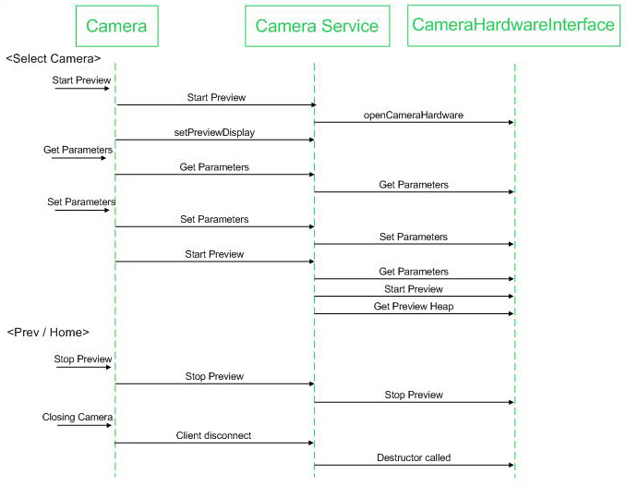

上图从说明了从Camera应用到Camera HAL部分的调用流程，下面从具体代码分析一下上面的流程：
Camera.java（应用程序）中的onCreate会启动一个线程来调用startPreview：
private void startPreview() throws CameraHardwareException {
if (mPausing || isFinishing()) return;

ensureCameraDevice();

// If we're previewing already, stop the preview first (this will blank
// the screen).
if (mPreviewing) stopPreview();

setPreviewDisplay(mSurfaceHolder);
setCameraParameters();

final long wallTimeStart = SystemClock.elapsedRealtime();
final long threadTimeStart = Debug.threadCpuTimeNanos();

// Set one shot preview callback for latency measurement.
mCameraDevice.setOneShotPreviewCallback(mOneShotPreviewCallback);
mCameraDevice.setErrorCallback(mErrorCallback);

try {
Log.v(TAG, "startPreview");
mCameraDevice.startPreview();
} catch (Throwable ex) {
closeCamera();
throw new RuntimeException("startPreview failed", ex);
}
mPreviewing = true;
mZooming = false;
mStatus = IDLE;

long threadTimeEnd = Debug.threadCpuTimeNanos();
long wallTimeEnd = SystemClock.elapsedRealtime();
if ((wallTimeEnd - wallTimeStart) > 3000) {
Log.w(TAG, "startPreview() to " + (wallTimeEnd - wallTimeStart)
+ " ms. Thread time was"
+ (threadTimeEnd - threadTimeStart) / 1000000 + " ms.");
}
}

打开Camera
确认摄像头存在：
private void ensureCameraDevice() throws CameraHardwareException {
if (mCameraDevice == null) {
mCameraDevice = CameraHolder.instance().open();
mInitialParams = mCameraDevice.getParameters();
}
}
打开camera @CameraHolder.java：
public synchronized android.hardware.Camera open()
throws CameraHardwareException {
Assert(mUsers == 0);
if (mCameraDevice == null) {
try {
mCameraDevice = android.hardware.Camera.open();
} catch (RuntimeException e) {
Log.e(TAG, "fail to connect Camera", e);
throw new CameraHardwareException(e);
}
mParameters = mCameraDevice.getParameters();
} else {
try {
mCameraDevice.reconnect();
} catch (IOException e) {
Log.e(TAG, "reconnect failed.");
throw new CameraHardwareException(e);
}
mCameraDevice.setParameters(mParameters);
}
++mUsers;
mHandler.removeMessages(RELEASE_CAMERA);
mKeepBeforeTime = 0;
return mCameraDevice;
}
调用Framework中的Camera.java @frameworks/base/core/java/android/hardware/Camera.java打开Camera：
public static Camera open() {
return new Camera();
}

Camera() {
mShutterCallback = null;
mRawImageCallback = null;
mJpegCallback = null;
mPreviewCallback = null;
mPostviewCallback = null;
mZoomCallback = null;

Looper looper;
if ((looper = Looper.myLooper()) != null) {
mEventHandler = new EventHandler(this, looper);
} else if ((looper = Looper.getMainLooper()) != null) {
mEventHandler = new EventHandler(this, looper);
} else {
mEventHandler = null;
}

native_setup(new WeakReference<Camera>(this));
}
Camera.java native_setup通过JNI调用android_hardware_Camera.cpp，通过调用Camera::connect来得到一个Camera指针：
static void android_hardware_Camera_native_setup(JNIEnv *env, jobject thiz, jobject weak_this)
{
sp<Camera> camera = Camera::connect();

if (camera == NULL) {
jniThrowException(env, "java/lang/RuntimeException",
"Fail to connect to camera service");
return;
}

// make sure camera hardware is alive
if (camera->getStatus() != NO_ERROR) {
jniThrowException(env, "java/lang/RuntimeException", "Camera initialization failed");
return;
}

jclass clazz = env->GetObjectClass(thiz);
if (clazz == NULL) {
jniThrowException(env, "java/lang/RuntimeException", "Can't find android/hardware/Camera");
return;
}

// We use a weak reference so the Camera object can be garbage collected.
// The reference is only used as a proxy for callbacks.
sp<JNICameraContext> context = new JNICameraContext(env, weak_this, clazz, camera);
context->incStrong(thiz);
camera->setListener(context);

// save context in opaque field
env->SetIntField(thiz, fields.context, (int)context.get());
}
接着调用Camera.cpp @frameworks/base/lib/ui/Camera.cpp，connect()通过getCameraService()得到一个ICameraService，再通过ICameraService -> connect(c)得到一个ICamera指针：
sp<Camera> Camera::connect()
{
LOGV("connect");
sp<Camera> c = new Camera();
const sp<ICameraService>& cs = getCameraService();
if (cs != 0) {
c->mCamera = cs->connect(c);
}
if (c->mCamera != 0) {
c->mCamera->asBinder()->linkToDeath(c);
c->mStatus = NO_ERROR;
} else {
c.clear();
}
return c;
}
调用ICameraService.cpp
virtual sp<ICamera> connect(const sp<ICameraClient>& cameraClient)
{
Parcel data, reply;
data.writeInterfaceToken(ICameraService::getInterfaceDescriptor());
data.writeStrongBinder(cameraClient->asBinder());
remote()->transact(BnCameraService::CONNECT, data, &reply);
return interface_cast<ICamera>(reply.readStrongBinder());
}
最后通过BnCameraService::onTransact把消息发出去：
status_t BnCameraService::onTransact(
uint32_t code, const Parcel& data, Parcel* reply, uint32_t flags)
{
switch(code) {
case CONNECT: {
CHECK_INTERFACE(ICameraService, data, reply);
sp<ICameraClient> cameraClient = interface_cast<ICameraClient>(data.readStrongBinder());
sp<ICamera> camera = connect(cameraClient);
reply->writeStrongBinder(camera->asBinder());
return NO_ERROR;
} break;
default:
return BBinder::onTransact(code, data, reply, flags);
}
}

StartPreview
应用中的mCameraDevice.startPreview()调用框架的native 函数startPreview @Camera.java，startPreview指向android_hardware_Camera_startPreview @android_hardware_Camera.cpp函数：
static void android_hardware_Camera_startPreview(JNIEnv *env, jobject thiz)
{
LOGV("startPreview");
sp<Camera> camera = get_native_camera(env, thiz, NULL);
if (camera == 0) return;

if (camera->startPreview() != NO_ERROR) {
jniThrowException(env, "java/lang/RuntimeException", "startPreview failed");
return;
}
}
调用startPreview：
status_t Camera::startPreview()
{
LOGV("startPreview");
sp <ICamera> c = mCamera;
if (c == 0) return NO_INIT;
return c->startPreview();
}
调用ICamera.cpp：
status_t startPreview()
{
LOGV("startPreview");
Parcel data, reply;
data.writeInterfaceToken(ICamera::getInterfaceDescriptor());
remote()->transact(START_PREVIEW, data, &reply);
return reply.readInt32();
}
BINDER调用：
status_t BnCamera::onTransact(
uint32_t code, const Parcel& data, Parcel* reply, uint32_t flags)
{
switch(code) {
…
case START_PREVIEW: {
LOGV("START_PREVIEW");
CHECK_INTERFACE(ICamera, data, reply);
reply->writeInt32(startPreview());
return NO_ERROR;
} break;
…
default:
return BBinder::onTransact(code, data, reply, flags);
}
}

