$d=l\sqrt{n}$

1. Limited data from 10-120, get average value

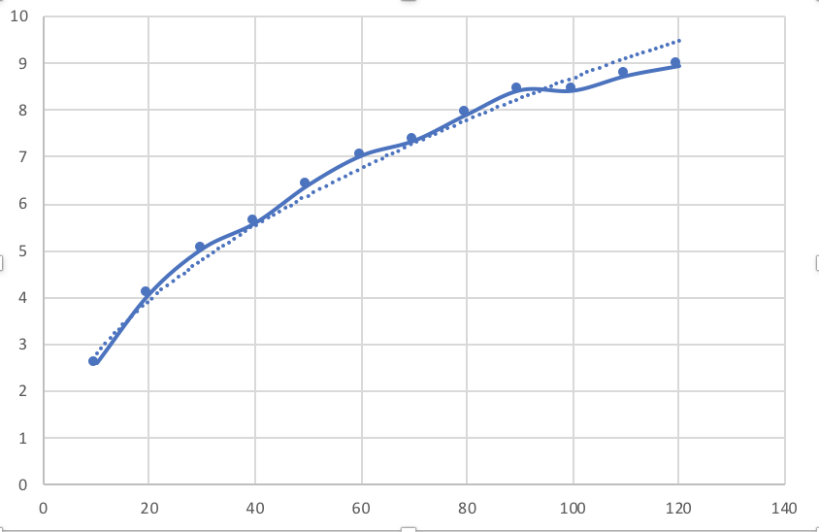

Collect data from step 0-299, length=1, get value to draw a diagram in Excel

Get more data:

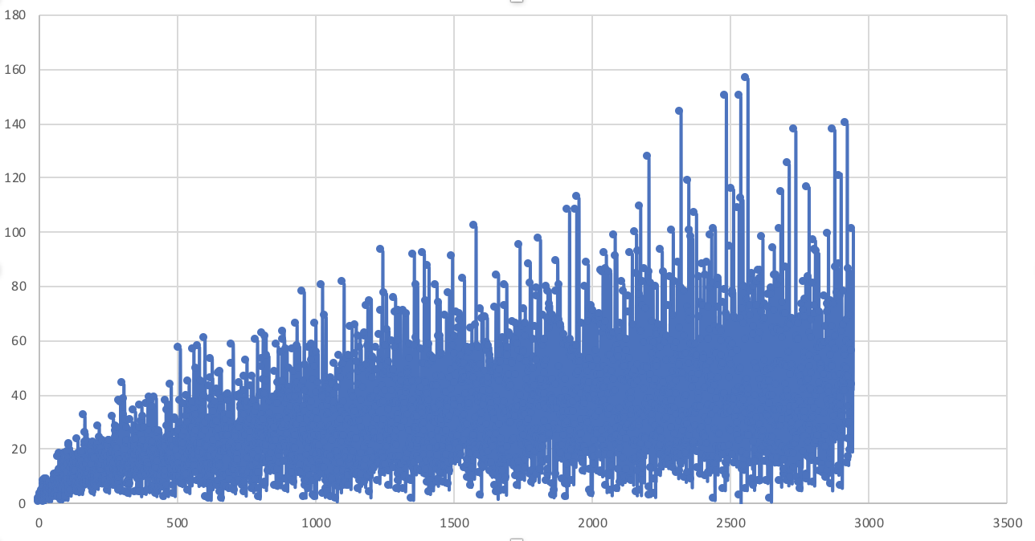

Distance is close to $l\sqrt{n}$

1. Run the code .java file in zip

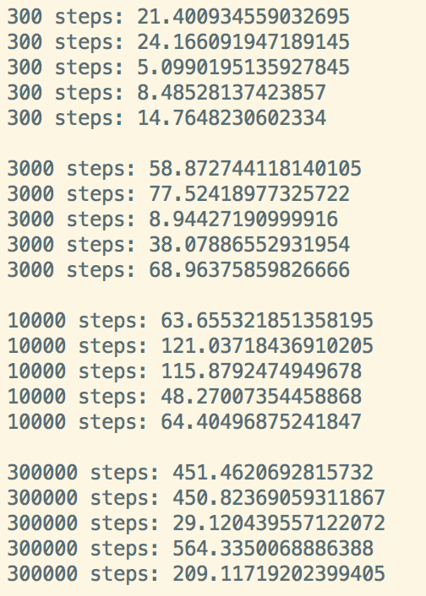

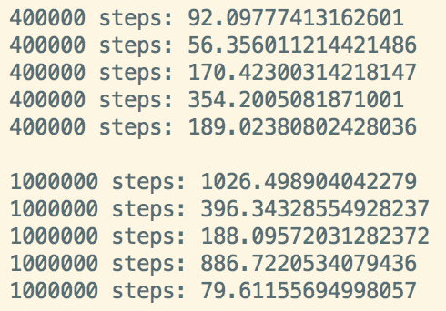

1. Unit test passing

