1. Unit test:

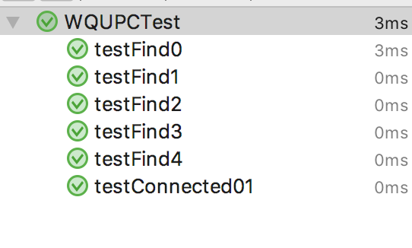

1. Run main ()

Input 100 as an example

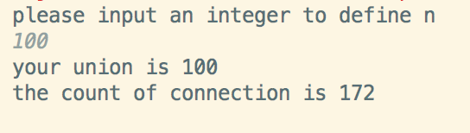

If the value of n is invalid, you are required to input another n until it is valid

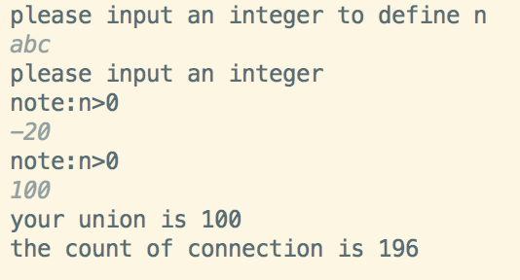

1. Run the program for multiple times, with different n value. Each n run for 100 times. Then we can get the average value.

And then use Excel to draw the diagram

Sample value:

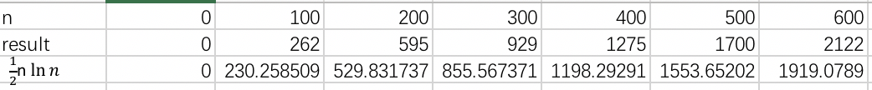



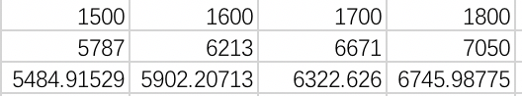

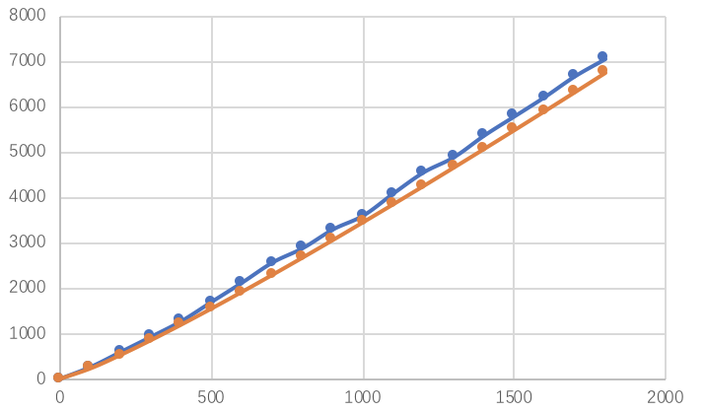

The blue line is the average result, the orange line is $\frac{1}{2}n\ln{n}$

From the diagram, we can know that they are very close and similar.

So we can draw a conclusion that the relationship $count\sim \frac{1}{2}n\ln{n}$ is correct.