**Problem 1**

Codes:

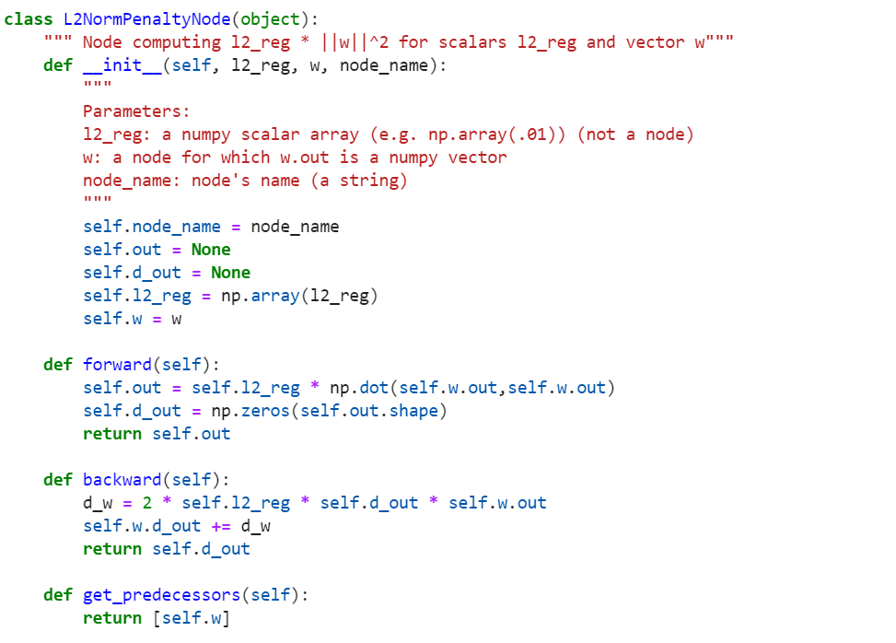

Test Results:

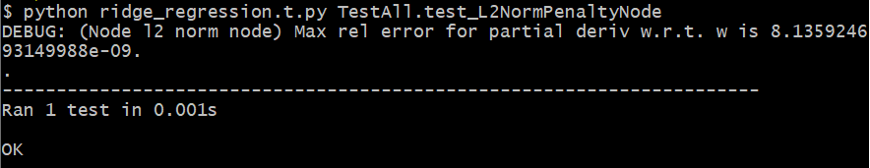

**Problem 2**

Codes:

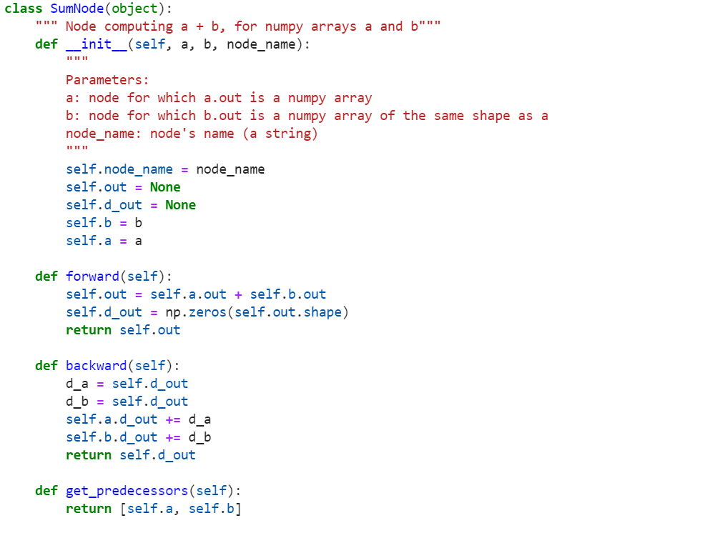

Test Results:

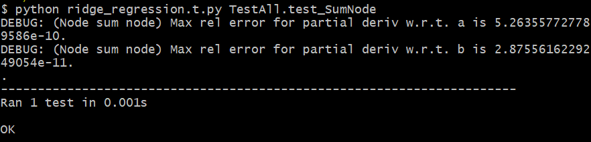

**Problem 3**

Codes:

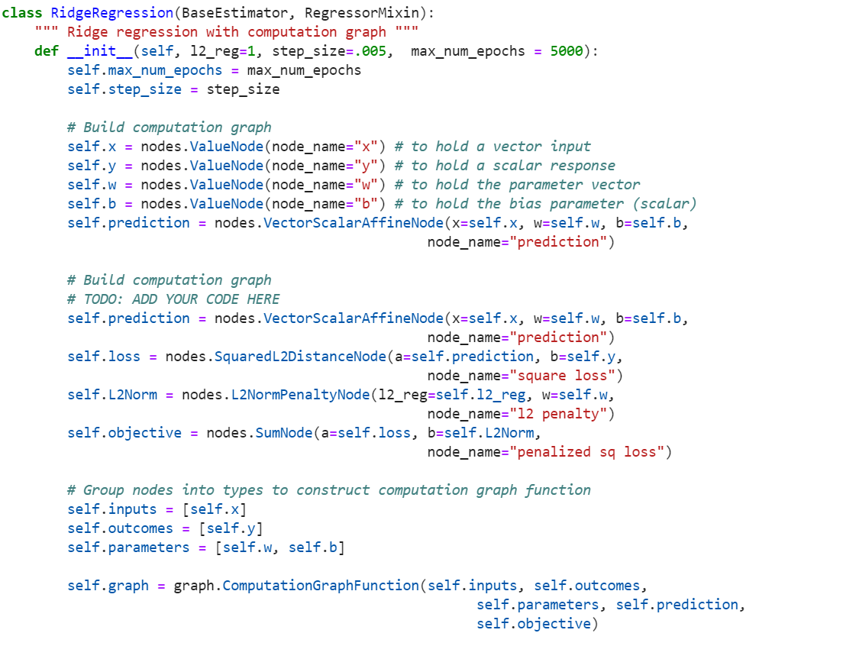

Test Results:

Setting 1: l2reg = 1, step_size=0.00005, max_num_epochs=2000

Average Square Error = **0.20121047965190475**

Setting 2: l2reg = 1, step_size=0.00005, max_num_epochs=500

Average Square Error = **0. 0443814303794584**

**Problem 4**

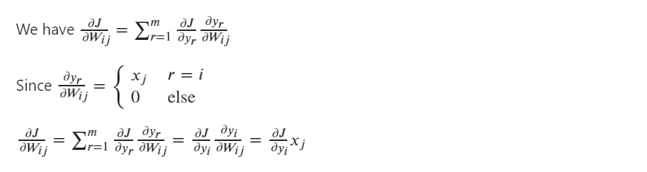

**Problem 5**

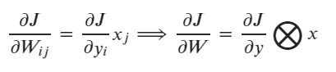

**Problem 6**

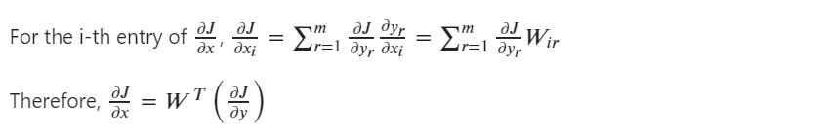

**Problem 7**

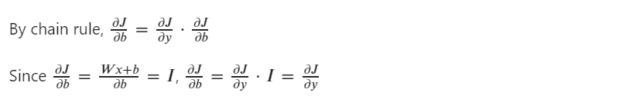

**Problem 8**

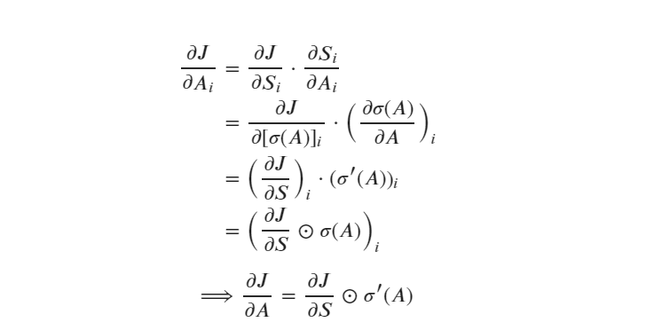

**Problem 9**

Code:

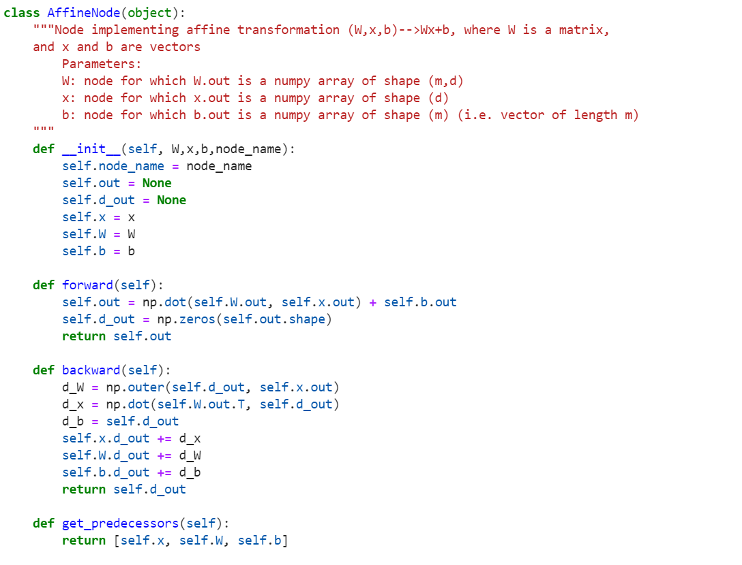

Test Results:

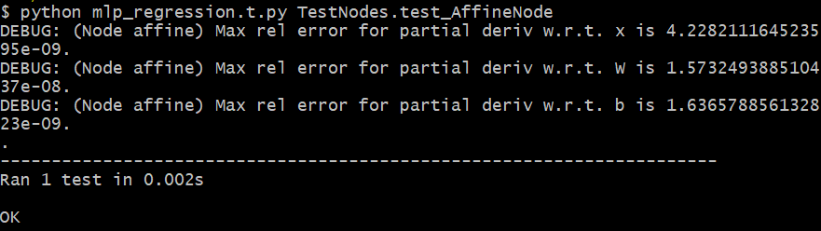

**Problem 10**

Codes:

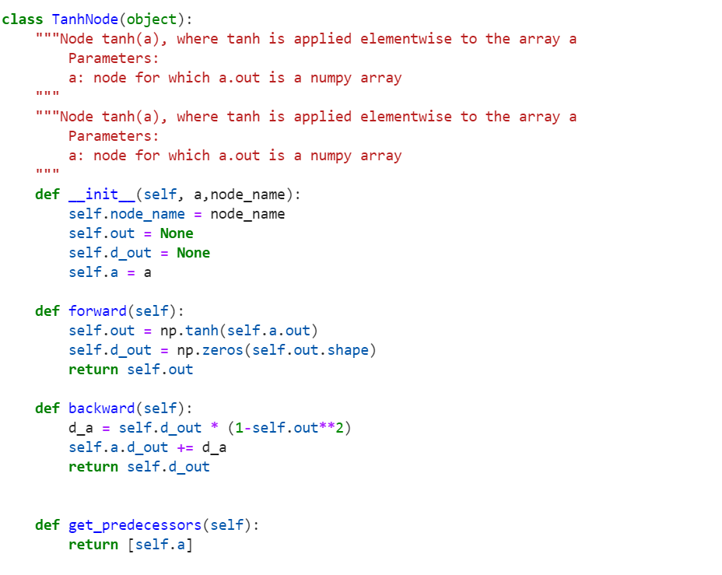

Test Results:

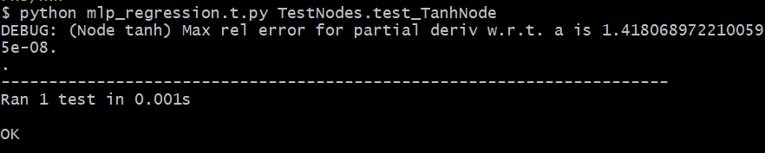

**Problem 11**

Codes:

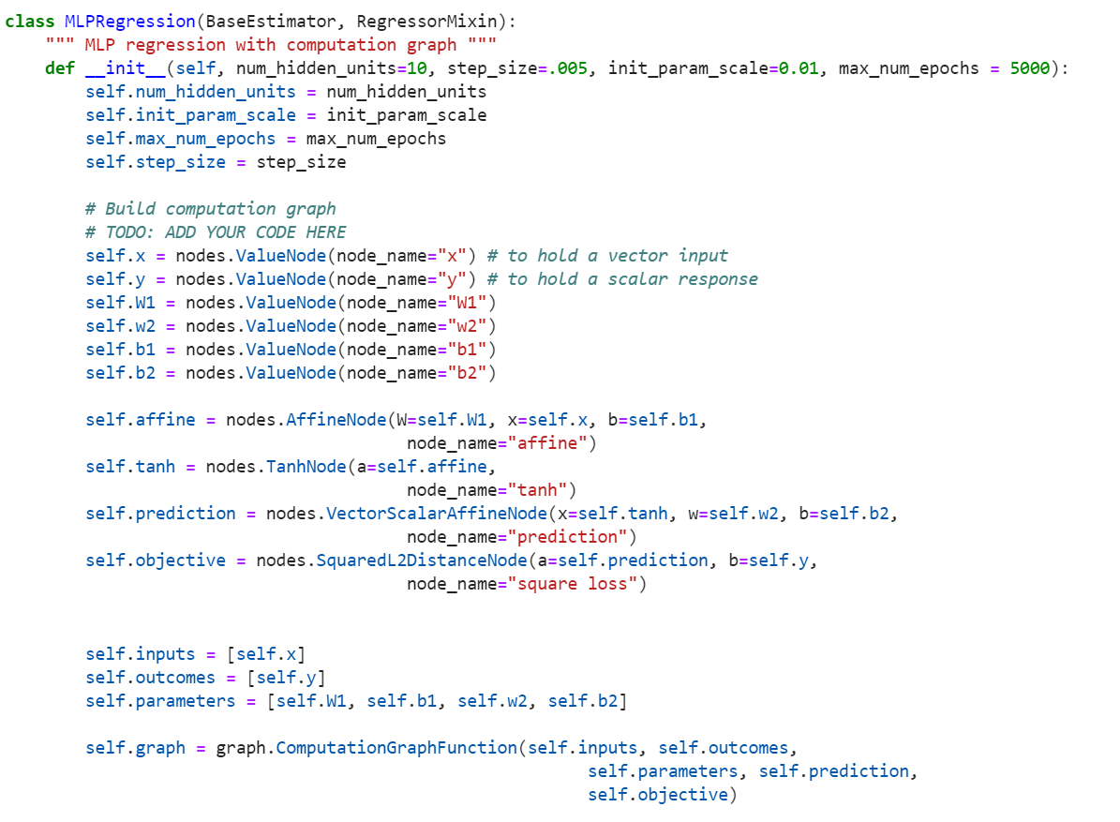

Test Results:

Setting 1: step_size=0.001, init_param_scale=.0005, max_num_epochs=5000

Average Square Error = **0.26107056770910664**

Setting 2: step_size=0.0005, init_param_scale=.01, max_num_epochs=500

Average Square Error = **0.0429245017966997**

