Revealing the Generalization Boundary of GNNs in Molecular Property Prediction:
A Multi-Seed Scaffold Split Study
Technical Report / Mini-Paper
Dataset: BBBP | Models: GCN, GraphSAGE, GAT | Seeds: 0–4

Abstract
Graph neural networks (GNNs) are widely used for molecular property prediction, but a high score on a single train–test split does not establish reliable generalization to structurally novel chemistry. This study examines the stability and chemical-space dependence of three representative GNN architectures—GCN, GraphSAGE, and GAT—on the blood–brain barrier penetration (BBBP) classification task. We used five seeded scaffold splits and observed a striking split-dependent failure: while Seeds 0, 1, 2, and 4 produced ROC-AUC values near 0.89–0.92 for most models, Seed 3 reduced ROC-AUC to 0.6952, 0.5681, and 0.5271 for GCN, GraphSAGE, and GAT, respectively. A hypothesis-driven diagnosis was then performed. H1, that Seed 3 represents a stronger chemical-space shift, was supported: its median test-to-train maximum Morgan/Tanimoto similarity was 0.3125 versus 0.4746–0.5513 for the other splits, and 62.9% of Seed 3 test molecules had similarity below 0.4. H2, that this shift was mainly concentrated in negative molecules, was not supported because positive and negative molecules in Seed 3 showed similarly low similarity distributions. H3, that lower chemical similarity is associated with worse molecular prediction, received partial support. Pooled similarity–BCE-loss correlations were negative for all models, and low-similarity bins showed consistently higher loss and lower accuracy. However, within-split Spearman correlations were weak and inconsistent, especially in Seed 3. These findings suggest that chemical-space shift is a useful split-level indicator of evaluation difficulty, whereas a single fingerprint-based similarity measure is insufficient as a molecule-level determinant of prediction failure. The study highlights the importance of multi-split evaluation, explicit chemical-space diagnostics, and cautious interpretation of benchmark performance in AIDD.
Keywords: molecular property prediction; graph neural networks; scaffold split; BBBP; out-of-distribution generalization; Morgan fingerprint; Tanimoto similarity; AIDD

1. Introduction
Molecular property prediction is a central component of AI-assisted drug discovery (AIDD), where machine-learning models are used to prioritize compounds before expensive downstream experiments. Graph neural networks are particularly attractive because molecules can be represented directly as graphs of atoms and bonds. Yet the practical question is not only whether a model can interpolate within a familiar benchmark distribution, but whether it remains reliable when evaluated on new chemical series.
MoleculeNet established scaffold splitting as a useful benchmark protocol for tasks such as BBBP because it separates molecules according to two-dimensional structural frameworks and is generally more challenging than a random split [1]. Subsequent molecular-representation studies emphasized that evaluation design strongly affects apparent generalization and that scaffold-aware evaluation can better probe transfer to new chemistry than purely random splitting [2]. However, a scaffold split is not a single deterministic difficulty level: when scaffold groups are assigned differently, the resulting train/test chemical relationship can change substantially.
This report investigates that variability rather than treating it as nuisance noise. The initial experiment compared GCN, GraphSAGE, and GAT under five scaffold-split seeds. The unexpected observation was a simultaneous performance collapse for all three architectures under Seed 3. This shared failure motivated a sequence of falsifiable hypotheses about chemical-space shift and prediction reliability. The central research question is therefore:
How does the chemical-space relationship between training and test molecules constrain the observed generalization of molecular GNNs?

2. Methods

2.1 Dataset and molecular graph construction
The experiments used the BBBP binary classification dataset, which contains slightly more than 2,000 compounds labeled by blood–brain barrier permeability. The supplied pipeline reads SMILES strings and labels, converts valid molecules with RDKit, and represents each molecule as a graph. Atom features include atom type, degree, formal charge, hybridization, chirality, ring membership, aromaticity, hydrogen count, and implicit valence. Bond features are constructed and stored in the graph object; however, the three evaluated convolution layers consume node features and edge indices rather than the stored bond attributes. This should be viewed as a property of the present baseline implementation, not as a general statement about GNNs.

2.2 Multi-seed scaffold splitting
Bemis–Murcko scaffolds were generated with RDKit. Molecules sharing the same scaffold were kept in the same partition. For each seed in {0,1,2,3,4}, scaffold groups were shuffled and allocated to approximately 80% training, 10% validation, and 10% test data, with safeguards to keep validation and test sets non-empty and to include both classes. The supplied implementation also enforces at least 20 negative examples in validation and test when possible. Each observed split contained 1,629 training molecules, 205 validation molecules, and 205 test molecules, with 1,102 scaffold groups.
Seed | Train pos/neg | Val pos/neg | Test pos/neg | Test positive prevalence
0 | 1262 / 367 | 154 / 51 | 144 / 61 | 0.7024
1 | 1235 / 394 | 153 / 52 | 172 / 33 | 0.8390
2 | 1243 / 386 | 154 / 51 | 163 / 42 | 0.7951
3 | 1232 / 397 | 152 / 53 | 176 / 29 | 0.8585
4 | 1239 / 390 | 168 / 37 | 153 / 52 | 0.7463

Table 1. Class composition of the five scaffold splits.

2.3 GNN architectures and training
Three message-passing architectures were compared under a common graph-level classification pipeline: a three-layer GCN, a three-layer GraphSAGE model using max aggregation, and a three-layer GAT with two attention heads in the hidden attention blocks. Hidden dimensionality was 64. Each convolution was followed by a nonlinear activation and dropout (p = 0.5), followed by global mean pooling and a linear binary-classification head.
Models were optimized with Adam (learning rate 1×10⁻³, weight decay 5×10⁻⁴) and BCEWithLogitsLoss for up to 100 epochs. Validation ROC-AUC selected the best checkpoint. Test performance was reported with ROC-AUC and average precision (PRC-AUC/AP). Because positive prevalence varied strongly across test splits, AP was interpreted together with the split-specific positive prevalence rather than as an isolated score.

2.4 Hypothesis-driven diagnosis
The diagnostic phase followed a hypothetico-deductive structure: an observation generated a falsifiable hypothesis; the hypothesis generated an observable prediction; and the prediction was tested without redefining success after seeing the result.
Hypothesis | Operational prediction | Primary test
H1: Seed 3 has stronger chemical-space shift. | Seed 3 maximum Tanimoto similarity distribution shifts to lower values. | Morgan fingerprint (radius 2, 2048 bits) + maximum train-set Tanimoto similarity.
H2: Seed 3 shift is mainly concentrated in negative molecules. | Seed 3 negatives have substantially lower similarity than Seed 3 positives. | Label-stratified similarity statistics within Seed 3 and across seeds.
H3: Lower test-to-train similarity is associated with worse GNN prediction. | Similarity is negatively associated with per-molecule BCE loss; low-similarity bins have worse outcomes. | Pooled/per-seed Spearman, similarity bins, and cross-model ErrorCount.

Table 2. Hypotheses, predictions, and diagnostic tests.
For each test molecule x, chemical proximity to the training set was defined as the maximum Tanimoto similarity between its Morgan fingerprint and any training-set fingerprint:
S(x) = maxₜ∈Train Tanimoto[FP(x), FP(t)].
For H3, model probabilities were converted to per-molecule binary cross-entropy (BCE) loss. Spearman correlation was used because the hypothesized relationship need not be linear. Similarity was also discretized into Low (<0.3), Medium (0.3–0.5), and High (≥0.5) bins. Finally, ErrorCount was defined as the number of the three models that misclassified a molecule at a prespecified probability threshold of 0.5.

3. Results

3.1 Multi-seed evaluation reveals a shared hard split
The main result was not a stable ranking among architectures, but strong split sensitivity. Seeds 0, 1, 2, and 4 generally produced ROC-AUC values around 0.89–0.92. Seed 3 instead caused all three models to deteriorate simultaneously.
Seed | GCN | GraphSAGE | GAT
0 | 0.9167 | 0.9186 | 0.8938
1 | 0.9077 | 0.8899 | 0.8941
2 | 0.9090 | 0.9187 | 0.9123
3 | 0.6952 | 0.5681 | 0.5271
4 | 0.8963 | 0.8968 | 0.8972

Table 3. Test ROC-AUC by scaffold-split seed.
Model | Test ROC-AUC | Test PRC-AUC
GCN | 0.8650 ± 0.0851 | 0.9583 ± 0.0159
GraphSAGE | 0.8384 ± 0.1357 | 0.9508 ± 0.0281
GAT | 0.8249 ± 0.1490 | 0.9456 ± 0.0322

Table 4. Five-seed aggregate performance. The reported standard deviation is the NumPy default population standard deviation (ddof=0) used by the supplied experiment script.
Across five splits, GCN had the highest mean ROC-AUC (0.8650) and the smallest reported variability (0.0851), followed by GraphSAGE (0.8384 ± 0.1357) and GAT (0.8249 ± 0.1490). These differences are small relative to split-to-split variation and should not be interpreted as evidence of statistically established architectural superiority. The shared Seed 3 failure instead suggests that properties of the split itself are central to the observed instability.

3.2 H1: Seed 3 exhibits a stronger chemical-space shift
H1 predicted that Seed 3 test molecules would be systematically farther from the corresponding training molecules. The prediction was strongly supported descriptively. Seed 3 had a median maximum Tanimoto similarity of 0.3125, compared with 0.4746, 0.4792, 0.5513, and 0.5333 for Seeds 0, 1, 2, and 4. Its first quartile was 0.2143, and 62.9% of test molecules had maximum similarity below 0.4, compared with 30.7–34.6% for Seeds 0–2 and 31.2% for Seed 4.
Seed | Mean | Median | Q1 | Q3 | %<0.3 | %<0.4 | %<0.5
0 | 0.494 | 0.475 | 0.351 | 0.625 | 15.1% | 34.6% | 52.7%
1 | 0.502 | 0.479 | 0.357 | 0.634 | 13.7% | 34.1% | 52.2%
2 | 0.525 | 0.551 | 0.364 | 0.646 | 13.7% | 30.7% | 40.5%
3 | 0.378 | 0.312 | 0.214 | 0.562 | 45.9% | 62.9% | 70.2%
4 | 0.528 | 0.533 | 0.369 | 0.673 | 9.3% | 31.2% | 43.9%

Table 5. Test-to-train maximum Morgan/Tanimoto similarity statistics.
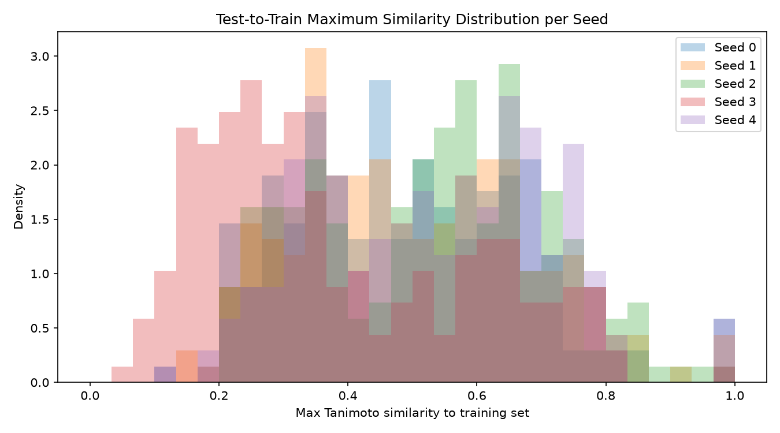
Figure 1. Distribution of test-to-train maximum Tanimoto similarity for the five scaffold splits.
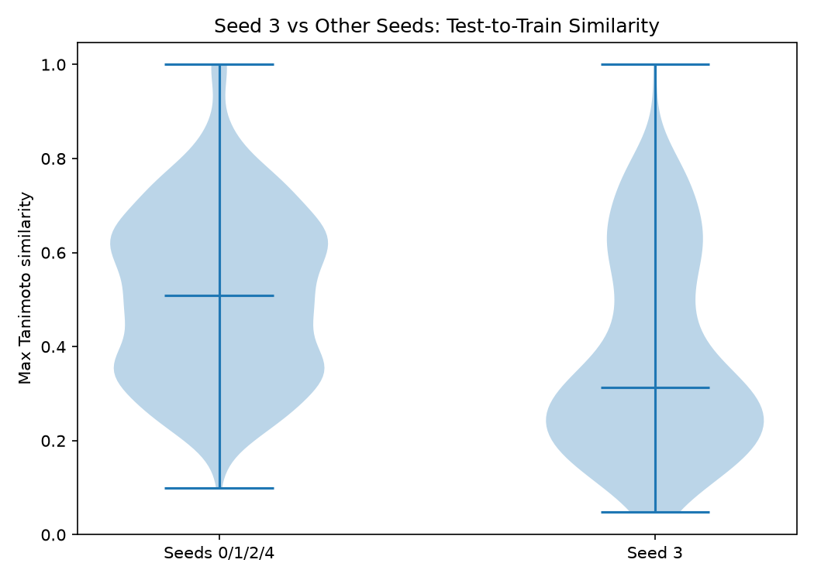
Figure 2. Seed 3 versus Seeds 0/1/2/4: maximum Tanimoto similarity distributions.
The distributional left shift indicates that Seed 3 is not merely affected by a few extreme molecules. H1 is therefore supported as a chemical-space-shift hypothesis. This result alone does not establish that the shift caused the ROC-AUC collapse; it establishes that the hard split and stronger chemical novelty co-occur.

3.3 H2: the shift is not specific to the negative class
H2 predicted that the unusual Seed 3 shift would be concentrated mainly in negative molecules. The observed pattern did not support this prediction. Within Seed 3, the positive-class median similarity was 0.3058 and the negative-class median was 0.3158. The fractions below 0.4 were 62.5% and 65.5%, respectively. Thus both classes occupy similarly unfamiliar chemical space under this fingerprint metric.
Group | N | Median similarity | Q1 | % similarity < 0.4
Seed 3 positive | 176 | 0.306 | 0.213 | 62.5%
Seed 3 negative | 29 | 0.316 | 0.302 | 65.5%

Table 6. Label-stratified similarity statistics for Seed 3.
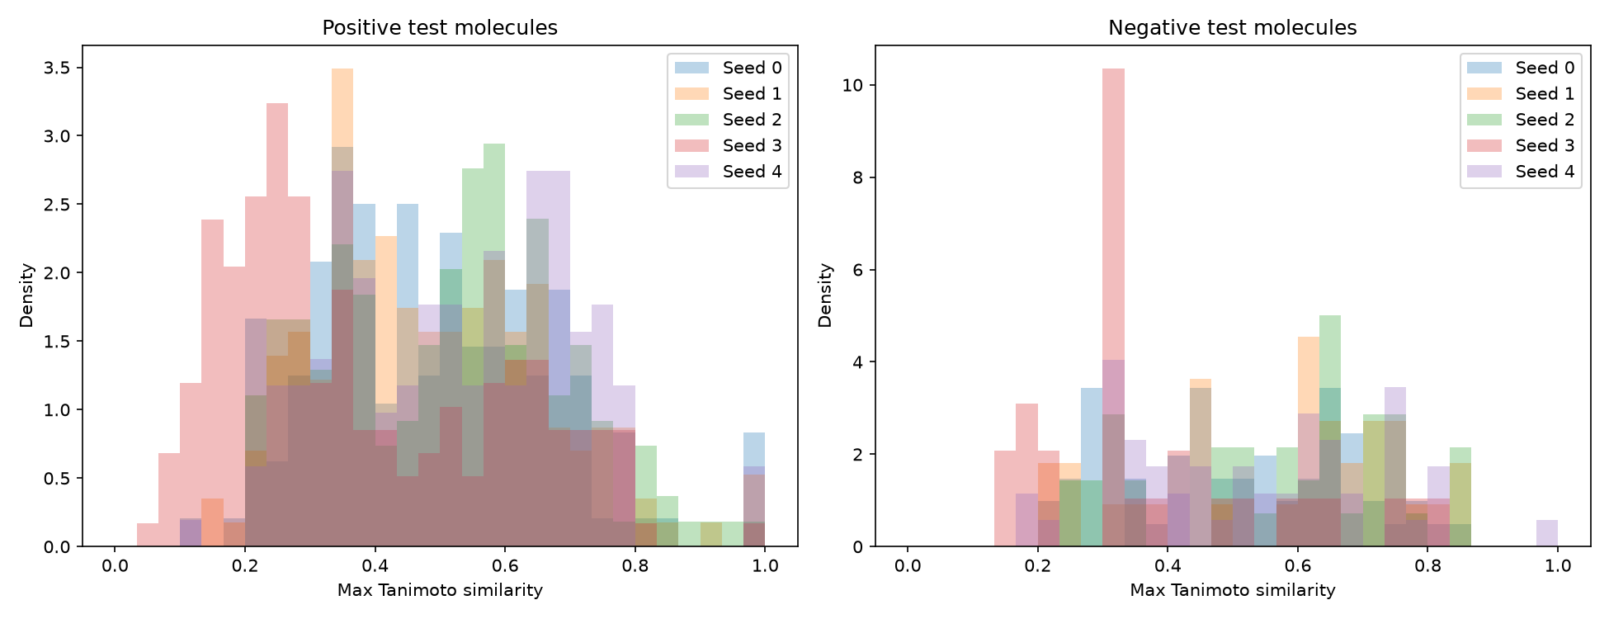
Figure 3. Test-to-train similarity distributions separated by positive and negative labels.
H2 is therefore not supported under Morgan/Tanimoto similarity. The small number of Seed 3 negatives (n = 29) may still increase the sampling variability of ROC-AUC, but it does not explain the observed dataset-wide chemical novelty.

3.4 H3: similarity is associated with difficulty at the pooled level, but weakly within individual splits
The H3 reproduction analysis regenerated per-molecule predictions before linking them to chemical similarity. Most reproduced test ROC-AUC values were very close to the original values. The largest absolute difference was 0.0451 for GCN on Seed 3; nevertheless, the qualitative hard-split phenomenon remained: reproduced Seed 3 ROC-AUC was 0.6501 for GCN, 0.5675 for GraphSAGE, and 0.5271 for GAT.
Seed | Model | Original_AUC | Reproduced_AUC | Delta
0 | GCN | 0.9167 | 0.9172 | 0.0005
0 | GraphSAGE | 0.9186 | 0.9167 | -0.0019
0 | GAT | 0.8938 | 0.8925 | -0.0013
1 | GCN | 0.9077 | 0.9087 | 0.0010
1 | GraphSAGE | 0.8899 | 0.8899 | -0.0000
1 | GAT | 0.8941 | 0.8941 | 0.0000
2 | GCN | 0.9090 | 0.9181 | 0.0091
2 | GraphSAGE | 0.9187 | 0.9175 | -0.0012
2 | GAT | 0.9123 | 0.9126 | 0.0003
3 | GCN | 0.6952 | 0.6501 | -0.0451
3 | GraphSAGE | 0.5681 | 0.5675 | -0.0006
3 | GAT | 0.5271 | 0.5271 | 0.0000
4 | GCN | 0.8963 | 0.8971 | 0.0008
4 | GraphSAGE | 0.8968 | 0.8974 | 0.0006
4 | GAT | 0.8972 | 0.8962 | -0.0010

Table 7. Reproduction check used before the H3 molecule-level analysis.
When all 1,025 test instances across the five splits were pooled, maximum Tanimoto similarity was negatively correlated with BCE loss for all three models. The association was weakest for GCN (ρ = −0.0682, p = 0.0290), stronger for GAT (ρ = −0.1548, p < 10⁻⁶), and strongest for GraphSAGE (ρ = −0.2224, p < 10⁻¹²). These p-values should not be read as standalone evidence of a large effect: effect sizes were small, and pooled observations include repeated split-level structure.
Model | Pooled_rho | Pooled_p | N
GCN | -0.068 | 0.029 | 1025
SAGE | -0.222 | 6e-13 | 1025
GAT | -0.155 | 6.4e-07 | 1025

Table 8. Pooled Spearman association between maximum similarity and per-molecule BCE loss.
Per-seed analysis substantially qualified the pooled result. Seed 3 itself showed weak, non-significant correlations (GCN ρ = +0.0900; GraphSAGE ρ = −0.0305; GAT ρ = −0.0779). Seed 2 was the only split in which all three architectures showed significant negative correlations. Thus, chemical similarity is not a stable molecule-level predictor of error within every split.
Seed | GAT | GCN | SAGE
0 | -0.042 | -0.010 | -0.126
1 | +0.017 | +0.035 | -0.014
2 | -0.159 | -0.186 | -0.232
3 | -0.078 | +0.090 | -0.031
4 | -0.067 | +0.031 | -0.170

Table 9. Per-seed Spearman ρ between maximum similarity and BCE loss.
The bin analysis nevertheless showed a highly consistent pooled gradient. For every architecture, low-similarity molecules had the highest mean BCE loss and the lowest accuracy, while high-similarity molecules had the lowest loss and highest accuracy.
Model | SimBin | N | Mean_Loss | Median_Loss | Accuracy
GCN | Low (<0.3) | 203 | 0.447 | 0.162 | 82.8%
GCN | Medium (0.3-0.5) | 350 | 0.385 | 0.112 | 84.9%
GCN | High (>=0.5) | 472 | 0.246 | 0.109 | 91.9%
SAGE | Low (<0.3) | 203 | 0.536 | 0.316 | 76.4%
SAGE | Medium (0.3-0.5) | 350 | 0.400 | 0.224 | 83.1%
SAGE | High (>=0.5) | 472 | 0.284 | 0.167 | 90.9%
GAT | Low (<0.3) | 203 | 0.558 | 0.336 | 72.9%
GAT | Medium (0.3-0.5) | 350 | 0.412 | 0.139 | 81.7%
GAT | High (>=0.5) | 472 | 0.306 | 0.127 | 87.7%

Table 10. Prediction quality across pooled chemical-similarity bins.
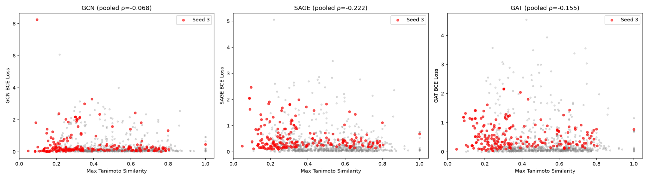
Figure 4. Maximum Tanimoto similarity versus BCE loss. Seed 3 molecules are highlighted.
Cross-model failure provided a complementary threshold-based view. Molecules correctly classified by all three models had median similarity 0.5000. The median declined to 0.4410, 0.3805, and 0.3571 as one, two, and three models misclassified the same molecule. This monotonic pooled pattern is consistent with shared difficulty on chemically unfamiliar examples.
ErrorCount | N | Median similarity | Mean similarity
0 | 808 | 0.500 | 0.500
1 | 74 | 0.441 | 0.446
2 | 50 | 0.380 | 0.424
3 | 93 | 0.357 | 0.419

Table 11. Pooled cross-model ErrorCount versus chemical similarity.
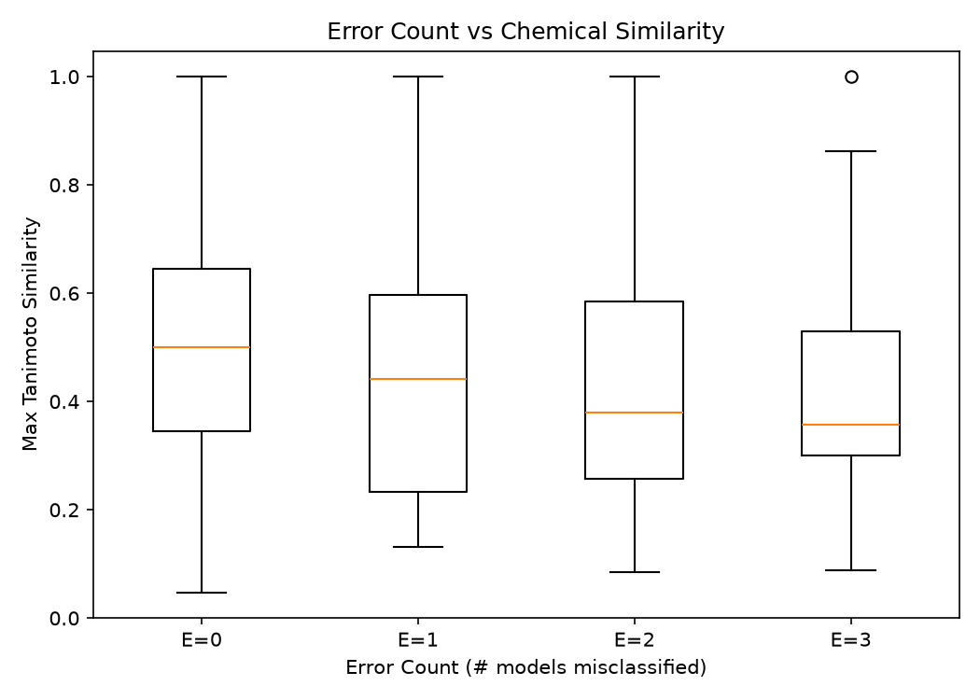
Figure 5. Chemical similarity grouped by the number of GNNs that misclassified each molecule.
However, Seed 3 alone did not show a strictly monotonic ErrorCount pattern: median similarities for ErrorCount 0, 1, 2, and 3 were 0.3333, 0.3077, 0.1892, and 0.3125. Together with the weak within-Seed-3 Spearman correlations, this supports a restrained interpretation of H3: chemical novelty is associated with prediction difficulty in the pooled population, but maximum Morgan/Tanimoto similarity is not sufficient to determine molecule-level success or failure.

4. Discussion

4.1 The main finding is a generalization-boundary phenomenon, not an architecture ranking
The five-seed experiment changes the interpretation of the original model comparison. A single favorable split could have suggested that one architecture was clearly preferable. Across multiple scaffold splits, however, the dominant signal is that all three architectures are sensitive to which chemical region is held out. Seed 3 behaves as a shared generalization stress test. Therefore, the present evidence is more informative about evaluation instability and chemical-space coverage than about which of GCN, GraphSAGE, or GAT is intrinsically superior.

4.2 Chemical-space shift is informative at the split level
H1 provides the clearest diagnostic result. Seed 3 combines the lowest chemical proximity to the training set with the worst performance for all three GNNs. This supports using explicit chemical-space diagnostics alongside benchmark metrics. In practical AIDD, the relevant question is often whether a model is being applied to chemistry sufficiently similar to the domain on which it learned. A single test ROC-AUC cannot expose that boundary.

4.3 A single Tanimoto score is not a molecule-level reliability oracle
H3 prevents an overly simple conclusion. Although pooled bins and cross-model errors align with the expected direction, within-split correlations are weak and split-dependent. Maximum Tanimoto similarity captures one notion of structural novelty under one fingerprint representation. Prediction difficulty can additionally depend on local label structure, representation quality, training density, functional groups, stereochemistry, model calibration, and other factors. The current study therefore supports a hierarchical interpretation: chemical-space shift is a useful descriptor of split-level difficulty, but it is not a deterministic molecule-level explanation.

4.4 Implications for AIDD evaluation
Three evaluation lessons follow from the present experiments. First, reporting a single scaffold split can conceal large variation in generalization difficulty; multiple seeded or otherwise repeated structurally disjoint evaluations are more informative. Second, classification metrics should be accompanied by split composition, particularly when class prevalence varies. Third, chemical-space diagnostics should be reported together with predictive metrics so that a performance decrease can be interpreted in relation to the novelty of the test chemistry rather than attributed immediately to model architecture.

4.5 Limitations and implementation audit
This is an exploratory single-dataset study and does not establish a universal law of molecular GNN generalization. The conclusions are limited to BBBP, five scaffold-split seeds, three baseline architectures, and Morgan fingerprints with radius 2 and 2048 bits. The test set contains only 205 molecules per split, and the number of negatives ranges from 29 to 61, which can make ROC-AUC estimates noisy. The pooled H3 analysis also reuses molecules across different seeded splits, so the 1,025 rows should not be treated as fully independent observations for formal inferential claims.
Important code-audit note. In the supplied current version of compare_model_GCN_SAGE_GAT.py, the early-stopping counter is incremented twice in the non-improvement branch. Therefore, a nominal patience of 20 may behave approximately like 10 consecutive non-improving epochs in that script. The H3 reproduction script uses a single increment. This implementation difference is a plausible contributor to the larger GCN Seed 3 reproduction difference (Δ = −0.0451). Before treating the present report as an external publication result, the baseline experiment should be rerun after correcting the duplicated increment, with checkpoints and per-molecule predictions saved directly from the final standardized pipeline.
A further reporting detail is that the aggregate standard deviations in the current summary use NumPy's default population standard deviation (ddof=0). For a paper treating the five splits as a sample of possible splits, sample standard deviation (ddof=1) or confidence intervals/bootstrapped uncertainty would be preferable. These refinements do not change the qualitative observation that Seed 3 is a shared hard split, but they matter for rigorous external reporting.

5. Conclusion
This study began as a comparison of three GNN architectures and evolved into an investigation of generalization under scaffold-dependent chemical-space shift. Five seeded scaffold splits revealed that apparent model performance can vary dramatically with the held-out chemistry. Seed 3 simultaneously degraded GCN, GraphSAGE, and GAT and exhibited a marked left shift in test-to-train maximum Tanimoto similarity. This shift affected both positive and negative classes. Lower similarity was associated with higher prediction loss and more shared model errors when data were pooled, but the relationship was not consistently strong within individual splits. The resulting interpretation is therefore deliberately bounded: chemical-space novelty is a useful split-level indicator of generalization difficulty, but a single fingerprint similarity measure is not a molecule-level reliability criterion.
For AIDD model evaluation, the practical implication is that benchmark performance should be accompanied by repeated structurally disjoint splits, class-composition information, and explicit chemical-space diagnostics. The next research step should move beyond merely observing the boundary toward estimating prediction reliability under chemical novelty—for example by comparing fingerprint distance with learned-embedding distance, ensemble disagreement, calibration, or other OOD/uncertainty signals—followed by validation on additional molecular property datasets.

References
[1] Wu, Z.; Ramsundar, B.; Feinberg, E. N.; et al. MoleculeNet: a benchmark for molecular machine learning. Chemical Science 9 (2018), 513–530. DOI: 10.1039/C7SC02664A.
[2] Yang, K.; Swanson, K.; Jin, W.; et al. Analyzing Learned Molecular Representations for Property Prediction. Journal of Chemical Information and Modeling 59 (2019), 3370–3388. DOI: 10.1021/acs.jcim.9b00237.
[3] Kipf, T. N.; Welling, M. Semi-Supervised Classification with Graph Convolutional Networks. ICLR (2017).
[4] Hamilton, W. L.; Ying, R.; Leskovec, J. Inductive Representation Learning on Large Graphs. NeurIPS (2017).
[5] Veličković, P.; Cucurull, G.; Casanova, A.; Romero, A.; Liò, P.; Bengio, Y. Graph Attention Networks. ICLR (2018).

Appendix A. Evidence map for H1–H3
Hypothesis | Result | Key evidence | Allowed conclusion
H1 | Supported | Seed 3 median similarity 0.3125; 62.9% < 0.4; whole distribution left-shifted. | Seed 3 represents stronger chemical novelty under Morgan/Tanimoto.
H2 | Not supported | Seed 3 positive vs negative median 0.3058 vs 0.3158; both classes strongly shifted. | The shift is not primarily a negative-class phenomenon under this metric.
H3 | Partially supported | Pooled ρ < 0 for all models; monotonic pooled bin/error-count trends; weak and inconsistent within-seed correlations. | Similarity is associated with difficulty at population/split level but is insufficient as a molecule-level determinant.

Appendix B. Recommended pre-submission cleanup
- Fix the duplicated early-stopping counter increment and rerun the five-seed baseline and H3 prediction export from one standardized pipeline.
- Save the best validation checkpoint and per-molecule predictions during the original run so that diagnostic analyses do not require retraining.
- Report sample standard deviation (ddof=1) and/or confidence intervals in addition to mean performance.
- Repeat the analysis on at least one additional molecular property dataset before making broad claims about molecular GNN generalization.
- If formal inference is pursued, account for repeated molecules across seeded splits (e.g., cluster-aware bootstrap or split-level summaries).

