**Drawing Course Selling Platform**

**Software Requirement Specifications**

Version: 1.0

Vietnam, October 2023

**Approval Page**

|  | |
| --- | --- |
| **Project** | Drawing Course Selling Platform |
| **Group** | Group 7 |
| **Group Member** | Nguyen Van Minh -SE172756  Dao Xuan Quy - SE170242  Tran Minh Ngoc Phuc - SE172099  Nguyen Minh Hien - SE161997 |
| **Supervisor** | Mr. Lai Duc Hung |

# **TABLE OF CONTENT**

**1. INTRODUCTION 3**

1.1. Purpose 4

1.2. Scope 4

1.3. Definitions, Acronyms, and Abbreviations 4

1.4. References 5

1.5. Overview 5

**2. OVERALL DESCRIPTION 6**

2.1. Product Overview 6

2.1.1. Customer Requirements 6

2.1.2 Instructor Requirements 6

2.1.3 Staff Requirements 7

2.1.4 Admin Requirements 7

**3. FUNCTIONAL REQUIREMENT 8**

3.1. Use Case Diagram: 8

3.2. Use Case List 9

3.3. Use Case Detail: 9

UC-01: Sign In 9

UC-02: Sign Up 12

UC-03: Search Course 14

UC-04: Add Course to Cart 17

UC-05: Remove Item(s) 20

UC-08: Learning Course 21

**4. DATABASE: 27**

# **1. INTRODUCTION**

## **1.1. Purpose**

This document represents the Software Requirements Specification (SRS) of **Drawing Course Selling Platform.** Its purpose is to describe the scope, both the functional and non-functional software requirements, as well as the design constraints of the whole logic sub-component. Furthermore, this document shows how the system's interfaces are designed in detail.

## **1.2. Scope**

**Drawing Course Selling Platform** is a website that supports customers who want to improve their thinking and create a love for painting but do not have to go to centres because of time and geographical constraints. This website also provides drawing courses to help customers access lessons quickly and learn comfortably and without much effort.

The staff can provide their website information using web-portal. This information will act as the base for the search results displayed to the user. An administrator also uses the web-portal in order to administer the system and keep the information accurate. Furthermore, the instructors can manage their courses and grade their students’ projects.

## **1.3. Definitions, Acronyms, and Abbreviations**

| **Acronym** | **Definition** |
| --- | --- |
| Customer | A person who signed in as a customer, whose purpose is to buy courses and learning. |
| Instructor | A person who signed in as an instructor, the purpose is to manage their courses. |
| Staff | A person who signed in as a staff, the purpose is to verify accounts, profiles, and posts. |
| Administrator | A person who signed in as an admin, the purpose is to manage information and organize accounts, and courses. |

## **1.4. References**

**This subsection is purpose to:**

❖ Provide a complete list of all documents referenced elsewhere in the SRS.

❖ Identify each document by title, report number (if applicable), date, and publishing organization.

❖ Specify the sources from which the references can be obtained.

This information may be provided by reference to an appendix or to another document

## **1.5. Overview**

The next chapter, the Overall Description, of this document provides an overview of the product's functionality. It describes the informal requirements and is used to establish the context for the specification in the next chapter.

The third chapter, the Functional Requirements section, of this document is written to describe the functionality of the product in technical terms including its use cases and details.

The fourth chapter, the Non-functional Requirements section, of this document is written to describe in detail the non-functionality of the product, defining how a system should look like.

The fifth chapter, the Database section, of this document is written to describe in detail the database (specifically, ERD and Relation Schema) of the product, defining how data are stored and organized.

The last chapter, the Supporting Information section, of this document provides the supporting information that makes the SRS easier to use. It includes:

* Table of contents
* Index
* Appendices and be considered part of the requirements or not.

# **2. OVERALL DESCRIPTION**

## **2.1. Product Overview**

### ***2.1.1. Customer Requirements***

Members are people who have signed in to the website with the “Customer” role. They can use all these following ones:

* Sign in/ Sign Up
* View Courses
* View/ Edit Profile
* Check Out
* Learning
* Give Feedbacks, Rates

### 2.1.2. Instructor Requirements

Members are people who have logged in to the website with the “Instructor” role. They can use all these following ones:

* Sign in/ Sign Up
* View/ Search Courses
* View/ Create/ Update/ Pause Courses
* View/ Edit Profile
* Grade their students’ projects on post

### 

### ***2.1.3. Staff Requirements***

Members are people who have logged in to the website with the “Staff” role. They can use all these following ones:

* Sign in/ Sign Up
* View/ Edit Profile
* Search and filter profile
* Create/ Update/ Delete Post
* Get Business Statistics

### ***2.1.4. Admin Requirements***

Members are people who have logged in to the admin dashboard website with “Admin” role. They can use all Guest’s functions, plus these following ones:

* Sign in/ Sign Up
* View/ Search Courses
* Organise all Accounts
* Verify Posts that are uploaded by Staffs.
* Get Business Statistics

# **3. FUNCTIONAL REQUIREMENT**

## **3.1. Use Case Diagram:**

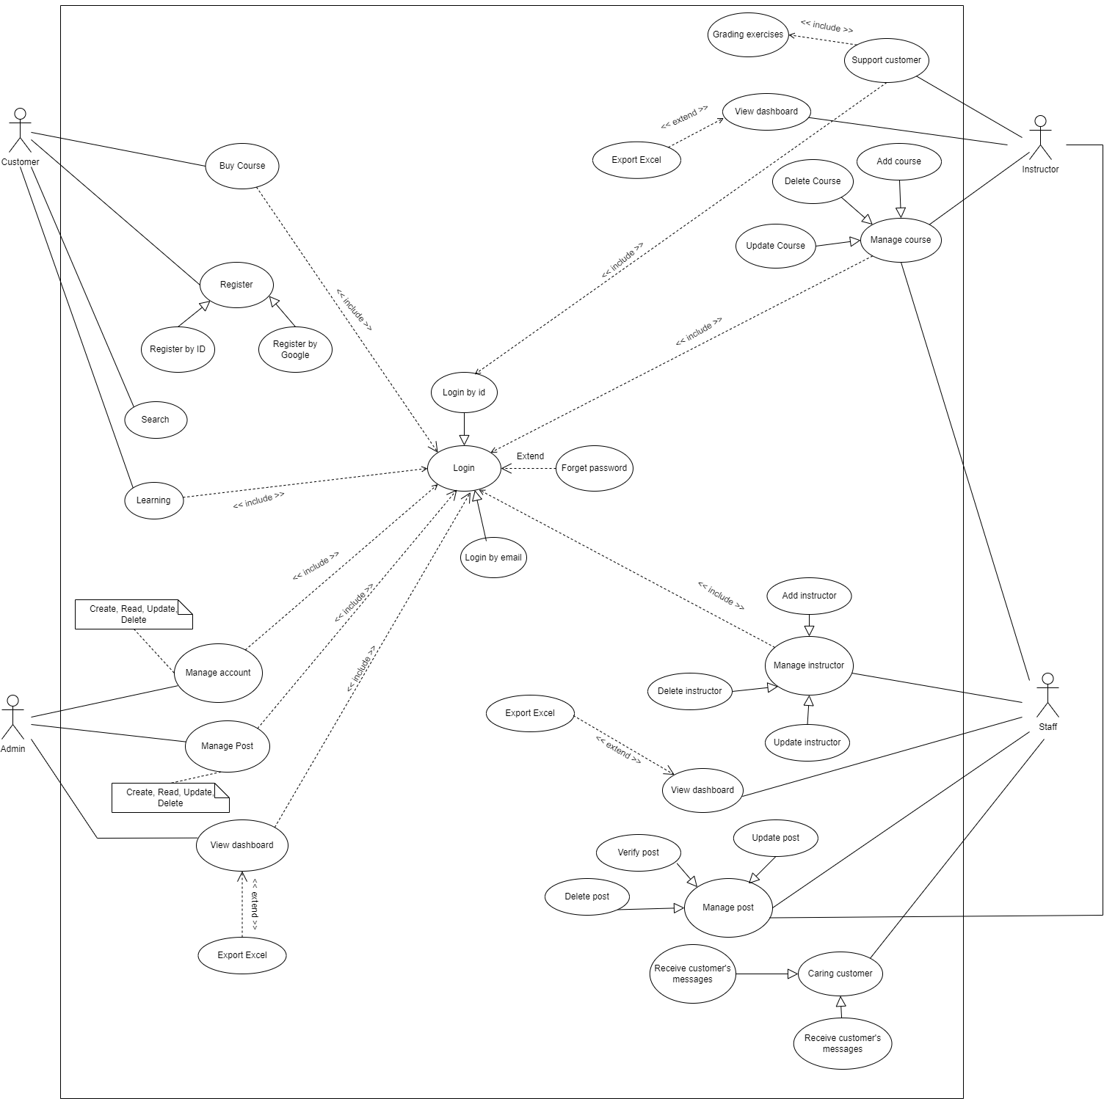

## 

## **3.2. Use Case List**

| ID | UseCase | Primary Actor |
| --- | --- | --- |
| UC-01 | Sign In | All Actor |
| UC-02 | Sign Up | All Actor |
| UC-03 | Search Courses | All Actor |
| UC-04 | Add Course to Cart | Customer |
| UC-05 | View Cart | Customer |
| UC-06 | Remove Item(s) | Customer |
| UC-07 | Check Out | Customer |
| UC-08 | Learning Course | Customer |

## 

## **3.3. Use Case Detail:**

### **UC-01: Sign In**

| **ID and Name:** | **UC-01: Sign In** | | |
| --- | --- | --- | --- |
| Created By: | Nguyen Minh Hien | Date Created: | 29/10/2023 |
| Primary Actor: | All Actor | Secondary Actors: | N/A |
| Priority: | High | Frequency of Use: | Usually |
| Trigger: | The actor wants to sign in to the Drawing course selling app. | | |
| Description: | This feature allows actor to login the system | | |
| Preconditions: | Actor has a Facebook Account or a Google Account or a phone number that has registered before | | |
| Post-conditions: | Success: Redirect to home page  Fail: The system shows error message corresponding to error code | | |

### 

| Normal Flow: | | Step | Actor Action | System Response | | --- | --- | --- | | 1 | In sign in page, Actor inputs email and passwords |  | | 2 | Actor clicks “sign in” | System redirects to the home page | | | |
| --- | --- | --- | --- | --- | --- | --- | --- | --- | --- | --- | --- | --- |

1:

| Step | Actor Action | System Response |
| --- | --- | --- |
| 1 | In sign in page, Actor clicks on the Facebook icon | System redirects to the Facebook interface and shows a confirmation message |
| 2 | Actor clicks “yes” button | System redirects to the home page |

2:

| Step | Actor Action | System Response |
| --- | --- | --- |
| 1 | In sign in page, Actor clicks on the Google icon | System shows a list of google accounts of users |
| 2 | Actor clicks the account they want to use to sign in | System redirects to the home page |

3:

| Step | Actor Action | System Response |
| --- | --- | --- |
| 1 | On sign-in page, Actor clicks on the Phone icon | System shows a form contains:   * Inputting phone number text box * Send OTP button * Inputting OTP text box * “Login” button |
| 2 | Actor inputs phone number |  |

| 3 | The actor clicks “Send OTP” button | System validates the phone number and invokes 3rd service to send OTP to the actor’s device. |
| --- | --- | --- |
| 4 | Actor inputs OTP number |  |
| 5 | Actor clicks “SignUp” | System checks OTP. If correct, create new customer account and redirect to home page |

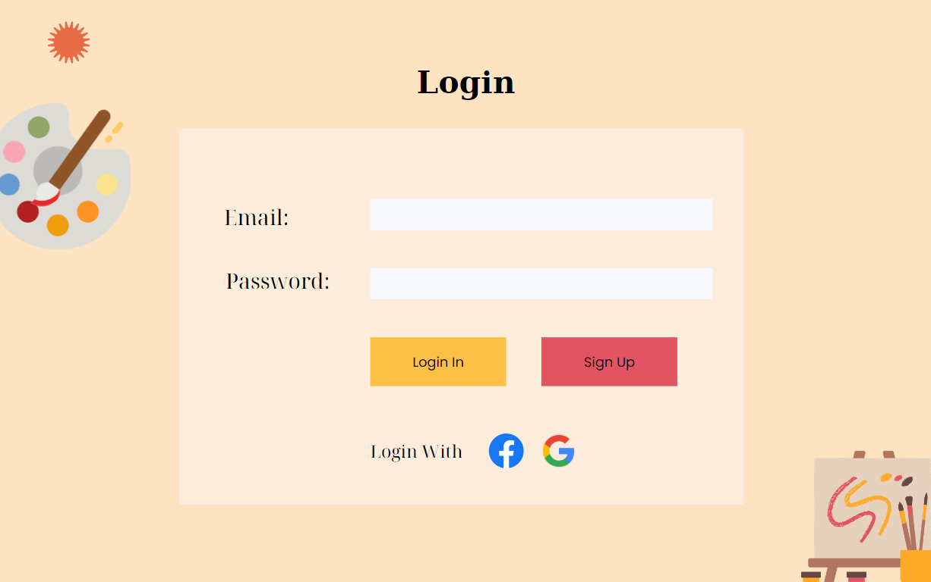

### 

### **UC-02: Sign Up**

| **ID and Name:** | **UC-02: Sign Up** | | |
| --- | --- | --- | --- |
| Created By: | Nguyen Minh Hien | Date Created: | 29/10/2023 |
| Primary Actor: | All Actor | Secondary Actors: | N/A |
| Priority: | High | Frequency of Use: | Usually |
| Trigger: | The actor wants to register an account in Drawing course selling App | | |
| Description: | This feature allows actor to create new account to become customer in the system | | |
| Preconditions: | Actor has an email that has been authorized before (Google, Facebook, … ). | | |
| Post-conditions: | Success: Redirect to home page  Fail: The system shows error message corresponding to error code | | |
| Normal Flow: | 1   | Step | Actor Action | System Response | | --- | --- | --- | | 1 | In the sign-in page, actor clicks “Sign Up” | System shows a form with these fields:  - Email: a text input, a string input must follow the email regex (XXX@YYY.ZZ).  - Password/Confirm Password: two strings must be identical, not empty, and at least 8 characters  - First name/Last name: two strings are not empty  - Phone number: a string of numbers has 9-11 characters. | | 2 | Actor inputs phone number, email, password, confirm password, first name, last name |  | | 3 | The actor clicks “Next” | System sends to that registered email an activation code, then shows a new form with a new field - activation code: A string of numbers that has 6 characters. | | 4 | Actor inputs activation |  | | 5 | Actor clicks “Sign Up” | System checks the activation code. If correct, create new customer account and redirect to home page | | | |

2

| Normal Flow: | | Step | Actor Action | System Response | | --- | --- | --- | | 1 | In the sign-in page, actor clicks “Sign Up” | Google login panel and login with Facebook | | 2 | Click on the application icon that the actor wants to link to register | The system notifies you if you want to link with the application | | 3 | The actor clicks “Next” | System sends to that registered email an activation code, then shows a new form with a new field - activation code: A string of numbers that has 6 characters. | | 4 | Actor inputs activation |  | | 5 | Actor clicks “Sign Up” | System checks the activation code. If correct, create new customer account and redirect to home page | | | |
| --- | --- | --- | --- | --- | --- | --- | --- | --- | --- | --- | --- | --- | --- | --- | --- | --- | --- | --- | --- | --- | --- |



### 

### **UC-03: Search Course**

| **ID and Name:** | **UC-03: Search Course** | | |
| --- | --- | --- | --- |
| Created By: | Tran Minh Ngoc Phuc | Date Created: | 30/10/2023 |
| Primary Actor: | All Actor | Secondary Actors: | N/A |
| Priority: | High | Frequency of Use: | Usually |
| Trigger: | The actor wants to search courses for learning in website | | |
| Description: | The "Search Course" function allows users to search for courses based on a provided keyword. The system will scan the course list and return the result as a list of courses containing the search keyword. | | |
| Preconditions: | N/A | | |
| Post-conditions: | Success: Search Results have been generated based on the user's search keywords. This result needs to be displayed for the user to see. | | |
| Normal Flow: | 1   | Step | Actor Action | System Response | | --- | --- | --- | | 1 | Users enter search keywords into the search field on the interface. |  | | 2 | The user presses the "Search" button or performs a similar action to initiate the search process. |  | | 3 | The system searches the course list and compares the search keywords with the description or name of each course.” |  | | 4 | The system returns a list of courses matching the search keyword. |  | | 5 | Search results are displayed on the interface, allowing users to view a list of courses containing the search keyword. |  | | | |



## 

### **UC-04: Add Course to Cart**

| **ID and Name:** | **UC-04: Add Course to Cart** | | |
| --- | --- | --- | --- |
| Created By: | Tran Minh Ngoc Phuc | Date Created: | 30/10/2023 |
| Primary Actor: | Customer | Secondary Actors: | N/A |
| Priority: | High | Frequency of Use: | Usually |
| Trigger: | The actor wants to add courses to cart for learning in website | | |
| Description: | This feature allows actor to add courses to cart before buying | | |
| Preconditions: | Actors must sign in as “Customer”.  Actors should be viewing details of a product. | | |
| Post-conditions: | Success: The actor has right to add courses and view cart  Fail: If the actor wants to add more than 1, the system will announce “Already Add to Cart” | | |
| Normal Flow: | 1   | Step | Actor Action | System Response | | --- | --- | --- | | 1 | The user clicks course to view detail | System redirects to the course detail page | | 2 | In the course detail page, actor click “Add to cart” button | System saves the course to the cart. | | 3 | In the course detail page, actor clicks “Add to cart” button | System redirects to the view cart page and checks all the courses that are added to cart. | | | |
| Alternative Flow: | N/A | | |
| Exceptions: | | No | Cause | System Response | | --- | --- | --- | | 1 | If the actor has already added to cart but clicks “Add to Cart” again | System shows message “Already Add to Car” | | | |
| Business Rules: | The course must be added once | | |
| Assumptions: | Actor’s internet connection is available | | |



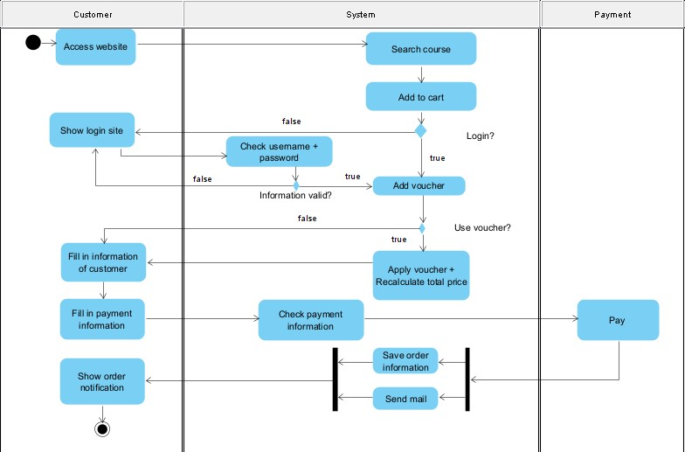

## 

## 

### 

### **UC-05: Remove Item(s)**

| **ID and Name:** | **UC-6: Remove Item(s)** | | |
| --- | --- | --- | --- |
| Created By: | Tran Minh Ngoc Phuc | Date Created: | 30/10/2023 |
| Primary Actor: | Customer | Secondary Actors: | N/A |
| Priority: | High | Frequency of Use: | Often |
| Trigger: | The actor wants to remove course(s) from Cart | | |
| Description: | This feature allows actor to remove the course(s) that they have chosen to buy from cart | | |
| Preconditions: | Actor has signed in as “Customer” and has picked some course(s) | | |
| Post-conditions: | Success: The Course is removed from the cart. | | |
| Normal Flow: | | Step | Actor Action | System Response | | --- | --- | --- | | 1 | In Edit account, Actor clicks “View Cart” section | System redirects to the cart section and shows some course cart that has been picked and a “checkout” button. | | 2 | Actor clicks the “Remove” button | The course card is removed from the cart. | | | |
| Alternative Flow: | N/A | | |
| Exceptions: | N/A | | |
| Business Rules: | N/A | | |
| Assumptions: | Actor’s internet connection is available | | |

### 

### **UC-08: Learning Course**



| **ID and Name:** | **UC-08: Learning Course** | | |
| --- | --- | --- | --- |
| Created By: | Dao Xuan Quy | Date Created: | 30/10/2023 |
| Primary Actor: | Customer | Secondary Actors: | N/A |
| Priority: | High | Frequency of Use: | Usually |
| Trigger: | The actor wants to search courses for learning in website | | |
| Description: | Transforming a drawing course selling website into a comprehensive learning course platform involves expanding your offerings to accommodate a wider range of subjects and educational materials. This transition can help you tap into a broader audience and diversify your revenue streams. | | |
| Preconditions: | N/A | | |
| Post-conditions: | Success: Learning Courses Have Been Displayed for User Based on Search Keywords | | |
| Normal Flow: | | Step | Actor Action | System Response | | --- | --- | --- | | 1 | Access the Learning Platform:  Open a web browser and access the learning platform's website. | The learning platform's homepage loads, and you can see the available courses and features. | | 2 | Search for a Course:  Use the platform's search function to find and select the course of your interest | The platform provides a search bar where you can enter keywords. As you type, the system suggests relevant courses, making it easier to find the course of your choice. | | 3 | View Course Information:  The website will display detailed information about the course, including its name, description, instructor, duration, price, and user ratings (if available). | When you select a course, the platform displays a dedicated course page with detailed information, including the course title, description, instructor's credentials, course duration, pricing, and user reviews. | | 4 | Enroll in the Course:  Choose the course you want to join by clicking on the "Enroll" button or a similar action. | If the course requires enrollment or payment, the system guides you through the process, which may include providing payment details and agreeing to terms and conditions. | | 5 | Confirm Enrollment:  If there is a registration or payment requirement, you will be directed to a confirmation page. Follow the instructions to complete the enrollment process. | After successful enrollment and payment, the system confirms your enrollment, and you receive access to the course materials. | | 6 | Access the Course:  After successful enrollment, you will gain access to the course's content. The platform will provide a link or method to access the course materials. | The platform provides a user-friendly interface to access course materials, such as video lectures, PDF documents, and interactive quizzes. You can navigate through the course content easily. | | 7 | Learn and Complete Assignments:  Begin your learning journey by watching video lectures, reading course materials, and participating in learning activities. Complete assignments or quizzes as required. | The system tracks your progress as you complete lessons, assignments, and quizzes. It may provide indicators of your progress and completion status. | | 8 | Engage in Discussions:  If the platform has discussion forums or chat features, you can engage in conversations with the instructor and fellow learners to discuss course content. | If there are discussion forums or chat features, you can interact with the instructor and fellow learners in real-time or asynchronously. The system sends notifications for new discussions or replies. | | 9 | Course Completion:  Once you have completed all course lessons and assessments, you will receive a completion certificate, if offered by the course. | Upon successfully completing all course requirements, the system generates a completion certificate or badge. You can download or share it as needed. | | 10 | Rate and Provide Feedback:  After completing the course, you can rate the course and leave feedback regarding your learning experience. | The platform prompts you to rate the course and leave feedback through a user-friendly interface. Your feedback is recorded and may be visible to other potential learners. | | 11 | Access Course Content After Completion:  If the course allows access to content after completion, you can continue to review or use the materials at your convenience. | If the course allows post-completion access, the system ensures you can continue to access the course content, review materials, or download resources as necessary. | | | |

# **4. DATABASE:**

