**DRAWING COURSES SELLING PLATFORM**

Hiện nay, nhu cầu học vẽ rất lớn, các bậc phụ huynh luôn mong muốn có những khóa học vẽ để giúp con mình nâng cao tư duy và tạo niềm yêu thích với hội họa. Tuy nhiên, việc phải học tại các trung tâm gây ra nhiều trở ngại về mặt thời gian, phần lớn thời gian rảnh đều tập trung vào các môn khác như toán, tiếng Anh…. Vì vậy, một nền tảng cung cấp các khóa học vẽ sẽ giúp phụ huynh tiếp cận các bài học vẽ một cách nhanh chóng, có thể học một cách thoải mái và không cần tốn nhiều công sức.

### **Functional Requirements**

* **Customers**
  + Register
  + Login/logout.
  + Search and filter course information.
  + Learn some courses that provide trial learning.
  + Buy a course/combo course from the instructors.
  + Make payments using some Payments Platform.
  + Watch their order history.
  + Access their video courses forever.
  + Give feedback and rate the courses which they learned
* **Instructors**
  + Upload and manage their courses.
  + Watch the order history.
  + See the reports of their courses including the history of order
  + Dashboard.
* **Staff**
  + Login/logout.
  + Search and filter the profile of instructors.
  + Manage the accounts of instructors and customers.
  + Manage posts.
* **Admin**
  + Login/logout.
  + Manage accounts.
  + Manage courses.
  + Manage posts
  + Dashboard

### **Câu hỏi phỏng vấn**

* **Customer**
* **Login :**
* **What information do we need during the registration process?**

**→** Username, password, age, phone number, is instructor???, email

* **Should there be any additional authentication steps for security?**

**→** Verification code

* **Course Search and Filter :**
* **What specific filters should be available for searching courses ?**

**→** Instructor name, section, age group, difficulty level, and drawing style.

* **Trial Learning:**
* **How many trial lessons should be available for each course?**

**→**1/4 or less than

* **Should there be any limitations on the trial access?**

**→** No, we let customers try to know what they can learn.

* **Purchasing Courses:**
* **Which payment platforms should be integrated for purchasing courses?**

→MOMO, BANKING API

* **Are there any specific payment methods or options preferred by the customers?**

→

* **Order History:**
* **What details should be included in the order history (e.g., course name, date of purchase, price)?**

**→** purchased courses, date of purchase, and price

* **Course Access:**
* **Can customers download course materials, or is it exclusively video-based?**

**→** Yes

* **Should there be any limitations on how many times a course can be accessed?**

**→** Customers have the right to access course videos at any time, indefinitely.

* **Feedback and Ratings:**
* **Are there any specific metrics or criteria for rating courses?**

**→** Customers can provide text feedback and rate courses based on their experience.

* **Instructor**
* ***Customer Support:***
* ***How can Customers contact the Instructor?***

***→*** *Buy email, feedback, and comment in each course*

* ***What is the level of interaction with instructors?***

***→*** *24/24*

* ***Can Instructors use customer’s personal information for more specific guides?***

***→*** *If necessary*

* **Uploading and Managing Courses:**
* **What file formats are used to support course materials (e.g., videos, PDFs, images)?**

**→** PDF, Youtube video

* **Is there a limit to the size of course files?**
* **Order History and Reports:**
* **What specific data do instructors need to see in their order history and reports?**

**→** Number of orders, courses, sections

* **Are there any analytics or statistics they're particularly interested in?**

**→** Number of customers interested in the course/ completed the course daily/weekly/monthly/yearly

* **Dashboard:**
* **What key metrics or information should be displayed on the instructor's dashboard?**

**→** Total earnings from courses and the number of enrolled students.

* **Staff**
* **Search and Filter Profiles:**
* **What criteria should staff use to search and filter instructor profiles?**

**→** Staff can search and filter instructor profiles based on criteria like name, course topic, and ratings.

* **Are there any specific details they need to see about instructors?**

**→** Instructor Qualifications, Teaching Style, Availability, Feedback from Other Students, Course Content

* **Managing Accounts:**
* **What actions can staff take in managing customer and instructor accounts (e.g., account creation, suspension, deletion)?**

**→** Staff have the authority to create accounts, temporarily suspend accounts, or delete accounts of both customers and instructors.

* **Managing Posts:**
* **What types of posts can staff manage, and what actions can they perform (e.g., editing, deleting)?**

**→** Staff can edit or delete any posts on the platform.

* **Admin**
* **When Customer learns a trial course, do they need to register and pay later?**

**→** Let them learn trial course without register and can pay later

* **Manage accounts :**
* **What level of access control should the admin have (content admin, user admin)?**

**→** The admin has the highest authority, overseeing the management of accounts for customers, instructors, and staff.

* **Manage courses :**
* **What actions can the admin take in managing courses (e.g., adding, editing, deleting)?**

**→** The admin has the power to add, edit, and delete courses on the platform.

* **Manage posts :**
* **Are there specific types of posts that the admin needs to manage, and what actions can they perform?**

**→** The admin can edit or delete any posts on the platform.

* **Dashboard :**
* **What key metrics or information should be displayed on the admin dashboard?**

**→** Total Registered Users, Active Courses, Total Revenue, Most popular courses, New registration, Revenue Trends, Recent Activity Feed

### **Use Case Diagram**

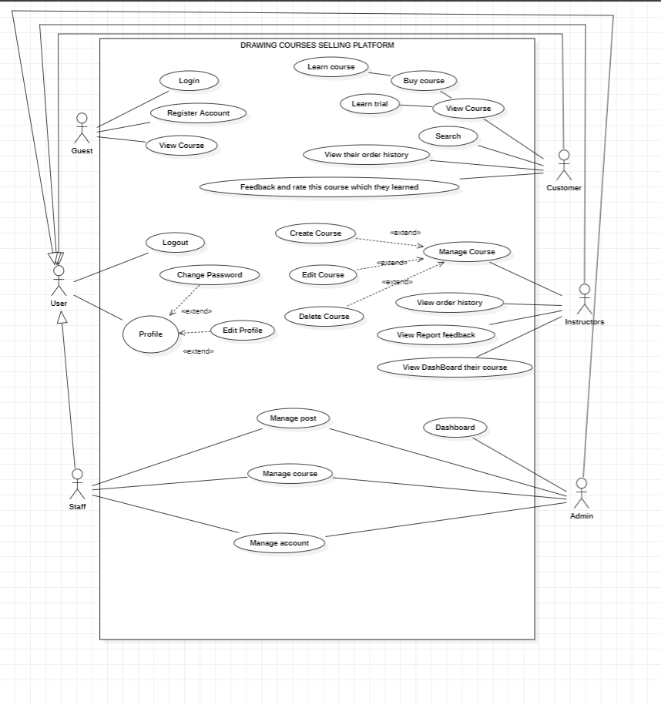

UI Design :

