多元数据分析作业
Table of contents

1. 多元数据分析作业

1.1 🧬 TCGA-LUSC 项目数据简报

1.1.1 📌 项目基本信息
项目字段 | 内容
Project ID | TCGA-LUSC
dbGaP Accession | phs000178
项目名称 | 肺鳞状细胞癌（Lung Squamous Cell Carcinoma）
疾病类型 | 2种疾病类型（包括肺鳞癌及相关亚型）
主站点 | 支气管和肺（Bronchus and Lung）
所属计划 | TCGA（癌症基因组图谱计划）

1.1.2 🧪 数据类型与可用性
数据类型 | 样本数量 | 覆盖率 | 备注说明
RNA-Seq | 501 | 99.4% | 高覆盖率，适用于差异表达分析（DEG）

1.2 第一步：载入数据
#### 1. 安装/载入必要包 ####
#required_pkgs <- c("DESeq2","edgeR","limma","cluster","factoextra","NbClust",
# "pheatmap","RColorBrewer","ggplot2","dplyr","sva","BiocManager")
#for(pkg in required_pkgs){
# if(!requireNamespace(pkg, quietly = TRUE)){
# if(pkg == "BiocManager") install.packages("BiocManager")
# else if(pkg %in% c("DESeq2","edgeR","limma","sva"))
# BiocManager::install(pkg, ask = FALSE, update = FALSE)
# else install.packages(pkg)
#}
# library(pkg, character.only = TRUE)
#}
# ---- 1. 载入/安装必要包 ----
pkgs_cran <- c("pheatmap","ggplot2","dplyr","RColorBrewer","factoextra","cluster","NbClust")
pkgs_bioc <- c("DESeq2","edgeR","apeglm","WGCNA")
for(p in pkgs_cran){
if(!requireNamespace(p, quietly = TRUE)) install.packages(p)
library(p, character.only = TRUE)
}
if(!requireNamespace("BiocManager", quietly = TRUE)) install.packages("BiocManager")
for(p in pkgs_bioc){
if(!requireNamespace(p, quietly = TRUE)) BiocManager::install(p, ask = FALSE, update = FALSE)
library(p, character.only = TRUE)
}
library(readr)
final_data <- read_csv("E:/acode/wsl/data2/GDCdata/TCGA-LUSC/rnaexp.csv", col_names = TRUE)
final_data <- final_data[ , -1] # 删除第一列
clinical_data <- read_csv("E:/acode/wsl/data2/GDCdata/TCGA-LUSC/clinical_metadata.csv", col_names = TRUE)
#|echo:true
head(clinical_data)
# A tibble: 6 × 4
case_id time event simplified_stage
<chr> <dbl> <dbl> <chr>
1 TCGA-85-6561 24 0 Early/Local (Stage I-II)
2 TCGA-37-5819 103 0 Advanced (Stage III)
3 TCGA-77-8008 2639 1 Early/Local (Stage I-II)
4 TCGA-56-8083 2 0 Early/Local (Stage I-II)
5 TCGA-56-A4ZJ 25 0 Early/Local (Stage I-II)
6 TCGA-85-7710 0 0 Early/Local (Stage I-II)
head(final_data)
# A tibble: 6 × 563
gene_name `TCGA-90-A4EE` `TCGA-85-8049` `TCGA-33-6737...5` `TCGA-39-5016`
<chr> <dbl> <dbl> <dbl> <dbl>
1 TSPAN6 8.48 8.90 24.2 21.0
2 TNMD 0.0149 0 0 0.0587
3 DPM1 35.1 25.3 23.2 63.1
4 SCYL3 3.91 2.58 1.29 3.36
5 C1orf112 3.76 2.85 2.62 2.77
6 FGR 14.2 9.12 7.31 3.78
# ℹ 558 more variables: `TCGA-56-8304` <dbl>, `TCGA-92-8063` <dbl>,
# `TCGA-22-4593...9` <dbl>, `TCGA-43-8115` <dbl>, `TCGA-22-4599` <dbl>,
# `TCGA-60-2712` <dbl>, `TCGA-21-1080` <dbl>, `TCGA-43-5670...14` <dbl>,
# `TCGA-33-AASI` <dbl>, `TCGA-56-7582...16` <dbl>, `TCGA-58-8388` <dbl>,
# `TCGA-56-7822` <dbl>, `TCGA-56-7579...19` <dbl>, `TCGA-22-1016...20` <dbl>,
# `TCGA-46-6025` <dbl>, `TCGA-60-2715` <dbl>, `TCGA-22-1005...23` <dbl>,
# `TCGA-L3-A4E7` <dbl>, `TCGA-60-2709...25` <dbl>, `TCGA-77-7141` <dbl>, …

1.3 🧾 1. 临床数据（clinical_data）
这是一个包含 样本基本信息和分期分类 的表格：
列名 | 类型 | 说明
case_id | 字符型 | TCGA 样本编号，如 TCGA-85-6561
time | 数值型 | 生存时间或随访时间（单位通常是月）
event | 数值型 | 生存事件（0 = 未死亡，1 = 死亡）
simplified_stage | 字符型 | 简化的分期分类，如 "Early/Local (Stage I-II)" 或 "Advanced (Stage III)"
这个表用于：
- 生存分析（如 Kaplan-Meier）
- 分组比较（DEG 分析）
- WGCNA 表型相关性计算

1.4 🧬 2. 表达数据（final_data 或 expr_df）
这是一个 RNA-Seq 表达矩阵，行为基因，列为样本：
gene_name | TCGA-90-A4EE | TCGA-85-8049 | TCGA-33-6737…5 | …
TSPAN6 | 8.48 | 8.90 | 24.2 | …
TNMD | 0.0149 | 0 | 0 | …
DPM1 | 35.1 | 25.3 | 23.2 | …
- 每个单元格是某个基因在某个样本中的表达量（通常是 raw count 或 log-transformed count）
- 第一列是 gene_name，需要设置为行名才能用于分析
- 总共有 563 个样本，6 个基因（这里只展示了前几行）
# 去重，只保留第一个出现的 gene_name
final_data <- final_data[!duplicated(final_data$gene_name), ]
# 从原始数据恢复 gene_name
gene_names <- final_data$gene_name
# 去除 gene_name 列，保留表达值
expr_df <- final_data[, -1]
# 设置行名
rownames(expr_df) <- gene_names
# 转换为数值矩阵
expr_mat <- as.matrix(expr_df)
mode(expr_mat) <- "numeric"
检测一下
sum(is.na(expr_mat)) # 显示总共多少个 NA
[1] 2248
2248

1.5 🔧 使用 impute.knn() 进行 KNN 插补
这个方法来自 impute 包，适用于 行是基因、列是样本 的表达矩阵。它通过寻找每个缺失值所在基因的 K 个最相似基因（邻居），用这些邻居的非缺失值来填补。

1.5.1 ✅ 安装并载入包
if (!requireNamespace("impute", quietly = TRUE)) {
install.packages("impute", repos = "http://bioconductor.org/packages/release/bioc")
}
library(impute)

1.5.2 📌 插补表达矩阵
# 确保是矩阵格式
# 执行 KNN 插补
#imputed <- impute.knn(expr_mat, k = 8) # k 可调，默认是10,大了会炸
#expr_mat <- imputed$data # 提取插补后的矩阵
Error:
! cannot allocate vector of size 13.2 Mb
Show Traceback
电脑太垃圾，带不动，删掉得了

1.6 🧠 参数说明（可调节）
参数 | 默认值 | 说明
k | 10 | 用于插补的邻居数量（越大越平滑）
rowmax | 0.5 | 若某行缺失超过 50%，则用样本均值填补
colmax | 0.8 | 若某列缺失超过 80%，则报错
maxp | 1500 | 每次插补的最大基因数，超过则分块处理

1.6.1 第二步：移除含 NA 的基因（行）
这是最常见的做法，确保每个基因都有完整表达值：
expr_mat <- expr_mat[complete.cases(expr_mat), ]
过滤阈值：cpm > 1 且至少 >=3 个样本，适合样本量中等的研究；若样本少，可放宽到 >=2。
#### 3. 过滤低表达基因（常见策略：CPM>1 在至少 n 样本出现） ####
library(edgeR)
dge <- DGEList(counts = expr_mat)
keep <- rowSums(cpm(dge) > 1) >= 3 # 至少3个样本，可按样本量修改
dge <- dge[keep, , keep.lib.sizes=FALSE]
cat("genes retained:", nrow(dge), "\n")
genes retained: 40685
Repeated column names found in count matrix
genes retained: 40685
# --------- 2. 匹配样本（表达矩阵列 与 clinical_data$case_id） ----------
if(!"case_id" %in% colnames(clinical_data)){
stop("clinical_data 中找不到 case_id 列，请确认列名。")
}
samples_expr <- colnames(expr_mat)
samples_clin <- clinical_data$case_id
common_samples <- intersect(samples_expr, samples_clin)
cat("表达中样本数:", length(samples_expr), "\n临床中样本数:", length(samples_clin), "\n匹配到的样本数:", length(common_samples), "\n")
表达中样本数: 562
临床中样本数: 493
匹配到的样本数: 429
if(length(common_samples) < 3) stop("匹配样本过少，无法继续。")
表达中样本数: 562
临床中样本数: 493
匹配到的样本数: 490
# 子集化并确保顺序一致
expr_mat <- expr_mat[, common_samples, drop = FALSE]
clinical_sub <- clinical_data[match(common_samples, clinical_data$case_id), , drop = FALSE]
rownames(clinical_sub) <- clinical_sub$case_id
# --------- 3. 排除 Unknown stage 的样本 ----------
if(!"simplified_stage" %in% colnames(clinical_sub)){
stop("clinical_data 中没有 simplified_stage 列，请先生成。")
}
keep_idx <- !is.na(clinical_sub$simplified_stage) & clinical_sub$simplified_stage != "Unknown"
expr_mat <- expr_mat[, keep_idx, drop = FALSE]
clinical_sub <- clinical_sub[keep_idx, , drop = FALSE]
cat("用于差异分析的样本数:", ncol(expr_mat), "\n各组分布:\n")
用于差异分析的样本数: 425
各组分布:
print(table(clinical_sub$simplified_stage))
Advanced (Stage III) Early/Local (Stage I-II)
76 349
用于差异分析的样本数: 425
各组分布:
Advanced (Stage III) Early/Local (Stage I-II)
76 349
归一化：TMM（edgeR）或 DESeq2 内置方法均可；DESeq2 更适合直接做差异分析（原始整数计数）。
# --------- 4. 低表达基因过滤（edgeR CPM） ----------
dge <- DGEList(counts = expr_mat)
keep_genes <- rowSums(cpm(dge) > 1) >= 3 # 至少 3 个样本 CPM>1；可根据样本量调整
dge <- dge[keep_genes, , keep.lib.sizes = FALSE]
cat("过滤后保留基因数:", nrow(dge), "\n")
过滤后保留基因数: 37156
过滤后保留基因数: 37156
# --------- 5. 无协变量（只根据 simplified_stage 分组） ----------
clinical_sub$simplified_stage <- factor(clinical_sub$simplified_stage)
if ("Early/Local (Stage I-II)" %in% levels(clinical_sub$simplified_stage)) {
clinical_sub$simplified_stage <- relevel(clinical_sub$simplified_stage, ref = "Early/Local (Stage I-II)")
}
# 设计公式
design_formula <- ~ simplified_stage
cat("使用的设计公式：", format(design_formula), "\n")
使用的设计公式： ~simplified_stage
expr_int <- apply(dge$counts, 2, as.integer)
rownames(expr_int) <- rownames(dge$counts)
dds <- DESeqDataSetFromMatrix(
countData = expr_int,
colData = clinical_sub,
design = design_formula
)
# --------- 6. 运行 DESeq2 ----------
dds <- DESeq(dds)
# --------- 7. 获取差异结果 ----------
contrast_vec <- c("simplified_stage", "Advanced (Stage III)", "Early/Local (Stage I-II)")
res_raw <- results(dds, contrast = contrast_vec)
if (requireNamespace("apeglm", quietly = TRUE)) {
resLFC <- lfcShrink(
dds,
coef = "simplified_stage_Advanced..Stage.III._vs_Early.Local..Stage.I.II.",
type = "apeglm"
)
} else {
message("未安装 apeglm，将返回未收缩的结果。")
resLFC <- res_raw
}
res_df <- as.data.frame(resLFC)
res_df$gene <- rownames(res_df)
res_df <- res_df[order(res_df$padj), ]
write.csv(res_df, "DEG_Advanced_vs_Early.csv", row.names = FALSE)
cat("差异分析结果已保存：DEG_Advanced_vs_Early.csv\n")
差异分析结果已保存：DEG_Advanced_vs_Early.csv
# --------- 8. 筛选显著基因 ----------
sig <- subset(res_df, !is.na(padj) & padj < 0.1 & abs(log2FoldChange) >= 0.3)
cat("显著 DEG 数量:", nrow(sig), "\n")
显著 DEG 数量: 26
write.csv(sig, "significant_DEGs.csv", row.names = FALSE)
显著 DEG 数量: 26
# --------- 9. 火山图 ----------
res_df$signif <- ifelse(!is.na(res_df$padj) & res_df$padj < 0.1 & abs(res_df$log2FoldChange) >= 0.3, "yes", "no")
library(ggplot2)
p_volcano <- ggplot(res_df, aes(x = log2FoldChange, y = -log10(pvalue), color = signif)) +
geom_point(alpha = 0.6, size = 1.2) +
scale_color_manual(values = c("no" = "grey70", "yes" = "red")) +
theme_minimal() +
labs(title = "Volcano Plot (Advanced vs Early)", x = "log2 Fold Change", y = "-log10(p-value)")
ggsave("Volcano_DEG.png", p_volcano, width = 7, height = 5, dpi = 300)
- 少量 DEG → 基于它们直接聚类不稳健（受单个基因强影响）。
- 优先做降维 / 聚合 / 模块化特征（比如 WGCNA 模块 eigengene、GSVA 路径得分、或 top-variance 基因集合）再聚类。
- 要同时做无监督（发现亚型）与有监督/验证（按 stage 分层或检验簇与分期/生存的关联），两者互为补充。
- 使用稳定性评估（silhouette, consensus clustering, bootstrap）来判定簇结果是否可靠
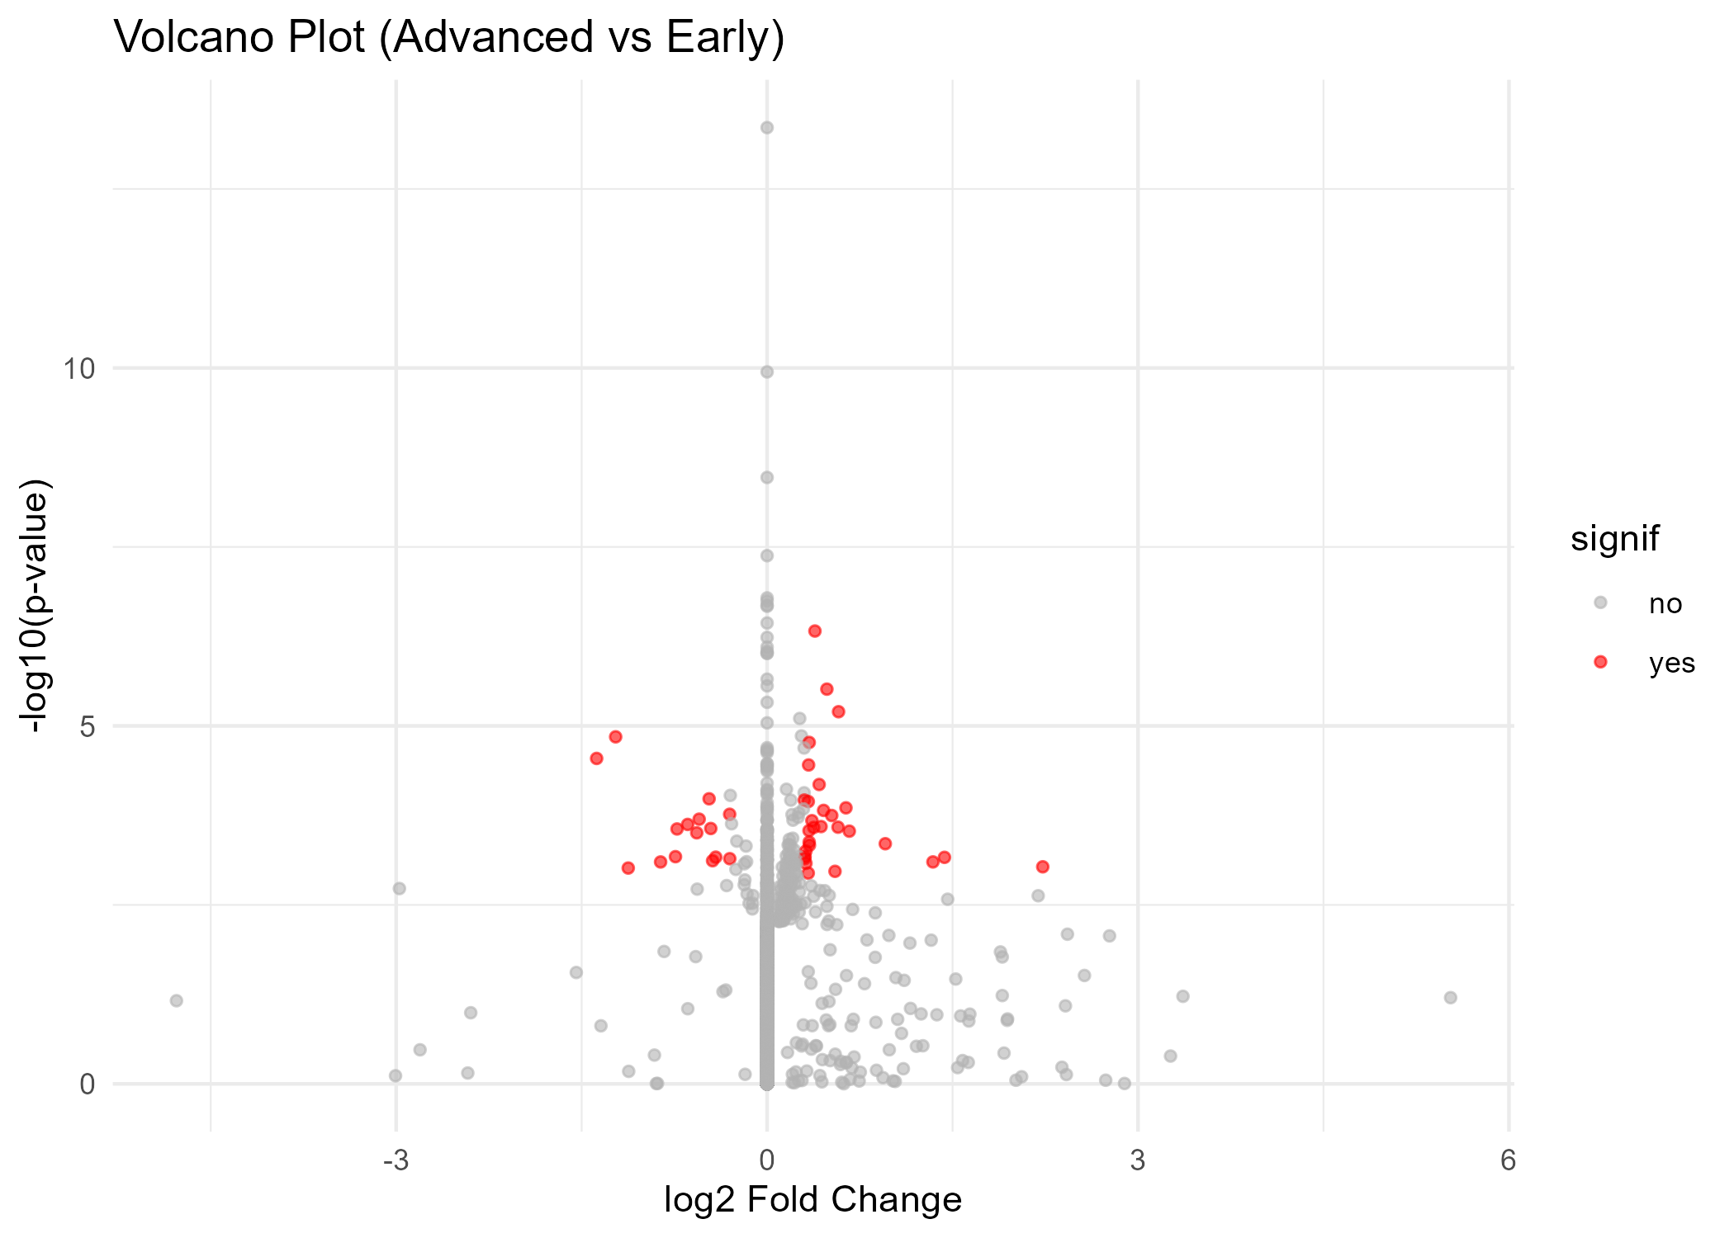

1.7 1) 基于 WGCNA 模块 Eigengenes 对样本聚类
理由：WGCNA 把基因集合成模块，再用模块 eigengene作为样本特征，维度低、信噪比高，适合样本聚类且易解释为生物学模块。
优点：比直接用几十个 DEG 更稳健；便于解释（模块 → 通路）
library(WGCNA)
options(stringsAsFactors = FALSE)
allowWGCNAThreads()
Allowing multi-threading with up to 16 threads.
# VST 转换
vsd <- vst(dds, blind = TRUE)
vst_mat <- assay(vsd)
# 选择高变基因
top_var_genes <- order(apply(vst_mat, 1, var), decreasing = TRUE)[1:5000]
datExpr <- t(vst_mat[top_var_genes, ])
# 检查缺失值
gsg <- goodSamplesGenes(datExpr, verbose = 3)
Flagging genes and samples with too many missing values...
..step 1
if (!gsg$allOK) datExpr <- datExpr[gsg$goodSamples, gsg$goodGenes]
# 计算软阈值
powers <- c(1:20)
sft <- pickSoftThreshold(datExpr, powerVector = powers, verbose = 5)
pickSoftThreshold: will use block size 5000.
pickSoftThreshold: calculating connectivity for given powers...
..working on genes 1 through 5000 of 5000
Power SFT.R.sq slope truncated.R.sq mean.k. median.k. max.k.
1 1 0.0179 -0.308 0.897 665.000 6.37e+02 1290.0
2 2 0.6500 -1.280 0.955 157.000 1.29e+02 529.0
3 3 0.8680 -1.670 0.956 52.600 3.35e+01 298.0
4 4 0.9220 -1.620 0.967 22.800 1.03e+01 192.0
5 5 0.9340 -1.510 0.972 11.800 3.56e+00 135.0
6 6 0.9350 -1.430 0.970 6.970 1.38e+00 101.0
7 7 0.9240 -1.390 0.969 4.490 5.85e-01 78.5
8 8 0.9350 -1.330 0.976 3.080 2.61e-01 62.8
9 9 0.9260 -1.320 0.973 2.220 1.23e-01 51.4
10 10 0.9090 -1.320 0.953 1.650 6.06e-02 42.8
11 11 0.9170 -1.300 0.964 1.260 3.06e-02 36.1
12 12 0.9190 -1.290 0.967 0.983 1.59e-02 30.8
13 13 0.9120 -1.290 0.964 0.780 8.46e-03 26.4
14 14 0.9040 -1.290 0.962 0.628 4.52e-03 22.9
15 15 0.9090 -1.280 0.968 0.511 2.49e-03 19.9
16 16 0.9110 -1.280 0.972 0.421 1.35e-03 17.4
17 17 0.9100 -1.280 0.973 0.349 7.48e-04 15.3
18 18 0.9140 -1.280 0.971 0.293 4.28e-04 13.5
19 19 0.9240 -1.260 0.977 0.247 2.42e-04 11.9
20 20 0.9250 -1.260 0.978 0.209 1.39e-04 10.6
softPower <- ifelse(any(sft$fitIndices[,2] > 0.8),
min(sft$fitIndices$Power[sft$fitIndices[,2] > 0.8]),
sft$fitIndices$Power[which.max(sft$fitIndices[,2])])
cat("Chosen softPower =", softPower, "\n")
Chosen softPower = 3
# 构建网络
net <- blockwiseModules(datExpr, power = softPower,
TOMType = "unsigned",
minModuleSize = 30,
mergeCutHeight = 0.25,
numericLabels = TRUE,
pamRespectsDendro = FALSE,
saveTOMs = FALSE,
verbose = 3)
Calculating module eigengenes block-wise from all genes
Flagging genes and samples with too many missing values...
..step 1
..Working on block 1 .
TOM calculation: adjacency..
..will not use multithreading.
Fraction of slow calculations: 0.000000
..connectivity..
..matrix multiplication (system BLAS)..
..normalization..
..done.
....clustering..
....detecting modules..
....calculating module eigengenes..
....checking kME in modules..
..removing 839 genes from module 1 because their KME is too low.
..removing 258 genes from module 2 because their KME is too low.
..removing 74 genes from module 3 because their KME is too low.
..removing 79 genes from module 4 because their KME is too low.
..removing 10 genes from module 5 because their KME is too low.
..removing 32 genes from module 6 because their KME is too low.
..removing 22 genes from module 7 because their KME is too low.
..removing 24 genes from module 8 because their KME is too low.
..removing 17 genes from module 9 because their KME is too low.
..removing 3 genes from module 10 because their KME is too low.
..removing 6 genes from module 11 because their KME is too low.
..removing 2 genes from module 12 because their KME is too low.
..reassigning 110 genes from module 1 to modules with higher KME.
..reassigning 55 genes from module 2 to modules with higher KME.
..reassigning 21 genes from module 3 to modules with higher KME.
..reassigning 11 genes from module 4 to modules with higher KME.
..reassigning 6 genes from module 5 to modules with higher KME.
..reassigning 1 genes from module 6 to modules with higher KME.
..reassigning 8 genes from module 7 to modules with higher KME.
..reassigning 1 genes from module 9 to modules with higher KME.
..reassigning 1 genes from module 10 to modules with higher KME.
..reassigning 1 genes from module 12 to modules with higher KME.
..merging modules that are too close..
mergeCloseModules: Merging modules whose distance is less than 0.25
Calculating new MEs...
MEs <- net$MEs
moduleColors <- labels2colors(net$colors)
# 提取样本顺序
sampleNames <- rownames(datExpr)
head(sampleNames)
[1] "TCGA-90-A4EE" "TCGA-85-8049" "TCGA-39-5016" "TCGA-56-8304" "TCGA-92-8063"
[6] "TCGA-43-8115"
# 从 clinical_sub 提取 simplified_stage
trait_df <- clinical_sub %>%
dplyr::filter(case_id %in% sampleNames) %>%
dplyr::arrange(match(case_id, sampleNames))
# 二值化 simplified_stage
trait <- ifelse(trait_df$simplified_stage == "Advanced (Stage III)", 1, 0)
length(trait)
[1] 425
length(sampleNames)
[1] 425
# datExpr 已经是行 = 样本, 列 = 基因
sampleNames <- rownames(datExpr)
# 确保 simplified_stage 存在且无 NA
clinical_sub <- clinical_data %>%
filter(case_id %in% sampleNames & !is.na(simplified_stage)) %>%
arrange(match(case_id, sampleNames))
# 检查匹配情况
cat("表达矩阵样本数:", nrow(datExpr), "\n临床匹配数:", nrow(clinical_sub), "\n")
表达矩阵样本数: 425
临床匹配数: 425
# 二值化 simplified_stage
trait <- ifelse(clinical_sub$simplified_stage == "Advanced (Stage III)", 1, 0)
# 检查 trait 长度是否匹配
length(trait)
[1] 425
length(sampleNames)
[1] 425
moduleTraitCor <- cor(MEs, trait, use = "p")
moduleTraitPvalue <- corPvalueStudent(moduleTraitCor, nSamples = nrow(datExpr))
# 绘制相关热图
textMatrix <- paste(signif(moduleTraitCor, 2), "\n(",
signif(moduleTraitPvalue, 1), ")", sep = "")
dim(textMatrix) <- dim(moduleTraitCor)
labeledHeatmap(Matrix = moduleTraitCor,
xLabels = "Simplified Stage (Advanced=1)",
yLabels = names(MEs),
ySymbols = names(MEs),
colorLabels = FALSE,
colors = blueWhiteRed(50),
textMatrix = textMatrix,
setStdMargins = FALSE,
cex.text = 0.7,
zlim = c(-1,1),
main = "Module-trait relationships")
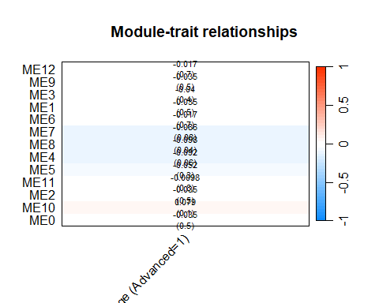
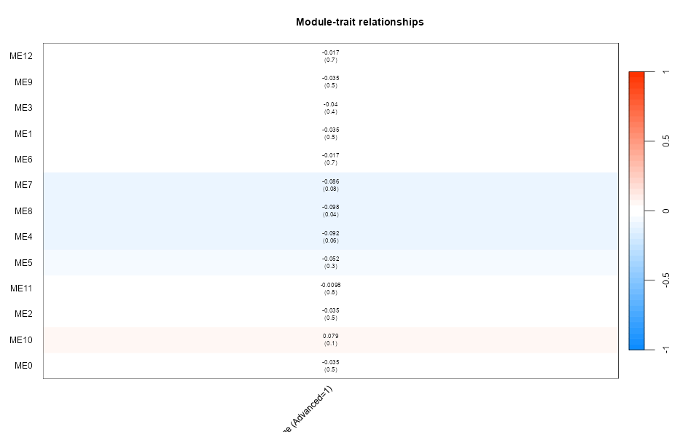
length(trait)
[1] 425
nrow(datExpr)
[1] 425
> length(trait)
+ nrow(datExpr)
[1] 425
[1] 425
# ==============================
# 第 8 步：提取显著模块 + DEG 并集
# ==============================
# 设置显著阈值
sig_modules <- rownames(moduleTraitCor)[abs(moduleTraitCor[,1]) > 0.3 & moduleTraitPvalue[,1] < 0.05]
cat("显著模块:", sig_modules, "\n")
显著模块:
# 若没有显著模块，可放宽阈值或选取 top 1 模块
if (length(sig_modules) == 0) {
sig_modules <- rownames(moduleTraitCor)[order(abs(moduleTraitCor[,1]), decreasing = TRUE)[1]]
cat("未找到显著模块，自动选择最高相关模块:", sig_modules, "\n")
}
未找到显著模块，自动选择最高相关模块: ME8
# 提取这些模块的基因
sig_genes <- names(net$colors)[net$colors %in% match(sig_modules, rownames(moduleTraitCor))]
cat("显著模块包含基因数:", length(sig_genes), "\n")
显著模块包含基因数: 226
# 取 DEG 的显著基因
DEG_genes <- rownames(resLFC[which(resLFC$padj < 0.2 & abs(resLFC$log2FoldChange) >= 0.5), ])
cat("差异基因数:", length(DEG_genes), "\n")
差异基因数: 18
# 并集
gene_union <- union(sig_genes, DEG_genes)
cat("用于聚类分析的基因数:", length(gene_union), "\n")
用于聚类分析的基因数: 244
expr_for_cluster <- t(vst_mat[intersect(rownames(vst_mat), gene_union), ])
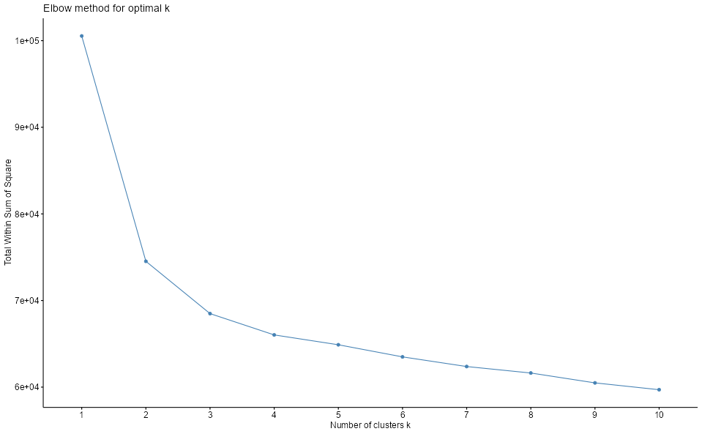
# ==============================
# 第 9 步：K-means 聚类 + 肘点法选择 k
# ==============================
library(factoextra)
# 计算总平方误差（SSE）
fviz_nbclust(expr_for_cluster, kmeans, method = "wss") +
ggtitle("Elbow method for optimal k")
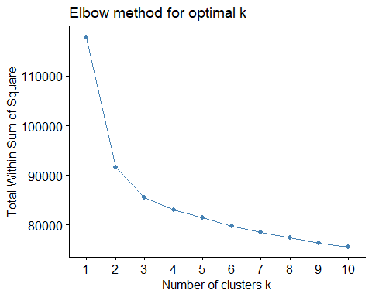
# （根据肘点选择 k 值，例如 k = 2 或 3）
set.seed(123)
k_opt <- 4 # 你可以根据上图肘点修改
km_res <- kmeans(scale(expr_for_cluster), centers = k_opt, nstart = 25)
# 将聚类结果附加到临床数据
clinical_cluster <- clinical_sub
clinical_cluster$cluster <- factor(km_res$cluster)
table(clinical_cluster$cluster)
1 2 3 4
124 131 85 85
1 2 3 4
125 131 84 85
# ==============================
# 第 10 步：绘制热图
# ==============================
library(pheatmap)
# 选择前 100 个最具方差基因以便可视化（否则太多）
top_genes_vis <- order(apply(expr_for_cluster, 2, var), decreasing = TRUE)[1:100]
annotation_col <- data.frame(
Stage = clinical_cluster$simplified_stage,
Cluster = clinical_cluster$cluster
)
rownames(annotation_col) <- rownames(expr_for_cluster)
pheatmap(
t(expr_for_cluster[, top_genes_vis]),
annotation_col = annotation_col,
show_colnames = FALSE,
show_rownames = FALSE,
scale = "row",
clustering_method = "ward.D2",
main = "DEG + WGCNA modules heatmap"
)
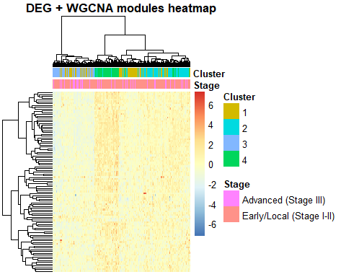
- 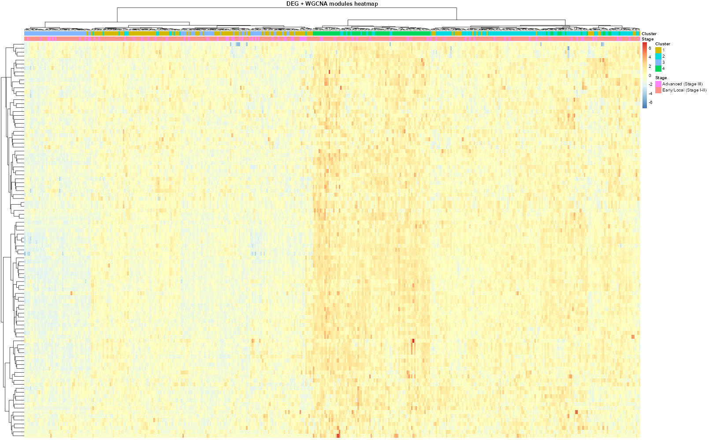
- DESeq2：只得到几十个差异基因 → 说明组间差异整体较弱；
- WGCNA：没找到显著相关模块，但发现了一个最相关模块（ME8，226个基因）；
- 热图结果：group 分组不能清晰区分样本表达模式
- 结论：分组（可能是高低、病例/对照）在表达层面上不够显著；
- 正确选择：不再用“监督聚类”（即强行按 group 区分），而改为 无监督聚类 或使用 外部数据库筛基因（如 GEPIA / GVES / TCGA）。
验证你的分组（如 simplified_stage 中的 “Early/Local (Stage I-II)” vs “Advanced (Stage III)”）是否能区分样本的表达模式，我们可以使用以下几种方法进行无监督与有监督的验证：

1.8 ✅ 方法一：主成分分析（PCA）
目的：查看不同分组的样本在主成分空间中是否聚集或分离。
r
# 使用 VST 转换后的表达矩阵
vsd <- vst(dds, blind = FALSE)
mat_vst <- assay(vsd)
# PCA
pca <- prcomp(t(mat_vst))
pc_df <- data.frame(PC1 = pca$x[,1], PC2 = pca$x[,2],
Stage = clinical_sub$simplified_stage)
ggplot(pc_df, aes(x = PC1, y = PC2, color = Stage)) +
geom_point(size = 2) +
theme_minimal() +
labs(title = "PCA: Expression Pattern by Stage")
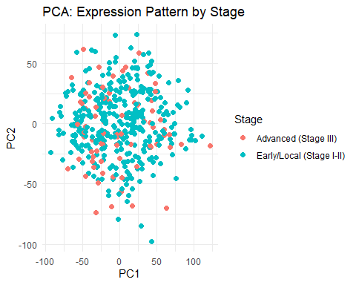
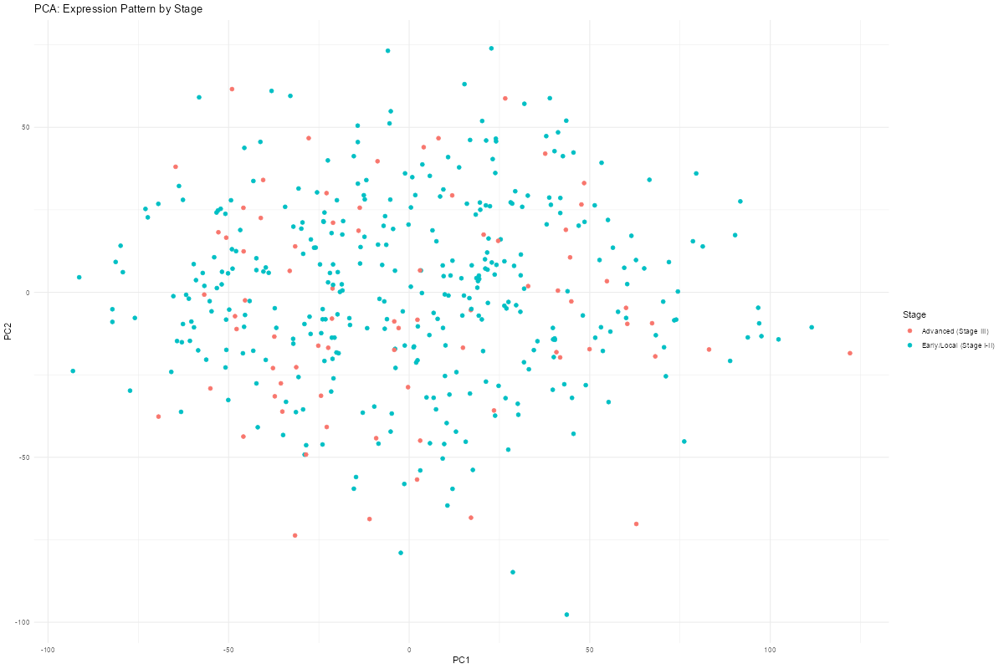
解读：
- 不同分组的样本在 PCA 图中不形成明显分离的簇，说明分组不能较好地区分表达模式。
- 混在一起，说明表达差异不明显或噪声较大。

1.9 🧬 三、无监督聚类的两种常用方法

1.9.1 1️⃣ 直接跳过WGCNAWGCNA
library(pheatmap)
library(factoextra)
# 使用样本表达矩阵的转置 (样本 × 基因)
# 用肘部法确定最佳K
fviz_nbclust(datExpr, kmeans, method = "wss")
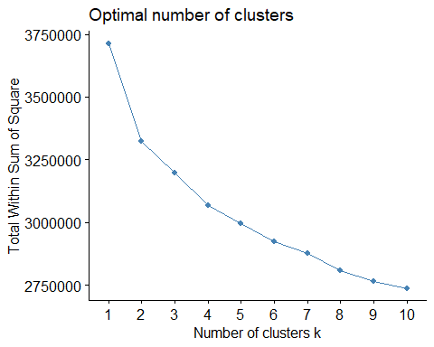
# 聚类
set.seed(123)
km_res <- kmeans(datExpr, centers = 4, nstart = 25)
fviz_cluster(km_res, data = datExpr)
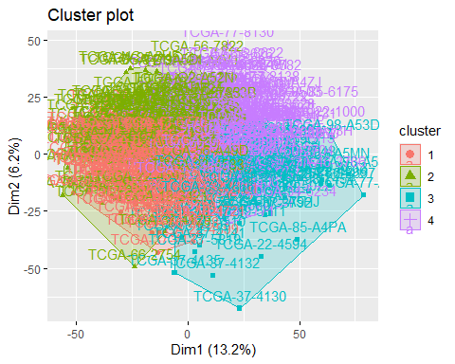
topVarGenes <- order(apply(mat_vst, 1, var), decreasing = TRUE)[1:1000]
common_samples <- intersect(common_samples, colnames(mat_vst))
expr_topVar <- mat_vst[topVarGenes, common_samples]
# 2. 标准化
expr_topVar <- t(scale(t(expr_topVar)))
rownames(annotation_col) <- colnames(expr_topVar)
pheatmap(expr_topVar,
annotation_col = annotation_col,
clustering_distance_cols = "euclidean",
clustering_method = "ward.D2",
show_colnames = FALSE,
show_rownames = FALSE,
main = "Unsupervised clustering of top variable genes")
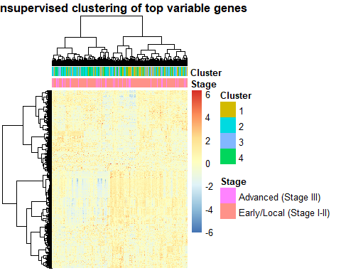
这一步可以帮助你发现新的样本亚型结构。
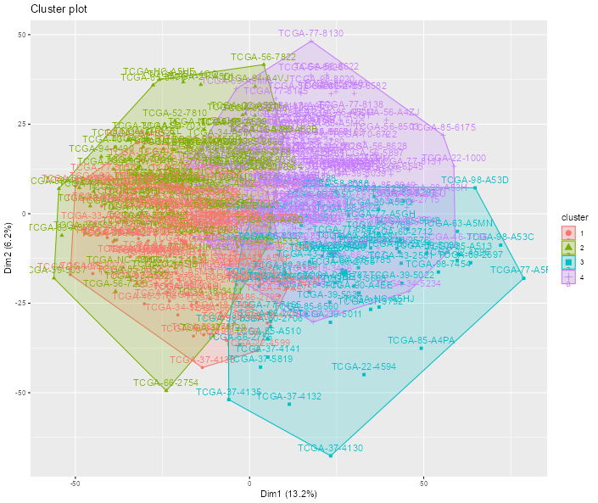
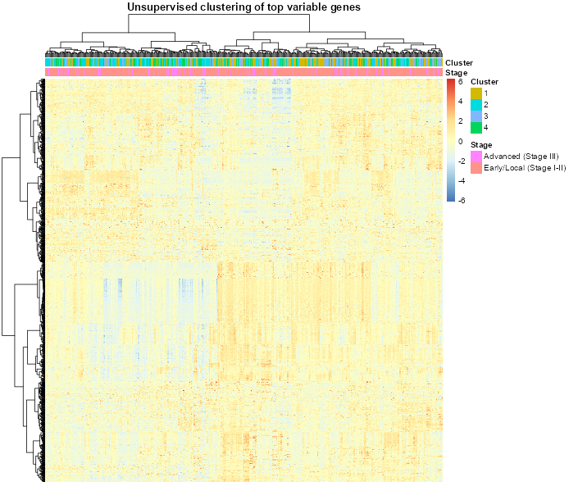
后面打算做gves的，但是感觉这个数据做这个可能没什么意义拉到得了

