Table of contents

1 🧬 Gold-Standard miRNA Expression Analysis Workflow

1.1 1. 📥 Data Acquisition
- Source: Download raw small RNA-seq data (FASTQ format) from repositories like SRA, ENCODE, TCGA, or GEO.
- Metadata: Collect sample metadata (tissue type, condition, replicate info).

1.2 2. 🧹 Quality Control (QC)
- Tools: FastQC, MultiQC
- Checks:
  - Adapter contamination
  - Read length distribution (miRNAs are ~18–30 nt)
  - Per-base quality scores

1.3 3. ✂️ Adapter Trimming
- Tools: Cutadapt, Trimmomatic, fastp
- Goal: Remove 3’ adapters and low-quality bases
- Note: miRNA libraries often have short inserts, so precise trimming is critical

1.4 4. 🧭 Alignment
- Tools: Bowtie, BWA-aln (used by GDC), STAR (for small RNA mode)
- Reference: Align to genome (e.g., GRCh38) and miRNA annotation (e.g., miRBase v22)
- Output: BAM files

1.5 5. 🧾 miRNA Quantification
- Tools: miRDeep2, sRNAbench, ShortStack, mirExpress
- Steps:
  - Count reads mapping to known miRNAs
  - Optionally predict novel miRNAs
- Output: Raw count matrix

1.6 6. 🧼 Post-Quantification QC
- Checks:
  - Distribution of counts across samples
  - Detection of outliers
  - Sample clustering (PCA, heatmaps)

1.7 7. 📊 Normalization
- Methods:
  - RPM (Reads Per Million)
  - TMM (edgeR), DESeq2 normalization
- Goal: Adjust for library size and composition

1.8 8. 📈 Expression Matrix
- Format: Rows = miRNAs, Columns = samples
- Values: Raw counts or normalized expression
- Use: Downstream analysis (differential expression, clustering, etc.)

2 🧬 Dataset Summary: ERX14406316

2.1 🔹 Study Title
Dysregulation of miRNAs in patients with Huntington’s Disease

2.2 🔹 Organism
Homo sapiens (human)

2.3 🔹 Library Strategy
miRNA-Seq — specifically designed to profile microRNAs

2.4 🔹 Sample Type
Peripheral blood mononuclear cells (PBMCs) from:
- 15 Huntington’s Disease (HD) patients
- 15 healthy controls

2.5 🔹 Platform
Illumina NovaSeq 6000

2.6 🔹 Run Info
- Run ID: ERR15002269
- Spots: 31.9 million
- Bases: 2.4 billion
- Size: ~819.5 MB (perfect for WSL)

3 🧪 Experimental Protocol Highlights
- RNA Extraction: TRIzol from PBMCs
- Quality Check: NanoDrop + TapeStation 4200
- Library Prep: QIAseq miRNA Library Kit (Qiagen)
- Quantification: Qubit + TapeStation
- Pooling: Equimolar indexing across samples
- Construction protocol: A miRNA analysis on peripheral blood mononuclear cells (PBMCs) was performed by RNA-seq in 30 subjects, including 15 HD patients and 15 healthy controls. The subjects were recruited at the Oasi Research Institute - IRCCS (Troina, Italy). PBMCs separation was performed using Ficoll-Paque (Ficoll Plaque PLUS–GE Healthcare Life Sciences, Piscataway, NJ, USA.Total RNA extraction from PBMC was performed using TRIzol reagent (TRIzol Reagent, Invitrogen Life Technologies, Carlsbad, CA, USA), according to the manufacturer’s instructions. RNA was stored at −80 ◦C until further processing.RNA concentration and purity were evaluated using NanoDrop™ 2000/2000c (Thermo Fisher Scientific),whereas sample integrity was analyzed by TapeStation 4200 (Agilent Technologies) using RNA ScreenTape Assay. 2.7. Indexed libraries were prepared from 250 ng purified RNA using QIAseq miRNA Library Kit (Qiagen) according to the manufacturer’s instructions. Libraries were quantified using the TapeStation 4200 (Agilent Technologies) and Qubit fluorometer (Invitrogen Co.), then pooled such that each index-tagged sample was present in equimolar amounts.
构建方案：采用 RNA-seq 技术对 30 名受试者（包括 15 名亨廷顿氏病患者和 15 名健康对照者）的外周血单核细胞（PBMC）进行 miRNA 分析。受试者由意大利特罗伊纳的 Oasi 研究所-IRCCS 招募。使用 Ficoll-Paque（Ficoll Plaque PLUS-GE Healthcare Life Sciences，Piscataway，新泽西州，美国）进行 PBMC 分离。使用 TRIzol 试剂（TRIzol Reagent，Invitrogen Life Technologies，Carlsbad，CA，美国）从 PBMC 中提取总 RNA，并按照制造商的说明进行。将 RNA 储存在 -80 ◦C 直至进一步处理。使用 NanoDrop™ 2000/2000c（Thermo Fisher Scientific）评估 RNA 浓度和纯度，而使用 RNA ScreenTape Assay 通过 TapeStation 4200（Agilent Technologies）分析样品完整性。2.7. 根据制造商的说明，使用 QIAseq miRNA Library Kit（Qiagen）从 250 ng 纯化 RNA 制备索引文库。使用 TapeStation 4200（Agilent Technologies）和 Qubit 荧光计（Invitrogen Co.）对文库进行定量，然后合并，使得每个索引标记的样本都以等摩尔量存在。

4 📥 Step 1: Download miRNA Data from SRA

4.1 📁 Download the SRA file
prefetch ERR15002269
what we get is
jayz@localhost:~/miRNA/data$ prefetch ERR15002269
2025-10-22T07:04:11 prefetch.3.0.3: Current preference is set to retrieve SRA Normalized Format files with full base quality scores.
2025-10-22T07:04:13 prefetch.3.0.3: 1) Downloading 'ERR15002269'...
2025-10-22T07:04:13 prefetch.3.0.3: SRA Normalized Format file is being retrieved, if this is different from your preference, it may be due to current file availability.
2025-10-22T07:04:13 prefetch.3.0.3: Downloading via HTTPS...
2025-10-22T07:05:38 prefetch.3.0.3: HTTPS download succeed
2025-10-22T07:05:40 prefetch.3.0.3: 'ERR15002269' is valid
2025-10-22T07:05:40 prefetch.3.0.3: 1) 'ERR15002269' was downloaded successfully
2025-10-22T07:05:40 prefetch.3.0.3: 'ERR15002269' has 0 unresolved dependencies

4.2 🔄 Convert to FASTQ
fasterq-dump ERR15002269 --split-files -O . -e 8
-O . saves output to current directory
-e 8 uses 8 threads for speed Output: ERR15002269.fastq
jayz@localhost:~/miRNA/data$ fasterq-dump ERR15002269 --split-files -O . -e 8
spots read : 31,944,685
reads read : 31,944,685
reads written : 31,944,685
jayz@localhost:~/miRNA/data$ ls
ERR15002269 ERR15002269.fastq
- Layout: SINGLE — confirmed in the metadata
- Library Strategy: miRNA-Seq — typically uses short, single-end reads
- Instrument: Illumina NovaSeq 6000 — supports both single and paired-end, but this run used single-end
So ERR15002269.fastq contains all the reads — no _1.fastq or _2.fastq split needed.

5 ✅ Run FastQC on the Single-End FASTQ
Here’s command:
fastqc ERR15002269.fastq -o .
This will generate:
- ERR15002269_fastqc.html — interactive QC report
- ERR15002269_fastqc.zip — raw QC data
jayz@localhost:~/miRNA/data$ fastqc ERR15002269.fastq -o .
null
Started analysis of ERR15002269.fastq
Approx 5% complete for ERR15002269.fastq
Approx 10% complete for ERR15002269.fastq
Approx 15% complete for ERR15002269.fastq
Approx 20% complete for ERR15002269.fastq
Approx 25% complete for ERR15002269.fastq
Approx 30% complete for ERR15002269.fastq
Approx 35% complete for ERR15002269.fastq
Approx 40% complete for ERR15002269.fastq
Approx 45% complete for ERR15002269.fastq
Approx 50% complete for ERR15002269.fastq
Approx 55% complete for ERR15002269.fastq
Approx 60% complete for ERR15002269.fastq
Approx 65% complete for ERR15002269.fastq
Approx 70% complete for ERR15002269.fastq
Approx 75% complete for ERR15002269.fastq
Approx 80% complete for ERR15002269.fastq
Approx 85% complete for ERR15002269.fastq
Approx 90% complete for ERR15002269.fastq
Approx 95% complete for ERR15002269.fastq
Analysis complete for ERR15002269.fastq
jayz@localhost:~/miRNA/data$ ls
ERR15002269 ERR15002269.fastq ERR15002269_fastqc.html ERR15002269_fastqc.zip
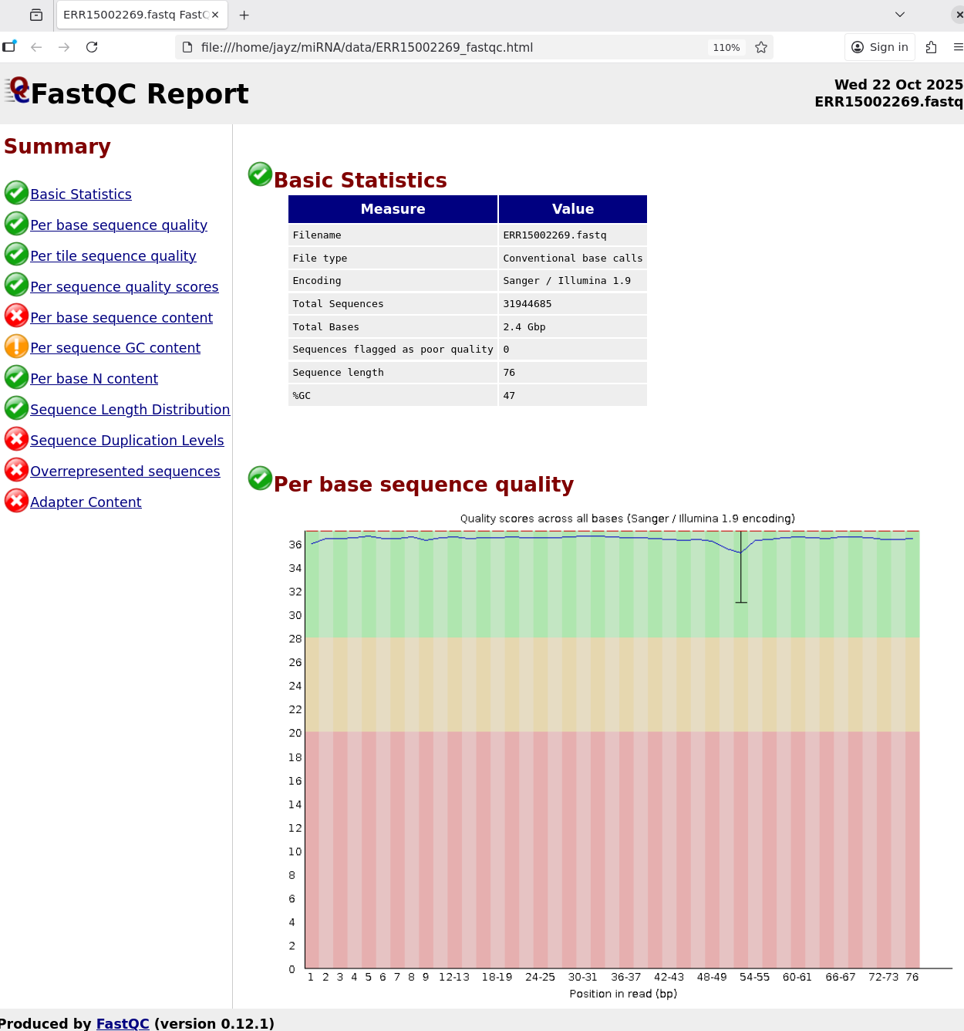
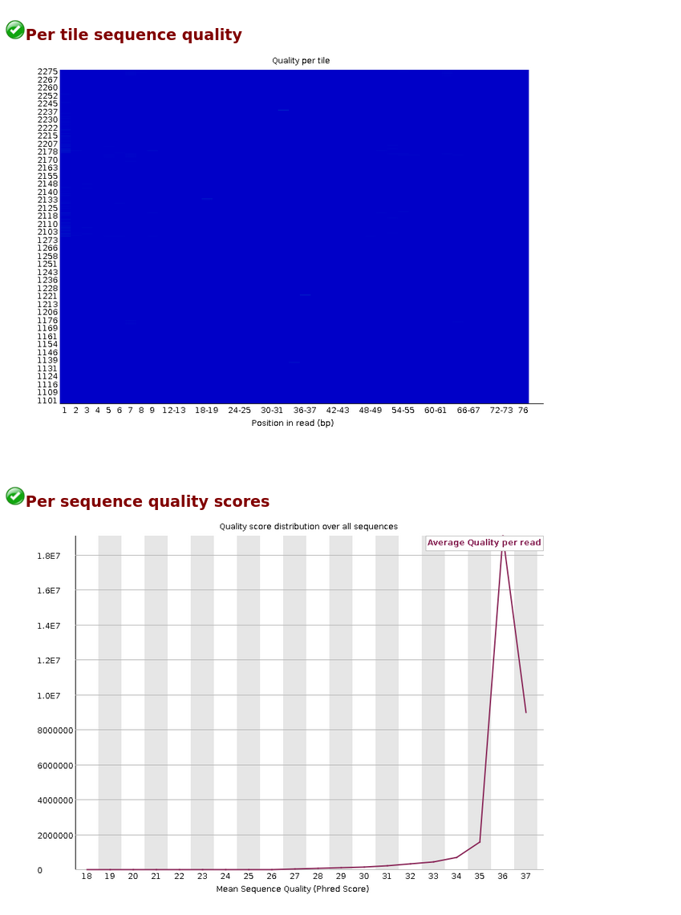
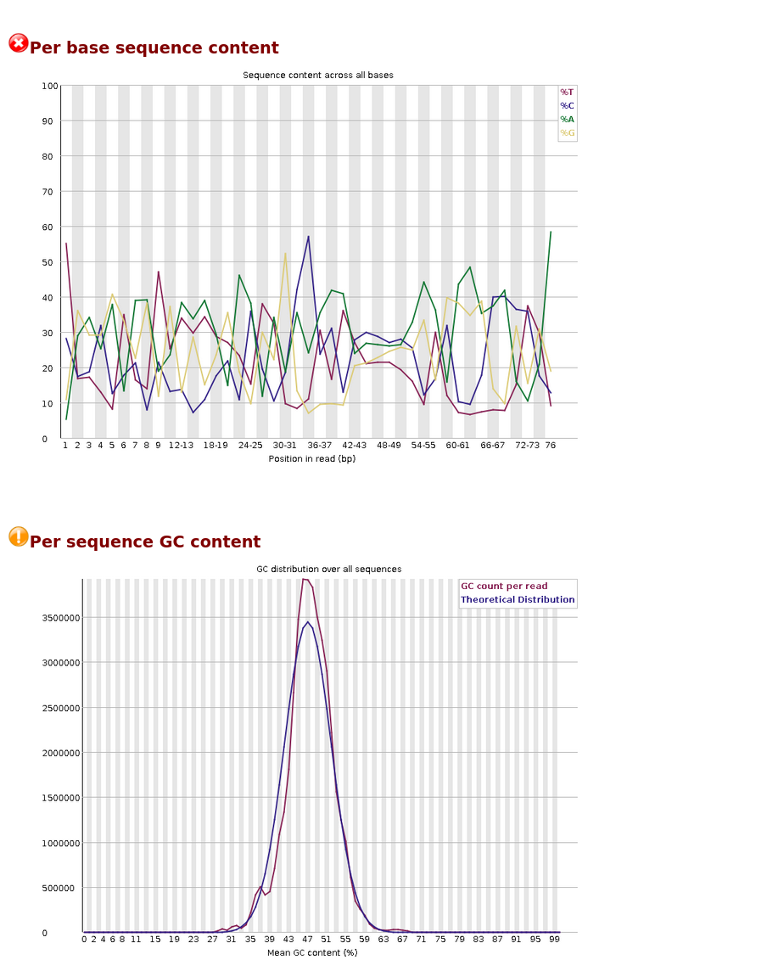
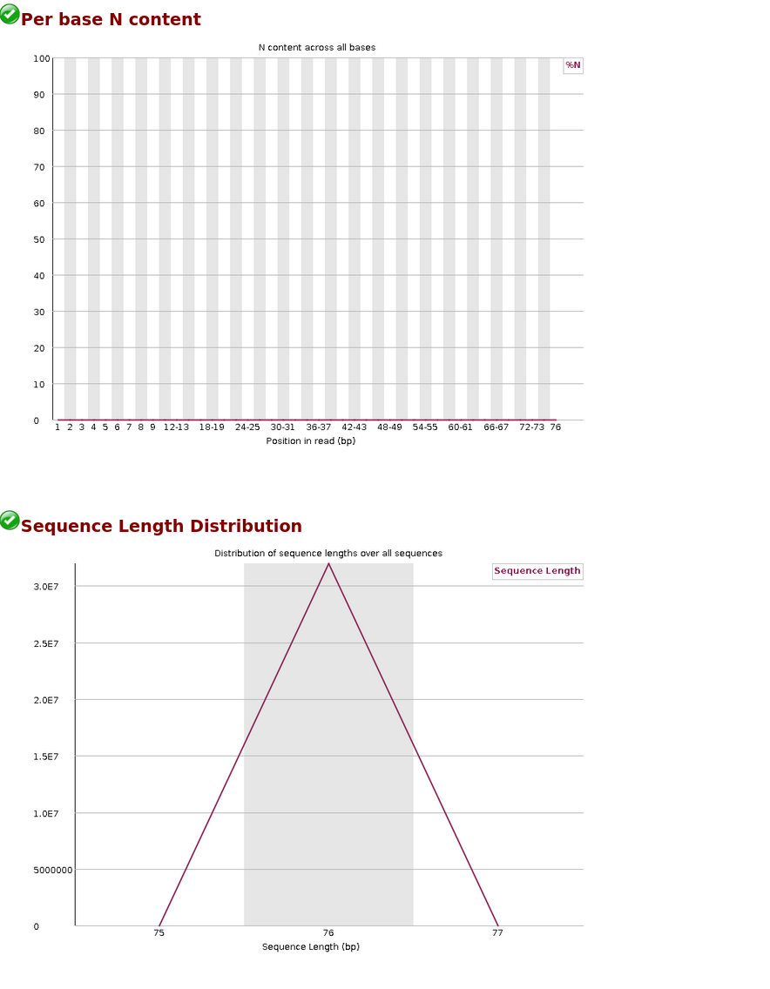
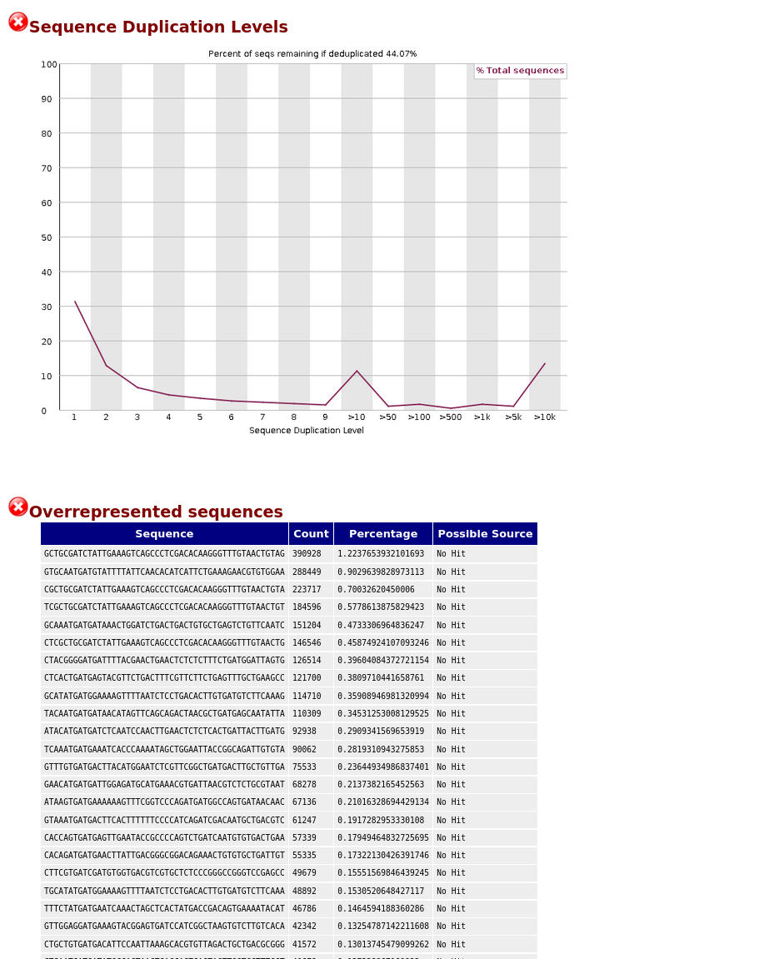

6 🚨 FastQC Red Flags & What They Mean
Metric | Issue Detected | Why It Matters
Per base sequence content | High variability across positions | Indicates adapter contamination or bias
Sequence duplication level | High duplication (>50%) | Common in miRNA due to short, repeated reads
Overrepresented sequences | Adapter sequences dominate | Must be trimmed to avoid false quantification
Adapter content | Strong signal | Confirms presence of 3’ adapter contamination

6.1 👌check in online
Direct answer: The QIAseq miRNA Library Kit uses specific adapter sequences for its 3’ and 5’ adapters, which are published by Qiagen. The commonly cited 3’ adapter sequence is AACTGTAGGCACCATCAAT (5’-3’), and the complementary 5’ adapter sequence is provided by Qiagen in their handbook and FAQs. For precise downstream parsing (e.g., trimming, deduplication) these adapters are typically trimmed along with the corresponding Illumina adapter sequences during data processing, using the kit’s own UMI-containing design.
from NGI Sweden » Adapter dilution and input optimisation for Qiagen QIAseq miRNA Library kit link
and QiagensmRNAmiRNAProtocol.pdf pdf

6.2 🔍 Run Adapter Detection
bash
fastp -i ERR15002269.fastq -o dummy.fastq -j fastp.json -h fastp.html --detect_adapter_for_pe
jayz@localhost:~/miRNA/data$ fastp -i ERR15002269.fastq -o dummy.fastq -j fastp.json -h fastp.html --detect_adapter_for_pe
Detecting adapter sequence for read1...
>QIASeq miRNA adapter
AACTGTAGGCACCATCAAT
Read1 before filtering:
total reads: 31944685
total bases: 2427796060
Q20 bases: 2397749570(98.7624%)
Q30 bases: 2336435126(96.2369%)
Read1 after filtering:
total reads: 29951211
total bases: 879659476
Q20 bases: 870151234(98.9191%)
Q30 bases: 847179780(96.3077%)
Filtering result:
reads passed filter: 29951211
reads failed due to low quality: 13009
reads failed due to too many N: 13
reads failed due to too short: 1980452
reads with adapter trimmed: 30405925
bases trimmed due to adapters: 1523102501
Duplication rate (may be overestimated since this is SE data): 26.5039%
JSON report: fastp.json
HTML report: fastp.html
fastp -i ERR15002269.fastq -o dummy.fastq -j fastp.json -h fastp.html --detect_adapter_for_pe
fastp v0.23.4, time used: 84 seconds
Even though your data is single-end, fastp will still try to guess the adapter. Check:
- fastp.html for adapter guess
- fastp.json for exact sequence
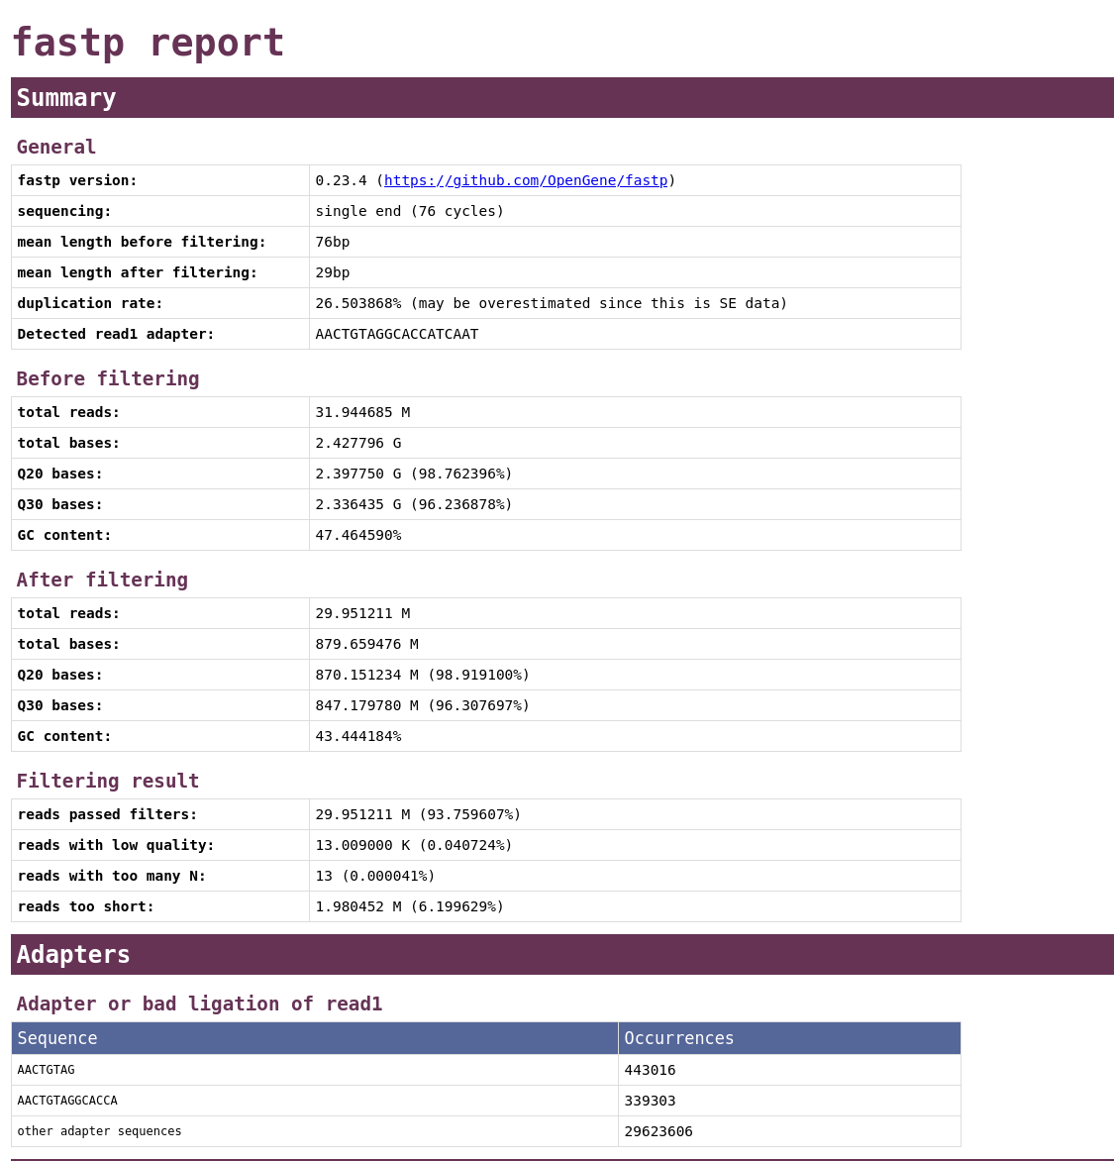
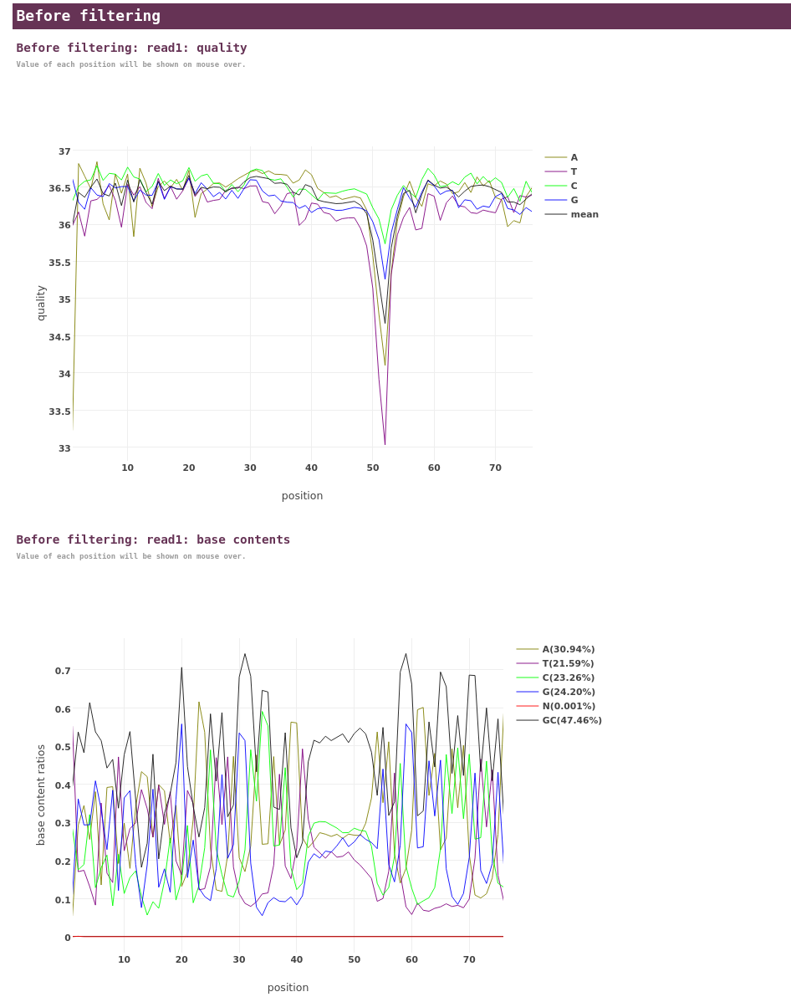
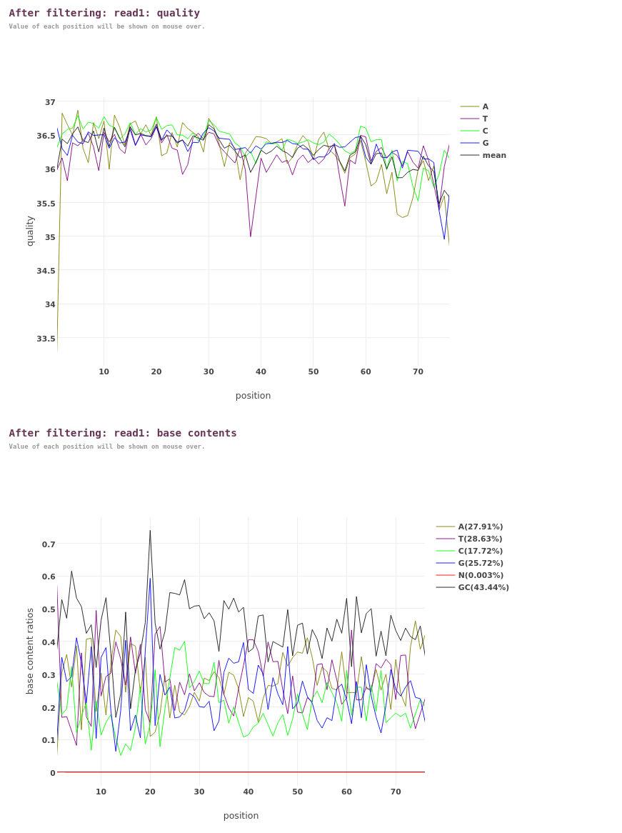

7 ✂️ Next Step: Adapter Trimming

7.1 ✅ Adapter Confirmed: AACTGTAGGCACCATCAAT
- Detected by fastp as the QIASeq miRNA adapter
- Trimmed from 30.4 million reads — strong evidence it was present and dominant
- Over 1.5 billion bases removed due to adapter contamination

8 📊 Quality Summary
Metric | Value
Total reads | 31.9 million
Reads after filtering | 29.95 million
Adapter-trimmed reads | 30.4 million
Bases trimmed | 1.52 billion
Duplication rate | 26.5% (normal for miRNA-Seq)
Q30 base percentage | ~96% (excellent quality)

9 ✂️ Next Step: Trim with cutadapt Using Confirmed Adapter
cutadapt -j 8 -a AACTGTAGGCACCATCAAT -m 18 -M 30 -o ERR15002269.trimmed.fastq ERR15002269.fastq

9.1 Explanation:
- -j 8: Tells cutadapt to use 8 parallel threads
- -a: Adapter sequence (confirmed: AACTGTAGGCACCATCAAT)
- -m 18 -M 30: Keep reads between 18 and 30 nt (typical for miRNAs)
- -o: Output trimmed FASTQ
jayz@localhost:~/miRNA/data$ cutadapt -j 8 -a AACTGTAGGCACCATCAAT -m 18 -M 30 -o ERR15002269.trimmed.fastq ERR15002269.fastq
This is cutadapt 4.4 with Python 3.12.3
Command line parameters: -j 8 -a AACTGTAGGCACCATCAAT -m 18 -M 30 -o ERR15002269.trimmed.fastq ERR15002269.fastq
Processing single-end reads on 8 cores ...
Done 00:00:24 31,944,685 reads @ 0.8 µs/read; 76.81 M reads/minute
Finished in 25.041 s (0.784 µs/read; 76.54 M reads/minute).
=== Summary ===
Total reads processed: 31,944,685
Reads with adapters: 30,363,819 (95.1%)
== Read fate breakdown ==
Reads that were too short: 2,959,416 (9.3%)
Reads that were too long: 6,369,160 (19.9%)
Reads written (passing filters): 22,616,109 (70.8%)
Total basepairs processed: 2,427,796,060 bp
Total written (filtered): 500,053,158 bp (20.6%)
=== Adapter 1 ===
Sequence: AACTGTAGGCACCATCAAT; Type: regular 3'; Length: 19; Trimmed: 30363819 times
Minimum overlap: 3
No. of allowed errors:
1-9 bp: 0; 10-19 bp: 1
Bases preceding removed adapters:
A: 18.2%
C: 6.3%
G: 30.7%
T: 44.8%
none/other: 0.0%
Overview of removed sequences
length count expect max.err error counts
3 238166 499135.7 0 238166
4 252542 124783.9 0 252542
5 143308 31196.0 0 143308
6 43788 7799.0 0 43788
7 138787 1949.7 0 138787
8 443018 487.4 0 443018
9 269305 121.9 0 269234 71
10 146457 30.5 1 139325 7132
11 202753 7.6 1 195252 7501
12 99058 1.9 1 89280 9778
13 99406 0.5 1 95635 3771
14 347694 0.1 1 339303 8391
15 235808 0.0 1 227945 7863
16 22512 0.0 1 18509 4003
17 41980 0.0 1 39622 2358
18 32510 0.0 1 31034 1476
19 15076 0.0 1 12162 2914
20 19427 0.0 1 18463 964
21 28542 0.0 1 26337 2205
22 48575 0.0 1 44780 3795
23 18637 0.0 1 17624 1013
24 35248 0.0 1 34144 1104
25 13161 0.0 1 12176 985
26 16834 0.0 1 16335 499
27 22552 0.0 1 21858 694
28 24166 0.0 1 23356 810
29 15361 0.0 1 14712 649
30 31817 0.0 1 30821 996
31 178227 0.0 1 173856 4371
32 234648 0.0 1 225911 8737
33 299014 0.0 1 286204 12810
34 471762 0.0 1 454815 16947
35 67644 0.0 1 58071 9573
36 47197 0.0 1 43206 3991
37 57858 0.0 1 55822 2036
38 65460 0.0 1 63356 2104
39 32607 0.0 1 31308 1299
40 30360 0.0 1 29117 1243
41 27801 0.0 1 26763 1038
42 59650 0.0 1 57907 1743
43 51101 0.0 1 49321 1780
44 42284 0.0 1 40560 1724
45 76193 0.0 1 73846 2347
46 93579 0.0 1 90669 2910
47 117229 0.0 1 112723 4506
48 223638 0.0 1 217648 5990
49 308109 0.0 1 299649 8460
50 115757 0.0 1 109189 6568
51 180117 0.0 1 173581 6536
52 985472 0.0 1 962368 23104
53 3350774 0.0 1 3273059 77715
54 11601442 0.0 1 11363608 237834
55 3906383 0.0 1 3702997 203386
56 1116947 0.0 1 1044962 71985
57 328980 0.0 1 310115 18865
58 287682 0.0 1 264033 23649
59 229471 0.0 1 216823 12648
60 308233 0.0 1 297144 11089
61 507955 0.0 1 487674 20281
62 497284 0.0 1 480012 17272
63 360736 0.0 1 343207 17529
64 329722 0.0 1 309528 20194
65 204341 0.0 1 193805 10536
66 169023 0.0 1 161793 7230
67 131732 0.0 1 126748 4984
68 120390 0.0 1 115664 4726
69 57711 0.0 1 55185 2526
70 31185 0.0 1 29787 1398
71 5707 0.0 1 4975 732
72 3329 0.0 1 2880 449
73 212 0.0 1 143 69
74 205 0.0 1 54 151
75 20 0.0 1 15 5
76 2160 0.0 1 2072 88

10 ✅ Trimming Summary
Metric | Value
Total reads processed | 31.94 million
Reads with adapter trimmed | 30.36 million (95.1%)
Reads passing filters | 22.62 million (70.8%)
Reads too short (<18 nt) | 2.96 million (9.3%)
Reads too long (>30 nt) | 6.37 million (19.9%)
Total bases written | ~500 million
Adapter sequence used | AACTGTAGGCACCATCAAT
Trimming speed | ~76 million reads/min (8 cores)

11 🔍 Interpretation
- Adapter removal was very successful — over 95% of reads had adapters trimmed.
- Filtering was strict but appropriate — keeping only reads between 18–30 nt ensures high-quality miRNA candidates.
- Final dataset is clean and ready for alignment or quantification.
Then re-run FastQC:
fastqc ERR15002269.trimmed.fastq -o .
jayz@localhost:~/miRNA/data$ ls
ERR15002269 ERR15002269.trimmed.fastq ERR15002269_fastqc.zip fastp.html
ERR15002269.fastq ERR15002269_fastqc.html dummy.fastq fastp.json
jayz@localhost:~/miRNA/data$ fastqc ERR15002269.trimmed.fastq -o .
null
Started analysis of ERR15002269.trimmed.fastq
Approx 5% complete for ERR15002269.trimmed.fastq
Approx 10% complete for ERR15002269.trimmed.fastq
Approx 15% complete for ERR15002269.trimmed.fastq
Approx 20% complete for ERR15002269.trimmed.fastq
Approx 25% complete for ERR15002269.trimmed.fastq
Approx 30% complete for ERR15002269.trimmed.fastq
Approx 35% complete for ERR15002269.trimmed.fastq
Approx 40% complete for ERR15002269.trimmed.fastq
Approx 45% complete for ERR15002269.trimmed.fastq
Approx 50% complete for ERR15002269.trimmed.fastq
Approx 55% complete for ERR15002269.trimmed.fastq
Approx 60% complete for ERR15002269.trimmed.fastq
Approx 65% complete for ERR15002269.trimmed.fastq
Approx 70% complete for ERR15002269.trimmed.fastq
Approx 75% complete for ERR15002269.trimmed.fastq
Approx 80% complete for ERR15002269.trimmed.fastq
Approx 85% complete for ERR15002269.trimmed.fastq
Approx 90% complete for ERR15002269.trimmed.fastq
Approx 95% complete for ERR15002269.trimmed.fastq
Analysis complete for ERR15002269.trimmed.fastq
This will confirm:
- Adapter removal
- Improved base composition
- Cleaner read length distribution
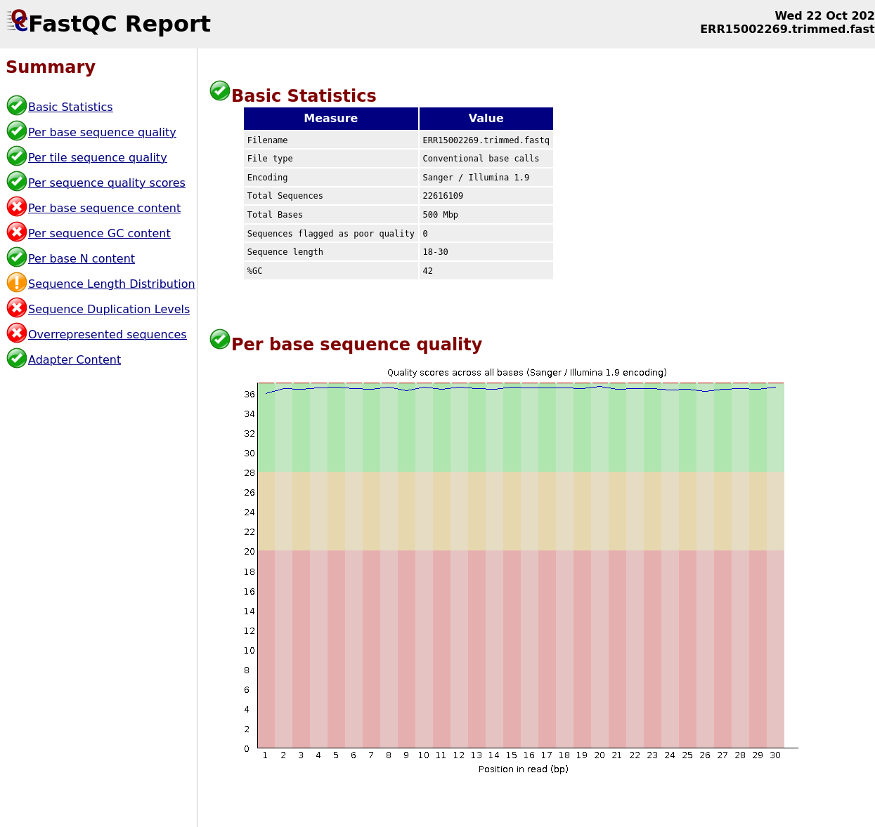

12 🚦 FastQC Red Flags: Should Worry?
Metric | Why It’s Red | Does It Matter for miRNA-Seq?
Per base sequence content | High base bias at each position | ❌ Not critical — miRNAs are short and have strong sequence motifs, so base bias is expected
GC content | Deviates from theoretical curve | ❌ Not critical — miRNAs have non-random GC profiles depending on tissue and disease
Sequence duplication level | High duplication rate | ⚠️ Expected — miRNAs are few in number and highly expressed, so duplication is normal
Overrepresented sequences | Adapter fragments or dominant miRNAs | ⚠️ Expected — top miRNAs will dominate, and adapter remnants may persist slightly

13 🧬 Why These Warnings Are Normal for miRNA-Seq
- miRNAs are short (18–30 nt) and often sequenced with single-end reads, so base composition and duplication behave differently than in mRNA-Seq.
- Highly expressed miRNAs (like let-7, miR-21) will naturally appear as overrepresented sequences.
- Adapter trimming removes most contamination, but some residual bias is tolerated.
jayz@localhost:~/miRNA/data$ ls
ERR15002269 ERR15002269.trimmed_fastqc.zip fastp.html
ERR15002269.fastq ERR15002269_fastqc.html fastp.json
ERR15002269.trimmed.fastq ERR15002269_fastqc.zip
ERR15002269.trimmed_fastqc.html dummy.fastq

14 🧬 Reference Setup for Human miRNA-Seq

15 #Unset the proxy
~/.wgetrc file is forcing wget to use a proxy at 127.0.0.1:7897, which is not running. Here’s how to fix it:

16 🧼 Step-by-Step: Disable Proxy for wget

16.1 1. ✏️ Edit ~/.wgetrc
Open the file:
nano ~/.wgetrc

16.2 2. 🔧 Comment Out Proxy Settings
Add # at the beginning of each proxy line:
#use_proxy = on #http_proxy = http://127.0.0.1:7897
#https_proxy = http://127.0.0.1:7897
jayz@localhost:~/miRNA/data$ wget https://ftp.ensembl.org/pub/release-110/fasta/homo_sapiens/dna/Homo_sapiens.GRCh38.dna.primary_assembly.fa.gz
--2025-10-22 16:22:22-- https://ftp.ensembl.org/pub/release-110/fasta/homo_sapiens/dna/Homo_sapiens.GRCh38.dna.primary_assembly.fa.gz
Connecting to 127.0.0.1:7897... failed: Connection refused.
jayz@localhost:~/miRNA/data$ cat ~/.wgetrc
use_proxy = on
http_proxy = http://127.0.0.1:7897
https_proxy = http://127.0.0.1:7897
jayz@localhost:~/miRNA/data$ nano ~/.wgetrc

16.3 1. 🧠 Genome Reference (for alignment)
- Genome: Human (GRCh38/hg38)
- Source: GENCODE or Ensembl
- File: Homo_sapiens.GRCh38.dna.primary_assembly.fa.gz

16.4 📥 Download (Ensembl)
wget --continue https://ftp.ensembl.org/pub/release-110/fasta/homo_sapiens/dna/Homo_sapiens.GRCh38.dna.primary_assembly.fa.gz
gunzip Homo_sapiens.GRCh38.dna.primary_assembly.fa.gz
jayz@localhost:~/miRNA/data$ wget --continue https://ftp.ensembl.org/pub/release-110/fasta/homo_sapiens/dna/Homo_sapiens.GRCh38.dna.primary_assembly.fa.gz
--2025-10-22 16:36:13-- https://ftp.ensembl.org/pub/release-110/fasta/homo_sapiens/dna/Homo_sapiens.GRCh38.dna.primary_assembly.fa.gz
Resolving ftp.ensembl.org (ftp.ensembl.org)... 193.62.193.169
Connecting to ftp.ensembl.org (ftp.ensembl.org)|193.62.193.169|:443... connected.
HTTP request sent, awaiting response... 200 OK
Length: 881964081 (841M) [application/x-gzip]
Saving to: ‘Homo_sapiens.GRCh38.dna.primary_assembly.fa.gz’
Homo_sapiens.GRCh38.dn 100%[============================>] 841.11M 8.29MB/s in 2m 13s
2025-10-22 16:38:28 (6.31 MB/s) - ‘Homo_sapiens.GRCh38.dna.primary_assembly.fa.gz’ saved [881964081/881964081]

16.5 2. 🎯 miRNA Annotation (for quantification)
- Database: miRBase v22
- File: hsa.gff3 or hsa.fa (for mature miRNA sequences)

16.6 📥 Download GFF3
wget https://www.mirbase.org/download/hsa.gff3
jayz@localhost:~/miRNA/data$ wget https://www.mirbase.org/download/hsa.gff3
--2025-10-22 16:45:14-- https://www.mirbase.org/download/hsa.gff3
Resolving www.mirbase.org (www.mirbase.org)... 130.88.97.249
Connecting to www.mirbase.org (www.mirbase.org)|130.88.97.249|:443... connected.
HTTP request sent, awaiting response... 200 OK
Length: 534796 (522K) [gff3]
Saving to: ‘hsa.gff3’
hsa.gff3 100%[============================>] 522.26K 346KB/s in 1.5s
2025-10-22 16:45:21 (346 KB/s) - ‘hsa.gff3’ saved [534796/534796]
Or for mature miRNA sequences:
wget https://www.mirbase.org/download/mature.fa
jayz@localhost:~/miRNA/data$ wget https://www.mirbase.org/download/mature.fa
--2025-10-22 16:48:08-- https://www.mirbase.org/download/mature.fa
Resolving www.mirbase.org (www.mirbase.org)... 130.88.97.249
Connecting to www.mirbase.org (www.mirbase.org)|130.88.97.249|:443... connected.
HTTP request sent, awaiting response... 200 OK
Length: 3866196 (3.7M) [gff3]
Saving to: ‘mature.fa’
mature.fa 100%[============================>] 3.69M 1.57MB/s in 2.4s
2025-10-22 16:48:12 (1.57 MB/s) - ‘mature.fa’ saved [3866196/3866196]

17 ⚙️ Alignment Options
We can now choose our aligner:
Tool | Purpose | Notes
Bowtie | Fast alignment to genome | Used by miRDeep2
STAR | Splice-aware, supports small RNA | Needs special config for short reads
BWA-aln | Used by GDC pipeline | Good for exact matches
jayz@localhost:~/miRNA/data$ ls
ERR15002269 Homo_sapiens.GRCh38.dna.primary_assembly.fa
ERR15002269.fastq Homo_sapiens.GRCh38.dna.primary_assembly.fa.gz.1
ERR15002269.trimmed.fastq dummy.fastq
ERR15002269.trimmed_fastqc.html fastp.html
ERR15002269.trimmed_fastqc.zip fastp.json
ERR15002269_fastqc.html hsa.gff3
ERR15002269_fastqc.zip mature.fa

18 🧰 Current Assets
File | Purpose
ERR15002269.trimmed.fastq | Cleaned miRNA reads
Homo_sapiens.GRCh38.dna.primary_assembly.fa | Human reference genome
hsa.gff3 | miRNA genomic coordinates (from miRBase)
mature.fa | Mature miRNA sequences (for quantification)

19 🧠 Tool Options for Alignment + Quantification

19.1 🔬 Recommended: miRDeep2
Best for:
- Known + novel miRNA detection
- Quantification and expression matrix
- Uses Bowtie for alignment
And we could not install with apt,and i do not want install conda
step-by-step guide to get miRDeep2 running manually:

20 🧰 Step 1: Clone the miRDeep2 Repository
git clone https://github.com/rajewsky-lab/mirdeep2.git cd mirdeep2
This gives you all the Perl scripts and documentation.

21 🛠 Step 2: Add miRDeep2 to our PATH
export PATH=$PWD:$PATH
To make this permanent, add it to our ~/.bashrc:
echo 'export PATH=$HOME/miRNA/data/mirdeep2:$PATH' >> ~/.bashrc source ~/.bashrc

22 #📦 Step 3: Install Dependencies
perl-bioperl isn’t available via apt, install via CPAN:
cpan install Bio::Perl
Or use cpanm if available:
cpanm Bio::Perl

23 🧪 Step 4: Test the Installation
Run:
miRDeep2.pl --help
mapper.pl --help
If these work, we’re ready to start collapsing reads and aligning.
jayz@localhost:~/miRNA/data/mirdeep2$ ls
CHANGELOG.md FAQ.md Rfam_for_miRDeep.fa install.pl tutorial_dir
CREDITS LICENSE TUTORIAL.md patch_files
DISCLAIMER README.md documentation.html src
jayz@localhost:~/miRNA/data/mirdeep2$ miRDeep2.pl --help
mapper.pl --help
miRDeep2.pl: command not found
mapper.pl: command not found
jayz@localhost:~/miRNA/data/mirdeep2$ export PATH=$PWD/src:$PATH
jayz@localhost:~/miRNA/data/mirdeep2$ echo 'export PATH=$HOME/miRNA/data/mirdeep2/src:$PATH' >> ~/.bashrc
source ~/.bashrc
jayz@localhost:~/miRNA/data/mirdeep2$ echo 'export PATH=$HOME/miRNA/data/mirdeep2/src:$PATH' >> ~/.bashrc
source ~/.bashrc
jayz@localhost:~/miRNA/data/mirdeep2$ miRDeep2.pl --help
mapper.pl --help
Please run the install.pl script first before using the miRDeep2 package
The install script is located in /home/jayz/miRNA/data/mirdeep2/ so just do
cd /home/jayz/miRNA/data/mirdeep2/
perl install.pl
at /home/jayz/miRNA/data/mirdeep2/src/miRDeep2.pl line 1128.
Please run the install.pl script first before using the miRDeep2 package
The install script is located in /home/jayz/miRNA/data/mirdeep2/ so just do
cd /home/jayz/miRNA/data/mirdeep2/
perl install.pl
jayz@localhost:~/miRNA/data/mirdeep2$ cd ~/miRNA/data/mirdeep2
perl install.pl
###############################################################################################
# Last update: Aug 27, 2024
# This is the miRDeep2 installer
# It is tested under a bash and zsh shell
# It will try to download all necessary third-party tools and install them.
# To run this installer you need to have mirdeep2.0.0.8 or later
#
###############################################################################################
gcc version: 13.3.0-6ubuntu2~24.04) already installed, nothing to do ...
bin directory created successful
Checking environment variables ...
adding variables PERL_MB_OPT,PERL_MM_OPT,PERL5LIB to .bashrc
please run the install.pl script again in a new terminal window or just type
source ~/.bashrc
perl install.pl
so that the new environment variables are visible to the install.pl script
the installer added critical environment variables to your .bashrc, but they haven’t taken effect yet. Let’s activate them and finish the setup:

24 ✅ Step 1: Reload Shell
Run this in our current terminal:
source ~/.bashrc

25 🔁 Step 2: Re-run the Installer
Then re-run the installer to complete setup:
perl install.pl
This second run will detect the new environment variables and finalize the installation.
Once that’s done, test:
miRDeep2.pl --help
mapper.pl --help
jayz@localhost:~/miRNA/data/mirdeep2$ miRDeep2.pl --help
mapper.pl --help
Please run the install.pl script first before using the miRDeep2 package
The install script is located in /home/jayz/miRNA/data/mirdeep2/ so just do
cd /home/jayz/miRNA/data/mirdeep2/
perl install.pl
at /home/jayz/miRNA/data/mirdeep2/src/miRDeep2.pl line 1128.
Please run the install.pl script first before using the miRDeep2 package
The install script is located in /home/jayz/miRNA/data/mirdeep2/ so just do
cd /home/jayz/miRNA/data/mirdeep2/
perl install.pl
Absolutely — we can map miRNA reads directly without using miRDeep2. In fact, many researchers prefer a modular pipeline using tools like Bowtie, SAMtools, and featureCounts for better control and reproducibility. Here’s how to do it:
Randfold can’t be installed and install.pl won’t complete without it, it’s totally reasonable to pivot away from miRDeep2.

26 🧬 Direct Mapping Pipeline for miRNA-Seq

27 🧬 Comparison: Bowtie + featureCounts vs Salmon
Aspect | Bowtie + featureCounts | Salmon
Strategy | Alignment-based (genome) | Alignment-free (transcriptome)
Input FASTA | Full genome (e.g., GRCh38) | Mature miRNA sequences (mature.fa)
Annotation format | GFF3 or GTF (e.g., hsa.gff3) | Not needed — sequences are in FASTA headers
Read input | FASTQ → SAM → BAM | FASTQ only
Tools used | bowtie, samtools, featureCounts | salmon
Speed | Slower (due to full alignment) | Faster (k-mer based)
Accuracy for short reads | High, but depends on annotation quality | High, optimized for short transcripts
Novel miRNA detection | Possible with extra tools (e.g., miRDeep2) | Not supported
Output | Raw counts per miRNA feature | TPM, counts, effective length per miRNA
Flexibility | Full control over alignment and filtering | Easy setup, less manual tuning

28 🔍 Which Should You Use?
- Use Bowtie + featureCounts if:
  - You want full control over alignment and annotation
  - You’re working with genome-based coordinates (e.g., hsa.gff3)
  - You may later integrate with other genome-wide analyses
- Use Salmon if:
  - You have clean mature.fa sequences
  - You want fast, alignment-free quantification
  - You don’t need novel miRNA discovery or genome context

28.1 ✅ Step 1: Build Bowtie Index
Use the human genome FASTA we already have,
bowtie-build Homo_sapiens.GRCh38.dna.primary_assembly.fa GRCh38_index
jayz@localhost:~/miRNA/data$ bowtie-build Homo_sapiens.GRCh38.dna.primary_assembly.fa GRCh38_index
Settings:
Output files: "GRCh38_index.*.ebwt"
Line rate: 6 (line is 64 bytes)
Lines per side: 1 (side is 64 bytes)
Offset rate: 5 (one in 32)
FTable chars: 10
Strings: unpacked
Max bucket size: default
Max bucket size, sqrt multiplier: default
Max bucket size, len divisor: 4
Difference-cover sample period: 1024
Endianness: little
Actual local endianness: little
Sanity checking: disabled
Assertions: disabled
Random seed: 0
Sizeofs: void*:8, int:4, long:8, size_t:8
Input files DNA, FASTA:
Homo_sapiens.GRCh38.dna.primary_assembly.fa
Reading reference sizes
Time reading reference sizes: 00:00:15
Calculating joined length
Writing header
Reserving space for joined string
Joining reference sequences
Time to join reference sequences: 00:00:10
bmax according to bmaxDivN setting: 737156938
Using parameters --bmax 552867704 --dcv 1024
Doing ahead-of-time memory usage test
Passed! Constructing with these parameters: --bmax 552867704 --dcv 1024
Constructing suffix-array element generator
Building DifferenceCoverSample
Building sPrime
Building sPrimeOrder
V-Sorting samples
V-Sorting samples time: 00:00:56
Allocating rank array
Ranking v-sort output
Ranking v-sort output time: 00:00:23
Invoking Larsson-Sadakane on ranks
Invoking Larsson-Sadakane on ranks time: 00:00:30
Sanity-checking and returning
Building samples
Reserving space for 12 sample suffixes
Generating random suffixes
QSorting 12 sample offsets, eliminating duplicates
Multikey QSorting 12 samples
(Using difference cover)
Multikey QSorting samples time: 00:00:00
QSorting sample offsets, eliminating duplicates time: 00:00:00
Calculating bucket sizes
Splitting and merging
Splitting and merging time: 00:00:00
Split 1, merged 7; iterating...
Splitting and merging
Splitting and merging time: 00:00:00
Avg bucket size: 4.21233e+08 (target: 552867703)
Converting suffix-array elements to index image
Allocating ftab, absorbFtab
Entering Ebwt loop
Getting block 1 of 7
Reserving size (552867704) for bucket 1
Calculating Z arrays for bucket 1
...
...
Sorting block of length 324375870 for bucket 5
(Using difference cover)
Sorting block time: 00:01:34
Returning block of 324375871 for bucket 5
Getting block 6 of 8
Reserving size (552867704) for bucket 6
Calculating Z arrays for bucket 6
Entering block accumulator loop for bucket 6:
bucket 6: 10%
bucket 6: 20%
bucket 6: 30%
bucket 6: 40%
bucket 6: 50%
bucket 6: 60%
bucket 6: 70%
bucket 6: 80%
bucket 6: 90%
bucket 6: 100%
Sorting block of length 262906209 for bucket 6
(Using difference cover)
Sorting block time: 00:01:13
Returning block of 262906210 for bucket 6
Getting block 7 of 8
Reserving size (552867704) for bucket 7
Calculating Z arrays for bucket 7
Entering block accumulator loop for bucket 7:
bucket 7: 10%
bucket 7: 20%
bucket 7: 30%
bucket 7: 40%
bucket 7: 50%
bucket 7: 60%
bucket 7: 70%
bucket 7: 80%
bucket 7: 90%
bucket 7: 100%
Sorting block of length 501135697 for bucket 7
(Using difference cover)
Sorting block time: 00:02:21
Returning block of 501135698 for bucket 7
Getting block 8 of 8
Reserving size (552867704) for bucket 8
Calculating Z arrays for bucket 8
Entering block accumulator loop for bucket 8:
bucket 8: 10%
bucket 8: 20%
bucket 8: 30%
bucket 8: 40%
bucket 8: 50%
bucket 8: 60%
bucket 8: 70%
bucket 8: 80%
bucket 8: 90%
bucket 8: 100%
Sorting block of length 384718895 for bucket 8
(Using difference cover)
Sorting block time: 00:01:49
Returning block of 384718896 for bucket 8
Exited Ebwt loop
fchr[A]: 0
fchr[C]: 870384190
fchr[G]: 1471627168
fchr[T]: 2075457683
fchr[$]: 2948627755
Exiting Ebwt::buildToDisk()
Returning from initFromVector
Wrote 846687581 bytes to primary EBWT file: GRCh38_index.rev.1.ebwt
Wrote 368578476 bytes to secondary EBWT file: GRCh38_index.rev.2.ebwt
Re-opening _in1 and _in2 as input streams
Returning from Ebwt constructor
Headers:
len: 2948627755
bwtLen: 2948627756
sz: 737156939
bwtSz: 737156939
lineRate: 6
linesPerSide: 1
offRate: 5
offMask: 0xffffffe0
isaRate: -1
isaMask: 0xffffffff
ftabChars: 10
eftabLen: 20
eftabSz: 80
ftabLen: 1048577
ftabSz: 4194308
offsLen: 92144618
offsSz: 368578472
isaLen: 0
isaSz: 0
lineSz: 64
sideSz: 64
sideBwtSz: 56
sideBwtLen: 224
numSidePairs: 6581759
numSides: 13163518
numLines: 13163518
ebwtTotLen: 842465152
ebwtTotSz: 842465152
reverse: 0
Total time for backward call to driver() for mirror index: 00:26:07
- Input: Homo_sapiens.GRCh38.dna.primary_assembly.fa
- Output: GRCh38_index.* files (used for alignment)
jayz@localhost:~/miRNA/data$ ls
ERR15002269
ERR15002269.fastq
ERR15002269.trimmed.fastq
ERR15002269.trimmed_fastqc.html
ERR15002269.trimmed_fastqc.zip
ERR15002269_fastqc.html
ERR15002269_fastqc.zip
GRCh38_index.1.ebwt
GRCh38_index.2.ebwt
GRCh38_index.3.ebwt
GRCh38_index.4.ebwt
GRCh38_index.rev.1.ebwt
GRCh38_index.rev.2.ebwt
Homo_sapiens.GRCh38.dna.primary_assembly.fa
Homo_sapiens.GRCh38.dna.primary_assembly.fa.gz.1
dummy.fastq
fastp.html
fastp.json
hsa.gff3
mature.fa

28.2 ✅ Step 2: Align Trimmed Reads
Use your adapter-trimmed FASTQ file:
bowtie -v 1 -p 8 -S GRCh38_index ERR15002269.trimmed.fastq > aligned.sam
- -v 1: allows 1 mismatch
- -p 8: uses 8 threads
- -S: outputs SAM format
jayz@localhost:~/miRNA/data$ bowtie -v 1 -p 8 -S GRCh38_index ERR15002269.trimmed.fastq > aligned.sam
Setting the index via positional argument will be deprecated in a future release. Please use -x option instead.
# reads processed: 22616109
# reads with at least one alignment: 22075012 (97.61%)
# reads that failed to align: 541097 (2.39%)
Reported 22075012 alignments

28.3 ✅ Step 3: Convert and Sort BAM
samtools view -bS aligned.sam > aligned.bam
samtools sort aligned.bam -o aligned.sorted.bam
samtools index aligned.sorted.bam
jayz@localhost:~/miRNA/data$ samtools view -bS aligned.sam > aligned.bam
samtools sort aligned.bam -o aligned.sorted.bam
samtools index aligned.sorted.bam
[bam_sort_core] merging from 4 files and 1 in-memory blocks...
check the file structure
jayz@localhost:~/miRNA/data$ ls
ERR15002269
ERR15002269.fastq
ERR15002269.trimmed.fastq
ERR15002269.trimmed_fastqc.html
ERR15002269.trimmed_fastqc.zip
ERR15002269_fastqc.html
ERR15002269_fastqc.zip
GRCh38_index.1.ebwt
GRCh38_index.2.ebwt
GRCh38_index.3.ebwt
GRCh38_index.4.ebwt
GRCh38_index.rev.1.ebwt
GRCh38_index.rev.2.ebwt
Homo_sapiens.GRCh38.dna.primary_assembly.fa
Homo_sapiens.GRCh38.dna.primary_assembly.fa.gz.1
aligned.bam
aligned.sam
aligned.sorted.bam
aligned.sorted.bam.bai
dummy.fastq
fastp.html
fastp.json
hsa.gff3
mature.fa

29 #Manual Installation

29.1 1. Download Subread
wget https://sourceforge.net/projects/subread/files/subread-2.0.3/subread-2.0.3-Linux-x86_64.tar.gz
jayz@localhost:~/miRNA/data$ wget https://sourceforge.net/projects/subread/files/subread-2.0.3/subread-2.0.3-Linux-x86_64.tar.gz
--2025-10-23 08:46:12-- https://sourceforge.net/projects/subread/files/subread-2.0.3/subread-2.0.3-Linux-x86_64.tar.gz
Resolving sourceforge.net (sourceforge.net)... 104.18.12.149, 104.18.13.149, 2606:4700::6812:c95, ...
Connecting to sourceforge.net (sourceforge.net)|104.18.12.149|:443... ^C
jayz@localhost:~/miRNA/data$ wget https://sourceforge.net/projects/subread/files/subread-2.0.3/subread-2.0.3-Linux-x86_64.tar.gz
--2025-10-23 08:48:13-- https://sourceforge.net/projects/subread/files/subread-2.0.3/subread-2.0.3-Linux-x86_64.tar.gz
Resolving sourceforge.net (sourceforge.net)... 104.18.12.149, 104.18.13.149, 2606:4700::6812:c95, ...
Connecting to sourceforge.net (sourceforge.net)|104.18.12.149|:443... connected.
HTTP request sent, awaiting response... 301 Moved Permanently
Location: https://sourceforge.net/projects/subread/files/subread-2.0.3/subread-2.0.3-Linux-x86_64.tar.gz/ [following]
--2025-10-23 08:49:23-- https://sourceforge.net/projects/subread/files/subread-2.0.3/subread-2.0.3-Linux-x86_64.tar.gz/
Reusing existing connection to sourceforge.net:443.
HTTP request sent, awaiting response... 301 Moved Permanently
Location: https://sourceforge.net/projects/subread/files/subread-2.0.3/subread-2.0.3-Linux-x86_64.tar.gz/download [following]
--2025-10-23 08:49:23-- https://sourceforge.net/projects/subread/files/subread-2.0.3/subread-2.0.3-Linux-x86_64.tar.gz/download
Reusing existing connection to sourceforge.net:443.
HTTP request sent, awaiting response... 302 Found
Location: https://downloads.sourceforge.net/project/subread/subread-2.0.3/subread-2.0.3-Linux-x86_64.tar.gz?ts=gAAAAABo-XuT7JfP1GJPYBLb8OgFcEYr5DfjuwNwsi2H_ILest0hXRCNmzr_duYhpvmIK9FZ0bFtud5c36pFLCbAZ4Rwg5Zmaw%3D%3D&use_mirror=cyfuture&r= [following]
--2025-10-23 08:49:23-- https://downloads.sourceforge.net/project/subread/subread-2.0.3/subread-2.0.3-Linux-x86_64.tar.gz?ts=gAAAAABo-XuT7JfP1GJPYBLb8OgFcEYr5DfjuwNwsi2H_ILest0hXRCNmzr_duYhpvmIK9FZ0bFtud5c36pFLCbAZ4Rwg5Zmaw%3D%3D&use_mirror=cyfuture&r=
Resolving downloads.sourceforge.net (downloads.sourceforge.net)... 104.18.13.149, 104.18.12.149, 2606:4700::6812:c95, ...
Connecting to downloads.sourceforge.net (downloads.sourceforge.net)|104.18.13.149|:443... connected.
HTTP request sent, awaiting response... 302 Found
Location: https://cyfuture.dl.sourceforge.net/project/subread/subread-2.0.3/subread-2.0.3-Linux-x86_64.tar.gz?viasf=1 [following]
--2025-10-23 08:49:24-- https://cyfuture.dl.sourceforge.net/project/subread/subread-2.0.3/subread-2.0.3-Linux-x86_64.tar.gz?viasf=1
Resolving cyfuture.dl.sourceforge.net (cyfuture.dl.sourceforge.net)... 49.50.119.27
Connecting to cyfuture.dl.sourceforge.net (cyfuture.dl.sourceforge.net)|49.50.119.27|:443...
connected.
HTTP request sent, awaiting response... 200 OK
Length: 50141646 (48M) [application/x-gzip]
Saving to: ‘subread-2.0.3-Linux-x86_64.tar.gz.1’
subread-2.0.3-Linux-x8 100%[============================>] 47.82M 4.22MB/s in 12s
2025-10-23 08:49:38 (3.92 MB/s) - ‘subread-2.0.3-Linux-x86_64.tar.gz.1’ saved [50141646/50141646]

29.2 2. Extract and add to PATH
tar -xvzf subread-2.0.3-Linux-x86_64.tar.gz
cd subread-2.0.3-Linux-x86_64/bin
export PATH=$PWD:$PATH
jayz@localhost:~/miRNA/data$ tar -xvzf subread-2.0.3-Linux-x86_64.tar.gz
cd subread-2.0.3-Linux-x86_64/bin
subread-2.0.3-Linux-x86_64/
subread-2.0.3-Linux-x86_64/README.txt
subread-2.0.3-Linux-x86_64/LICENSE
subread-2.0.3-Linux-x86_64/doc/
subread-2.0.3-Linux-x86_64/doc/._SubreadUsersGuide.pdf
subread-2.0.3-Linux-x86_64/doc/SubreadUsersGuide.pdf
subread-2.0.3-Linux-x86_64/doc/SubreadUsersGuide.tex
subread-2.0.3-Linux-x86_64/test/
subread-2.0.3-Linux-x86_64/test/chr901.fa
subread-2.0.3-Linux-x86_64/test/exactSNP/
subread-2.0.3-Linux-x86_64/test/exactSNP/exactSNP-test.sh
subread-2.0.3-Linux-x86_64/test/exactSNP/data/
subread-2.0.3-Linux-x86_64/test/exactSNP/data/test-in.BAM
subread-2.0.3-Linux-x86_64/test/featureCounts/
subread-2.0.3-Linux-x86_64/test/featureCounts/data/
subread-2.0.3-Linux-x86_64/test/featureCounts/data/corner-Jcounts.ora.jcounts
subread-2.0.3-Linux-x86_64/test/featureCounts/data/test-minimum-UNSTR.ora
subread-2.0.3-Linux-x86_64/test/featureCounts/data/intron_between.bam.ora
subread-2.0.3-Linux-x86_64/test/featureCounts/data/across_intron.gtf
subread-2.0.3-Linux-x86_64/test/featureCounts/data/intron_between_nointron.sam.ora
subread-2.0.3-Linux-x86_64/test/featureCounts/data/across_genes_r2.sam.ora
subread-2.0.3-Linux-x86_64/test/featureCounts/data/corner-BothEnds.ora
subread-2.0.3-Linux-x86_64/test/featureCounts/data/corner-IgnoreDup.ora
subread-2.0.3-Linux-x86_64/test/featureCounts/data/across_genes_r1.sam
subread-2.0.3-Linux-x86_64/test/featureCounts/data/corner-Chimeric.ora
subread-2.0.3-Linux-x86_64/test/featureCounts/data/test-chrname.ora
subread-2.0.3-Linux-x86_64/test/featureCounts/data/corner-fractions.sam
subread-2.0.3-Linux-x86_64/test/featureCounts/data/intron_between.gtf
subread-2.0.3-Linux-x86_64/test/featureCounts/data/test-minimum-3ext.ora
subread-2.0.3-Linux-x86_64/test/featureCounts/data/corner-Read2Pos5.ora
subread-2.0.3-Linux-x86_64/test/featureCounts/data/across_intron_r1.bam
subread-2.0.3-Linux-x86_64/test/featureCounts/data/test-chralias.sam
subread-2.0.3-Linux-x86_64/test/featureCounts/data/corner-fractions.ora
subread-2.0.3-Linux-x86_64/test/featureCounts/data/intron_between_nointron.sam
subread-2.0.3-Linux-x86_64/test/featureCounts/data/across_intron_r1.bam.ora
subread-2.0.3-Linux-x86_64/test/featureCounts/data/test-fracOverlap.ora
...
...
subread-2.0.3-Linux-x86_64/test/featureCounts/test_chr_inference.sh
subread-2.0.3-Linux-x86_64/test/featureCounts/test_corner_cases.sh
subread-2.0.3-Linux-x86_64/test/featureCounts/test_chr_aliases.sh
subread-2.0.3-Linux-x86_64/test/featureCounts/test_minimal_example.sh
subread-2.0.3-Linux-x86_64/test/featureCounts/featureCounts-test.sh
subread-2.0.3-Linux-x86_64/test/featureCounts/test_featurelevel.sh
subread-2.0.3-Linux-x86_64/test/featureCounts/test_commonusage.sh
...
...
we can add that export line to your ~/.bashrc to make it permanent.
To make it permanent:
echo 'export PATH=$HOME/miRNA/data/subread-2.0.3-Linux-x86_64/bin:$PATH' >> ~/.bashrc
source ~/.bashrc

29.3 4. ✅ Test It

30 🧪 Test It
featureCounts -v
jayz@localhost:~/miRNA/data/subread-2.0.3-Linux-x86_64/bin$ featureCounts -v
featureCounts v2.0.3
it prints version info, we’re good to go.

30.1 ✅ Step 4: Quantify miRNAs with featureCounts
Use your hsa.gff3 annotation:
featureCounts -T 4 -t miRNA -g Name -a hsa.gff3 -o counts.txt aligned.sorted.bam
- -t miRNA: feature type in GFF3
- -g Name: attribute to group by (e.g., miRNA ID)
- -a hsa.gff3: annotation file
- -o counts.txt: output file
jayz@localhost:~/miRNA/data$ featureCounts -T 4 -t miRNA -g Name -a hsa.gff3 -o counts.txt aligned.sorted.bam
========== _____ _ _ ____ _____ ______ _____
===== / ____| | | | _ \| __ \| ____| /\ | __ \
===== | (___ | | | | |_) | |__) | |__ / \ | | | |
==== \___ \| | | | _ <| _ /| __| / /\ \ | | | |
==== ____) | |__| | |_) | | \ \| |____ / ____ \| |__| |
========== |_____/ \____/|____/|_| \_\______/_/ \_\_____/
v2.0.3
//========================== featureCounts setting ===========================\\
|| ||
|| Input files : 1 BAM file ||
|| ||
|| aligned.sorted.bam ||
|| ||
|| Output file : counts.txt ||
|| Summary : counts.txt.summary ||
|| Paired-end : no ||
|| Count read pairs : no ||
|| Annotation : hsa.gff3 (GTF) ||
|| Dir for temp files : ./ ||
|| ||
|| Threads : 4 ||
|| Level : meta-feature level ||
|| Multimapping reads : not counted ||
|| Multi-overlapping reads : not counted ||
|| Min overlapping bases : 1 ||
|| ||
\\============================================================================//
//================================= Running ==================================\\
|| ||
|| Load annotation file hsa.gff3 ... ||
|| Features : 2883 ||
|| Meta-features : 2652 ||
|| Chromosomes/contigs : 24 ||
|| ||
|| Process BAM file aligned.sorted.bam... ||
|| Single-end reads are included. ||
|| Total alignments : 22616109 ||
|| Successfully assigned alignments : 19649842 (86.9%) ||
|| Running time : 0.03 minutes ||
|| ||
|| Write the final count table. ||
|| Write the read assignment summary. ||
|| ||
|| Summary of counting results can be found in file "counts.txt.summary" ||
|| ||
\\============================================================================//
jayz@localhost:~/miRNA/data$ ls
ERR15002269
ERR15002269.fastq
ERR15002269.trimmed.fastq
ERR15002269.trimmed_fastqc.html
ERR15002269.trimmed_fastqc.zip
ERR15002269_fastqc.html
ERR15002269_fastqc.zip
GRCh38_index.1.ebwt
GRCh38_index.2.ebwt
GRCh38_index.3.ebwt
GRCh38_index.4.ebwt
GRCh38_index.rev.1.ebwt
GRCh38_index.rev.2.ebwt
Homo_sapiens.GRCh38.dna.primary_assembly.fa
Homo_sapiens.GRCh38.dna.primary_assembly.fa.gz.1
aligned.bam
aligned.sam
aligned.sorted.bam
aligned.sorted.bam.bai
counts.txt
counts.txt.summary
dummy.fastq
fastp.html
fastp.json
hsa.gff3
mature.fa
subread-2.0.3-Linux-x86_64
subread-2.0.3-Linux-x86_64.tar.gz
🎉 Success! We’ve just completed a full genome-based miRNA quantification pipeline using:
- ✅ Bowtie for alignment
- ✅ SAMtools for BAM conversion and sorting
- ✅ featureCounts for expression quantification

31 📦 What we Just Produced
File | Description
counts.txt | miRNA expression matrix (raw counts per feature)
counts.txt.summary | Summary of read assignment statistics

32 📊 Next Steps

32.1 🔍 1. Inspect counts.txt
You can preview the top rows:
head counts.txt
It should show miRNA IDs (from hsa.gff3) and their corresponding read counts.
jayz@localhost:~/miRNA/data$ head counts.txt
# Program:featureCounts v2.0.3; Command:"featureCounts" "-T" "4" "-t" "miRNA" "-g" "Name" "-a" "hsa.gff3" "-o" "counts.txt" "aligned.sorted.bam"
Geneid Chr Start End Strand Length aligned.sorted.bam
hsa-miR-6859-5p chr1;chr1;chr15;chr16 17409;187931;101973529;17092 17431;187953;101973551;17114 -;-;+;- 92 3
hsa-miR-6859-3p chr1;chr1;chr15;chr16 17369;187891;101973569;17052 17391;187913;101973591;17074 -;-;+;- 92 0
hsa-miR-1302 chr1;chr12;chr15;chr19;chr2;chr2;chr20;chr7;chr8;chr9;chr9 30438;112695082;101960504;72045;113583004;207269328;50614689;18127234;141786255;30216;97363596 30458;112695102;101960524;72065;113583024;207269348;50614709;18127254;141786275;30236;97363616 +;-;-;+;-;-;-;-;-;+;- 231 0
hsa-miR-12136 chr1 632668 632685 - 18 630
hsa-miR-200b-5p chr1 1167124 1167145 + 22 4
hsa-miR-200b-3p chr1 1167160 1167181 + 22 84
hsa-miR-200a-5p chr1 1167878 1167899 + 22 39
hsa-miR-200a-3p chr1 1167916 1167937 + 22 117

33 🔍 Example Interpretation
hsa-miR-200a-3p chr1 1167916 1167937 + 22 117
- hsa-miR-200a-3p is on chromosome 1
- It spans positions 1167916–1167937 on the + strand
- It’s 22 bp long
- 117 reads were assigned to it

33.1 Use less (scrollable)
less counts.txt.summary
- Use arrow keys to scroll
- Press q to quit
Status aligned.sorted.bam
Assigned 19649842
Unassigned_Unmapped 541097
Unassigned_Read_Type 0
Unassigned_Singleton 0
Unassigned_MappingQuality 0
Unassigned_Chimera 0
Unassigned_FragmentLength 0
Unassigned_Duplicate 0
Unassigned_MultiMapping 0
Unassigned_Secondary 0
Unassigned_NonSplit 0
Unassigned_NoFeatures 1991088
Unassigned_Overlapping_Length 0
Unassigned_Ambiguity 434082

34 📊 Summary Interpretation
Category | Count | Meaning
Assigned | 19,649,842 | ✅ Reads successfully matched to miRNA features in hsa.gff3
Unassigned_Unmapped | 541,097 | ❌ Reads didn’t align to the genome at all
Unassigned_NoFeatures | 1,991,088 | ❌ Reads aligned to the genome but didn’t overlap any annotated miRNA
Unassigned_Ambiguity | 434,082 | ⚠️ Reads overlapped multiple features and couldn’t be uniquely assigned
Other Unassigned | 0 | ✅ No issues with read type, duplicates, quality, etc.

35 🧠 What This Tells
- 86.9% of reads were successfully assigned — that’s excellent for miRNA-Seq.
- The ~2 million unassigned reads likely hit intergenic or non-miRNA regions.
- The 434k ambiguous reads suggest some miRNAs overlap or share coordinates — common in miRNA families.

36 🧬 miRNA Quantification with Salmon

36.1 🔹 Step 1: Prepare our Reference
Use your mature.fa file from miRBase — this contains mature miRNA sequences.
ls mature.fa
Make sure it’s properly formatted (FASTA headers like >hsa-miR-21-5p).

36.2 🔹 Step 2: Build Salmon Index
salmon index -t mature.fa -i mirna_index -k 17
- -t: transcript FASTA (our mature.fa)
- -i: output index directory
- -k 17: k-mer size (17–21 is ideal for miRNA, which are ~22 nt long)
[2025-10-23 09:24:55.349] [puff::index::jointLog] [info] Replaced 304398 non-ATCG nucleotides
[2025-10-23 09:24:55.349] [puff::index::jointLog] [info] Clipped poly-A tails from 1 transcripts
wrote 48071 cleaned references
[2025-10-23 09:24:55.368] [puff::index::jointLog] [info] Filter size not provided; estimating from number of distinct k-mers
[2025-10-23 09:24:55.377] [puff::index::jointLog] [info] ntHll estimated 233665 distinct k-mers, setting filter size to 2^22
Threads = 2
Vertex length = 17
Hash functions = 5
Filter size = 4194304
Capacity = 1
Files:
mirna_index/ref_k17_fixed.fa
--------------------------------------------------------------------------------
Round 0, 0:4194304
Pass Filling Filtering
1 0 0
2 0 0
True junctions count = 5429
False junctions count = 101504
Hash table size = 106933
Candidate marks count = 116021
--------------------------------------------------------------------------------
Reallocating bifurcations time: 0
True marks count: 105160
Edges construction time: 0
--------------------------------------------------------------------------------
Distinct junctions = 5429
TwoPaCo::buildGraphMain:: allocated with scalable_malloc; freeing.
TwoPaCo::buildGraphMain:: Calling scalable_allocation_command(TBBMALLOC_CLEAN_ALL_BUFFERS, 0);
allowedIn: 20
Max Junction ID: 96233
seen.size():769873 kmerInfo.size():96234
approximateContigTotalLength: 242257
counters for complex kmers:
(prec>1 & succ>1)=493 | (succ>1 & isStart)=324 | (prec>1 & isEnd)=339 | (isStart & isEnd)=7
contig count: 53161 element count: 1121286 complex nodes: 1163
# of ones in rank vector: 53160
[2025-10-23 09:24:56.048] [puff::index::jointLog] [info] Starting the Pufferfish indexing by reading the GFA binary file.
[2025-10-23 09:24:56.048] [puff::index::jointLog] [info] Setting the index/BinaryGfa directory mirna_index
size = 1121286
-----------------------------------------
| Loading contigs | Time = 168.82 us
-----------------------------------------
size = 1121286
-----------------------------------------
| Loading contig boundaries | Time = 71.113 us
-----------------------------------------
Number of ones: 53160
Number of ones per inventory item: 512
Inventory entries filled: 104
53160
[2025-10-23 09:24:56.051] [puff::index::jointLog] [info] Done wrapping the rank vector with a rank9sel structure.
[2025-10-23 09:24:56.052] [puff::index::jointLog] [info] contig count for validation: 53160
[2025-10-23 09:24:56.060] [puff::index::jointLog] [info] Total # of Contigs : 53160
[2025-10-23 09:24:56.061] [puff::index::jointLog] [info] Total # of numerical Contigs : 53160
[2025-10-23 09:24:56.061] [puff::index::jointLog] [info] Total # of contig vec entries: 59816
[2025-10-23 09:24:56.061] [puff::index::jointLog] [info] bits per offset entry 16
[2025-10-23 09:24:56.063] [puff::index::jointLog] [info] Done constructing the contig vector. 53161
[2025-10-23 09:24:56.067] [puff::index::jointLog] [info] # segments = 53160
[2025-10-23 09:24:56.067] [puff::index::jointLog] [info] total length = 1121286
[2025-10-23 09:24:56.072] [puff::index::jointLog] [info] Reading the reference files ...
[2025-10-23 09:24:56.083] [puff::index::jointLog] [info] positional integer width = 21
[2025-10-23 09:24:56.083] [puff::index::jointLog] [info] seqSize = 1121286
[2025-10-23 09:24:56.083] [puff::index::jointLog] [info] rankSize = 1121286
[2025-10-23 09:24:56.083] [puff::index::jointLog] [info] edgeVecSize = 0
[2025-10-23 09:24:56.083] [puff::index::jointLog] [info] num keys = 270726
for info, total work write each : 2.331 total work inram from level 3 : 4.322 total work raw : 25.000
[Building BooPHF] 100 % elapsed: 0 min 0 sec remaining: 0 min 0 sec
Bitarray 1424512 bits (100.00 %) (array + ranks )
final hash 0 bits (0.00 %) (nb in final hash 0)
[2025-10-23 09:24:56.105] [puff::index::jointLog] [info] mphf size = 0.169815 MB
[2025-10-23 09:24:56.105] [puff::index::jointLog] [info] chunk size = 560643
[2025-10-23 09:24:56.105] [puff::index::jointLog] [info] chunk 0 = [0, 560651)
[2025-10-23 09:24:56.105] [puff::index::jointLog] [info] chunk 1 = [560651, 1121270)
[2025-10-23 09:24:56.111] [puff::index::jointLog] [info] finished populating pos vector
[2025-10-23 09:24:56.111] [puff::index::jointLog] [info] writing index components
[2025-10-23 09:24:56.113] [puff::index::jointLog] [info] finished writing dense pufferfish index
[2025-10-23 09:24:56.114] [jLog] [info] done building index

37 📦 Key Stats from the Log
Metric | Value | Meaning
Cleaned references | 48,071 | Number of usable miRNA transcripts
Distinct k-mers | 233,665 | Unique sequence fragments used for mapping
Contigs | 53,160 | Indexed miRNA sequences
Total sequence length | 1,121,286 | Combined length of all miRNAs
Index size | ~0.17 MB | Lightweight and fast

37.1 🔹 Step 3: Quantify Expression
Use your trimmed FASTQ file:
salmon quant -i mirna_index -l A -r ERR15002269.trimmed.fastq -o salmon_quant --validateMappings
- -l A: auto-detect library type
- -r: single-end reads
- --validateMappings: improves accuracy for short reads
jayz@localhost:~/miRNA/data$ salmon quant -i mirna_index -l A -r ERR15002269.trimmed.fastq -o salmon_quant --validateMappings
### salmon (selective-alignment-based) v1.10.2
### [ program ] => salmon
### [ command ] => quant
### [ index ] => { mirna_index }
### [ libType ] => { A }
### [ unmatedReads ] => { ERR15002269.trimmed.fastq }
### [ output ] => { salmon_quant }
### [ validateMappings ] => { }
Logs will be written to salmon_quant/logs
[2025-10-23 09:28:18.953] [jointLog] [info] setting maxHashResizeThreads to 16
[2025-10-23 09:28:18.953] [jointLog] [info] Fragment incompatibility prior below threshold. Incompatible fragments will be ignored.
[2025-10-23 09:28:18.953] [jointLog] [info] Usage of --validateMappings implies use of minScoreFraction. Since not explicitly specified, it is being set to 0.65
[2025-10-23 09:28:18.953] [jointLog] [info] Setting consensusSlack to selective-alignment default of 0.35.
[2025-10-23 09:28:18.953] [jointLog] [info] parsing read library format
-----------------------------------------
| Loading contig table | Time = 3.1963 ms
-----------------------------------------
size = 53161
-----------------------------------------
| Loading contig offsets | Time = 306.09 us
-----------------------------------------
-----------------------------------------
| Loading reference lengths | Time = 200.91 us
-----------------------------------------
-----------------------------------------
| Loading mphf table | Time = 151.66 us
-----------------------------------------
size = 1121286
Number of ones: 53160
Number of ones per inventory item: 512
Inventory entries filled: 104
-----------------------------------------
| Loading contig boundaries | Time = 2.0608 ms
-----------------------------------------
size = 1121286
-----------------------------------------
| Loading sequence | Time = 355.69 us
-----------------------------------------
size = 270726
-----------------------------------------
| Loading positions | Time = 508.91 us
-----------------------------------------
size = 1051325
-----------------------------------------
| Loading reference sequence | Time = 240.39 us
-----------------------------------------
-----------------------------------------
| Loading reference accumulative lengths | Time = 261.56 us
-----------------------------------------
[2025-10-23 09:28:18.955] [jointLog] [info] There is 1 library.
[2025-10-23 09:28:18.955] [jointLog] [info] Loading pufferfish index
[2025-10-23 09:28:18.955] [jointLog] [info] Loading dense pufferfish index.
[2025-10-23 09:28:18.963] [jointLog] [info] done
[2025-10-23 09:28:19.036] [jointLog] [info] Index contained 48204 targets
[2025-10-23 09:28:19.041] [jointLog] [info] Number of decoys : 0
[2025-10-23 09:28:19.182] [jointLog] [info] Automatically detected most likely library type as SF
processed 22500001 fragments
hits: 7061246; hits per frag: 0.314018
...
...
[2025-10-23 09:28:24.193] [jointLog] [warning] Only 4004407 fragments were mapped, but the number of burn-in fragments was set to 5000000.
The effective lengths have been computed using the observed mappings.
[2025-10-23 09:28:24.193] [jointLog] [info] Mapping rate = 17.706%
[2025-10-23 09:28:24.193] [jointLog] [info] finished quantifyLibrary()
[2025-10-23 09:28:24.193] [jointLog] [info] Starting optimizer
[2025-10-23 09:28:24.200] [jointLog] [info] Marked 0 weighted equivalence classes as degenerate
[2025-10-23 09:28:24.212] [jointLog] [info] iteration = 0 | max rel diff. = 6725.05
[2025-10-23 09:28:24.311] [jointLog] [info] iteration = 100 | max rel diff. = 0.003271
[2025-10-23 09:28:24.312] [jointLog] [info] Finished optimizer
[2025-10-23 09:28:24.312] [jointLog] [info] writing output
jayz@localhost:~/miRNA/data$ ls
ERR15002269 aligned.bam
ERR15002269.fastq aligned.sam
ERR15002269.trimmed.fastq aligned.sorted.bam
ERR15002269.trimmed_fastqc.html aligned.sorted.bam.bai
ERR15002269.trimmed_fastqc.zip counts.txt
ERR15002269_fastqc.html counts.txt.summary
ERR15002269_fastqc.zip dummy.fastq
GRCh38_index.1.ebwt fastp.html
GRCh38_index.2.ebwt fastp.json
GRCh38_index.3.ebwt hsa.gff3
GRCh38_index.4.ebwt mature.fa
GRCh38_index.rev.1.ebwt mirna_index
GRCh38_index.rev.2.ebwt salmon_quant
Homo_sapiens.GRCh38.dna.primary_assembly.fa subread-2.0.3-Linux-x86_64
Homo_sapiens.GRCh38.dna.primary_assembly.fa.gz.1 subread-2.0.3-Linux-x86_64.tar.gz

38 🧬 Key Highlights from Salmon Log
Metric | Value | Meaning
Fragments processed | 22,500,001 | Total reads Salmon attempted to quantify
Fragments mapped | 4,004,407 | Reads successfully mapped to miRNA targets
Mapping rate | 17.7% | Reasonable for short miRNA reads; depends on reference quality
Targets in index | 48,204 | Number of miRNA entries from mature.fa
Library type detected | SF | Single-end, Forward strand — auto-detected
Effective lengths computed | ✅ Yes | Salmon adjusted for transcript length bias

39 📦 Output Files
Check inside the salmon_quant/ folder. andfind:
File | Purpose
quant.sf | Main result: TPMs, counts, effective lengths per miRNA
lib_format_counts.json | Library type stats
cmd_info.json | Command and version metadata
logs/ | Detailed logs (optional)
jayz@localhost:~/miRNA/data/salmon_quant$ ls
aux_info cmd_info.json libParams lib_format_counts.json logs quant.sf

40 🔍 Next Step: View Results
To preview the top miRNAs:
head quant.sf
Each row includes:
- Name: miRNA ID
- Length: transcript length
- EffectiveLength: adjusted for bias
- TPM: normalized expression
- NumReads: raw counts
jayz@localhost:~/miRNA/data/salmon_quant$ head quant.sf
Name Length EffectiveLength TPM NumReads
cel-let-7-5p 22 2.211 0.000000 0.000
cel-let-7-3p 22 2.211 0.000000 0.000
cel-lin-4-5p 21 2.198 0.000000 0.000
cel-lin-4-3p 22 2.211 0.000000 0.000
cel-miR-1-5p 22 2.211 0.000000 0.000
cel-miR-1-3p 21 2.198 0.000000 0.000
cel-miR-2-5p 22 2.211 0.000000 0.000
cel-miR-2-3p 23 2.223 0.000000 0.000
cel-miR-34-5p 22 2.211 0.000000 0.000

41 🔢 Sort by NumReads (Descending)
bash
tail -n +2 quant.sf | sort -k5,5nr | head

41.1 Explanation:
- tail -n +2: skips the header
- sort -k5,5nr: sorts by column 5 (NumReads), numerically and in reverse (descending)
- head: shows the top 10 expressed miRNAs
jayz@localhost:~/miRNA/data/salmon_quant$ tail -n +2 quant.sf | sort -k5,5nr | head
aca-miR-191-5p 23 2.223 204252.114267 821467.161
xla-miR-126-2-3p 21 2.198 187922.791178 747209.000
oha-miR-191-5p 23 2.223 168531.722682 677805.839
gga-miR-142-5p 22 2.211 122638.904800 490473.582
hsa-miR-142-5p 21 2.198 77865.288412 309603.981
mne-miR-24-3p 22 2.211 48481.357718 193893.000
ggo-miR-150 22 2.211 40599.789654 162372.000
oni-miR-26b 22 2.211 20459.421505 81824.000
oga-miR-342 24 2.235 19482.240597 78783.817
eca-miR-335 23 2.223 16012.876916 64401.059

42 📊 Column Breakdown
Column | Meaning
Name | miRNA ID (from mature.fa)
Length | Length of the miRNA sequence
EffectiveLength | Adjusted length used for TPM normalization
TPM | Transcripts Per Million — normalized expression
NumReads | Raw number of reads assigned to this miRNA

43 🔍 What You’re Seeing
These miRNAs had the highest read counts in our sample:
miRNA ID | Species Prefix | NumReads | TPM | Notes
aca-miR-191-5p | Ailuropoda (giant panda) | 821,467 | 204,252 | Likely cross-species match
xla-miR-126-2-3p | Xenopus laevis (frog) | 747,209 | 187,922 | Non-human, possibly conserved
oha-miR-191-5p | Ornithorhynchus (platypus) | 677,805 | 168,531 | Another conserved hit
gga-miR-142-5p | Gallus gallus (chicken) | 490,473 | 122,638 | Avian match
hsa-miR-142-5p | Homo sapiens | 309,604 | 77,865 | ✅ Human miRNA
mne-miR-24-3p | Macaca nemestrina (monkey) | 193,893 | 48,481 | Primate match
ggo-miR-150 | Gorilla gorilla | 162,372 | 40,599 | Primate match
oni-miR-26b | Oreochromis niloticus (tilapia) | 81,824 | 20,459 | Fish match
oga-miR-342 | Otolemur garnettii (lemur) | 78,784 | 19,482 | Primate match
eca-miR-335 | Equus caballus (horse) | 64,401 | 16,013 | Mammal match

44 🧠 Why So Many Non-Human miRNAs?
mature.fa likely includes miRNAs from multiple species (e.g., from miRBase). Salmon will quantify any matching sequence, regardless of species prefix.

44.1 ✅ What We Can Do:
- Filter for human miRNAs: Keep only those starting with hsa-
- grep '^hsa' quant.sf > hsa_quant.sf
jayz@localhost:~/miRNA/data/salmon_quant$ tail -n +2 hsa_quant.sf | sort -k5,5nr | head
hsa-miR-142-5p 21 2.198 77865.288412 309603.981
hsa-miR-671-5p 23 2.223 302.387973 1216.153
hsa-miR-532-3p 22 2.211 99.020168 396.014
hsa-miR-1255a 23 2.223 90.754719 365.000
hsa-miR-4732-5p 23 2.223 18.896873 76.000
hsa-miR-766-3p 22 2.211 17.746509 70.974
hsa-miR-6882-5p 22 2.211 12.502091 50.000
hsa-miR-1255b-5p 22 2.211 6.501087 26.000
hsa-miR-5189-3p 21 2.198 6.035991 24.000
hsa-miR-6876-5p 22 2.211 6.001004 24.000
ayz@localhost:~/miRNA/data$ tree
.
├── ERR15002269
│ └── ERR15002269.sra
├── ERR15002269.fastq
├── ERR15002269.trimmed.fastq
├── ERR15002269.trimmed_fastqc.html
├── ERR15002269.trimmed_fastqc.zip
├── ERR15002269_fastqc.html
├── ERR15002269_fastqc.zip
├── GRCh38_index.1.ebwt
├── GRCh38_index.2.ebwt
├── GRCh38_index.3.ebwt
├── GRCh38_index.4.ebwt
├── GRCh38_index.rev.1.ebwt
├── GRCh38_index.rev.2.ebwt
├── Homo_sapiens.GRCh38.dna.primary_assembly.fa
├── Homo_sapiens.GRCh38.dna.primary_assembly.fa.gz.1
├── aligned.bam
├── aligned.sam
├── aligned.sorted.bam
├── aligned.sorted.bam.bai
├── counts.txt
├── counts.txt.summary
├── dummy.fastq
├── fastp.html
├── fastp.json
├── hsa.gff3
├── mature.fa
├── mirna_index
│ ├── complete_ref_lens.bin
│ ├── ctable.bin
│ ├── ctg_offsets.bin
│ ├── duplicate_clusters.tsv
│ ├── info.json
│ ├── mphf.bin
│ ├── pos.bin
│ ├── pre_indexing.log
│ ├── rank.bin
│ ├── refAccumLengths.bin
│ ├── ref_indexing.log
│ ├── reflengths.bin
│ ├── refseq.bin
│ ├── seq.bin
│ └── versionInfo.json
├── salmon_quant
│ ├── aux_info
│ │ ├── ambig_info.tsv
│ │ ├── expected_bias.gz
│ │ ├── fld.gz
│ │ ├── meta_info.json
│ │ ├── observed_bias.gz
│ │ └── observed_bias_3p.gz
│ ├── cmd_info.json
│ ├── hsa_quant.sf
│ ├── libParams
│ │ └── flenDist.txt
│ ├── lib_format_counts.json
│ ├── logs
│ │ └── salmon_quant.log
│ └── quant.sf
├── subread-2.0.3-Linux-x86_64
│ ├── LICENSE
│ ├── README.txt
│ ├── annotation
│ │ ├── hg19_RefSeq_exon.txt
│ │ ├── hg38_RefSeq_exon.txt
│ │ ├── mm10_RefSeq_exon.txt
│ │ └── mm9_RefSeq_exon.txt
│ ├── bin
│ │ ├── exactSNP
│ │ ├── featureCounts
│ │ ├── subindel
│ │ ├── subjunc
│ │ ├── sublong
│ │ ├── subread-align
│ │ ├── subread-buildindex
│ │ └── utilities
│ │ ├── detectionCall
│ │ ├── flattenGTF
│ │ ├── genRandomReads
│ │ ├── propmapped
│ │ ├── qualityScores
│ │ ├── removeDup
│ │ ├── repair
│ │ ├── subread-fullscan
│ │ └── txUnique
│ ├── doc
│ │ ├── SubreadUsersGuide.pdf
│ │ └── SubreadUsersGuide.tex
│ └── test
│ ├── chr901.fa
│ ├── exactSNP
│ │ ├── data
│ │ │ └── test-in.BAM
│ │ └── exactSNP-test.sh
│ ├── featureCounts
│ │ ├── data
│ │ │ ├── across_genes.gtf
│ │ │ ├── across_genes_r1.bam
│ │ │ ├── across_genes_r1.bam.ora
│ │ │ ├── across_genes_r1.sam
│ │ │ ├── across_genes_r1.sam.ora
│ │ │ ├── across_genes_r2.bam
│ │ │ ├── across_genes_r2.bam.ora
│ │ │ ├── across_genes_r2.sam
│ │ │ ├── across_genes_r2.sam.ora
│ │ │ ├── across_intron.gtf
│ │ │ ├── across_intron_r1.bam
│ │ │ ├── across_intron_r1.bam.ora
│ │ │ ├── across_intron_r1.sam
│ │ │ ├── across_intron_r1.sam.ora
│ │ │ ├── across_intron_r2.bam
│ │ │ ├── across_intron_r2.bam.ora
│ │ │ ├── across_intron_r2.sam
│ │ │ ├── across_intron_r2.sam.ora
│ │ │ ├── compare.sh
│ │ │ ├── corner-BINS.SAF
│ │ │ ├── corner-BINS.sam
│ │ │ ├── corner-BothEnds.ora
│ │ │ ├── corner-Chimeric.ora
│ │ │ ├── corner-DoNotSort.ora
│ │ │ ├── corner-EXON-ONLY.ora
│ │ │ ├── corner-Extend3.ora
│ │ │ ├── corner-Extend5.ora
│ │ │ ├── corner-Fraction.ora
│ │ │ ├── corner-INDEL.ora
│ │ │ ├── corner-INDEL.sam
│ │ │ ├── corner-IgnoreDup.ora
│ │ │ ├── corner-JUNC-ONLY.ora
│ │ │ ├── corner-JUNC.ora
│ │ │ ├── corner-JUNC.sam
│ │ │ ├── corner-Jcounts-FA.ora
│ │ │ ├── corner-Jcounts-FA.ora.jcounts
│ │ │ ├── corner-Jcounts.ora
│ │ │ ├── corner-Jcounts.ora.jcounts
│ │ │ ├── corner-LargestOverlap.ora
│ │ │ ├── corner-MaxOPs.ora
│ │ │ ├── corner-MinMAPQ.ora
│ │ │ ├── corner-MinOverlap.ora
│ │ │ ├── corner-MultiMapping.ora
│ │ │ ├── corner-NH-PM.ora
│ │ │ ├── corner-NH.ora
│ │ │ ├── corner-NH.sam
│ │ │ ├── corner-ONEEND-BOTH.ora
│ │ │ ├── corner-ONEEND.ora
│ │ │ ├── corner-ONEEND.sam
│ │ │ ├── corner-PEdist.ora
│ │ │ ├── corner-Read2Pos3.ora
│ │ │ ├── corner-Read2Pos5.ora
│ │ │ ├── corner-fractions.SAF
│ │ │ ├── corner-fractions.ora
│ │ │ ├── corner-fractions.sam
│ │ │ ├── corner-reduction.sam
│ │ │ ├── intron_between.bam
│ │ │ ├── intron_between.bam.ora
│ │ │ ├── intron_between.gtf
│ │ │ ├── intron_between.sam
│ │ │ ├── intron_between.sam.ora
│ │ │ ├── intron_between_nointron.bam
│ │ │ ├── intron_between_nointron.bam.ora
│ │ │ ├── intron_between_nointron.sam
│ │ │ ├── intron_between_nointron.sam.ora
│ │ │ ├── test-chralias.GTF
│ │ │ ├── test-chralias.SAF
│ │ │ ├── test-chralias.ora
│ │ │ ├── test-chralias.sam
│ │ │ ├── test-chralias.txt
│ │ │ ├── test-chrname.SAF
│ │ │ ├── test-chrname.ora
│ │ │ ├── test-chrname.sam
│ │ │ ├── test-dup.sam
│ │ │ ├── test-fracOverlap.ora
│ │ │ ├── test-fracOverlap.sam
│ │ │ ├── test-junc.sam
│ │ │ ├── test-minimum-35ext.ora
│ │ │ ├── test-minimum-3ext.ora
│ │ │ ├── test-minimum-5ext.ora
│ │ │ ├── test-minimum-5reduce.ora
│ │ │ ├── test-minimum-FL.ora
│ │ │ ├── test-minimum-O.ora
│ │ │ ├── test-minimum-PE.ora
│ │ │ ├── test-minimum-SE.ora
│ │ │ ├── test-minimum-STR.ora
│ │ │ ├── test-minimum-UNSTR.ora
│ │ │ ├── test-minimum-dup.ora
│ │ │ ├── test-minimum.GTF
│ │ │ ├── test-minimum.SAF
│ │ │ ├── test-minimum.bam
│ │ │ ├── test-minimum.ora
│ │ │ └── test-minimum.sam
│ │ ├── featureCounts-test.sh
│ │ ├── test_chr_aliases.sh
│ │ ├── test_chr_inference.sh
│ │ ├── test_commonusage.sh
│ │ ├── test_corner_cases.sh
│ │ ├── test_featurelevel.sh
│ │ └── test_minimal_example.sh
│ ├── subjunc
│ │ ├── data
│ │ │ ├── junction-reads-A.fq
│ │ │ └── junction-reads-B.fq
│ │ └── subjunc-test.sh
│ ├── subread-align
│ │ ├── data
│ │ │ ├── cigar-test-1.fq
│ │ │ ├── cigar-test-2.fq
│ │ │ ├── indel-test1.fq
│ │ │ ├── indel-test2.fq
│ │ │ ├── subfusion_test.fa
│ │ │ ├── subfusion_test2.fa
│ │ │ ├── test-err-mut-r1.fq.gz
│ │ │ ├── test-err-mut-r2.fq.gz
│ │ │ ├── test-error-r1.fq
│ │ │ ├── test-error-r2.fq
│ │ │ ├── test-noerror-r1.fq
│ │ │ └── test-noerror-r2.fq
│ │ ├── gmon.out
│ │ ├── readname_cigar_match.py
│ │ ├── readname_ora_match.py
│ │ └── subread-align-test.sh
│ └── test_all.sh
└── subread-2.0.3-Linux-x86_64.tar.gz
21 directories, 201 files

