Table of contents

first to load the data
import pandas as pd
from sqlalchemy import create_engine
import duckdb
import io
clinical_outfile = r"E:\acode\wsl\data2\GDCdata\TCGA-LUSC\clinical_metadata.csv"
clinical_df = pd.read_csv(clinical_outfile)
# Load RNA expression matrix
expression_file = "E:/acode/wsl/data2/GDCdata/TCGA-LUSC/rnaexp.csv"
expression_df = pd.read_csv(expression_file, index_col=0)
print("✅ Expression matrix loaded. Shape:", expression_df.shape)
# Optional: Preview
print(expression_df.iloc[:5, :5])
print(clinical_df.iloc[:5, :5])
✅ Expression matrix loaded. Shape: (60664, 563)
gene_name TCGA-90-A4EE TCGA-85-8049 TCGA-33-6737 TCGA-39-5016
1 TSPAN6 8.4836 8.9006 24.1585 21.0036
2 TNMD 0.0149 0.0000 0.0000 0.0587
3 DPM1 35.1344 25.3093 23.1613 63.1033
4 SCYL3 3.9120 2.5760 1.2931 3.3603
5 C1orf112 3.7604 2.8456 2.6190 2.7706
case_id vital_status days_to_death days_to_last_followup age_at_dx
0 TCGA-85-6561 Alive NaN 24.0 66.0
1 TCGA-37-5819 Alive NaN 103.0 64.0
2 TCGA-77-8008 Dead 2639.0 NaN 68.0
3 TCGA-56-8083 Alive NaN 2.0 56.0
4 TCGA-56-A4ZJ Alive NaN 25.0 75.0
clinical_ids = set(clinical_df['case_id'])
expression_ids = set(expression_df.columns)
overlap = clinical_ids.intersection(expression_ids)
print(f"🧪 Overlapping samples: {len(overlap)}")
🧪 Overlapping samples: 501
print(clinical_df.columns)
Index(['case_id', 'vital_status', 'days_to_death', 'days_to_last_followup',
'age_at_dx', 'stage', 'gender', 'tumor_status', 'smoking_history',
'pack_years_smoked', 'residual_tumor', 'ecog_score',
'radiation_therapy', 'primary_therapy_outcome'],
dtype='object')

1. ML with clinical data and genes to predict

1.1 🧬 Step 1: Define Your Gene List
gene_list = [
'HSD17B14', 'CLTA', 'C9orf72', 'TTC39A', 'C4orf48', 'TESK1', 'FAM241B',
'C5', 'TP53I3', 'SLC39A4', 'CLDN3', 'NRIP3', 'PYCR1', 'MT1M', 'H19',
'PSD3', 'ETNK1', 'HMGB3', 'TRPM2', 'MELK', 'HILPDA', 'ATP23', 'IFFO2',
'TMEM80', 'PRAG1', 'SVIP'
]
gene_list_sql = ', '.join([f"'{gene}'" for gene in gene_list])

1.2 🧪 Step 2: Unpivot RNA Expression Matrix in DuckDB
# --- 2. DuckDB Setup ---
# Create an in-memory database or a file-backed one ('path/to/my.duckdb')
con = duckdb.connect(database=':memory:', read_only=False)
print("✅ DuckDB connection established (in-memory).")
# --- Loading Data into DuckDB ---
# DuckDB can read directly from pandas DataFrames using the 'register' function.
# Register the DataFrames as temporary tables in DuckDB
con.register('clinical_metadata_db', clinical_df)
con.register('rna_expression_matrix_db', expression_df)
print("✅ DataFrames registered as tables in DuckDB.")
# --- Verification Query in DuckDB ---
# Example: Querying the registered tables
duckdb_query = """
SELECT t1.case_id, t1.vital_status, t2."TSPAN6", t2."DPM1"
FROM clinical_metadata_db t1
INNER JOIN rna_expression_matrix_db t2
ON t1.case_id = t2.case_id -- Note: we'll need to ensure case_id is a column in expression_df for a direct join!
LIMIT 5;
"""
# Based on wer data structure, we might need to UNPIVOT the RNA data first in DuckDB
# The join key is `case_id` from clinical_df and the column *names* (TCGA-...) in expression_df.
print("\n--- DuckDB Verification Query (Sample) ---")
✅ DuckDB connection established (in-memory).
✅ DataFrames registered as tables in DuckDB.
--- DuckDB Verification Query (Sample) ---
expression_cols = [col for col in expression_df.columns if col.startswith('TCGA-')]
#This grabs all sample columns (e.g. TCGA-18-3406, TCGA-18-3407) from your expression matrix.
unpivot_query = f"""
CREATE TEMP TABLE rna_expression_unpivoted AS
SELECT
gene_name,
s.case_id AS sample_id,
s.expression AS expression_value
FROM (
SELECT
gene_name,
unnest(list_value(
{', '.join([
f"struct_pack(case_id := '{col}', expression := \"{col}\")"
for col in expression_cols
])}
)) AS s
FROM rna_expression_matrix_db
);
"""
con.execute(unpivot_query)
FloatProgress(value=0.0, layout=Layout(width='auto'), style=ProgressStyle(bar_color='black'))
<_duckdb.DuckDBPyConnection at 0x23a427fc4f0>
This part:
f"struct_pack(case_id := '{col}', expression := \"{col}\")"
is inside a Python f-string. Here’s what each part means:
- 'case_id := '{col}' → sets the sample ID as a string (e.g. 'TCGA-18-3406')
- expression := \"{col}\" → references the actual column in DuckDB
You’re building a Python string that will be embedded inside a SQL string. The backslash escapes the double quotes so Python doesn’t treat them as the end of the string

1.2.1 What This Does:
- struct_pack(...) creates a mini-record for each sample: {case_id: 'TCGA-...', expression: value}
- list_value(...) builds a list of these structs for each gene
- unnest(...) explodes that list into rows
- Final result: one row per (gene_name, sample_id, expression_value)

1.3 🔗 Step 3: Join with Clinical Metadata
survival_query = f"""
SELECT
t1.case_id,
t1.vital_status,
COALESCE(t1.days_to_death, t1.days_to_last_followup) AS survival_days,
t1.age_at_dx,
t1.stage,
t1.gender,
t1.tumor_status,
t1.smoking_history,
t1.pack_years_smoked,
t2.gene_name,
t2.expression_value
FROM clinical_metadata_db t1
INNER JOIN rna_expression_unpivoted t2
ON t1.case_id = t2.sample_id
WHERE t2.gene_name IN ({gene_list_sql})
"""
survival_df_long = con.execute(survival_query).fetchdf()

1.4 📊 Step 4: Pivot to Wide Format
survival_df = survival_df_long.pivot_table(
index=[
'case_id', 'vital_status', 'survival_days', 'age_at_dx',
'stage', 'gender', 'tumor_status', 'smoking_history', 'pack_years_smoked'
],
columns='gene_name',
values='expression_value'
).reset_index()

1.5 💾 Step 5: Save to CSV
survival_df.to_csv(r"E:\acode\wsl\data2\GDCdata\TCGA-LUSC\survival_data_27genes.csv", index=False)
print("✅ Survival-ready dataset with 27 genes and full clinical metadata saved.")
✅ Survival-ready dataset with 27 genes and full clinical metadata saved.

1.5.1 🔍 Root Cause: Gene Filtering + Expression Missingness
Even though you’re preserving clinical samples and deferring imputation, your query still includes this line:
WHERE t2.gene_name IN ({gene_list_sql})
This filters the RNA expression to only your 27 selected genes. So if a sample is missing expression for even one of those genes, it won’t appear in the long-format result. And since you’re pivoting afterward, only samples with at least one matching expression value survive.

1.5.2 🧠 What’s Actually Happening
- You have ~500 clinical samples.
- But only 311 have expression values for at least one of your 27 genes.
- The rest are dropped during the INNER JOIN or because they don’t match the WHERE clause.

1.5.3 If we want to get the overlapping data
# --- 2. DuckDB Setup ---
# Create an in-memory database or a file-backed one ('path/to/my.duckdb')
con = duckdb.connect(database=':memory:', read_only=False)
print("✅ DuckDB connection established (in-memory).")
# --- Loading Data into DuckDB ---
# DuckDB can read directly from pandas DataFrames using the 'register' function.
# Register the DataFrames as temporary tables in DuckDB
con.register('clinical_metadata_db', clinical_df)
con.register('rna_expression_matrix_db', expression_df)
print("✅ DataFrames registered as tables in DuckDB.")
# --- Verification Query in DuckDB ---
# Example: Querying the registered tables
duckdb_query = """
SELECT t1.case_id, t1.vital_status, t2."TSPAN6", t2."DPM1"
FROM clinical_metadata_db t1
INNER JOIN rna_expression_matrix_db t2
ON t1.case_id = t2.case_id -- Note: we'll need to ensure case_id is a column in expression_df for a direct join!
LIMIT 5;
"""
# Based on wer data structure, we might need to UNPIVOT the RNA data first in DuckDB
# The join key is `case_id` from clinical_df and the column *names* (TCGA-...) in expression_df.
print("\n--- DuckDB Verification Query (Sample) ---")
✅ DuckDB connection established (in-memory).
✅ DataFrames registered as tables in DuckDB.
--- DuckDB Verification Query (Sample) ---

1.5.4 ✅ Step 1: Unpivot RNA Expression Matrix (same as before)
expression_cols = [col for col in expression_df.columns if col.startswith('TCGA-')]
unpivot_query = f"""
CREATE TEMP TABLE rna_expression_unpivoted AS
SELECT
gene_name,
s.case_id AS sample_id,
s.expression AS expression_value
FROM (
SELECT
gene_name,
unnest(list_value(
{', '.join([
f"struct_pack(case_id := '{col}', expression := \"{col}\")"
for col in expression_cols
])}
)) AS s
FROM rna_expression_matrix_db
);
"""
con.execute(unpivot_query)
FloatProgress(value=0.0, layout=Layout(width='auto'), style=ProgressStyle(bar_color='black'))
<_duckdb.DuckDBPyConnection at 0x23a42be3bf0>

1.5.5 🔗 Step 2: LEFT JOIN with Clinical Metadata
gene_list_sql = ', '.join([f"'{gene}'" for gene in gene_list])
survival_query = f"""
SELECT
t1.case_id,
t1.vital_status,
t1.age_at_dx,
t1.stage,
t1.gender,
t1.tumor_status,
t1.smoking_history,
t1.pack_years_smoked,
t2.gene_name,
t2.expression_value
FROM clinical_metadata_db t1
LEFT JOIN rna_expression_unpivoted t2
ON t1.case_id = t2.sample_id
WHERE t2.gene_name IN ({gene_list_sql})
"""
survival_df_long = con.execute(survival_query).fetchdf()

1.5.6 📊 Pivot with Minimal Index, Add Clinical Later
pivot_df = survival_df_long.pivot_table(
index=['case_id'],
columns='gene_name',
values='expression_value'
).reset_index()
# Merge back clinical metadata
clinical_cols = ['case_id', 'vital_status', 'age_at_dx',
'stage', 'gender', 'tumor_status', 'smoking_history', 'pack_years_smoked']
clinical_subset = survival_df_long[clinical_cols].drop_duplicates(subset='case_id')
survival_df = pivot_df.merge(clinical_subset, on='case_id', how='left')
survival_df.to_csv(r"E:\acode\wsl\data2\GDCdata\TCGA-LUSC\survival_data_27genes2.csv", index=False)
print("✅ Survival-ready dataset with 27 genes and full clinical metadata saved.")
✅ Survival-ready dataset with 27 genes and full clinical metadata saved.

1.6 🧼 Step 1: Preprocess Stage and Event
import pandas as pd
df = pd.read_csv(r"E:\acode\wsl\data2\GDCdata\TCGA-LUSC\survival_data_27genes.csv")
# Simplify stage
def simplify_stage(stage):
if pd.isna(stage):
return "Unknown"
elif stage in ["Stage I", "Stage IA", "Stage IB", "Stage II", "Stage IIA", "Stage IIB"]:
return "Early/Local (Stage I-II)"
elif stage in ["Stage III", "Stage IIIA", "Stage IIIB", "Stage IV", "Stage IVA", "Stage IVB"]:
return "Advanced (Stage III IV)"
else:
return "Other/Unknown"
df["simplified_stage"] = df["stage"].apply(simplify_stage)
# Create binary event
df["event"] = df["vital_status"].map({"Dead": 1, "Alive": 0})
check the data
print(df.head(5))
print(df.columns)
case_id vital_status survival_days age_at_dx stage gender \
0 TCGA-18-3406 Dead 371.0 67.0 Stage IA MALE
1 TCGA-18-3407 Dead 136.0 72.0 Stage IB MALE
2 TCGA-18-3408 Alive 2099.0 77.0 Stage IB FEMALE
3 TCGA-18-3409 Alive 2417.0 74.0 Stage IA MALE
4 TCGA-18-3411 Alive 1415.0 63.0 Stage IIIA FEMALE
tumor_status smoking_history pack_years_smoked ATP23 ... PYCR1 \
0 WITH TUMOR 4.0 200.0 5.6033 ... 11.8991
1 TUMOR FREE 3.0 40.0 0.8756 ... 13.3749
2 WITH TUMOR 4.0 30.0 4.7196 ... 2.7003
3 TUMOR FREE 3.0 20.0 2.5146 ... 11.6042
4 TUMOR FREE 2.0 50.0 4.6513 ... 44.2339
SLC39A4 SVIP TESK1 TMEM80 TP53I3 TRPM2 TTC39A \
0 2.0324 7.0555 11.0774 1.9570 6.3318 2.2126 1.7314
1 3.3303 1.1290 13.5017 5.4117 6.1919 1.8058 0.7852
2 0.3969 2.1804 7.7895 0.8571 6.1753 0.3600 1.2734
3 7.3355 5.9671 8.2695 3.9009 5.4604 1.4607 0.3505
4 11.1194 0.5988 9.0761 2.0017 11.4973 3.9703 1.8747
simplified_stage event
0 Early/Local (Stage I-II) 1
1 Early/Local (Stage I-II) 1
2 Early/Local (Stage I-II) 0
3 Early/Local (Stage I-II) 0
4 Advanced (Stage III IV) 0
[5 rows x 37 columns]
Index(['case_id', 'vital_status', 'survival_days', 'age_at_dx', 'stage',
'gender', 'tumor_status', 'smoking_history', 'pack_years_smoked',
'ATP23', 'C4orf48', 'C5', 'C9orf72', 'CLDN3', 'CLTA', 'ETNK1',
'FAM241B', 'H19', 'HILPDA', 'HMGB3', 'HSD17B14', 'IFFO2', 'MELK',
'MT1M', 'NRIP3', 'PRAG1', 'PSD3', 'PYCR1', 'SLC39A4', 'SVIP', 'TESK1',
'TMEM80', 'TP53I3', 'TRPM2', 'TTC39A', 'simplified_stage', 'event'],
dtype='object')
>>> print(df.head(5))
... print(df.columns)
case_id vital_status ... simplified_stage event
0 TCGA-18-3406 Dead ... Early/Local (Stage I-II) 1
1 TCGA-18-3407 Dead ... Early/Local (Stage I-II) 1
2 TCGA-18-3408 Alive ... Early/Local (Stage I-II) 0
3 TCGA-18-3409 Alive ... Early/Local (Stage I-II) 0
4 TCGA-18-3411 Alive ... Advanced (Stage III IV) 0
[5 rows x 37 columns]
Index(['case_id', 'vital_status', 'survival_days', 'age_at_dx', 'stage',
'gender', 'tumor_status', 'smoking_history', 'pack_years_smoked', 'ATP23',
'C4orf48', 'C5', 'C9orf72', 'CLDN3', 'CLTA', 'ETNK1', 'FAM241B', 'H19',
'HILPDA', 'HMGB3', 'HSD17B14', 'IFFO2', 'MELK', 'MT1M', 'NRIP3', 'PRAG1',
'PSD3', 'PYCR1', 'SLC39A4', 'SVIP', 'TESK1', 'TMEM80', 'TP53I3', 'TRPM2',
'TTC39A', 'simplified_stage', 'event'],
dtype='object')

1.6.1 🧹 Step 1: Drop Unnecessary Columns
Since vital_status and stage are now encoded into event and simplified_stage, you can drop them:
df = df.drop(columns=["vital_status", "stage"])
df = df.drop(columns=["survival_days"])

1.6.2 🔍 Step 2: Check Unique Values for Categorical Features
This helps you understand how to encode them:
print("Gender:", df["gender"].unique())
print("Tumor Status:", df["tumor_status"].unique())
print("Simplified Stage:", df["simplified_stage"].unique())
Gender: ['MALE' 'FEMALE']
Tumor Status: ['WITH TUMOR' 'TUMOR FREE']
Simplified Stage: ['Early/Local (Stage I-II)' 'Advanced (Stage III IV)']
Gender: ['MALE' 'FEMALE']
Tumor Status: ['WITH TUMOR' 'TUMOR FREE']
Simplified Stage: ['Early/Local (Stage I-II)' 'Advanced (Stage III IV)']

1.6.3 🔄 Step 3: Encode Categorical Variables
You can use label encoding or one-hot encoding. For Discriminant Analysis, label encoding is often sufficient:
from sklearn.preprocessing import LabelEncoder
for col in ["gender", "tumor_status", "simplified_stage"]:
le = LabelEncoder()
df[col] = le.fit_transform(df[col])
This will convert:
- gender: MALE → 1, FEMALE → 0
- tumor_status: WITH TUMOR → 1, TUMOR FREE → 0
- simplified_stage: Encoded numerically (e.g., Early/Local → 0, Advanced → 1, etc.)

1.6.4 🧪 Step 4: Prepare Features and Target
Now you’re ready to split features and target:
X = df.drop(columns=["case_id", "event"])
# Drop ID and target
y = df["event"]
check the data right now
print(X.head(5))
print(X.columns)
age_at_dx gender tumor_status smoking_history pack_years_smoked \
0 67.0 1 1 4.0 200.0
1 72.0 1 0 3.0 40.0
2 77.0 0 1 4.0 30.0
3 74.0 1 0 3.0 20.0
4 63.0 0 0 2.0 50.0
ATP23 C4orf48 C5 C9orf72 CLDN3 ... PSD3 PYCR1 SLC39A4 \
0 5.6033 2.8345 0.9613 3.4351 0.8934 ... 2.0129 11.8991 2.0324
1 0.8756 1.3487 2.4564 7.9812 0.7860 ... 6.6344 13.3749 3.3303
2 4.7196 0.0538 2.4395 15.6769 0.0228 ... 9.5953 2.7003 0.3969
3 2.5146 1.2988 0.9280 1.5068 1.6712 ... 16.6347 11.6042 7.3355
4 4.6513 2.5755 0.8727 3.3174 2.7984 ... 3.6455 44.2339 11.1194
SVIP TESK1 TMEM80 TP53I3 TRPM2 TTC39A simplified_stage
0 7.0555 11.0774 1.9570 6.3318 2.2126 1.7314 1
1 1.1290 13.5017 5.4117 6.1919 1.8058 0.7852 1
2 2.1804 7.7895 0.8571 6.1753 0.3600 1.2734 1
3 5.9671 8.2695 3.9009 5.4604 1.4607 0.3505 1
4 0.5988 9.0761 2.0017 11.4973 3.9703 1.8747 0
[5 rows x 32 columns]
Index(['age_at_dx', 'gender', 'tumor_status', 'smoking_history',
'pack_years_smoked', 'ATP23', 'C4orf48', 'C5', 'C9orf72', 'CLDN3',
'CLTA', 'ETNK1', 'FAM241B', 'H19', 'HILPDA', 'HMGB3', 'HSD17B14',
'IFFO2', 'MELK', 'MT1M', 'NRIP3', 'PRAG1', 'PSD3', 'PYCR1', 'SLC39A4',
'SVIP', 'TESK1', 'TMEM80', 'TP53I3', 'TRPM2', 'TTC39A',
'simplified_stage'],
dtype='object')

1.7 pick the important features

1.8 🌲 Option 1: Random Forest Feature Importance
Random Forests are great for estimating feature relevance, even if you’re ultimately using Discriminant Analysis. Here’s how to extract importance scores:
from sklearn.ensemble import RandomForestClassifier
import matplotlib.pyplot as plt
import pandas as pd
# Train a Random Forest
rf = RandomForestClassifier(n_estimators=100, random_state=42)
rf.fit(X, y)
# Get feature importances
importances = pd.Series(rf.feature_importances_, index=X.columns)
importances_sorted = importances.sort_values(ascending=False)
# Plot top features
plt.figure(figsize=(10, 6))
importances_sorted.head(20).plot(kind='barh')
plt.title("Top 20 Feature Importances (Random Forest)")
plt.xlabel("Importance Score")
plt.gca().invert_yaxis()
plt.tight_layout()
plt.show()
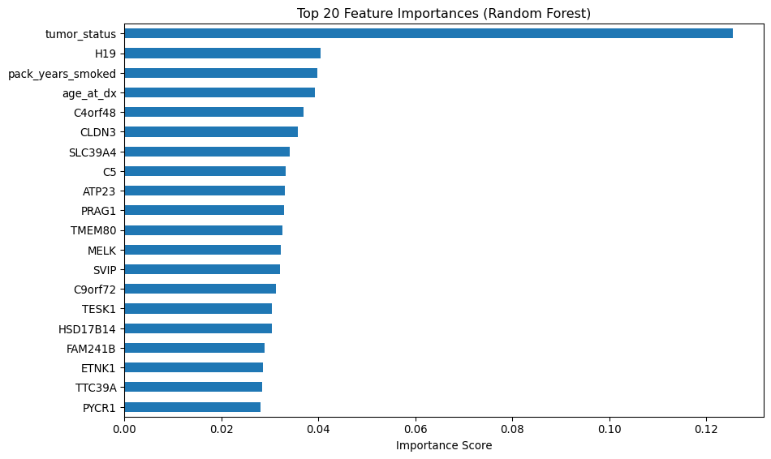
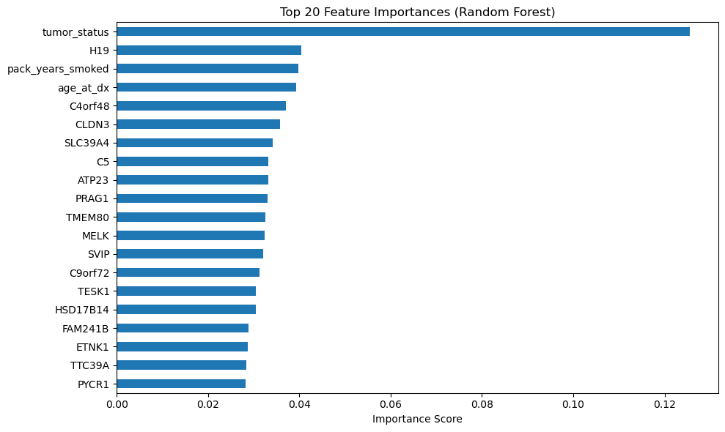
check
print(importances_sorted)
tumor_status 0.125528
H19 0.040419
pack_years_smoked 0.039808
age_at_dx 0.039261
C4orf48 0.037028
CLDN3 0.035837
SLC39A4 0.034131
C5 0.033265
ATP23 0.033165
PRAG1 0.032984
TMEM80 0.032625
MELK 0.032337
SVIP 0.032040
C9orf72 0.031263
TESK1 0.030438
HSD17B14 0.030422
FAM241B 0.028915
ETNK1 0.028655
TTC39A 0.028447
PYCR1 0.028165
PSD3 0.027984
NRIP3 0.027635
CLTA 0.026768
TP53I3 0.026439
HMGB3 0.026315
TRPM2 0.026061
HILPDA 0.024921
MT1M 0.023093
IFFO2 0.021146
smoking_history 0.006051
simplified_stage 0.004483
gender 0.004372
dtype: float64
>>> print(importances_sorted)
tumor_status 0.125528
H19 0.040419
pack_years_smoked 0.039808
age_at_dx 0.039261
C4orf48 0.037028
CLDN3 0.035837
SLC39A4 0.034131
C5 0.033265
ATP23 0.033165
PRAG1 0.032984
TMEM80 0.032625
MELK 0.032337
SVIP 0.032040
C9orf72 0.031263
TESK1 0.030438
HSD17B14 0.030422
FAM241B 0.028915
ETNK1 0.028655
TTC39A 0.028447
PYCR1 0.028165
PSD3 0.027984
NRIP3 0.027635
CLTA 0.026768
TP53I3 0.026439
HMGB3 0.026315
TRPM2 0.026061
HILPDA 0.024921
MT1M 0.023093
IFFO2 0.021146
smoking_history 0.006051
simplified_stage 0.004483
gender 0.004372
dtype: float64

1.9 📊 Option 2: Correlation with Target (event)
This gives a quick statistical view of how each feature relates to the binary outcome:
correlations = df.drop(columns=["case_id"]).corr()["event"].abs().sort_values(ascending=False)
print(correlations.head(20))
event 1.000000
tumor_status 0.505101
age_at_dx 0.141032
H19 0.124147
simplified_stage 0.115560
gender 0.088613
HSD17B14 0.080875
CLDN3 0.076875
TRPM2 0.072143
PYCR1 0.070471
TMEM80 0.070332
IFFO2 0.060668
FAM241B 0.054786
SVIP 0.054521
MELK 0.051436
NRIP3 0.051194
HMGB3 0.050364
ETNK1 0.045469
TP53I3 0.042114
C5 0.039073
Name: event, dtype: float64
... print(correlations.head(20))
event 1.000000
tumor_status 0.505101
age_at_dx 0.141032
H19 0.124147
simplified_stage 0.115560
gender 0.088613
HSD17B14 0.080875
CLDN3 0.076875
TRPM2 0.072143
PYCR1 0.070471
TMEM80 0.070332
IFFO2 0.060668
FAM241B 0.054786
SVIP 0.054521
MELK 0.051436
NRIP3 0.051194
HMGB3 0.050364
ETNK1 0.045469
TP53I3 0.042114
C5 0.039073
Name: event, dtype: float64
This helps you spot features with strong linear relationships to the target.

1.10 🧪 Step 2: LASSO for Gene Selection
from sklearn.linear_model import LassoCV
from sklearn.preprocessing import StandardScaler
gene_list = [
'HSD17B14', 'CLTA', 'C9orf72', 'TTC39A', 'C4orf48', 'TESK1', 'FAM241B',
'C5', 'TP53I3', 'SLC39A4', 'CLDN3', 'NRIP3', 'PYCR1', 'MT1M', 'H19',
'PSD3', 'ETNK1', 'HMGB3', 'TRPM2', 'MELK', 'HILPDA', 'ATP23', 'IFFO2',
'TMEM80', 'PRAG1', 'SVIP'
]
gene_cols = [col for col in df.columns if col in gene_list] # your 27 genes
X = df[gene_cols]
y = df["event"]
# Normalize gene expression
scaler = StandardScaler()
X_scaled = scaler.fit_transform(X)
# LASSO with cross-validation
lasso = LassoCV(cv=5, random_state=42)
lasso.fit(X_scaled, y)
# Extract selected genes
selected_genes = [gene for gene, coef in zip(gene_cols, lasso.coef_) if abs(coef) > 1e-4]
print("🧬 Selected genes via LASSO:", selected_genes)
🧬 Selected genes via LASSO: []

1.11 📊 Step 3: Check Relevance to Stage
import seaborn as sns
import matplotlib.pyplot as plt
for gene in selected_genes:
plt.figure(figsize=(6, 4))
sns.boxplot(x="simplified_stage", y=gene, data=df)
plt.title(f"{gene} Expression vs. Stage")
plt.xticks(rotation=45)
plt.tight_layout()
plt.show()
from sklearn.linear_model import ElasticNetCV
enet = ElasticNetCV(cv=5, l1_ratio=0.7, random_state=42)
enet.fit(X_scaled, y)
selected_genes = [gene for gene, coef in zip(gene_cols, enet.coef_) if abs(coef) > 1e-4]
print("🧬 Selected genes via ElasticNet:", selected_genes)
🧬 Selected genes via ElasticNet: []

1.11.1 ✅ Step-by-Step Code to Select Overlapping Important Features
import pandas as pd
from sklearn.ensemble import RandomForestClassifier
# 1. Train Random Forest and get importances
rf = RandomForestClassifier(n_estimators=100, random_state=42)
rf.fit(X, y)
rf_importances = pd.Series(rf.feature_importances_, index=X.columns)
# 2. Compute correlation with target
correlations = df[X.columns.tolist() + ['event']].corr()['event'].drop('event').abs()
# 3. Set thresholds (adjust as needed)
rf_thresh = 0.025
corr_thresh = 0.05
# 4. Filter features above both thresholds
important_rf = rf_importances[rf_importances > rf_thresh].index
important_corr = correlations[correlations > corr_thresh].index
# 5. Take intersection
selected_features = list(set(important_rf).intersection(set(important_corr)))
# 6. Subset your data
X_selected = X[selected_features]
print(f"Selected {len(selected_features)} features:")
print(selected_features)
Selected 12 features:
['TMEM80', 'TRPM2', 'PYCR1', 'MELK', 'NRIP3', 'IFFO2', 'HSD17B14', 'H19', 'SVIP', 'HMGB3', 'FAM241B', 'CLDN3']
Selected 13 features:
['CLDN3', 'H19', 'SVIP', 'TRPM2', 'MELK', 'tumor_status', 'PYCR1', 'HMGB3', 'FAM241B', 'NRIP3', 'age_at_dx', 'HSD17B14', 'TMEM80']
And i think they are so much different,and i prefer pick the important features of random forest

1.11.2 ✅ Finalize Feature Selection from Random Forest
You can set a threshold (e.g., importance > 0.025) or just pick the top N features. Based on your earlier output, here’s how to do it programmatically:
# Set threshold for importance
rf_thresh = 0.03
# Filter features above threshold
selected_rf_features = rf_importances[rf_importances > rf_thresh].sort_values(ascending=False).index.tolist()
# Subset your data
X_rf_selected = X[selected_rf_features]
print(f"Selected {len(selected_rf_features)} features from Random Forest:")
print(selected_rf_features)
Selected 21 features from Random Forest:
['SLC39A4', 'C4orf48', 'TMEM80', 'CLDN3', 'H19', 'NRIP3', 'C5', 'TESK1', 'C9orf72', 'MELK', 'PYCR1', 'SVIP', 'TTC39A', 'CLTA', 'ATP23', 'FAM241B', 'TP53I3', 'PRAG1', 'HMGB3', 'HSD17B14', 'TRPM2']

1.11.3 🧪 Step-by-Step: Discriminant Analysis with Visualization

1.11.3.1 1. Prepare Your Data
X_selected = df[['CLDN3', 'H19', 'SVIP', 'TRPM2', 'MELK', 'tumor_status',
'PYCR1', 'HMGB3', 'FAM241B', 'NRIP3', 'age_at_dx',
'HSD17B14', 'TMEM80']]
y = df['event']

1.11.3.2 2. Train LDA Model
from sklearn.discriminant_analysis import LinearDiscriminantAnalysis
lda = LinearDiscriminantAnalysis()
X_lda = lda.fit_transform(X_selected, y)

1.11.3.3 3. Visualize Fisher Projection (2D Scatter)
import matplotlib.pyplot as plt
plt.figure(figsize=(8, 6))
colors = ['blue', 'red']
for label in [0, 1]:
plt.scatter(X_lda[y == label, 0], X_lda[y == label, 1] if X_lda.shape[1] > 1 else [0]*sum(y==label),
label=f'Event {label}', alpha=0.7, color=colors[label])
plt.title("LDA Projection (Fisher Criterion)")
plt.xlabel("LD1")
if X_lda.shape[1] > 1:
plt.ylabel("LD2")
plt.legend()
plt.grid(True)
plt.tight_layout()
plt.show()
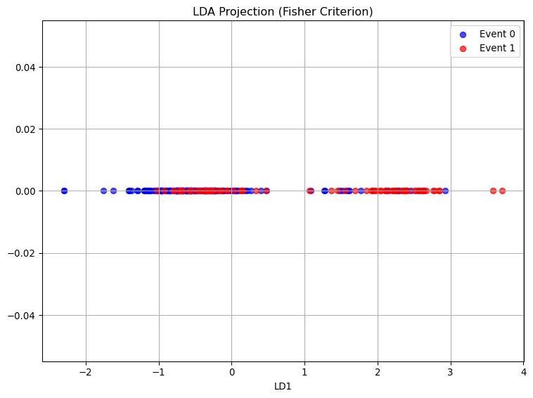
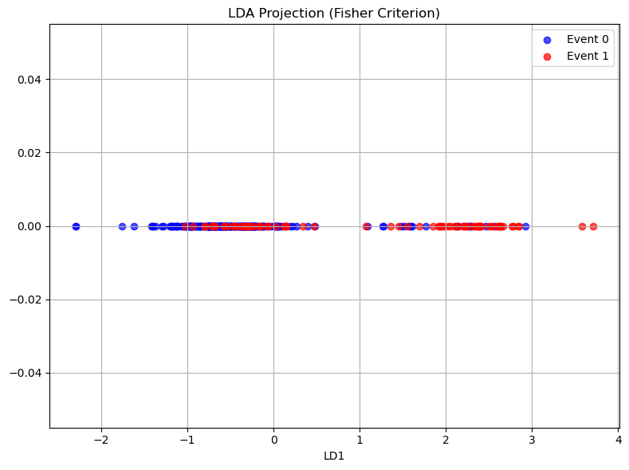

1.11.3.4 4. Visualize 1D Histogram of LD1
plt.figure(figsize=(8, 4))
plt.hist(X_lda[y == 0, 0], bins=30, alpha=0.6, label='Alive', color='blue')
plt.hist(X_lda[y == 1, 0], bins=30, alpha=0.6, label='Dead', color='red')
plt.title("LDA Component 1 Distribution")
plt.xlabel("LD1")
plt.ylabel("Frequency")
plt.legend()
plt.tight_layout()
plt.show()
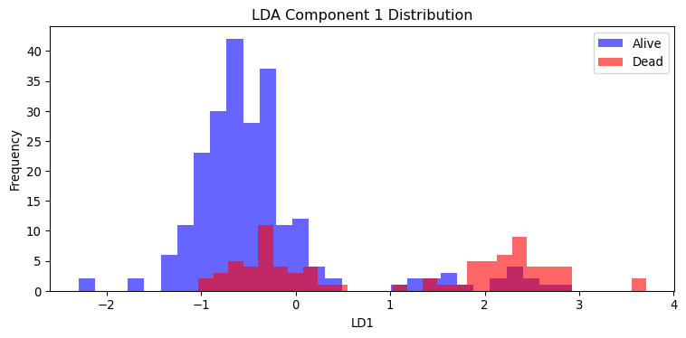
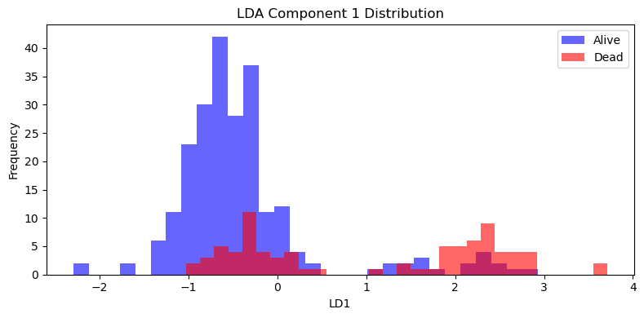

1.11.3.5 5. Bayesian Classification Report
from sklearn.model_selection import train_test_split
from sklearn.metrics import classification_report
X_train, X_test, y_train, y_test = train_test_split(X_selected, y, test_size=0.2, random_state=42)
lda.fit(X_train, y_train)
y_pred = lda.predict(X_test)
print(classification_report(y_test, y_pred))
precision recall f1-score support
0 0.88 0.96 0.92 52
1 0.67 0.36 0.47 11
accuracy 0.86 63
macro avg 0.77 0.66 0.69 63
weighted avg 0.84 0.86 0.84 63
... print(classification_report(y_test, y_pred))
precision recall f1-score support
0 0.88 0.96 0.92 52
1 0.67 0.36 0.47 11
accuracy 0.86 63
macro avg 0.77 0.66 0.69 63
weighted avg 0.84 0.86 0.84 63

1.11.4 🧪 Step-by-Step: Cross-Validation with Multiple Models

1.11.4.1 1. Prepare Your Data
X_selected = df[['tumor_status', 'H19', 'pack_years_smoked', 'age_at_dx', 'C4orf48', 'CLDN3', 'SLC39A4', 'C5', 'ATP23', 'PRAG1', 'TMEM80', 'MELK', 'SVIP', 'C9orf72', 'TESK1', 'HSD17B14']]
y = df['event']

1.11.4.2 2. Import Models and Tools
from sklearn.model_selection import cross_val_score, StratifiedKFold
from sklearn.metrics import make_scorer, accuracy_score, precision_score, recall_score, f1_score
from sklearn.ensemble import RandomForestClassifier
from sklearn.linear_model import LogisticRegression
import xgboost as xgb
import lightgbm as lgb

1.11.4.3 3. Define Models
models = {
"XGBoost": xgb.XGBClassifier(use_label_encoder=False, eval_metric='logloss')
}

1.11.4.4 4. Cross-Validation Setup
cv = StratifiedKFold(n_splits=5, shuffle=True, random_state=42)
scorers = {
'Accuracy': make_scorer(accuracy_score),
'Precision': make_scorer(precision_score),
'Recall': make_scorer(recall_score),
'F1': make_scorer(f1_score)
}

1.11.4.5 5. Run Cross-Validation
for name, model in models.items():
print(f"\n{name}")
for score_name, scorer in scorers.items():
scores = cross_val_score(model, X_selected, y, cv=cv, scoring=scorer)
print(f"{score_name}: {scores.mean():.3f} ± {scores.std():.3f}")
XGBoost
Accuracy: 0.756 ± 0.023
Precision: 0.560 ± 0.063
Recall: 0.365 ± 0.073
F1: 0.438 ± 0.061
this is shit actaully

