医疗大数据作业
Table of contents

what i write is made by myself and AI , i could prove code if you want to check
jayz 周杰 113120230073

1. Getting the data🤷
Now we pick the data from TCGA, this is the link
Project 项目

1.1 TCGA-LUSC
Total of 总计
504Cases 案例
32,329Files 文件
3,770Annotations 注释

1.2 Summary 概括
Project ID 项目 ID | TCGA-LUSC
dbGaP Study Accession dbGaP 研究加入 | phs000178
Project Name 项目名称 | Lung Squamous Cell Carcinoma  肺鳞状细胞癌
Disease Type 疾病类型 | - 2 Disease Types 2种疾病类型
Primary Site 主站点 | Bronchus and lung 支气管和肺
Program 程序 | TCGA
In survival analysis, it’s often best to combine these stages into broader prognostic groups to ensure each group has enough patients and to capture the major jumps in prognosis.

1.2.1 Clinical Interpretation and Grouping
For solid tumors like LUSC, a standard way to simplify staging for survival analysis is:
Simplified Group | Included Original Stages | Clinical Meaning
Early Stage | I (IA, IB) | Locally confined tumor, best prognosis.
Locally Advanced | II (IIA, IIB) | Larger tumor or spread to nearby lymph nodes.
Advanced Stage | III (IIIA, IIIB) | Tumor spread to distant lymph nodes or large primary tumors.
Metastatic | IV (If present) | Worst prognosis (although LUSC often presents earlier).
and we have
--- Distribution of Simplified Stages ---
# A tibble: 3 × 2
simplified_stage n
<chr> <int>
1 Advanced (Stage III) 84
2 Early/Local (Stage I-II) 405
3 Unknown 4
--- Survival Model Summary (Log-Rank Test) ---
Call:
survdiff(formula = surv_object ~ simplified_stage, data = survival_for_analysis)
N Observed Expected (O-E)^2/E (O-E)^2/V
simplified_stage=Early/Local (Stage I-II) 405 119 127.2 0.528 2.96
simplified_stage=Advanced (Stage III) 84 36 27.8 2.417 2.96
Chisq= 3 on 1 degrees of freedom, p= 0.09
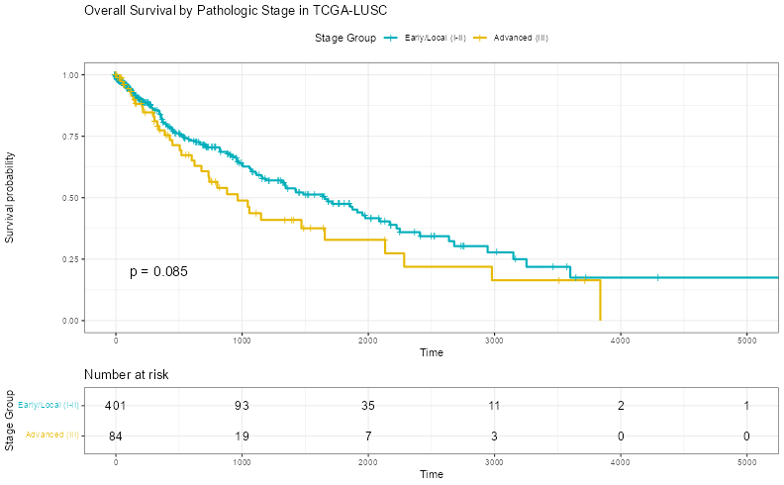

2. Get more meta data from our xml.file
We’re dealing with XML files that use namespaces, which are essential for distinguishing elements that might otherwise have the same name but come from different schemas. Here’s why and how it works:

2.0.1 🧠 Why we Need to Define Namespaces
XML namespaces are like last names(姓氏) for XML tags—they prevent confusion when multiple XML vocabularies are used in the same document.

2.0.1.1 ✅ Purpose of Namespaces
- Avoids name collisions between elements from different sources.
- Ensures accurate XPath queries—without namespaces, lxml won’t find elements like <shared:bcr_patient_barcode> because it doesn’t know what shared: means.
- Allows we to target specific schemas (e.g., clinical vs. administrative metadata).

2.0.1.2 🧩 Example
wer XML contains:
<shared:bcr_patient_barcode xmlns:shared="http://tcga.nci/bcr/xml/shared/2.7">TCGA-XX-XXXX</shared:bcr_patient_barcode>
To extract this with XPath, we must tell lxml what shared: refers to:
root.xpath('//shared:bcr_patient_barcode', namespaces=ns)
Without namespaces=ns, this query fails silently.

2.0.2 🧬 Expanded Python XML Parser for TCGA Clinical Metadata
from lxml import etree
import pandas as pd
import glob
# Define namespaces
ns = {
'shared': 'http://tcga.nci/bcr/xml/shared/2.7',
'clin_shared': 'http://tcga.nci/bcr/xml/clinical/shared/2.7',
'shared_stage': 'http://tcga.nci/bcr/xml/clinical/shared/stage/2.7',
'lung_shared': 'http://tcga.nci/bcr/xml/clinical/shared/lung/2.7',
'admin': 'http://tcga.nci/bcr/xml/administration/2.7'
}
def parse_clinical_xml(file):
tree = etree.parse(file)
root = tree.getroot()
def get_text(xpath):
el = root.xpath(xpath, namespaces=ns)
return el[0].text if el else None
return {
'case_id': get_text('//shared:bcr_patient_barcode'),
'vital_status': get_text('//clin_shared:vital_status'),
'days_to_death': get_text('//clin_shared:days_to_death'),
'days_to_last_followup': get_text('//clin_shared:days_to_last_followup'),
'age_at_dx': get_text('//clin_shared:age_at_initial_pathologic_diagnosis'),
'stage': get_text('//shared_stage:pathologic_stage'),
'gender': get_text('//shared:gender'),
'tumor_status': get_text('//clin_shared:person_neoplasm_cancer_status'),
'smoking_history': get_text('//shared:tobacco_smoking_history'),
'pack_years_smoked': get_text('//clin_shared:number_pack_years_smoked'),
'residual_tumor': get_text('//clin_shared:residual_tumor'),
'ecog_score': get_text('//clin_shared:eastern_cancer_oncology_group'),
'radiation_therapy': get_text('//clin_shared:radiation_therapy'),
'primary_therapy_outcome': get_text('//clin_shared:primary_therapy_outcome_success')
}
# Load all XML files
xml_files = glob.glob("E:/acode/wsl/data2/GDCdata/TCGA-LUSC/Clinical/Clinical_Supplement/**/*.xml", recursive=True)
# Parse and combine
records = [parse_clinical_xml(f) for f in xml_files]
clinical_df = pd.DataFrame(records)
# Clean numeric columns
for col in ['days_to_death', 'days_to_last_followup', 'age_at_dx', 'pack_years_smoked']:
clinical_df[col] = pd.to_numeric(clinical_df[col], errors='coerce')
# Preview
print(clinical_df.head())
print(clinical_df.describe())
case_id vital_status days_to_death days_to_last_followup age_at_dx \
0 TCGA-85-6561 Alive NaN 24.0 66.0
1 TCGA-37-5819 Alive NaN 103.0 64.0
2 TCGA-77-8008 Dead 2639.0 NaN 68.0
3 TCGA-56-8083 Alive NaN 2.0 56.0
4 TCGA-56-A4ZJ Alive NaN 25.0 75.0
stage gender tumor_status smoking_history pack_years_smoked \
0 Stage IB MALE TUMOR FREE 4 35.0
1 Stage IIIA MALE TUMOR FREE 4 45.0
2 Stage IB MALE None 4 61.5
3 Stage IB MALE TUMOR FREE 4 30.0
4 Stage IA FEMALE TUMOR FREE 4 100.0
residual_tumor ecog_score radiation_therapy primary_therapy_outcome
0 R0 None None None
1 R0 1 None None
2 R0 1 None None
3 R0 None None None
4 R0 None None None
days_to_death days_to_last_followup age_at_dx pack_years_smoked
count 157.000000 383.000000 495.000000 427.000000
mean 835.598726 585.295039 67.276768 52.913478
std 888.682876 796.793252 8.608804 31.156992
min 0.000000 -10.000000 39.000000 1.000000
25% 211.000000 37.000000 62.000000 31.125000
50% 506.000000 211.000000 68.000000 50.000000
75% 1114.000000 857.000000 73.000000 64.500000
max 5287.000000 4299.000000 90.000000 240.000000
save and load the RNA data
# Save clinical metadata
clinical_outfile = r"E:\acode\wsl\data2\GDCdata\TCGA-LUSC\clinical_metadata.csv"
clinical_df.to_csv(clinical_outfile, index=False)
print(f"✅ Clinical metadata saved to: {clinical_outfile}")
✅ Clinical metadata saved to: E:\acode\wsl\data2\GDCdata\TCGA-LUSC\clinical_metadata.csv
clinical_outfile = r"E:\acode\wsl\data2\GDCdata\TCGA-LUSC\clinical_metadata.csv"
clinical_df = pd.read_csv(clinical_outfile)
# Load RNA expression matrix
expression_file = "E:/acode/wsl/data2/GDCdata/TCGA-LUSC/rnaexp.csv"
expression_df = pd.read_csv(expression_file, index_col=0)
print("✅ Expression matrix loaded. Shape:", expression_df.shape)
# Optional: Preview
print(expression_df.iloc[:5, :5])
✅ Expression matrix loaded. Shape: (60664, 563)
gene_name TCGA-90-A4EE TCGA-85-8049 TCGA-33-6737 TCGA-39-5016
1 TSPAN6 8.4836 8.9006 24.1585 21.0036
2 TNMD 0.0149 0.0000 0.0000 0.0587
3 DPM1 35.1344 25.3093 23.1613 63.1033
4 SCYL3 3.9120 2.5760 1.2931 3.3603
5 C1orf112 3.7604 2.8456 2.6190 2.7706
Our plan for building a system to link clinical and RNA expression data! Using PostgreSQL for a robust, production-ready database and DuckDB for fast, in-process analytical queries in Python is an excellent approach.
Here is the plan, starting with the necessary packages and steps to load wer data into both systems.

2.1 📦 Package Installation
First, we’ll need to install the required Python packages. we already have pandas for data manipulation. we’ll need psycopg2-binary (or psycopg for a modern, pure-Python driver) for PostgreSQL and duckdb for the in-process analytics database.
# Recommended installation for the project
pip install pandas duckdb sqlalchemy psycopg2-binary

2.1.1 Use the postgreSQL database
This Python script is designed to load wer TCGA clinical and RNA expression data into a PostgreSQL database so we can query and manage it efficiently. Here’s a breakdown of what each part does:

2.1.2 🧠 What This Code Does

2.1.2.1 1. Imports Required Libraries
import pandas as pd
from sqlalchemy import create_engine
import duckdb
import io
- pandas: for handling DataFrames
- sqlalchemy: to connect to PostgreSQL
- duckdb and io: not used in this snippet, but could be for in-memory SQL or streaming later

2.1.2.2 2. Defines PostgreSQL Connection Parameters
PG_USER = "wer_user"
PG_PASS = "wer_password"
PG_HOST = "localhost"
PG_PORT = "5432"
PG_DB = "clinical_rna_db"
These are placeholders—we’d replace them with wer actual PostgreSQL credentials.

2.1.2.3 3. Creates a SQLAlchemy Engine
pg_engine_url = f"postgresql://{PG_USER}:{PG_PASS}@{PG_HOST}:{PG_PORT}/{PG_DB}"
pg_engine = create_engine(pg_engine_url)
This sets up a connection to wer PostgreSQL database so we can send data to it.

2.1.2.4 4. Prepares the Expression Data
expression_df = expression_df.reset_index(names=['gene_name'])
If gene_name was the index, this makes it a proper column so it can be stored in SQL.

2.1.2.5 5. Loads DataFrames into PostgreSQL
clinical_df.to_sql('clinical_metadata', pg_engine, if_exists='replace', index=False) expression_df.to_sql('rna_expression_matrix', pg_engine, if_exists='replace', index=False)
- clinical_df goes into a table called clinical_metadata
- expression_df goes into rna_expression_matrix
- if_exists='replace' means it will overwrite the table if it already exists

2.1.2.6 6. Handles Connection Errors Gracefully
except Exception as e:
print(f"❌ Could not connect to PostgreSQL or load data: {e}")
If the connection fails (e.g., wrong password, server not running), it prints a helpful error message.

2.1.3 2. DuckDB Setup (In-Process, No external server needed)
DuckDB runs entirely within wer Python process, making it perfect for rapid analytical queries.
# --- 2. DuckDB Setup ---
# Create an in-memory database or a file-backed one ('path/to/my.duckdb')
con = duckdb.connect(database=':memory:', read_only=False)
print("✅ DuckDB connection established (in-memory).")
# --- Loading Data into DuckDB ---
# DuckDB can read directly from pandas DataFrames using the 'register' function.
# Register the DataFrames as temporary tables in DuckDB
con.register('clinical_metadata_db', clinical_df)
con.register('rna_expression_matrix_db', expression_df)
print("✅ DataFrames registered as tables in DuckDB.")
# --- Verification Query in DuckDB ---
# Example: Querying the registered tables
duckdb_query = """
SELECT t1.case_id, t1.vital_status, t2."TSPAN6", t2."DPM1"
FROM clinical_metadata_db t1
INNER JOIN rna_expression_matrix_db t2
ON t1.case_id = t2.case_id -- Note: we'll need to ensure case_id is a column in expression_df for a direct join!
LIMIT 5;
"""
# Based on wer data structure, we might need to UNPIVOT the RNA data first in DuckDB
# The join key is `case_id` from clinical_df and the column *names* (TCGA-...) in expression_df.
print("\n--- DuckDB Verification Query (Sample) ---")
try:
# A crucial step for linking is ensuring the 'case_id' column is present in the expression data.
# If the case IDs are the *column names*, we need to *unpivot* the expression matrix first.
# ❗ IMPORTANT: Unpivot the RNA data for easier joining
# This assumes the original expression_df has 'gene_name' and columns are 'TCGA-...' case IDs.
expression_cols = [col for col in expression_df.columns if col.startswith('TCGA-')]
# Build struct_pack list
structs = ', '.join([
f"struct_pack(case_id := '{col}', expression := \"{col}\")"
for col in expression_cols
])
# Corrected SQL: unpack struct fields explicitly
unpivot_query = f"""
CREATE TEMP TABLE rna_expression_unpivoted AS
SELECT
gene_name,
s.case_id AS sample_id,
s.expression AS expression
FROM (
SELECT
gene_name,
unnest(list_value(
{', '.join([
f"struct_pack(case_id := '{col}', expression := \"{col}\")"
for col in expression_cols
])}
)) AS s
FROM rna_expression_matrix_db
);
"""
con.execute(unpivot_query)
print("✅ RNA expression matrix unpivoted and flattened.")
print("✅ RNA expression matrix unpivoted and cleaned for linking.")
# Now, the join is straightforward
linking_query = """
SELECT
t1.case_id,
t1.vital_status,
t1.age_at_dx,
t2.gene_name,
t2.sample_id,
t2.expression
FROM clinical_metadata_db t1
INNER JOIN rna_expression_unpivoted t2
ON t1.case_id = t2.sample_id
LIMIT 10;
"""
linked_data = con.execute(linking_query).fetchdf()
print("Successfully linked clinical and expression data (sample):")
print(linked_data)
except Exception as e:
print(f"❌ DuckDB query/unpivot failed: {e}")
✅ DuckDB connection established (in-memory).
✅ DataFrames registered as tables in DuckDB.
--- DuckDB Verification Query (Sample) ---
FloatProgress(value=0.0, layout=Layout(width='auto'), style=ProgressStyle(bar_color='black'))
✅ RNA expression matrix unpivoted and flattened.
✅ RNA expression matrix unpivoted and cleaned for linking.
Successfully linked clinical and expression data (sample):
case_id vital_status age_at_dx gene_name sample_id expression
0 TCGA-90-A4EE Alive 53.0 TSPAN6 TCGA-90-A4EE 8.4836
1 TCGA-85-8049 Alive 57.0 TSPAN6 TCGA-85-8049 8.9006
2 TCGA-33-6737 None NaN TSPAN6 TCGA-33-6737 24.1585
3 TCGA-39-5016 Alive 44.0 TSPAN6 TCGA-39-5016 21.0036
4 TCGA-56-8304 Alive 73.0 TSPAN6 TCGA-56-8304 14.7462
5 TCGA-92-8063 Alive 52.0 TSPAN6 TCGA-92-8063 11.5989
6 TCGA-22-4593 Dead 77.0 TSPAN6 TCGA-22-4593 21.0880
7 TCGA-43-8115 Alive 72.0 TSPAN6 TCGA-43-8115 10.2988
8 TCGA-22-4599 Dead 73.0 TSPAN6 TCGA-22-4599 12.1437
9 TCGA-60-2712 Dead 79.0 TSPAN6 TCGA-60-2712 5.9034
This script is a complete local pipeline that uses DuckDB to join wer TCGA clinical metadata and RNA expression matrix—without needing PostgreSQL or any external database. Here’s a breakdown of what it’s doing and why it’s clever:
case_id vital_status age_at_dx gene_name sample_id expression
0 TCGA-90-A4EE Alive 53.0 TSPAN6 TCGA-90-A4EE 8.4836
1 TCGA-85-8049 Alive 57.0 TSPAN6 TCGA-85-8049 8.9006
2 TCGA-33-6737 None NaN TSPAN6 TCGA-33-6737 24.1585
3 TCGA-39-5016 Alive 44.0 TSPAN6 TCGA-39-5016 21.0036
4 TCGA-56-8304 Alive 73.0 TSPAN6 TCGA-56-8304 14.7462
5 TCGA-92-8063 Alive 52.0 TSPAN6 TCGA-92-8063 11.5989
6 TCGA-22-4593 Dead 77.0 TSPAN6 TCGA-22-4593 21.0880
7 TCGA-43-8115 Alive 72.0 TSPAN6 TCGA-43-8115 10.2988
8 TCGA-22-4599 Dead 73.0 TSPAN6 TCGA-22-4599 12.1437
9 TCGA-60-2712 Dead 79.0 TSPAN6 TCGA-60-2712 5.9034
Total unique clinical samples: 504

2.1.4 🧠 What This DuckDB Script Does

2.1.4.1 ✅ 1. Creates an In-Memory DuckDB Database
con = duckdb.connect(database=':memory:', read_only=False)
- Fast, lightweight, and no installation overhead.
- we could also use a file-backed DB by replacing ':memory:' with a path like 'E:/acode/my_tcga.duckdb'.

2.1.4.2 ✅ 2. Registers Pandas DataFrames as DuckDB Tables
con.register('clinical_metadata_db', clinical_df) con.register('rna_expression_matrix_db', expression_df)
- These are temporary views—we can query them like SQL tables.
- No need to write to disk or convert formats.

2.1.4.3 ⚠️ 3. Unpivots the RNA Expression Matrix
expression_cols = [f'"{col}"' for col in expression_df.columns if col.startswith('TCGA-')]
- wer expression matrix is wide format: genes as rows, samples as columns.
- To join with clinical data (which is long format), we unpivot it:
  - Each row becomes: (gene_name, case_id, expression)
  - This is done using DuckDB’s unnest(list_value(...)) + struct_pack(...)

2.1.4.4 🔗 4. Joins Clinical and Expression Data
SELECT
t1.case_id,
t1.vital_status,
t1.age_at_dx,
t2.gene_name,
t2.expression
FROM clinical_metadata_db t1
INNER JOIN rna_expression_unpivoted t2
ON t1.case_id = t2.case_id
WHERE t2.gene_name IN ('TSPAN6', 'DPM1')
- Now that both tables have a case_id column, we can join them directly.
- This query filters for two genes (TSPAN6, DPM1) and returns their expression values alongside clinical metadata.

2.1.5 ✅ Why This Is Smart
- No PostgreSQL setup needed—perfect for local analysis.
- DuckDB is blazing fast for analytical queries on tabular data.
- we can now run complex SQL joins, filters, and aggregations entirely in memory.

2.2 🔗 The Liking/Linking Strategy
The core challenge in wer data is that the two DataFrames have different structures for the common key:
- clinical_df: Has a column named case_id (e.g., TCGA-85-6561).
- expression_df: Has gene_name as an ID, but the patient IDs (TCGA-90-A4EE, etc.) are the column names.
To perform a relational join (a “liking” in wer terms), the expression_df must be unpivoted (or melted) so that all patient IDs are in a single column.
The Python code above uses a DuckDB SQL UNPIVOT/UNNEST technique to transform the wide RNA matrix into a long format (case_id, gene_name, expression), which is the correct relational structure for joining with the clinical_metadata table. This is the key step to “build the liking” between wer datasets.

2.3 1. DuckDB SQL: How the Samples Were Linked
The connection between the clinical_metadata_db and the rna_expression_matrix_db is built in two key SQL steps, which are necessary because the patient IDs (e.g., TCGA-90-A4EE) exist as column names in the expression data but as row values (case_id) in the clinical data.

2.3.1 Step 1: Unpivoting the RNA Expression Data (The Key “Liking” Step)
The first step creates a temporary table in the correct relational format.
CREATE TEMP TABLE rna_expression_unpivoted AS
SELECT
gene_name,
unnest(list_value(
-- This part manually creates a structured list of {case_id, expression} pairs
struct_pack(case_id := 'TCGA-90-A4EE', expression := "TCGA-90-A4EE"),
struct_pack(case_id := 'TCGA-85-8049', expression := "TCGA-85-8049"),
-- ... and so on for all patient columns
...
)).*
FROM rna_expression_matrix_db;
linking_query1 = """
SELECT
t1.case_id,
t1.vital_status,
t1.age_at_dx,
t2.gene_name,
t2.sample_id,
t2.expression
FROM clinical_metadata_db t1
INNER JOIN rna_expression_unpivoted t2
ON t1.case_id = t2.sample_id
WHERE t2.gene_name IN ('TSPAN6', 'DPM1')
LIMIT 1000;
"""
cursor = con.execute(linking_query1).fetchdf()
Based on the padj​ values we provided, a common threshold for significance is padj​<0.05.

2.3.2 1. Identify Truly Significant Genes
We will filter the genes we provided to select those that meet the statistical significance threshold of padj​<0.05.
Gene | padj​ | Significant (padj​<0.05)?
HSD17B14 | 0.0176 | YES
CLTA | 0.0176 | YES
C9orf72 | 0.0206 | YES
TTC39A | 0.0268 | YES
C4orf48 | 0.0306 | YES
TESK1 | 0.0366 | YES
FAM241B | 0.0413 | YES
C5 | 0.0536 | NO
TP53I3 | 0.0536 | NO
SLC39A4 | 0.0536 | NO
CLDN3 | 0.0536 | NO
NRIP3 | 0.0536 | NO
PYCR1 | 0.0561 | NO
MT1M | 0.0777 | NO
H19 | 0.0821 | NO
PSD3 | 0.0821 | NO
ETNK1 | 0.0942 | NO
HMGB3 | 0.0966 | NO
TRPM2 | 0.0966 | NO
MELK | 0.0966 | NO
HILPDA | 0.0969 | NO
ATP23 | 0.0969 | NO
IFFO2 | 0.0969 | NO
TMEM80 | 0.0969 | NO
PRAG1 | 0.0969 | NO
SVIP | 0.0984 | NO
The 7 Significant Genes (padj​<0.05) are: HSD17B14, CLTA, C9orf72, TTC39A, C4orf48, TESK1, and FAM241B.

2.3.3 2. DuckDB Query for Survival Analysis Data
We will use the unpivoted expression table (rna_expression_unpivoted) and the clinical metadata table (clinical_metadata_db) to extract the exact data needed for survival analysis.
To perform survival analysis using DuckDB, we’ll need to:
- Filter the expression data for wer 7 significant genes.
- Join it with clinical metadata (especially vital_status, days_to_death, days_to_last_followup).
- Create a survival-ready table with one row per patient, including expression values and survival time/status.
- Export that table to Python (e.g., for use with lifelines or scikit-survival).

2.3.4 Step-by-Step DuckDB Query for Survival Prep
Here’s how to build the query:

2.3.4.1 ✅ 1. Define wer Gene List in SQL
significant_genes = ['HSD17B14', 'CLTA', 'C9orf72', 'TTC39A', 'C4orf48', 'TESK1', 'FAM241B']
gene_list_sql = ', '.join([f"'{gene}'" for gene in significant_genes])

2.3.4.2 ✅ 2. Query to Build Survival Table
survival_query = f"""
SELECT
t1.case_id,
t1.vital_status,
COALESCE(t1.days_to_death, t1.days_to_last_followup) AS survival_days,
t1.age_at_dx,
t2.gene_name,
t2.expression
FROM clinical_metadata_db t1
INNER JOIN rna_expression_unpivoted t2
ON t1.case_id = t2.sample_id
WHERE t2.gene_name IN ({gene_list_sql})
"""

2.3.4.3 ✅ 3. Fetch and Pivot in Python
survival_df_long = con.execute(survival_query).fetchdf()
# Pivot to wide format: one row per patient
survival_df = survival_df_long.pivot_table(
index=['case_id', 'vital_status', 'survival_days', 'age_at_dx'],
columns='gene_name',
values='expression'
).reset_index()
print("✅ Survival-ready DataFrame:")
print(survival_df.head())
✅ Survival-ready DataFrame:
gene_name case_id vital_status survival_days age_at_dx C4orf48 \
0 TCGA-18-3406 Dead 371.0 67.0 2.8345
1 TCGA-18-3407 Dead 136.0 72.0 1.3487
2 TCGA-18-3408 Alive 2099.0 77.0 0.0538
3 TCGA-18-3409 Alive 2417.0 74.0 1.2988
4 TCGA-18-3410 Dead 146.0 81.0 6.3692
gene_name C9orf72 CLTA FAM241B HSD17B14 TESK1 TTC39A
0 3.4351 149.4185 7.8203 6.8117 11.0774 1.7314
1 7.9812 51.1565 3.7595 3.3361 13.5017 0.7852
2 15.6769 80.5977 13.0744 2.2227 7.7895 1.2734
3 1.5068 39.9578 14.0642 9.4156 8.2695 0.3505
4 0.9963 43.2127 13.9918 3.8372 10.0191 2.1708
save
survival_df.to_csv(r"E:\acode\wsl\data2\GDCdata\TCGA-LUSC\survial_data.csv")
✅ Survival-ready DataFrame:
gene_name case_id vital_status survival_days age_at_dx ... FAM241B HSD17B14 TESK1 TTC39A
0 TCGA-18-3406 Dead 371.0 67.0 ... 7.8203 6.8117 11.0774 1.7314
1 TCGA-18-3407 Dead 136.0 72.0 ... 3.7595 3.3361 13.5017 0.7852
2 TCGA-18-3408 Alive 2099.0 77.0 ... 13.0744 2.2227 7.7895 1.2734
3 TCGA-18-3409 Alive 2417.0 74.0 ... 14.0642 9.4156 8.2695 0.3505
4 TCGA-18-3410 Dead 146.0 81.0 ... 13.9918 3.8372 10.0191 2.1708
[5 rows x 11 columns]

2.4 survival analysis

2.4.1 ✅ Step 1: Convert vital_status to Binary
# Convert 'Dead' → 1, 'Alive' → 0
survival_df['event'] = survival_df['vital_status'].map({'Dead': 1, 'Alive': 0})

2.4.2 ✅ Step 2: Check Column Types
print(survival_df.dtypes)
gene_name
case_id object
vital_status object
survival_days float64
age_at_dx float64
C4orf48 float64
C9orf72 float64
CLTA float64
FAM241B float64
HSD17B14 float64
TESK1 float64
TTC39A float64
event int64
dtype: object
we want:
- survival_days: float or int
- event: int (0/1)
- Gene columns: float
- age_at_dx: float or int
If anything is object, convert it:
survival_df['survival_days'] = pd.to_numeric(survival_df['survival_days'], errors='coerce')
survival_df['age_at_dx'] = pd.to_numeric(survival_df['age_at_dx'], errors='coerce')

2.4.3 ✅ Step 3: KNN impute the miss data

2.4.3.1 ✅ Apply KNN Imputer
from sklearn.impute import KNNImputer
# Select columns to impute (excluding case_id and vital_status)
impute_cols = ['survival_days', 'age_at_dx'] + significant_genes
# Create a copy to avoid modifying original
impute_df = survival_df[impute_cols].copy()
# Initialize the imputer
imputer = KNNImputer(n_neighbors=10)
# Fit and transform
imputed_array = imputer.fit_transform(impute_df)
# Replace the original columns with imputed values
survival_df[impute_cols] = imputed_array

2.4.4 ✅ Step 4: Run Kaplan-Meier Survival Curves
Here’s an example for one gene (TESK1):
from lifelines import KaplanMeierFitter
import matplotlib.pyplot as plt
# Median split
survival_df['TESK1_group'] = survival_df['TESK1'] > survival_df['TESK1'].median()
kmf = KaplanMeierFitter()
plt.figure(figsize=(8, 6))
for group in [True, False]:
mask = survival_df['TESK1_group'] == group
label = 'High TESK1' if group else 'Low TESK1'
kmf.fit(survival_df.loc[mask, 'survival_days'], survival_df.loc[mask, 'event'], label=label)
kmf.plot_survival_function()
plt.title("Kaplan-Meier Survival Curve: TESK1")
plt.xlabel("Days")
plt.ylabel("Survival Probability")
plt.grid(True)
plt.show()
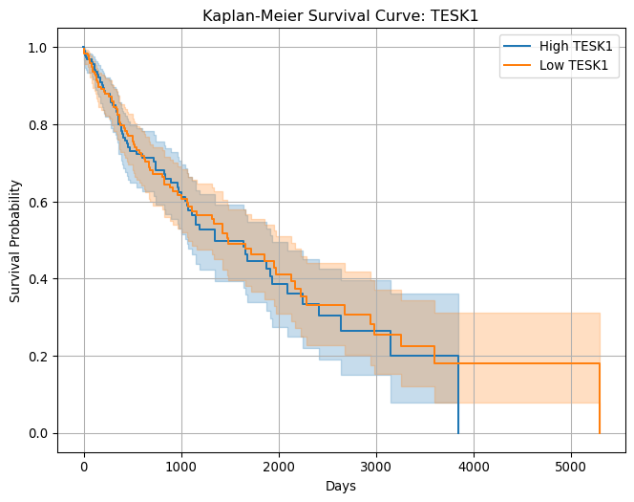

2.4.5 ✅ Step 5: Fit Cox Proportional Hazards Model
from lifelines import CoxPHFitter
cox_df = survival_df[['survival_days', 'event', 'age_at_dx'] + significant_genes]
cph = CoxPHFitter()
cph.fit(cox_df, duration_col='survival_days', event_col='event')
cph.print_summary()
model | lifelines.CoxPHFitter
duration col | ‘survival_days’
event col | ‘event’
baseline estimation | breslow
number of observations | 489
number of events observed | 154
partial log-likelihood | -757.38
time fit was run | 2025-10-13 13:42:02 UTC

 | coef | exp(coef) | se(coef) | coef lower 95% | coef upper 95% | exp(coef) lower 95% | exp(coef) upper 95% | cmp to | z | p | -log2(p)
age_at_dx | 0.02 | 1.02 | 0.01 | 0.00 | 0.05 | 1.00 | 1.05 | 0.00 | 2.19 | 0.03 | 5.12
HSD17B14 | -0.01 | 0.99 | 0.01 | -0.02 | 0.01 | 0.98 | 1.01 | 0.00 | -0.73 | 0.46 | 1.11
CLTA | -0.00 | 1.00 | 0.00 | -0.01 | 0.00 | 0.99 | 1.00 | 0.00 | -0.60 | 0.55 | 0.87
C9orf72 | -0.00 | 1.00 | 0.03 | -0.06 | 0.05 | 0.95 | 1.05 | 0.00 | -0.09 | 0.93 | 0.10
TTC39A | 0.09 | 1.09 | 0.04 | 0.00 | 0.18 | 1.00 | 1.19 | 0.00 | 1.99 | 0.05 | 4.41
C4orf48 | 0.02 | 1.02 | 0.01 | -0.00 | 0.04 | 1.00 | 1.04 | 0.00 | 1.51 | 0.13 | 2.93
TESK1 | 0.00 | 1.00 | 0.01 | -0.01 | 0.02 | 0.99 | 1.02 | 0.00 | 0.48 | 0.63 | 0.66
FAM241B | -0.01 | 0.99 | 0.01 | -0.03 | 0.02 | 0.97 | 1.02 | 0.00 | -0.35 | 0.73 | 0.46
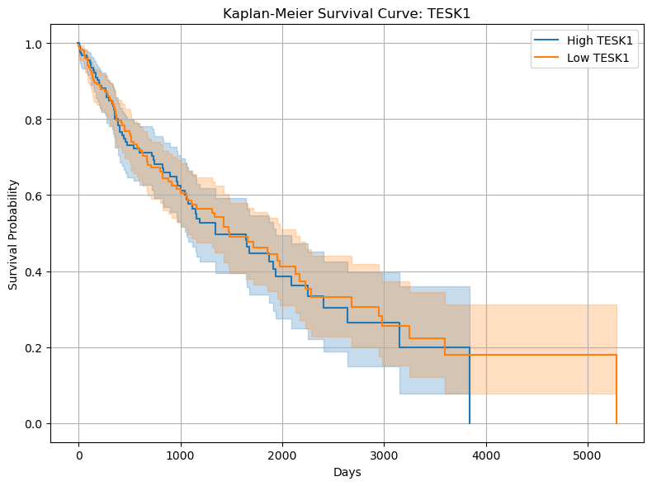
- Run a Cox model with all 7 genes together
- Stratify by clinical features like stage or gender
- Visualize hazard ratios with confidence intervals

2.4.6 🧬 1. use the TTC39A
from lifelines import KaplanMeierFitter
import matplotlib.pyplot as plt
# Median split
survival_df['TTC39A_group'] = survival_df['TTC39A'] > survival_df['TTC39A'].median()
kmf = KaplanMeierFitter()
plt.figure(figsize=(8, 6))
for group in [True, False]:
mask = survival_df['TTC39A_group'] == group
label = 'High TTC39A' if group else 'Low TTC39A'
kmf.fit(survival_df.loc[mask, 'survival_days'], survival_df.loc[mask, 'event'], label=label)
kmf.plot_survival_function()
plt.title("Kaplan-Meier Survival Curve: TTC39A")
plt.xlabel("Days")
plt.ylabel("Survival Probability")
plt.grid(True)
plt.show()
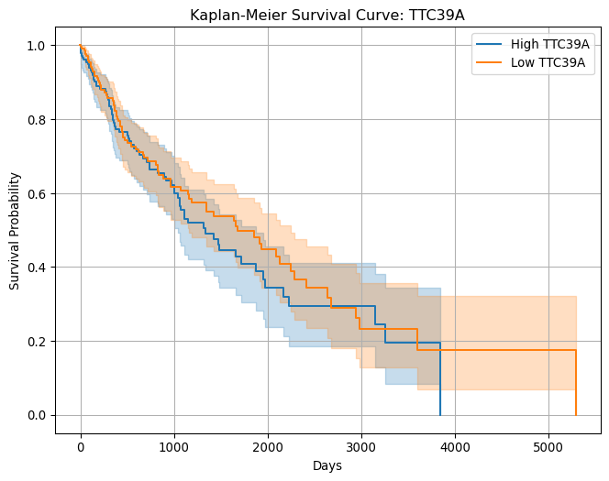
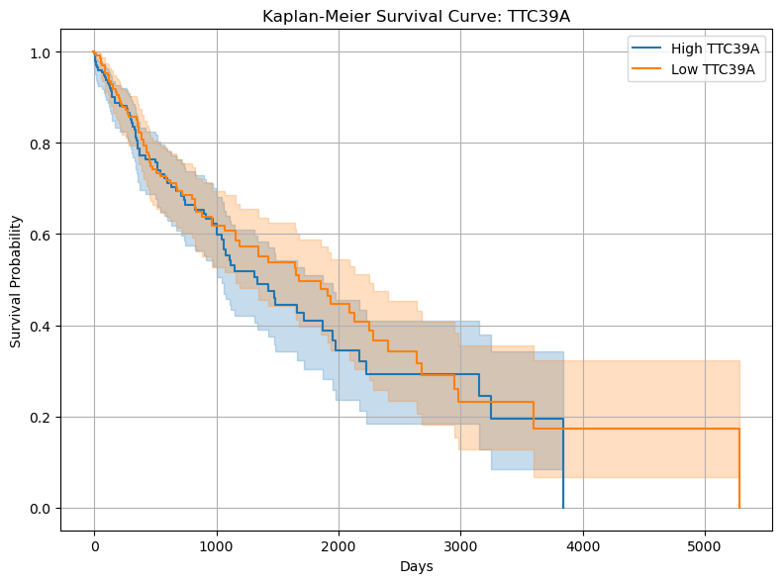

2.4.7 🧠 2. Stratify by Clinical Features (e.g. Stage, Gender)
Stratification means analyzing survival within subgroups to see if gene effects differ.

2.4.7.1 Example: Stratify by gender
I have not extracted the meta data like tis ,so skip
we can do the same for stage, tumor_status, or any other clinical variable.

2.4.8 📊 3. Visualize Hazard Ratios with Confidence Intervals
Use lifelines to generate a forest plot:
import matplotlib.pyplot as plt
# Plot hazard ratios
ax = cph.plot(hazard_ratios=True)
# Customize the plot afterward
fig = ax.get_figure()
fig.set_size_inches(8, 6)
plt.title("Hazard Ratios for 7 Significant Genes")
plt.grid(True)
plt.tight_layout()
plt.show()
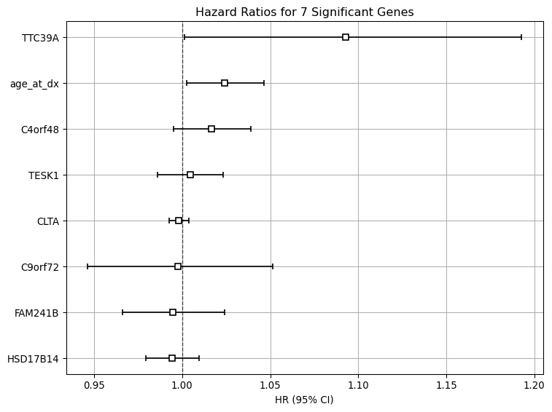
This plot shows:
- HR > 1: higher risk
- HR < 1: protective effect
- Confidence intervals: statistical certainty
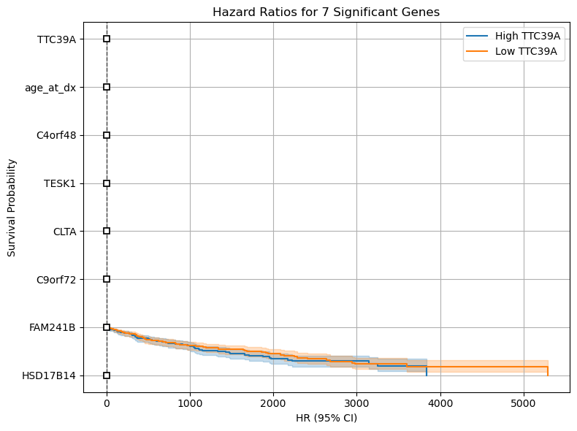

2.5 Seems our so called significant genes is not significant at all
The most important genes in Lung Squamous Cell Carcinoma (LUSC), particularly those frequently altered or associated with prognosis (survival), include:

2.6 Key Driver and Highly Mutated Genes
These genes are frequently mutated or altered in LUSC and are considered major drivers of the disease:
- TP53: This is the most commonly mutated gene in LUSC, with a mutation frequency of over 80%. As a tumor suppressor gene, its inactivation is a critical event in LUSC development.
- CDKN2A: This tumor suppressor gene is often lost or deleted. It’s an important factor in cell cycle regulation.
- PIK3CA: Mutations in this gene activate the PI3K signaling pathway, which promotes cell growth and survival, making it an important driver.
- NFE2L2: Alterations in this gene are also a frequent driver in LUSC, involved in antioxidant response.
- SOX2 and TP63: These genes are often overexpressed and amplified, acting as spectrum factors that help define the squamous cell type.

2.6.1 ✅ Updated Gene List (LUSC Drivers)
significant_genes = ['TP53', 'CDKN2A', 'PIK3CA', 'NFE2L2', 'SOX2', 'TP63']
gene_list_sql = ', '.join([f"'{gene}'" for gene in significant_genes])

2.6.2 ✅ Updated DuckDB Query
survival_query = f"""
SELECT
t1.case_id,
t1.vital_status,
COALESCE(t1.days_to_death, t1.days_to_last_followup) AS survival_days,
t1.age_at_dx,
t2.gene_name,
t2.expression
FROM clinical_metadata_db t1
INNER JOIN rna_expression_unpivoted t2
ON t1.case_id = t2.sample_id
WHERE t2.gene_name IN ({gene_list_sql})
"""
survival_df_long = con.execute(survival_query).fetchdf()

2.6.3 ✅ Pivot to Wide Format
survival_df = survival_df_long.pivot_table(
index=['case_id', 'vital_status', 'survival_days', 'age_at_dx'],
columns='gene_name',
values='expression'
).reset_index()
print("✅ Survival-ready DataFrame:")
print(survival_df.head())
✅ Survival-ready DataFrame:
gene_name case_id vital_status survival_days age_at_dx CDKN2A \
0 TCGA-18-3406 Dead 371.0 67.0 0.1111
1 TCGA-18-3407 Dead 136.0 72.0 7.8677
2 TCGA-18-3408 Alive 2099.0 77.0 14.7748
3 TCGA-18-3409 Alive 2417.0 74.0 4.5390
4 TCGA-18-3410 Dead 146.0 81.0 0.1752
gene_name NFE2L2 PIK3CA SOX2 TP53 TP63
0 71.1991 3.5253 7.8118 11.1669 91.2031
1 102.7201 3.5564 101.7467 4.4468 197.8747
2 116.5379 17.2093 229.6729 25.1026 137.9216
3 28.1534 2.8343 0.7877 6.0767 97.3364
4 28.7284 2.0180 13.9919 46.3015 19.8604

2.6.4 💾 Save to CSV
survival_df.to_csv(r"E:\acode\wsl\data2\GDCdata\TCGA-LUSC\survial_data.csv", index=False)

2.7 🧠 Step 1: Impute Missing Values (KNN)
# Select columns to impute (excluding case_id and vital_status)
impute_cols = ['survival_days', 'age_at_dx'] + significant_genes
# Create a copy to avoid modifying original
impute_df = survival_df[impute_cols].copy()
# Initialize the imputer
imputer = KNNImputer(n_neighbors=10)
# Fit and transform
imputed_array = imputer.fit_transform(impute_df)
# Replace the original columns with imputed values
survival_df[impute_cols] = imputed_array

2.8 🔁 Step 2: Convert vital_status to Binary Event
survival_df['event'] = survival_df['vital_status'].map({'Dead': 1, 'Alive': 0}).astype(int)

2.8.1 ⚖️ Step 2: Z-score Normalization (Standardization)
This centers each gene’s expression around 0 and scales by standard deviation:
from sklearn.preprocessing import StandardScaler
scaler = StandardScaler()
survival_df[significant_genes] = scaler.fit_transform(survival_df[significant_genes])

2.9 📊 Step 3: Run Multivariate Cox
from lifelines import CoxPHFitter
cox_df = survival_df[['survival_days', 'event', 'age_at_dx'] + significant_genes]
cph = CoxPHFitter()
cph.fit(cox_df, duration_col='survival_days', event_col='event')
cph.print_summary()
model | lifelines.CoxPHFitter
duration col | ‘survival_days’
event col | ‘event’
baseline estimation | breslow
number of observations | 489
number of events observed | 154
partial log-likelihood | -755.72
time fit was run | 2025-10-13 14:17:05 UTC

 | coef | exp(coef) | se(coef) | coef lower 95% | coef upper 95% | exp(coef) lower 95% | exp(coef) upper 95% | cmp to | z | p | -log2(p)
age_at_dx | 0.02 | 1.02 | 0.01 | 0.00 | 0.04 | 1.00 | 1.04 | 0.00 | 2.15 | 0.03 | 4.99
TP53 | -0.00 | 1.00 | 0.01 | -0.02 | 0.01 | 0.98 | 1.01 | 0.00 | -0.42 | 0.68 | 0.56
CDKN2A | -0.01 | 0.99 | 0.01 | -0.02 | 0.01 | 0.98 | 1.01 | 0.00 | -1.21 | 0.23 | 2.15
PIK3CA | -0.04 | 0.96 | 0.04 | -0.12 | 0.05 | 0.89 | 1.05 | 0.00 | -0.83 | 0.40 | 1.31
NFE2L2 | 0.00 | 1.00 | 0.00 | -0.00 | 0.01 | 1.00 | 1.01 | 0.00 | 0.75 | 0.45 | 1.14
SOX2 | -0.00 | 1.00 | 0.00 | -0.00 | 0.00 | 1.00 | 1.00 | 0.00 | -0.69 | 0.49 | 1.03
TP63 | -0.00 | 1.00 | 0.00 | -0.01 | 0.00 | 0.99 | 1.00 | 0.00 | -1.26 | 0.21 | 2.27

Concordance | 0.59
Partial AIC | 1525.45
log-likelihood ratio test | 13.45 on 7 df
-log2(p) of ll-ratio test | 4.01

2.10 📈 Step 4: Visualize Hazard Ratios
import matplotlib.pyplot as plt
ax = cph.plot(hazard_ratios=True)
fig = ax.get_figure()
fig.set_size_inches(8, 6)
plt.title("Hazard Ratios for LUSC Driver Genes")
plt.grid(True)
plt.tight_layout()
plt.show()
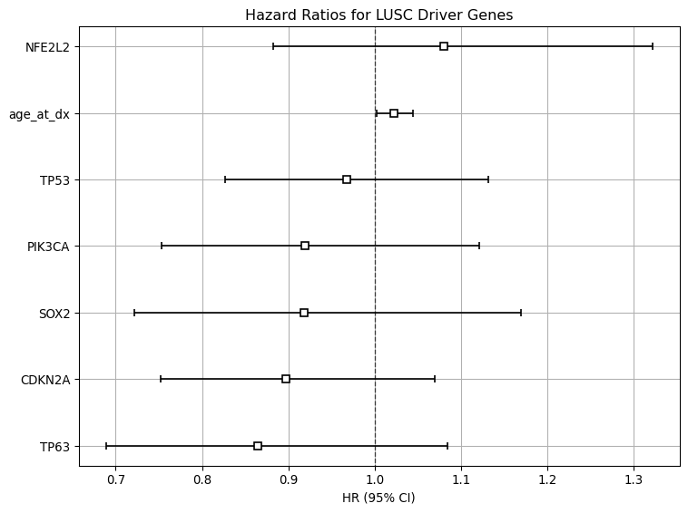
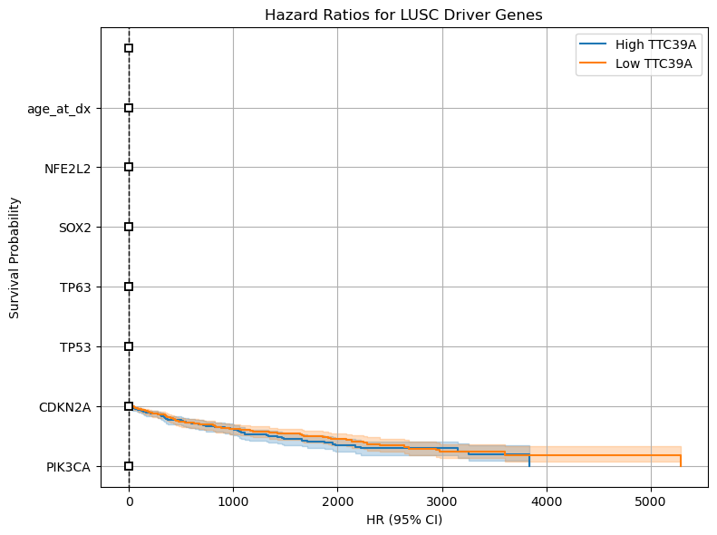

2.11 🧪 Step 5: Explore Gene-Gene Interactions or Build Risk Score

2.11.1 Option A: Interaction Terms
cox_df['TP53_x_PIK3CA'] = cox_df['TP53'] * cox_df['PIK3CA']
cph.fit(cox_df, duration_col='survival_days', event_col='event')
cph.print_summary()

2.11.2 Option B: Risk Score (linear combination of weighted expression)
risk_score = cph.predict_partial_hazard(cox_df)
survival_df['risk_score'] = risk_score.values
print(survival_df['risk_score'].head())
0 1.153991
1 0.968188
2 0.894628
3 1.335779
4 1.279238
Name: risk_score, dtype: float64
... print(survival_df['risk_score'].head())
0 1.153991
1 0.968188
2 0.894628
3 1.335779
4 1.279238
hold on ,i think it is not good at all,the data sucks i guess ,fuck it

