genome
Table of contents

杨昆 11312023119
made by jayz

0.1 🧬 数据来源与背景
- 项目名称：CDC Traveler-Based Genomic Surveillance Program
- 提交单位：Ginkgo Bioworks（通过其子公司 Concentric 执行测序任务）
- 目标：监测从多个美国主要机场入境的国际旅客所携带的 SARS-CoV-2 变异株及其他病原体，进行基因组测序分析。

0.2 📦 样本与实验信息
字段 | 内容 | 说明
Sample ID | SAMN52666403 | 生物样本编号
SRA Experiment ID | SRS26846718 | 实验编号
Organism | SARS-CoV-2 | 测序对象为新冠病毒
Library Name | COVID-19 WGS | 表示这是一个全基因组测序（WGS）库
Instrument | Element AVITI | 使用的测序仪器型号
Strategy | AMPLICON | 使用扩增子测序策略，常用于变异检测
Source | VIRAL RNA | 样本来源为病毒 RNA
Selection | RT-PCR | 使用逆转录 PCR 技术进行样本选择与扩增
Layout | PAIRED | 双端测序（paired-end），提高测序准确性

0.3 📊 数据量与运行信息
字段 | 内容 | 说明
Run ID | SRR35790159 | 具体运行编号，可用于下载原始数据
Spots | 2,320,503 | 测序读取数（reads）或测序点数
Bases | 464.1M | 总碱基数（即读取的核苷酸总数）
Size | 271.9Mb | 下载数据的大小
Published Date | 2025-10-14 | 数据公开时间
jayz@localhost:~$ mkdir yankun
jayz@localhost:~$ cd yankun
jayz@localhost:~/yankun$ mkdir data
jayz@localhost:~/yankun$ cd data
jayz@localhost:~/yankun/data$ prefetch SRR35790159
2025-10-17T03:00:37 prefetch.3.0.3: Current preference is set to retrieve SRA Normalized Format files with full base quality scores.
2025-10-17T03:00:38 prefetch.3.0.3: 1) Downloading 'SRR35790159'...
2025-10-17T03:00:38 prefetch.3.0.3: SRA Normalized Format file is being retrieved, if this is different from your preference, it may be due to current file availability.
2025-10-17T03:00:38 prefetch.3.0.3: Downloading via HTTPS...
2025-10-17T03:01:04 prefetch.3.0.3: HTTPS download succeed
2025-10-17T03:01:04 prefetch.3.0.3: 'SRR35790159' is valid
2025-10-17T03:01:04 prefetch.3.0.3: 1) 'SRR35790159' was downloaded successfully
2025-10-17T03:01:04 prefetch.3.0.3: 'SRR35790159' has 0 unresolved dependencies
jayz@localhost:~/yankun/data$ ls
SRR35790159
jayz@localhost:~/yankun/data$ fasterq-dump SRR35790159
spots read : 2,320,503
reads read : 4,641,006
reads written : 4,641,006
jayz@localhost:~/yankun/data$ fasterq-dump SRR35790159 --split-files -O fastq_files
spots read : 2,320,503
reads read : 4,641,006
reads written : 4,641,006
jayz@localhost:~/yankun/data$ ls
SRR35790159 SRR35790159_1.fastq SRR35790159_2.fastq fastq_files
jayz@localhost:~/yankun/data$ fastqc SRR35790159_1.fastq SRR35790159_2.fastq
null
null
Started analysis of SRR35790159_1.fastq
Approx 5% complete for SRR35790159_1.fastq
Approx 10% complete for SRR35790159_1.fastq
Approx 15% complete for SRR35790159_1.fastq
Approx 20% complete for SRR35790159_1.fastq
Approx 25% complete for SRR35790159_1.fastq
Approx 30% complete for SRR35790159_1.fastq
Approx 35% complete for SRR35790159_1.fastq
Approx 40% complete for SRR35790159_1.fastq
Approx 45% complete for SRR35790159_1.fastq
Approx 50% complete for SRR35790159_1.fastq
Approx 55% complete for SRR35790159_1.fastq
Approx 60% complete for SRR35790159_1.fastq
Approx 65% complete for SRR35790159_1.fastq
Approx 70% complete for SRR35790159_1.fastq
Approx 75% complete for SRR35790159_1.fastq
Approx 80% complete for SRR35790159_1.fastq
Approx 85% complete for SRR35790159_1.fastq
Approx 90% complete for SRR35790159_1.fastq
Approx 95% complete for SRR35790159_1.fastq
Analysis complete for SRR35790159_1.fastq
Started analysis of SRR35790159_2.fastq
Approx 5% complete for SRR35790159_2.fastq
Approx 10% complete for SRR35790159_2.fastq
Approx 15% complete for SRR35790159_2.fastq
Approx 20% complete for SRR35790159_2.fastq
Approx 25% complete for SRR35790159_2.fastq
Approx 30% complete for SRR35790159_2.fastq
Approx 35% complete for SRR35790159_2.fastq
Approx 40% complete for SRR35790159_2.fastq
Approx 45% complete for SRR35790159_2.fastq
Approx 50% complete for SRR35790159_2.fastq
Approx 55% complete for SRR35790159_2.fastq
Approx 60% complete for SRR35790159_2.fastq
Approx 65% complete for SRR35790159_2.fastq
Approx 70% complete for SRR35790159_2.fastq
Approx 75% complete for SRR35790159_2.fastq
Approx 80% complete for SRR35790159_2.fastq
Approx 85% complete for SRR35790159_2.fastq
Approx 90% complete for SRR35790159_2.fastq
Approx 95% complete for SRR35790159_2.fastq
Analysis complete for SRR35790159_2.fastq
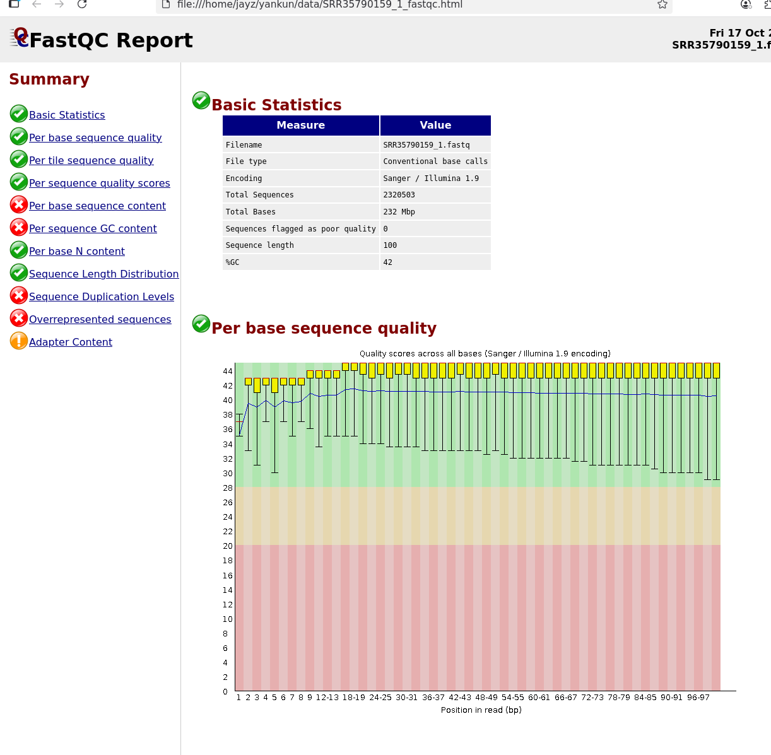
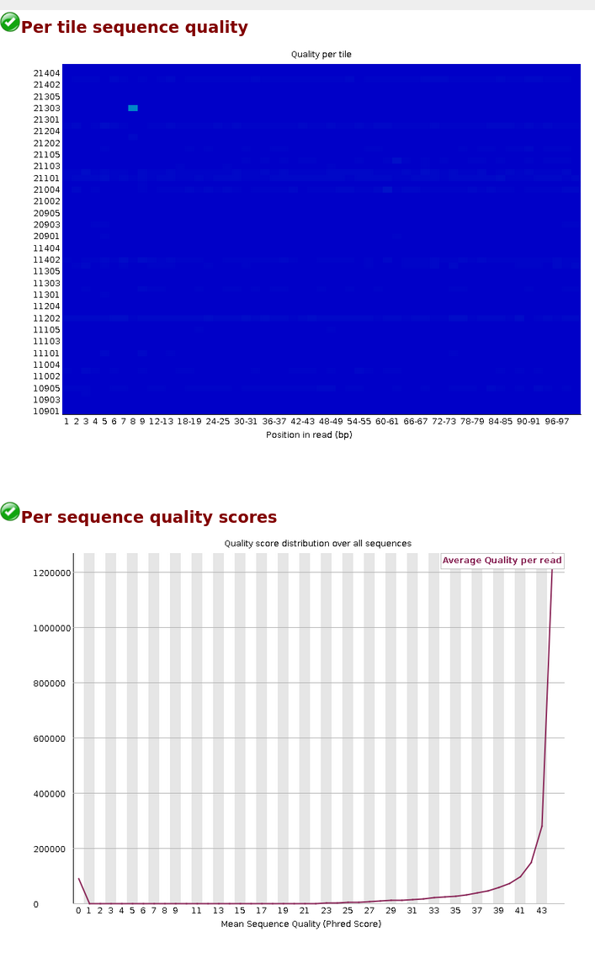
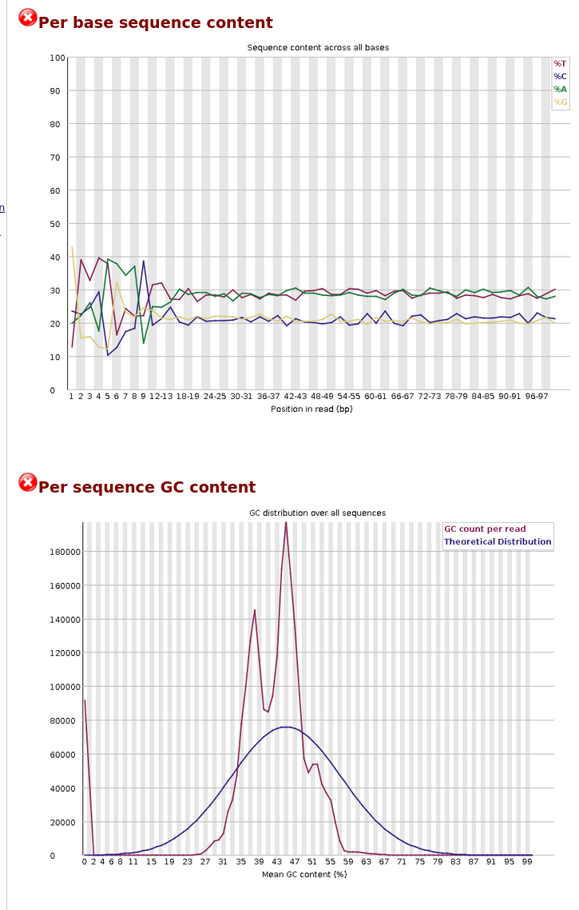
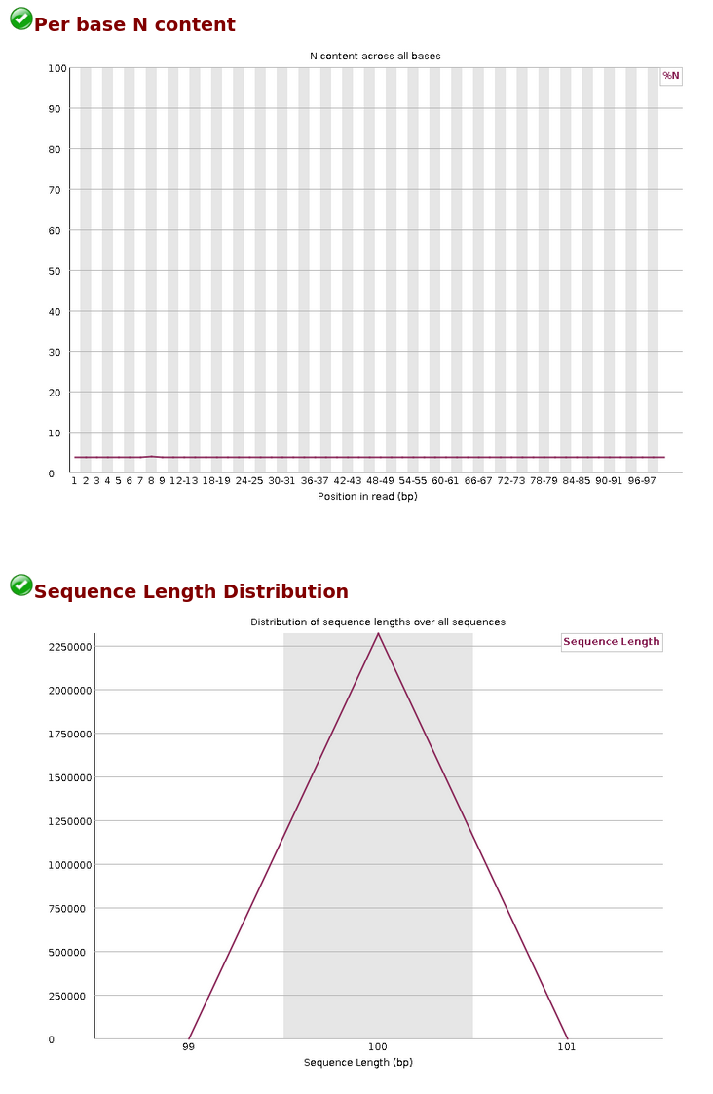
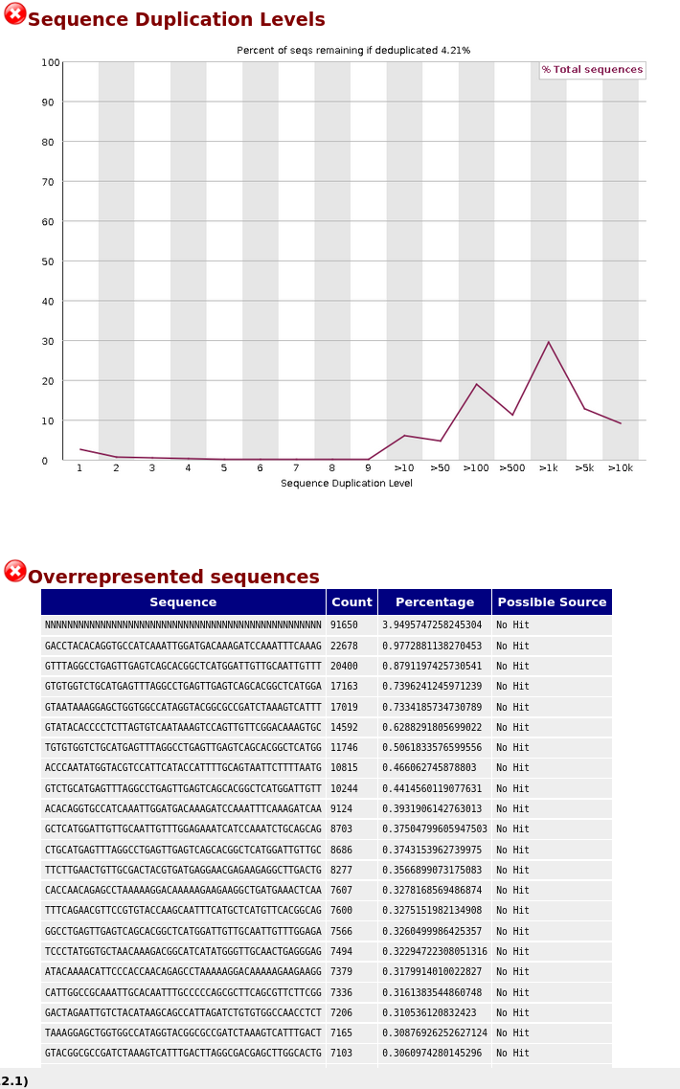
看看第二个fatsq文件
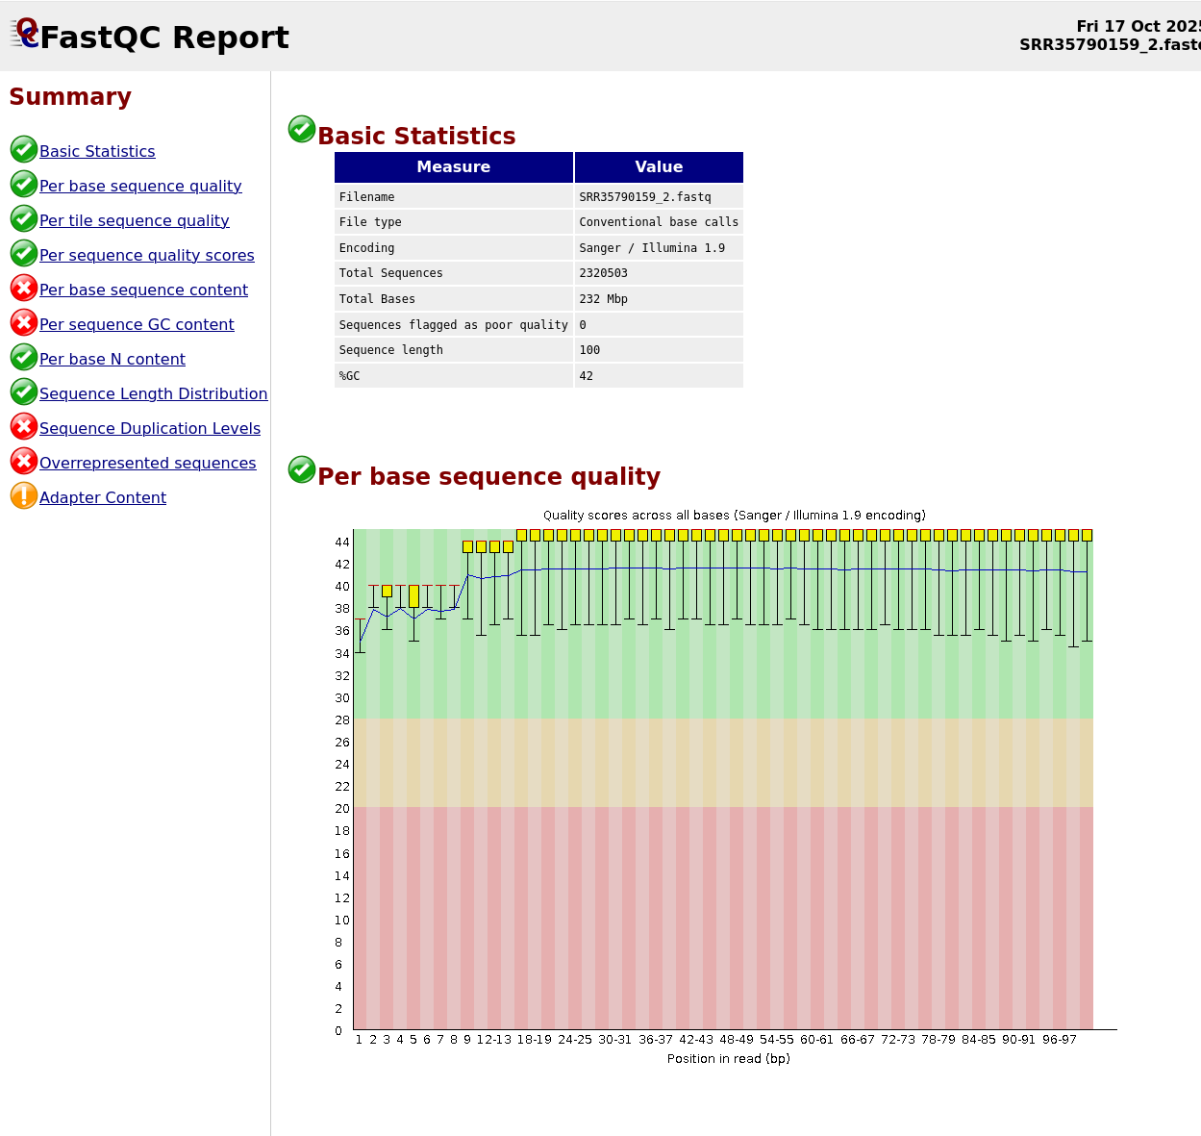

0.4 🔬 FastQC 模块解释与分析
模块 | 含义 | 标红的可能原因 | 是否建议使用 fastp
Per Sequence Content | 检查每条 read 中各位置的碱基组成是否一致 | AMPLICON 测序常见，因引物或扩增偏好导致前几位碱基组成偏离 | ✅ 是，fastp 可剪切前端偏差区域
Per GC Content | 检查 reads 的 GC 含量分布是否符合正态分布 | 病毒基因组 GC 含量本身偏低或样本混杂 | ✅ 是，fastp 可去除异常 reads，改善分布
Sequence Duplication Levels | 检查重复 reads 的比例 | AMPLICON 测序中 PCR 扩增会导致高重复 | ✅ 是，fastp 可去除完全重复 reads
Overrepresented Sequences | 检查是否存在频率异常高的序列（如接头、引物） | 接头污染、引物残留或扩增伪影 | ✅ 是，fastp 可自动识别并去除接头序列

0.5 ✅ 是否有必要使用 fastp？
非常有必要。
尽管 AMPLICON 测序本身会导致某些 FastQC 模块偏离“理想状态”，但：
- 接头污染 和 重复 reads 会影响比对效率和变异检测准确性；
- 前端碱基偏差 会干扰某些下游分析（如变异定位）；
- fastp 可自动处理这些问题，并生成新的质控报告，帮助你判断清洗效果。

0.6 🧪 推荐 fastp 命令（双端数据）
fastp \
-i SRR35790159_1.fastq \
-I SRR35790159_2.fastq \
-o SRR35790159_trimmed_1.fastq \
-O SRR35790159_trimmed_2.fastq \
--detect_adapter_for_pe \
--trim_poly_g \
--cut_front \
--cut_tail \
--cut_window_size 4 \
--cut_mean_quality 20 \
--length_required 50 \
--thread 8 \
--html SRR35790159_fastp.html \
--json SRR35790159_fastp.json
jayz@localhost:~/yankun/data$ fastp \
-i SRR35790159_1.fastq \
-I SRR35790159_2.fastq \
-o SRR35790159_trimmed_1.fastq \
-O SRR35790159_trimmed_2.fastq \
--detect_adapter_for_pe \
--trim_poly_g \
--cut_front \
--cut_tail \
--cut_window_size 4 \
--cut_mean_quality 20 \
--length_required 50 \
--thread 8 \
--html SRR35790159_fastp.html \
--json SRR35790159_fastp.json
Detecting adapter sequence for read1...
>I7_Nextera_Transposase_1 | >Trans2_rc | >I7_Nextera_Transposase_1 | >Trans2_rc
CTGTCTCTTATACACATCTCCGAGCCCACGAGAC
Detecting adapter sequence for read2...
>I5_Nextera_Transposase_1 | >Trans1_rc | >I5_Nextera_Transposase_1 | >Trans1_rc
CTGTCTCTTATACACATCTGACGCTGCCGACGA
Read1 before filtering:
total reads: 2320503
total bases: 232050300
Q20 bases: 219390368(94.5443%)
Q30 bases: 212369986(91.5189%)
Read2 before filtering:
total reads: 2320503
total bases: 232050300
Q20 bases: 220444754(94.9987%)
Q30 bases: 215945831(93.0599%)
Read1 after filtering:
total reads: 2198482
total bases: 215526175
Q20 bases: 212304242(98.5051%)
Q30 bases: 205663485(95.4239%)
Read2 after filtering:
total reads: 2198482
total bases: 215591822
Q20 bases: 213302358(98.9381%)
Q30 bases: 209004462(96.9445%)
Filtering result:
reads passed filter: 4396964
reads failed due to low quality: 660
reads failed due to too many N: 356
reads failed due to too short: 243026
reads with adapter trimmed: 535660
bases trimmed due to adapters: 12174695
Duplication rate: 70.2497%
Insert size peak (evaluated by paired-end reads): 148
JSON report: SRR35790159_fastp.json
HTML report: SRR35790159_fastp.html
fastp -i SRR35790159_1.fastq -I SRR35790159_2.fastq -o SRR35790159_trimmed_1.fastq -O SRR35790159_trimmed_2.fastq --detect_adapter_for_pe --trim_poly_g --cut_front --cut_tail --cut_window_size 4 --cut_mean_quality 20 --length_required 50 --thread 8 --html SRR35790159_fastp.html --json SRR35790159_fastp.json
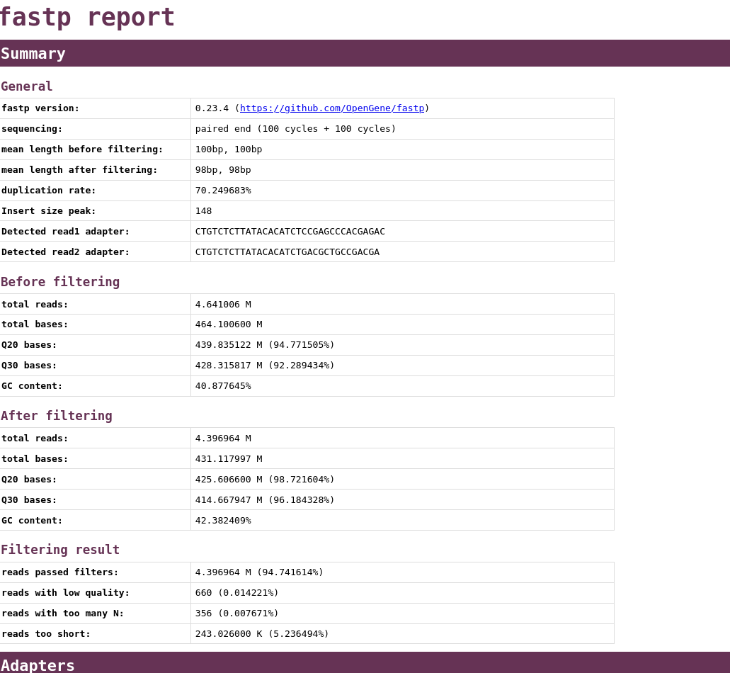
之后fastqc查看一下
jayz@localhost:~/yankun/data$ fastqc SRR35790159_trimmed_1.fastq SRR35790159_trimmed_2.fastq
null
null
Started analysis of SRR35790159_trimmed_1.fastq
Approx 5% complete for SRR35790159_trimmed_1.fastq
Approx 10% complete for SRR35790159_trimmed_1.fastq
Approx 15% complete for SRR35790159_trimmed_1.fastq
Approx 20% complete for SRR35790159_trimmed_1.fastq
Approx 25% complete for SRR35790159_trimmed_1.fastq
Approx 30% complete for SRR35790159_trimmed_1.fastq
Approx 35% complete for SRR35790159_trimmed_1.fastq
Approx 40% complete for SRR35790159_trimmed_1.fastq
Approx 45% complete for SRR35790159_trimmed_1.fastq
Approx 50% complete for SRR35790159_trimmed_1.fastq
Approx 55% complete for SRR35790159_trimmed_1.fastq
Approx 60% complete for SRR35790159_trimmed_1.fastq
Approx 65% complete for SRR35790159_trimmed_1.fastq
Approx 70% complete for SRR35790159_trimmed_1.fastq
Approx 75% complete for SRR35790159_trimmed_1.fastq
Approx 80% complete for SRR35790159_trimmed_1.fastq
Approx 85% complete for SRR35790159_trimmed_1.fastq
Approx 90% complete for SRR35790159_trimmed_1.fastq
Approx 95% complete for SRR35790159_trimmed_1.fastq
Analysis complete for SRR35790159_trimmed_1.fastq
Started analysis of SRR35790159_trimmed_2.fastq
Approx 5% complete for SRR35790159_trimmed_2.fastq
Approx 10% complete for SRR35790159_trimmed_2.fastq
Approx 15% complete for SRR35790159_trimmed_2.fastq
Approx 20% complete for SRR35790159_trimmed_2.fastq
Approx 25% complete for SRR35790159_trimmed_2.fastq
Approx 30% complete for SRR35790159_trimmed_2.fastq
Approx 35% complete for SRR35790159_trimmed_2.fastq
Approx 40% complete for SRR35790159_trimmed_2.fastq
Approx 45% complete for SRR35790159_trimmed_2.fastq
Approx 50% complete for SRR35790159_trimmed_2.fastq
Approx 55% complete for SRR35790159_trimmed_2.fastq
Approx 60% complete for SRR35790159_trimmed_2.fastq
Approx 65% complete for SRR35790159_trimmed_2.fastq
Approx 70% complete for SRR35790159_trimmed_2.fastq
Approx 75% complete for SRR35790159_trimmed_2.fastq
Approx 80% complete for SRR35790159_trimmed_2.fastq
Approx 85% complete for SRR35790159_trimmed_2.fastq
Approx 90% complete for SRR35790159_trimmed_2.fastq
Approx 95% complete for SRR35790159_trimmed_2.fastq
Analysis complete for SRR35790159_trimmed_2.fastq
jayz@localhost:~/yankun/data$ ls
SRR35790159 SRR35790159_2_fastqc.zip SRR35790159_trimmed_2.fastq
SRR35790159_1.fastq SRR35790159_fastp.html SRR35790159_trimmed_2_fastqc.html
SRR35790159_1_fastqc.html SRR35790159_fastp.json SRR35790159_trimmed_2_fastqc.zip
SRR35790159_1_fastqc.zip SRR35790159_trimmed_1.fastq fastq_files
SRR35790159_2.fastq SRR35790159_trimmed_1_fastqc.html
SRR35790159_2_fastqc.html SRR35790159_trimmed_1_fastqc.zip

0.7 🧬 推荐参考基因组：SARS-CoV-2 Wuhan-Hu-1
- NCBI RefSeq ID：NC_045512.2
- 描述：这是最早发布的 SARS-CoV-2 完整参考基因组（Wuhan-Hu-1 株）
- 长度：29,903 bp
- 用途：广泛用于变异检测、比对、注释等分析任务

0.8 📥 下载参考基因组并放入 reference/ 文件夹
你可以使用以下命令在 Linux 终端中完成下载：
mkdir -p reference
cd reference
# 下载参考基因组 FASTA 文件
wget -O SARS-CoV-2_reference.fasta "https://ftp.ncbi.nlm.nih.gov/genomes/all/GCF/009/858/895/GCF_009858895.2_ASM985889v3/GCF_009858895.2_ASM985889v3_genomic.fna.gz"
# 解压
gunzip GCF_009858895.2_ASM985889v3_genomic.fna.gz
# 重命名为统一格式
mv GCF_009858895.2_ASM985889v3_genomic.fna SARS-CoV-2_reference.fasta
jayz@localhost:~/yankun/data/reference$ wget --no-proxy -O SARS-CoV-2_reference.fasta.gz "https://ftp.ncbi.nlm.nih.gov/genomes/all/GCF/009/858/895/GCF_009858895.2_ASM985889v3/GCF_009858895.2_ASM985889v3_genomic.fna.gz"
--2025-10-17 11:42:09-- https://ftp.ncbi.nlm.nih.gov/genomes/all/GCF/009/858/895/GCF_009858895.2_ASM985889v3/GCF_009858895.2_ASM985889v3_genomic.fna.gz
Resolving ftp.ncbi.nlm.nih.gov (ftp.ncbi.nlm.nih.gov)... 130.14.250.11, 130.14.250.12, 130.14.250.31, ...
Connecting to ftp.ncbi.nlm.nih.gov (ftp.ncbi.nlm.nih.gov)|130.14.250.11|:443... connected.
HTTP request sent, awaiting response... 200 OK
Length: 9591 (9.4K) [application/x-gzip]
Saving to: ‘SARS-CoV-2_reference.fasta.gz’
SARS-CoV-2_reference.fasta.gz 100%[=================================================>] 9.37K --.-KB/s in 0s
2025-10-17 11:42:11 (193 MB/s) - ‘SARS-CoV-2_reference.fasta.gz’ saved [9591/9591]
jayz@localhost:~/yankun/data/reference$ ls
SARS-CoV-2_reference.fasta SARS-CoV-2_reference.fasta.gz
jayz@localhost:~/yankun/data/reference$

0.9 下一步建议
- 构建索引（以 bwa 为例）：
- bwa index reference/SARS-CoV-2_reference.fasta
jayz@localhost:~/yankun/data$ bwa index reference/SARS-CoV-2_reference.fasta
[bwa_index] Pack FASTA... 0.00 sec
[bwa_index] Construct BWT for the packed sequence...
[bwa_index] 0.00 seconds elapse.
[bwa_index] Update BWT... 0.00 sec
[bwa_index] Pack forward-only FASTA... 0.00 sec
[bwa_index] Construct SA from BWT and Occ... 0.00 sec
[main] Version: 0.7.17-r1188
[main] CMD: bwa index reference/SARS-CoV-2_reference.fasta
[main] Real time: 0.076 sec; CPU: 0.002 sec
- 比对 reads 到参考基因组：
- bwa mem reference/SARS-CoV-2_reference.fasta \
SRR35790159_trimmed_1.fastq SRR35790159_trimmed_2.fastq \
> SRR35790159_aligned.sam
jayz@localhost:~/yankun/data$ bwa mem reference/SARS-CoV-2_reference.fasta \
SRR35790159_trimmed_1.fastq SRR35790159_trimmed_2.fastq \
> SRR35790159_aligned.sam
[M::bwa_idx_load_from_disk] read 0 ALT contigs
[M::process] read 101986 sequences (10000008 bp)...
[M::process] read 101942 sequences (10000099 bp)...
[M::mem_pestat] # candidate unique pairs for (FF, FR, RF, RR): (5, 49958, 0, 8)
[M::mem_pestat] skip orientation FF as there are not enough pairs
[M::mem_pestat] analyzing insert size distribution for orientation FR...
[M::mem_pestat] (25, 50, 75) percentile: (129, 174, 230)
[M::mem_pestat] low and high boundaries for computing mean and std.dev: (1, 432)
[M::mem_pestat] mean and std.dev: (183.42, 72.11)
[M::mem_pestat] low and high boundaries for proper pairs: (1, 533)
[M::mem_pestat] skip orientation RF as there are not enough pairs
[M::mem_pestat] skip orientation RR as there are not enough pairs
[M::mem_process_seqs] Processed 101986 reads in 1.489 CPU sec, 1.417 real sec
[M::process] read 101990 sequences (10000097 bp)...
...
...
[M::mem_pestat] skip orientation FF as there are not enough pairs
[M::mem_pestat] analyzing insert size distribution for orientation FR...
[M::mem_pestat] (25, 50, 75) percentile: (129, 174, 230)
[M::mem_pestat] low and high boundaries for computing mean and std.dev: (1, 432)
[M::mem_pestat] mean and std.dev: (183.93, 72.18)
[M::mem_pestat] low and high boundaries for proper pairs: (1, 533)
[M::mem_pestat] skip orientation RF as there are not enough pairs
[M::mem_pestat] skip orientation RR as there are not enough pairs
[M::mem_process_seqs] Processed 101944 reads in 1.532 CPU sec, 1.488 real sec
[M::mem_pestat] # candidate unique pairs for (FF, FR, RF, RR): (1, 5568, 0, 0)
[M::mem_pestat] skip orientation FF as there are not enough pairs
[M::mem_pestat] analyzing insert size distribution for orientation FR...
[M::mem_pestat] (25, 50, 75) percentile: (131, 176, 230)
[M::mem_pestat] low and high boundaries for computing mean and std.dev: (1, 428)
[M::mem_pestat] mean and std.dev: (184.31, 71.90)
[M::mem_pestat] low and high boundaries for proper pairs: (1, 527)
[M::mem_pestat] skip orientation RF as there are not enough pairs
[M::mem_pestat] skip orientation RR as there are not enough pairs
[M::mem_process_seqs] Processed 11366 reads in 0.211 CPU sec, 0.176 real sec
[main] Version: 0.7.17-r1188
[main] CMD: bwa mem reference/SARS-CoV-2_reference.fasta SRR35790159_trimmed_1.fastq SRR35790159_trimmed_2.fastq
[main] Real time: 62.444 sec; CPU: 66.297 sec
```
``` bash
jayz@localhost:~/yankun/data$ ls
SRR35790159 SRR35790159_2_fastqc.zip SRR35790159_trimmed_1_fastqc.zip test.sam
SRR35790159_1.fastq SRR35790159_aligned.sam SRR35790159_trimmed_2.fastq test_1.fastq
SRR35790159_1_fastqc.html SRR35790159_fastp.html SRR35790159_trimmed_2_fastqc.html test_2.fastq
SRR35790159_1_fastqc.zip SRR35790159_fastp.json SRR35790159_trimmed_2_fastqc.zip test_minimap.sam
SRR35790159_2.fastq SRR35790159_trimmed_1.fastq fastq_files
SRR35790159_2_fastqc.html SRR35790159_trimmed_1_fastqc.html reference
```
- **转换为 BAM 并排序**：
``` bash
samtools view -Sb SRR35790159_aligned.sam | samtools sort -o SRR35790159_sorted.bam
samtools index SRR35790159_sorted.bam
```
``` bash
jayz@localhost:~/yankun/data$ samtools view -Sb SRR35790159_aligned.sam | samtools sort -o SRR35790159_sorted.bam
[bam_sort_core] merging from 1 files and 1 in-memory blocks...
jayz@localhost:~/yankun/data$ samtools index SRR35790159_sorted.bam
```
- **覆盖度分析**：
``` bash
samtools depth SRR35790159_sorted.bam > SRR35790159_coverage.txt
```
``` bash
jayz@localhost:~/yankun/data$ samtools view -Sb SRR35790159_aligned.sam | samtools sort -o SRR35790159_sorted.bam
[bam_sort_core] merging from 1 files and 1 in-memory blocks...
jayz@localhost:~/yankun/data$ samtools index SRR35790159_sorted.bam
jayz@localhost:~/yankun/data$ samtools depth SRR35790159_sorted.bam > SRR35790159_coverage.txt
jayz@localhost:~/yankun/data$ head SRR35790159_coverage.txt -n 10
NC_045512.2 47 1
NC_045512.2 48 5
NC_045512.2 49 9
NC_045512.2 50 9
NC_045512.2 51 9
NC_045512.2 52 9
NC_045512.2 53 11
NC_045512.2 54 15
NC_045512.2 55 15
NC_045512.2 56 30
```
表示参考序列 `NC_045512.2` 的第 47 个碱基位置被覆盖了 1 次
### 🔍 快速分析
- 从第 47 位开始，覆盖度逐渐上升，说明测序 reads 在这个区域开始有比对。
- 第 56 位覆盖度达到 30，说明该区域可能是 reads 富集区域或 PCR 富集区域。
把文件导入windows可视化，不想在linux做，因为下包太慢了
::: {.cell execution_count=1}
``` {.python .cell-code}
import pandas as pd
import matplotlib.pyplot as plt
df = pd.read_csv(r"E:\acode\wsl\data4\SRR35790159_coverage.txt", sep="\t", header=None, names=["ref", "pos", "depth"])
plt.figure(figsize=(12, 4))
plt.plot(df["pos"], df["depth"], color="steelblue")
plt.xlabel("Position on reference")
plt.ylabel("Coverage depth")
plt.title("Coverage profile of SRR35790159")
plt.tight_layout()
plt.show()
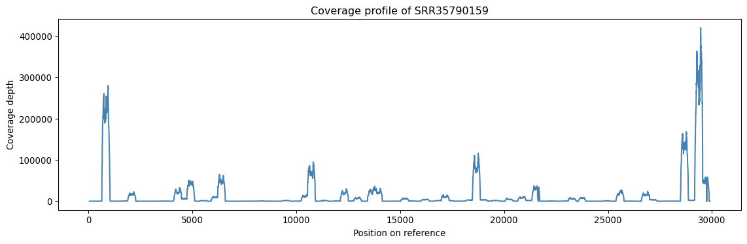
:::
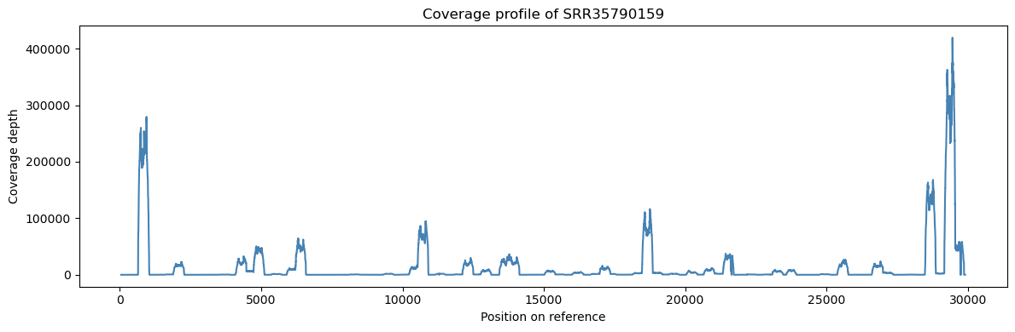

0.9.1 ✅ 总覆盖位置数（即有 reads 覆盖的位置数）
wc -l SRR35790159_coverage.txt
jayz@localhost:~/yankun/data$ wc -l SRR35790159_coverage.txt
26444 SRR35790159_coverage.txt

0.9.2 ✅ 平均覆盖深度
awk '{sum+=$3} END {print "Average depth:", sum/NR}' SRR35790159_coverage.txt
jayz@localhost:~/yankun/data$ awk '{sum+=$3} END {print "Average depth:", sum/NR}' SRR35790159_coverage.txt
Average depth: 15891

0.9.3 ✅ 最大覆盖深度
awk 'max<$3{max=$3} END{print "Max depth:", max}' SRR35790159_coverage.txt
jayz@localhost:~/yankun/data$ awk 'max<$3{max=$3} END{print "Max depth:", max}' SRR35790159_coverage.txt
Max depth: 419399

0.9.4 ✅ 最小覆盖深度（非零）
awk 'min==0 || ($3<min && $3>0){min=$3} END{print "Min depth:", min}' SRR35790159_coverage.txt
jayz@localhost:~/yankun/data$ awk 'min==0 || ($3<min && $3>0){min=$3} END{print "Min depth:", min}' SRR35790159_coverage.txt
Min depth: 1

0.10 ✅ 筛选出覆盖度 >30× 的区域总数
awk '$3 > 30 {count++} END {print "Positions with depth >30x:", count}' SRR35790159_coverage.txt
jayz@localhost:~/yankun/data$ awk '$3 > 30 {count++} END {print "Positions with depth >30x:", count}' SRR35790159_coverage.txt
Positions with depth >30x: 22451
如果想计算比例（覆盖度 >30× 的区域占总参考长度）：
total=$(wc -l < SRR35790159_coverage.txt)
high=$(awk '$3 > 30 {count++} END {print count}' SRR35790159_coverage.txt)
echo "Proportion >30x: " $(echo "$high/$total" | bc -l)
jayz@localhost:~/yankun/data$ total=$(wc -l < SRR35790159_coverage.txt)
high=$(awk '$3 > 30 {count++} END {print count}' SRR35790159_coverage.txt)
echo "Proportion >30x: " $(echo "$high/$total" | bc -l)
Proportion >30x: .84900166389351081530
发现约 84.9% 的参考区域覆盖度高于 30×

1 SNP变异分析

2 🧱 第一步：生成高覆盖区域 BED 文件（>30×）
awk '$3 > 30 {print $1"\t"$2-1"\t"$2}' SRR35790159_coverage.txt > high_coverage.bed
说明：
- BED 格式是 0-based 左闭右开，所以 start = pos - 1, end = pos
- 输出格式为：<ref> <start> <end>

3 第二步：SNP Calling 流程（推荐用 bcftools）
：
- 排序后的 BAM 文件：SRR35790159_sorted.bam
- 索引文件：SRR35790159_sorted.bam.bai
- 参考序列：SARS-CoV-2_reference.fasta（已索引）

3.1 ✅ 1. 创建 mpileup（限制在高覆盖区域）
bcftools mpileup --threads 8 -f reference/SARS-CoV-2_reference.fasta SRR35790159_sorted.bam -Oz -o raw.vcf.gz
#threads 8 ,8核心加快速度

3.2 ✅ 2. SNP Calling
bcftools call -m --ploidy 1 -Oz -o call.vcf.gz raw.vcf.gz

4 🧭 索引 VCF 文件
使用 tabix 为压缩的 VCF 文件创建索引：
tabix -p vcf call.vcf.gz
这会生成 call.vcf.gz.tbi 索引文件，供后续快速查询和可视化使用。

5 📊 可视化 SNP 分布（Python）
你可以用 pysam 或 cyvcf2 读取 VCF 文件并用 matplotlib 可视化 SNP 分布：

5.1 ✅ 示例：绘制 SNP 在参考序列上的位置分布
import gzip
import matplotlib.pyplot as plt
positions = []
with gzip.open(r"E:\acode\wsl\data4\call.vcf.gz", "rt") as f:
for line in f:
if line.startswith("#"):
continue
fields = line.strip().split("\t")
pos = int(fields[1])
positions.append(pos)
plt.figure(figsize=(12, 4))
plt.hist(positions, bins=100, color="darkorange", edgecolor="black")
plt.xlabel("Position on reference genome")
plt.ylabel("SNP count")
plt.title("SNP Distribution Across Reference")
plt.tight_layout()
plt.show()
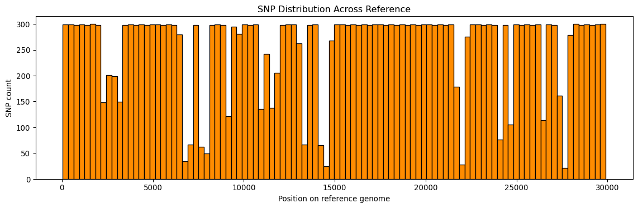

5.2 ✅ 示例：统计 SNP 数量和质量分布
import gzip
import matplotlib.pyplot as plt
qual_scores = []
with gzip.open(r"E:\acode\wsl\data4\call.vcf.gz", "rt") as f:
for line in f:
if line.startswith("#"):
continue
fields = line.strip().split("\t")
qual_field = fields[5]
if qual_field != ".":
try:
qual = float(qual_field)
qual_scores.append(qual)
except ValueError:
continue # 忽略无法解析的质量值
plt.figure(figsize=(8, 4))
plt.hist(qual_scores, bins=50, color="steelblue", edgecolor="black")
plt.xlabel("SNP Quality Score")
plt.ylabel("Count")
plt.title("SNP Quality Distribution")
plt.tight_layout()
plt.show()
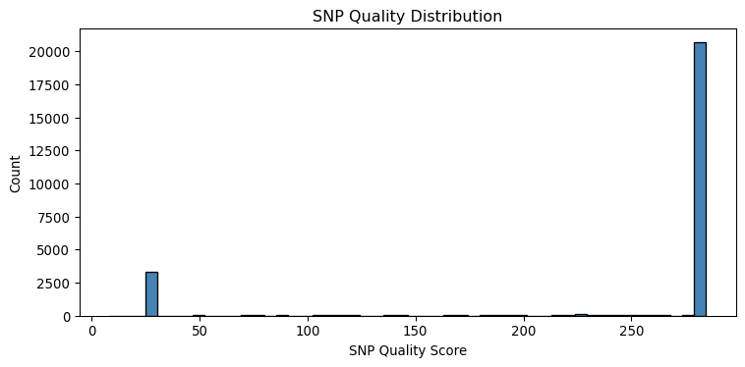
jayz@localhost:~/yankun$ tree
└── data
├── SRR35790159
│ └── SRR35790159.sra
├── SRR35790159_1.fastq
├── SRR35790159_1_fastqc.html
├── SRR35790159_1_fastqc.zip
├── SRR35790159_2.fastq
├── SRR35790159_2_fastqc.html
├── SRR35790159_2_fastqc.zip
├── SRR35790159_aligned.sam
├── SRR35790159_coverage.txt
├── SRR35790159_fastp.html
├── SRR35790159_fastp.json
├── SRR35790159_raw.bcf
├── SRR35790159_sorted.bam
├── SRR35790159_sorted.bam.bai
├── SRR35790159_trimmed_1.fastq
├── SRR35790159_trimmed_1_fastqc.html
├── SRR35790159_trimmed_1_fastqc.zip
├── SRR35790159_trimmed_2.fastq
├── SRR35790159_trimmed_2_fastqc.html
├── SRR35790159_trimmed_2_fastqc.zip
├── call.vcf.gz
├── call.vcf.gz.tbi
├── fastq_files
│ ├── SRR35790159_1.fastq
│ └── SRR35790159_2.fastq
├── high_coverage.bed
├── raw.vcf.gz
├── reference
│ ├── SARS-CoV-2_reference.fasta
│ ├── SARS-CoV-2_reference.fasta.amb
│ ├── SARS-CoV-2_reference.fasta.ann
│ ├── SARS-CoV-2_reference.fasta.bwt
│ ├── SARS-CoV-2_reference.fasta.fai
│ ├── SARS-CoV-2_reference.fasta.gz
│ ├── SARS-CoV-2_reference.fasta.pac
│ └── SARS-CoV-2_reference.fasta.sa
├── test.sam
├── test_1.fastq
├── test_2.fastq
└── test_minimap.sam
5 directories, 38 files

