

MIDDLE EAST TECHNICAL UNIVERSITY

Electrical & Electronics Engineering

EE568-Selected Topics on Electrical Machines

Project 2

Huzeyfe Hintoğlu - 2483782

Table of Contents

1. Introduction 3

2. Analytical Modelling 4

a) Reluctance and inductance of the system 4

b) Torque of the system 5

c) Improving the model considering non-linear effects 6

3. FEA Modelling (2D-Linear Materials) 6

a) Flux density vectors 6

b) Inductance and stored energy 8

c) Torque 9

4. FEA Modelling (2D-Nonlinear Materials) 9

a) Flux density vectors 9

b) Inductance and stored energy 11

c) Torque 12

d) Comparing the linear and nonlinear material characteristics 12

5. Control Method 12

6. Conclusion 12

7. Appendix 13

# Introduction

In this project, motor winding diagrams and their effects on characteristics of an electrical machines are analyzed. Starting with integral-slot winding design, the effect of the pitch angle and distribution factor to the machine is examined. Then, the fractional-slot winding design is performed and the effects of this design to induced voltages are investigated. 2 designs are compared with each other. Finally, a fractional-slot winding design is verified using the finite element analysis tool which is ANSYS Maxwell FEA tool.

# Integral-Slot Winding Design

Properties of the electrical machine are as follows:

* 20 pole
* 120 slot
* 3 phase

## Winding diagram

For this machine, a full-pitched winding is designed. The number of slots per pole per phase is calculated as 2 (120 slots/20 poles/3 phase). The machine is designed assuming double layer winding configuration. The winding diagram considering these properties is shown in Table 1.

Table 1.Integral-slot winding diagram

|  |  |  |  |  |  |  |  |  |  |  |  |
| --- | --- | --- | --- | --- | --- | --- | --- | --- | --- | --- | --- |
| 1 | 2 | 3 | 4 | 5 | 6 | 7 | 8 | 9 | 10 | 11 | 12 |
| A1 | A2 | -C3 | -C4 | B1 | B2 | -A3 | -A4 | C1 | C2 | -B3 | -B4 |
| A3 | A4 | -C1 | -C2 | B3 | B4 | -A1 | -A2 | C3 | C4 | -B1 | -B2 |

## Distribution factor, pitch factor and winding factor calculation for fundamental component

To calculate distribution factor, pitch factor and winding factor, equations (1), (2) and (3) are used.

$Distribution Factor: k_{d}=\frac{\sin{(h*\frac{q*a}{2})}}{q*\sin{(h*\frac{a}{2})}}$ (1)

$Pitch Factor: k_{p}=\sin{(h*\frac{λ}{2})}$ (2)

$Winding Factor: k_{w}=k_{p}* k_{d}$ (3)

α: Electrical angle between two adjacent coils.

h: Harmonics number.

q: Number of coils ( Number of slots per phase per pole)

λ: Coil-pitch in electrical degrees

As the machine is designed being full-pitched, pitch factor is 1. Also, q is found as 2 which is explained in part a. Electrical angle (α) is equal to 30˚ (360˚/12). Coil pitch (λ) is equal to 180˚. Using equations above, results are found using a calculator for fundamental component as follows;

$$k_{d}=0.9659$$

$$k_{p}=1$$

$$k_{w}=0.9659$$

## Parameters for 3rd and 5th harmonics

To calculate the same parameters for 3rd and 5th harmonics, we need to insert harmonics value to the equations (1), (2) and (3).

For 3rd harmonics;

$$k_{d}=0.707$$

$$k_{p}=-1$$

$$k_{w}=-0.707$$

For 5th harmonics;

$$k_{d}=0.259$$

$$k_{p}=1$$

$$k_{w}=0.259$$

As we include the harmonics, we can see that winding factors can be negative. Thus, this may affect our machine negatively as it would introduce negative voltages to the machine, and it is not a desired effect. Hence, winding can be designed short-pitched or over-pitched to eliminate 3rd harmonics which would increase the efficiency of the machine.

# Fractional-Slot Winding Design

A 3-phase permanent magnet synchronous machine with a fractional-slot winding is analyzed. Emetor Winding Desing is used to choose pole and slot number. According to program, pole number is determined to be 20 and slot number is determined as 24 because choosing these variables accordingly would give the highest winding factor which is 0.966.

## Phase angles of the induced voltage

q is calculated as 0.4 (24 slots/20 poles/3 phase). Electrical angle (α) is equal to 150˚ (360˚/ (24/10)).

|  |  |  |  |  |  |  |  |  |  |  |  |  |
| --- | --- | --- | --- | --- | --- | --- | --- | --- | --- | --- | --- | --- |
| Slot number | 1 | 2 | 3 | 4 | 5 | 6 | 7 | 8 | 9 | 10 | 11 | 12 |
| Phase angle of 1st component | 0 | 150 | 300 | 90 | 240 | 30 | 180 | 330 | 120 | 270 | 60 | 210 |
| Phase angle of 3rd component | 0 | 90 | 180 | 270 | 0 | 90 | 180 | 270 | 0 | 90 | 180 | 270 |
| Phase angle of 5th component | 0 | 30 | 60 | 90 | 120 | 150 | 180 | 210 | 240 | 270 | 300 | 330 |
| Coil Distribution | A1 | -A1 | B1 | -B1 | C1 | -C1 | -A2 | A2 | -B2 | B2 | -C2 | C2 |

|  |  |  |  |  |  |  |  |  |  |  |  |  |
| --- | --- | --- | --- | --- | --- | --- | --- | --- | --- | --- | --- | --- |
| Slot number | 13 | 14 | 15 | 16 | 17 | 18 | 19 | 20 | 21 | 22 | 23 | 24 |
| Phase angle of 1st component | 0 | 150 | 300 | 90 | 240 | 30 | 180 | 330 | 120 | 270 | 60 | 210 |
| Phase angle of 3rd component | 0 | 90 | 180 | 270 | 0 | 90 | 180 | 270 | 0 | 90 | 180 | 270 |
| Phase angle of 5th component | 0 | 30 | 60 | 90 | 120 | 150 | 180 | 210 | 240 | 270 | 300 | 330 |
| Coil Distribution | A3 | -A3 | B3 | -B3 | C3 | -C3 | -A4 | A4 | -B4 | B4 | -C4 | C4 |

## Inductance and stored energy

## Torque

Using

# FEA Modelling (2D-Nonlinear Materials)

A 2D finite element model is created to analyze the magnetic system. In this part, the materials are chosen as nonlinear materials.

## Flux density vectors

Flux density vectors for position 0°,45°,90° using the FEA model. The resultant waveforms are illustrated in Figures 11,12 and 13 respectively.

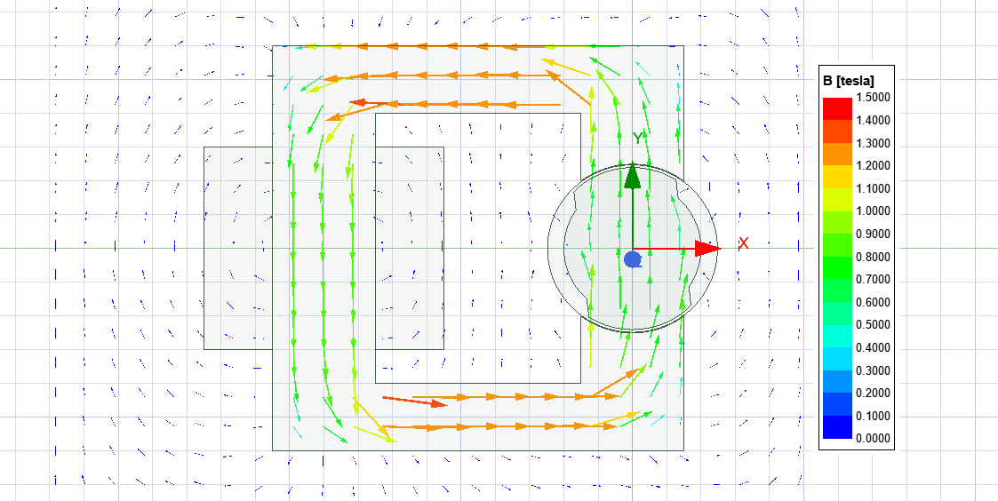

Figure 11: Flux density vectors of the system with nonlinear materials at 0°

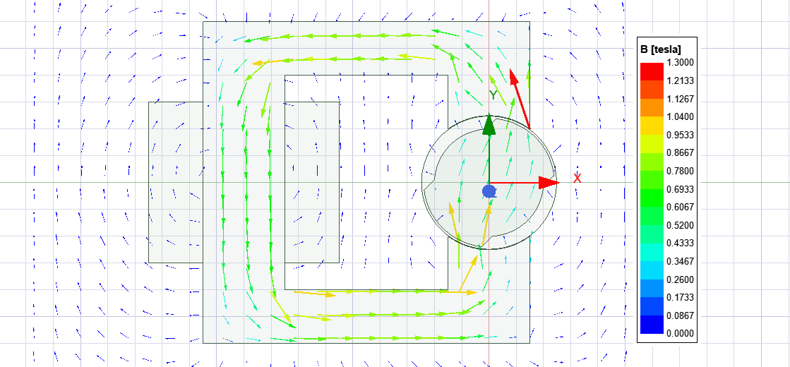

Figure 12: Flux density vectors of the system with nonlinear materials at 45°

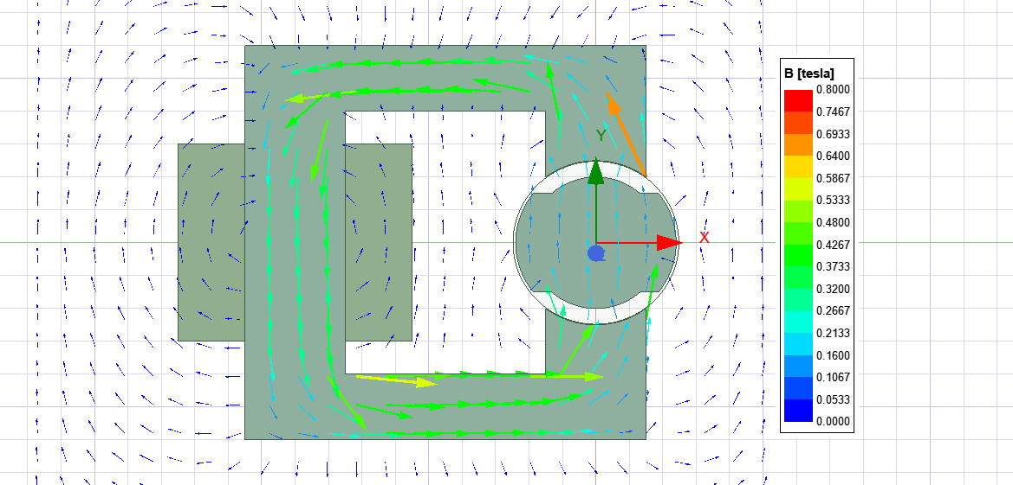

Figure 13: Flux density vectors of the system with nonlinear materials at 90°

The reason flux density vectors are changing because of the change in reluctance of the machine. Thus, the minimum magnetic field is observed when the reluctance is maximum and vice versa.

## Inductance and stored energy

U

## Torque

U

# Conclusion

In this project, the analysis of a magnetic system with linear and nonlinear materials are performed. Firstly, analytical calculations are performed. Then, a 2D FEA model is created. Solving the FEA model with linear and nonlinear materials, the results are compared. Later, it is seen that there is little mismatch between analytical results and simulations as the number of samples are less and some assumptions are made. Finally, a control method is proposed for this system. The rotor cannot fully rotate as DC excitation is able to oscillate the rotor between 2 positions.

# Appendix