

MIDDLE EAST TECHNICAL UNIVERSITY

Electrical & Electronics Engineering

EE568-Selected Topics on Electrical Machines

Project 1

Huzeyfe Hintoğlu - 2483782

Table of Contents

1. Introduction 3

2. Analytical Modelling 4

a) Reluctance and inductance of the system 4

b) Torque of the system 5

c) Improving the model considering non-linear effects 6

3. FEA Modelling (2D-Linear Materials) 6

a) Flux density vectors 6

b) Inductance and stored energy 8

c) Torque 9

4. FEA Modelling (2D-Nonlinear Materials) 9

a) Flux density vectors 9

b) Inductance and stored energy 11

c) Torque 12

d) Comparing the linear and nonlinear material characteristics 12

5. Control Method 12

6. Conclusion 12

7. Appendix 13

# Introduction

In this report, analytical analysis of magnetic materials is performed. The analytical results are compared with the finite element analysis tool which is ANSYS Maxwell FEA tool. Both linear and non-linear characteristics are examined in this work.

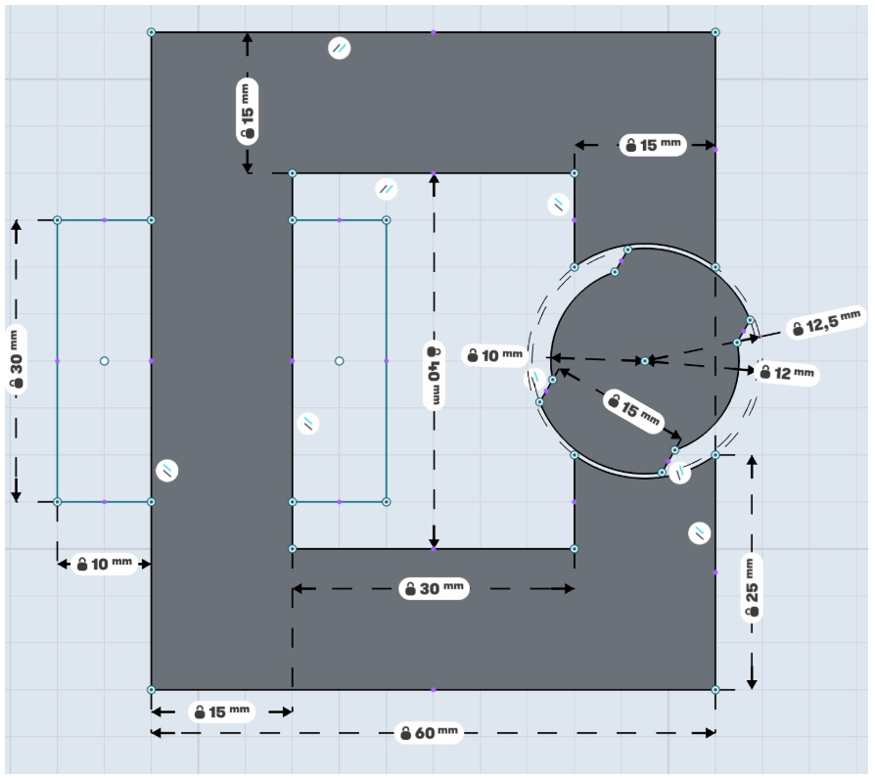

Figure 1: A variable reluctance magnetic system

Properties of the magnetic system are as follows:

* Coils are wound within 30mmx10mm rectangle areas
* Each airgap clearance is 0.5mm
* Depth of the core is 20mm
* Number of turns = 250
* Coil Current = 3 A DC

# Analytical Modelling

To solve the magnetic problem, reluctance and inductance equations should be derived. For the system shown in Figure 1, 6 points are taken for analysis and equations are solved using these points. After obtaining the values, the reluctance and inductance values are fitted into a sine wave using curve fitting tool of the Matlab. The written code can be found at the Appendix section.

## Reluctance and inductance of the system

There are 6 points taken in the analysis of the system. These points are at the rotor position at 0°,45°,90°,135°,180°,225°,270°,315°. The airgaps are calculated using the system parameters shown in Figure 1. Then, the formula shown in equation (1) to find reluctance is used.

$R=\frac{l}{µ_{0}*A}$ (1)

The resultant reluctance waveform is illustrated in Figure 2.

metin içeren bir resim

Açıklama otomatik olarak oluşturuldu

Figure 2: Effective reluctance of the system

For the inductance calculation, equation (2) is used as the reluctance is calculated above and turns ratio is known.

$L=\frac{N^{2}}{R}$ (2)

The resultant inductance waveform is illustrated in Figure 3.

metin, harita içeren bir resim

Açıklama otomatik olarak oluşturuldu

Figure 3: Effective inductance of the system

## Torque of the system

To derive the torque of the magnetic system, equation (3) is used.

$T=\frac{1}{2}*i^{2}*\frac{dL}{dθ}$ (3)

Since the inductance of the system is calculated in part a, the torque is calculated and plotted using this information. The resultant torque waveform is shown in Figure 4.

metin içeren bir resim

Açıklama otomatik olarak oluşturuldu

Figure 4: Effective torque of the system

## Improving the model considering non-linear effects

To improve the model, more points can be chosen to reduce the error. Considering the performance of the solver, having calculated more points helps to eliminate the error so that more realistic results can be obtained.

It is assumed that infinitely permeable core is used. To have a more realistic solution, a realistic magnetic material can be considered instead of using infinitely permeable core. Also, fringing affects the effective airgap length. The total reluctance decreases because of the fringing effect. This effect can be modelled to obtain more realistic model.

# FEA Modelling (2D-Linear Materials)

A 2D finite element model is created to analyze the magnetic system. In this part, the materials are chosen as linear materials. The model is accessible at GitHub page.

## Flux density vectors

Flux density vectors for position 0°,45°,90° using the FEA model. The resultant waveforms are illustrated in Figures 5,6 and 7 respectively.

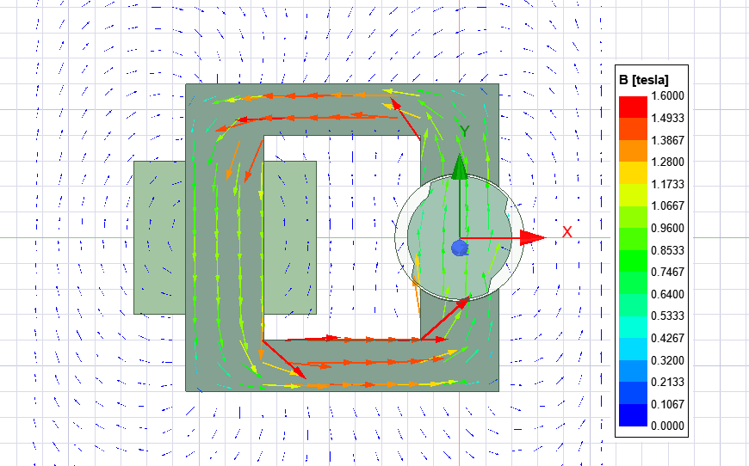

Figure 5: Flux density vectors at 0°

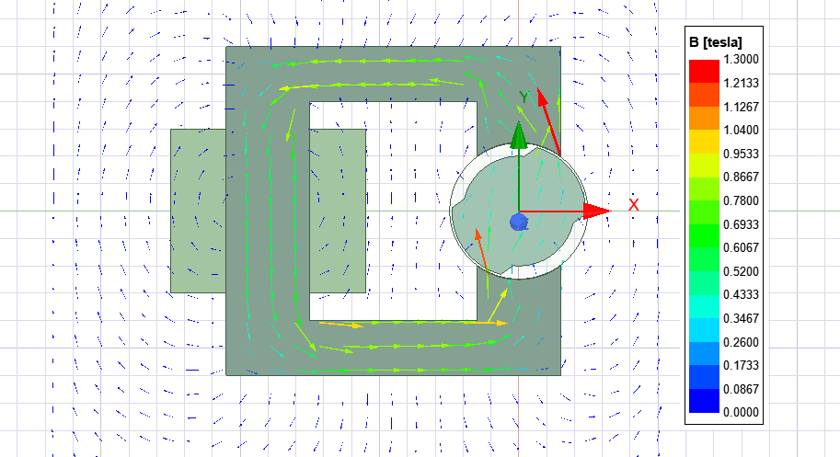

Figure 6: Flux density vectors at 45°

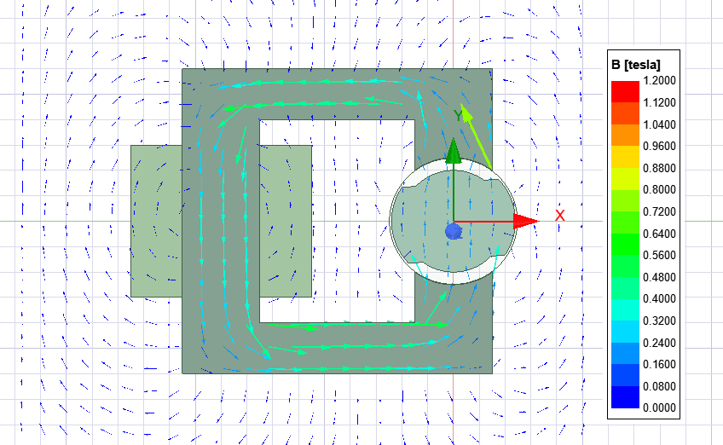

Figure 7: Flux density vectors at 90°

The reason flux density vectors are changing because of the change in reluctance of the machine. Thus, the minimum magnetic field is observed when the reluctance is maximum and vice versa.

## Inductance and stored energy

Using FEA, the inductance and stored energy values are obtained as shown in Figure 8 and 9.

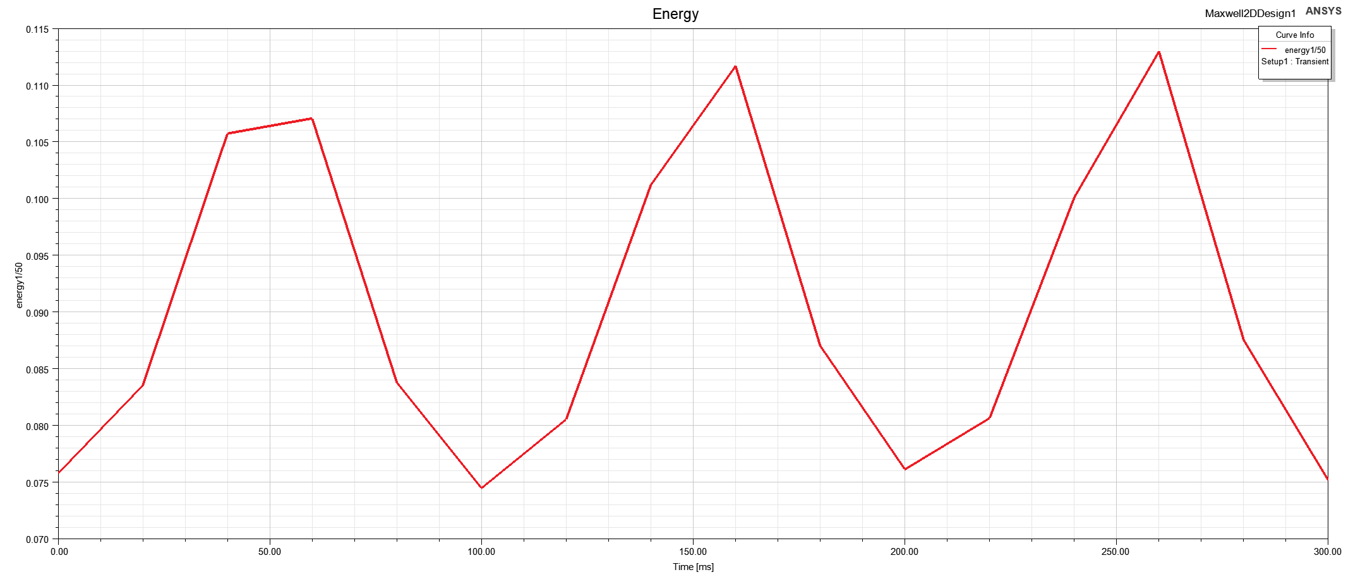

Figure 8: Stored energy of the system at 3 positions of the rotor

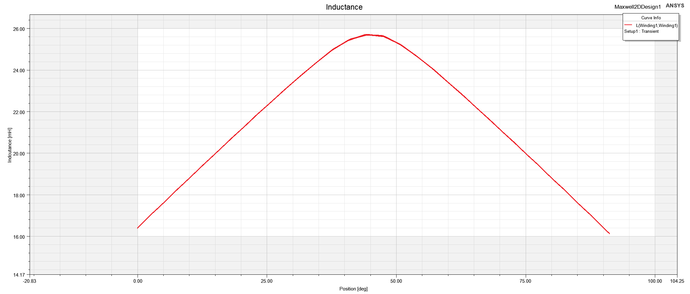

Figure 9: Inductance of the system at 3 positions of the rotor

Since the reluctance and inductance values are inversely proportional to each other, the inductance is maximum when the reluctance is minimum. Also, the stored energy is increasing with increasing inductance, the stored energy is proportional with the inductance.

## Torque

Using FEA, the torque values for the 3 points are obtained as shown in Figure 10.

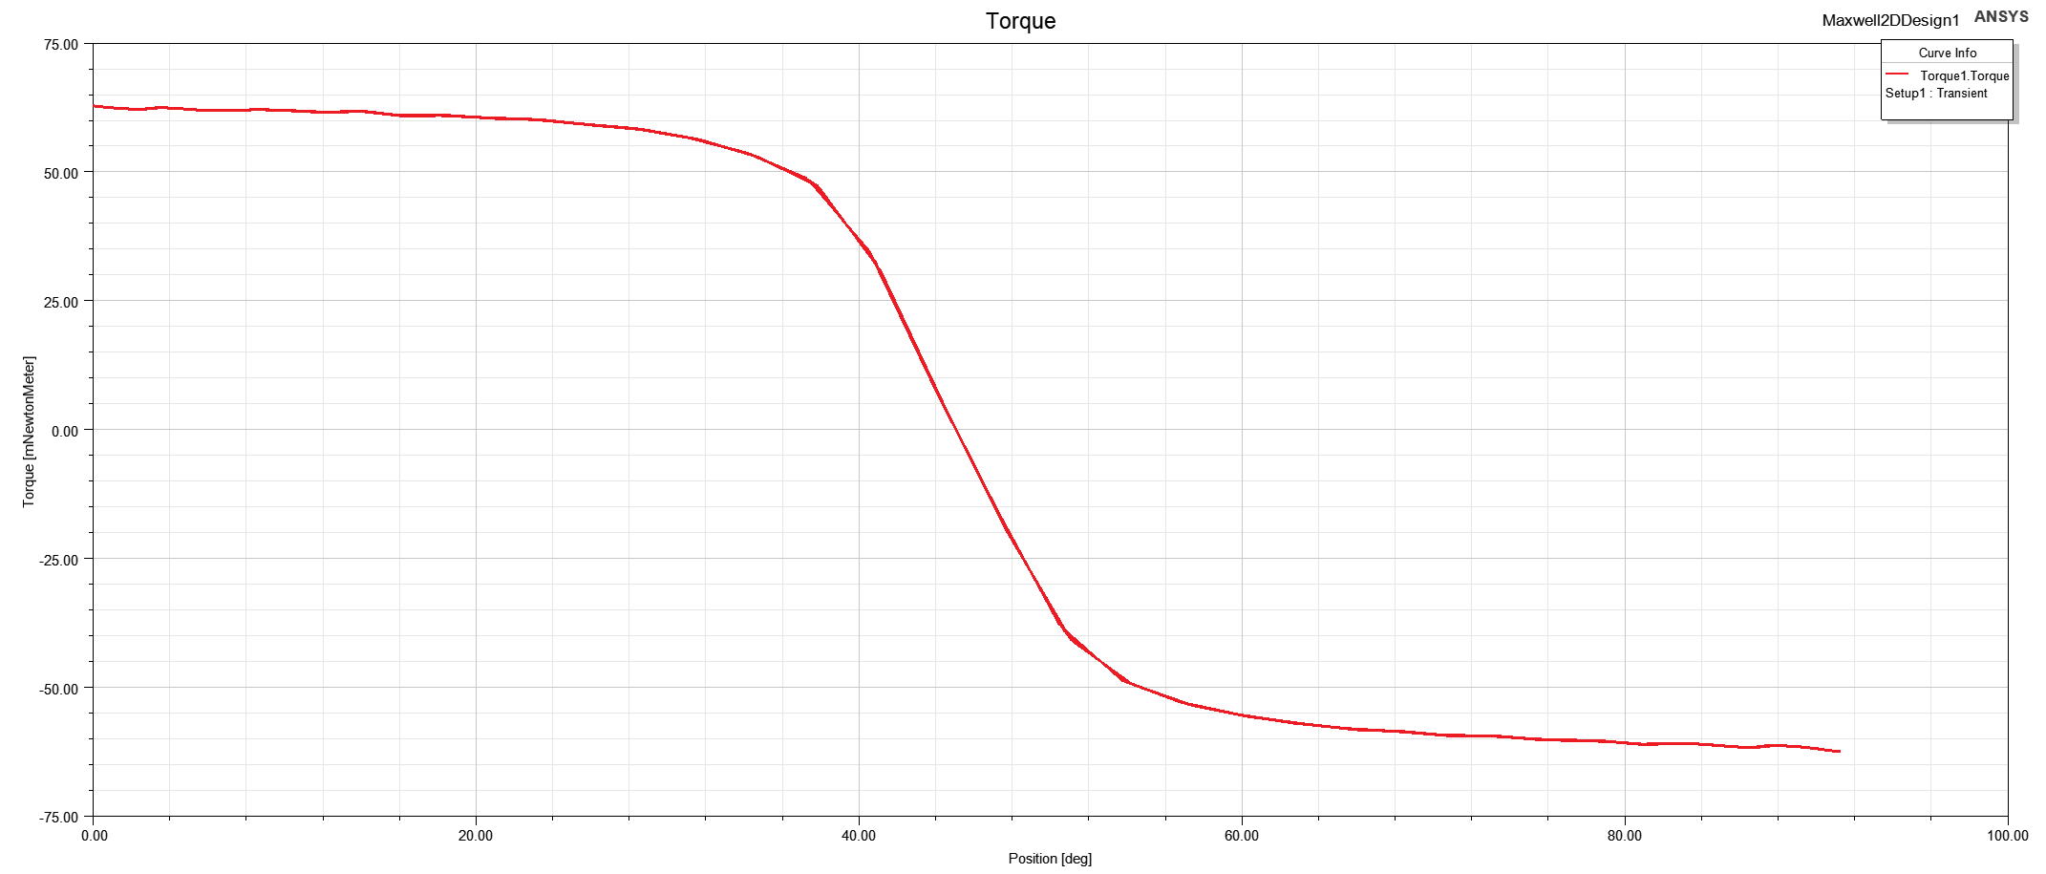

Figure 10: Torque of the system at 3 positions of the rotor

# FEA Modelling (2D-Nonlinear Materials)

A 2D finite element model is created to analyze the magnetic system. In this part, the materials are chosen as nonlinear materials.

## Flux density vectors

Flux density vectors for position 0°,45°,90° using the FEA model. The resultant waveforms are illustrated in Figures 11,12 and 13 respectively.

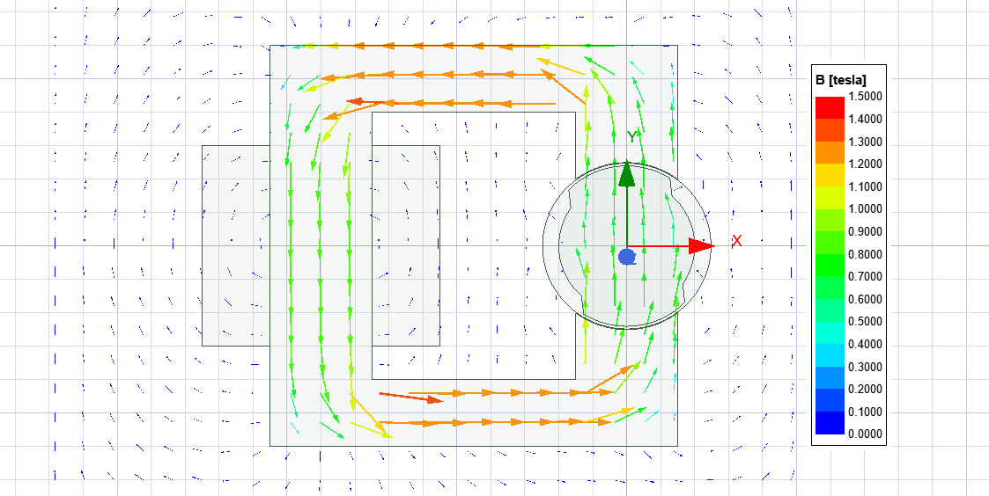

Figure 11: Flux density vectors of the system with nonlinear materials at 0°

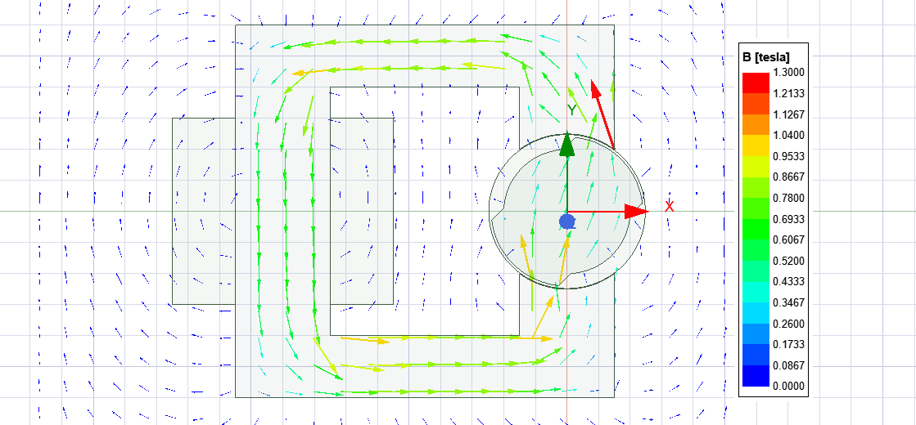

Figure 12: Flux density vectors of the system with nonlinear materials at 45°

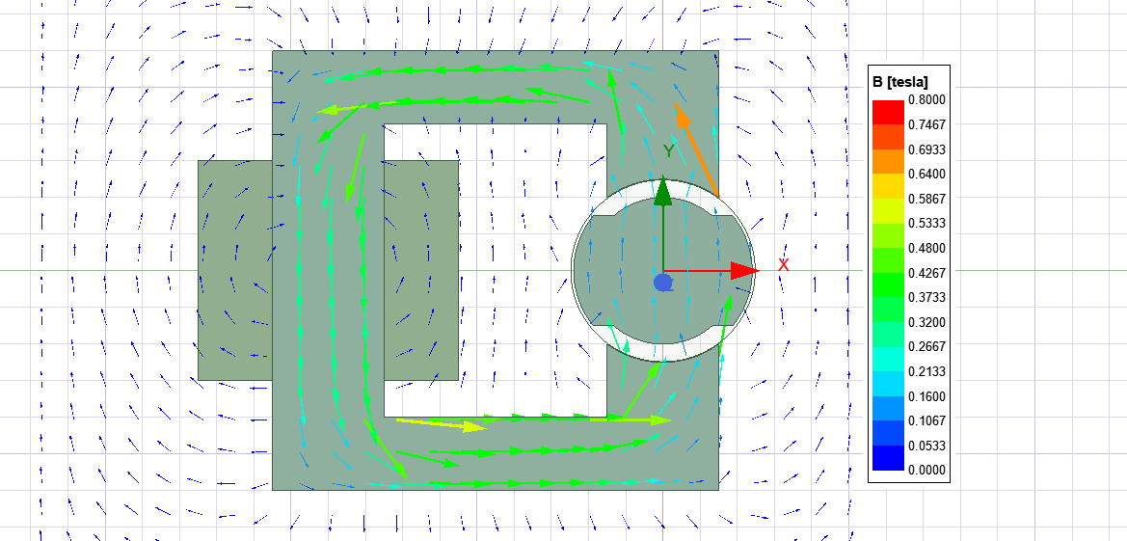

Figure 13: Flux density vectors of the system with nonlinear materials at 90°

The reason flux density vectors are changing because of the change in reluctance of the machine. Thus, the minimum magnetic field is observed when the reluctance is maximum and vice versa.

## Inductance and stored energy

Using FEA, the inductance and stored energy values are obtained as shown in Figure 14 and 15.

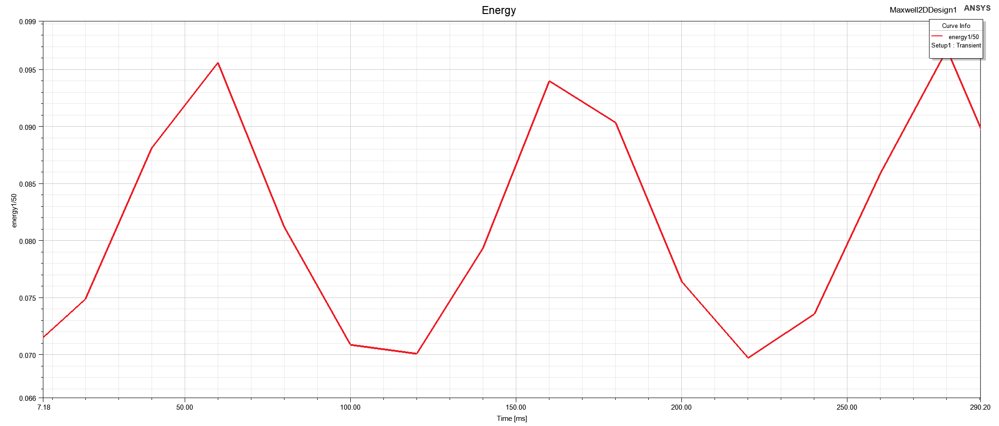

Figure 14: Stored energy of the system with nonlinear materials at 3 positions of the rotor

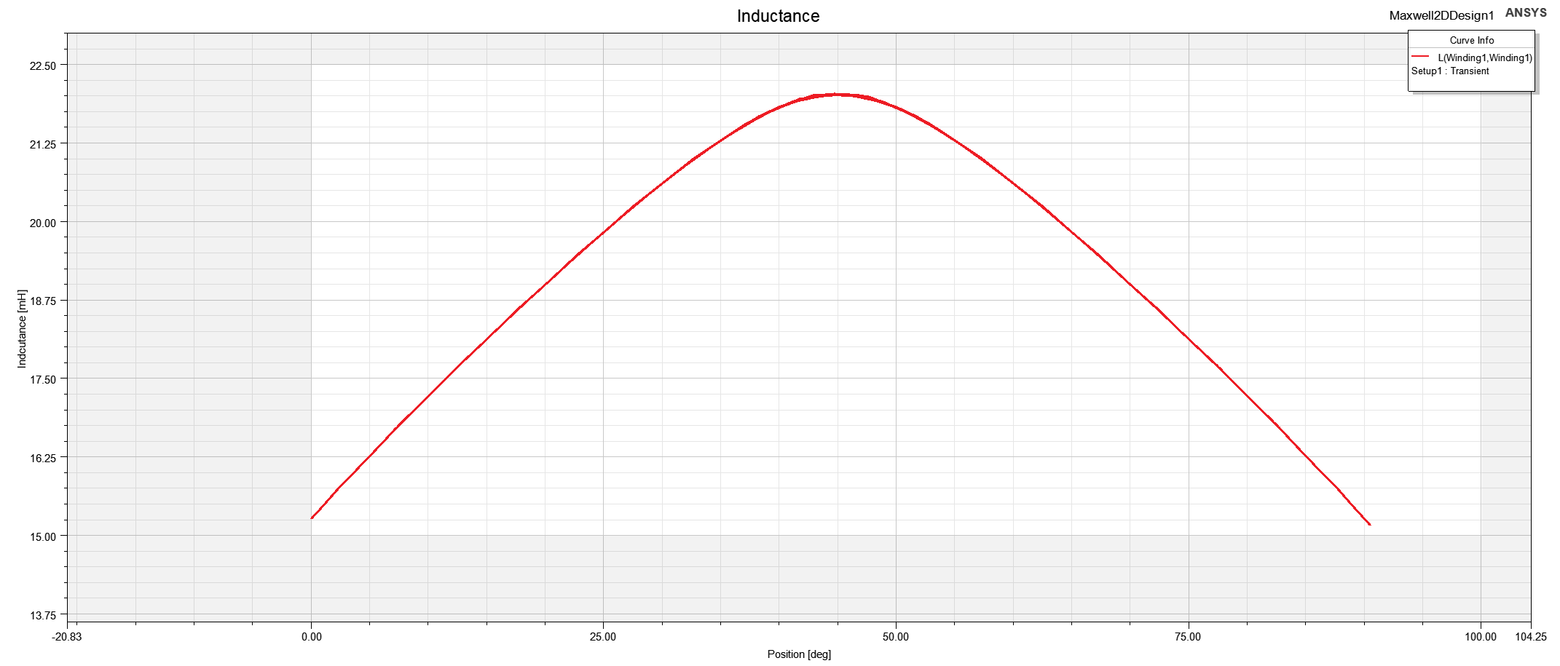

Figure 15: Inductance of the system with nonlinear materials at 3 positions of the rotor

## Torque

Using FEA, the torque values for the 3 points are obtained as shown in Figure 16.

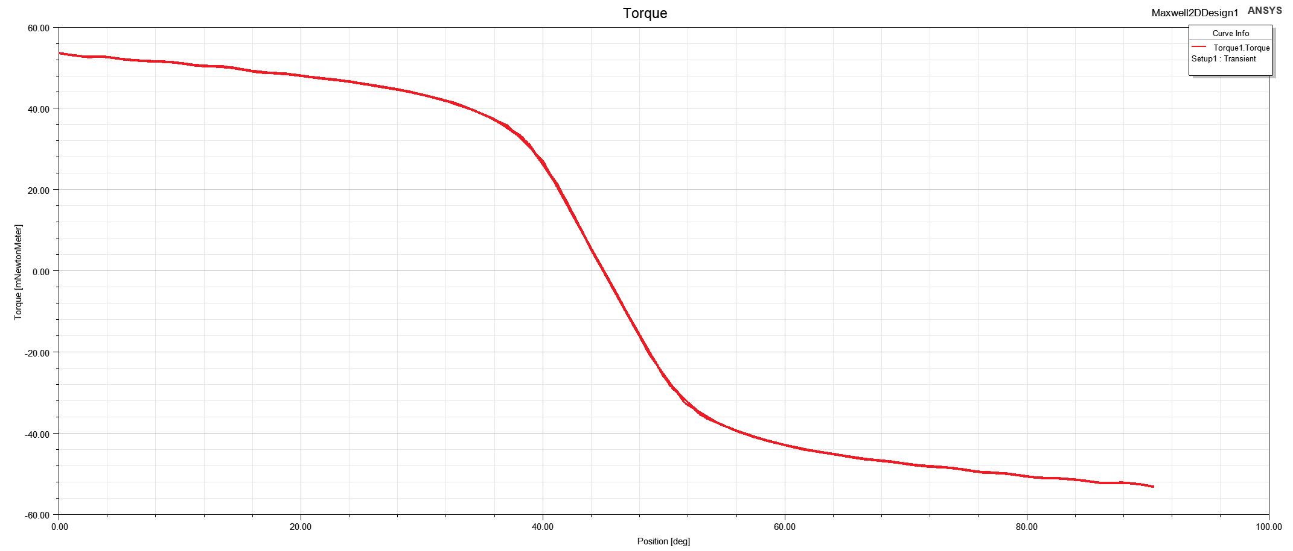

Figure 16: Torque of the system with nonlinear materials at 3 positions of the rotor

## Comparing the linear and nonlinear material characteristics

The simulation results differ from each other as the permeability of nonlinear material is smaller comparing the linear material. In our case, the core is not saturated as MMF is not high enough to go in saturating part.

# Control Method

Normally, to control a machine, the excitation shouldn’t be DC as it is only able to align the rotor to a position. In order to control a machine, an AC excitation should be implemented to the system and frequency, magnitude can be controlled to control speed and position of the system. This AC signal can be sinusoidal or square wave. Note that if the rotor position is totally aligned with stator part, even AC signal is not enough to control it as it cannot rotate the rotor.

The torque can be calculated using the equation (3). The excitation can be taken as sinusoidal waveform. Then, net torque can be calculated. In the formulized torque equation, the system depends on electrical frequency and rotor position. By adjusting the excitation waveforms, machine can be controlled.

# Conclusion

In this project, the analysis of a magnetic system with linear and nonlinear materials are performed. Firstly, analytical calculations are performed. Then, a 2D FEA model is created. Solving the FEA model with linear and nonlinear materials, the results are compared. Later, it is seen that there is little mismatch between analytical results and simulations as the number of samples are less and some assumptions are made. Finally, a control method is proposed for this system. The rotor cannot fully rotate as DC excitation is able to oscillate the rotor between 2 positions.

# Appendix

theta= [0 45 90 135 180 225 270 315 360 ]; %% degree

airgap= [0.5 1.5 2.5 1.5 0.5 1.5 2.5 1.5 0.5 ]; % mm

mu=4*pi*1e-7;

App= (2*pi*12.5*20)*76/360; %% mm^2

R=1e3*2*airgap/(mu*App);

N= 250;

L= N^2./R;

figure();

plot(theta,R,'LineWidth',2);

title('Effective reluctance according to position');

ylabel('Airgap(mm)');

xlabel('Position(Degree)');

grid on;

figure();

plot(theta,L,'LineWidth',2);

title('Effective inductance according to position');

ylabel('Airgap(mm)');

xlabel('Position(Degree)');

grid on;

%%

theta= [0 45 90 135 180 225 270 315];

dL= L(2:end)-L(1:end-1);

dL_theta= dL*4/pi;

T= 4.5*dL_theta;

figure();

plot(theta,T,'LineWidth',2);

title('Effective Torque according to position');

ylabel('Torque(N.m)');

xlabel('Position(Degree)');

grid on;