

MIDDLE EAST TECHNICAL UNIVERSITY

Electrical & Electronics Engineering

Simulation Project #1

EE 463

Huzeyfe Hintoğlu - 2093920



Introduction

In this project, we are asked to design and simulate Single Phase Diode rectifier with different load types, i.e. R, RL, RC. Also, THD analysis will be done for that circuit. For real applications, commercially available products will be chosen and analyzed as well.

Q1) Single Phase Diode rectifier is built for Turkish Grid (400Vl-l and 50 Hz) system. Since single phase diode rectifiers are connected to line to neutral, 230√2 ≈ 325Vpeak is applied to the system.

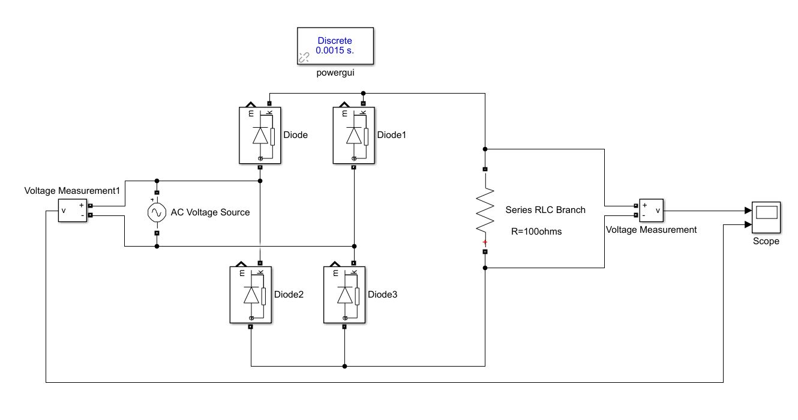

Figure 1: Single Phase Diode Rectifier with RLOAD = 100 Ω.

As seen from Fig.1, 4 diodes are used with load resistance 100Ω. At first, I was having trouble with simulation in Simulink because I did not add ‘powergui’ GUI into the simulation subblock. Powergui is used for simulating any Simulink model containing Simscape™ Electrical™ Specialized Power Systems blocks. It stores the equivalent Simulink circuit that represents the state-space equations of the model.

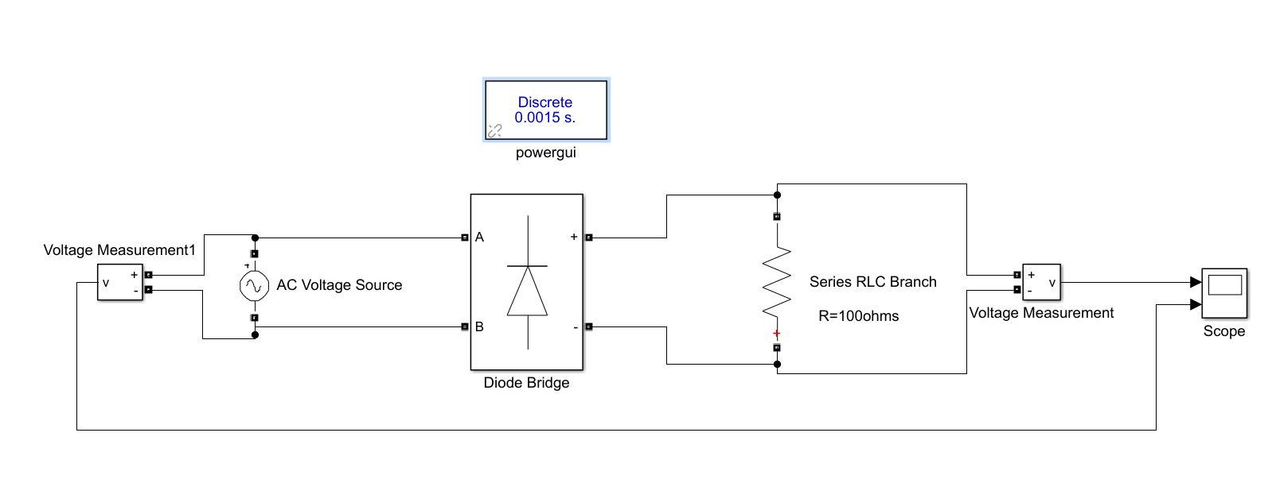

Figure 2: Single Phase Diode Rectifier with Diode Bridge and RLOAD = 100 Ω.

Later on, I tried using Diode Bridge Rectifier subblock for simplification purposes. The subblock is shown in Fig.2. The simulation results are same with the model in Fig.1.

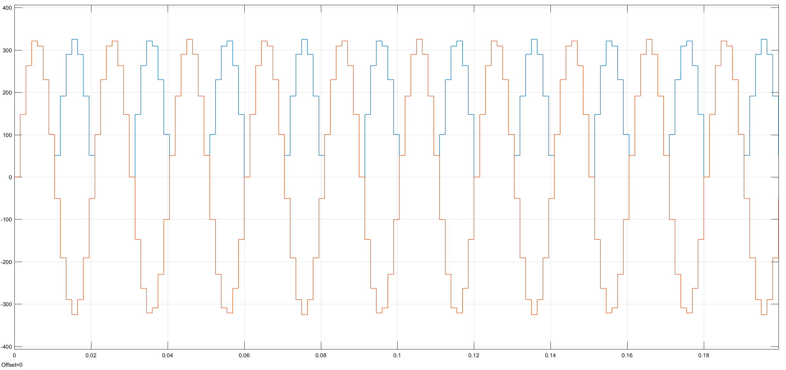

Figure 3: Input and output voltage waveforms of SPD Rectifier with step size 1.5mS

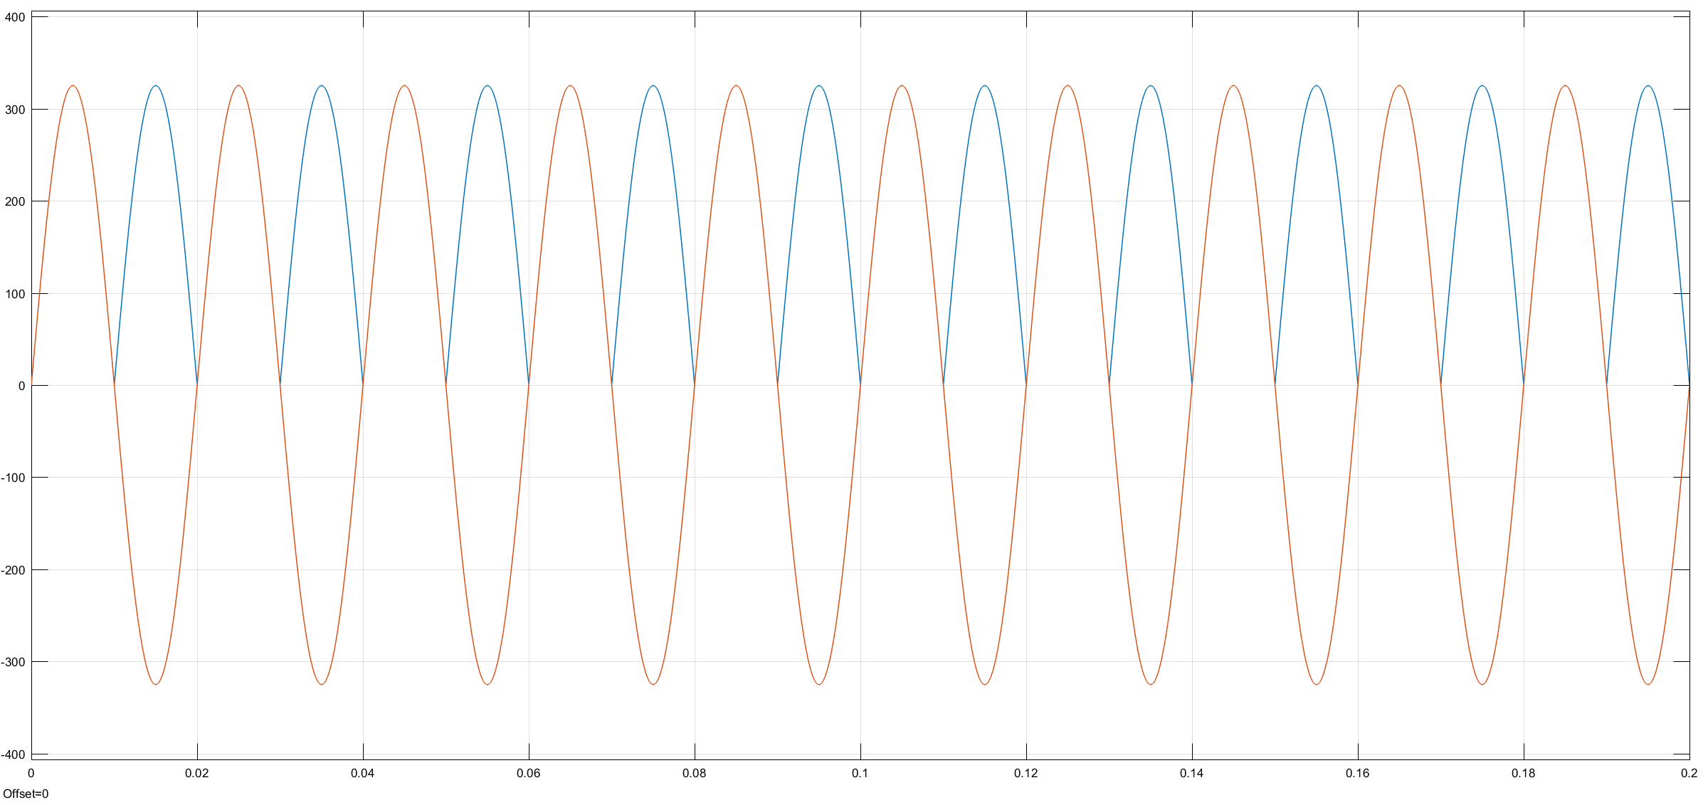

Figure 4: Input and output voltage waveforms of SPD Rectifier with step size 10µS

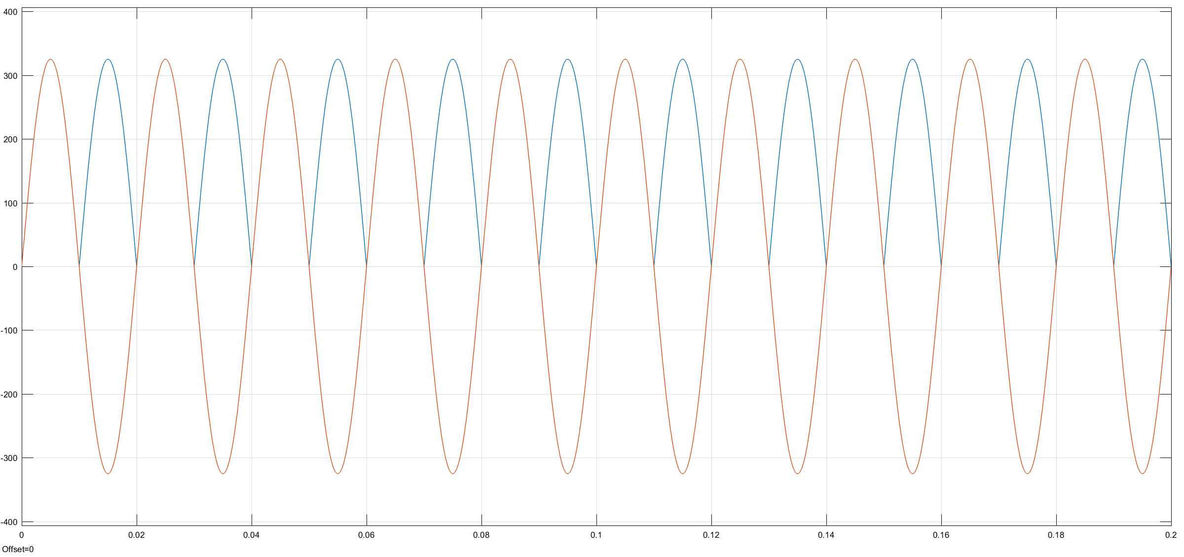

Figure 5: Input and output voltage waveforms of SPD Rectifier with step size 1µS

When we decrease the step size, the simulation results become more realistic because we are taking samples with narrow time intervals. This helps us to simulate the system very much a like to continuous system. It can be easily seen from Fig.3, Fig.4 and Fig.5 that decrease in the step size means more realistic analysis in continuous domain. The drawback here is microprocessor should work faster and we force it to work harder by increasing sampling rate.

Q2) The step size is taken as 1µS for this question.

2-1. Note that mean values are shown in the circuit schematic.

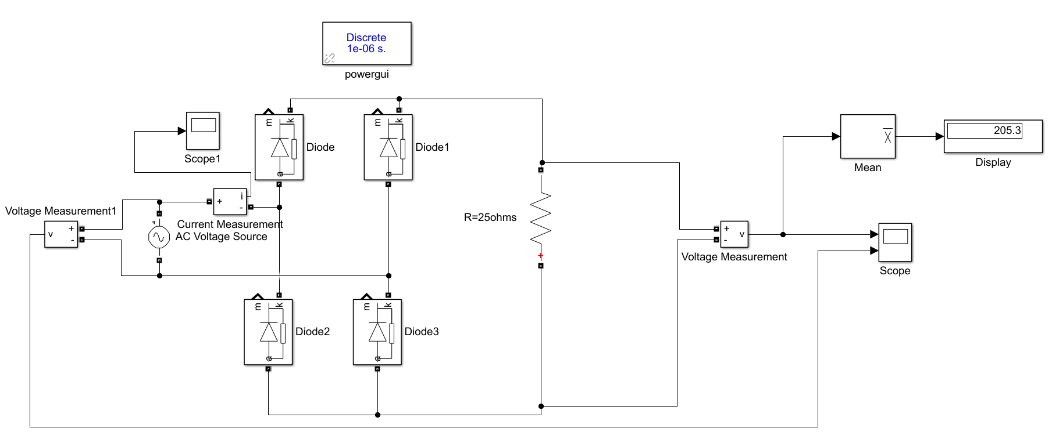

Figure 6: Circuit simulated for R Load

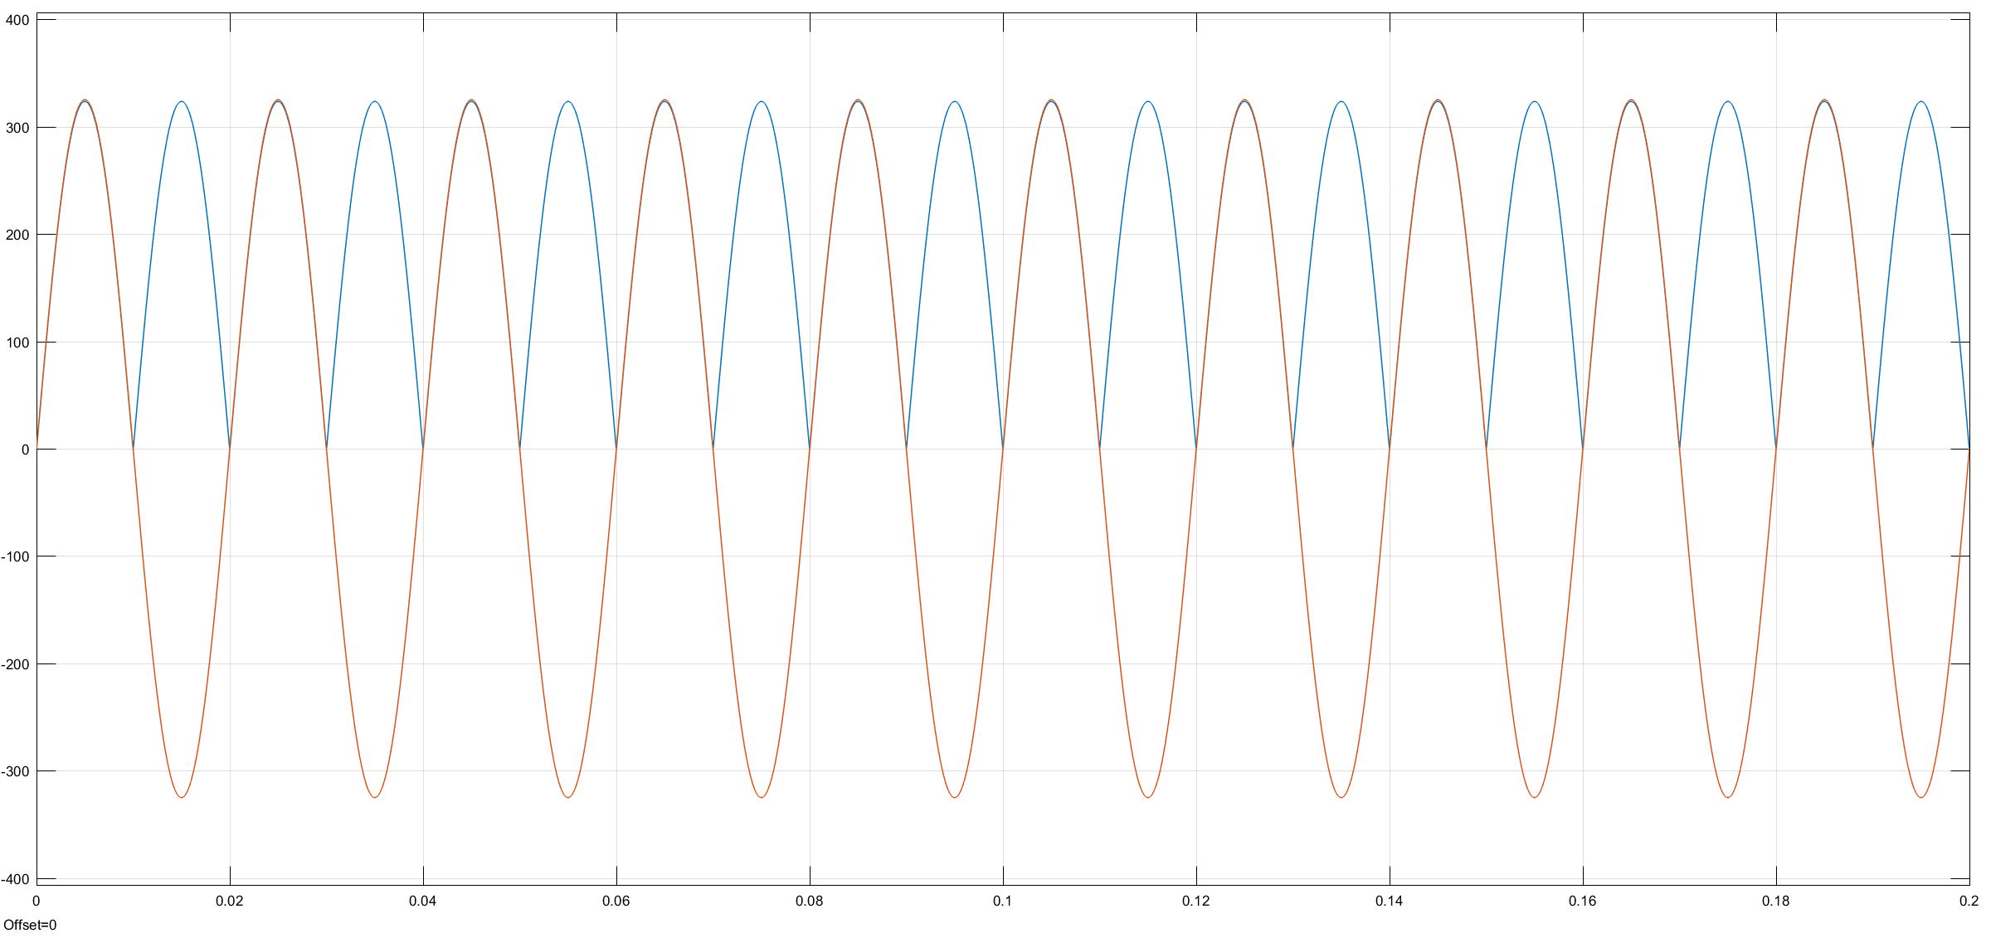

Figure 7: Input and output voltage waveforms of SPD Rectifier with RLOAD 25Ω.

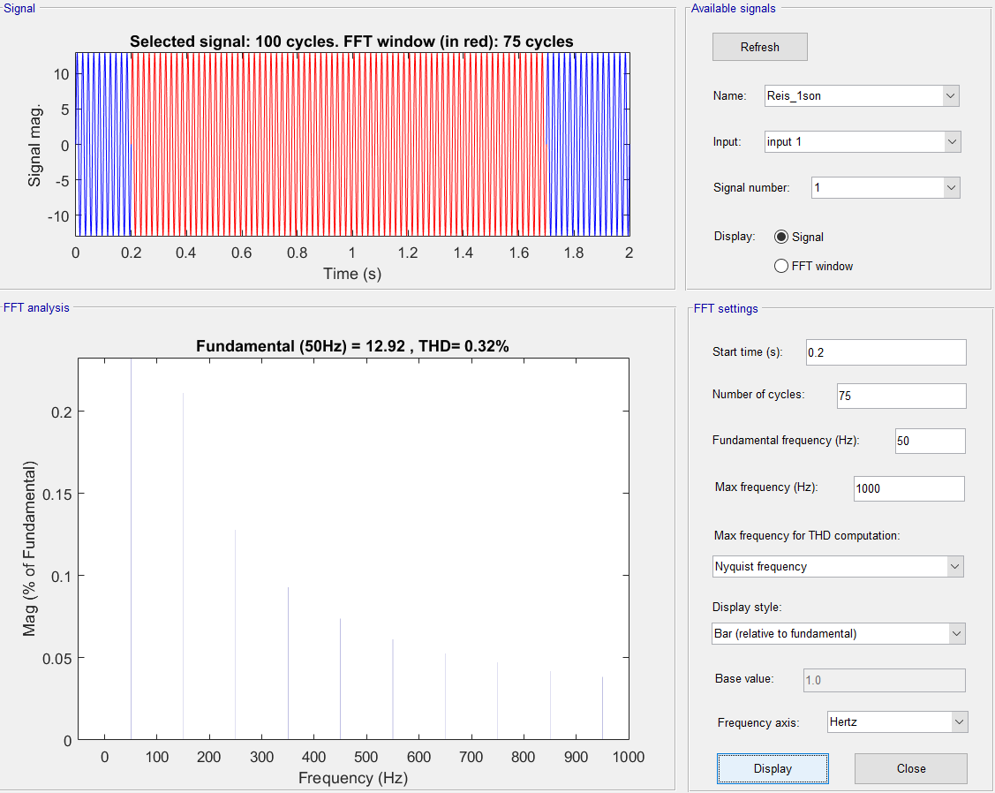

Figure 8: THD of SPD Rectifier

with RLOAD 25Ω.

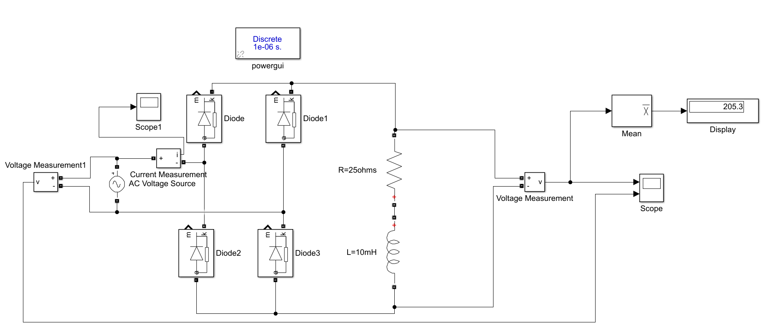

Figure 9: Circuit simulated for RLOAD 25Ω and LLOAD 10mH.

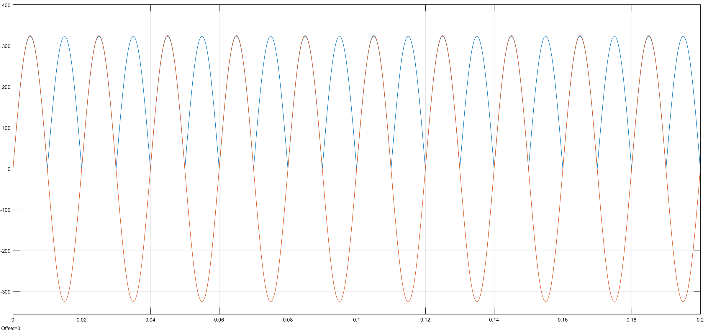

Figure 10: Input and output voltage waveforms of SPD Rectifier

with RLOAD 25Ω and LLOAD 10mH.

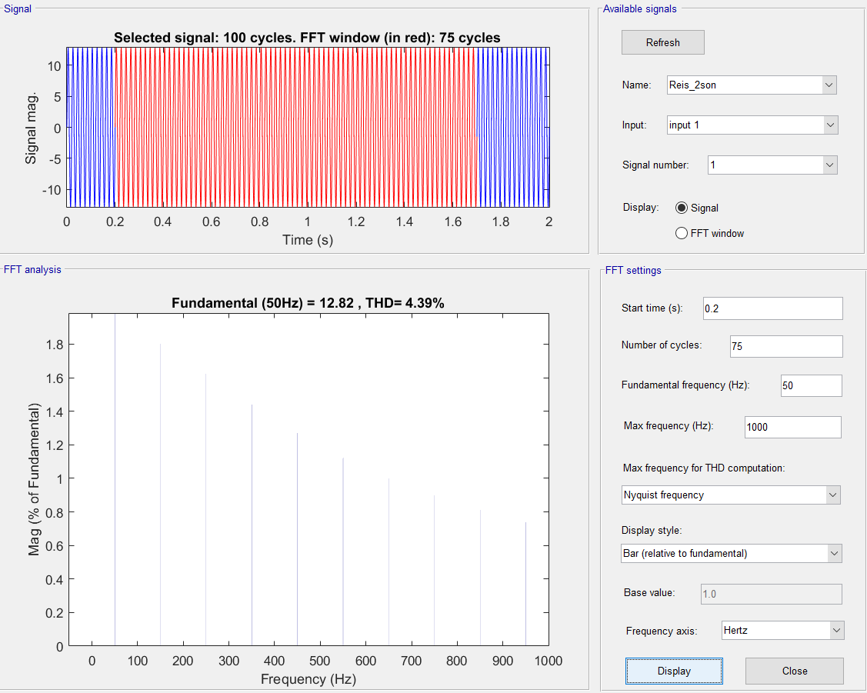

Figure 11: THD of SPD Rectifier

with RLOAD 25Ω and LLOAD 10mH.

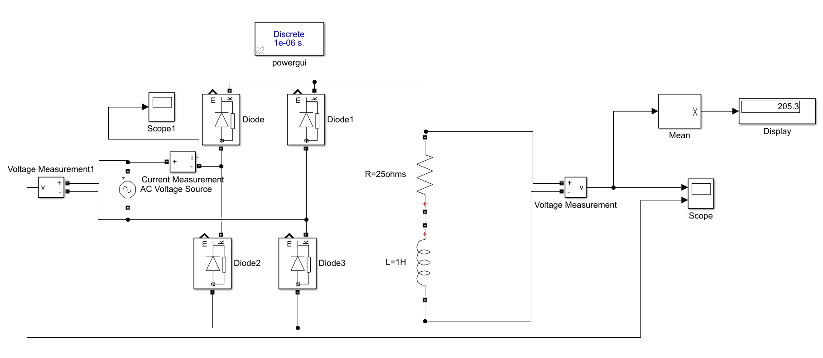

Figure 12: Circuit simulated for RLOAD 25Ω and LLOAD 1H.

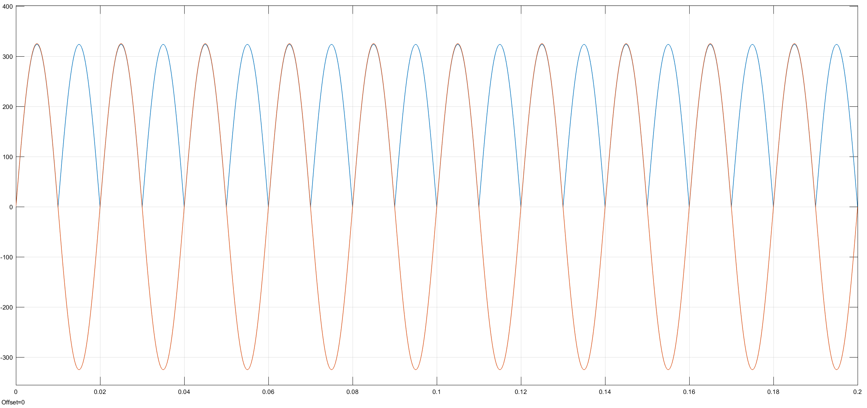

Figure 13: Input and output voltage waveforms of SPD Rectifier

with RLOAD 25Ω and LLOAD 1H.

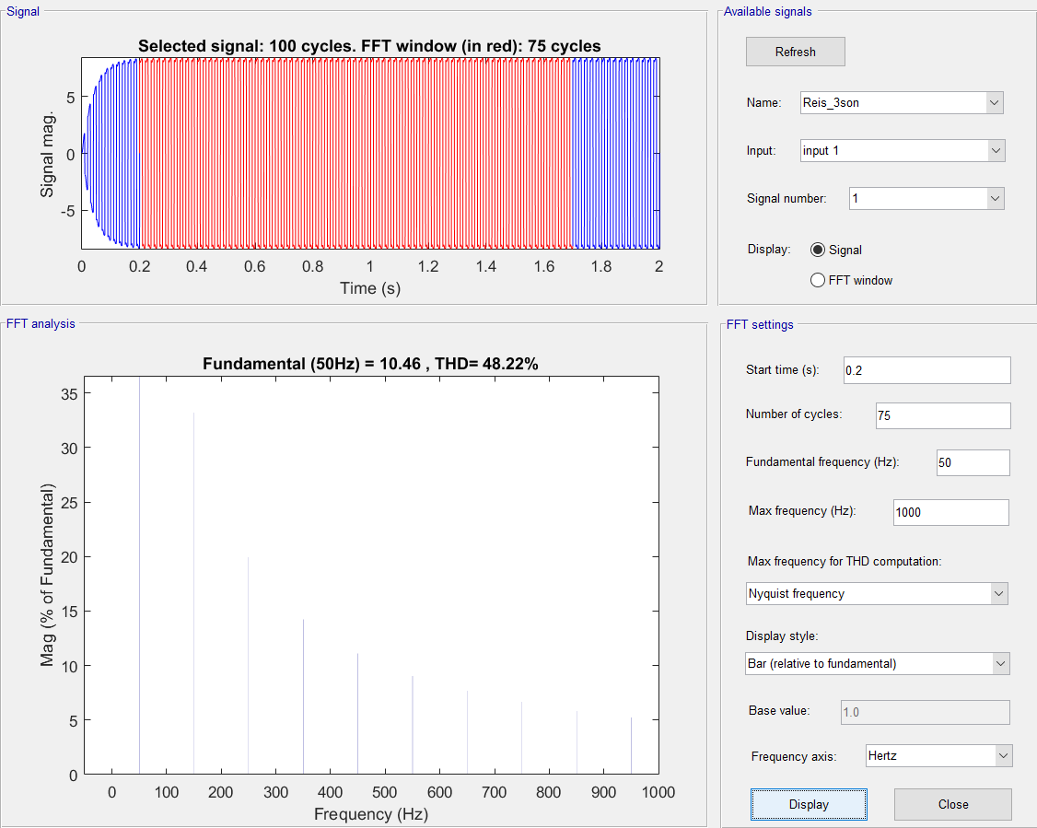

Figure 14: THD of SPD Rectifier

with RLOAD 25Ω and LLOAD 1H.

In conclusion, it is realized that THD of the line currents increases as we increase the inductance values at the load which implies when the current drawn from the load is more likely to ideal current source, THD increases. It can be also seen from the current waveforms that when we increase the inductance value, line current changes its form from sinusoidal to square. That is the reason why THD increases. Also, note that when we have 1H of inductance which is slightly higher value, we can behave load as ideal current source as in ideal it is infinity inductance. Hence, THD of 1H load is found as %48 which we also found in the lecture mathematically.

When the average values are considered, in all cases with different types of loads, VMEAN are same and equal to 205.3V as it is measured from the Mean block of the Simulink. It concludes that even the inductance value is increases, average voltage is not affected from it and it stays constant.

2.2-

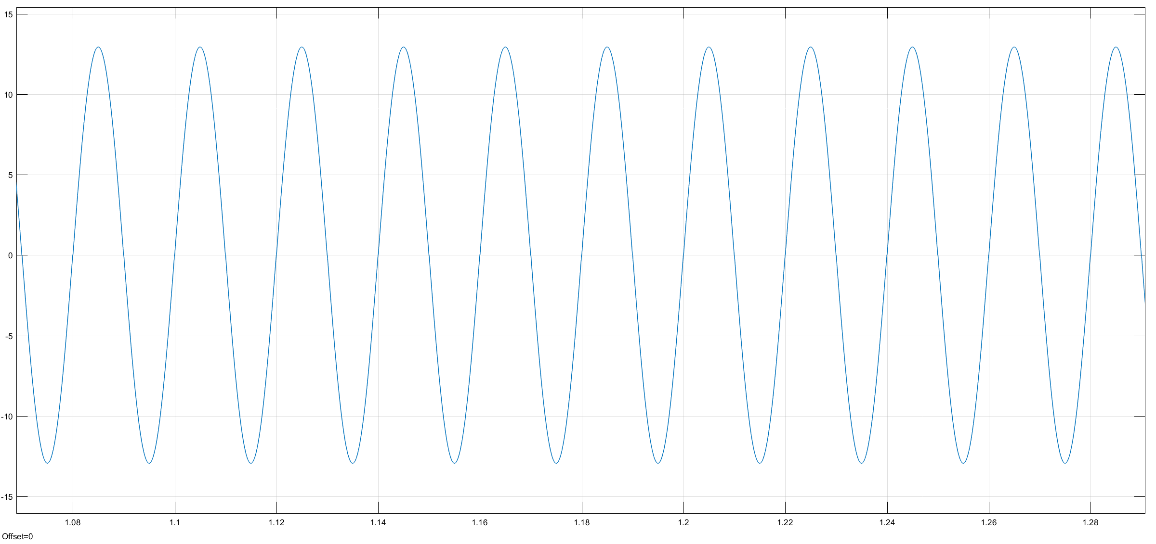

Figure 15: Current waveform on supply

Figure 13 illustrates the drawn main current waveform of rectifier. As seen from the Figure 13, I need to choose a diode which is capable of handling 13A and more in conduction and reverse action. Also, I need to consider breakdown voltage. As illustrated above in Figures, my diodes should be durable up to 325 V. Then, I searched on Digikey for discrete elements. I have chosen MUR1540G of On Semiconductor Company This diode is chosen with considerations of safety margins.

Some important features of diode:

* VRRM = 400V
* IF(AVG) = 15A
* VF =1.25V(typ)
* tRR =60nS
* TJ = -65°C to 175°C

Safety margin for VRRM is 75 V which is suitable, maybe same cases unnecessary to have these high value but it is OK. Forward current is 15A which is enough for system to operate properly but it is somehow critical value. Forward voltage drop is a bit high but we can tolerate it. Reverse recovery time is great and operating temperature is -65°C to 175°C which is a general number and it is good.

Price = $1.25

Link for diode:

<https://www.digikey.com/product-detail/en/on-semiconductor/MUR1540G/MUR1540GOS-ND/919901>

Let’s now choose a rectifier module for our system. Same considerations with the selection of diodes are valid. I have chosen GBPC15-04 of Vishay General Semiconductor.

Some important features of rectifier module:

* VRRM = 400V
* IF(AVG) = 15A
* VF =1.1V(typ)
* TJ = -55°C to 150°C
* CJ = 300pF

Safety margin for VRRM is 75V which is same as diodes. It is suitable for our project. Forward current is 15A which holds same reasons with the diode. Forward voltage drop is now less and it is good news. Operating temperature is -55°C to 150°C which is same as diode semiconductors and it is good. Junction capacitance is a low value which results in lower switching loss.

Price = $4.74

Link for rectifier module: <https://www.digikey.com/product-detail/en/vishay-semiconductor-diodes-division/GBPC1504-E4-51/GBPC1504-E4-51-ND/2139813>

As compared with 2 options, voltage and current values are chosen same as it is researched for that. In diodes, we have more voltage drop in every diode about 1.25 V and it is too much compared with the rectifier module. However, rectifier module is not able to work in the temperature range of diode used rectifier. There can also make more comparisons between two but this comparison is enough for our case.

2.3-

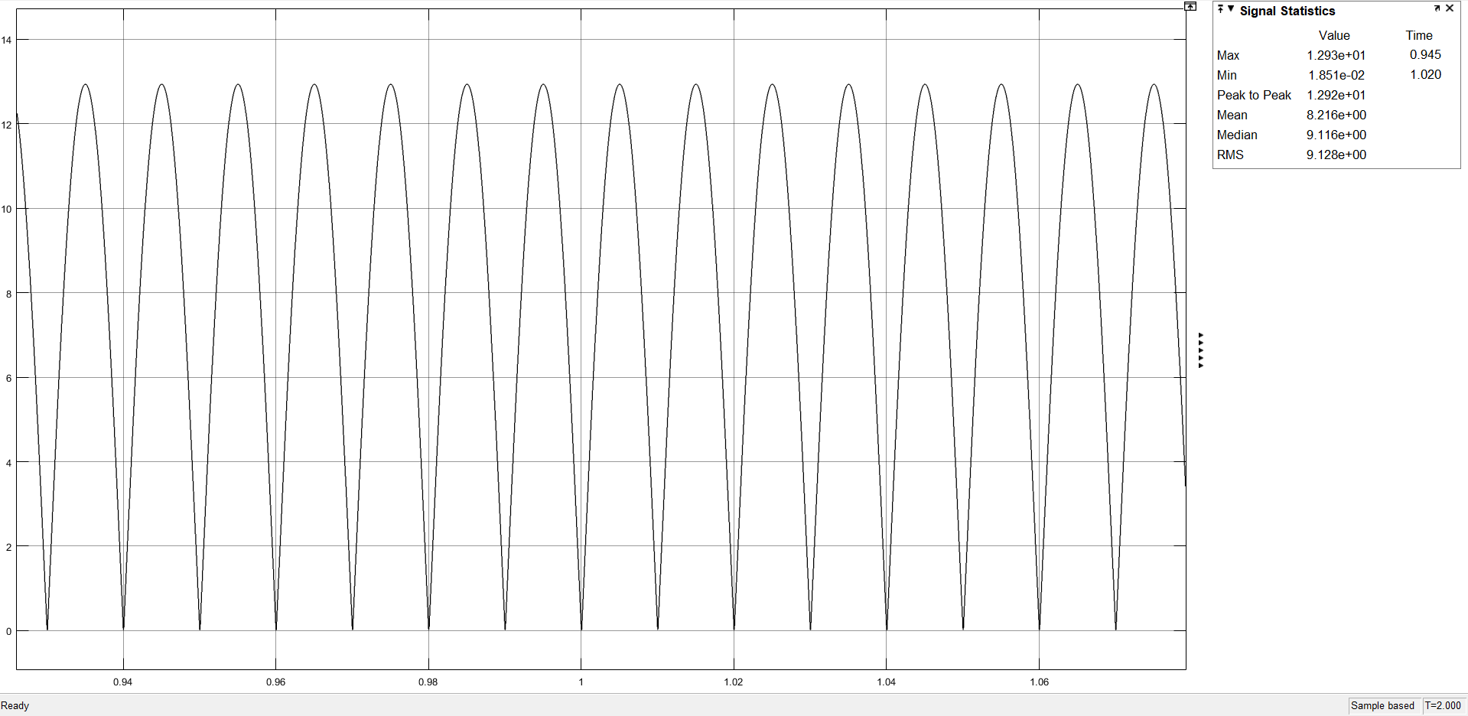

Figure 16: Output current waveform with RLOAD = 100Ω.

As shown in Figure 16, mean value of output current is about 8A. The calculation of smoothing capacitor is based on this information [1].

(1)

From equation (1),

Note it is said in [1] that the main advantages of a full-wave bridge rectifier is that it has a smaller AC ripple value for a given load and a smaller reservoir or smoothing capacitor than an equivalent half-wave rectifier. Therefore, the fundamental frequency of the ripple voltage is twice that of the AC supply frequency (100Hz) where for the half-wave rectifier it is exactly equal to the supply frequency (50Hz). Hence, frequency taken as 100Hz. Ripple is %20 of average voltage value. As a result, output capacitor is 2mF = 2000µF.

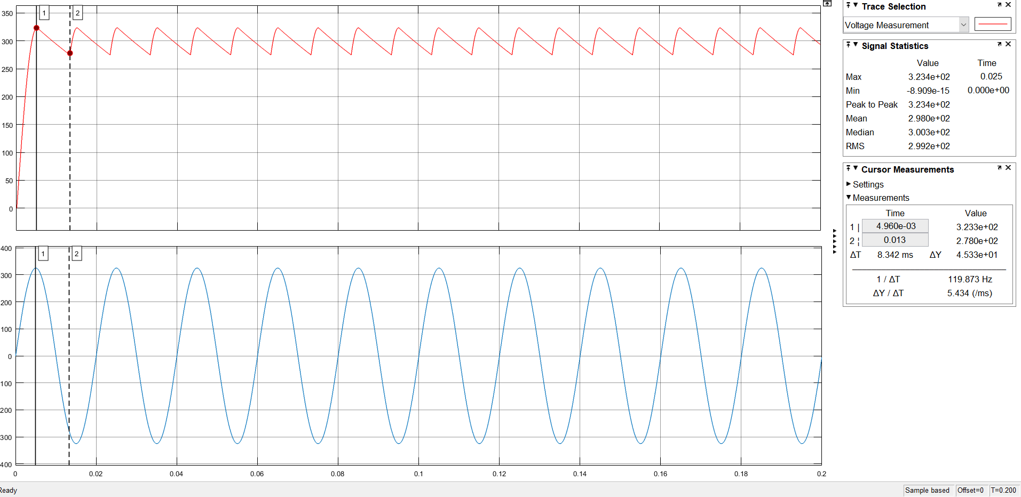

Figure 17: Output voltage with smoothing capacitor and input voltage waveform.

As seen in Figure 17, VAVG = 300V with 2000µF capacitor. VP-P,ripple= 45V. Hence, VP-P,ripple is %20. It is %15. Therefore, we can select a lower valued capacitor but this one makes our job done. Let’s now choose a commercial diode.

ALS70H202KE400-ND of KEMET is chosen as a bulk capacitor. The features of it:

VRated =400V

C = 2000µF

Aluminum Electrolytic Capacitor

Price: $18

This capacitor is highly reliable and it has high capacitance and voltage rating. That is why it is a little bit expensive but it is suitable for our need.

Link for capacitor: <https://www.digikey.com/product-detail/en/kemet/ALS70H202KE400/ALS70H202KE400-ND/6871053>

2.4-

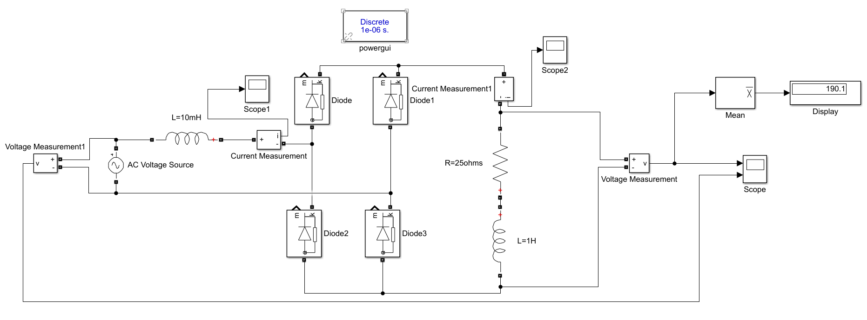

Figure 18: Simulated circuit

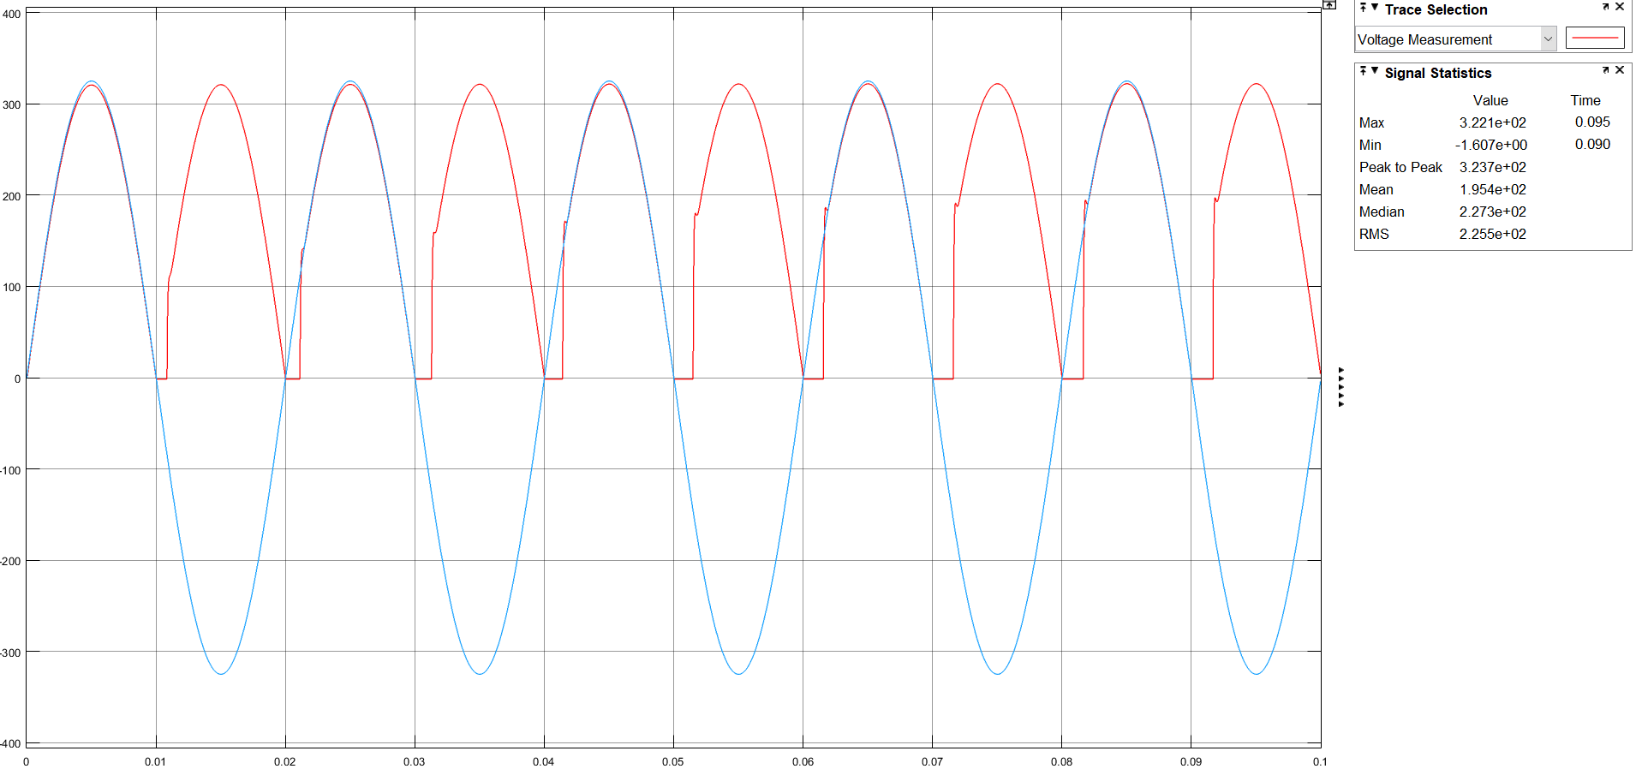

Figure 19: Input and output voltage waveforms of SPD Rectifier

with RLOAD 25Ω and LLOAD 1H and LS 10mS.

As seen from figure 18 and 19, we have seen the effect of commutation on the grid side. Voltage waveform is distorted with the effect of commutation which resulted in decrease in VMEAN. This is because the inductor cannot charge or discharge suddenly. It requires some time for that. At this period, there is a moment in which 4 diodes are one and output is shorted. That is the reason we see 0 Voltage at the output during commutation.

2.5-

References

[1] Bridge Rectifier Ripple Voltage. Retrieved from <https://www.electronics-tutorials.ws/diode/diode_6.html>