

MIDDLE EAST TECHNICAL UNIVERSITY

Electrical & Electronics Engineering

Simulation Project #2

EE 463

Huzeyfe Hintoğlu – 2093920

Enes Ayaz – 2093318



Table of Contents

Introduction 3

Question-1) Controlled Rectifiers 3

a) 3

b) 6

c) 9

Q2) DC Motor Drive 10

a) 10

b) 10

c) 11

Q3) 12-Pulse Series Full-wave Rectifier 14

a) 14

b) 15

Conclusion 18

References 19

# Introduction

In this project, we are asked to design and simulate controlled rectifiers and DC motor drive. The aim of the project is to observe the differences, advantages and disadvantages of half-controlled, fully controlled rectifiers and effects of the freewheeling diodes on each topology. In this document, related theoretical calculations are illustrated and the simulations are done in Simulink.

# Question-1) Controlled Rectifiers

## a)

Average Output Voltage

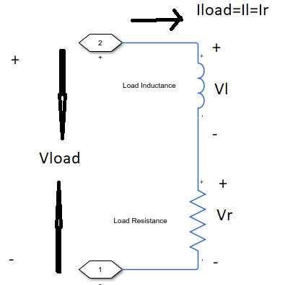

Figure 1 Load Voltage and Current Diagram

As can be seen at Figure 1, Load voltage can be found with respect to Load current, inductance and resistance value. However, we cannot know load current with respect to time. Only average value of current is given, ripple of load current is not known. So, Average voltage of load should be found by using only resistance value and average current of load. In addition, there is some assumption that voltage drop due to commutation is calculated average current, not minimum current.

If required analytical explanation,



Equation 1

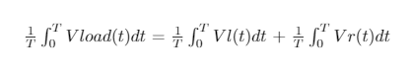

Equation 2

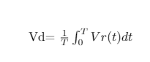

Equation 3

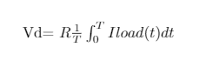

Equation 4

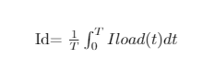

Equation 5

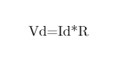

Equation 6

Equation 1 shows that KVL is valid for load. Series RL circuit has common current. For the time independent formulation, we take a mean value of each side of equation like Equation 2. For inductor, second voltage law says that mean value of inductor voltage must be zero. So, we can reduce the equation like Equation 3. Then, with property of integral, average value of voltage is written as kind of average current. Finally, Equation 6 is obtained and it indicates that average voltage of output is independent from inductance.

Average output voltage is 160 V for resistor with 4 Ω and this calculation is independent from source side. Thus, both of circuits, fully and half controlled, have same average voltage. Average current gives us the voltage drop from commutation and firing angle can be found by using output voltages and input voltages.

Firing Angle Calculation of Fully Controlled Rectifier

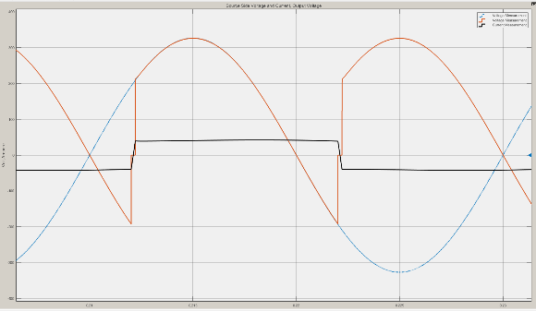

Figure 2: Input current and voltage waveforms of fully controlled rectifier

As can be seen Figure 2, there is a commutation at transition between thyristors. It reduces average voltage of rectifier. For the calculation of average voltage, it cannot be ignored.

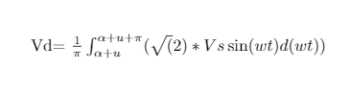

Equation 7

Equation 7 is used for calculate average output voltage of rectifier. The equation contains commutation time.

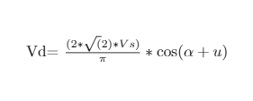

Equation 8

Equation 8 is deducted from equation 7. Average voltage depends on both firing angle and commutation time.

Commutation time depends on line inductance. It balances that current changes with respect to time. It is found by using voltage seconds law. (Equation 9). [1]

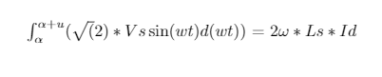

Equation 9

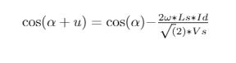

Equation 10

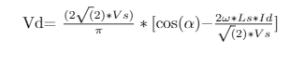

Equation 11

Then, average voltage is written with only firing angle dependency. It is not required commutation time to find firing angle

If numerical values are placed and firing angle that provides required average current is found 36.1 degree. Simulation are adjusted to 36.1° firing angle.

Firing Angle Calculation of Half Controlled Rectifier

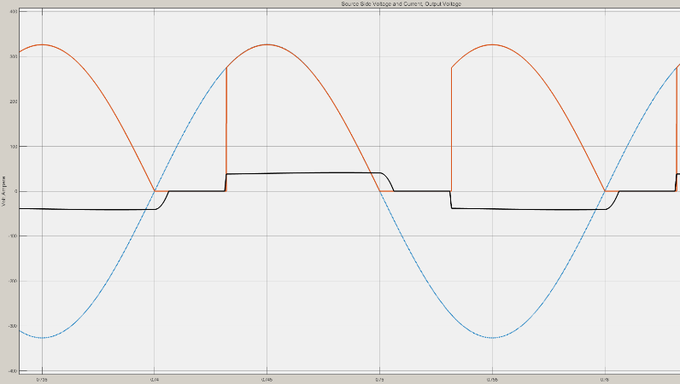

Figure 3: Input current and voltage waveforms of half controlled rectifier

As can be seen Figure 3 output voltage cannot pass negative cycle because of diodes. So, commutation occurs for transition between -Id and zero or zero and Id.

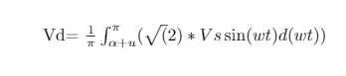

Equation 12

Equation 12 shows that average output with respect to firing angle and commutation time. The equation is reduced to Equation 13.

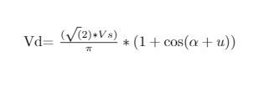

Equation 13

Commutation time depends on line inductance, current and grid frequency. Then, Equation 14 is written to calculate commutation and it is written as Equation 15.

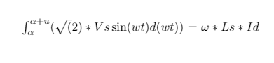

Equation 14

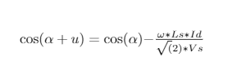

Equation 15

Then, average output voltage can be calculated as only firing angle variable if the circuit parameters and average current are known.

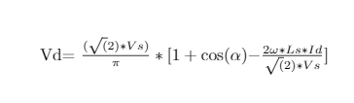

Equation 16

From equation 16, only unknown is firing angle. By placing other parameters numerical, firing angle is drawn as 56.06 degree. Simulation are adjusted to give 56.06° firing angle.

## b)

Simulation Results of Fully Controlled Rectifier

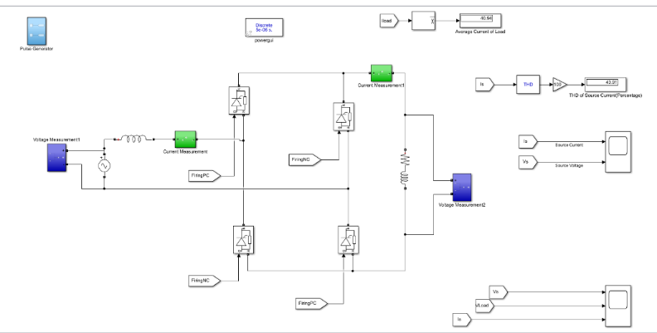

Figure 4: The simulation setup for fully controlled rectifier

All circuit diagram shown Figure 4. The circuit has some subsystem that provides firing angles, measurement of currents, voltages and calculation of mean value and THD.

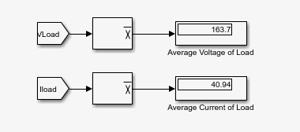

Figure 5: Average output voltage and current values

Average voltage and current at Figure 5 are almost the same as analytical solution. In simulation, thyristors have snubber circuits and it can change result in small size. In addition, we can solve analytically with assumption that commutation occurs at the average current level.

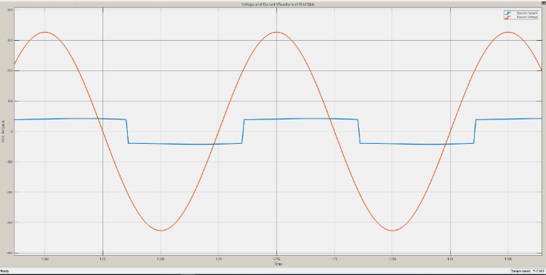

Figure 6: Input current and input voltage waveforms of fully controlled rectifier

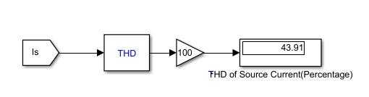

Figure 7: THD of line current

As expected, there is a phase difference at line current and line voltages. The circuit works on rectifier mode because of firing angle is smaller than 90 degrees. The phase difference depends on firing angle and commutation time.



Equation 17

THD is smaller than 48% because commutation makes the current smoother than square wave.

Simulation Results of Half Controlled Rectifier

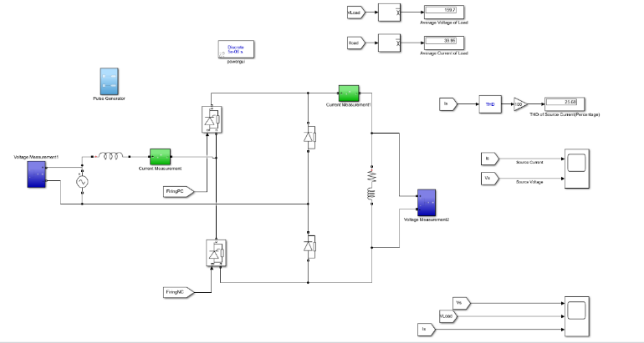

Figure 8: The simulation setup for half controlled rectifier

There is a half-controlled rectifier at Figure 8. It is two ways to create these circuit. One of them is using one diode and 4 thyristors. Other one is established by 2 diodes and 2 thyristors. Second one is used for this setup.

There are some subsystems to measure the required voltage and current and calculation about them.

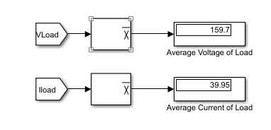

Figure 9: Average output voltage and current values

Figure 9 represents that our analytical calculation is true because as expected, the average current is like 40A. Small changes are related to snubber circuit among diodes and thyristors. For the commutation, average current is taken to calculate analytically by assumption.

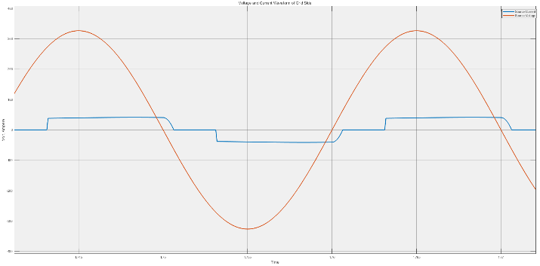

Figure 10: Input current and input voltage waveforms of half controlled rectifier

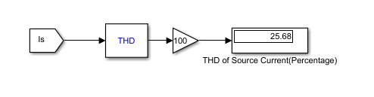

Figure 11: THD of line current

Current waveform is related to diodes. There is no negative current at output voltage and diodes provides that current is circulated. This behavior reduces the THD of line current because the waveform is much smoother.

The phase difference between line current and line voltage depends on firing angle. (Equation 18)



Equation 18

## c)

Fully controlled thyristor rectifier is used for one directional current at positive or negative polarity of voltage. Then, it can be used as rectifying or inverting mode by adjusting firing angle. However, it is not useful because of less average output voltage and worse power factor. The rectifier operates at inverting mode with the help of not firing thyristor. This causes at negative voltage is taken as output and decreases average output voltage. So, the circuit can be improved by connect freewheeling diode. This diode does not let output to be negative. Then, it increases the average output. The rectifier is called as half-controlled rectifier. The rectifier cannot be used in inverting mode.

# Q2) DC Motor Drive

## a)

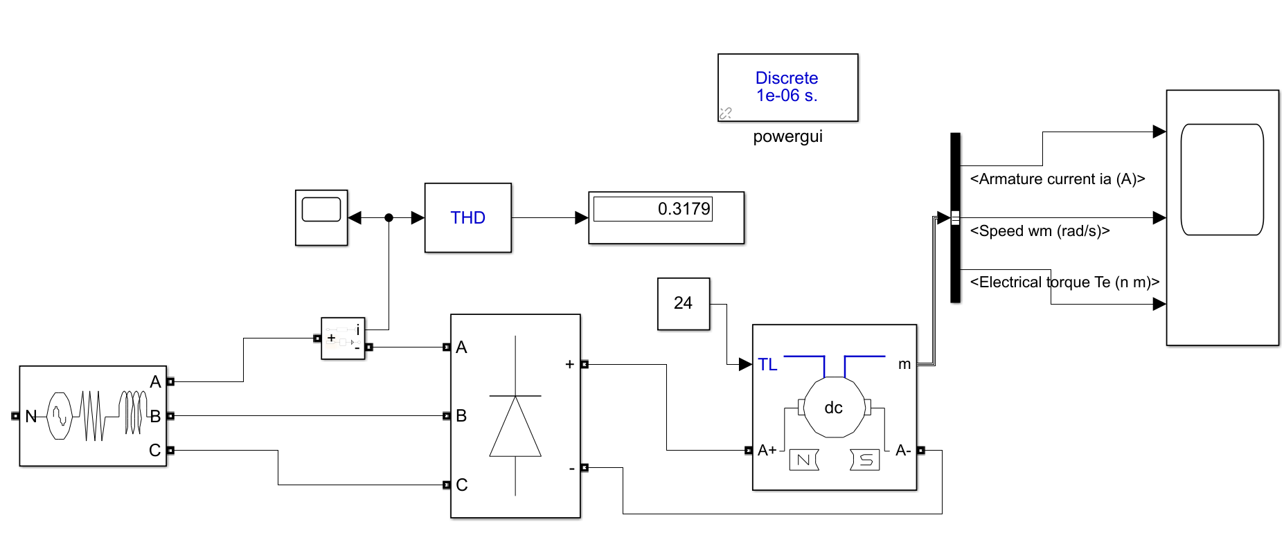

Figure 12: Circuit simulated DC motor drive

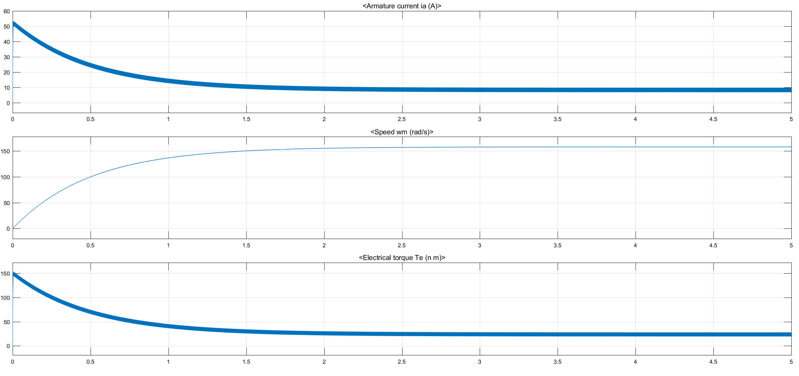

Figure 13: Armature Current, Speed and Electrical Torque waveforms

## b)

Note that THD is calculated and displayed on Figure 12 as %31.8

We want to drive our DC motor with a constant DC voltage. However, we have 3Ɵ full-bridge rectifier for DC rectification. As known, 3Ɵ full-bridge rectifier is the reason we have ripple at the output voltage, current and thus torque waveforms.

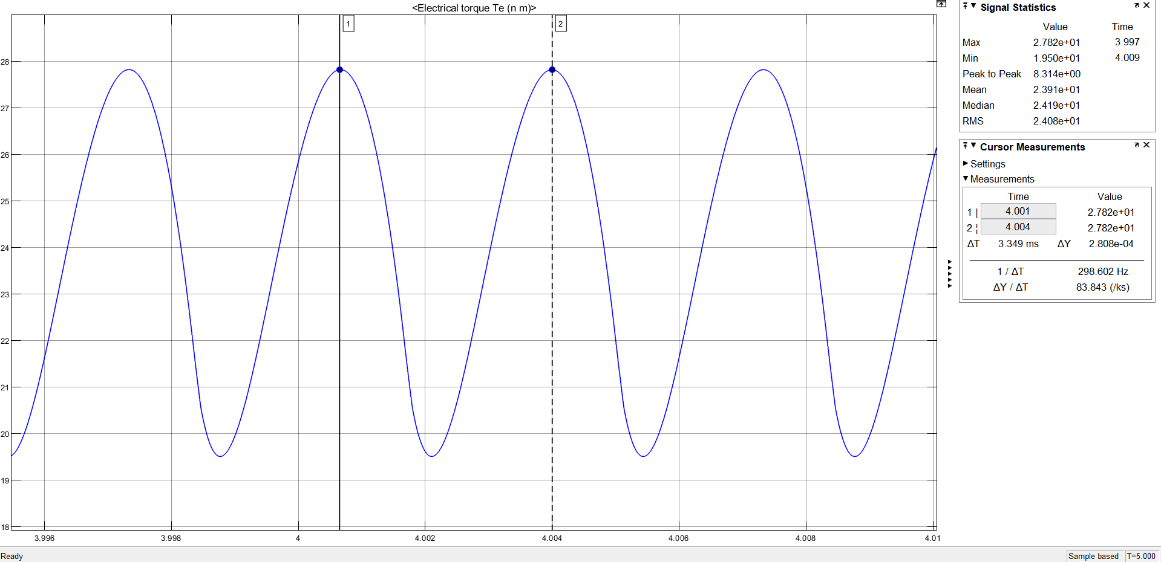

Figure 14: Electrical Torque waveform

In Figure 14, torque waveform is illustrated at steady state. When the cursor measurements are done, we see that torque waveform has 299Hz frequency. We expect it to be happen because at the output of 3Ɵ full-bridge rectifier, we have 6 pulses in each cycle which corresponds to 50Hz*6=300Hz.

In magnitude case, the ripple is considerably high which oscillates between 19.5Nm to 27.5Nm where the average is 24Nm. The ripple is more than %10. In practice, it may cause problems and it should be decreased to a reasonable value.

## c)

To reduce the ripple, we can connect a parallel capacitor to load or connect a series inductor to load. By this way, we can reduce the output torque ripple by smoothing the current waveform and hence torque.

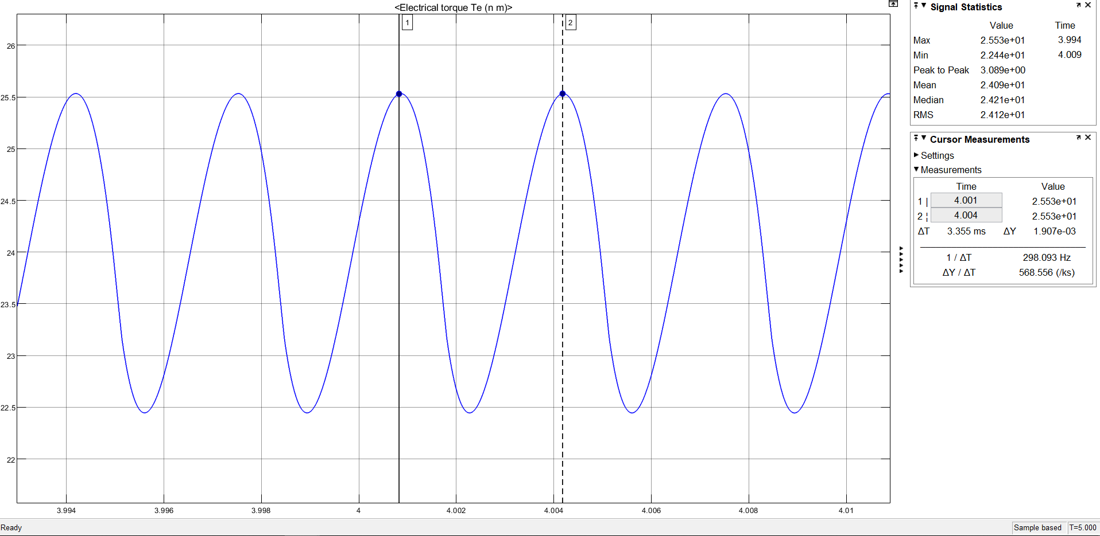

Figure 15: Electrical Torque waveform with L = 0.02H

As shown in Figure 15, a series connection of L=0.02H reduces torque ripple about %6.

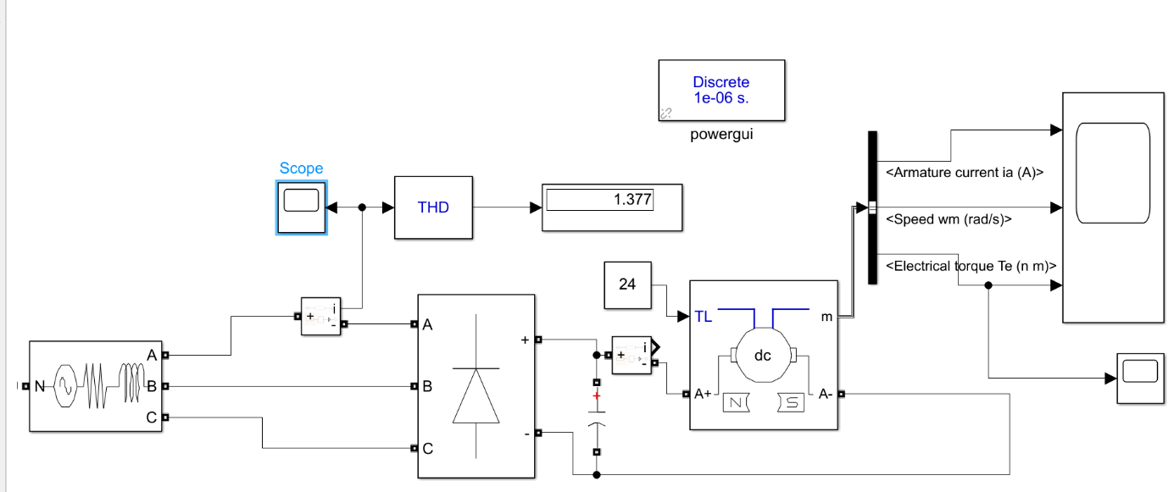

Figure 16: Circuit simulated with parallel capacitor of 1mF

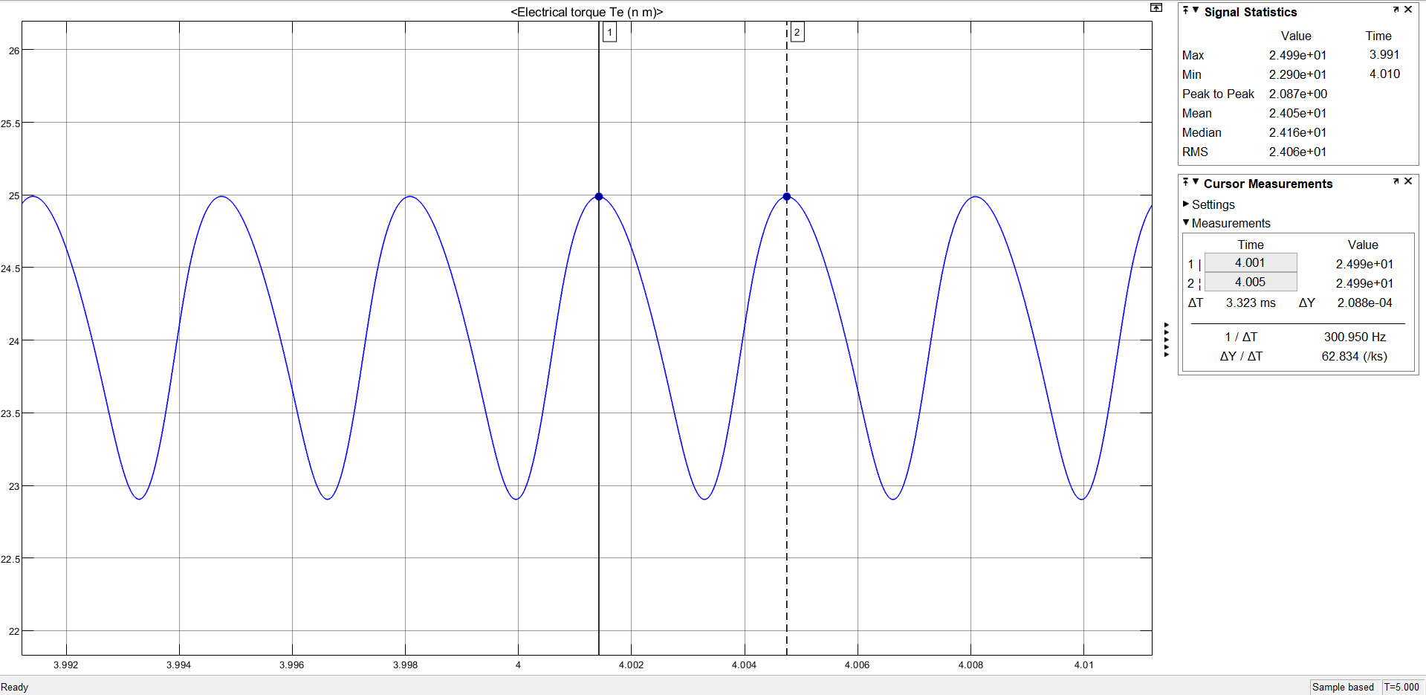

Figure 17: Electrical Torque waveform with C = 1mF

As shown in Figure 17, a parallel connection of C = 1mF reduces torque ripple about %4.

Although adding a parallel capacitor decreases the ripple at the output, it increases the THD to %137 which is shown in circuit schematic illustrated in Figure 16.

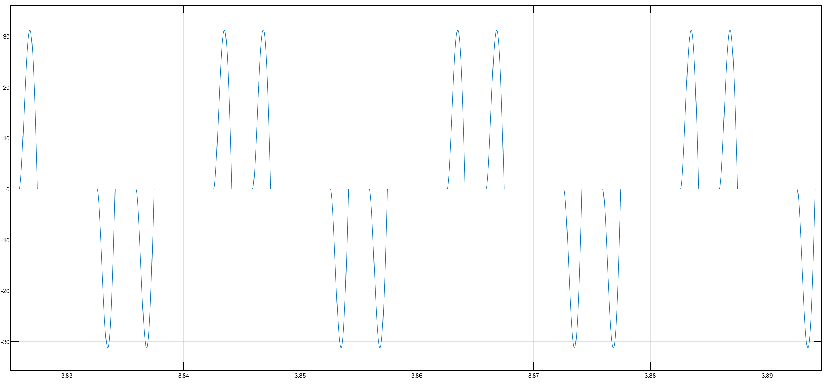

Figure 18: Current waveform when C=1mF is connected

Current waveform of the source side is illustrated in Figure 18. We do not prefer parallel capacitor connection because it increases the THD and current waveform is not desirable.

By connecting an extra circuit component, we can reduce the ripple torque which enables us to have more reliable torque characteristics for motor. Having smoother waveform is also important for mechanical concerns. If we have too much ripple at torque output, shaft of motor cannot be durable comparing with less ripple torque case.

What we trade-off here is adding an extra component to circuit. This increases the conduction losses. Also, for higher voltage values as in our case, we need to implement high voltage and current capacity elements which is directly related with the sizes of components. Having bigger components is hard for implementing circuit into board. Furthermore, it is harder to cool the system with bigger sized components. THD consideration and current waveforms are stated before.

d. Note that following values are calculated at steady state. Current, speed and voltage values are found from graphical analysis on Simulink. All values are approximated accordingly.

Input power = 3*Single-Ɵ Power input = 3*230V*7A = 4830W

Output mechanical power = T*w = 24Nm*164.5rad/sec = 3948W

Drive efficiency = 3948W/4830W = %82

For loss calculations;

Power on Source Side = 4764W

Loss on Source Side = 4830W-4764W = 66W

Output Power of Rectifier = 4738W

Then, loss on Rectifier = 4764W- 4738W = 26W

Armature loss = Output Power of Rectifier – Output Mechanical Power

= 4738W-3948W =790W

Diagram 1: Distribution of Power Dissipation on the motor

# Q3) 12-Pulse Series Full-wave Rectifier

## a)

It is called as ‘Twelve-Pulse Rectifier’. This topology is used for improving dc output over single phase rectifier. Output has less harmonics, the frequency of output is 6 times of input. In addition, there are two transformers, one of them Y-Delta, other one is Y-Y. Y-Delta is required to create a 30° phase shift. So, six phases are created by using only 2 transformers and three phase sources.

DC output of the 12- pulse rectifier is the sum of 2 rectifying unit, one is 30 degree shifted.



Equation 19

For diode rectifier, firing angle is zero. Equation 19 shows that average output voltage is bigger than full bridge diode rectifier. [2]

Kinds of this topology are used in the high voltage DC application. Output level is increasing and ripple is decreasing without using capacitance and inductance filter. For the HV DC rectifying, filtering to output requires more cost components like capacitor and inductor.

The multi-phase converters like 12 pulse branch single-way and bridge rectifier. Some converters are 3 phase single way, 6 phase single phase, 6 pulse bridge, 24 pulse and 48 pulse bridge rectifiers. These rectifiers can be compared in respect to average output level, output ripple frequency and output ripple. Number of phases increases the output voltage and decreases the ripple and ripple frequency. In addition, bridge rectifiers are better than single way rectifiers with respect to output voltage and ripple value if the phase numbers are equal.

## b)

Simulation Setup and results for 12-Pulse Rectifier

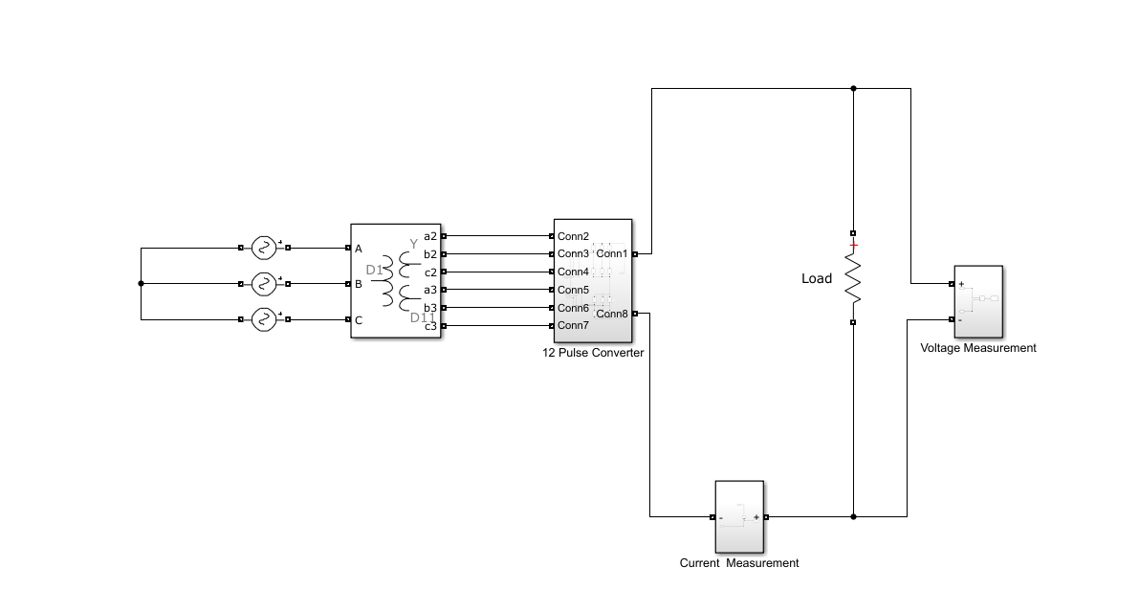

Figure 19: Circuit schematic of 12-pulse rectifier

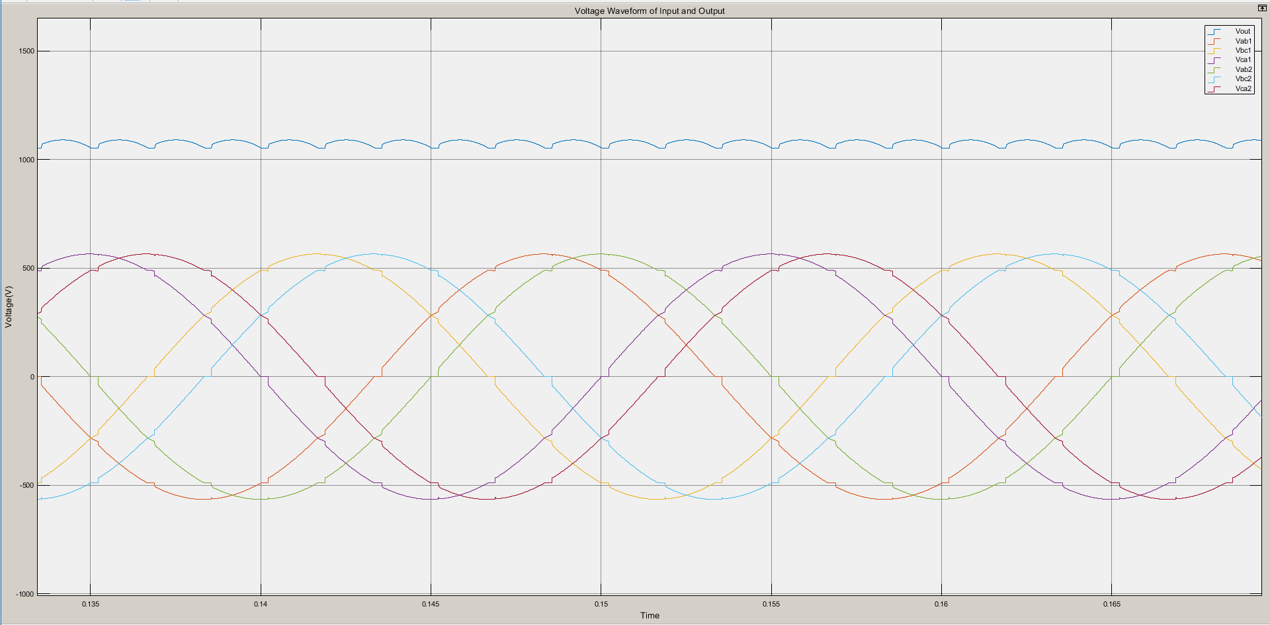

Figure 20: Input and output voltage waveforms of 12-pulse rectifier

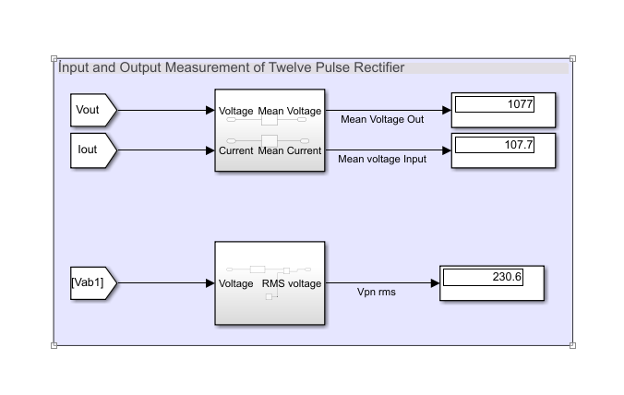

Figure 21: Input,output voltage and current values of 12-pulse rectifier

Simulation Setup and results for Full Bridge Rectifier

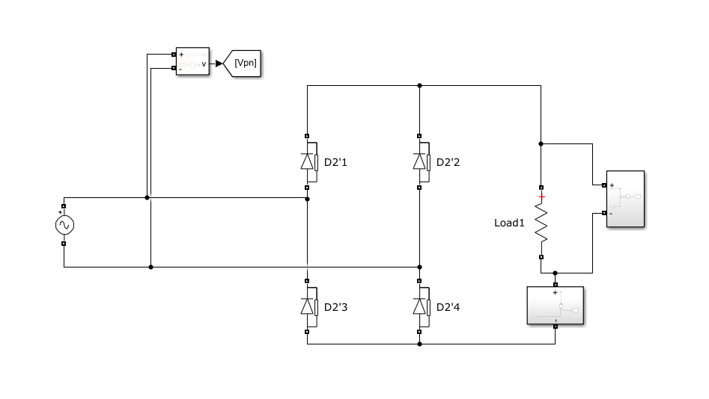

Figure 22: Circuit schematic of full-bridge rectifier

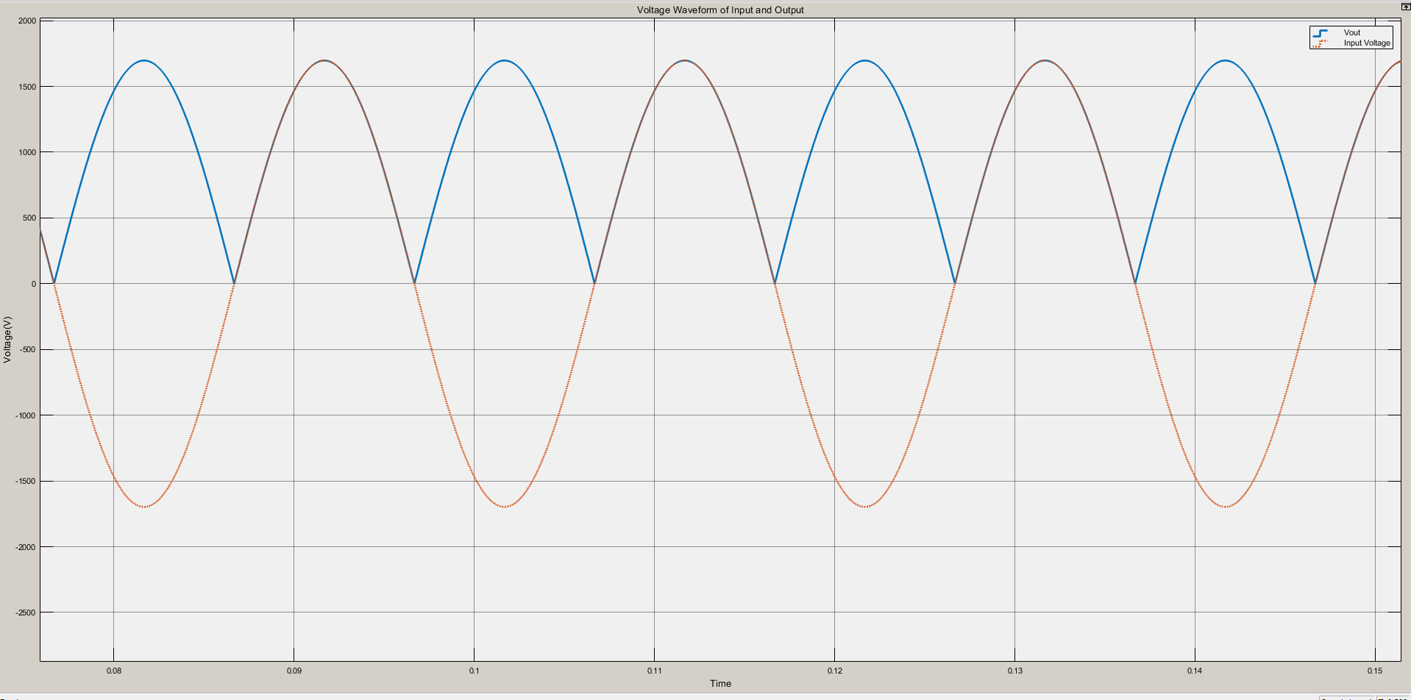

Figure 23: Input and output voltage waveforms of full-bridge rectifier

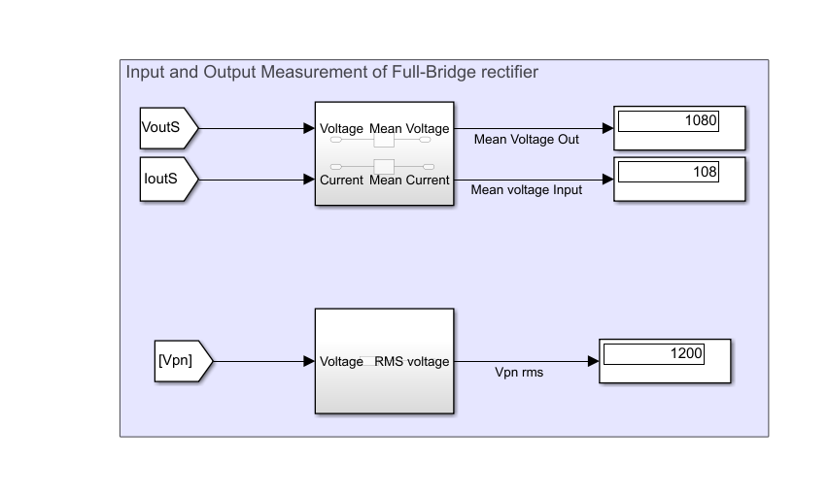

Figure 24: Input,output voltage and current values of full-bridge rectifier

Comparison

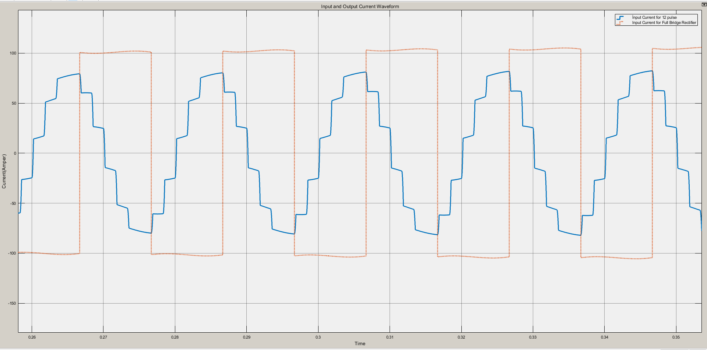

Figure 25: Line current waveforms of the 12-pulse and full bridge rectifier with constant current load

There are some topics that is compared to rectifiers. One of them is output voltage level. 12 pulse rectifiers have more average output level with respect to full-bridge rectifier. 12 pulse rectifiers can be used HV DC converters for this characteristic. In addition, output ripple is important for the converter’s quality. 12 pulse rectifiers have lower ripple than full bridge rectifier and it is not required to use filters.

Source side current THD is another topic. For comparing THD of line current, the circuit is installed as constant current load. Figure 18 and Figure 19 shows that line current of 12 pulse rectifiers draws like sinusoidal current while full-bridge rectifier draws square waveform current.

These considerations show that 12 pulse is more advantageous than full- bridge rectifier. However, for the 12-pulse generation from 3 phase sources, there is a required two transformers. It increases the cost of rectifier. Until the voltage is very high, 12 pulse rectifiers are not sensible. [3]

# Conclusion

In this document, controlled rectifiers with different topologies are analysed. The effect of firing angles onto output voltage and currents and the resultant effect of THDs and effects are examined. Characteristics for each topology is mathematically derived and explained respectively.

DC motor drive which is fed by 3-phase AC grid, rectified with full-bridge rectifier, is analysed. Output waveforms are illustrated such as speed, back emf voltage and armature current etc. Two methods, combining capacitor and inductors accordingly, are proposed to reduce the ripple at the output torque which is related with the output current. Power and efficiency calculations are done. They are illustrated in the pie chart.

12-pulse rectifier is analysed and compared with the full-bridge rectifiers. Advantageous and disadvantageous of 12-pulse rectifier are discussed and compared with the other converter topologies.

# References

[1] Mohan, N., Undeland, T. M., & Robbins, W. P. (2002). *Power electronics: Converters, applications, and design*. New York: John Wiley.

[2] Hart, D.W. (2011). *Power electronics*. New York: Mc Graw Hill.

[3] *AC to DC Converters*. Retrieved from: <https://nptel.ac.in/courses/Webcourse-contents/IIT%20Kharagpur/Power%20Electronics/PDF/L-11(DK)(PE)%20((EE)NPTEL).pdf>