

MIDDLE EAST TECHNICAL UNIVERSITY

Electrical & Electronics Engineering

Simulation Project #3

EE 463

Huzeyfe Hintoğlu – 2093920

Furkan Karacabey – 1876358



Table of Contents

Introduction 3

Q1) 3-Phase Thyristor Converter 3

Q2) Buck Converter 5

Q3) Boost Converter (Webench) 7

3.1) 7

3.2) 8

Comments 12

Conclusion 13

References 13

Appendix 14

Datasheets & Links of Components For Buck Converter 14

# Introduction

In this project, we are asked to design and simulate three phase controlled rectifier which is feeding a DC motor on Simulink. In order to adjust the firing angle of the thyristor rectifier for desired speed, a PI controller is fed back by motor speed into the system. Also, DC/DC converter topologies, namely Buck Converter and Boost Converter, are investigated deeply. Buck converter is designed regarding the commercial products considering the cost, efficiency, ripple etc. of the system. For Boost Converter, Webench digital platform, a Texas Instruments digital tool, is used.

The aim of the project is to observe the three phase fully controlled rectifier on controlling a DC motor with a feedback system for adjustable speed and designing DC/DC converters. In this document, related theoretical calculations are illustrated and the simulations are done in Simulink.

# Q1) 3-Phase Thyristor Converter

For the 1st part, speed control of a DC Motor is simulated on Simulink. The subsystems are illustrated in Figure 1. DC Motor is modeled as in Simulation Project #2 as same motor parameters are given.

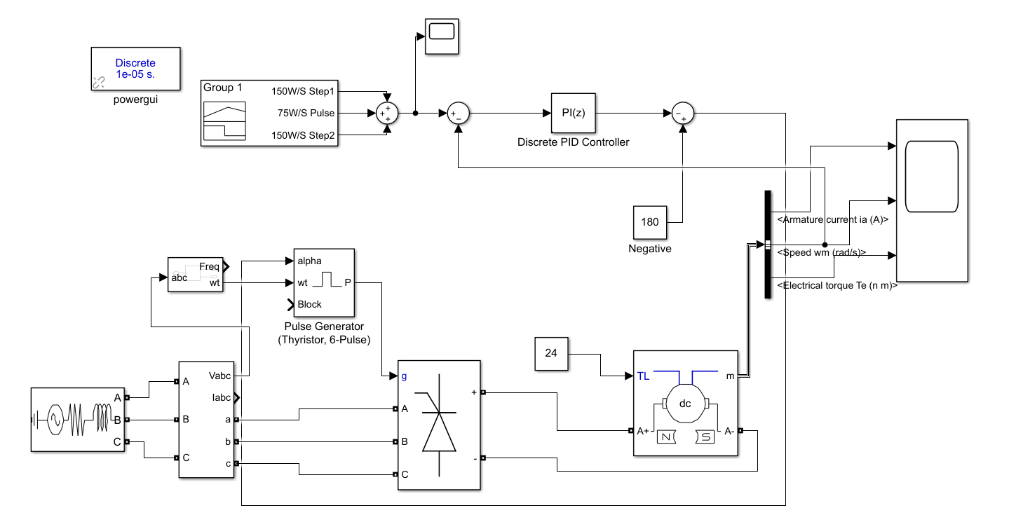

Figure 1: Simulated schematic for DC motor control with PI controller

Input is 3-Phase AC-Yg. The motor is controlled by 3-Phase Thyristor Converter. The speed control is achieved by taking samples from output as speed and feeding it back to system via PI controller. By adjusting the firing angles of thyristors inside the 3-Phase controlled rectifier, speed is regulated accordingly.

For thyristor to work reliable and proper, output of the controller block is subtracted from 180° because output is limited by saturation variables in PI controller block. PI values are chosen by trial-error. KP is chosen as 4 and KI is chosen as 1. With these parameters, we achieve not too aggressive but a stable system with reasonable settling time, about 10s and steady-state errors, near to 0.1.

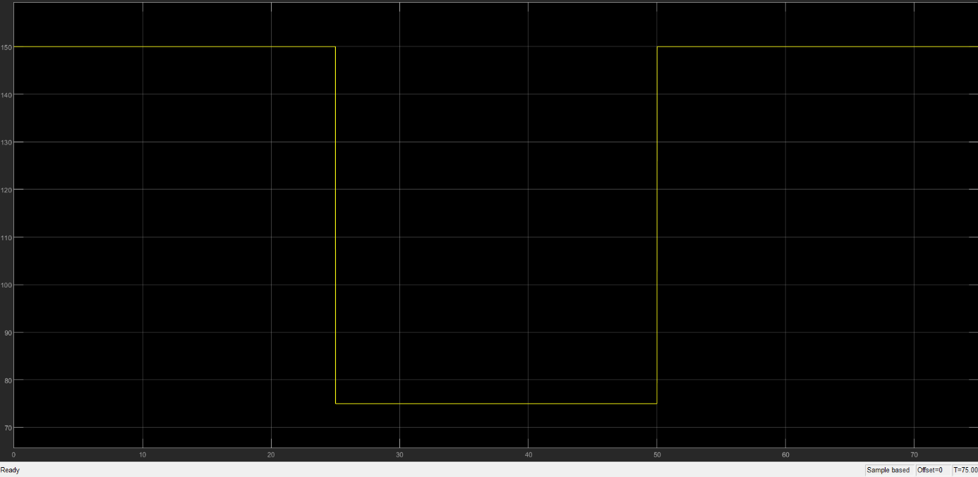

Figure 2: Input signal given to the system

In order to test the system as asked in project description, 3 signals are combined with 25 seconds period of each as 150W/S and 75W/S and 150W/S again respectively as shown in Figure 2.

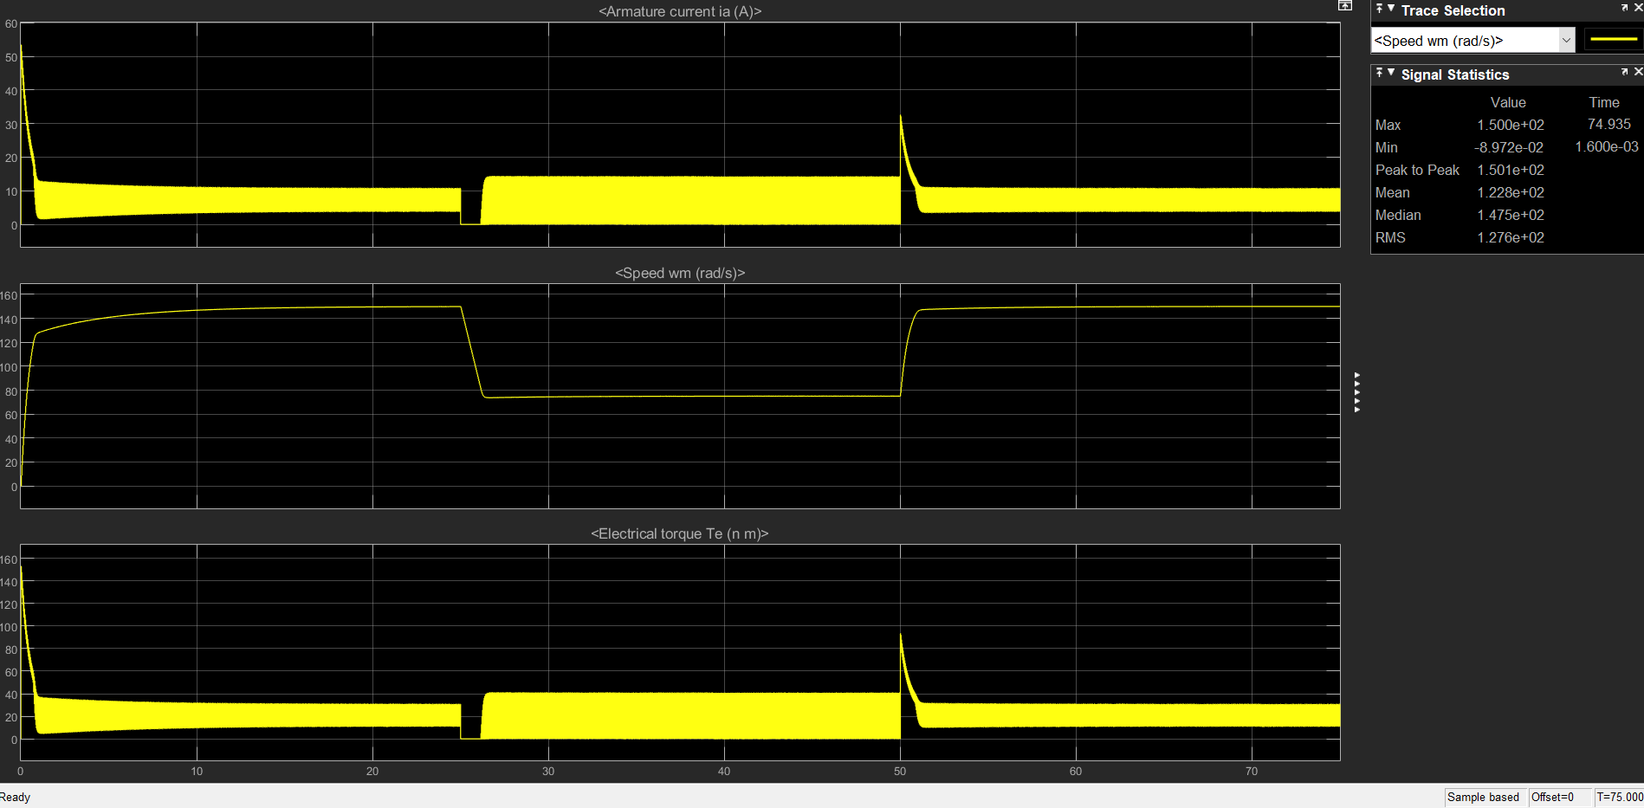

Figure 3: Armature Current, Speed and Torque graphs with KP =4 and KI =1 for given input

As shown in Figure 3, system works properly for adjusted PI values. When the speed is reduced to 75W/S via input, the system responses this input quickly and stabilizes with a little steady-state error as 0.1 which is definitely a good value. The drawback here is to have oscillations both in current and hence torque. However, the oscillations are in a small range which can be tolerated via the motor we have considering it has 24 Nm constant torque demand.

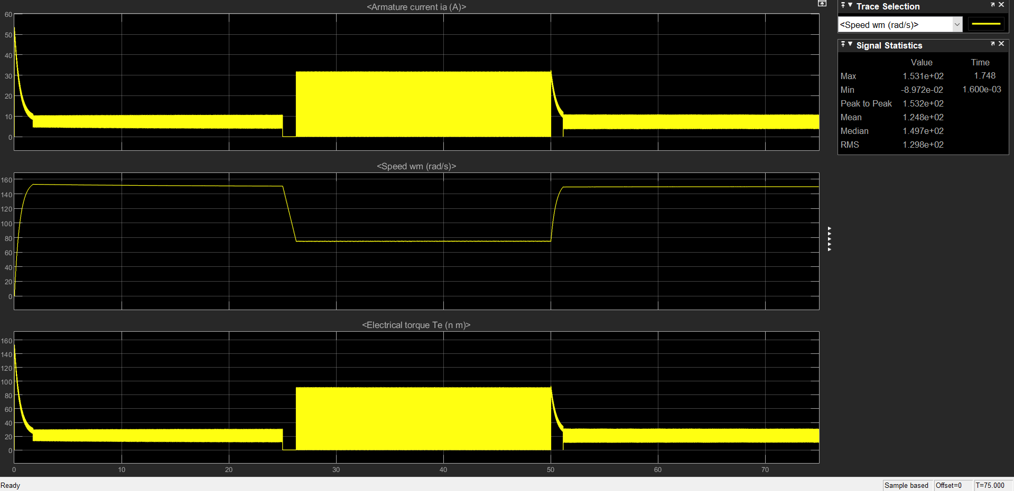

Figure 4: Armature Current, Speed and Torque graphs with KP =150 and KI =10 for given input

It is also tried that having KP as 150 and KI is chosen as 10. In that case system works again with less steady-state error and improved settling time. However, the oscillations in the current and torque are increased dramatically as shown in Figure 4. Hence, it is better use KP and KI values previously analyzed.

All in all, 3-phase thyristor rectifier can be used to control the speed of a DC motor via PI controller setup with adjusted parameters. It is achieved by adjusting the firing angles according to the information coming from the DC motor speed output. Note that in real time, an encoder for speed measurement can be used while a microcontroller for PI controller an adjusting the firing angles.

# Q2) Buck Converter

In the second part of the project, the aim is to design and simulate a buck converter with commercially available components. In Figure 5, the simulation schematic of buck converter is illustrated.

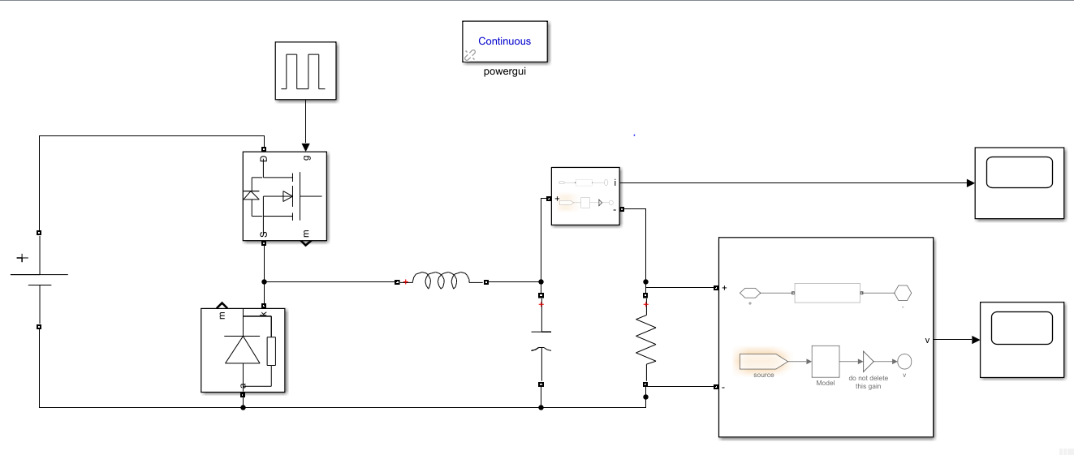

Figure 5: Buck Converter

Input voltage of the converter is 56V. Pulse generator which has 35kHz and %50 duty cycle pulse is connected the gate of MOSFET. Inductor, Capacitor and Resistor values are selected 180µH, 15µF and 4Ω. Ripple current and voltage is founded smaller than 0.1A and 0.3V. Figures 2,3,4 and 5 show the graph of the output current, graph of the output voltage, ripple current and ripple voltage respectively.

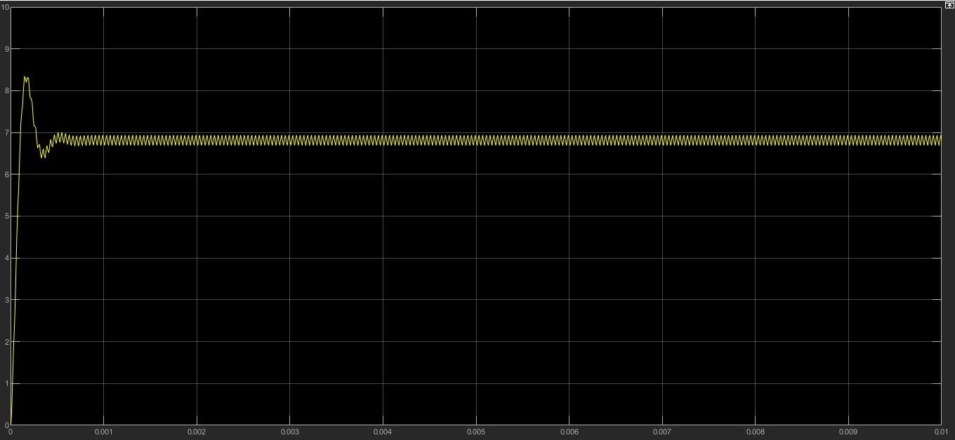

Figure 6: Output Current waveform of Buck Converter

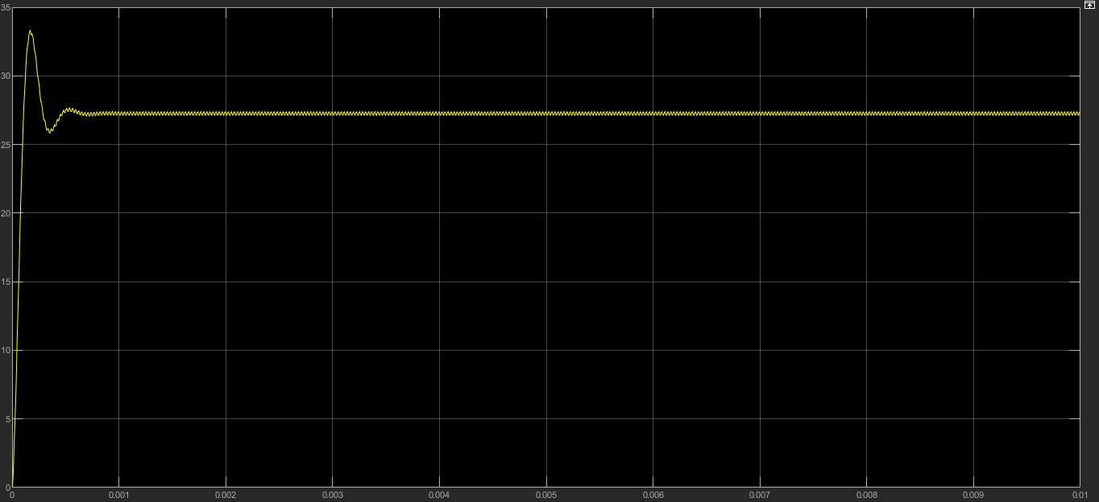

Figure 7: Output Voltage waveform of Buck Converter

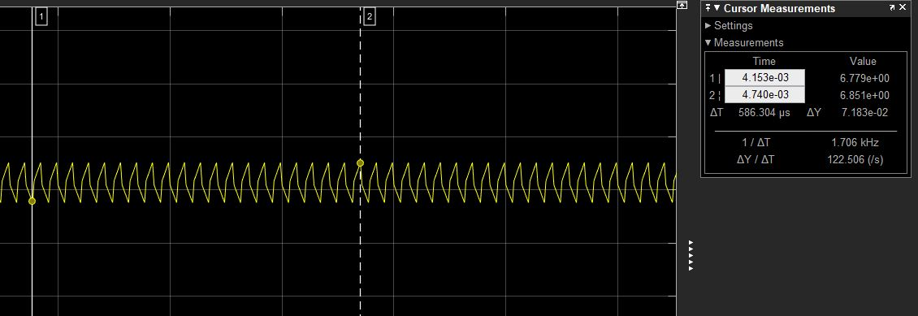

Figure 8: Ripple Current on Buck Converter

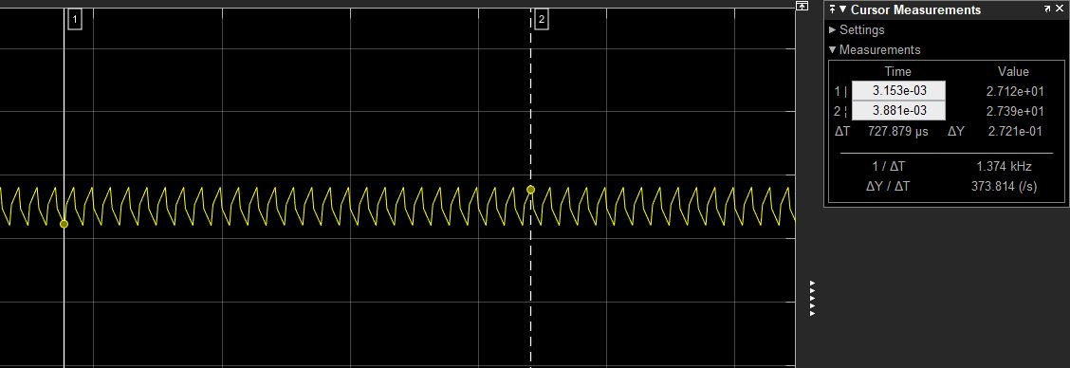

Figure 9: Ripple Voltage on Buck Converter

Api Delevan’s 180µH inductor is selected because it has 7.28A continuous and 9.86A with saturation current. Its DC resistance is max 45mOhm and its price 8 $. Vishay Sprague’s 15µF capacitor is selected because it has 82mA ripple current for high frequencies. Its price is 6$. Taiwan Semiconductor Corporation’s diode is selected because it has 60VR and 12A current characteristics. Its price 0.35 $. For Mosfet, Micro Commercial Co’s Mosfet is selected because it has 60VDS voltage and 12A continuous current rating. Its price is 0.87$. Total price is 15.22$. Note that all component related links and datasheets are given in Appendix section of this document.

The output power is measured 185.5 W and it is illustrated in Figure 10.

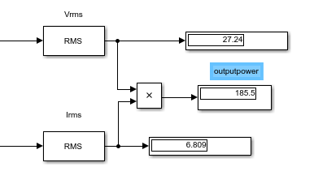

Figure 10: Output Power

Mosfet has 3W loss according to the its datasheet. 4.6 W is loss because of the diode which is measured from multiplying forward voltage and current passing the diode. The inductor has approximately 4.5 W loss and capacitor loss is ignored. Then total loss is approximately 12.1W. The efficiency is 174.4/185.5=%94. Switching elements cause the loss. If the frequency is decreased efficiency will be increased but ripple will be increased.

# Q3) Boost Converter (Webench)

## 3.1)

Note that all analysis in Q3 are done using Webench [1] digital platform of Texas Instruments.

Since the interface of the Webench has changed, we are not able to compare the topologies via Advanced Charting method. Instead a comparison chart is used for this reason. When the desired input output parameters are implemented into the filters, there are 28 options we face with for boost converters. Looking the big picture, most of the suggestions are controllers for different converter topologies. However, some of them are fully integrated (controller included) converters. Controller integrated IC’s are preferred for simplicity.

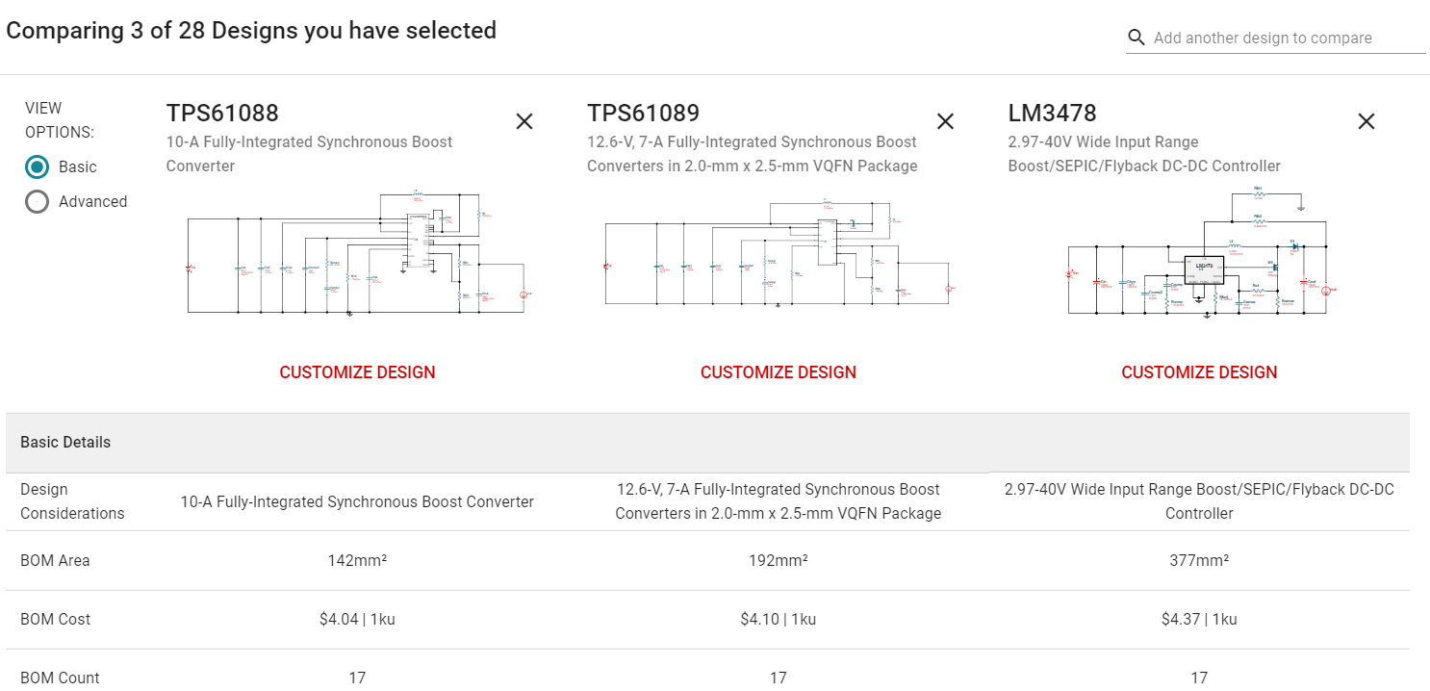



Figure 11: Comparison Chart for 3 different converter IC

Considering efficiency, BOM count, BOM area, frequency range and BOM cost, the best IC is chosen as TPS61088, a fully-integrated Synchronous Boost Converter as shown in Figure 11.

## 3.2)

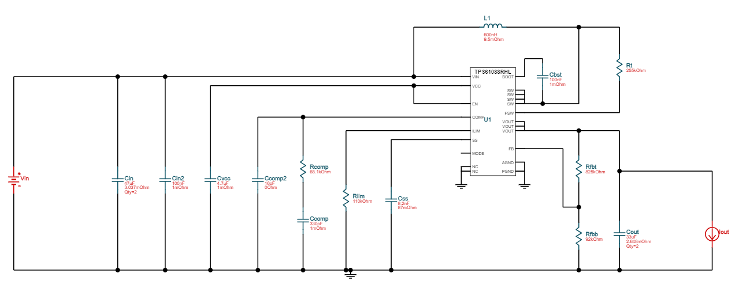

Figure 12: Circuit schematic with TPS61088 IC

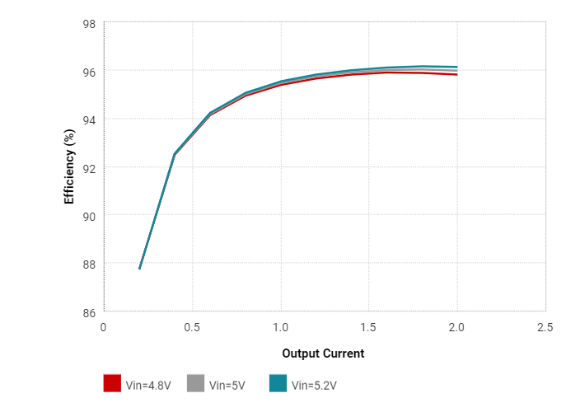

Figure 13: Efficiency vs output current waveform

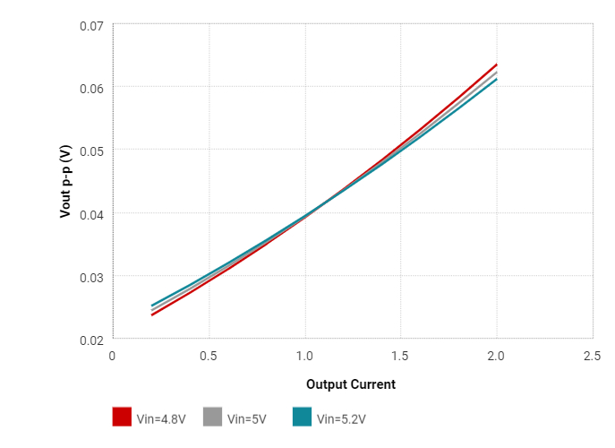

Figure 14: Output voltage ripple vs output current waveform

















Figure 15: Operation values of designed Boost Converter

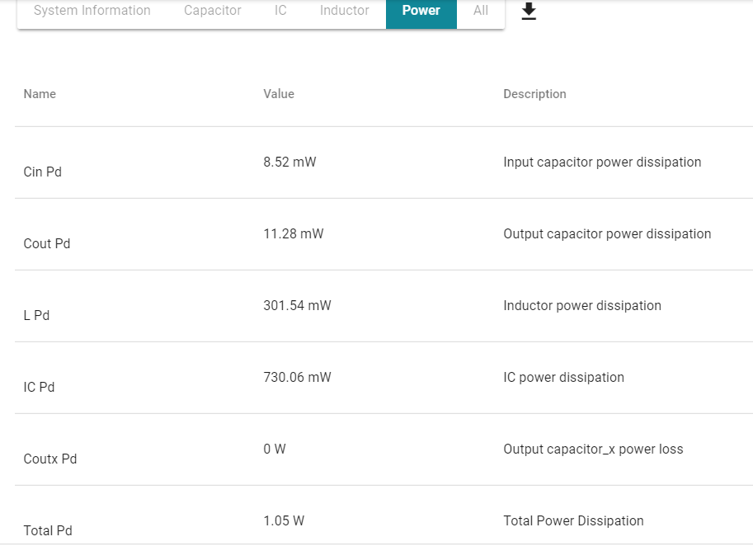

Figure 16: Power dissipation of circuit elements

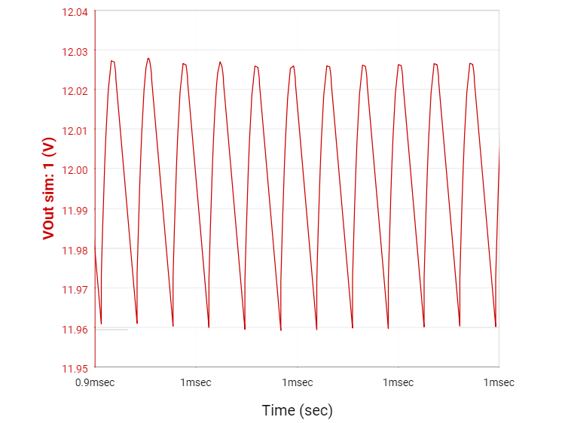

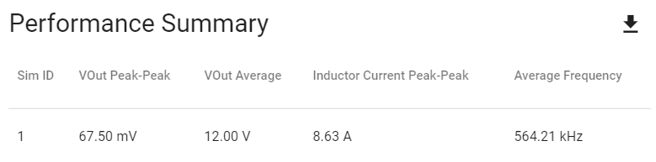

Figure 17: Vout vs Time graph and performance summary at Steady State

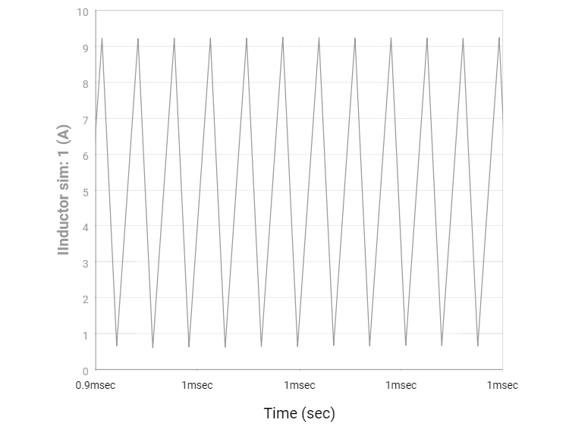

Figure 18: Inductor Current vs Time at Steady State

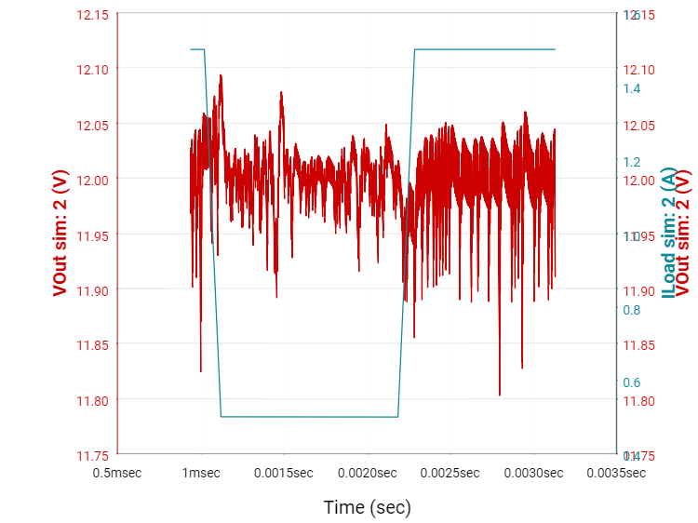

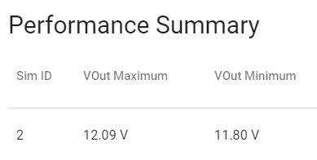

Figure 19: Vout & Iload vs Time graph and performance summary at Transient

### Comments

The desired output voltage is obtained as 12V with small ripple which is less than 0.1V at steady state, 0.83%. Hence, the performance for voltage output is satisfactory. However, inductor current has high ripples which may cause high di/dt problems and thus parasitic voltages in the system. Also, it causes huge loss on the system as 301mW, second in total loss chart after IC power consumption. However, in total we have 1.05W of power loss which is significantly low power dissipation for a converter topology.

Noting the efficiency is about %96, we have excellent efficiency level for input range 4.8V-5.2V. Considering also the BOM cost and footprint, designed boost converter is very logical and advantageous system for applications. Also, thermal characteristics of the system is satisfactory with junction temperature 53°C. We can use this system without a heatsink with this temperature and power dissipation rate.

All in all, the designed Boost Converter works very well for given parameters in the aspects of efficiency, BOM Cost, footprint, thermal characteristics, power dissipation rate, voltage and current characteristics.

# Conclusion

In this project, firstly, a DC motor drive which is fed by 3-phase AC grid, rectified with 3-phase full-bridge rectifier, is analyzed. We controlled the DC Motor’s speed with a PI controller closed loop system. Since the firing angles are used in regulation of the speed, our aim is to design the controller in order to change the firing angles accordingly. For this reason, output speed is feedback to our reference point and via PI controller, the regulation process is done by changing the firing angle.

Secondly, a Buck converter is designed and simulated on Simulink. The switching frequency and inductance values are chosen to be affordable and output voltage ripple to be low. Also, commercial components are chosen and analyzed for Buck converter for real-time applications. At last, a financial analysis is done for the converter.

Finally, a Boost converter is designed on Webench which is a digital platform of Texas Instruments. In Webench, an engineer can design various converter topologies with given parameters. It includes all IC’s and the sample application notes and analysis of each application. This helps the designer a lot in design process and make proper and fast calculations and analysis. In the project, with the given parameters, an IC is chosen and designed on Webench. Starting with analysis of output voltage ripples and load currents, required arrangements are done and the performance is improved. With the help of the charts given, the best match is chosen and efficiency, power and cost analysis are done. After that, the resultant performance characteristics and other info related with BOM and footprints are illustrated.

# References

[1] *Webench Power Designer*. Retrieved from: <https://webench.ti.com/power-designer/>

# Appendix

## Datasheets & Links of Components For Buck Converter

Inductor

Link: <https://www.digikey.com/product-detail/en/api-delevan-inc/DC1390-184K/DC1390-184K-ND/4202759>

Datasheet: <http://www.delevan.com/seriesPDFs/DC1390.pdf>

Capacitor

Link: <https://www.digikey.com/product-detail/en/vishay-sprague/30D156M040BA6A/30D156M040BA6A-ND/5609488>

Datasheet: <http://www.vishay.com/docs/42041/30d.pdf>

Diode

Link: <https://www.digikey.com/product-detail/en/taiwan-semiconductor-corporation/SK12H60-A0G/SK12H60A0G-ND/7376931>

Datasheet: <http://www.taiwansemi.com/products/datasheet/SK12H45%20SERIES_E13.pdf>

MOSFET

Link: <https://www.digikey.com/product-detail/en/micro-commercial-co/MCQ12N06-TP/MCQ12N06-TPMSDKR-ND/9656008>

Datasheet: <http://www.mccsemi.com/up_pdf/MCQ12N06(SOP-8)-A.pdf>