Timing of testosterone suppression and recovery with GnRH antagonists in a registry analysis of prostate cancer trials

Abstract
Background. Gonadotropin-releasing hormone (GnRH) antagonists and agonists differ in the onset of androgen suppression, but comparisons across observation windows can obscure distinct treatment objectives. We examined randomized registry evidence on treatment initiation, sustained suppression, and testosterone recovery in prostate cancer.
Methods. ClinicalTrials.gov records were retrieved on 16 October 2026 for trials initiated during 2006–2025. Eligible records directly compared an antagonist with an agonist under randomized allocation and comparable background treatment. Source-reported probabilities, confidence intervals, endpoint windows, and analysis populations were retained; Kaplan–Meier estimates were not converted to event counts. Compatible 12-week International Prostate Symptom Score (IPSS) changes were synthesized using restricted maximum likelihood and modified Hartung–Knapp–Sidik–Jonkman inference. Outcome availability, trial geography, and serious adverse events were described separately. One retained comparison had conflicting registry design descriptions, which were flagged for confirmation. The CS21 contrast retained its source-reported 97.5% confidence level. Outcome-level denominators were used when visit-specific sample sizes were unavailable, limiting symptom precision.
Results. Of 187 screened records, 21 were eligible and 11 had posted results; listed locations spanned 36 countries or territories. In CS21, day-3 castration occurred in 96.1% with licensed-dose degarelix versus 0% with leuprolide, whereas day-28–364 maintenance was 97.2% versus 96.4%. In HERO, day-15 castration probabilities were 98.71% with relugolix and 12.05% with leuprolide. Day-29–337 maintenance favored relugolix by 7.9 percentage points (95% confidence interval 4.1–11.8), while the later profound-suppression contrast was inconclusive. In the selected recovery population, probabilities above 280 ng/dL at 90 days were 53.93% versus 3.23%; these estimates were not population-wide event fractions. Three urinary-symptom comparisons yielded a pooled IPSS difference of −1.84 points (modified 95% interval −4.38 to 0.69). The conventional normal interval excluded zero (−3.00 to −0.69), but the modified interval did not (p = 0.089). Serious adverse event comparisons differed in population, observation period, and ascertainment and were not pooled.
Conclusions. Rapid biochemical suppression was the most consistent antagonist advantage. Maintenance and recovery require molecule-specific interpretation with explicit thresholds, time windows, and eligible populations. Additional urinary-symptom benefit and cardiovascular superiority remain uncertain. These aggregate results clarify endocrine treatment profiles without establishing improved survival or a validated individual treatment-selection model.
Keywords. Prostate cancer; androgen-deprivation therapy; GnRH antagonists; testosterone; treatment timing

Introduction
Androgen-deprivation therapy (ADT) is central to prostate cancer treatment, but its objectives change over time. Treatment initiation may require a rapid and predictable testosterone decline; continued therapy requires sustained suppression with an acceptable treatment burden. After a planned finite course, recovery becomes relevant for patients who no longer require hypogonadism. These objectives are related, but an advantage in one phase need not extend to another. Randomized comparisons of degarelix and relugolix with agonists allow these distinctions to be examined directly [1,2].
Gonadotropin-releasing hormone (GnRH) antagonists directly block the pituitary receptor, whereas agonists initially stimulate the axis before producing sustained suppression. Their different onset profiles may matter when rapid endocrine control is needed. However, biochemical testosterone surge, symptomatic tumor flare, urinary retention, and survival are distinct outcomes. Preventing a laboratory surge does not establish prevention of an obstructive or neurological emergency. Similarly, suppression below a testosterone threshold does not establish broader clinical benefit. The association between testosterone nadir and progression in a secondary PR-7 analysis supports studying suppression quality, without validating every treatment contrast as a survival surrogate [3].
Much of the published evidence derives from overlapping randomized populations. CS21 generated secondary analyses of biochemical control and cardiovascular safety [4,5], as well as an extension in which leuprolide recipients crossed over to degarelix [6]. After crossover, the extension no longer represents an independent initial antagonist–agonist randomization. Pooled individual-participant analyses likewise reuse contributing trials [7]. A registry-based analysis can clarify these relationships and distinguish the number of reports from the number of independent comparisons.
Recovery requires drug-specific assessment. Findings after relugolix withdrawal cannot automatically be extended to injectable degarelix, because formulation, exposure duration, baseline testosterone, and follow-up eligibility may differ. A randomized phase 2 radiotherapy trial compared relugolix with degarelix, and subsequent secondary analyses examined additional radiotherapy settings [8,9]. These provide context rather than independent antagonist–agonist replications. Studies of short-course degarelix and intermittent treatment duration further show that stopping therapy is a distinct intervention with a defined assessment schedule [10,11]. Recovery estimates should therefore retain their off-treatment population rather than inherit the main efficacy denominator.
ClinicalTrials.gov provides structured registration information and summary results that allow outcome labels, observation windows, and treatment groups to be examined independently of journal reports. Its results database improves access to trial findings, although incompleteness and reporting problems persist [12,13]. This structure is useful when a label such as sustained castration conceals the difference between observation beginning on day 3 and after the first month. Public access nevertheless requires careful interpretation of denominators and probabilities, alongside compliance with data-reuse terms.
We conducted a registry-based analysis of randomized antagonist–agonist comparisons initiated during the 20 calendar years from 2006 through 2025. The primary objective was to characterize endocrine efficacy over time using source-reported estimates. Secondary objectives were to synthesize compatible urinary-symptom changes, describe serious adverse events and the geographic distribution of registered trials, and identify constraints on clinical interpretation. We sought a reproducible treatment profile that distinguishes directly observed effects from claims requiring further validation.

Methods

Study design and analytical scope
We retrospectively reanalyzed publicly available aggregate clinical trial records. Registry screening used the NCT record as its unit; quantitative synthesis used an eligible randomized treatment contrast within a compatible outcome and follow-up window. Registration and posted summary results fields formed the primary dataset. Journal reports were used to confirm trial identity, resolve important metadata discrepancies, and interpret findings. Numerical results absent from the registry were not incorporated into the main analytic dataset without disclosure. The study comprised a ClinicalTrials.gov evidence census and endpoint-specific synthesis, rather than an exhaustive review of all international registries and publications. Retrieval and reporting were informed by guidance on registry research and trial register searching [14,15].
The analysis was not prospectively registered. Feasibility screening preceded formulation of the final timing-based research question, and the compatible symptom synthesis was calculated after eligibility criteria and endpoint definitions had been specified. PRISMA principles informed the selection flow and descriptions of outcome availability; the single-registry search was not considered a comprehensive global systematic review [16].

Data source, access, and reuse
ClinicalTrials.gov is maintained by the United States National Library of Medicine (NLM). We retrieved records through its public version 2 application programming interface (API) on 16 October 2026, without a restricted account or access to local hospital data or a publication repository dataset. The version endpoint reported API version 2.0.5 and a source processing timestamp of 2026-10-16T09:00:05. The timestamp is reported exactly as supplied because the string did not specify a timezone. The modernized interface provides standardized data fields and programmatic retrieval [17].
ClinicalTrials.gov data were reused under its Terms and Conditions, which address attribution, currency, disclosure of the processing date, and description of modifications when data are published or distributed. The analysis used factual aggregate numerical entries and original derived analyses. These reuse provisions were not treated as a blanket Creative Commons or public domain license for sponsor attachments, consent forms, published article text, or individual participant data. ClinicalTrials.gov does not endorse this analysis [18].

Search strategy and eligibility
The initial search combined the condition Prostate Cancer with degarelix, relugolix, abarelix, cetrorelix, and ozarelix. A supplementary query added generic GnRH antagonist phrases, teverelix, and the development identifiers FE200486, ASP3550, TAK385, TAK-385, MVT601, and MVT-601. The supplementary response included every record from the initial search; deduplication by NCT identifier yielded 187 unique records. Screening examined structured study fields and detailed intervention descriptions to distinguish direct randomized comparisons from records that mentioned either drug class only as permissible background treatment.
Eligible trials enrolled patients with prostate cancer, began between 1 January 2006 and 31 December 2025, and directly randomized an antagonist against an agonist at treatment initiation. Background radiotherapy or systemic treatment was permitted when matched within the selected contrast. Records without posted results remained in the evidence inventory. We excluded nonrandomized dose cohorts, comparisons permitting either class in both groups as background therapy, unmatched treatment intensification, and extension or crossover records that no longer preserved an independent initial class comparison. Ongoing trials contributed to the registry map but not to unreported outcome estimates. Results posted in 2026 were eligible if available by the retrieval cutoff; the date restriction applied to trial initiation, not publication.
For three-arm trials, we selected a clinically interpretable contrast without duplicating a shared control. In CS21, the principal comparison was degarelix 240 mg as a loading dose followed by 80 mg monthly versus monthly leuprolide; the higher maintenance dose was retained in the raw data but not analyzed as an independent comparison. In CS37, continuous degarelix was compared with continuous leuprolide. Intermittent degarelix was not treated as a matched withdrawal comparison once treatment schedules diverged [19]. In REVELUTION, the randomized contrast comprised radiotherapy plus relugolix versus radiotherapy plus leuprolide; the radiation-alone cohort was excluded from class comparisons [20]. C27002 was retained using the detailed random-allocation description despite conflicting title and masking metadata; its design classification requires confirmation [38].

Data extraction and endpoint definitions
Extraction retained trial and treatment group identifiers, outcome indices, units, parameter types, dispersion labels, population descriptions, and JSON pointers linking each selected estimate to its position in the source record. All available outcome measurements were flattened programmatically before endpoint selection. An analytical verification pass checked the principal endocrine estimates, symptom means and standard deviations, and safety numerators and denominators. This procedure did not constitute independent duplicate clinical adjudication or involve participant-level records. Discrepancies between registry metadata and primary reports were documented in view of recognized differences between registry and publication reporting [21].
Early control was defined by the source assessment day and testosterone threshold, including measurements on day 3 or 4 and day 15. Standard suppression thresholds of 0.5 ng/mL and 50 ng/dL were treated as equivalent after explicit conversion, while source-specific strict or inclusive inequalities were preserved. Profound suppression below 20 ng/dL was a separate endpoint. Biochemical surge retained the source definition of a testosterone increase and was not recoded as clinical flare. Maintenance endpoints retained the exact interval over which suppression was required. A day 3–364 requirement therefore included initiation and was distinguished from maintenance beginning on day 28 or 29.
Recovery endpoints retained the reported testosterone threshold, assessment time after discontinuation, and selected follow-up population. Kaplan–Meier probabilities were not converted into event counts by multiplication by a sample size. Directly reported treatment differences and confidence intervals took precedence over subtraction of rounded arm estimates. The original 97.5% confidence level was retained for the CS21 maintenance contrast. When no direct contrast was supplied, arm probabilities and their source intervals were reported descriptively without reconstructing participant numerators or between-group standard errors.

Urinary symptom synthesis and uncertainty
The compatible symptom outcome was change in total International Prostate Symptom Score (IPSS) at 12 weeks in CS28 and CS30 [22,23] and in CS31, which used the same score and follow-up schedule [24]. Lower change scores indicated greater improvement. Each trial provided arm means, standard deviations, and an outcome-level analysis denominator. We calculated unadjusted mean differences and sampling variances as the sum of the two arm mean variances. Registry outcome-level denominators were used without imputing unavailable visit-specific sample sizes. Missing data methods and differences between these unadjusted estimates and source-adjusted contrasts were recorded during the audit. In all three symptom comparisons, the agonist regimen comprised goserelin with short-course bicalutamide flare protection.
Between-study variance was estimated by restricted maximum likelihood (REML). The pooled confidence interval used the modified Hartung–Knapp–Sidik–Jonkman method, a t distribution with two degrees of freedom, and a variance multiplier bounded below by one. The lower bound prevents a dispersion multiplier below one from producing an artificially narrow interval, although inference remains limited by the inclusion of only three studies [25,26]. A conventional normal interval was reported as a sensitivity analysis. Between-study variance, Cochran Q, and I² described observed heterogeneity; zero estimates were not taken to establish identical populations or effects [27,28].
Leave-one-trial-out analyses assessed the influence of each comparison without determining study exclusion. Week 4 and week 8 trajectories were displayed descriptively to contextualize the week 12 result; repeated observations were not counted as independent trials. Meta-regression, funnel asymmetry testing, and network treatment ranking were not performed with three studies. The approximately three-point change discussed in the symptom literature provided context for patient-perceived within-person improvement; it was not applied as a validated threshold for a between-group mean difference in prostate cancer [29].

Safety, geography, and evidence appraisal
Serious adverse event displays used explicitly reported numbers of affected participants and populations at risk. If an event group summary omitted a denominator, event-level safety statistics were used only when the same denominator was explicitly and consistently reported. Wilson intervals described arm risks. Safety results were not pooled because observation duration, background treatment, event definitions, and ascertainment varied. PRONOUNCE excluded specified nonfatal cardiovascular endpoint events from standard serious adverse event reporting; its serious event total therefore did not represent comprehensive cardiovascular harm. The newer relugolix comparison reported generic adverse event outcomes without a usable endocrine comparison [30].
Geography was described by distinct trial–country memberships among eligible records with listed locations. Each country received one count per trial, regardless of the number of facilities. Countries and territories followed source labels, with name matching documented for mapping; Natural Earth public domain vector boundaries supplied the base map [31]. Counts represented the location of registered research activity, not participant allocation by country or disease prevalence. Missing locations were not considered evidence that no relevant research had occurred in a country.
Interpretability was appraised through documentation of randomization, masking and outcome objectivity, completeness of reported populations, endpoint consistency, missingness, and overlap between reports. RoB 2 informed these questions, but the records did not support a complete, independently adjudicated assessment of every domain [32]. Precision of biochemical estimates was distinguished from certainty about clinical benefit, consistent with outcome- and use-specific assessment of certainty. No formal GRADE rating was assigned to this incompletely characterized registry-only evidence base [33].

Results

Study selection and geographic distribution
The supplementary search returned 187 unique records. Screening excluded 166 records, leaving 21 records classified as eligible randomized antagonist–agonist comparisons; 11 had posted summary results and ten had not. The additional supplementary records contributed no eligible comparisons. The inventory included completed and ongoing trials. Enrollment totals combined actual and estimated counts and were therefore not treated as the number of observed participants contributing to analyses. Figure 1 presents selection, and Table 1 lists the eligible trials.
Eligible records listed locations in 36 countries or territories, comprising 100 distinct trial–country memberships. The United States appeared in 13 records, Germany and the United Kingdom in seven each, and Canada in six. These counts represented repeated participation in multicountry programs rather than independent national patient samples (Figure 2, upper and lower panels). The Chinese and Japanese randomized degarelix studies remained in the inventory despite having no registry summary results available for extraction. Their publications informed interpretation but did not replace missing registry entries in the principal dataset [34,35].

Early suppression and biochemical surge
The licensed-dose CS21 comparison included 207 exposed patients receiving degarelix and 201 receiving leuprolide. On day 3, testosterone was at or below 0.5 ng/mL in 96.1% (95% confidence interval 92.5–98.3) and 0% (0–1.8), respectively. The larger randomized allocation was not substituted for this exposed efficacy population [36]. HERO's primary exposed population comprised 622 relugolix recipients and 308 leuprolide recipients, distinct from both the full registry enrollment of 1134 and the primary randomized population of 934 [37].
In HERO, day 4 castration probabilities were 56.04% (52.18–59.97) with relugolix and 0% with leuprolide; the registry supplied no estimable comparator interval. By day 15, the corresponding probabilities were 98.71% (97.56–99.39) and 12.05% (8.88–16.25). Profound suppression below 20 ng/dL on day 15 occurred with probabilities of 78.38% and 0.98%, with a reported between-group difference of 77.41 percentage points (73.98–80.83). These Kaplan–Meier estimates were retained as probabilities, without reconstructing event fractions. Figure 3 displays early suppression by trial, assessment day, and threshold.
In CS21, biochemical surge during the first two weeks was reported in 0% of the licensed-dose degarelix group and 80.1% of the leuprolide group (Figure 4A). This endpoint required a source-defined increase above baseline and did not enumerate symptomatic flare events. In the phase 2 C27002 trial, median time to testosterone below 50 ng/dL was four days with the 120 mg relugolix regimen and 29 days with leuprorelin. The corresponding ranges were 4–57 and 15–57 days, not confidence intervals [38].

Suppression maintenance by observation interval
In CS21, suppression from day 28 to 364 was 97.2% with degarelix and 96.4% with leuprolide (Figure 4B). The reported treatment difference was 0.9 percentage points (97.5% confidence interval −3.2 to 5.0), which was retained despite differing slightly from subtraction of the rounded arm percentages. In HERO, standard suppression from day 29 to 337 was 96.7% versus 88.8%, a reported difference of 7.9 percentage points (95% confidence interval 4.1–11.8). Profound suppression over the same interval was 81.6% versus 68.6%, a difference of 13.0 percentage points (6.9–19.1). For the later profound suppression interval beginning on day 169, estimates were 84.6% versus 87.5%, with a difference of −2.9 percentage points (−7.8 to 2.0). These source-reported treatment contrasts are shown in Figure 5A.
CS35 reported suppression from day 3 to 364 in 85.0% versus 5.3%, with a directly reported difference of 79.6 percentage points (75.6–83.7). This endpoint included immediate induction (Figure 5B). For day 28–364 maintenance, the record reported a degarelix estimate of 90.0% but no corresponding goserelin estimate [39]. C27002 reported observed effective castration from week 5 to 25 in 91% of the 120 mg relugolix group and 96% of the leuprorelin group, with respective intervals of 79.7–96.9 and 78.9–99.9. The shorter interval, small comparator group, and absence of a direct between-group interval precluded combination with the pivotal maintenance contrasts. These results were displayed separately without estimating a common sustained-castration effect (Table 2).

Testosterone recovery after discontinuation
HERO reported recovery probabilities at 90 days after discontinuation. Recovery to at least 50 ng/dL was 93.01% (87.82–96.54) with relugolix versus 10.12% (3.84–25.24) with leuprolide. Recovery above 280 ng/dL was 53.93% (45.20–63.16) versus 3.23% (0.46–20.77). For the alternative threshold above baseline or 280 ng/dL, probabilities were 54.73% versus 3.23%. Differences calculated from these arm estimates were descriptive subtractions rather than separately reported inferential contrasts.
Although the registry described a selected recovery population, it repeated the full efficacy denominators. The dedicated primary report identified 184 participants—137 receiving relugolix and 47 receiving leuprolide—who completed 48 weeks and were not indicated to continue androgen deprivation [40]. This information was used to explain the denominator discrepancy while retaining the posted probabilities and confidence intervals. No binomial numerator was reconstructed from either denominator. Figure 6 and Table 3 present recovery in this selected population and the wider comparator uncertainty.

Urinary symptom changes
Three trials reported compatible changes in total IPSS at 12 weeks. All three unadjusted mean differences favored degarelix: −3.51 points in CS28 (95% confidence interval −8.70 to 1.68), −1.82 in CS30 (−3.33 to −0.31), and −1.65 in CS31 (−3.57 to 0.27). The respective outcome-level denominators were 27 versus 13, 177 versus 63, and 82 versus 97. These estimates concerned selected prostate cancer populations with differing baseline symptom burdens. Table 4 reports arm summaries and trial-specific estimates.
The pooled mean difference was −1.84 points. Estimated between-study variance and I² were zero, and Cochran Q was 0.44. The conventional normal interval was −3.00 to −0.69, whereas the modified Hartung–Knapp interval was −4.38 to 0.69 (p = 0.089). Thus, the small-study interval did not establish superiority despite the direction of the pooled estimate. Leave-one-out analyses did not alter inclusion in the principal analysis. Figure 7 presents the trial and pooled estimates.
Descriptive trajectories at weeks 4, 8, and 12 generally showed symptom improvement during treatment, with substantial between-study variation in the initial reduction. Changes in both arms were larger in CS28 than in the other trials, consistent with differences in the symptomatic populations (Figure 8, CS28, CS30, and CS31 panels). Repeated measurements provided context for the week 12 comparison and were not treated as additional independent contrasts. These trajectories did not establish that faster biochemical suppression caused greater symptom improvement.

Outcome availability, safety, and source discrepancies
Each endocrine domain was reported by only a subset of eligible records, with comparative recovery after discontinuation particularly limited. Other records reported symptoms, median hormone measurements, or safety outcomes without a compatible suppression probability. Ten eligible trials had no posted results at the snapshot. Figure 9 distinguishes these patterns of availability; an unavailable endpoint was not treated as a zero event count or treatment failure.
Serious adverse event results varied across trials. HERO reported serious adverse events in 76 of 622 relugolix recipients and 47 of 308 leuprolide recipients. PRONOUNCE reported 47 of 275 degarelix recipients and 44 of 269 leuprolide recipients, subject to its stated exclusion of specified cardiovascular endpoint events from standard serious event reporting [41]. The newer relugolix comparison reported 13 of 191 versus five of 187 affected participants. Differences in direction, ascertainment, and trial context precluded a uniform safety ranking. Figure 10 and Table 5 present all trial-specific counts, denominators, and uncertainty without pooling risks.
Several source discrepancies affected interpretation. In addition to the HERO denominator discrepancy and differences in confidence levels, CS30 and CS31 labeled prostate volume changes in milliliters, although their registered analysis descriptions and index publications identified percentage reductions. REVELUTION reported contradictory units for testosterone kinetics and an uncertain common interval after discontinuation. The C27002 title described an observational cohort, whereas its detailed description explicitly stated randomized allocation to leuprorelin. These discrepancies were addressed through explicit analysis decisions rather than silent recoding (Supplementary Table S1).

Discussion
This registry-based analysis identifies timing as essential to interpreting randomized GnRH antagonist–agonist comparisons. Rapid testosterone suppression and avoidance of an initial biochemical surge were the most consistent antagonist advantages. Maintenance, recovery, urinary symptoms, and cardiovascular outcomes required separate conclusions. This profile can inform ADT discussions, but provides neither individual probabilities of clinical benefit nor a validated treatment-selection model (Supplementary Table S2).
The initiation findings accord with direct pituitary GnRH-receptor blockade. CS21 showed marked early suppression and no biochemical surge with licensed-dose degarelix, supporting its consideration when speed and predictability matter [1,36]. However, laboratory surge does not establish symptomatic flare, and its avoidance does not demonstrate prevention of retention, spinal cord compression, hospitalization, or death. These outcomes require direct comparative assessment.
Endpoint timing explains otherwise misleading contrasts. CS35 suppression from day 3 to 364 includes induction; CS21 maintenance from day 28 to 364 begins after suppression is generally established. Pooling both as sustained castration could misrepresent an initiation advantage as superior maintenance. Thresholds, interval boundaries, and analysis populations must therefore accompany every estimate. CS21 supported effective maintenance in both groups and the original noninferiority interpretation for degarelix versus leuprolide [1]. HERO favored relugolix over leuprolide for standard and profound suppression over days 29–337 [2], but the later profound-suppression contrast over days 169–337 was inconclusive. These are molecule- and window-specific findings, rather than evidence of a uniform class effect throughout treatment.
The depth of suppression also requires careful interpretation. The PR-7 association between testosterone nadir and disease-control outcomes provides biological rationale for examining suppression quality [3]. It does not validate the observed relugolix–leuprolide difference as a treatment effect on progression or survival. Precise biochemical estimates cannot substitute for follow-up of patient-important endpoints.
All three 12-week IPSS differences favored degarelix, but the pooled difference of −1.84 points had a modified Hartung–Knapp interval of −4.38 to 0.69. Additional symptom benefit therefore remains uncertain. The trials enrolled selected prostate cancer populations with different baseline symptom burdens; their findings do not generalize to all lower urinary tract symptoms or benign prostatic hyperplasia [44,45]. The neoadjuvant comparison additionally involved planned radiotherapy [46]. Neither these mean differences nor the endocrine results establish prevention of obstructive complications or replace urgent retention management. A three-point threshold for meaningful within-patient improvement should not be applied mechanically to between-group mean differences [29]. Baseline severity, variability, responder proportions, and the distribution of benefit matter: a small mean difference can coexist with worthwhile improvement in some patients. Catheter use, acute obstruction, and validated symptom-responder outcomes would address clinical questions that group means cannot resolve.
After planned treatment cessation, the selected HERO recovery subset supported faster recovery with relugolix than leuprolide [40]. The registry denominator inconsistency requires retaining the posted Kaplan–Meier probabilities with their source definitions and eligible population; it precludes reconstructing population-wide event risks. Recovery selection was not a new randomization. Faster recovery may be valuable after finite treatment, but does not imply better suppression during continued therapy. Recovery should not be generalized across antagonists. Short-course degarelix produced a different recovery pattern in the study by Sasaki and colleagues [47]. Formulation, exposure duration, residual drug activity, age, and pretreatment endocrine status influence recovery. Long-term randomized follow-up and TRANSPORT likewise emphasize treatment duration and patient characteristics [42,48]. Treatment-specific estimates and standardized off-treatment windows are therefore needed.
Route and schedule also affect implementation. Daily oral therapy and depot injections differ in medication-taking demands, access, preferences, injection-site events, and follow-up. Faster recovery makes interruption and adherence relevant during continued relugolix treatment, but these aggregate data cannot quantify missed-dose consequences or identify who will adhere better. Treatment discussions should align these burdens with the intended duration and purpose of ADT.
Cardiovascular superiority remains unresolved. PRONOUNCE studied adjudicated cardiovascular outcomes in men with established atherosclerotic disease, but early termination and fewer events than planned left the primary comparison inconclusive [49]. HERO's favorable cardiovascular signal arose under different ascertainment, eligibility, and objectives [2]. Serious adverse event counts are a separate outcome, with heterogeneous observation windows and specific PRONOUNCE reporting exceptions. Pooling these measures would imply unwarranted precision; cardiovascular risk assessment remains necessary.
Disease stage, radiotherapy, and systemic intensification further constrain extrapolation from the ADT backbone alone. HERO's concomitant-medication analysis [50], quality-of-life report [43], and radiotherapy subsets [9] add relevant domains but reuse parent populations. They cannot supply independent validation of treatment-selection claims. Patient-reported outcomes remain essential alongside laboratory findings, and the volume of secondary publications should not be mistaken for independent replication.
Structured source records improve traceability by preserving endpoint wording, groups, windows, and reported analyses. The retained NCT identifiers link these features to identifiable registry entries. Geographic mapping describes registered study locations, rather than disease prevalence, participant residence, treatment availability, or national representativeness. Greater trial participation should therefore not be interpreted as greater disease burden. Important limitations remain. Registry aggregates are not independently re-adjudicated participant data; entries may be incomplete, inconsistent, or revised after the snapshot. Missing outcomes indicate unavailable reporting, not absent effects. A single-registry search and initiation-date window do not constitute an exhaustive global review. The analysis was not prospectively registered, and extraction and harmonization involved researcher discretion. Archived raw records and explicit decisions improve transparency without removing these constraints.
Without participant data, baseline adjustment, individual effect-modification analysis, and prediction-model validation were unavailable. Cross-trial differences may reflect populations, comparators, formulations, follow-up, or analyses. Three compatible symptom trials provide limited assessment of heterogeneity and publication bias, while short follow-up limits inference about durable benefit. CS30 supplied repeated outcome-level denominators rather than visit-specific samples; applying them at week 12 may overstate precision if follow-up was incomplete. Inconclusive and unfavorable findings must remain visible alongside favorable results.
Future trials should assess initiation, maintenance, recovery, and clinical outcomes within a common design, including flare symptoms, retention, catheter use, interruptions, and symptom responders. Finite-course studies should specify recovery eligibility, baseline testosterone, follow-up completeness, and time to recovery. Prospective confirmation is needed before post hoc multimodal-treatment findings support individualized selection [9].

Conclusions
Randomized registry results support rapid testosterone suppression without an initial biochemical surge as the most consistent initiation-phase advantage of GnRH antagonists. Subsequent outcomes require drug-specific interpretation: CS21 supported comparable maintenance with degarelix and leuprolide, whereas HERO favored relugolix for maintenance and recovery in a selected follow-up subset. The pooled urinary-symptom comparison remained inconclusive, and cardiovascular superiority is unresolved. Preserving thresholds, observation windows, populations, and cohort overlap makes these findings useful for treatment discussions without implying a survival benefit or validated individual treatment-selection model.

Declarations

Funding

Availability of Data and Materials
The study used publicly available aggregate ClinicalTrials.gov records, with an author-reported retrieval date of 16 October 2026. NCT identifiers are provided in Table 1. The analysis did not use individual participant records.

Competing Interests

Ethics Approval and Consent to Participate
The study analyzed publicly reported aggregate trial information without participant contact, intervention, or access to identifiable individual data.

Consent to Publish declaration

Author Contributions

Acknowledgments

Figures
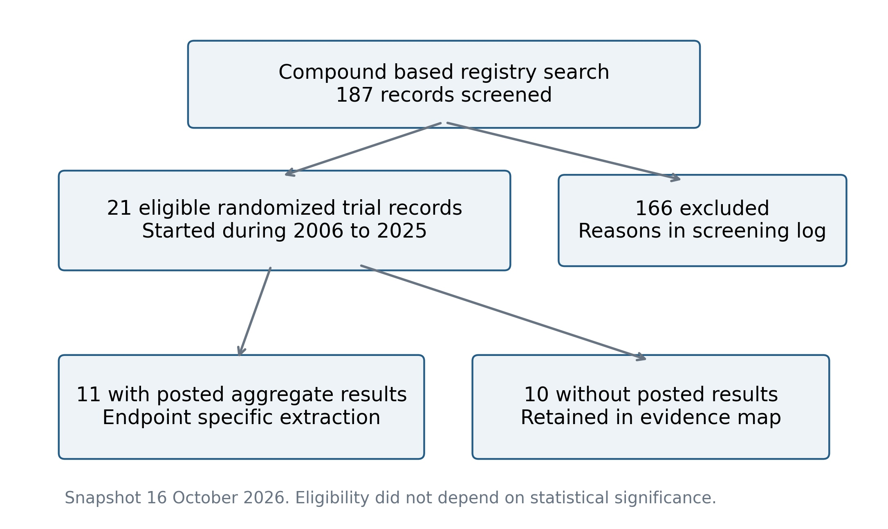
Figure 1. Selection of registry records.
The compound and synonym search yielded 187 records; 21 were classified as eligible direct randomized comparisons and 11 had posted aggregate results. Records without results remained in the evidence map. Counts are retained from the reported 16 October 2026 search; the full screening log and exact queries require author-supplied source materials.
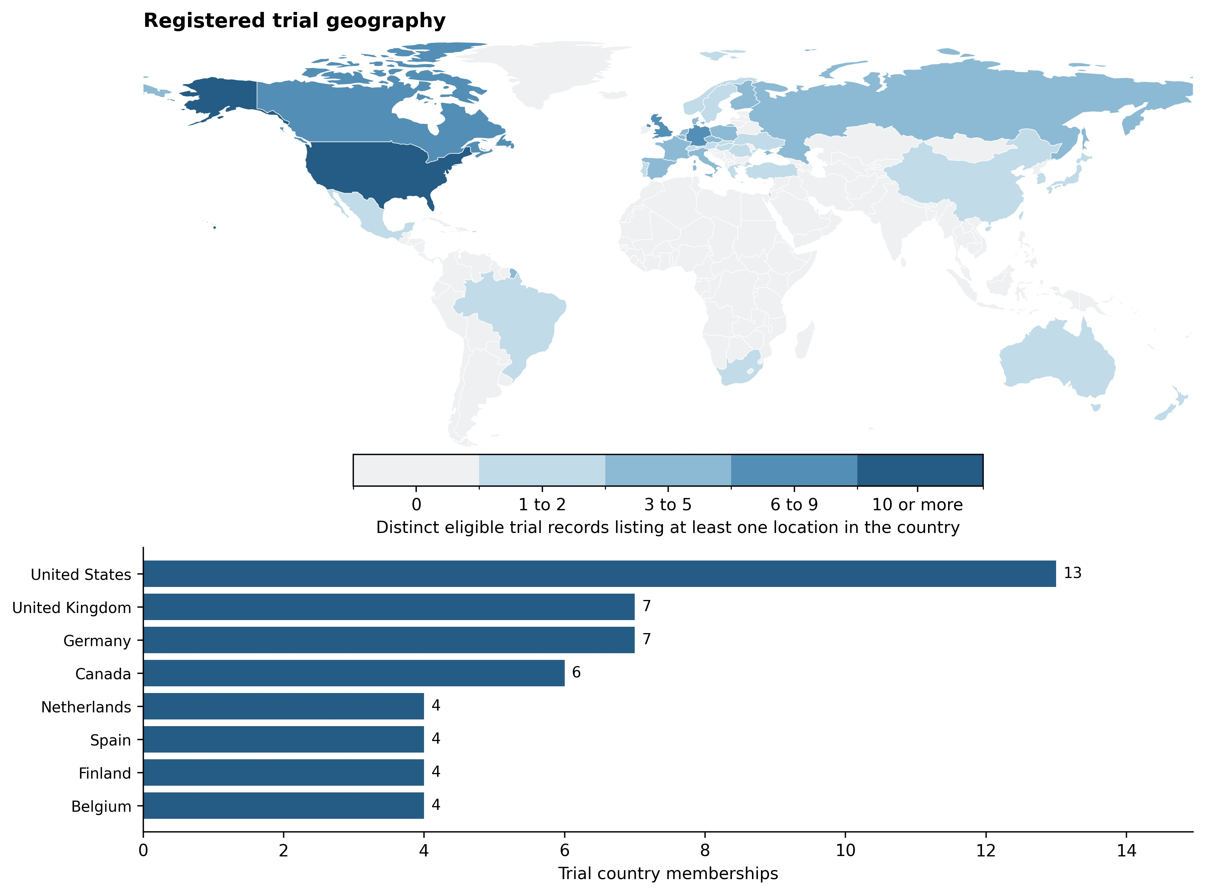
Figure 2. Geographic distribution of eligible trial records.
The upper panel maps distinct trial–country memberships; the lower panel shows the eight most frequently listed countries. The 21 records listed 36 countries or territories and 100 memberships. Counts describe registered research participation rather than participants, prevalence, or national uptake. Country names follow the registry, and the Natural Earth basemap is public domain [31].
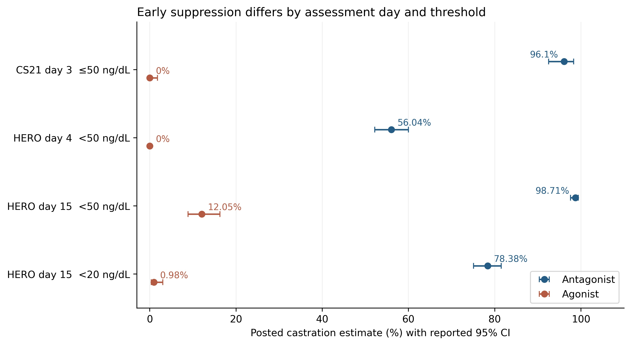
Figure 3. Early biochemical suppression by trial, assessment day, and threshold.
Points and intervals reproduce source-reported arm estimates and 95% confidence intervals. CS21 compares licensed-dose degarelix with leuprolide; HERO compares relugolix with leuprolide. HERO values are Kaplan–Meier probabilities, not reconstructed event fractions. Its day 4 leuprolide interval was not estimable. Sampling days and strict/inclusive testosterone thresholds remain distinct.
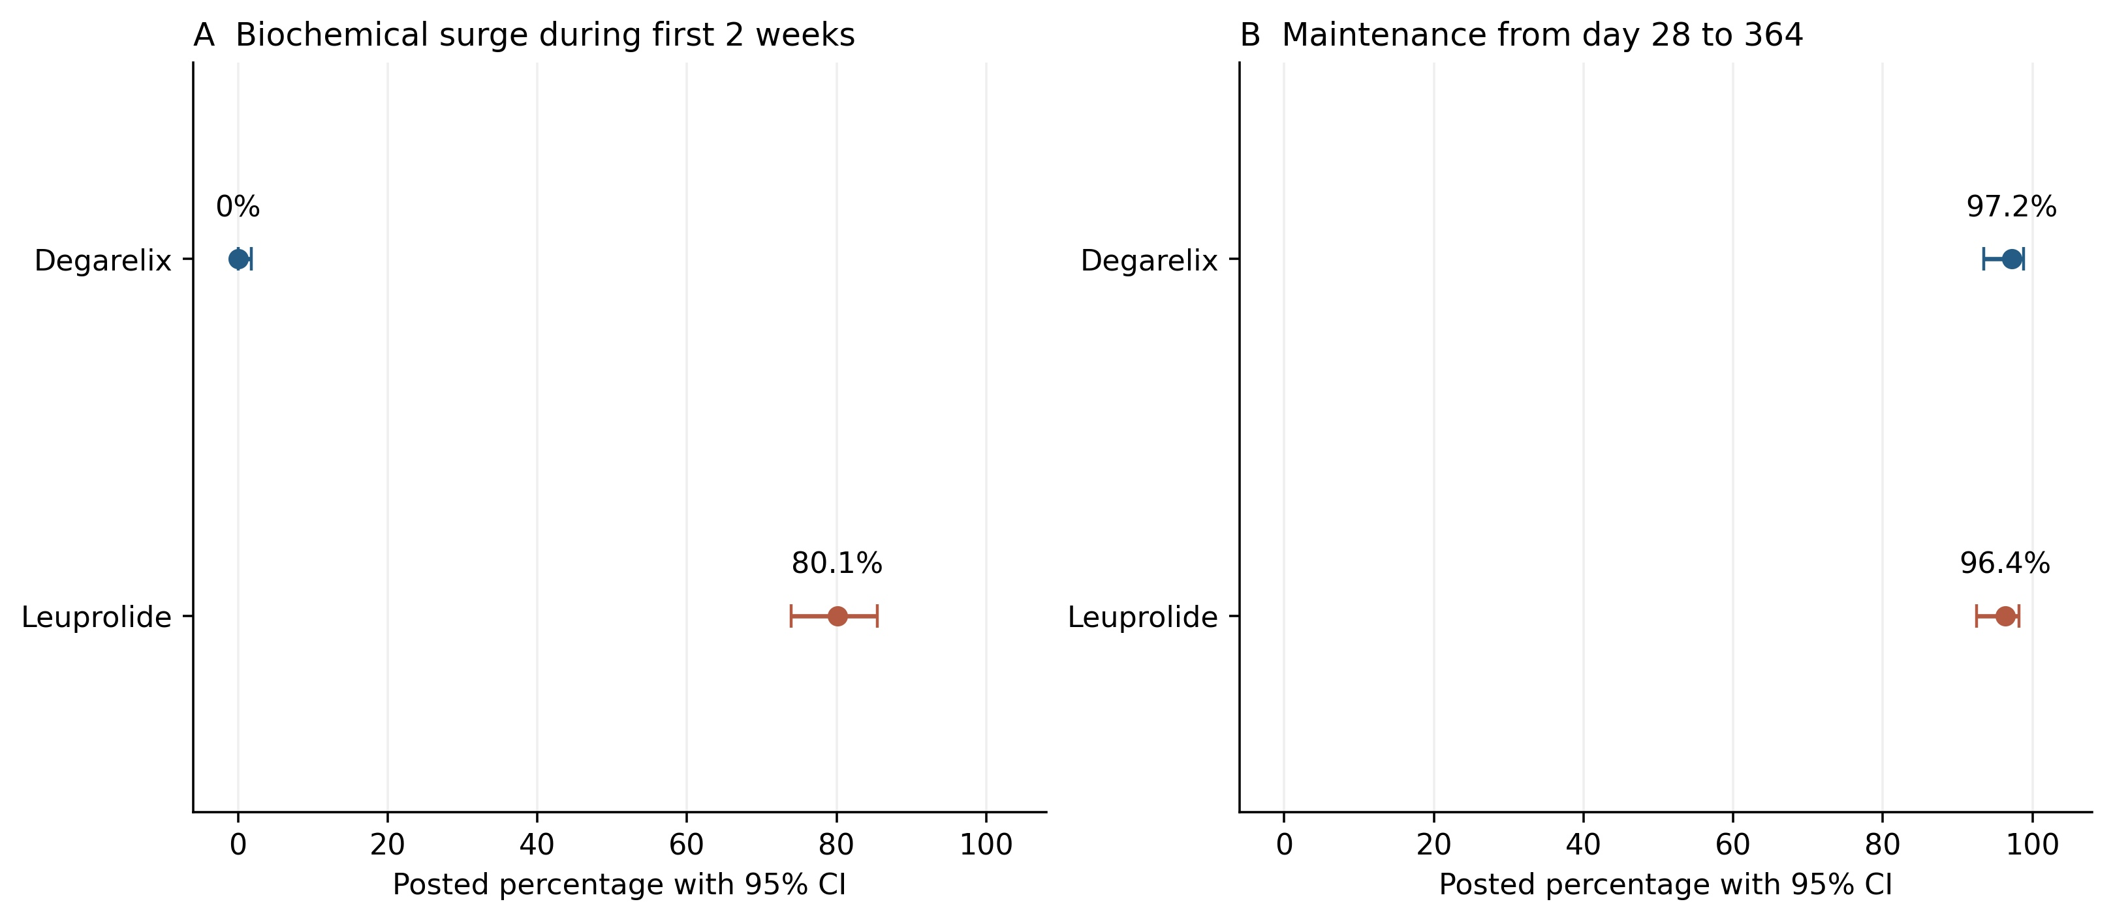
Figure 4. Biochemical surge and later maintenance in CS21.
A shows the source-defined testosterone surge during the first two weeks. B shows Kaplan–Meier suppression maintenance from day 28 to 364. Arm intervals are source-reported 95% confidence intervals; the direct maintenance contrast in Table 2 retains its distinct 97.5% confidence level. Biochemical surge is not an adjudicated symptomatic flare.
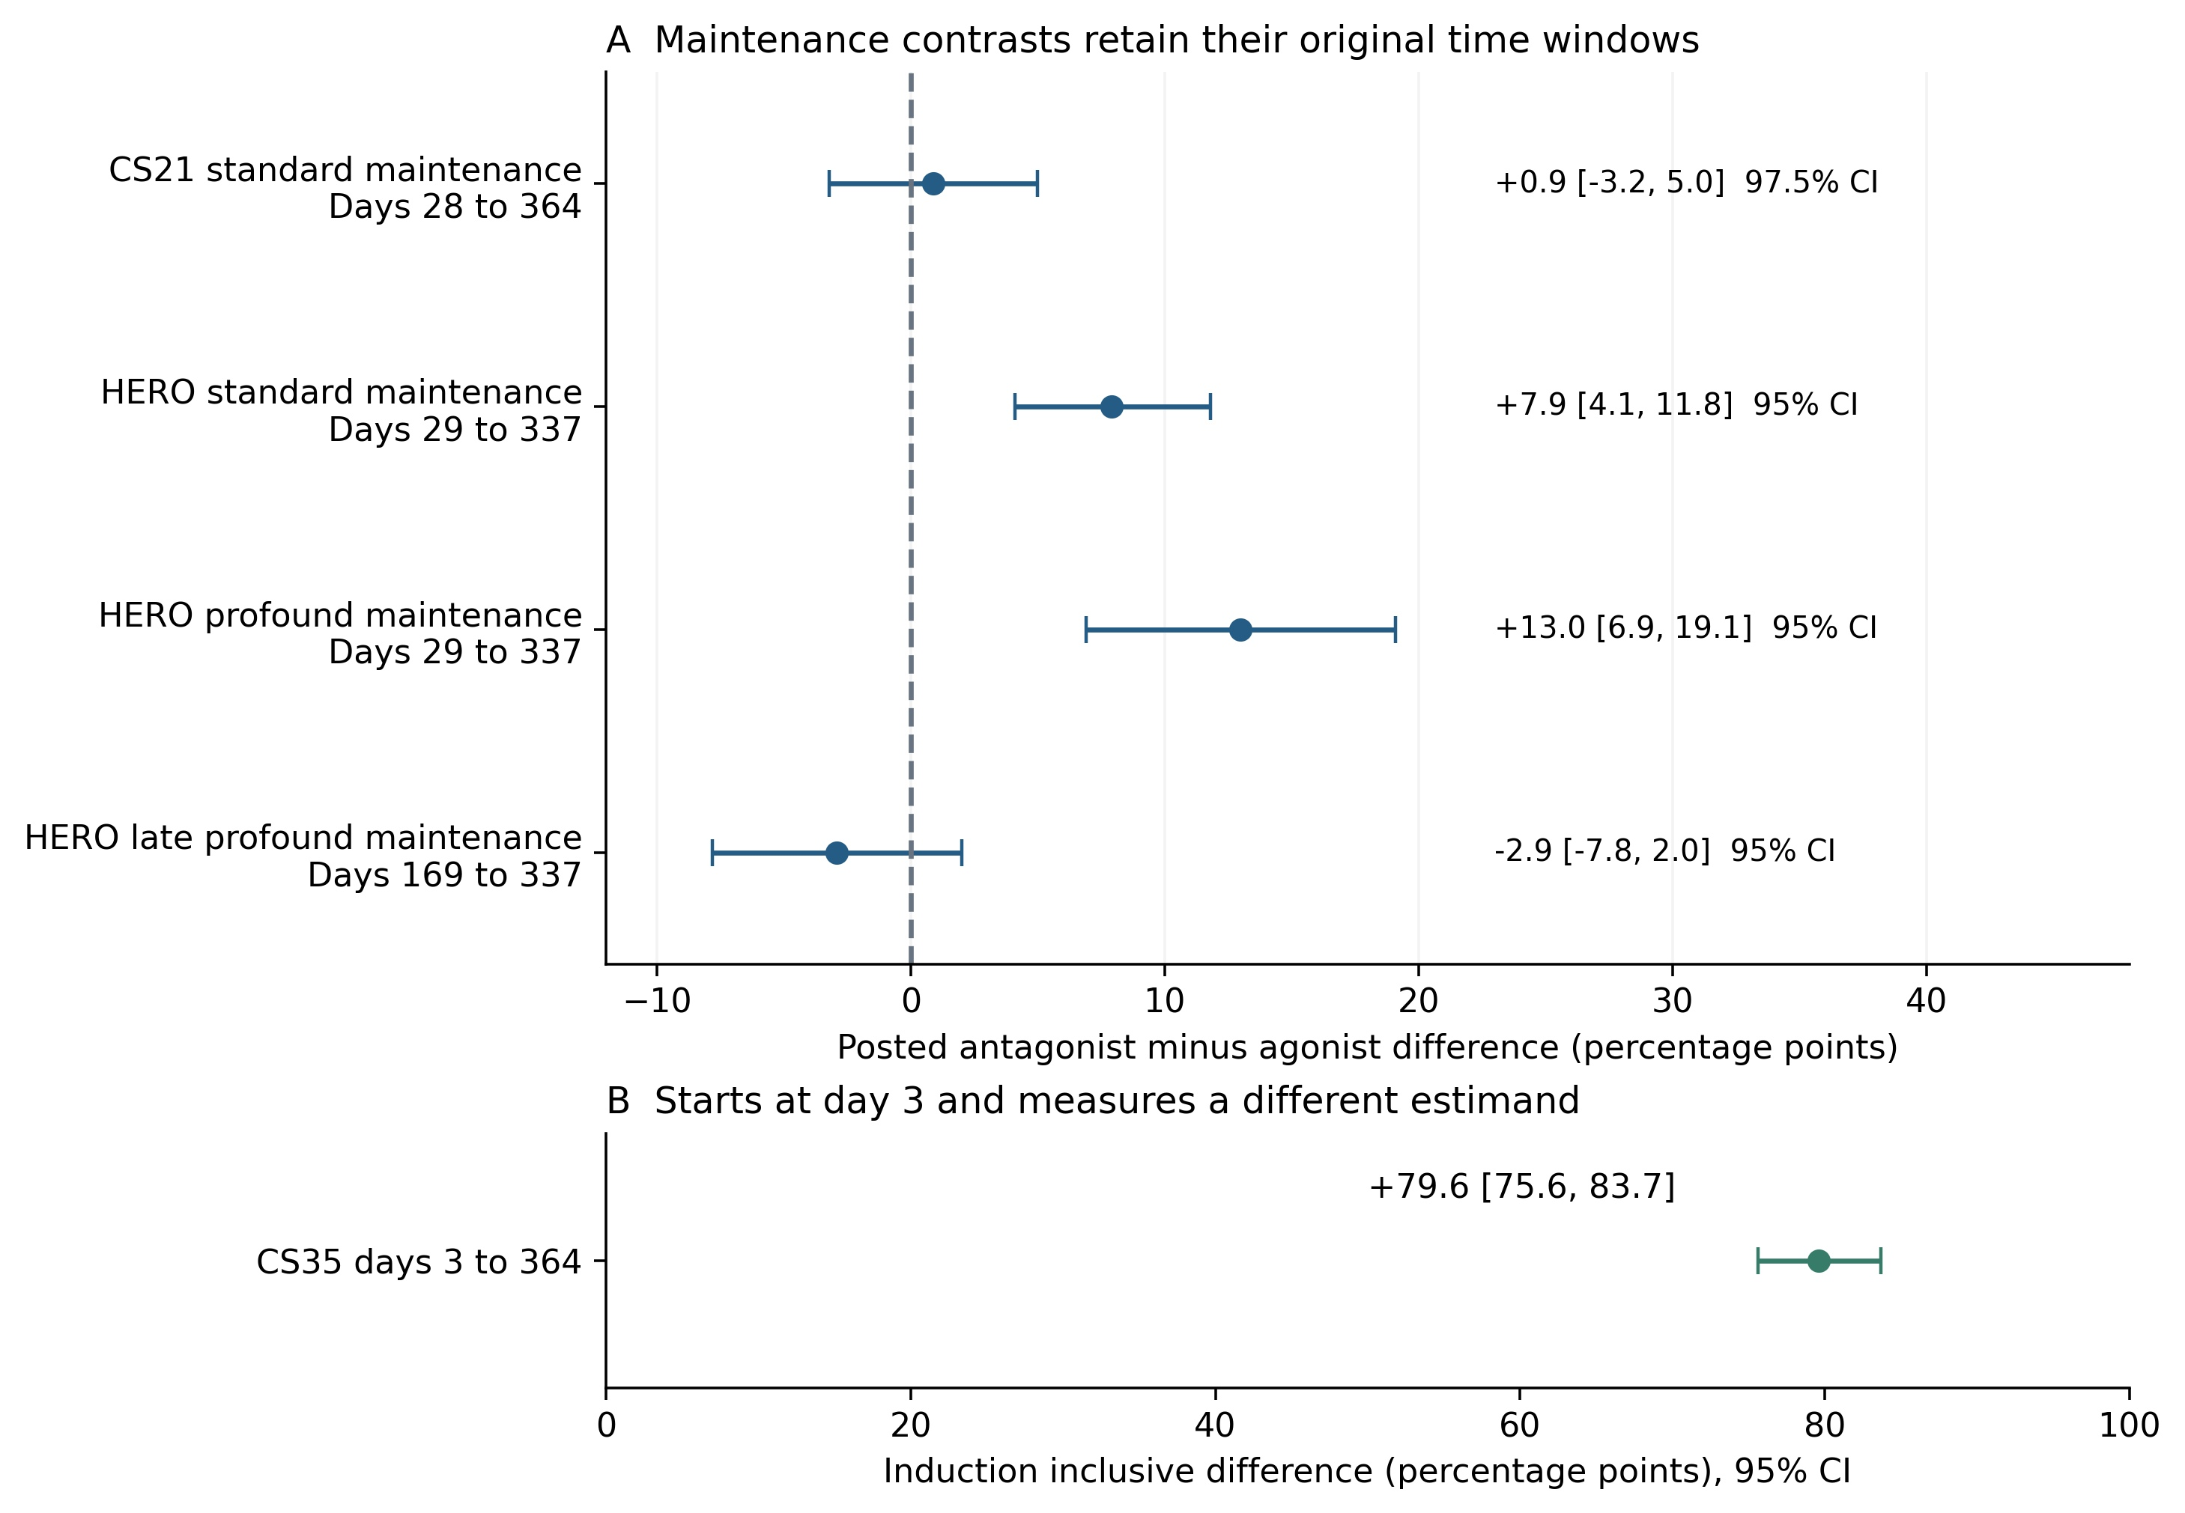
Figure 5. Dependence of endocrine contrasts on the observation window.
A preserves each standard- or profound-suppression interval and reported confidence level, including the 97.5% CS21 interval. B separately displays the CS35 day 3–364 endpoint, which includes induction. Positive differences favor the antagonist for suppression. C27002 is not plotted, and no pooled class effect was calculated.
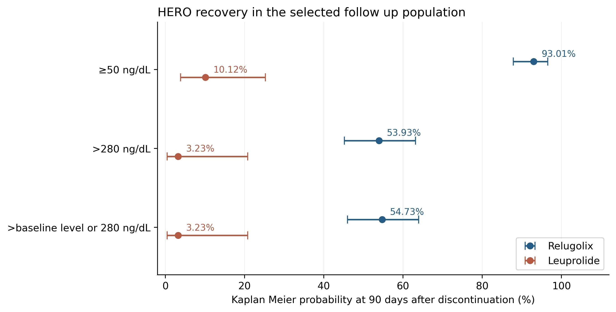
Figure 6. Testosterone recovery in the selected HERO follow-up population.
Points and 95% intervals are posted Kaplan–Meier probabilities at 90 days after discontinuation. The dedicated primary report identifies 137 relugolix and 47 leuprolide recipients, while the registry repeats main efficacy denominators [40]. Recovery selection was not a new randomization. Threshold labels follow the source; no participant event counts were reconstructed.
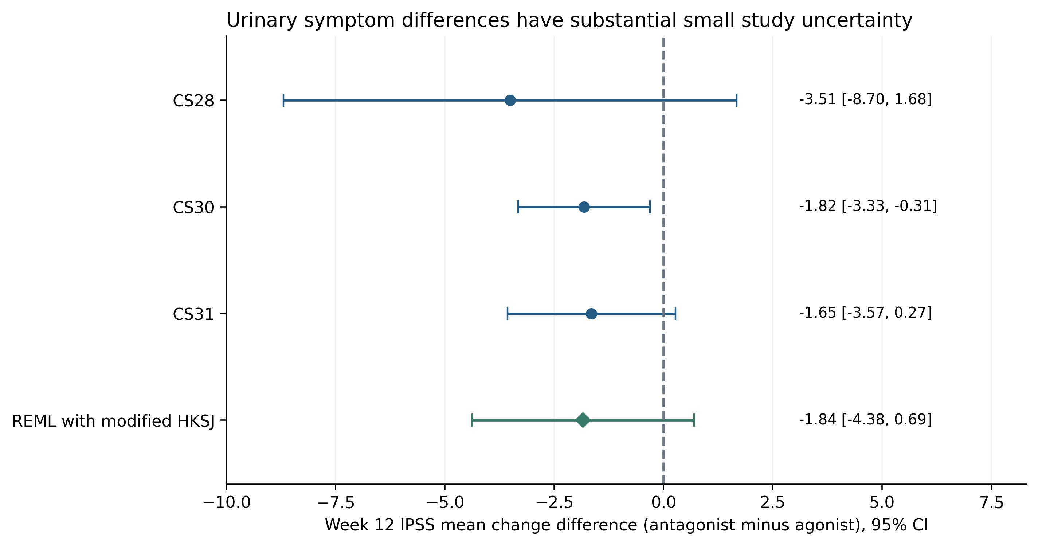
Figure 7. Week 12 IPSS change with degarelix versus goserelin plus bicalutamide.
Negative mean differences favor degarelix. Trial bars are unadjusted 95% confidence intervals. The pooled diamond uses restricted maximum likelihood with modified Hartung–Knapp–Sidik–Jonkman inference and two degrees of freedom: −1.84 points, 95% interval −4.38 to 0.69. Outcome denominators, missing-data methods, and the CS30 visit-specific denominator limitation are stated in Table 4.
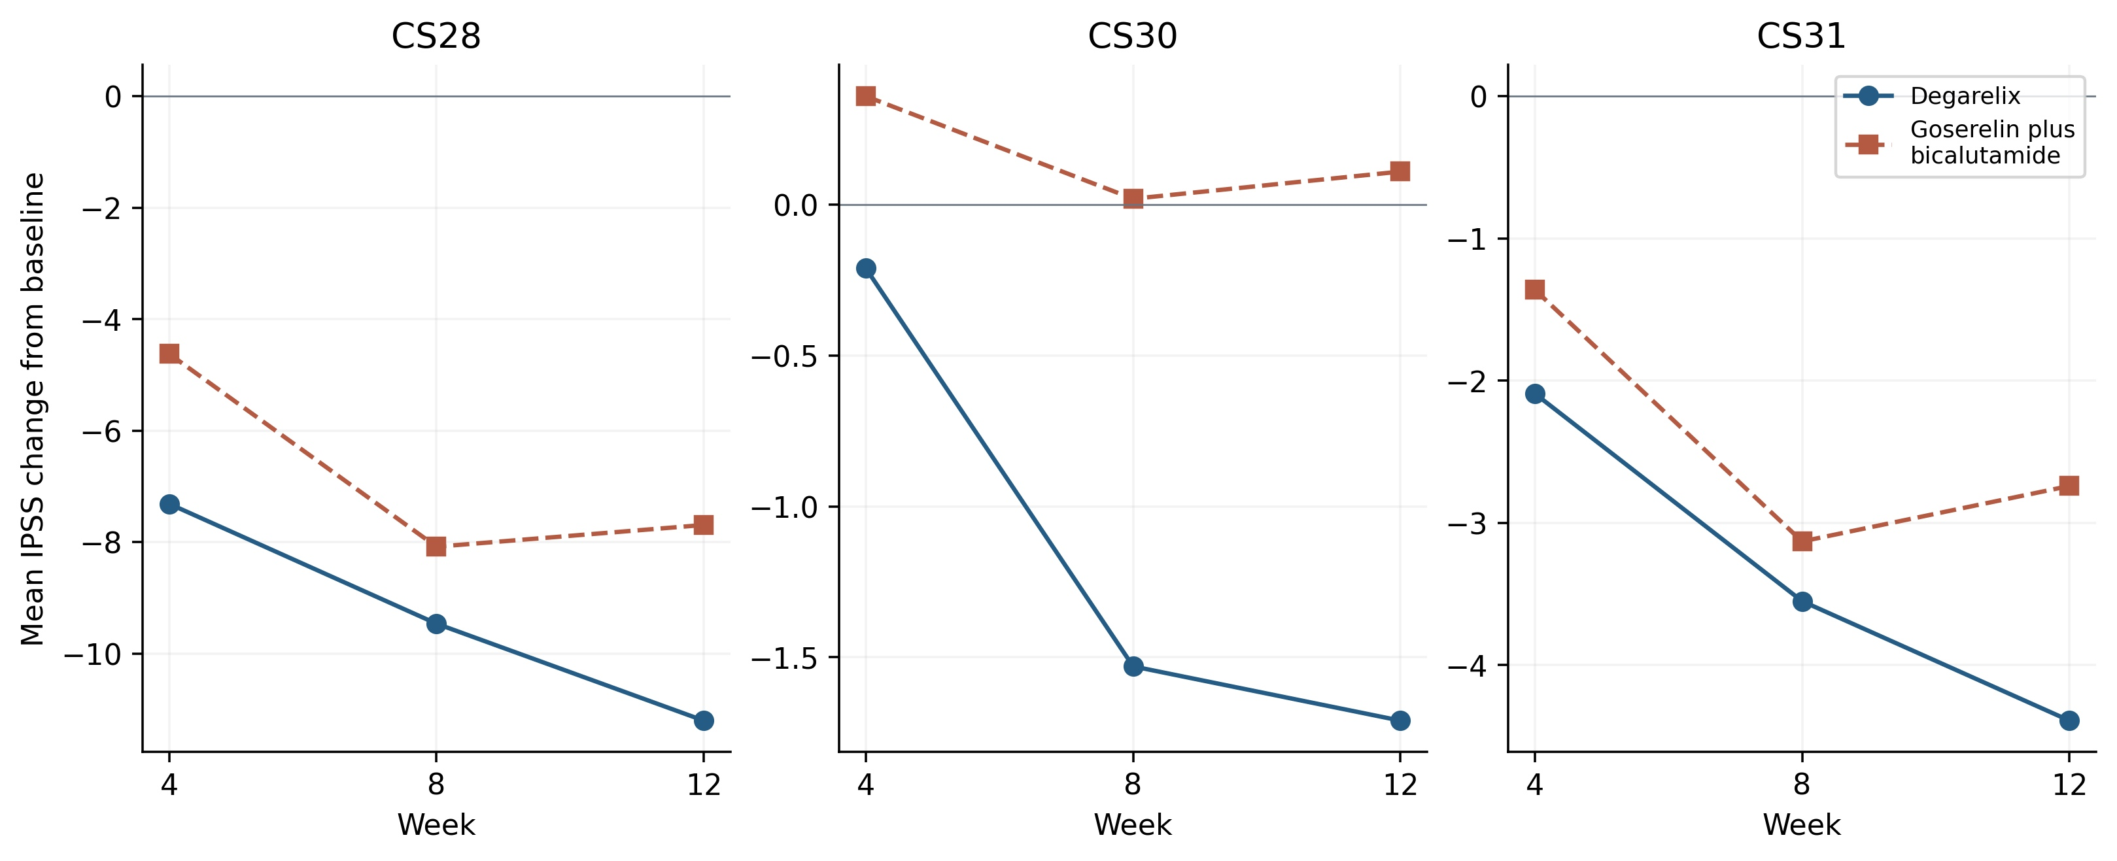
Figure 8. Descriptive IPSS trajectories at weeks 4, 8, and 12.
Panels show CS28, CS30, and CS31 from left to right, with separate vertical-axis scales and different trial populations. Goserelin regimens included short-course bicalutamide. Lines connect reported arm means and do not represent an independently fitted longitudinal model or additional independent comparisons. CS30’s agonist week 12 change is +0.11, so improvement was not uniform across all arms and visits.
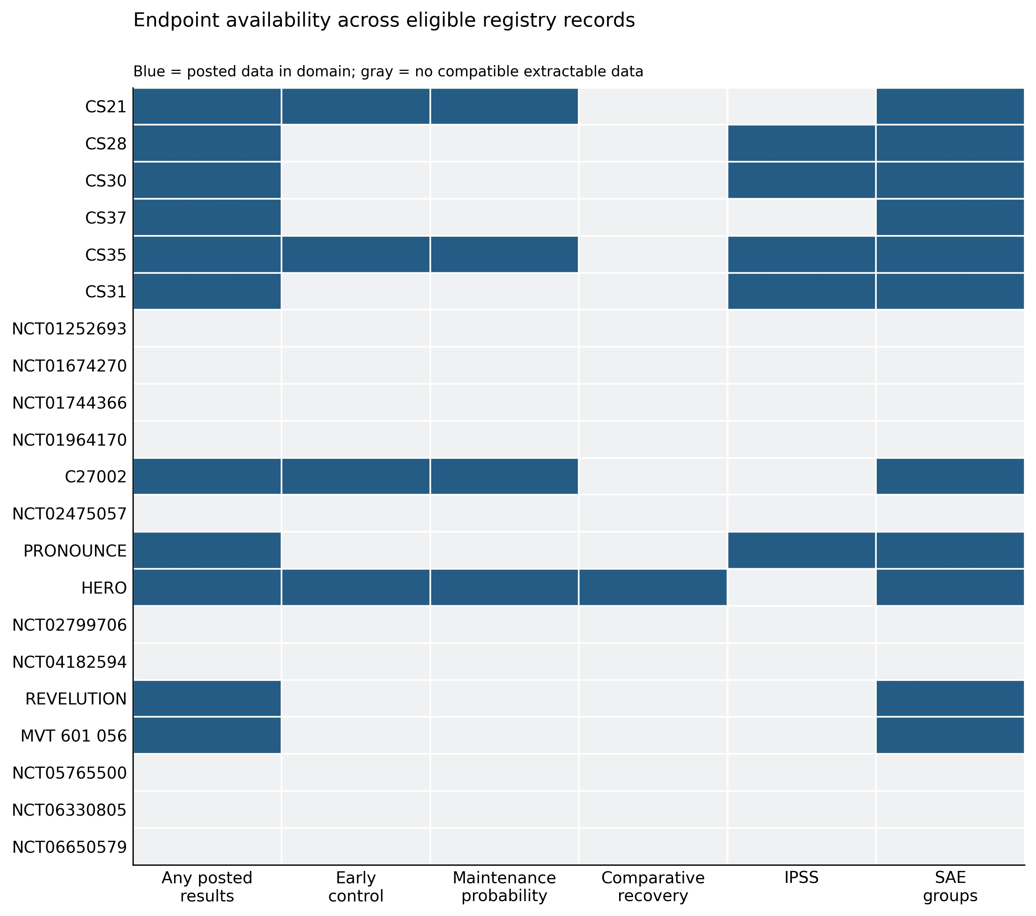
Figure 9. Availability of outcome domains among eligible records.
Blue indicates posted data in the specified domain; gray indicates no compatible extractable data. Availability does not indicate a favorable finding or low risk of bias. CS35 posts a conventional maintenance probability only for the antagonist arm. Comparative recovery is restricted to HERO; other cessation designs do not provide a matched withdrawal comparison.
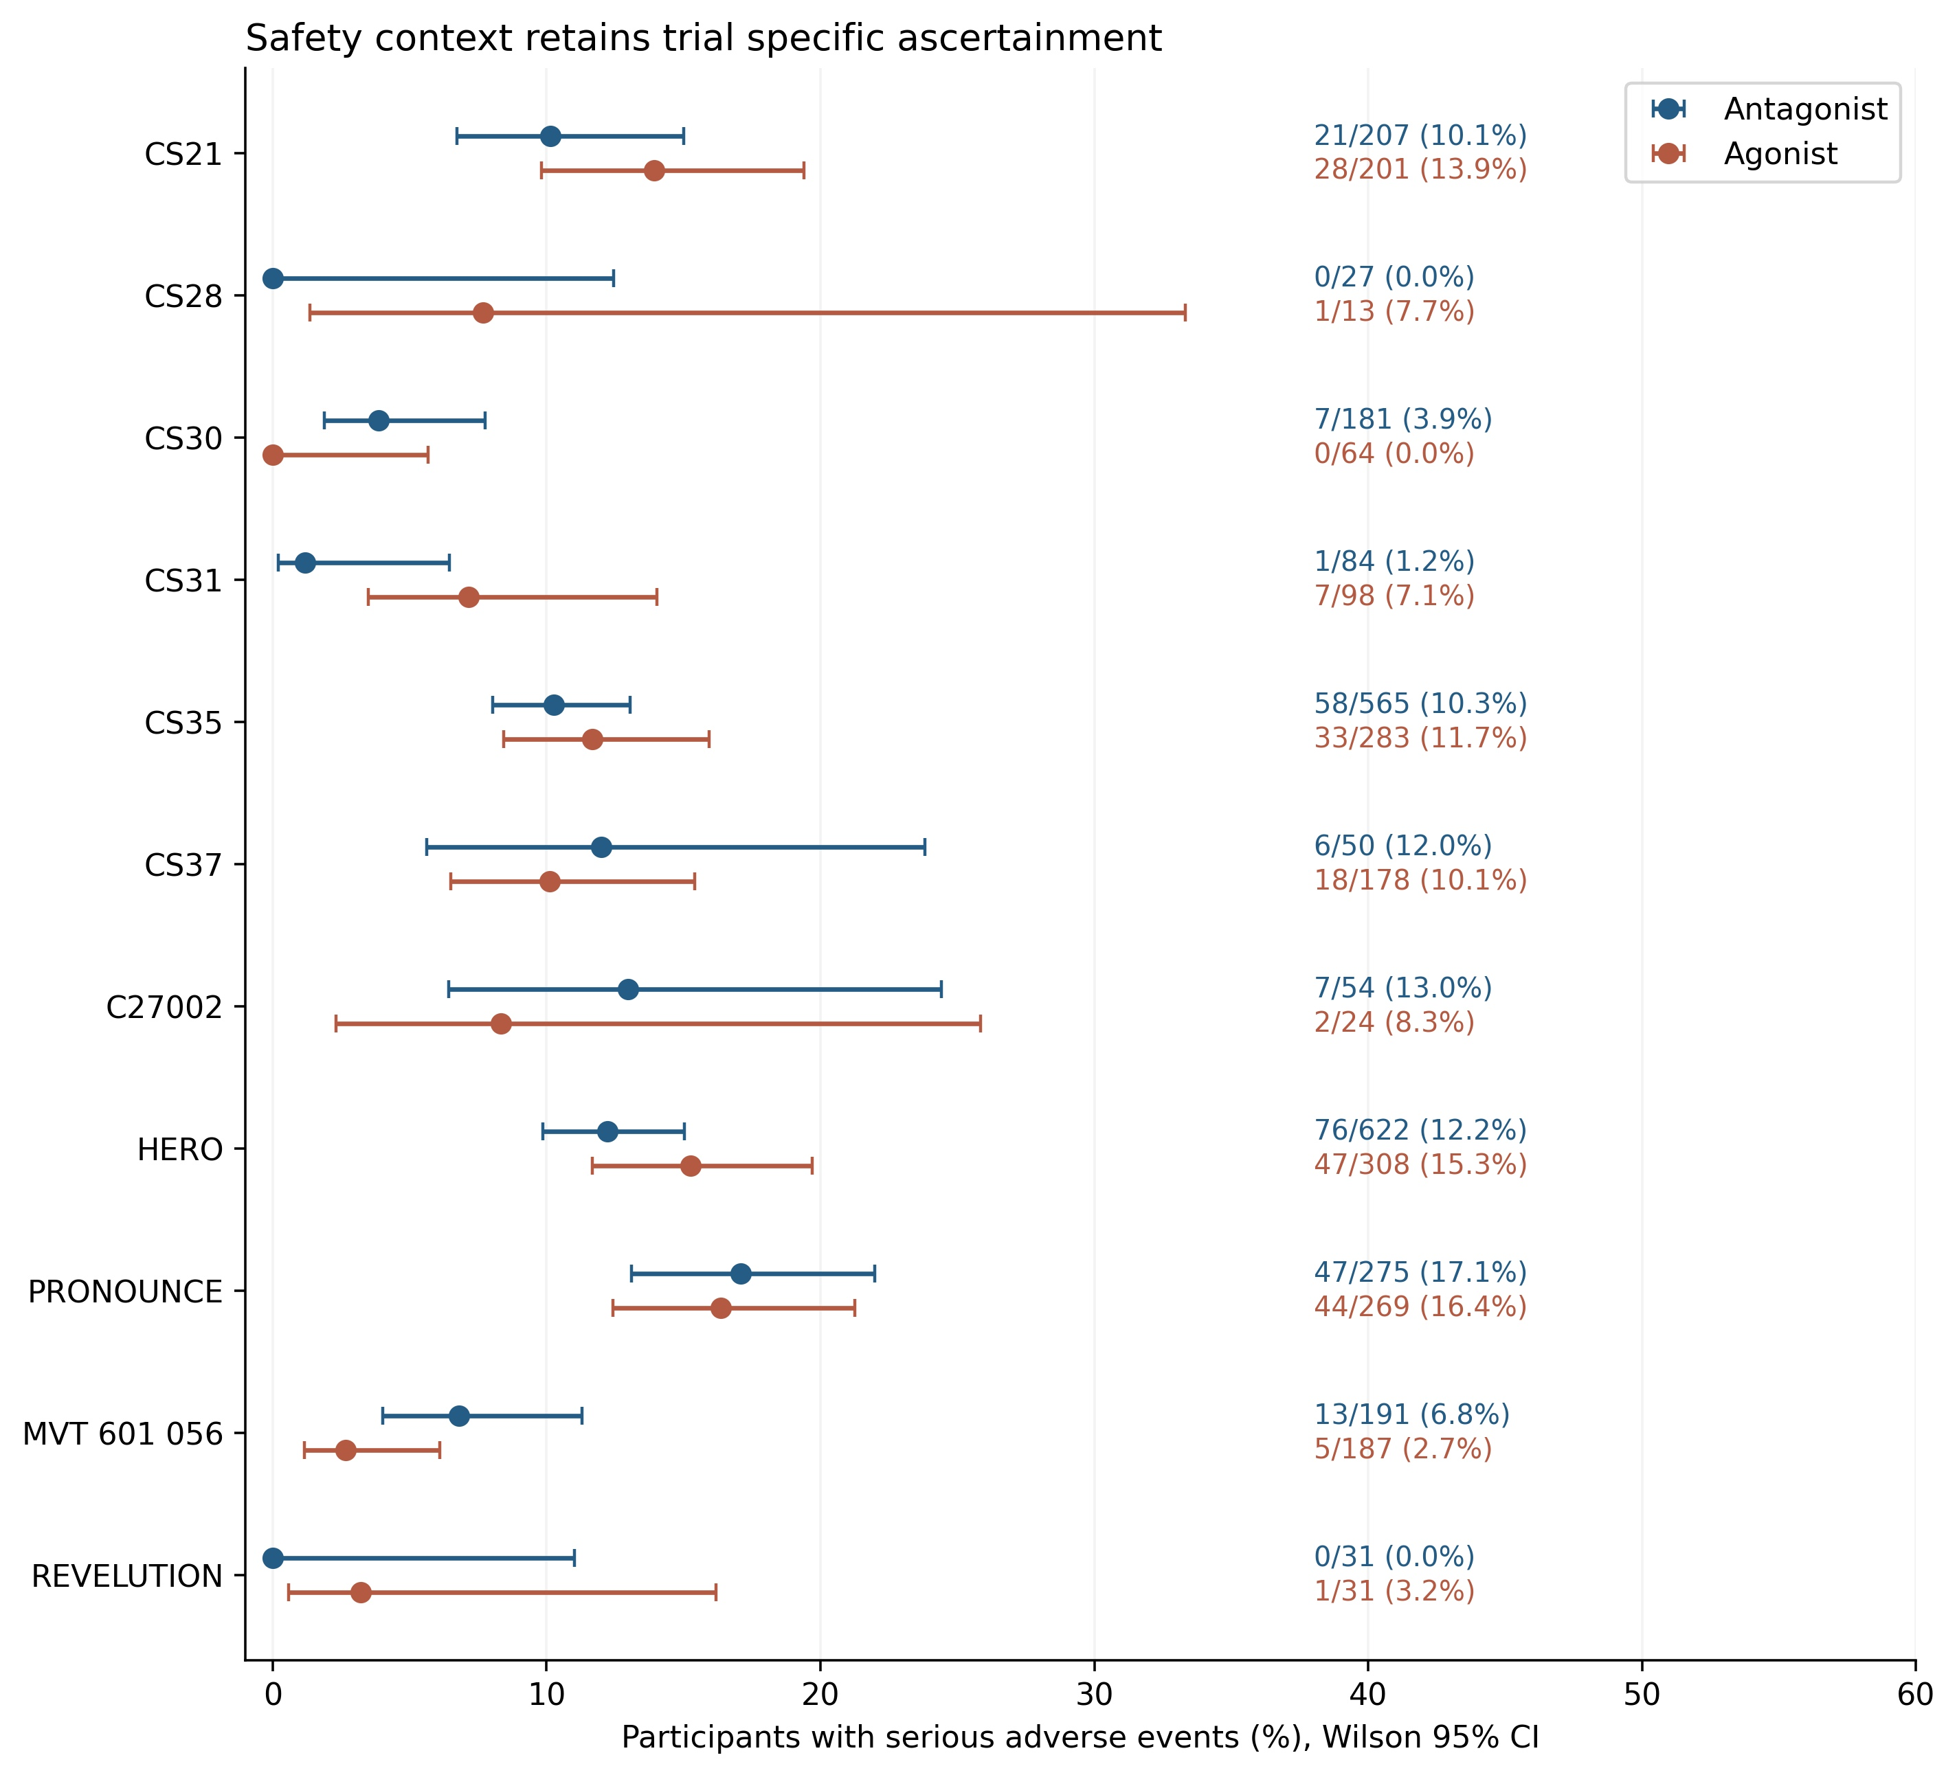
Figure 10. Serious adverse events in trials with posted results.
Points are affected-participant counts divided by explicit populations at risk; intervals are calculated Wilson 95% confidence intervals. Licensed-dose, continuous-treatment, or matched-background groups were selected as appropriate. Observation windows and ascertainment differ, and risks were not pooled. PRONOUNCE excludes specified nonfatal cardiovascular endpoint events from standard serious adverse event reporting. Table 5 provides the counts and windows.

Tables
Table 1. Registry records classified as eligible randomized comparisons
Trial | Start | Enrollment | Count type | Posted results
CS21  NCT00295750 | 2006-02 | 620 | Actual | Yes
CS28  NCT00831233 | 2009-04 | 42 | Actual | Yes
CS30  NCT00833248 | 2009-04 | 246 | Actual | Yes
CS37  NCT00928434 | 2009-05 | 409 | Actual | Yes
CS35  NCT00946920 | 2009-06 | 859 | Actual | Yes
CS31  NCT00884273 | 2009-08 | 182 | Actual | Yes
NCT01252693 | 2010-11 | 203 | Actual | No
NCT01674270 | 2012-08 | 35 | Actual | No
NCT01744366 | 2013-01 | 285 | Actual | No
NCT01964170 | 2013-08-13 | 234 | Actual | No
C27002  NCT02083185 | 2014-03-26 | 136 | Actual | Yes
NCT02475057 | 2015-08 | 80 | Actual | No
PRONOUNCE  NCT02663908 | 2016-04-19 | 545 | Actual | Yes
HERO  NCT03085095 | 2017-04-18 | 1134 | Actual | Yes
NCT02799706 | 2017-09-25 | 885 | Estimated | No
NCT04182594 | 2020-01-17 | 80 | Estimated | No
REVELUTION  NCT05320406 | 2022-06-06 | 94 | Actual | Yes
MVT 601 056  NCT05605964 | 2023-01-28 | 387 | Actual | Yes
NCT05765500 | 2024-02-12 | 110 | Estimated | No
NCT06330805 | 2024-08-12 | 70 | Estimated | No
NCT06650579 | 2025-01-31 | 72 | Estimated | No
Enrollment refers to the whole registry record rather than an endpoint analysis population. Actual and estimated counts are distinguished and were not summed as observed participants. Posted results indicates availability of summary results at the 16 October 2026 snapshot. NCT identifiers identify the source registrations; conflicting C27002 design descriptions are documented in Supplementary Table S1.
Table 2. Endocrine comparisons retain their observation windows
Trial | Window | Antagonist % | Agonist % | Difference pp | Reported interval
CS21 | Days 28 to 364 | 97.2 | 96.4 | +0.9 | -3.2 to 5.0 (97.5% CI)
HERO standard | Days 29 to 337 | 96.7 | 88.8 | +7.9 | 4.1 to 11.8 (95% CI)
HERO profound | Days 29 to 337 | 81.6 | 68.6 | +13.0 | 6.9 to 19.1 (95% CI)
HERO late profound | Days 169 to 337 | 84.6 | 87.5 | -2.9 | -7.8 to 2.0 (95% CI)
C27002 120 mg | Weeks 5 to 25 | 91.0 | 96 | -5.0 descriptive | Contrast interval not posted
CS35 induction inclusive | Days 3 to 364 | 85.0 | 5.3 | +79.6 | 75.6 to 83.7 (95% CI)
CS35 maintenance | Days 28 to 364 | 90.0 | Not posted | Not estimable | Comparator absent
Antagonist and agonist values are percentages. Standard suppression uses 50 ng/dL or its equivalent; profound suppression uses 20 ng/dL. Source-reported direct contrasts take precedence over subtraction of rounded arm percentages. The C27002 difference is descriptive only. CS35 day 3–364 includes induction; its day 28–364 outcome lacks a posted comparator estimate. Confidence levels are retained as reported.
Table 3. HERO recovery probabilities at 90 days after discontinuation
Threshold | Relugolix % | Leuprolide % | Difference pp
≥50 ng/dL | 93.01 | 10.12 | 82.89
>280 ng/dL | 53.93 | 3.23 | 50.7
>baseline level or 280 ng/dL | 54.73 | 3.23 | 51.5
Values are source-reported Kaplan–Meier percentages. Differences are descriptive subtractions of relugolix minus leuprolide, without separately reported contrast intervals. Figure 6 displays the arm intervals. The registry repeats main efficacy denominators, whereas the dedicated primary report identifies a selected recovery subset of 137 relugolix and 47 leuprolide recipients [40]; these probabilities were not converted to participant event counts.
Table 4. Compatible week 12 urinary symptom comparisons
Trial | N antagonist / agonist | Antagonist mean (SD) | Agonist mean (SD) | MD [95% CI]
CS28 | 27/13 | -11.20 (8.29) | -7.69 (7.61) | -3.51 [-8.70, 1.68]
CS30 | 177/63 | -1.71 (5.54) | 0.11 (5.13) | -1.82 [-3.33, -0.31]
CS31 | 82/97 | -4.39 (6.66) | -2.74 (6.37) | -1.65 [-3.57, 0.27]
Means are change from baseline; SD denotes standard deviation. MD is antagonist minus agonist, and negative values favor degarelix. All three agonist regimens included goserelin plus short-course bicalutamide. N is the registry outcome-level denominator. CS28 and CS31 used last observation carried forward (LOCF); CS30 used observed cases. CS30 supplies no visit-specific denominators: its week 12 standard error and interval depend on applying the repeated outcome denominators 177 and 63 and may overstate precision if follow-up is missing. The pooled modified 95% interval is −4.38 to 0.69; the conventional normal interval is −3.00 to −0.69. No participant-level adjustment was possible.
Table 5. Explicit serious adverse event counts in selected randomized contrasts
Trial | Antagonist | Agonist | Observation window
CS21 | 21/207 (10.1%) | 28/201 (13.9%) | AE field unspecified
CS28 | 0/27 (0.0%) | 1/13 (7.7%) | 12 weeks
CS30 | 7/181 (3.9%) | 0/64 (0.0%) | 12 weeks
CS31 | 1/84 (1.2%) | 7/98 (7.1%) | 12 weeks
CS35 | 58/565 (10.3%) | 33/283 (11.7%) | To day 364
CS37 | 6/50 (12.0%) | 18/178 (10.1%) | 15 months
C27002 | 7/54 (13.0%) | 2/24 (8.3%) | Up to 106.7 weeks
HERO | 76/622 (12.2%) | 47/308 (15.3%) | Up to 52 weeks
PRONOUNCE | 47/275 (17.1%) | 44/269 (16.4%) | Treatment plus 3 months
MVT 601 056 | 13/191 (6.8%) | 5/187 (2.7%) | Up to 1 year
REVELUTION | 0/31 (0.0%) | 1/31 (3.2%) | 12 months
Counts are affected participants and explicit safety denominators. CS21 denominators were identified from consistent event-level numAtRisk fields. CS37 uses the continuous-degarelix and continuous-leuprolide event groups, not whole-trial enrollment. Observation windows and ascertainment differ, and PRONOUNCE has specified cardiovascular event reporting exceptions. These counts were not pooled and do not establish a comprehensive safety ranking.

References
1. Klotz L, Boccon-Gibod L, Shore ND, Andreou C, Persson BE, Cantor P, et al. The efficacy and safety of degarelix: a 12-month, comparative, randomized, open-label, parallel-group phase III study in patients with prostate cancer. BJU Int. 2008;102(11):1531-1538. doi:10.1111/j.1464-410X.2008.08183.x. PMID:19035858.
2. Shore ND, Saad F, Cookson MS, George DJ, Saltzstein DR, Tutrone R, et al. Oral Relugolix for Androgen-Deprivation Therapy in Advanced Prostate Cancer. N Engl J Med. 2020;382(23):2187-2196. doi:10.1056/NEJMoa2004325. PMID:32469183.
3. Klotz L, O'Callaghan C, Ding K, Toren P, Dearnaley D, Higano CS, et al. Nadir testosterone within first year of androgen-deprivation therapy (ADT) predicts for time to castration-resistant progression: a secondary analysis of the PR-7 trial of intermittent versus continuous ADT. J Clin Oncol. 2015;33(10):1151-1156. doi:10.1200/JCO.2014.58.2973. PMID:25732157.
4. Tombal B, Miller K, Boccon-Gibod L, Schröder F, Shore N, Crawford ED, et al. Additional analysis of the secondary end point of biochemical recurrence rate in a phase 3 trial (CS21) comparing degarelix 80 mg versus leuprolide in prostate cancer patients segmented by baseline characteristics. Eur Urol. 2010;57(5):836-842. doi:10.1016/j.eururo.2009.11.029. PMID:19962227.
5. Smith MR, Klotz L, Persson BE, Olesen TK, Wilde AA. Cardiovascular safety of degarelix: results from a 12-month, comparative, randomized, open label, parallel group phase III trial in patients with prostate cancer. J Urol. 2010;184(6):2313-2319. doi:10.1016/j.juro.2010.08.012. PMID:20952020.
6. Crawford ED, Tombal B, Miller K, Boccon-Gibod L, Schröder F, Shore N, et al. A phase III extension trial with a 1-arm crossover from leuprolide to degarelix: comparison of gonadotropin-releasing hormone agonist and antagonist effect on prostate cancer. J Urol. 2011;186(3):889-897. doi:10.1016/j.juro.2011.04.083. PMID:21788033.
7. Klotz L, Miller K, Crawford ED, Shore N, Tombal B, Karup C, et al. Disease control outcomes from analysis of pooled individual patient data from five comparative randomised clinical trials of degarelix versus luteinising hormone-releasing hormone agonists. Eur Urol. 2014;66(6):1101-1108. doi:10.1016/j.eururo.2013.12.063. PMID:24440304.
8. Dearnaley DP, Saltzstein DR, Sylvester JE, Karsh L, Mehlhaff BA, Pieczonka C, et al. The Oral Gonadotropin-releasing Hormone Receptor Antagonist Relugolix as Neoadjuvant/Adjuvant Androgen Deprivation Therapy to External Beam Radiotherapy in Patients with Localised Intermediate-risk Prostate Cancer: A Randomised, Open-label, Parallel-group Phase 2 Trial. Eur Urol. 2020;78(2):184-192. doi:10.1016/j.eururo.2020.03.001. PMID:32273183.
9. Spratt DE, George DJ, Shore ND, Cookson MS, Saltzstein DR, Tutrone R, et al. Efficacy and Safety of Radiotherapy Plus Relugolix in Men With Localized or Advanced Prostate Cancer. JAMA Oncol. 2024;10(5):594-602. doi:10.1001/jamaoncol.2023.7279. PMID:38451492.
10. Korzeniowski MA, Crook JM, Bowes D, Gaztañaga M, Ots A, Jazwal J, et al. A Phase II trial of 8 weeks of degarelix for prostate volume reduction: Efficacy and hormonal recovery. Brachytherapy. 2018;17(3):530-536. doi:10.1016/j.brachy.2017.12.005. PMID:29398594.
11. Klotz L, Loblaw A, Siemens R, Ouellette P, Kapoor A, Kebabdjian M, et al. A Phase II, Randomized, Multicenter Study Comparing 10 Months versus 4 Months of Degarelix Therapy in Prolonging the Off Treatment Interval in Men with Localized Prostate Cancer Receiving Intermittent Androgen Deprivation Therapy for Biochemical Recurrence following Radical Local Therapy. J Urol. 2018;200(2):335-343. doi:10.1016/j.juro.2018.03.010. PMID:29534997.
12. Zarin DA, Tse T, Williams RJ, Califf RM, Ide NC. The ClinicalTrials.gov results database--update and key issues. N Engl J Med. 2011;364(9):852-60. doi:10.1056/NEJMsa1012065. PMID:21366476.
13. Zarin DA, Fain KM, Dobbins HD, Tse T, Williams RJ. 10-Year Update on Study Results Submitted to ClinicalTrials.gov. N Engl J Med. 2019;381(20):1966-1974. doi:10.1056/NEJMsr1907644. PMID:31722160.
14. Tse T, Fain KM, Zarin DA. How to avoid common problems when using ClinicalTrials.gov in research: 10 issues to consider. BMJ. 2018;361:k1452. doi:10.1136/bmj.k1452. PMID:29802130.
15. Hunter KE, Webster AC, Page MJ, Willson M, McDonald S, Berber S, et al. Searching clinical trials registers: guide for systematic reviewers. BMJ. 2022;377:e068791. doi:10.1136/bmj-2021-068791. PMID:35473822.
16. Page MJ, McKenzie JE, Bossuyt PM, Boutron I, Hoffmann TC, Mulrow CD, et al. The PRISMA 2020 statement: an updated guideline for reporting systematic reviews. BMJ. 2021;372:n71. doi:10.1136/bmj.n71. PMID:33782057.
17. ClinicalTrials.gov. ClinicalTrials.gov API version 2.0. News and Updates. 19 March 2024. https://clinicaltrials.gov/about-site/news-and-updates. Accessed 18 October 2026.
18. National Library of Medicine. ClinicalTrials.gov Terms and Conditions. Accessed 16 October 2026. https://clinicaltrials.gov/about-site/terms-conditions
19. ClinicalTrials.gov. A Study of Degarelix in Patients With Prostate Cancer. NCT00928434. Registry record and posted aggregate results. Accessed 16 October 2026. https://clinicaltrials.gov/study/NCT00928434
20. ClinicalTrials.gov. RElugolix VErsus LeUprolide Cardiac Trial. NCT05320406. Registry record and posted aggregate results. Accessed 16 October 2026. https://clinicaltrials.gov/study/NCT05320406
21. Hartung DM, Zarin DA, Guise JM, McDonagh M, Paynter R, Helfand M. Reporting discrepancies between the ClinicalTrials.gov results database and peer-reviewed publications. Ann Intern Med. 2014;160(7):477-83. doi:10.7326/M13-0480. PMID:24687070.
22. ClinicalTrials.gov. Symptomatic Study Investigating Degarelix in Patients Suffering From Prostate Cancer. NCT00831233. Registry record and posted aggregate results. Accessed 16 October 2026. https://clinicaltrials.gov/study/NCT00831233
23. ClinicalTrials.gov. Neoadjuvant Study Investigating Degarelix in Patients Suffering From Prostate Cancer. NCT00833248. Registry record and posted aggregate results. Accessed 16 October 2026. https://clinicaltrials.gov/study/NCT00833248
24. ClinicalTrials.gov. Investigation of the Effect of Degarelix in Terms of Prostate Volume Reduction in Prostate Cancer Patients. NCT00884273. Registry record and posted aggregate results. Accessed 16 October 2026. https://clinicaltrials.gov/study/NCT00884273
25. IntHout J, Ioannidis JP, Borm GF. The Hartung-Knapp-Sidik-Jonkman method for random effects meta-analysis is straightforward and considerably outperforms the standard DerSimonian-Laird method. BMC Med Res Methodol. 2014;14:25. doi:10.1186/1471-2288-14-25. PMID:24548571.
26. Röver C, Knapp G, Friede T. Hartung-Knapp-Sidik-Jonkman approach and its modification for random-effects meta-analysis with few studies. BMC Med Res Methodol. 2015;15:99. doi:10.1186/s12874-015-0091-1. PMID:26573817.
27. Veroniki AA, Jackson D, Viechtbauer W, Bender R, Bowden J, Knapp G, et al. Methods to estimate the between-study variance and its uncertainty in meta-analysis. Res Synth Methods. 2016;7(1):55-79. doi:10.1002/jrsm.1164. PMID:26332144.
28. Higgins JP, Thompson SG, Deeks JJ, Altman DG. Measuring inconsistency in meta-analyses. BMJ. 2003;327(7414):557-60. doi:10.1136/bmj.327.7414.557. PMID:12958120.
29. Barry MJ, Williford WO, Chang Y, Machi M, Jones KM, Walker-Corkery E, et al. Benign prostatic hyperplasia specific health status measures in clinical research: how much change in the American Urological Association symptom index and the benign prostatic hyperplasia impact index is perceptible to patients?. J Urol. 1995;154(5):1770-1774. doi:10.1016/s0022-5347(01)66780-6. PMID:7563343.
30. ClinicalTrials.gov. Randomized Study to Evaluate MACE in Patients With Prostate Cancer Treated With Relugolix or Leuprolide Acetate. NCT05605964. Registry record and posted aggregate results. Accessed 16 October 2026. https://clinicaltrials.gov/study/NCT05605964
31. Natural Earth. About Natural Earth Vector [README]. https://raw.githubusercontent.com/nvkelso/natural-earth-vector/ca96624a56bd078437bca8184e78163e5039ad19/README.md. Accessed 18 October 2026.
32. Sterne JAC, Savović J, Page MJ, Elbers RG, Blencowe NS, Boutron I, et al. RoB 2: a revised tool for assessing risk of bias in randomised trials. BMJ. 2019;366:l4898. doi:10.1136/bmj.l4898. PMID:31462531.
33. Guyatt GH, Oxman AD, Vist GE, Kunz R, Falck-Ytter Y, Alonso-Coello P, et al. GRADE: an emerging consensus on rating quality of evidence and strength of recommendations. BMJ. 2008;336(7650):924-6. doi:10.1136/bmj.39489.470347.AD. PMID:18436948.
34. Sun Y, Xie L, Xu T, Jakobsen JS, Han W, Sørensen PS, et al. Efficacy and safety of degarelix in patients with prostate cancer: Results from a phase III study in China. Asian J Urol. 2020;7(3):301-308. doi:10.1016/j.ajur.2019.09.003. PMID:32742930.
35. Ozono S, Tsukamoto T, Naito S, Horie S, Ohashi Y, Uemura H, et al. Efficacy and safety of 3-month dosing regimen of degarelix in Japanese subjects with prostate cancer: A phase III study. Cancer Sci. 2018;109(6):1920-1929. doi:10.1111/cas.13600. PMID:29624800.
36. ClinicalTrials.gov. The Efficacy and Safety of Degarelix One Month Dosing Regimens in Prostate Cancer. NCT00295750. Registry record and posted aggregate results. Accessed 16 October 2026. https://clinicaltrials.gov/study/NCT00295750
37. ClinicalTrials.gov. A Study to Evaluate the Safety and Efficacy of Relugolix in Men With Advanced Prostate Cancer. NCT03085095. Registry record and posted aggregate results. Accessed 16 October 2026. https://clinicaltrials.gov/study/NCT03085095
38. ClinicalTrials.gov. A Phase 2 Study to Evaluate the Safety and Efficacy of TAK-385, Together With a Leuprorelin Observational Cohort, in Participants With Prostate Cancer. NCT02083185. Registry record and posted aggregate results. Accessed 16 October 2026. https://clinicaltrials.gov/study/NCT02083185
39. ClinicalTrials.gov. A Trial of Degarelix in Patients With Prostate Cancer. NCT00946920. Registry record and posted aggregate results. Accessed 16 October 2026. https://clinicaltrials.gov/study/NCT00946920
40. Tutrone R, Saad F, George DJ, Tombal B, Bailen JL, Cookson MS, et al. Testosterone Recovery for Relugolix Versus Leuprolide in Men with Advanced Prostate Cancer: Results from the Phase 3 HERO Study. Eur Urol Oncol. 2024;7(4):906-913. doi:10.1016/j.euo.2023.11.024. PMID:38143206.
41. ClinicalTrials.gov. A Trial Comparing Cardiovascular Safety of Degarelix Versus Leuprolide in Patients With Advanced Prostate Cancer and Cardiovascular Disease. NCT02663908. Registry record and posted aggregate results. Accessed 16 October 2026. https://clinicaltrials.gov/study/NCT02663908
42. Nabid A, Carrier N, Vigneault E, Martin AG, Bahary JP, Van Nguyen T, et al. Testosterone recovery after androgen deprivation therapy in localised prostate cancer: Long-term data from two randomised trials. Radiother Oncol. 2024;195:110256. doi:10.1016/j.radonc.2024.110256. PMID:38552845.
43. Tombal B, Collins S, Morgans AK, Hunsche E, Brown B, Zhu E, et al. Impact of Relugolix Versus Leuprolide on the Quality of Life of Men with Advanced Prostate Cancer: Results from the Phase 3 HERO Study. Eur Urol. 2023;84(6):579-587. doi:10.1016/j.eururo.2023.09.007. PMID:37833178.
44. Axcrona K, Aaltomaa S, da Silva CM, Ozen H, Damber JE, Tankó LB, et al. Androgen deprivation therapy for volume reduction, lower urinary tract symptom relief and quality of life improvement in patients with prostate cancer: degarelix vs goserelin plus bicalutamide. BJU Int. 2012;110(11):1721-1728. doi:10.1111/j.1464-410X.2012.11107.x. PMID:22500884.
45. Anderson J, Al-Ali G, Wirth M, Gual JB, Gomez Veiga F, Colli E, et al. Degarelix versus goserelin (+ antiandrogen flare protection) in the relief of lower urinary tract symptoms secondary to prostate cancer: results from a phase IIIb study (NCT00831233). Urol Int. 2013;90(3):321-328. doi:10.1159/000345423. PMID:23258223.
46. Mason M, Maldonado Pijoan X, Steidle C, Guerif S, Wiegel T, van der Meulen E, et al. Neoadjuvant androgen deprivation therapy for prostate volume reduction, lower urinary tract symptom relief and quality of life improvement in men with intermediate- to high-risk prostate cancer: a randomised non-inferiority trial of degarelix versus goserelin plus bicalutamide. Clin Oncol (R Coll Radiol). 2013;25(3):190-196. doi:10.1016/j.clon.2012.09.010. PMID:23257248.
47. Sasaki H, Miki K, Tashiro K, Mori K, Urabe F, Fukuokaya W, et al. Differences in sex hormone recovery profile after cessation of 12-week gonadotropin-releasing hormone antagonist versus agonist therapy. Andrology. 2022;10(2):270-278. doi:10.1111/andr.13107. PMID:34510814.
48. Ong WL, Romero T, Roy S, Nikitas J, Joseph D, Zapatero A, et al. Testosterone Recovery Following Androgen Suppression and Prostate Radiotherapy (TRANSPORT): A Pooled Analysis of Five Randomized Trials from the Meta-Analysis of Randomized Trials in Cancer of the Prostate (MARCAP) Consortium. Eur Urol. 2025;87(1):49-57. doi:10.1016/j.eururo.2024.09.009. PMID:39304428.
49. Lopes RD, Higano CS, Slovin SF, Nelson AJ, Bigelow R, Sørensen PS, et al. Cardiovascular Safety of Degarelix Versus Leuprolide in Patients With Prostate Cancer: The Primary Results of the PRONOUNCE Randomized Trial. Circulation. 2021;144(16):1295-1307. doi:10.1161/CIRCULATIONAHA.121.056810. PMID:34459214.
50. George DJ, Saad F, Cookson MS, Saltzstein DR, Tutrone R, Bossi A, et al. Impact of Concomitant Prostate Cancer Medications on Efficacy and Safety of Relugolix Versus Leuprolide in Men With Advanced Prostate Cancer. Clin Genitourin Cancer. 2023;21(3):383-392.e2. doi:10.1016/j.clgc.2023.03.009. PMID:37062659.

