Public registry evidence on cytomegalovirus prevention and hematologic tolerability with letermovir after kidney transplantation

Abstract
Background Letermovir is an alternative to valganciclovir for preventing cytomegalovirus (CMV) disease after high-risk kidney transplantation. We examined public trial records to clarify the evidence for efficacy and hematologic tolerability, with attention to endpoint definitions, analysis populations, and observation periods.
Methods We retrieved ClinicalTrials.gov version 2 records on October 16, 2026, and mapped interventional kidney-only primary-prophylaxis studies initiated during 2006–2025. The pivotal randomized comparison and Japanese single-arm study were analyzed separately. We retained the source-reported adjusted noninferiority estimate and recalculated unadjusted absolute differences for native integer adverse-event cells using Newcombe 95% confidence intervals. Randomized, treated, and efficacy populations were distinguished, as were source-reported counts and numerators reconstructed from rounded percentages. Registrations without results contributed to the evidence map but supplied no clinical outcomes. The randomized comparison evaluated letermovir plus acyclovir against kidney-function-adjusted valganciclovir for approximately 200 days. Serostatus and comparative design were retained when interpreting studies from different settings.
Results Five of ten registrations were eligible; three were randomized and two had posted results. Registered locations spanned 18 countries. In the pivotal trial, adjudicated CMV disease through week 52 occurred in 10.4% of 289 letermovir and 11.8% of 297 valganciclovir efficacy participants. The adjusted difference was −1.4 percentage points (95% CI, −6.5 to 3.8), meeting the prespecified 10-point noninferiority margin. Named nonserious leukopenia affected 35/292 versus 105/297 treated participants, an absolute difference of −23.37 points (95% CI, −29.83 to −16.65). Neutropenia affected 7/292 versus 50/297, a difference of −14.44 points (95% CI, −19.27 to −9.89). These potentially overlapping terms differed from the clinical/laboratory composite and were not added. Ordinary adverse-event surveillance ended 14 days after prophylaxis, whereas later surveillance covered drug-related serious events through week 52. The Japanese study contributed noncomparative observations from 22 safety and 21 efficacy participants. The Japanese efficacy population comprised 12 D+/R− and nine recipient-seropositive recipients.
Conclusions Public records support noninferior CMV prevention and fewer specific hematologic adverse events with the letermovir regimen in the studied population. Accurate interpretation requires endpoint-specific denominators and ascertainment periods. This aggregate reanalysis clarifies established prophylaxis evidence without providing independent patient-level clinical validation.
Keywords kidney transplantation; letermovir; cytomegalovirus; valganciclovir; hematologic toxicity

Introduction
Cytomegalovirus (CMV) remains an important complication after kidney transplantation. Clinical disease may require antiviral treatment, hospitalization, and modification of immunosuppression, while prophylaxis adds monitoring requirements and potential toxicity. CMV-seronegative recipients of kidneys from seropositive donors (D+/R−) face primary infection without pre-existing recipient immunity. In this high-risk population, effective prevention must be considered alongside the tolerability of prolonged prophylaxis [31].
Valganciclovir is an established prophylactic agent in high-risk kidney transplantation. The IMPACT trial showed that extending prophylaxis from 100 to 200 days reduced CMV disease, with a sustained benefit after treatment ended [18,19]. However, changing kidney function and hematologic toxicity complicate its use. Leukopenia and neutropenia can affect decisions about antiviral exposure, other marrow-suppressive medications, and immunosuppression, making treatment tolerance an important component of prevention [31].
Letermovir inhibits the CMV terminase complex and provides an alternative to valganciclovir. Its pivotal randomized trial in adult D+/R− kidney-transplant recipients assessed noninferiority for adjudicated CMV disease through week 52 and hematologic outcomes during prophylaxis [1,37]. These endpoints address complementary aspects of treatment: noninferior disease prevention and improved hematologic tolerability do not establish superior antiviral efficacy or better graft survival. Interpretation therefore depends on the trial's statistical framework and the definitions and observation periods of individual outcomes.
Other studies extend the research setting beyond the pivotal comparison. A Japanese phase 3 study enrolled recipients with mixed CMV serostatus [2], while newer registrations investigate additional populations and prevention strategies [42,43,45]. Primary prophylaxis differs from treatment of active infection and secondary prophylaxis in baseline risk, endpoints, and clinical objectives. These distinctions also affect geographic applicability: a Chinese registration without reported outcomes identifies ongoing research but cannot establish local effectiveness.
We conducted a registry-based evidence map and aggregate reanalysis of interventional primary-prophylaxis studies initiated during 2006–2025. Our objectives were to characterize the available studies, retain the pivotal trial's adjusted noninferiority estimate, quantify absolute differences in selected safety outcomes, and describe the Japanese experience separately. By linking endpoint definitions, analysis populations, and observation periods, we aimed to clarify the clinical interpretation of existing evidence on CMV prevention and treatment tolerability.

Methods

Design and analytical scope
We conducted a retrospective registry evidence map and secondary analysis of publicly available aggregate results. Eligible studies were initiated from January 1, 2006, to December 31, 2025; records were retrieved on October 16, 2026. These dates defined the study-initiation window, not the duration of follow-up. The comparative analysis focused on NCT03443869, the pivotal randomized trial of letermovir versus valganciclovir in high-risk adult kidney-transplant recipients. NCT04129398 was analyzed separately to describe the Japanese experience. The analysis was not prospectively registered. Screening and extraction decisions were documented, and findings were retained regardless of statistical significance. Reporting drew on relevant PRISMA transparency principles; the study was a targeted registry investigation rather than a comprehensive systematic review of the literature [36].

Sources and independent access
ClinicalTrials.gov was the primary data source. Public version 2 application programming interface records supplied machine-readable protocols and structured aggregate results. The principal query combined letermovir with kidney transplantation, and additional queries assessed completeness. Records were identified by retrieval date and NCT identifier. The cited January 2026 FDA prescribing information corroborated treatment context, trial design, and efficacy and safety summaries, while original publications provided clinical and methodological context. The analysis used public registry records and aggregate cells, without access to confidential patient records [37].
Registry data were used with source attribution under the ClinicalTrials.gov Terms and Conditions [38]. Analytical figures were generated from extracted data, and contextual published estimates were attributed to their original reports.

Eligibility and reproducible screening
Eligible studies were interventional studies assigning letermovir as primary CMV prophylaxis to kidney-transplant recipients within the initiation window. Randomized and nonrandomized studies with active comparators, historical comparators, or single-arm designs were included. CMV serostatus was unrestricted for mapping but was extracted explicitly to distinguish seropositive-recipient studies from D+/R− evidence. Eligibility did not depend on recruitment status or posted results. When a registry purpose label differed from the intervention description, classification followed the described clinical strategy, and the discrepancy was recorded.
We excluded studies initiated in 2026, treatment studies for active CMV infection, secondary-prophylaxis studies after treatment of infection, and non-kidney or observational studies. These settings were distinct from primary prevention immediately after transplantation. Each retrieved registration received an inclusion decision or a specific exclusion reason, with NCT identifiers defining unique records. Eligible registrations without results remained in the map but contributed no clinical outcomes. Mapping counts represented studies rather than independent patient cohorts or treatment effects.

Extraction and evidence classification
For each eligible registration, we extracted the title, initiation date, recruitment status, allocation, enrollment, CMV serostatus, comparator, prophylaxis duration, follow-up, countries, and availability of structured results. Enrollment retained its actual or estimated designation, and missing fields were not imputed from study titles or locations. Evidence was classified as a randomized D+/R− comparison, noncomparative mixed-serostatus experience, or a registration without usable comparative findings.
Detailed extraction covered participant flow, outcome groups, analysis denominators, event counts, percentages, confidence limits, and endpoint definitions. Registry group identifiers linked outcome and adverse-event cells to treatment assignments. Original wording and numerical precision were retained alongside standardized labels. Randomized, treated, efficacy-evaluable, and study-completing populations were checked separately; endpoint-specific denominators were retained, and missing results were not coded as zero events. Source discrepancies were recorded rather than resolved by assumption.

Clinical endpoints and observation periods
The pivotal efficacy endpoint was independently adjudicated CMV disease through post-transplant week 52, comprising CMV syndrome or end-organ disease under the trial definition. Letermovir with concomitant acyclovir was compared with kidney-function-adjusted valganciclovir, with prophylaxis planned for approximately 200 days. The comparison therefore included the accompanying herpesvirus-prevention strategy. Disease during prophylaxis was distinguished from disease over full follow-up. Quantifiable DNAemia, investigator-reported disease, and antiviral treatment initiation were analyzed as distinct outcomes [40,37].
The published leukopenia-or-neutropenia composite during prophylaxis combined named adverse events with central-laboratory white-cell or neutrophil counts crossing prespecified thresholds, counting each participant once. This composite was used as contextual evidence and was not reconstructed by summing registry terms [1]. We separately extracted named adverse events, drug-related serious events, explicitly reported discontinuations, and laboratory abnormalities with available definitions. Potentially overlapping categories were not added, and comparisons retained their source-specific populations and observation periods.
Adverse-event numerators represented affected participants rather than recurrent episodes. Under the trial analysis plan, ordinary adverse events were collected during prophylaxis and for 14 days afterward; subsequent surveillance through week 52 was limited to drug-related serious events. The registry's maximum follow-up header was interpreted in this context. Serious and nonserious tables were examined separately because participants could contribute to multiple terms or seriousness categories. Broader endpoints were not reconstructed without an explicit participant-level union from the source. Available reporting thresholds, ascertainment descriptions, and period-specific population changes were retained. Missing terms or zero-filled cells in thresholded tables were not considered proof that no events occurred.

Noninferiority and retained source analyses
The primary contrast was the source-reported, stratum-adjusted difference in CMV-disease risk, defined as letermovir minus valganciclovir. Its two-sided 95% confidence interval was assessed against the trial's prespecified positive 10-percentage-point noninferiority margin. An interval crossing zero does not preclude noninferiority and does not establish superiority or equivalence. We retained the original margin and adjusted inference rather than substituting an unadjusted analysis [40].
The primary estimate retained the trial's observed-failure approach, under which premature study discontinuation was not itself classified as CMV disease [1,40]. Interpretation distinguished the clinical endpoint from the handling of intercurrent events and missing follow-up [39]. The estimate did not imply complete 52-week ascertainment for every randomized participant. Published sensitivity analyses provided context and were not recalculated. Hazard ratios and other adjusted summaries were reproduced only when reported in the cited source. No participant-level models, simulated survival curves, event times, or synthetic participants were generated.

Recalculated absolute effects and Japanese estimates
For randomized-trial outcomes with exact compatible event counts, we recalculated unadjusted risk differences as letermovir risk minus valganciclovir risk. Two-sided 95% confidence intervals were calculated using Newcombe's method, combining Wilson score limits without continuity correction [34]. These estimates complemented the source-adjusted efficacy result but did not reproduce its stratification. Negative differences favored letermovir for undesirable outcomes. Multiple safety-term analyses were descriptive, and results were retained regardless of whether confidence intervals crossed the null or P values indicated significance.
Efficacy and hematologic findings were presented separately. No net-benefit score was calculated because aggregate counts could not account for differences in the severity, duration, and consequences of CMV disease and cytopenia. We therefore assigned no utility weights and did not assume that avoiding one safety event offset one disease event or established a lifetime treatment advantage.
For the Japanese single-arm study, we retained source-reported percentages and exact 95% confidence intervals. An integer numerator was reconstructed only when a one-decimal percentage and its denominator identified a unique compatible count. This rule also applied to percentage-only randomized outcomes; named adverse-event counts used in recalculations were native integer cells. Zero-event estimates retained nonzero upper confidence limits. The Japanese study's mixed serostatus, small sample, and lack of a concurrent comparator precluded comparative causal inference or external validation of an individualized treatment rule. Its proportions were not pooled with the pivotal D+/R− trial arms or used to infer equal efficacy across transplant populations [41,2].

Geographic mapping and evidence appraisal
The world map counted unique eligible registrations listing a study location in each country or territory. Multiple sites within one study and country were counted once; multinational studies contributed to each listed country. Country totals could therefore exceed the number of studies. This measure described geographic research participation, not CMV prevalence, transplant volume, recruitment totals, prescribing access, or national effectiveness. Registrations without location data remained geographically unclassified.
Appraisal considered masking, endpoint adjudication, analysis-population selection, missingness, observation periods, ascertainment, and comparative design. These features were assessed without assigning a numerical study-quality score. Screening reproducibility and numerical agreement could not overcome limitations of the original designs, and aggregate summaries did not permit external clinical validation. The analysis involved public, nonidentifiable aggregate data, with no participant contact or access to confidential medical records.

Results
The search identified ten registrations, of which five met the study-initiation, kidney-only population, interventional-design, and primary-prophylaxis criteria. Searches using letermovir's development and trade-name aliases returned the same ten identifiers. Three studies were excluded because they began in 2026, outside the 2006–2025 eligibility window. One evaluated letermovir-based dual therapy for established CMV infection, and another examined secondary prophylaxis in a population including simultaneous kidney–pancreas recipients. The five eligible studies began between May 2018 and May 2025. Figure 1A presents study selection and Figure 1B registered enrollment; Table 1 summarizes study characteristics.
Three eligible studies were randomized, one compared a prospective letermovir group with historical valganciclovir controls, and one was single-arm. Three were completed, one was recruiting, and one had unknown status. Results were posted for the multinational randomized trial NCT03443869 and the Japanese study NCT04129398. The completed African American study NCT06001320 had no posted results; its registered primary-completion date was September 2026. This absence was recorded as a source-availability limitation without judging regulatory timeliness. Actual enrollment in these three completed studies was 601, 22, and 30, respectively. The other studies listed estimated enrollments of 100 and 290. The historical-control study's actual enrollment of 30 was distinguished from its planned 30-plus-30 comparison.
Eligibility and regimens varied across studies. The pivotal and African American studies enrolled D+/R− recipients. NCT06341686 required D+/R+ serostatus and antithymocyte-globulin induction and excluded D+/R− recipients. The Japanese study included D+/R− and recipient-seropositive participants; the available Chinese criteria did not explicitly restrict donor–recipient serostatus. The pivotal trial used valganciclovir 900 mg daily with renal adjustment, whereas the Chinese registration specified 450 mg daily. NCT06341686 compared letermovir prophylaxis with monitoring and preemptive treatment. In the pivotal trial, letermovir was given at 480 mg daily, reduced to 240 mg with cyclosporine, plus acyclovir 400 mg twice daily. Both randomized regimens began within seven days after transplantation and continued for 28 weeks. The Japanese study used the same cyclosporine-dependent letermovir dose adjustment; intravenous administration was permitted but was not used. Table 2 distinguishes the populations, accompanying medications, and regimens of the studies with results.
Registered locations covered 18 countries and 19 study–country pairs. The United States appeared in two studies, and each other country appeared once. The pivotal trial represented 16 countries, with separate registrations in Japan and China. NCT06341686 had no location-country field and remained geographically unclassified. Country assignments were not inferred from investigator or institutional affiliations. Figure 2A maps registered research presence. Figure 2B displays the United States and a subset of countries tied at one study–country pair; it does not show a complete ranking. Neither panel attributes participant numbers or treatment effects to individual countries.
In the pivotal trial, adjudicated CMV disease through week 52 occurred in 10.4% of 289 letermovir participants and 11.8% of 297 valganciclovir participants in the posted efficacy analysis. The source-reported stratum-adjusted difference was −1.4 percentage points (95% CI, −6.5 to 3.8). Its upper confidence bound was below the prespecified 10-percentage-point margin, supporting noninferiority; the interval included zero and did not establish superiority. Figure 3 shows the estimate, complete confidence interval, and margin. The difference between the displayed percentages was also −1.4 points. Those percentages uniquely corresponded to 30/289 and 35/297, but these numerators were classified as reconstructed counts. Inference remained based on the reported stratified analysis and its handling of incomplete follow-up.
Through week 28, CMV disease was reported in 0.0% and 1.7% of participants, with a source-adjusted difference of −1.7 percentage points (95% CI, −3.4 to 0.1). Any adverse event occurred in 92.8% and 92.9%, respectively, a source-reported difference of −0.1 points (95% CI, −4.4 to 4.2). Drug-related serious adverse events occurred in 1.4% and 5.1%, a difference of −3.7 points (95% CI, −7.0 to −0.9). All four source-reported contrasts were retained, including intervals crossing zero. For the fifth registered outcome, time to CMV disease, neither median was reached, and no comparative hazard ratio was available (Table 3; Figure 4).
Named nonserious hematologic events were less frequent with letermovir. Leukopenia affected 35/292 letermovir recipients (12.0%) and 105/297 valganciclovir recipients (35.4%), an absolute difference of −23.4 percentage points (95% CI, −29.8 to −16.7) and a risk ratio of 0.34 (95% CI, 0.24–0.48). Neutropenia affected 7/292 (2.4%) and 50/297 (16.8%), respectively, an absolute difference of −14.4 points (95% CI, −19.3 to −9.9) and a risk ratio of 0.14 (95% CI, 0.07–0.31). Counts represented participants with each named event, not recurrent episodes.
“White blood cell count decreased” affected 3/292 participants (1.0%) versus 15/297 (5.1%), an absolute difference of −4.0 percentage points (95% CI, −7.2 to −1.3). Anaemia affected 24/292 (8.2%) versus 34/297 (11.4%); the difference was −3.2 points (95% CI, −8.1 to 1.6), with the interval crossing zero. Precision therefore varied across hematologic terms. Leukopenia, neutropenia, and laboratory-count terms were not added because participants could contribute to multiple categories (Table 4; Figure 5).
Other selected adverse-event contrasts were less conclusive. Diarrhoea affected 33.9% versus 28.6%, an absolute difference of 5.3 percentage points (95% CI, −2.2 to 12.7). Urinary-tract infection affected 14.0% versus 15.2%, a difference of −1.1 points (95% CI, −6.8 to 4.6). Increased blood creatinine affected 8.9% versus 13.1%, a difference of −4.2 points (95% CI, −9.3 to 0.9). At least one serious adverse event occurred in 118/292 participants (40.4%) versus 129/297 (43.4%), a difference of −3.0 points (95% CI, −10.9 to 4.9). This overall serious-event endpoint was distinct from investigator-attributed drug-related serious events.
Study noncompletion occurred in 45/301 randomized letermovir participants (15.0%) and 34/300 valganciclovir participants (11.3%), an absolute difference of 3.6 percentage points (95% CI, −1.8 to 9.1) and a risk ratio of 1.32 (95% CI, 0.87–2.00). These participant-flow milestones described follow-up retention, not prophylaxis discontinuation. Ascertainment periods also differed: ordinary adverse-event collection ended 14 days after prophylaxis, whereas drug-related serious-event surveillance continued through week 52. The registry's maximum follow-up header therefore did not indicate year-long collection of all ordinary adverse events (Table 5; Figure 6).
The Japanese study provided an uncontrolled description of primary prophylaxis. Twenty-two participants were enrolled, and 21 were included in the efficacy analysis: 12 D+/R− and nine recipient-seropositive recipients. Through week 28, no adjudicated CMV disease or disease-or-anti-CMV-treatment events were reported. For each zero-event endpoint, the reported upper confidence bound was 16.1% overall, 26.5% in D+/R− recipients, and 33.6% in recipient-seropositive recipients. Quantifiable DNAemia was reported in 4.8% (95% CI, 0.1%–23.8%), corresponding to a reconstructed count of one of 21 participants. Overall week-28 estimates are shown in the left panel of Figure 7.
By week 52, disease or anti-CMV treatment was reported in 19.0% (95% CI, 5.4%–41.9%), compatible with four of 21 participants. Adjudicated disease was reported in 9.5% (95% CI, 1.2%–30.4%), compatible with two participants, and quantifiable DNAemia in 23.8% (95% CI, 8.2%–47.2%), compatible with five. All reported week-52 events for these endpoints occurred in the D+/R− subgroup, with corresponding proportions of 33.3%, 16.7%, and 41.7% [41]. The nine recipient-seropositive participants had no observed events, although their confidence bounds remained compatible with appreciable risk. Table 6 summarizes overall estimates for both cumulative windows; the right panel of Figure 7 shows the week-52 estimates.
In the Japanese safety population, anaemia and leukopenia each affected two of 22 participants, and decreased neutrophil count affected three. Any adverse event was reported in 90.9%; by week 28, 13.6% had discontinued study drug because of an adverse event. Participant flow separately recorded 20 study completers and two noncompleters, illustrating the distinction between drug discontinuation and study completion. These observations were not pooled with the randomized comparison because the Japanese study was single-arm and included mixed serostatus.
The randomized-trial denominator audit distinguished 301/300 randomized participants, 292/297 treated participants in the safety analysis, and 289/297 participants in the posted efficacy analysis. The primary observed-failure approach did not automatically classify premature discontinuation as CMV disease. Source-adjusted estimates were retained with their analysis populations. Counts uniquely reconstructed from one-decimal percentages and denominators, including disease and percentage-only safety outcomes, remained distinct from native observations. The Japanese denominators were 22 for safety and 21 for efficacy (Supplementary Table S1; Figure 8).
Endpoint availability differed across sources. Both registries reported adjudicated CMV disease, broad safety outcomes, and named hematologic adverse events. The randomized clinical/laboratory cytopenia composite and resistance-sequencing findings required regulatory or primary-report sources and could not be reconstructed from named adverse-event rows. The Japanese registry directly reported drug discontinuation, whereas corresponding randomized-trial information required additional sources. The combined extract contained 19 registered outcome entries: five from the randomized trial and 14 from Japan. Four Japanese intravenous pharmacokinetic entries had zero participants and no numerical estimates because no participant received intravenous treatment. They were classified as unobserved measurements. Figure 9 distinguishes source completeness from observed zeros, and native data from derived arithmetic.

Discussion
Public trial records support noninferior CMV prevention and fewer specific hematologic adverse events with letermovir plus acyclovir than with valganciclovir in high-risk adult kidney-transplant recipients. The adjusted week-52 disease difference was −1.4 percentage points (95% CI, −6.5 to 3.8) [1]. Its upper limit was below the prespecified 10-point margin, supporting noninferiority without establishing superiority or equivalence [35]. Our unadjusted, score-based safety estimates complement this stratified efficacy analysis [34]. The contribution of this reanalysis is to clarify how definitions, denominators, and ascertainment periods affect interpretation.
Adjudicated disease, quantifiable DNAemia, suspected disease, and antiviral initiation measure different outcomes [32]. Treatment interruptions and medication discontinuation also require distinct handling from withdrawal of follow-up and consequent missing observations [39]. Named nonserious leukopenia and neutropenia counts favored letermovir, but these potentially overlapping categories cannot reconstruct the published composite, which also included laboratory thresholds [1]. Ordinary adverse events were collected during prophylaxis and for 14 days afterward; subsequent surveillance through week 52 was limited to drug-related serious events. The registry header therefore does not indicate uniform year-long safety ascertainment. Study completion also differs from treatment persistence: 256/301 letermovir and 266/300 valganciclovir participants completed follow-up. These counts do not establish completion of 200 prophylaxis days. The published reduction in prophylaxis discontinuation due to adverse events concerns a separate endpoint [1]; participants could discontinue medication while remaining under observation.
Hematologic tolerability matters because cytopenia may prompt additional testing, growth-factor treatment, infection assessment, or adjustment of immunosuppression. Observational studies associate leukopenia and neutropenia with clinical events and healthcare use [23,24]. However, these associations do not establish that prophylaxis caused every event or that changing agents prevents all downstream complications. Other medications, infections, and recipient characteristics also contribute, and the randomized findings concern specific reported hematologic outcomes.
Letermovir's terminase target differs from the polymerase target of ganciclovir, while renal-impairment pharmacokinetic data inform differences in dose management [28,14]. Interactions with calcineurin inhibitors and other immunosuppressants remain relevant [16]. The pivotal regimen included acyclovir for accompanying herpes simplex and varicella-zoster prevention [1,37]. A dedicated study examined letermovir–acyclovir interactions in healthy participants [15]. The clinical comparison therefore concerns complete prophylactic regimens and their monitoring requirements. Conversion cohorts report improved hematologic tolerance and explore preservation of mycophenolate exposure [8,12], while other observational studies highlight tacrolimus interactions [9,7]. De novo abdominal-organ experience and studies in CMV-seropositive kidney recipients broaden implementation knowledge [10,11]. Their selected populations and differing designs, however, cannot independently establish the randomized treatment effect in D+/R− recipients.
The comparator was an established prolonged-prophylaxis regimen: IMPACT demonstrated greater protection with 200 than 100 days of valganciclovir [18,19]. Ganciclovir exposure analyses provide pharmacokinetic context [26], whereas valacyclovir and preemptive-strategy trials address different prevention choices [29,20]. These comparisons cannot be combined into a single estimate of letermovir's effect. Late-onset CMV disease remains relevant after prophylaxis ends [30], making week-28 and week-52 outcomes complementary. Aggregate proportions cannot reveal individual immune recovery or reconstruct event times. Analyses of CMV-specific cellular immunity within the pivotal trial [6] and small conversion studies [13] suggest research directions, but do not establish individualized stopping thresholds. The available data cannot assess prediction, treatment-effect modification, or the clinical utility of immune-guided prophylaxis, nor determine whether longer treatment improves outcomes.
Resistance estimates depend on testing. No detected letermovir resistance among selected participants investigated for suspected disease or DNAemia does not establish its absence in all recipients [3]. Sequence variants also require validated phenotypic interpretation [27]. Differences in participant selection, assays, and follow-up preclude direct comparison with historical UL97 and UL54 findings after valganciclovir prophylaxis [25].
The Japanese study included 22 safety participants and 21 efficacy participants, comprising 12 D+/R− and nine seropositive recipients. No adjudicated disease occurred through week 28; by week 52, the reported percentages were compatible with two participants having disease and four meeting the broader disease-or-treatment endpoint [2]. Small numbers, mixed serostatus, and no concurrent control limit comparative inference; zero events remain compatible with appreciable risk. A Chinese registration without posted outcomes likewise cannot establish local effectiveness. Geographic mapping describes registered research participation, not prevalence, access, or national treatment benefit.
Older-recipient and kidney-function analyses refine interpretation but reuse the pivotal population [4,5]; subgroup imprecision limits conclusions about differential effects. Earlier hematopoietic-cell-transplant trials [22,21] and a kidney-transplant study of preemptive treatment [17] support letermovir's broader development history, but address different populations and clinical decisions. Pooling them with primary-prophylaxis evidence would overstate replication and precision.
The 2018 and 2025 consensus guidelines reflect an evolving evidence base [33,31]. The cited January 2026 FDA prescribing information includes D+/R− kidney-transplant recipients aged at least 12 years and weighing at least 40 kg [37], whereas the analyzed trial populations were adults. Favorable hematologic outcomes alone cannot establish cost-effectiveness because acquisition costs, monitoring, interactions, and avoided complications were not jointly assessed. Future studies should measure medication persistence, immunosuppressant adjustments, healthcare use, patient-reported burden, and postprophylaxis outcomes in independent populations. These measures would help assess whether improved tolerability translates into sustained clinical benefit and clarify implementation costs.
This study has limitations. The targeted, single-registry search was not prospectively registered and does not constitute a comprehensive worldwide review, although PRISMA principles informed reporting [36]. Records may change after the retrieval date. Trial registrations and secondary publications do not necessarily represent independent cohorts, and studies without results contribute no clinical observations. Aggregate data preclude new confounder adjustment, individual benefit prediction, and external clinical validation. Endpoint-specific missingness, reporting thresholds, and ascertainment windows further constrain comparisons. Neither reconstructed integer counts nor agreement with published summaries resolves these limitations. The findings should therefore inform interpretation of established evidence within its original causal and population scope.

Conclusions
Public randomized evidence supports letermovir plus acyclovir as noninferior to valganciclovir for preventing CMV disease in high-risk adult D+/R− kidney-transplant recipients, with fewer specific hematologic adverse events. Interpretation requires distinct treatment of named adverse events, laboratory composites, medication discontinuation, and study completion. The Japanese study provides limited noncomparative context, while registrations without outcomes identify remaining evidence gaps. Independent studies should assess treatment persistence, immunosuppression management, resource use, and outcomes after prophylaxis.

Declarations

Funding

Availability of Data and Materials
The analysis used publicly available aggregate ClinicalTrials.gov records retrieved on October 16, 2026. Native integer cells were distinguished from counts reconstructed from rounded percentages. Study identifiers are provided in Table 1.

Competing Interests

Ethics Approval and Consent to Participate
The analysis used public, nonidentifiable aggregate trial data and involved no participant contact or access to confidential medical records.

Consent to Publish declaration

Author Contributions

Acknowledgments

Figures
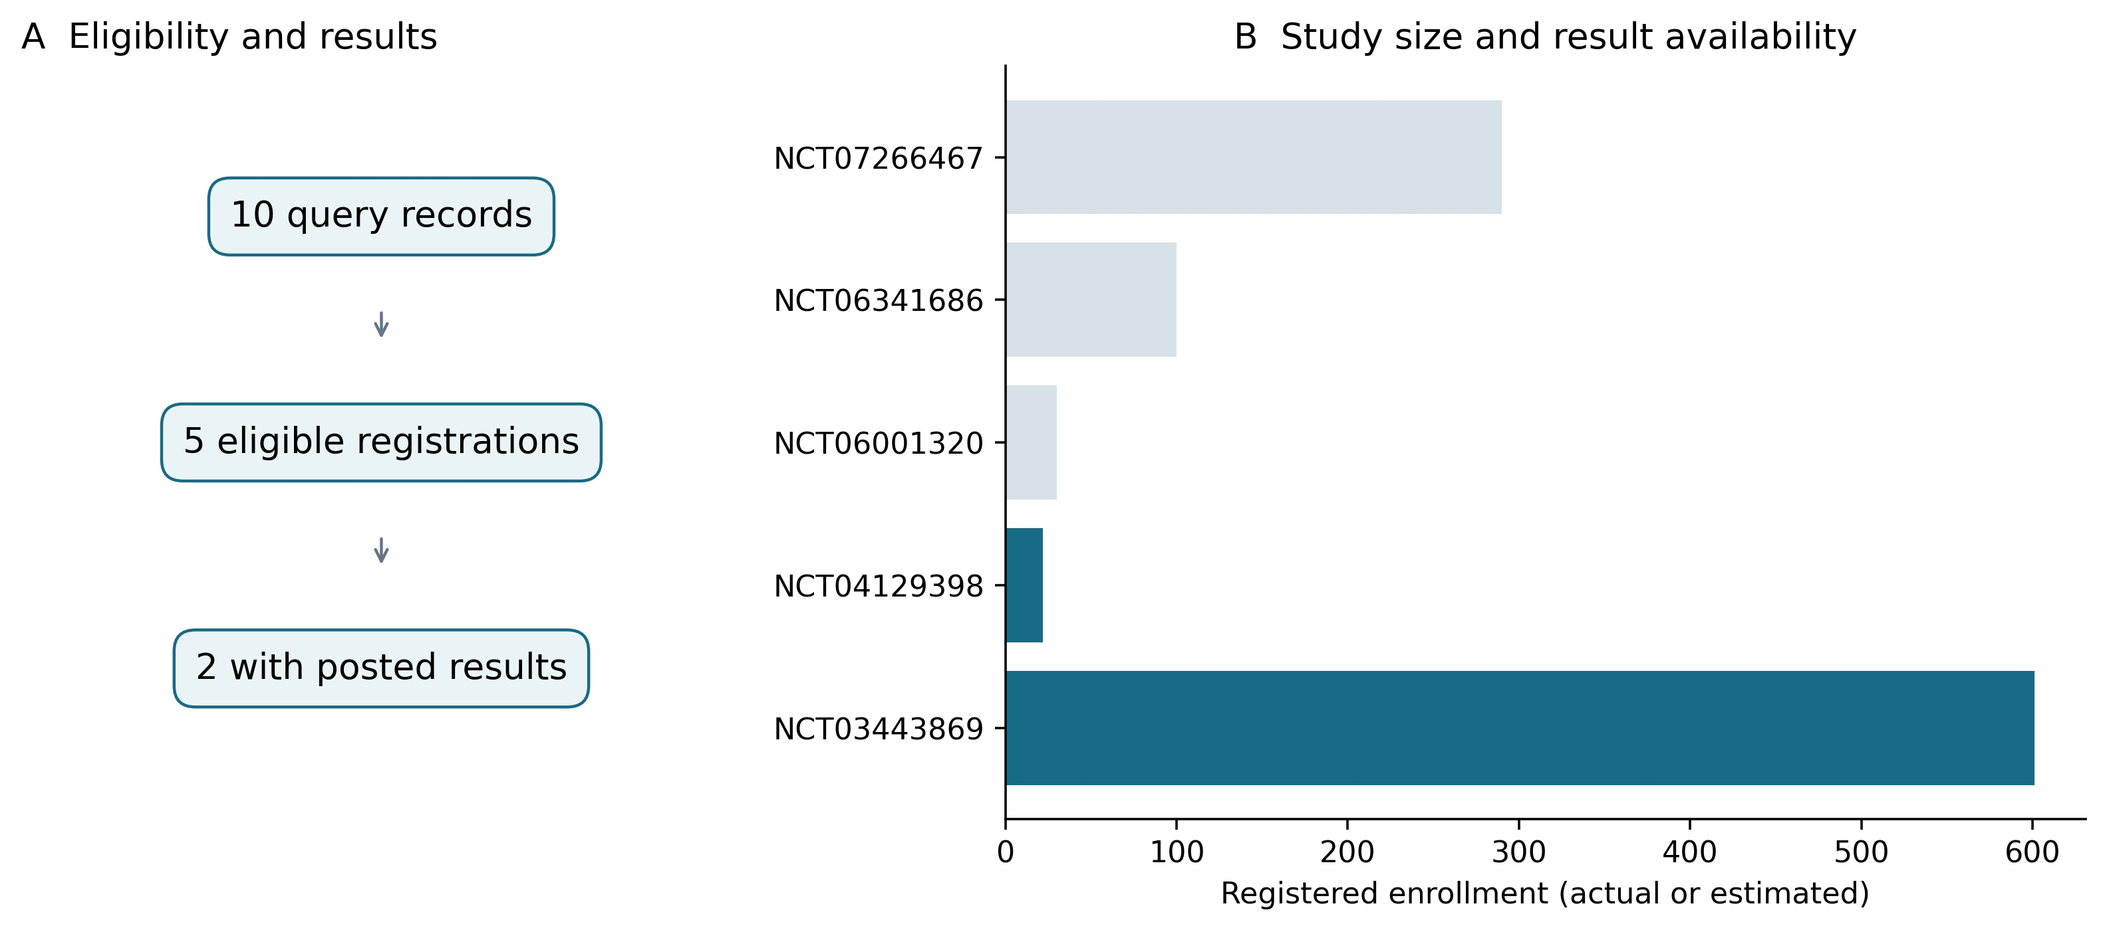
Figure 1 Selection and enrollment of eligible primary-prophylaxis studies.
A shows the ten retrieved registrations, five eligible studies, and two with posted structured results. B shows registered enrollment; dark bars identify studies with posted results and pale bars those without results. Enrollment may be actual or estimated and does not represent independent clinical validation.
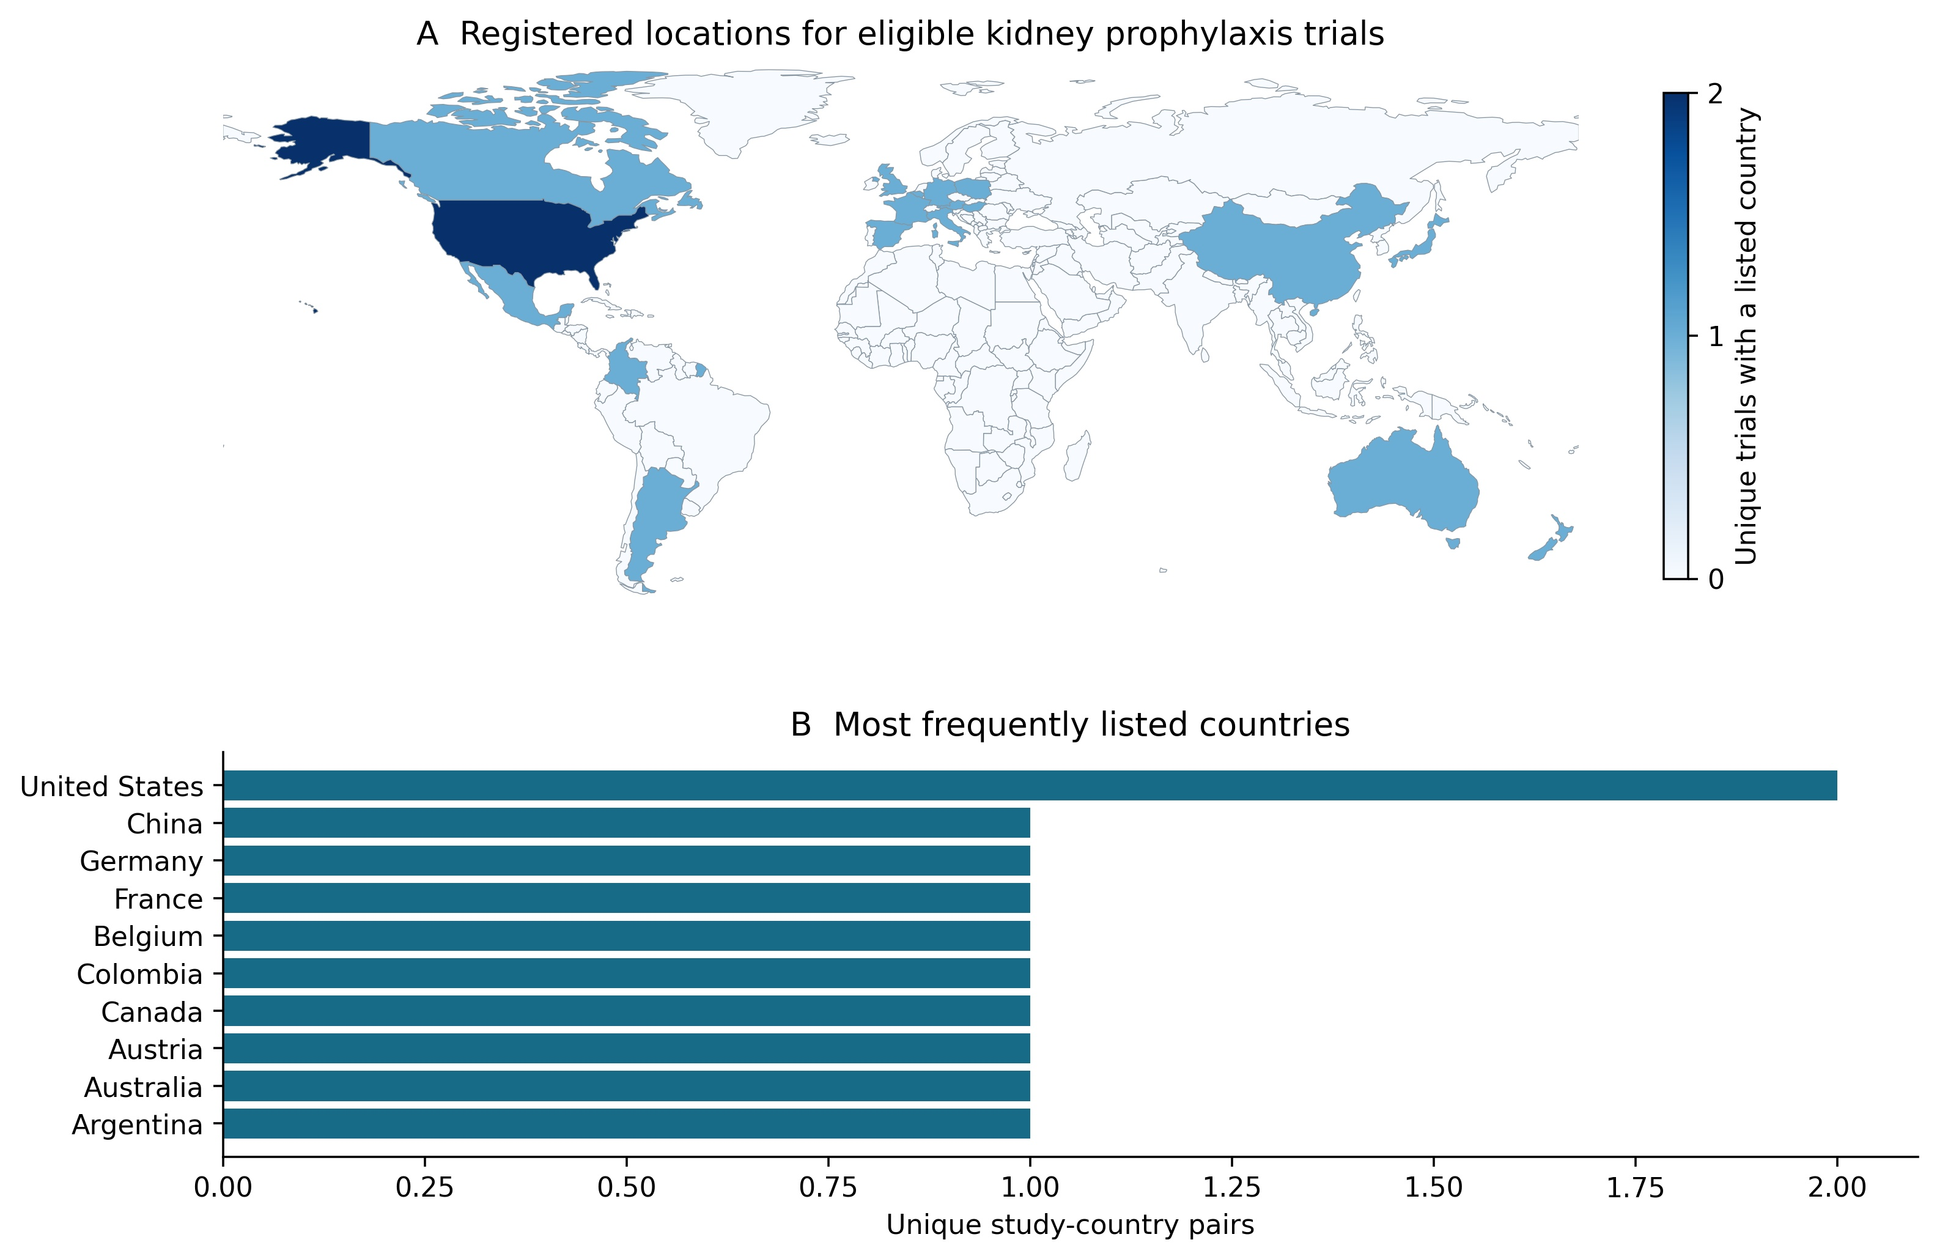
Figure 2 Geographic distribution of registered kidney-transplant prophylaxis research.
A maps unique study–country pairs, counting multiple sites within the same study and country once. B shows the United States and a displayed subset of countries tied at one study–country pair, rather than a complete ranking. Eighteen countries and 19 pairs are represented overall; one eligible study lacks location-country data. The map describes research geography rather than CMV prevalence, enrollment totals, or national effectiveness. Basemap data are from Natural Earth (public domain).
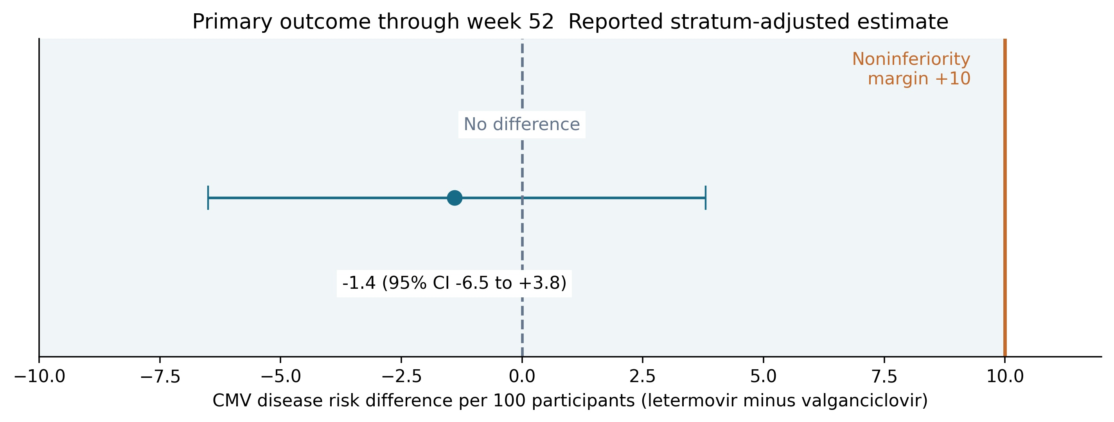
Figure 3 Noninferiority analysis for adjudicated CMV disease through week 52.
The point and interval retain the source-reported stratum-adjusted risk difference and 95% confidence interval. The upper limit of 3.8 percentage points is below the prespecified 10-point noninferiority margin. An interval crossing zero does not negate noninferiority or establish superior efficacy. Shading is a visual aid rather than a two-sided equivalence region [40].
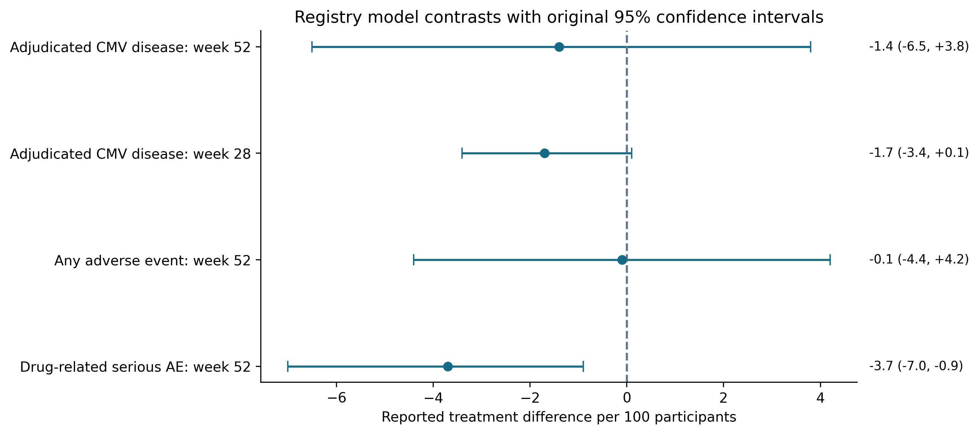
Figure 4 Source-reported treatment contrasts from the randomized trial.
Disease contrasts are stratum-adjusted; safety contrasts retain their original source intervals. The “week 52” wording in the adverse-event labels reflects the registry reporting framework and maximum follow-up. Ordinary adverse-event collection was limited to prophylaxis and 14 days afterward, whereas drug-related serious-event surveillance continued through week 52. Endpoints and ascertainment periods therefore differ. Median time to CMV disease was not reached and is not plotted as a zero effect [40].
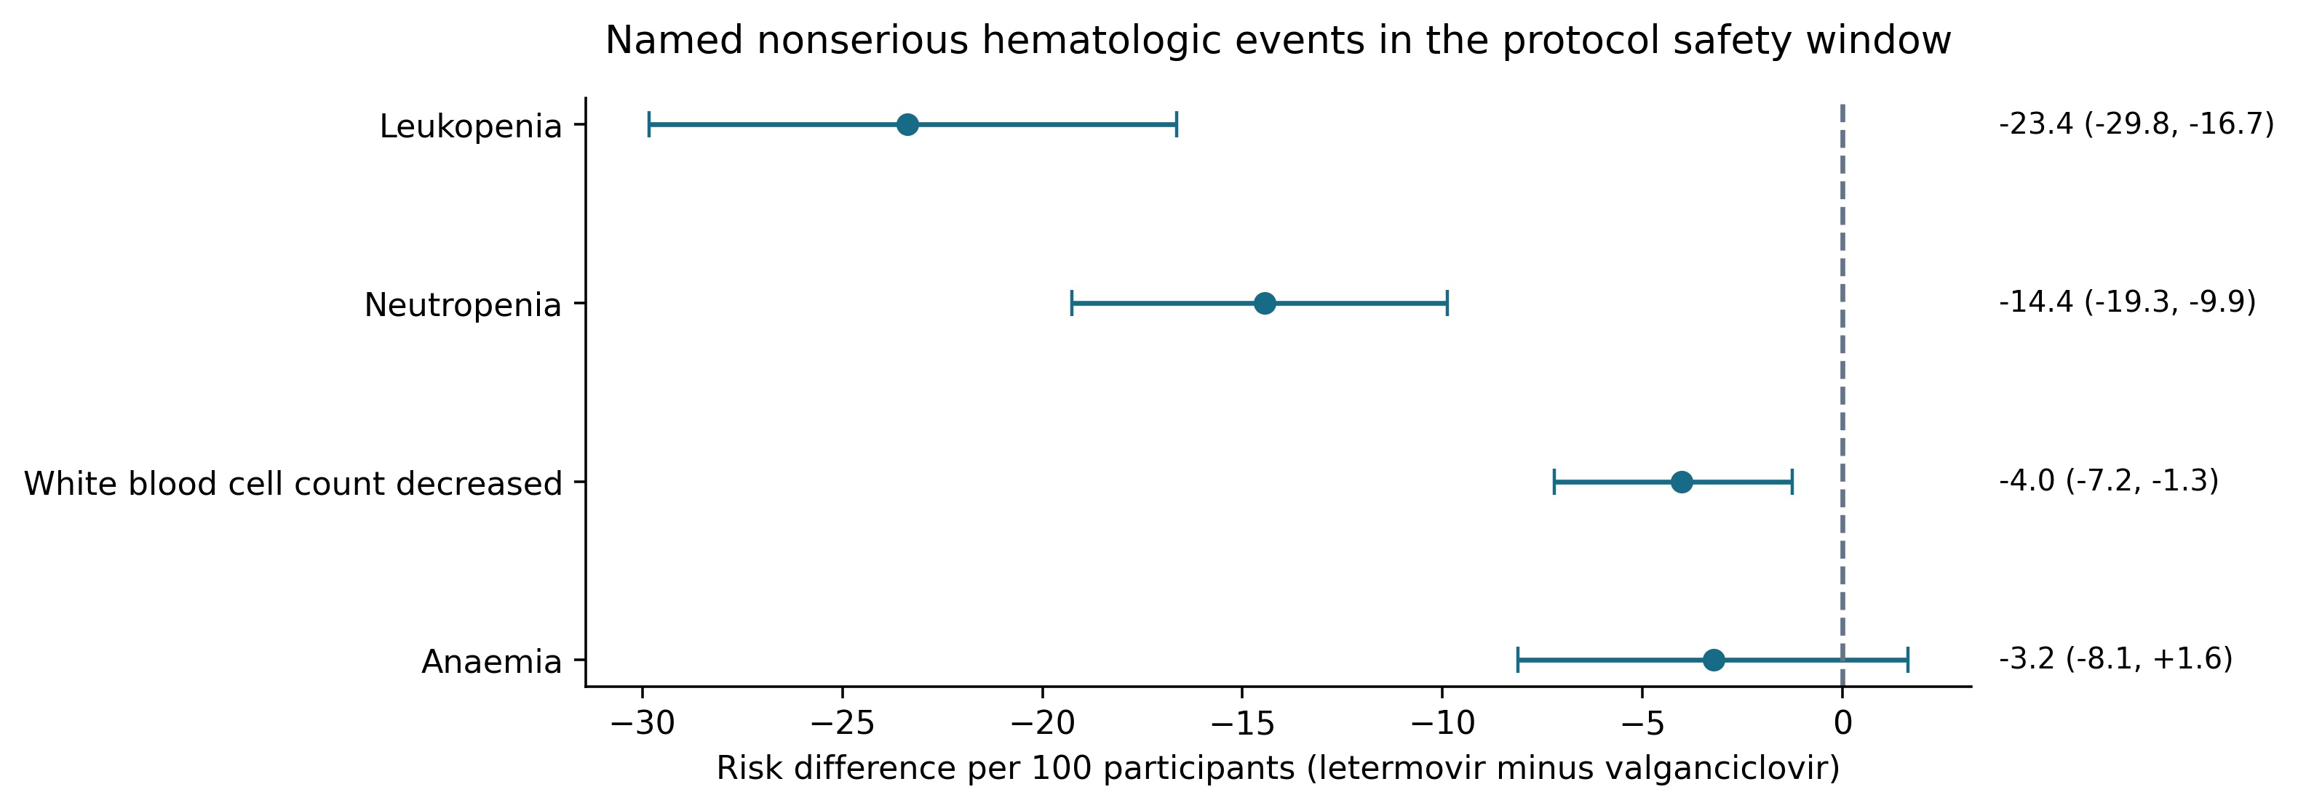
Figure 5 Named nonserious hematologic adverse events.
Points and bars show recalculated risk differences and Newcombe 95% confidence intervals. Ordinary adverse events were collected during prophylaxis and for 14 days afterward; later surveillance covered drug-related serious events through week 52. Counts are affected participants within each term. Terms and seriousness categories may overlap and cannot reconstruct the combined clinical/laboratory cytopenia endpoint. Native counts are reported in Table 4.
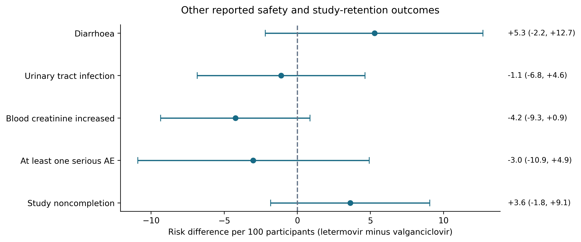
Figure 6 Other safety outcomes and study retention.
Points and bars show unadjusted risk differences and Newcombe 95% confidence intervals. Diarrhoea, urinary tract infection, and blood creatinine increased are named nonserious terms; any serious adverse event uses the event-group total. Study noncompletion uses all randomized participants and describes follow-up retention rather than medication discontinuation. Ascertainment periods differ, and estimates are exploratory. Counts are reported in Table 5.
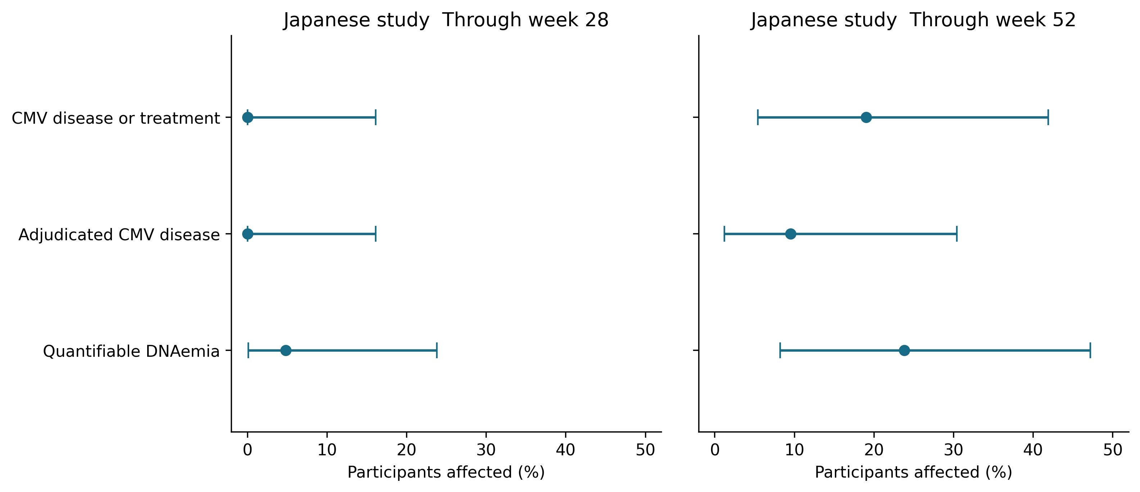
Figure 7 Japanese single-arm study outcomes through weeks 28 and 52.
The left and right panels show source-reported percentages and exact 95% confidence intervals through weeks 28 and 52, respectively, for all 21 efficacy participants. The disease-or-anti-CMV-treatment composite, adjudicated CMV disease, and quantifiable DNAemia are distinct endpoints. Subgroup results are not plotted: 12 D+/R− and nine R+ recipients partition the overall population. Zero-event estimates retain nonzero upper limits. There was no concurrent comparator [41].
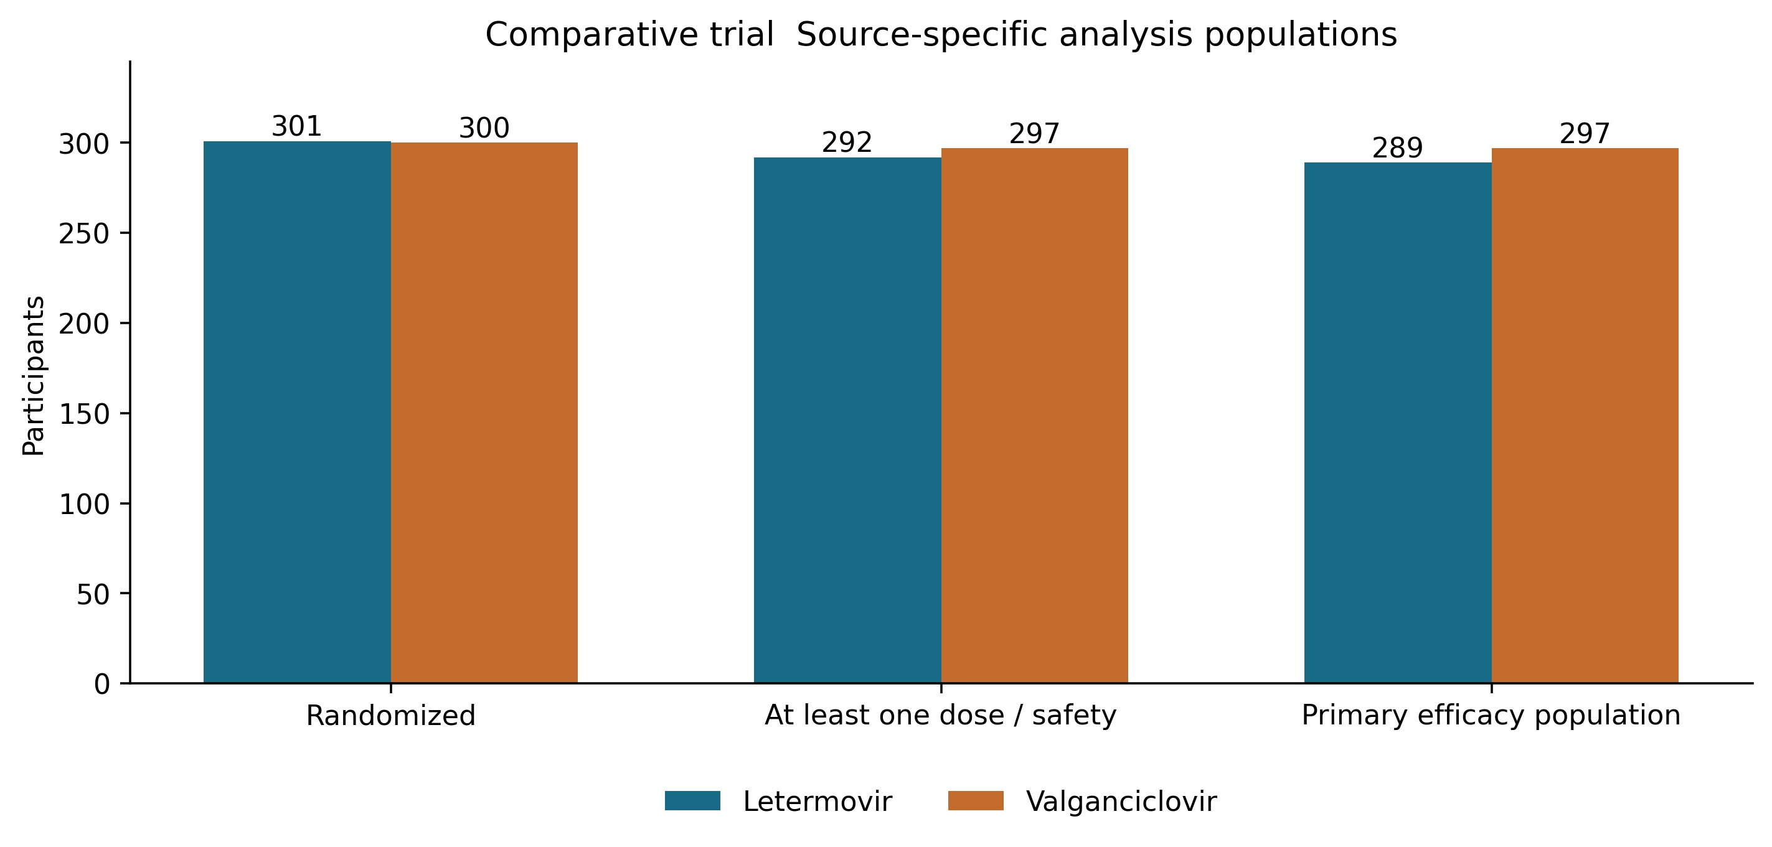
Figure 8 Analysis populations in the randomized trial.
Randomized, treated safety, and primary-efficacy populations have distinct denominators and are not event counts. Letermovir plus acyclovir was compared with valganciclovir. The figure does not identify the individual reasons for exclusion from an analysis [40].
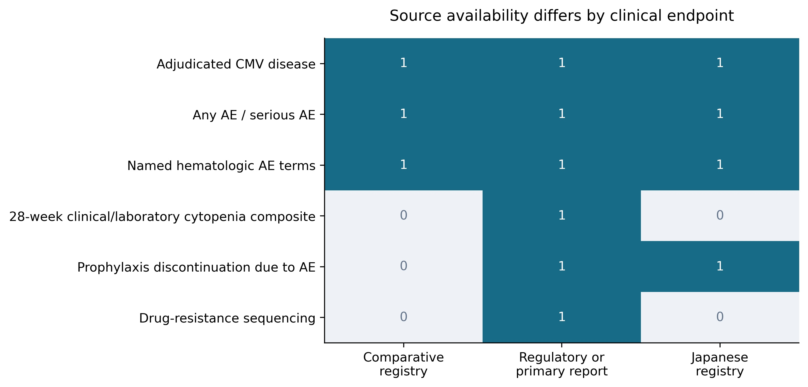
Figure 9 Endpoint availability across evidence sources.
A value of 1 indicates identifiable reporting in the specified source category; 0 indicates that the endpoint cannot be extracted directly there. Named hematologic adverse-event cells are available in both registries. The combined clinical/laboratory cytopenia endpoint, resistance sequencing, and randomized-trial prophylaxis discontinuation cannot be reconstructed from the five posted comparative outcomes. Regulatory and primary reports provide contextual information from the original evidence, rather than a second independent cohort.

Tables
Table 1 Eligible primary prophylaxis registrations
Identifier | Start | Enrollment | Serostatus | Randomized | Results
NCT03443869 [40] | 2018-05-03 | 601 actual | D+/R- | Yes | Yes
NCT04129398 [41] | 2019-12-27 | 22 actual | Mixed D+/R- and R+ (D+/R+ or D-/R+) | No | Yes
NCT06001320 [43] | 2023-09-25 | 30 actual | D+/R-;African American | No | No
NCT06341686 [45] | 2024-05-05 | 100 estimated | D+/R+;ATG induction | Yes | No
NCT07266467 [42] | 2025-05-13 | 290 estimated | CMV serostatus not explicitly restricted in available inclusion criteria;Chinese adults | Yes | No
Kidney-only primary-prophylaxis studies are included. The secondary-prophylaxis study that included kidney–pancreas recipients was excluded [44]. Enrollment is actual or estimated as registered; comparator doses, prophylaxis durations, and CMV serostatus differ across studies. Trial identifiers refer to the dated registry records used in this analysis.
Table 2 Design and populations of studies with results
Feature | Comparative trial | Japanese study
Registry identifier | NCT03443869 [40] | NCT04129398 [41]
Design | Randomized double-blind active-controlled | Open-label single-arm
Population | Adults with CMV D+/R- kidney transplant | Adults with D+/R-, D+/R+, or D-/R+
Randomized or enrolled | 301 letermovir; 300 valganciclovir | 22 letermovir
Treated safety population | 292; 297 | 22
Efficacy population | 289; 297 | 21 total; 12 D+/R- and 9 R+
Preventive regimen | Letermovir plus acyclovir versus valganciclovir | Letermovir; no concurrent control
Intended prophylaxis | Up to 28 weeks / approximately 200 days | Up to 28 weeks
Follow-up | Up to 52 weeks | Up to 52 weeks
Study completed | 256/301; 266/300 | 20/22
Comparative inference | Prespecified 10-percentage-point noninferiority margin | No causal comparative inference
Letermovir is listed before valganciclovir. D and R denote donor and recipient CMV serostatus. Safety and efficacy denominators differ. The Japanese D+/R− and R+ subgroups partition the 21 efficacy participants and are not additional cohorts.
Table 3 All posted comparative model contrasts
Outcome | Letermovir versus valganciclovir | Reported difference and 95% CI
Adjudicated CMV disease through week 52 | 10.4% versus 11.8% | -1.4 (-6.5 to +3.8)
Adjudicated CMV disease through week 28 | 0.0% versus 1.7% | -1.7 (-3.4 to +0.1)
Any adverse event | 92.8% versus 92.9% | -0.1 (-4.4 to +4.2)
Drug-related serious adverse event | 1.4% versus 5.1% | -3.7 (-7.0 to -0.9)
Differences are percentage points, defined as letermovir minus valganciclovir. Disease contrasts are stratum-adjusted; safety contrasts retain the source-reported methods and intervals. The week-52 upper confidence limit of 3.8 is below the prespecified 10-point noninferiority margin. Intervals crossing zero do not establish superiority or equivalence. For the fifth posted outcome, median time to CMV disease was not reached in either group [40].
Table 4 Named nonserious hematologic adverse events
Registered term | Letermovir | Valganciclovir | Risk difference per 100 and 95% CI
Leukopenia | 35/292 (12.0%) | 105/297 (35.4%) | -23.37 (-29.83 to -16.65)
Neutropenia | 7/292 (2.4%) | 50/297 (16.8%) | -14.44 (-19.27 to -9.89)
White blood cell count decreased | 3/292 (1.0%) | 15/297 (5.1%) | -4.02 (-7.21 to -1.25)
Anaemia | 24/292 (8.2%) | 34/297 (11.4%) | -3.23 (-8.12 to +1.64)
Counts are native affected-participant cells for named nonserious adverse events, distinct from laboratory thresholds and the combined leukopenia/neutropenia endpoint. Terms and seriousness categories may overlap and cannot be summed. Ordinary adverse events were collected during prophylaxis and for 14 days afterward; subsequent surveillance covered drug-related serious events through week 52. The registry header gives the maximum follow-up. Intervals are exploratory Newcombe 95% confidence intervals.
Table 5 Other safety outcomes and study retention
Outcome | Letermovir | Valganciclovir | Risk difference per 100 and 95% CI
Diarrhoea | 99/292 (33.9%) | 85/297 (28.6%) | +5.28 (-2.20 to +12.69)
Urinary tract infection | 41/292 (14.0%) | 45/297 (15.2%) | -1.11 (-6.84 to +4.64)
Blood creatinine increased | 26/292 (8.9%) | 39/297 (13.1%) | -4.23 (-9.35 to +0.87)
At least one serious AE | 118/292 (40.4%) | 129/297 (43.4%) | -3.02 (-10.91 to +4.92)
Study noncompletion | 45/301 (15.0%) | 34/300 (11.3%) | +3.62 (-1.82 to +9.06)
Symptom and laboratory-description terms are native nonserious adverse-event reports. Any serious adverse event uses the event-group total. Study noncompletion uses all randomized participants and describes follow-up retention, rather than prophylaxis discontinuation. Ascertainment periods differ by endpoint. Intervals are unadjusted exploratory Newcombe estimates.
Table 6 Japanese single-arm study outcomes and source-reported confidence intervals
Outcome | Through week | Source percentage and 95% CI | Compatible count
CMV disease or antiviral treatment | 28 | 0.0 (0.0 to 16.1) | 0/21
CMV disease or antiviral treatment | 52 | 19.0 (5.4 to 41.9) | 4/21
Adjudicated CMV disease | 28 | 0.0 (0.0 to 16.1) | 0/21
Adjudicated CMV disease | 52 | 9.5 (1.2 to 30.4) | 2/21
Quantifiable CMV DNAemia | 28 | 4.8 (0.1 to 23.8) | 1/21
Quantifiable CMV DNAemia | 52 | 23.8 (8.2 to 47.2) | 5/21
Percentages and exact 95% confidence limits are source-reported. Compatible integer counts are uniquely reconstructed from the one-decimal percentages and denominators; they are derived counts rather than native source cells. The overall efficacy population (n=21) comprises D+/R− (n=12) and R+ (n=9) subgroups. These subgroups are not additional cohorts and were not pooled with the randomized trial [41].

References
1. Limaye AP, Budde K, Humar A, Vincenti F, Kuypers DRJ, Carroll RP, et al. Letermovir vs Valganciclovir for Prophylaxis of Cytomegalovirus in High-Risk Kidney Transplant Recipients: A Randomized Clinical Trial. JAMA. 2023;330(1):33-42. doi:10.1001/jama.2023.9106. https://pubmed.ncbi.nlm.nih.gov/37279999/
2. Ishida H, Goto N, Imamura R, Sasaki H, Unagami K, Futamura K, et al. Letermovir safety and efficacy for cytomegalovirus prophylaxis in adult Japanese kidney transplant recipients: a multicenter, open-label, noncomparative Phase 3 study. Clin Exp Nephrol. 2024;28(8):822-831. doi:10.1007/s10157-024-02471-0. https://pubmed.ncbi.nlm.nih.gov/38615067/
3. Strizki JM, Diamond TL, Teal VL, Gilbert CL, Wang W, Stauffer N, et al. Cytomegalovirus Antiviral Resistance Among Kidney Transplant Recipients in a Phase 3 Trial of Letermovir vs Valganciclovir Prophylaxis. J Infect Dis. 2024;230(6):e1287-e1298. doi:10.1093/infdis/jiae287. https://pubmed.ncbi.nlm.nih.gov/38853607/
4. Bunnapradist S, Vincenti F, Witzke O, Schneeberger S, Nguyen MH, Broyde N, et al. Favorable Adherence and Tolerability of Letermovir Versus Valganciclovir for Cytomegalovirus Prophylaxis in Kidney Transplant Recipients Aged 65 y or Older: Findings From a Randomized, Phase 3 Trial. Transplant Direct. 2026;12(9):e1990. doi:10.1097/txd.0000000000001990. https://pubmed.ncbi.nlm.nih.gov/42639594/
5. Budde K, Kamar N, Crespo M, Small CB, Stauffer N, Broyde N, et al. Impact of kidney function on 200 days of antiviral prophylaxis for cytomegalovirus disease in cytomegalovirus-seronegative recipients of cytomegalovirus-seropositive donor kidneys: Post hoc analysis of a randomized, phase 3 trial of letermovir vs valganciclovir prophylaxis. Am J Transplant. 2025;25(12):2621-2633. doi:10.1016/j.ajt.2025.07.2471. https://pubmed.ncbi.nlm.nih.gov/40701254/
6. Limaye AP, Crespo M, Kamar N, Humar A, Carroll RP, Pereira MR, et al. Cytomegalovirus (CMV)-Specific Cell-Mediated Immunity for Prediction of Postprophylaxis CMV Disease in a Phase 3 Trial of Letermovir Versus Valganciclovir Prophylaxis in Donor CMV-Seropositive/Recipient CMV-Seronegative Kidney Transplant Recipients. Clin Infect Dis. 2026;82(2):e316-e324. doi:10.1093/cid/ciaf632. https://pubmed.ncbi.nlm.nih.gov/41321121/
7. Benotmane I, Schvartz B, Garrouste C, Runyo F, Boud'hors C, Flahaut G, et al. Real-World Evaluation of Letermovir Use in Kidney Transplant Recipients: Drug Interactions, Safety, and Impact on Renal Function. Transpl Int. 2025;38:15371. doi:10.3389/ti.2025.15371. https://pubmed.ncbi.nlm.nih.gov/41424458/
8. Jorgenson MR, Descourouez JL, Saddler CM, Smith JA, Odorico JS, Rice JP, et al. Real world experience with conversion from valganciclovir to letermovir for cytomegalovirus prophylaxis: Letermovir reverses leukopenia and avoids mycophenolate dose reduction. Clin Transplant. 2023;37(12):e15142. doi:10.1111/ctr.15142. https://pubmed.ncbi.nlm.nih.gov/37755141/
9. Winstead RJ, Kumar D, Brown A, Yakubu I, Song C, Thacker L, et al. Letermovir prophylaxis in solid organ transplant-Assessing CMV breakthrough and tacrolimus drug interaction. Transpl Infect Dis. 2021;23(4):e13570. doi:10.1111/tid.13570. https://pubmed.ncbi.nlm.nih.gov/33469975/
10. Descourouez JL, Kleiboeker H, Saddler CM, Smith JA, Rice JP, Mandelbrot DA, et al. The UW Experience: Feasibility of De Novo Letermovir for Primary Prophylaxis After Abdominal Solid Organ Transplant. Ann Pharmacother. 2025;59(8):730-735. doi:10.1177/10600280241307383. https://pubmed.ncbi.nlm.nih.gov/39815618/
11. Kleiboeker HL, Jorgenson MR, Scolarici MJ, Descourouez JL, Leverson GE, Saddler C, et al. De Novo Letermovir After Cytomegalovirus Seropositive Kidney Transplant Improves Toxicity and Mycophenolate Tolerance Over the Current Standard of Care. Clin Transplant. 2025;39(12):e70423. doi:10.1111/ctr.70423. https://pubmed.ncbi.nlm.nih.gov/41408959/
12. Amin SJ, Rogers AW, Yun AN, Nigo M, Ghobrial RM, Gaber AO. Letermovir Conversion for Cytomegalovirus Prophylaxis in Solid Organ Transplant. Clin Transplant. 2025;39(11):e70366. doi:10.1111/ctr.70366. https://pubmed.ncbi.nlm.nih.gov/41137659/
13. Jorgenson MR, Kleiboeker H, Garg N, Parajuli S, Mandelbrot DA, Odorico JS, et al. Letermovir conversion after valganciclovir treatment in cytomegalovirus high-risk abdominal solid organ transplant recipients may promote development of cytomegalovirus-specific cell mediated immunity. Transpl Infect Dis. 2022;24(1):e13766. doi:10.1111/tid.13766. https://pubmed.ncbi.nlm.nih.gov/34799964/
14. Kropeit D, Scheuenpflug J, Erb-Zohar K, Halabi A, Stobernack HP, Hulskotte EGJ, et al. Pharmacokinetics and safety of letermovir, a novel anti-human cytomegalovirus drug, in patients with renal impairment. Br J Clin Pharmacol. 2017;83(9):1944-1953. doi:10.1111/bcp.13292. https://pubmed.ncbi.nlm.nih.gov/28345163/
15. Menzel K, McCrea JB, Fancourt C, Witter R, Zhao T, Stoch SA, et al. A drug-drug interaction study with letermovir and acyclovir in healthy participants. Br J Clin Pharmacol. 2023;89(5):1690-1694. doi:10.1111/bcp.15648. https://pubmed.ncbi.nlm.nih.gov/36537620/
16. McCrea JB, Macha S, Adedoyin A, Marshall W, Menzel K, Cho CR, et al. Pharmacokinetic Drug-Drug Interactions Between Letermovir and the Immunosuppressants Cyclosporine, Tacrolimus, Sirolimus, and Mycophenolate Mofetil. J Clin Pharmacol. 2019;59(10):1331-1339. doi:10.1002/jcph.1423. https://pubmed.ncbi.nlm.nih.gov/30990905/
17. Stoelben S, Arns W, Renders L, Hummel J, Mühlfeld A, Stangl M, et al. Preemptive treatment of Cytomegalovirus infection in kidney transplant recipients with letermovir: results of a Phase 2a study. Transpl Int. 2014;27(1):77-86. doi:10.1111/tri.12225. https://pubmed.ncbi.nlm.nih.gov/24164420/
18. Humar A, Lebranchu Y, Vincenti F, Blumberg EA, Punch JD, Limaye AP, et al. The efficacy and safety of 200 days valganciclovir cytomegalovirus prophylaxis in high-risk kidney transplant recipients. Am J Transplant. 2010;10(5):1228-1237. doi:10.1111/j.1600-6143.2010.03074.x. https://pubmed.ncbi.nlm.nih.gov/20353469/
19. Humar A, Limaye AP, Blumberg EA, Hauser IA, Vincenti F, Jardine AG, et al. Extended valganciclovir prophylaxis in D+/R- kidney transplant recipients is associated with long-term reduction in cytomegalovirus disease: two-year results of the IMPACT study. Transplantation. 2010;90(12):1427-1431. doi:10.1097/tp.0b013e3181ff1493. https://pubmed.ncbi.nlm.nih.gov/21197713/
20. Reischig T, Vlas T, Kacer M, Pivovarcikova K, Lysak D, Nemcova J, et al. A Randomized Trial of Valganciclovir Prophylaxis Versus Preemptive Therapy in Kidney Transplant Recipients. J Am Soc Nephrol. 2023;34(5):920-934. doi:10.1681/asn.0000000000000090. https://pubmed.ncbi.nlm.nih.gov/36749127/
21. Marty FM, Ljungman P, Chemaly RF, Maertens J, Dadwal SS, Duarte RF, et al. Letermovir Prophylaxis for Cytomegalovirus in Hematopoietic-Cell Transplantation. N Engl J Med. 2017;377(25):2433-2444. doi:10.1056/nejmoa1706640. https://pubmed.ncbi.nlm.nih.gov/29211658/
22. Chemaly RF, Ullmann AJ, Stoelben S, Richard MP, Bornhäuser M, Groth C, et al. Letermovir for cytomegalovirus prophylaxis in hematopoietic-cell transplantation. N Engl J Med. 2014;370(19):1781-1789. doi:10.1056/nejmoa1309533. https://pubmed.ncbi.nlm.nih.gov/24806159/
23. Beyer AP, Moise PA, Wong M, Gao W, Xiang C, Shen P, et al. Clinical events and healthcare resource utilization associated with neutropenia and leukopenia among adult kidney transplant recipients receiving valganciclovir. World J Transplant. 2025;15(2):102671. doi:10.5500/wjt.v15.i2.102671. https://pubmed.ncbi.nlm.nih.gov/40535505/
24. Ingold L, Halter J, Martinez M, Amico P, Wehmeier C, Hirt-Minkowski P, et al. Short- and long-term impact of neutropenia within the first year after kidney transplantation. Transpl Int. 2021;34(10):1875-1885. doi:10.1111/tri.13976. https://pubmed.ncbi.nlm.nih.gov/34272771/
25. Boivin G, Goyette N, Farhan M, Ives J, Elston R. Incidence of cytomegalovirus UL97 and UL54 amino acid substitutions detected after 100 or 200 days of valganciclovir prophylaxis. J Clin Virol. 2012;53(3):208-213. doi:10.1016/j.jcv.2011.12.019. https://pubmed.ncbi.nlm.nih.gov/22237003/
26. Welker H, Farhan M, Humar A, Washington C. Ganciclovir pharmacokinetic parameters do not change when extending valganciclovir cytomegalovirus prophylaxis from 100 to 200 days. Transplantation. 2010;90(12):1414-1419. doi:10.1097/tp.0b013e3182000042. https://pubmed.ncbi.nlm.nih.gov/21076372/
27. Chou S, Watanabe J. Phenotypes of cytomegalovirus genetic variants encountered in a letermovir clinical trial illustrate the importance of genotyping validation. Antiviral Res. 2024;228:105935. doi:10.1016/j.antiviral.2024.105935. https://pubmed.ncbi.nlm.nih.gov/38880196/
28. Goldner T, Hewlett G, Ettischer N, Ruebsamen-Schaeff H, Zimmermann H, Lischka P. The novel anticytomegalovirus compound AIC246 (Letermovir) inhibits human cytomegalovirus replication through a specific antiviral mechanism that involves the viral terminase. J Virol. 2011;85(20):10884-10893. doi:10.1128/jvi.05265-11. https://pubmed.ncbi.nlm.nih.gov/21752907/
29. Reischig T, Kacer M, Jindra P, Hes O, Lysak D, Bouda M. Randomized trial of valganciclovir versus valacyclovir prophylaxis for prevention of cytomegalovirus in renal transplantation. Clin J Am Soc Nephrol. 2015;10(2):294-304. doi:10.2215/cjn.07020714. https://pubmed.ncbi.nlm.nih.gov/25424991/
30. Lamoth F, Manuel O, Venetz JP, Faouzi M, Meylan P, Pascual M. What is the impact of late-onset cytomegalovirus disease after valganciclovir prophylaxis in kidney transplantation?. Transplantation. 2008;86(9):1323-1324. doi:10.1097/tp.0b013e3181890788. https://pubmed.ncbi.nlm.nih.gov/19005418/
31. Kotton CN, Kumar D, Manuel O, Chou S, Hayden RT, Danziger-Isakov L, et al. The Fourth International Consensus Guidelines on the Management of Cytomegalovirus in Solid Organ Transplantation. Transplantation. 2025;109(7):1066-1110. doi:10.1097/tp.0000000000005374. https://pubmed.ncbi.nlm.nih.gov/40200403/
32. Ljungman P, Chemaly RF, Khawaya F, Alain S, Avery R, Badshah C, et al. Consensus Definitions of Cytomegalovirus (CMV) Infection and Disease in Transplant Patients Including Resistant and Refractory CMV for Use in Clinical Trials: 2024 Update From the Transplant Associated Virus Infections Forum. Clin Infect Dis. 2024;79(3):787-794. doi:10.1093/cid/ciae321. https://pubmed.ncbi.nlm.nih.gov/39041385/
33. Kotton CN, Kumar D, Caliendo AM, Huprikar S, Chou S, Danziger-Isakov L, et al. The Third International Consensus Guidelines on the Management of Cytomegalovirus in Solid-organ Transplantation. Transplantation. 2018;102(6):900-931. doi:10.1097/tp.0000000000002191. https://pubmed.ncbi.nlm.nih.gov/29596116/
34. Newcombe RG. Interval estimation for the difference between independent proportions: comparison of eleven methods. Stat Med. 1998;17(8):873-890. doi:10.1002/(sici)1097-0258(19980430)17:8<873::aid-sim779>3.0.co;2-i. https://pubmed.ncbi.nlm.nih.gov/9595617/
35. Piaggio G, Elbourne DR, Pocock SJ, Evans SJ, Altman DG, CONSORT Group. Reporting of noninferiority and equivalence randomized trials: extension of the CONSORT 2010 statement. JAMA. 2012;308(24):2594-2604. doi:10.1001/jama.2012.87802. https://pubmed.ncbi.nlm.nih.gov/23268518/
36. Page MJ, McKenzie JE, Bossuyt PM, Boutron I, Hoffmann TC, Mulrow CD, et al. The PRISMA 2020 statement: an updated guideline for reporting systematic reviews. BMJ. 2021;372:n71. doi:10.1136/bmj.n71. https://pubmed.ncbi.nlm.nih.gov/33782057/
37. Merck Sharp & Dohme LLC. PREVYMIS (letermovir) tablets, oral pellets, and injection: prescribing information. Revised January 2026. 2026. https://dailymed.nlm.nih.gov/dailymed/lookup.cfm?setid=1b49df80-be4f-47e0-a0b7-123f3e69395b&version=28. Accessed 16 October 2026.
38. National Library of Medicine. ClinicalTrials.gov: Terms and Conditions. No publication date stated. https://clinicaltrials.gov/about-site/terms-conditions. Accessed 16 October 2026.
39. International Council for Harmonisation of Technical Requirements for Pharmaceuticals for Human Use. Addendum on Estimands and Sensitivity Analysis in Clinical Trials to the Guideline on Statistical Principles for Clinical Trials E9(R1). 2019. https://database.ich.org/sites/default/files/E9-R1_Step4_Guideline_2019_1203.pdf. Accessed 16 October 2026.
40. Merck Sharp & Dohme LLC. A Phase III, Randomized, Double-Blind, Active Comparator-Controlled Study to Evaluate the Efficacy and Safety of MK-8228 (Letermovir) Versus Valganciclovir for the Prevention of Human Cytomegalovirus (CMV) Disease in Adult Kidney Transplant Recipients. ClinicalTrials.gov identifier: NCT03443869. Updated 2023-07-28. https://clinicaltrials.gov/study/NCT03443869. Accessed 16 October 2026.
41. Merck Sharp & Dohme LLC. A Phase 3, Open-Label, Single-Arm Clinical Study to Evaluate the Safety, Efficacy and Pharmacokinetics of MK-8228 (Letermovir) for the Prevention of Human Cytomegalovirus (CMV) Infection and Disease in Adult Japanese Kidney Transplant Recipients. ClinicalTrials.gov identifier: NCT04129398. Updated 2024-08-21. https://clinicaltrials.gov/study/NCT04129398. Accessed 16 October 2026.
42. First Affiliated Hospital Xi'an Jiaotong University. Efficacy and Safety of Leymovir Versus Valganciclovir in Prevention of Cytomegalovirus Infection and Cytomegalovirus Disease in Chinese Kidney Transplant Recipients. ClinicalTrials.gov identifier: NCT07266467. Updated 2025-12-05. https://clinicaltrials.gov/study/NCT07266467. Accessed 16 October 2026.
43. Virginia Commonwealth University. Historical Controlled, Single Center Open Label Pilot Comparing the Effectiveness and Tolerability of De-novo Initiation of Letermovir Versus Valganciclovir for Cytomegalovirus Prophylaxis in AA Kidney Transplant Recipients. ClinicalTrials.gov identifier: NCT06001320. Updated 2026-09-23. https://clinicaltrials.gov/study/NCT06001320. Accessed 16 October 2026.
44. University of Wisconsin, Madison. An Interventional Study of Letermovir for Secondary Prophylaxis After Treatment of Cytomegalovirus Infection in High Risk (D+/R-) Kidney and Kidney/Pancreas Transplant Recipients. ClinicalTrials.gov identifier: NCT06407232. Updated 2026-06-11. https://clinicaltrials.gov/study/NCT06407232. Accessed 16 October 2026.
45. Hospital do Rim e Hipertensão. Efficacy and Safety of Prophylactic Use of Letermovir Versus Preemptive Strategy in Kidney Transplant Recipients at Higher Risk of Cytomegalovirus Infection: a Prospective Randomized Study. ClinicalTrials.gov identifier: NCT06341686. Updated 2024-04-02. https://clinicaltrials.gov/study/NCT06341686. Accessed 16 October 2026.

