Cytomegalovirus prevention and hematologic tolerability with letermovir in kidney transplant recipients
  - A registry-based evidence map of studies initiated in 2006–2025

Abstract
Background Letermovir is an alternative to valganciclovir for cytomegalovirus (CMV) prophylaxis in CMV-seronegative kidney recipients of seropositive donor organs (D+/R−). We examined the extent of publicly available trial evidence and how endpoint definitions, analysis populations, and observation periods affect its interpretation.
Methods We retrieved ClinicalTrials.gov version 2 records on October 16, 2026 and identified interventional studies of primary CMV prophylaxis in kidney-only recipients initiated during 2006–2025. The pivotal randomized comparison and Japanese single-arm study were analyzed separately. We retained the trial-reported adjusted noninferiority estimate and recalculated absolute risk differences with Newcombe 95% confidence intervals for directly reported integer adverse-event counts. Rounded percentage-derived counts were identified separately, and efficacy, safety, and follow-up populations were distinguished.
Results Five of ten registrations were eligible; three were randomized and two had posted results. Registered locations spanned 18 countries. In the pivotal trial, adjudicated CMV disease through week 52 was reported in 10.4% of 289 letermovir and 11.8% of 297 valganciclovir efficacy participants. The adjusted difference was −1.4 percentage points (95% CI, −6.5 to 3.8), meeting the prespecified 10-percentage-point noninferiority margin. Named nonserious leukopenia affected 35/292 versus 105/297 treated participants, an absolute difference of −23.37 percentage points (95% CI, −29.83 to −16.65). Neutropenia affected 7/292 versus 50/297, a difference of −14.44 percentage points (95% CI, −19.27 to −9.89). These potentially overlapping terms were distinct from the combined laboratory/adverse-event cytopenia endpoint. General adverse events were collected during prophylaxis and for 14 days thereafter, whereas subsequent surveillance through week 52 covered drug-related serious events. The Japanese study included 22 safety and 21 efficacy participants and provided noncomparative evidence; its week-52 adjudicated disease estimate was 9.5% (95% CI, 1.2%–30.4%).
Conclusions Public trial records support the established noninferiority of letermovir plus acyclovir to valganciclovir for CMV prevention in adult D+/R− kidney transplant recipients and show fewer reports of specific hematologic adverse events. Clinical interpretation depends on maintaining the distinctions among named events, laboratory composites, medication discontinuation, and study completion. The Japanese study adds prospective context, while registrations without results identify unresolved questions in other populations.
Keywords kidney transplantation; letermovir; valganciclovir; cytomegalovirus; leukopenia

Introduction
Cytomegalovirus (CMV) disease remains a major complication after kidney transplantation, requiring antiviral treatment and sometimes hospitalization or modification of immunosuppression. Risk is particularly high when a CMV-seronegative recipient receives a kidney from a seropositive donor (D+/R−). For these recipients, prophylaxis must balance prevention of infection and disease against the toxicity and monitoring burden of prolonged antiviral exposure [31].
The IMPACT trial established the benefit of extending valganciclovir prophylaxis from 100 to 200 days in high-risk kidney transplant recipients, with a reduction in CMV disease that persisted beyond prophylaxis [18,19]. Valganciclovir dosing must accommodate changes in kidney function, while leukopenia and neutropenia can complicate the use of other marrow-suppressive medicines and maintenance immunosuppression [31]. Treatment tolerability is therefore relevant to both antiviral selection and the feasibility of completing prophylaxis.
Letermovir inhibits the CMV terminase complex and provides an alternative prophylactic mechanism. Its pivotal trial demonstrated noninferiority to valganciclovir for adjudicated CMV disease through week 52 in adult D+/R− kidney transplant recipients and reported favorable hematologic outcomes during prophylaxis [1,37]. These findings concern distinct clinical dimensions: a prespecified noninferiority comparison for disease prevention and safety outcomes with their own definitions and observation periods. Clear separation of these dimensions is necessary to interpret the treatment comparison.
The broader trial portfolio includes a Japanese phase 3 study in recipients with mixed CMV serostatus and registrations evaluating other populations and prevention strategies [2]. Their relevance depends on the setting, comparator, and availability of results. Primary prophylaxis immediately after transplantation also differs from treatment of active CMV infection and secondary prophylaxis after infection. A Chinese registration may identify a setting for future evaluation, but its contribution to current clinical evidence depends on reported outcomes.
We conducted a registry-based evidence map and aggregate reanalysis of interventional primary-prophylaxis studies. We aimed to describe the registered research portfolio, retain the pivotal trial’s adjusted noninferiority result, quantify absolute differences in selected hematologic and other safety outcomes, and characterize the Japanese study separately. Across these sources, we examined how endpoint definitions, analysis denominators, and observation periods shape the interpretation of CMV prevention and treatment tolerability.

Methods

Design and analytical scope
We conducted a retrospective evidence map and secondary analysis of publicly available aggregate trial results. Eligible studies began between January 1, 2006, and December 31, 2025; records were retrieved on October 16, 2026. The comparative analysis centered on NCT03443869, the pivotal randomized trial in adult D+/R− kidney transplant recipients. NCT04129398 provided a separate description of Japanese recipients. The analysis was not prospectively registered. Screening and extraction decisions were documented, and findings were retained irrespective of statistical significance. Relevant PRISMA reporting principles informed the account of search and selection [36].

Sources and independent access
ClinicalTrials.gov was the primary data source. Records were retrieved through its public version 2 application programming interface using a query combining letermovir with kidney transplantation. Additional queries using development or trade-name aliases checked the completeness of the principal result set. Requests, retrieval dates, NCT identifiers, and retrieved responses were retained. FDA prescribing information provided regulatory and treatment context, and original publications informed interpretation of the registry summaries [37].
Reuse of registry information followed the ClinicalTrials.gov Terms and Conditions, including source attribution and identification of retrieval dates and modifications [38]. Analytical figures were generated from extracted aggregate data. Published estimates were attributed to their original reports, and the version of the regulatory label used for context was identified.

Eligibility and reproducible screening
Eligible studies were interventional studies assigning letermovir as primary CMV prophylaxis to kidney transplant recipients within the study-start window. Randomized, historically controlled, and single-arm designs were included. Serostatus was unrestricted for mapping and extracted explicitly. Eligibility did not depend on study status or results availability. When a registry purpose label differed from the intervention description, classification followed the clinical strategy described in the record, and the discrepancy was noted.
We excluded studies initiated in 2026, treatment studies of established CMV infection, secondary-prophylaxis studies conducted after treatment of infection, non-kidney studies, and observational records. Each retrieved registration received an inclusion decision or a specific exclusion reason. NCT identifiers defined unique records. Eligible registrations without posted results contributed to the evidence map but not to clinical effect estimates.

Extraction and evidence classification
For each eligible registration, we extracted the title, initiation date, recruitment status, allocation, enrollment, CMV serostatus, comparator, prophylaxis duration, follow-up, countries, and availability of structured results. Enrollment retained its actual or estimated designation, and missing fields remained missing. Studies were classified by design and clinical setting before their results were interpreted.
Detailed extraction from studies with results covered participant flow, treatment-group identifiers, outcome denominators, affected-participant counts, percentages, confidence intervals, and endpoint definitions. Original wording and numerical precision were retained alongside standardized labels. Randomized, treated, efficacy-evaluable, and study-completing populations were checked separately. Each outcome retained its reported denominator, and missing results were distinguished from observed zero events. Differences between sources were retained in the extraction record.

Clinical endpoints and observation periods
The pivotal efficacy endpoint was independently adjudicated CMV disease through post-transplant week 52, comprising CMV syndrome or end-organ disease under the trial definition. Letermovir with concomitant acyclovir was compared with kidney-function-adjusted valganciclovir, with prophylaxis intended for approximately 200 days. Outcomes during prophylaxis and over the full follow-up period were distinguished. Quantifiable CMV DNAemia, investigator-reported disease, adjudicated disease, and initiation of antiviral treatment were treated as separate endpoints [40,37].
The published leukopenia-or-neutropenia composite during prophylaxis combined reported adverse events with specified central-laboratory thresholds and counted each participant once [1]. We retained this composite as contextual evidence and extracted named registry adverse-event terms separately. Named terms, laboratory abnormalities, serious events, and medication discontinuation retained their source definitions, populations, and collection windows. Potentially overlapping categories were not summed.
For adverse-event tables, the numerator represented affected participants rather than recurrent episodes. General adverse events were collected during prophylaxis and for 14 days thereafter; subsequent collection through week 52 was limited to drug-related serious events. The registry’s maximum follow-up header was interpreted alongside this ascertainment rule. Serious and nonserious categories were inspected separately, and reporting thresholds were retained where available. A missing term or zero-filled cell in a thresholded table was not treated as evidence that the event never occurred.

Noninferiority and retained source analyses
The primary contrast was the source-reported stratum-adjusted risk difference for CMV disease, defined as letermovir minus valganciclovir. Its two-sided 95% confidence interval was assessed against the prespecified positive 10-percentage-point noninferiority margin. Noninferiority was supported when the upper confidence limit was below this margin; inclusion of zero addresses superiority rather than noninferiority. We retained the original stratified estimate and margin [40].
The primary estimate retained the trial’s observed-failure handling of premature discontinuation, under which discontinuation itself was not classified as CMV disease. The analysis population and incomplete-follow-up strategy were therefore considered together. Published sensitivity analyses were used as context. Aggregate summaries did not provide participant-level data for new adjusted or time-to-event analyses [39].

Recalculated absolute effects and Japanese estimates
For selected randomized-trial safety and retention outcomes with compatible integer counts, we recalculated unadjusted risk differences as the letermovir proportion minus the valganciclovir proportion. Two-sided 95% confidence intervals used the Newcombe method combining Wilson score limits without continuity correction [34]. Negative differences favored letermovir for undesirable outcomes. Safety comparisons were descriptive and unadjusted for multiple comparisons; all selected estimates were retained regardless of whether their intervals included zero. These calculations complemented the source’s adjusted efficacy analysis.
Efficacy and hematologic outcomes were presented separately. Aggregate counts could not characterize differences in severity, duration, or downstream consequences sufficiently to combine them into a net-benefit measure.
For the Japanese study, source-reported percentages and exact 95% confidence intervals were retained. When a one-decimal percentage and its denominator identified a unique compatible integer count, that count was labeled as reconstructed rather than directly reported. The same rule applied to percentage-only randomized outcomes. Zero-event estimates retained their nonzero upper confidence limits. The Japanese study was described separately because of its small sample, mixed serostatus, and single-arm design; its proportions were not pooled with the randomized D+/R− comparison [41,2].

Geography and interpretation
Geographic mapping counted unique eligible study–country pairs. Multiple sites within the same country and trial were counted once, and multinational trials contributed to each listed country. Registrations without location-country information remained geographically unclassified. Country counts described research participation rather than country-specific enrollment, disease burden, or treatment effectiveness.
Interpretation considered masking, adjudication, analysis-population selection, missingness, observation periods, ascertainment, and comparative design. Appraisal was organized around these features rather than a numerical study-quality score. The analysis used public aggregate information without participant contact or access to confidential medical records.

Results
Ten registrations were identified, of which five met the study-start, kidney-only population, interventional-design, and primary-prophylaxis criteria. Additional searches using letermovir aliases returned the same ten identifiers. Three studies were excluded because they began in 2026. One evaluated treatment of established CMV infection with letermovir-based dual therapy, and one evaluated secondary prophylaxis in a population including simultaneous kidney–pancreas recipients. The five eligible studies began between May 2018 and May 2025 (Figure 1; Table 1).
Table 1 Eligible primary-prophylaxis registrations
Identifier | Start | Enrollment | Serostatus | Randomized | Results
NCT03443869 [40] | 2018-05-03 | 601 actual | D+/R- | Yes | Yes
NCT04129398 [41] | 2019-12-27 | 22 actual | Mixed D+/R- and R+ (D+/R+ or D-/R+) | No | Yes
NCT06001320 [43] | 2023-09-25 | 30 actual | D+/R-;African American | No | No
NCT06341686 [45] | 2024-05-05 | 100 estimated | D+/R+;ATG induction | Yes | No
NCT07266467 [42] | 2025-05-13 | 290 estimated | CMV serostatus not explicitly restricted in available inclusion criteria;Chinese adults | Yes | No
Only primary prophylaxis in kidney-only cohorts is included. The mixed kidney–pancreas secondary-prophylaxis study was excluded [44]. Enrollment retains its registered actual or estimated designation. Comparator doses and intended prophylaxis durations differ across studies.
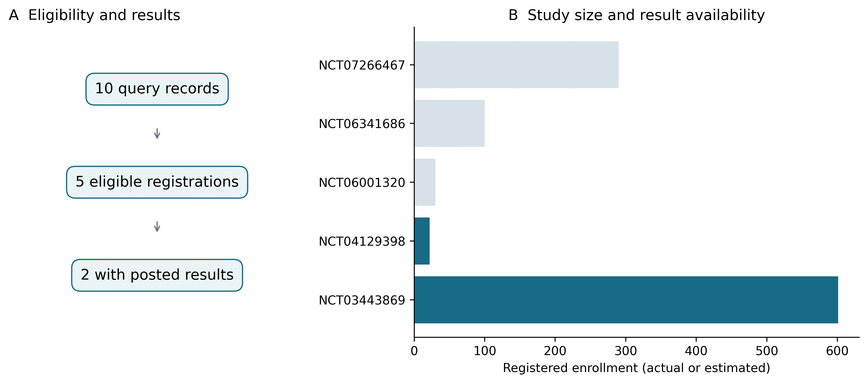
Figure 1 Selection and enrollment of eligible primary-prophylaxis studies. A, ten retrieved records, five eligible studies, and two studies with structured results. B, registered enrollment, with dark bars indicating studies with posted results and pale bars indicating those without results. Enrollment is identified as actual or estimated in Table 1.
Three eligible studies were randomized, one used a prospective letermovir group with historical valganciclovir controls, and one was single-arm. Three were listed as completed, one as recruiting, and one as having unknown status. Results were posted for NCT03443869 and NCT04129398. The completed African American study, NCT06001320, had no posted results and a registered primary-completion date in September 2026. The three completed studies reported actual enrollments of 601, 22, and 30; the other studies reported estimated enrollments of 100 and 290. For the historically controlled study, the planned 30-plus-30 comparison was distinguished from the actual enrollment field of 30.
Eligibility and regimens varied. The pivotal and African American studies enrolled D+/R− recipients. NCT06341686 required D+/R+ serostatus and antithymocyte-globulin induction and excluded D+/R− recipients. The Japanese study included D+/R− and recipient-seropositive participants, while the available Chinese criteria did not explicitly restrict CMV serostatus. The pivotal trial used valganciclovir 900 mg daily with renal adjustment; the Chinese registration specified 450 mg daily. NCT06341686 compared letermovir prophylaxis with monitoring and preemptive treatment. In the pivotal trial, letermovir was given at 480 mg daily, reduced to 240 mg with cyclosporine, with acyclovir 400 mg twice daily. Both regimens began within seven days after transplantation, with prophylaxis intended for up to 28 weeks. The Japanese study used the same cyclosporine-dependent dose adjustment; intravenous treatment was permitted but received by no participants (Table 2).
Table 2 Design and analysis populations of studies with results
Feature | Comparative trial | Japanese study
Registry identifier | NCT03443869 [40] | NCT04129398 [41]
Design | Randomized double-blind active-controlled | Open-label single-arm
Population | Adults with CMV D+/R- kidney transplant | Adults with D+/R-, D+/R+, or D-/R+
Randomized or enrolled | 301 letermovir; 300 valganciclovir | 22 letermovir
Treated safety population | 292; 297 | 22
Efficacy population | 289; 297 | 21 total; 12 D+/R- and 9 R+
Preventive regimen | Letermovir plus acyclovir versus valganciclovir | Letermovir; no concurrent control
Intended prophylaxis | Up to 28 weeks / approximately 200 days | Up to 28 weeks
Follow-up | Up to 52 weeks | Up to 52 weeks
Study completed | 256/301; 266/300 | 20/22
Comparative inference | Prespecified 10-percentage-point noninferiority margin | No causal comparative inference
Letermovir is listed before valganciclovir. D and R indicate donor and recipient CMV serostatus. Safety and efficacy denominators differ. The 12 D+/R− and nine recipient-seropositive Japanese efficacy participants partition the total of 21 and are not additional cohorts.
Registered locations spanned 18 countries and 19 study–country pairs. The United States appeared in two studies and each other country in one. The pivotal trial listed 16 countries; Japan and China contributed separate registrations. NCT06341686 had no location-country field and remained geographically unclassified. The map represents registered study locations without assigning enrollment or treatment effects to individual countries (Figure 2).
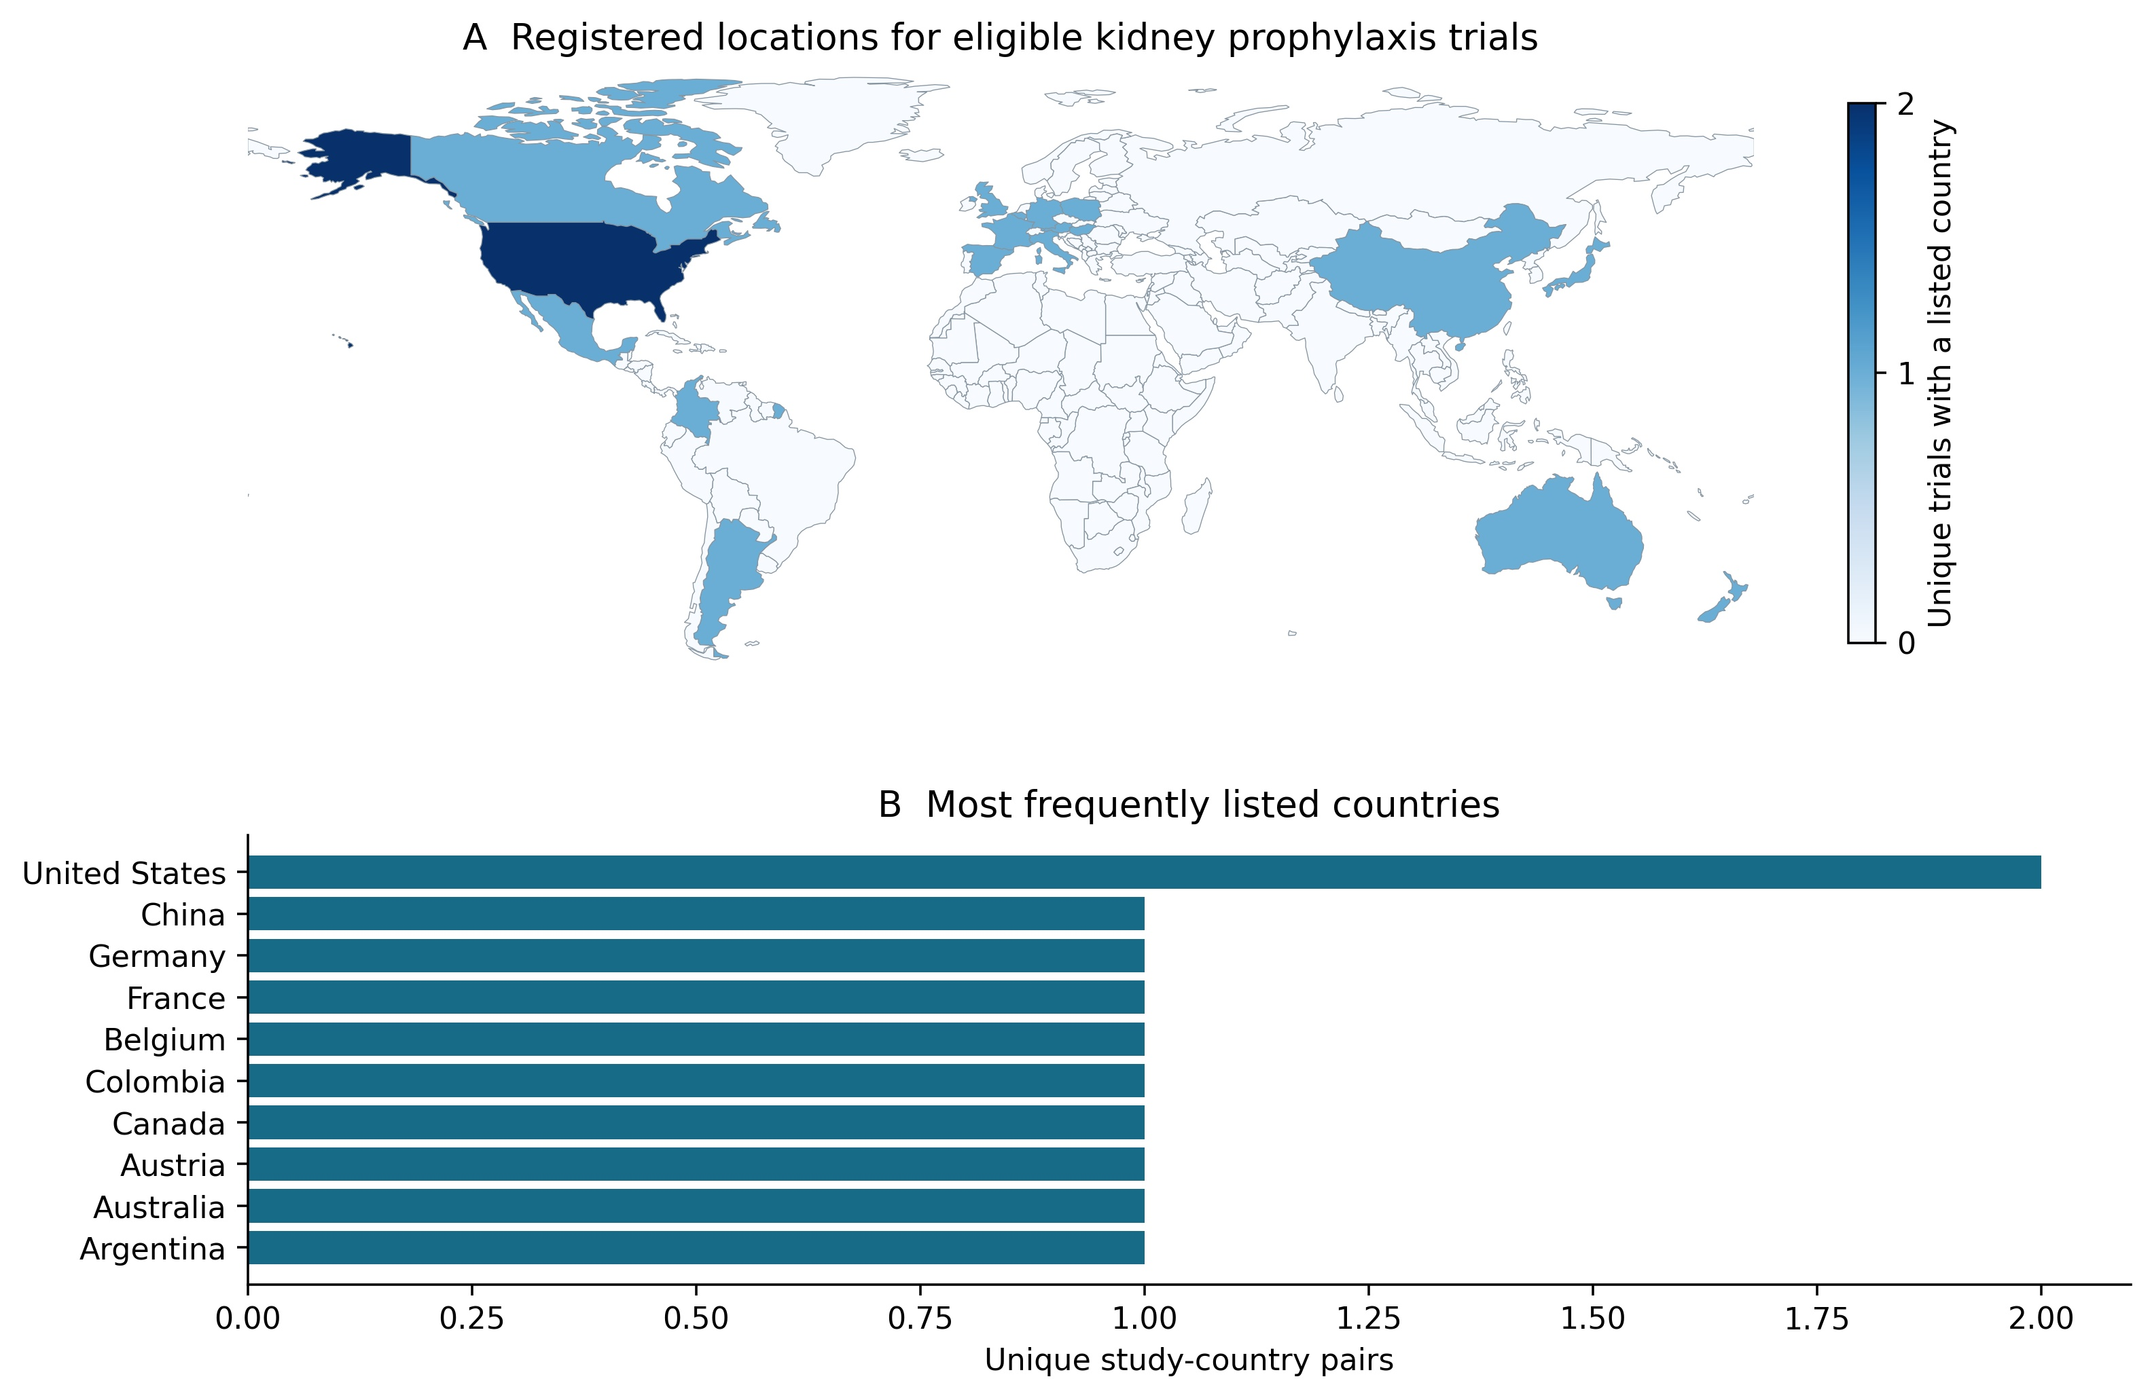
Figure 2 Geographic distribution of registered kidney-transplant prophylaxis studies. A, unique study–country pairs, counting repeated sites within each trial and country once. B, the most frequently listed countries. The map covers 18 countries and 19 pairs; one eligible study has no location-country field. Country counts represent registered research locations. Basemap: Natural Earth public-domain data.
In the pivotal trial, adjudicated CMV disease through week 52 was reported in 10.4% of 289 letermovir and 11.8% of 297 valganciclovir efficacy participants. The stratum-adjusted difference was −1.4 percentage points (95% CI, −6.5 to 3.8). Its upper limit was below the prespecified 10-percentage-point margin, supporting noninferiority; the interval did not establish superiority (Figure 3). The displayed percentages uniquely corresponded to 30/289 and 35/297, which were labeled as reconstructed counts. Inference followed the reported stratified analysis and its original handling of incomplete follow-up.
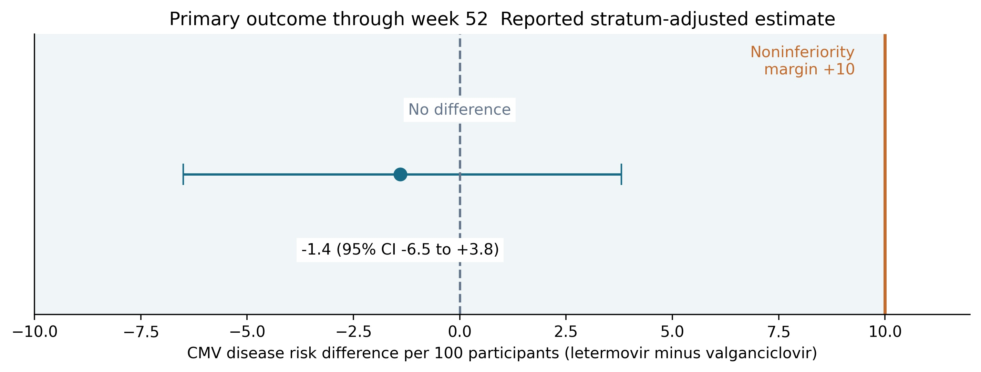
Figure 3 Noninferiority analysis for adjudicated CMV disease through week 52. The point and interval show the source-reported stratum-adjusted risk difference and 95% confidence interval. The upper limit of 3.8 percentage points is below the prespecified 10-percentage-point margin. The interval includes zero and does not establish superiority. Shading indicates a visual reference region rather than an equivalence region. Source [40].
Through week 28, CMV disease was reported in 0.0% and 1.7% of participants, with an adjusted difference of −1.7 percentage points (95% CI, −3.4 to 0.1). Any adverse event was reported in 92.8% and 92.9%, with a source-reported difference of −0.1 percentage points (95% CI, −4.4 to 4.2). Drug-related serious events occurred in 1.4% and 5.1%, with a difference of −3.7 percentage points (95% CI, −7.0 to −0.9). These four reported contrasts are presented in Table 3 and Figure 4. The fifth registered outcome, time to CMV disease, had no estimable median in either group and no extractable comparative hazard ratio.
Table 3 Source-reported comparative treatment contrasts
Outcome | Letermovir versus valganciclovir | Reported difference and 95% CI
Adjudicated CMV disease through week 52 | 10.4% versus 11.8% | -1.4 (-6.5 to +3.8)
Adjudicated CMV disease through week 28 | 0.0% versus 1.7% | -1.7 (-3.4 to +0.1)
Any adverse event | 92.8% versus 92.9% | -0.1 (-4.4 to +4.2)
Drug-related serious adverse event | 1.4% versus 5.1% | -3.7 (-7.0 to -0.9)
Differences are percentage points. CMV-disease contrasts are stratum-adjusted; safety contrasts retain the source-reported methods and intervals. The week-52 CMV-disease upper limit of 3.8 is below the prespecified 10-percentage-point margin. Median time to CMV disease was not reached in either group. Source [40].
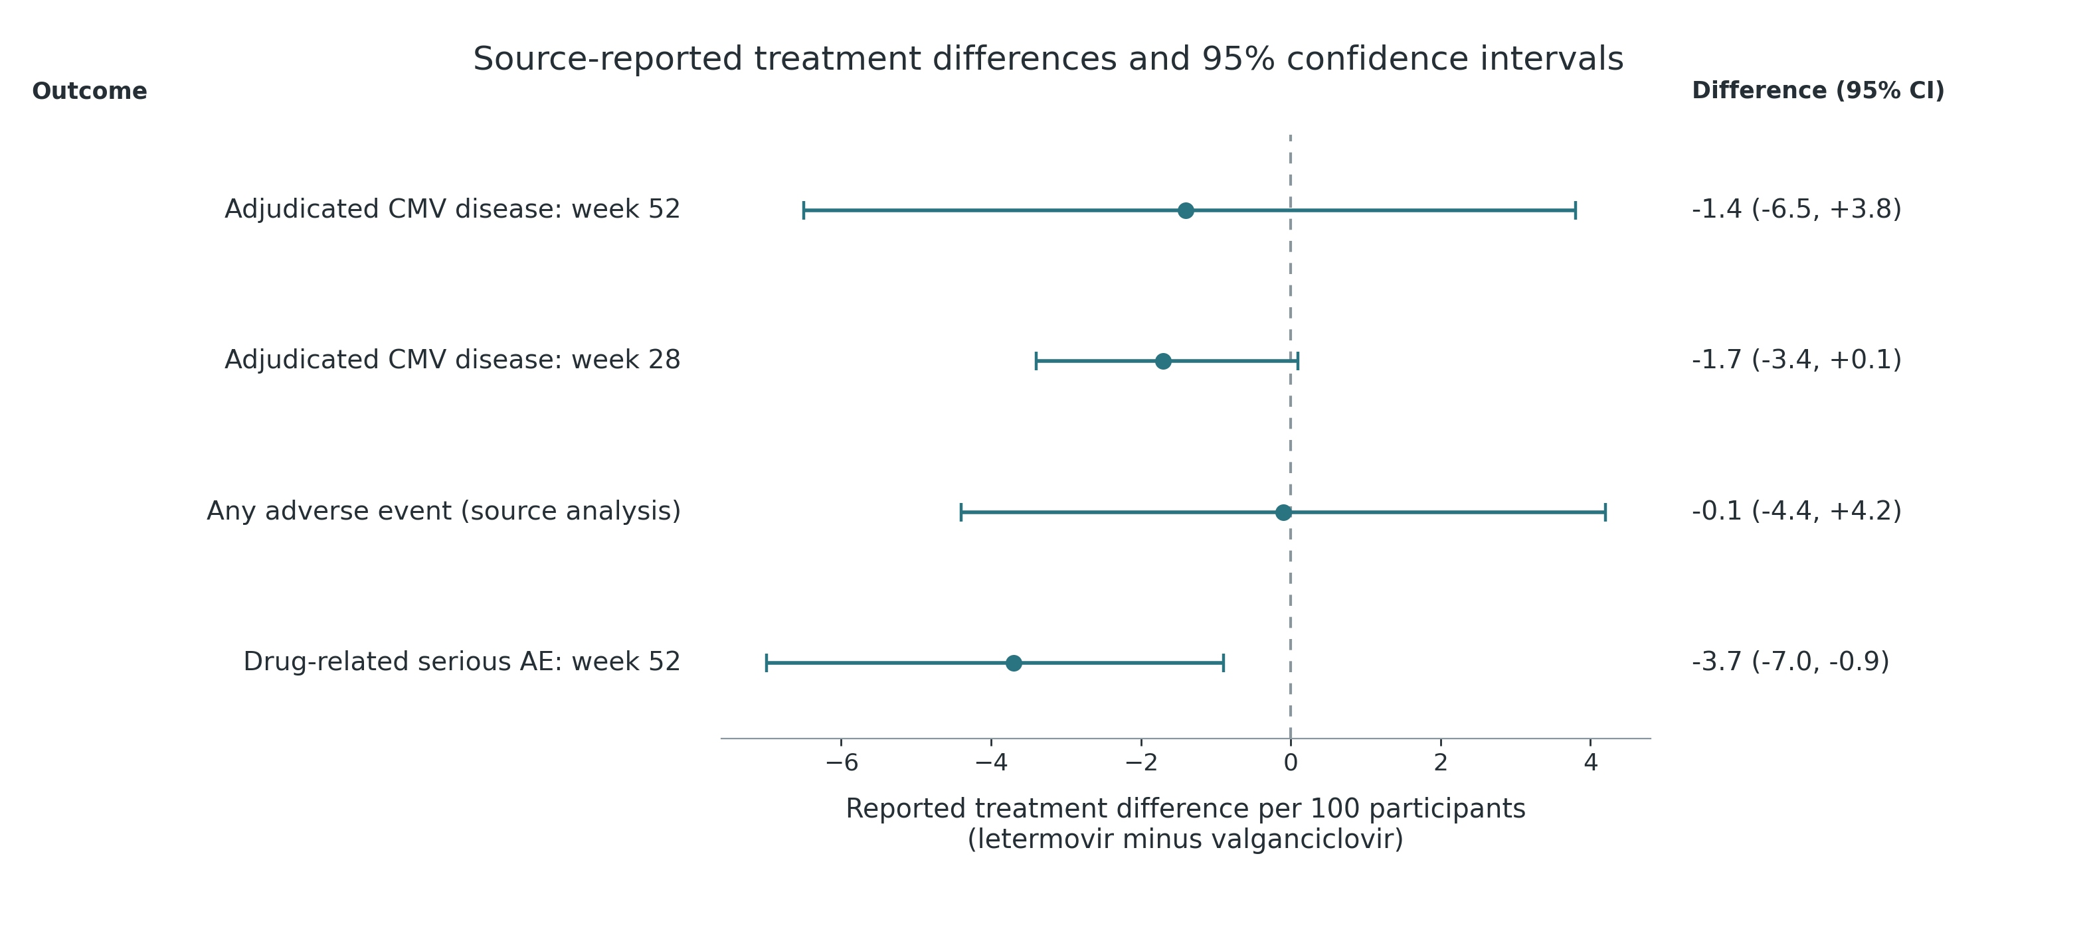
Figure 4 Source-reported treatment contrasts in the randomized trial. Points and bars show risk differences and their original 95% confidence intervals. CMV-disease contrasts are stratum-adjusted. General adverse events were collected during prophylaxis and for 14 days thereafter; subsequent surveillance through week 52 was restricted to drug-related serious events. The general adverse-event estimate therefore does not represent uniform 52-week surveillance. The unestimable median time to CMV disease is not plotted. Source [40].
Named nonserious hematologic events differed between regimens. Leukopenia affected 35/292 letermovir recipients (12.0%) and 105/297 valganciclovir recipients (35.4%), giving a recalculated risk difference of −23.4 percentage points (95% CI, −29.8 to −16.7). Neutropenia affected 7/292 (2.4%) and 50/297 (16.8%), respectively, with a difference of −14.4 percentage points (95% CI, −19.3 to −9.9). Counts represented participants affected by each named event rather than recurrent episodes.
The term “white blood cell count decreased” affected 3/292 participants (1.0%) versus 15/297 (5.1%), a difference of −4.0 percentage points (95% CI, −7.2 to −1.3). Anemia affected 24/292 (8.2%) versus 34/297 (11.4%); the difference was −3.2 percentage points (95% CI, −8.1 to 1.6). The anemia interval included zero, indicating less precise evidence for this term. Categories were analyzed separately because participants could contribute to more than one term (Table 4; Figure 5).
Table 4 Named nonserious hematologic adverse events
Registered term | Letermovir | Valganciclovir | Risk difference per 100 and 95% CI
Leukopenia | 35/292 (12.0%) | 105/297 (35.4%) | -23.37 (-29.83 to -16.65)
Neutropenia | 7/292 (2.4%) | 50/297 (16.8%) | -14.44 (-19.27 to -9.89)
White blood cell count decreased | 3/292 (1.0%) | 15/297 (5.1%) | -4.02 (-7.21 to -1.25)
Anaemia | 24/292 (8.2%) | 34/297 (11.4%) | -3.23 (-8.12 to +1.64)
Counts are directly reported affected-participant counts from the nonserious adverse-event table. They are distinct from central-laboratory abnormalities and the combined clinical/laboratory leukopenia-or-neutropenia endpoint. Terms and seriousness categories may overlap and are not summed. General adverse-event collection covered prophylaxis and 14 days thereafter; later collection through week 52 covered drug-related serious events. Risk differences and Newcombe 95% confidence intervals are descriptive.
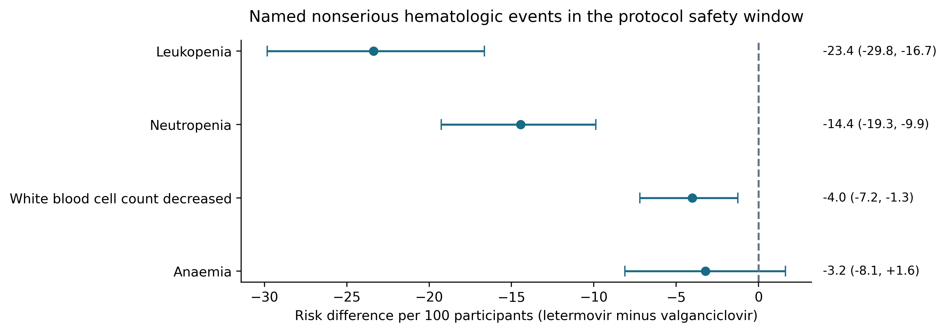
Figure 5 Named nonserious hematologic adverse events. Points show recalculated risk differences and bars show Newcombe 95% confidence intervals. General adverse-event collection covered prophylaxis and 14 days thereafter, with later surveillance restricted to drug-related serious events through week 52. Counts are affected participants within each term. Overlapping terms cannot be summed to reconstruct the combined clinical/laboratory cytopenia endpoint. Counts are provided in Table 4.
Other selected safety contrasts were less precise. Diarrhea affected 33.9% versus 28.6%, a difference of 5.3 percentage points (95% CI, −2.2 to 12.7). Urinary tract infection affected 14.0% versus 15.2%, a difference of −1.1 percentage points (95% CI, −6.8 to 4.6). Increased blood creatinine affected 8.9% versus 13.1%, a difference of −4.2 percentage points (95% CI, −9.3 to 0.9). At least one serious adverse event affected 118/292 participants (40.4%) versus 129/297 (43.4%), a difference of −3.0 percentage points (95% CI, −10.9 to 4.9). This endpoint was distinct from investigator-attributed drug-related serious events.
Study noncompletion was recorded in 45/301 randomized letermovir participants (15.0%) and 34/300 valganciclovir participants (11.3%), a difference of 3.6 percentage points (95% CI, −1.8 to 9.1). These participant-flow counts measured completion of study follow-up rather than discontinuation of prophylaxis. Safety estimates also retained their endpoint-specific ascertainment windows (Table 5; Figure 6).
Table 5 Other safety outcomes and study retention
Outcome | Letermovir | Valganciclovir | Risk difference per 100 and 95% CI
Diarrhoea | 99/292 (33.9%) | 85/297 (28.6%) | +5.28 (-2.20 to +12.69)
Urinary tract infection | 41/292 (14.0%) | 45/297 (15.2%) | -1.11 (-6.84 to +4.64)
Blood creatinine increased | 26/292 (8.9%) | 39/297 (13.1%) | -4.23 (-9.35 to +0.87)
At least one serious AE | 118/292 (40.4%) | 129/297 (43.4%) | -3.02 (-10.91 to +4.92)
Study noncompletion | 45/301 (15.0%) | 34/300 (11.3%) | +3.62 (-1.82 to +9.06)
Named symptom and laboratory-description terms are directly reported nonserious adverse events. At least one serious adverse event uses the affected-participant group total. Study noncompletion uses randomized participants and is distinct from prophylaxis discontinuation. Ascertainment windows differ by endpoint. Intervals are unadjusted Newcombe 95% confidence intervals for descriptive comparisons.
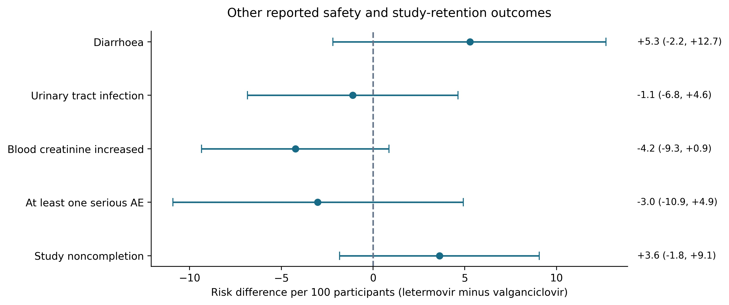
Figure 6 Other safety outcomes and study retention. Points and bars show unadjusted risk differences and Newcombe 95% confidence intervals. Diarrhea, urinary tract infection, and blood creatinine increased are named nonserious terms. At least one serious adverse event uses the affected-participant group total. Study noncompletion uses all randomized participants and measures follow-up retention. Collection windows differ by endpoint. Counts are provided in Table 5.
The Japanese study enrolled 22 participants, with 21 in the efficacy population: 12 D+/R− and nine recipient-seropositive recipients. Through week 28, no adjudicated CMV disease or disease-or-anti-CMV-treatment events were reported. For either zero-event endpoint, the reported upper 95% confidence limit was 16.1% overall, 26.5% in D+/R− recipients, and 33.6% in recipient-seropositive recipients. The quantifiable DNAemia estimate was 4.8% overall (95% CI, 0.1%–23.8%), uniquely corresponding to one of 21 participants.
By week 52, disease or anti-CMV treatment was reported in 19.0% (95% CI, 5.4%–41.9%), adjudicated disease in 9.5% (95% CI, 1.2%–30.4%), and quantifiable DNAemia in 23.8% (95% CI, 8.2%–47.2%). These percentages uniquely corresponded to reconstructed counts of four, two, and five of 21 participants, respectively. All reported week-52 events occurred in the D+/R− subgroup, in which the corresponding percentages were 33.3%, 16.7%, and 41.7%. The nine recipient-seropositive participants had zero observed events, with nonzero upper confidence limits (Table 6; Figure 7).
Table 6 Japanese single-arm study outcomes with source-reported confidence intervals
Outcome | Through week | Source percentage and 95% CI | Compatible count
CMV disease or antiviral treatment | 28 | 0.0 (0.0 to 16.1) | 0/21
CMV disease or antiviral treatment | 52 | 19.0 (5.4 to 41.9) | 4/21
Adjudicated CMV disease | 28 | 0.0 (0.0 to 16.1) | 0/21
Adjudicated CMV disease | 52 | 9.5 (1.2 to 30.4) | 2/21
Quantifiable CMV DNAemia | 28 | 4.8 (0.1 to 23.8) | 1/21
Quantifiable CMV DNAemia | 52 | 23.8 (8.2 to 47.2) | 5/21
Percentages and exact confidence intervals are source-reported. Compatible integer counts are reconstructed from one-decimal percentages and their denominators. The 12 D+/R− and nine R+ participants partition the efficacy population of 21. Results are described separately from the randomized trial. Source [41].
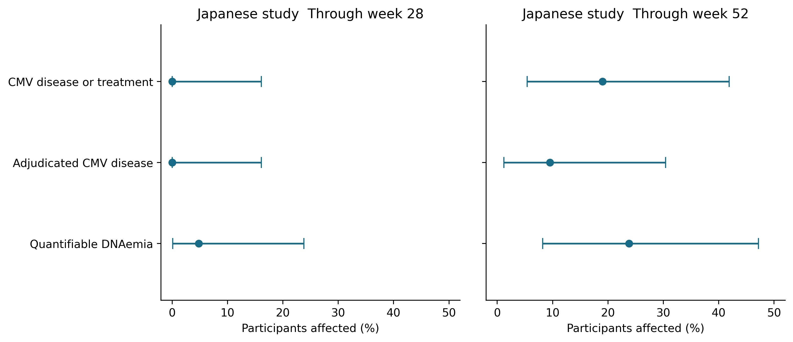
Figure 7 Japanese single-arm study outcomes through weeks 28 and 52. Points and intervals show source-reported percentages and exact 95% confidence intervals for 21 efficacy participants. The displayed endpoints are the composite of CMV disease or anti-CMV treatment, adjudicated CMV disease, and quantifiable CMV DNAemia. The 12 D+/R− and nine R+ participants partition the overall population. Zero-event estimates retain nonzero upper confidence limits. Source [41].
In the Japanese safety population, anemia and leukopenia each affected two of 22 participants, and decreased neutrophil count affected three. Any adverse event was reported in 90.9%, and 13.6% discontinued study drug because of an adverse event by week 28. Participant flow separately recorded 20 study completers and two noncompleters. Medication discontinuation and follow-up completion were therefore distinct outcomes in this study as well.
The pivotal trial used different populations for randomization (301/300), treated safety analyses (292/297), and posted efficacy analyses (289/297). Its adjusted primary estimate retained the original observed-failure handling of premature discontinuation. Counts derived from rounded percentages were identified separately from directly reported integer counts. Corresponding Japanese denominators were 22 for safety and 21 for efficacy (Table 7; Figure 8).
Table 7 Endpoint interpretation and clinical application
Issue | Supported interpretation | Boundary
Primary prevention | Randomized noninferiority supports the studied D+/R- adult indication | Not superior CMV prevention, allograft benefit, or treatment of active infection
Hematologic safety | Native named nonserious terms favor letermovir for leukopenia and neutropenia | The 28-week AE/laboratory composite is different and is not reconstructed
Analysis populations | 301/300 randomized; 292/297 treated; 289/297 efficacy | Excluded or unevaluable participants cannot simply be assigned invented outcomes
Treatment stopping | Published prophylaxis discontinuation can differ from overall study completion | The public randomized flow measures follow-up retention, not medication adherence
Regimen context | Letermovir plus acyclovir was compared with valganciclovir | HSV/VZV coverage and immunosuppressant interactions require attention
Geography and extension | Japan supplies small noncomparative prospective data; China has a registered study | Neither establishes a new comparative validation cohort
Current label | Current kidney indication includes D+/R- recipients age 12 or older and weight at least 40 kg | The analyzed pivotal randomized population was adult; no new pediatric validation is claimed
Clinical context follows the regulatory label [37] and international CMV guidance [31]. Interpretations retain the populations, endpoints, and ascertainment windows of the original studies.
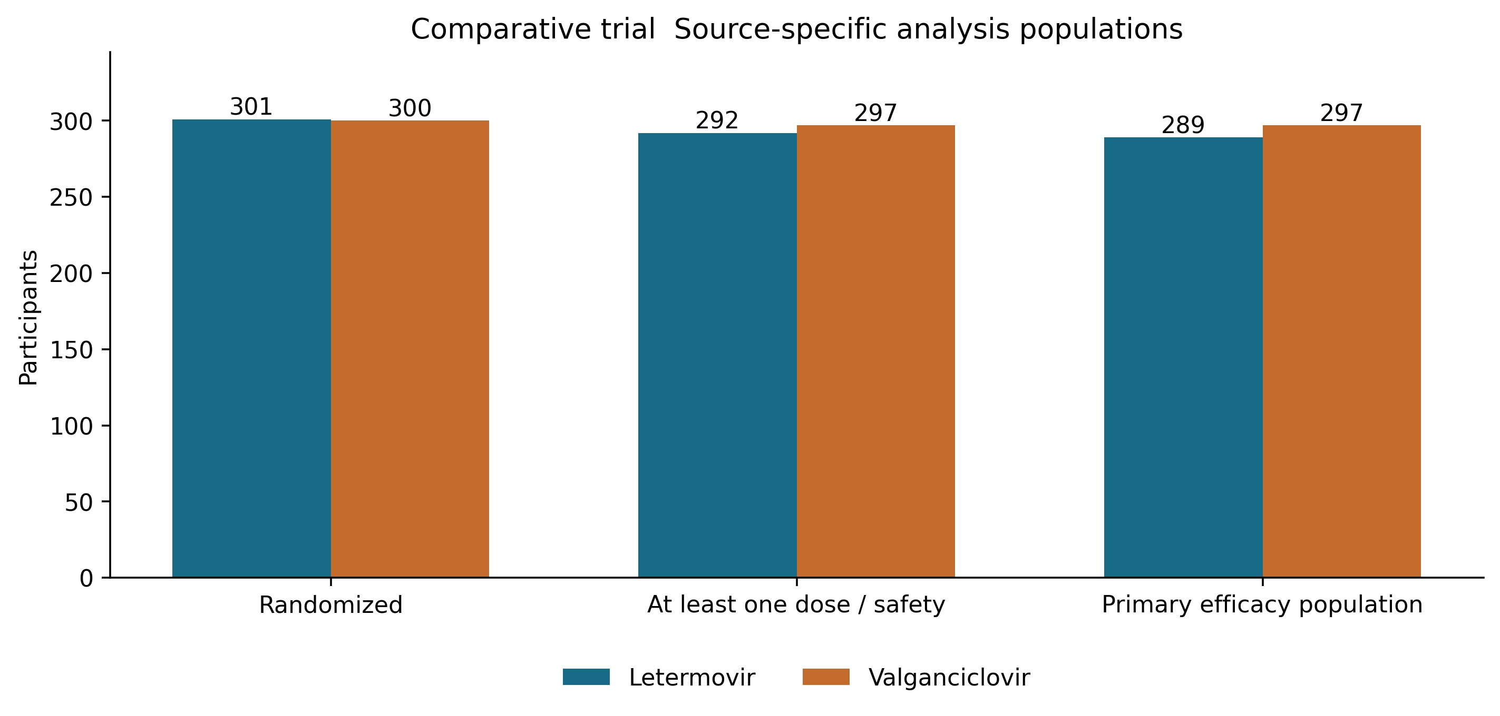
Figure 8 Analysis populations in the randomized trial. Bars show randomized, treated safety, and primary-efficacy populations, with letermovir listed before valganciclovir. These counts represent different analysis denominators. The letermovir regimen included acyclovir. Reasons for every individual exclusion cannot be reconstructed from the aggregate counts. Source [40].
Endpoint availability varied by source. Both registries reported adjudicated CMV disease, broad safety outcomes, and named hematologic adverse events. The randomized clinical/laboratory cytopenia composite and resistance-sequencing findings required regulatory or primary-report sources. The Japanese registry directly reported drug discontinuation; the randomized registry required additional source material for this endpoint. The combined extract contained 19 registered outcome entries: five from the randomized trial and 14 from Japan. Four Japanese intravenous pharmacokinetic entries had zero participants and no numerical estimate because no participants received intravenous treatment; these entries represented unobserved measurements rather than observed zero effects (Figure 9).
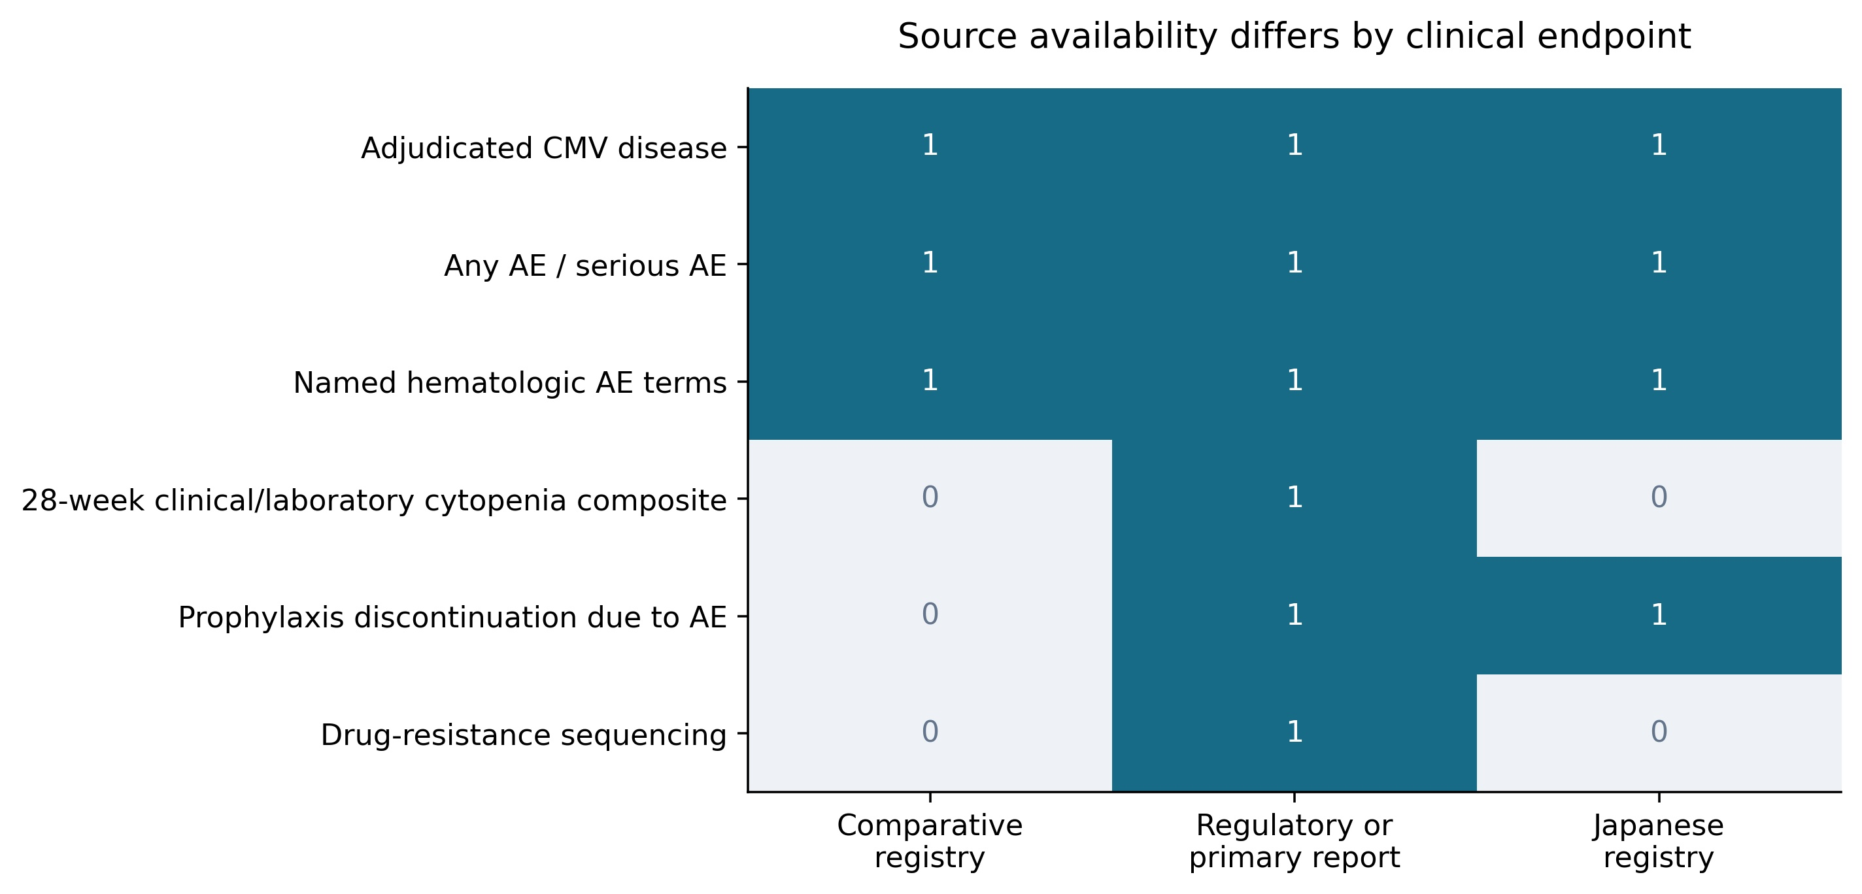
Figure 9 Availability of clinical endpoints across sources. A value of 1 indicates identifiable reporting in the source category; 0 indicates that the endpoint is not directly extractable there. The randomized combined clinical/laboratory cytopenia endpoint, resistance sequencing, and prophylaxis discontinuation are not recoverable from the five posted comparative outcomes. Named hematologic adverse-event terms are reported in both registries. Regulatory and primary reports provide additional information about the original studies.

Discussion
This registry-based evidence map clarifies the balance between CMV prevention and hematologic tolerability after high-risk kidney transplantation. In the pivotal D+/R− trial, adjudicated CMV disease through week 52 occurred in 10.4% of 289 letermovir and 11.8% of 297 valganciclovir efficacy participants, with an adjusted difference of −1.4 percentage points (95% CI, −6.5 to 3.8) [1]. The upper confidence limit was below the prespecified 10-point margin, demonstrating noninferiority without establishing superior prevention or equivalence [35]. The clearest additional differences concerned specific hematologic events: nonserious leukopenia affected 35/292 versus 105/297 treated participants, a difference of −23.4 points (95% CI, −29.8 to −16.7), and neutropenia affected 7/292 versus 50/297, a difference of −14.4 points (95% CI, −19.3 to −9.9). The direction was also favorable for “white blood cell count decreased,” whereas the anemia interval crossed zero, showing that the pattern was not uniform across hematologic terms. These unadjusted score-based intervals complement the original stratified efficacy analysis [34]. The multiple safety comparisons remain exploratory. Named adverse-event terms can overlap and cannot reconstruct the published laboratory/adverse-event cytopenia composite. Their collection during prophylaxis and the following 14 days also differs from drug-related serious-event surveillance through week 52. These events can prompt repeat testing, growth-factor use, or reassessment of other marrow-suppressive medicines. Cytopenias are associated with healthcare use and can complicate immunosuppression management, although those associations do not demonstrate that changing prophylaxis prevents downstream complications [23,24]. The active comparator was an established regimen: IMPACT supported 200 rather than 100 days of valganciclovir prophylaxis, with benefit persisting during follow-up [18,19]. Late-onset disease nevertheless remains relevant when interpreting favorable on-prophylaxis findings [30]. Disease, DNAemia, and antiviral-treatment initiation describe different outcomes under consensus definitions [32]. Likewise, medication discontinuation and study noncompletion represent different intercurrent events and should inform separate treatment discussions [39].
Letermovir inhibits the CMV terminase complex, providing pharmacologic context for the regimen comparison [28]. Renal-impairment pharmacokinetic data inform prescribing, while immunosuppressant interactions require monitoring [14,16]. Concomitant acyclovir was part of the pivotal regimen, so the comparison concerns complete prophylaxis strategies; dedicated interaction data inform this coadministration [15]. Conversion cohorts report improved hematologic tolerance and examine preservation of mycophenolate exposure [8,12]. Other real-world reports emphasize tacrolimus interactions and monitoring during conversion [7,9]. De novo abdominal-organ and seropositive kidney-transplant studies extend implementation experience to different populations [10,11]. Older-recipient and kidney-function analyses refine interpretation within the pivotal cohort rather than provide independent randomized replication [4,5]. CMV-specific cellular-immunity studies similarly generate hypotheses about postprophylaxis risk without establishing a validated stopping threshold [6,13]. Resistance findings require attention to testing: the pivotal analysis examined selected participants with suspected disease or DNAemia, and sequence variants require validated phenotypic interpretation [3,27]. Historical valganciclovir analyses describe resistance substitutions and pharmacokinetic exposure, respectively, but address different questions from the present comparison [25,26]. Trials involving valacyclovir or preemptive therapy address different prevention decisions [29,20]. Earlier hematopoietic-cell-transplant trials established prophylactic activity in another transplant population [21,22]. The kidney-transplant phase 2a study addressed preemptive treatment of established replication [17]. These studies explain the broader development history but should not be pooled as replications of primary prophylaxis in D+/R− kidney recipients.
The Japanese study adds prospective experience, with 22 safety participants and 21 efficacy participants, including 12 D+/R− and nine seropositive recipients [2]. No adjudicated disease occurred through week 28, but the overall upper confidence bound was 16.1%; by week 52, disease affected 9.5% and the broader disease-or-treatment endpoint affected 19.0%. All reported week-52 events occurred in D+/R− recipients; zero events among nine seropositive recipients remained compatible with appreciable risk. Mixed serostatus, small numbers, and the absence of a concurrent comparator limit comparative interpretation. Across the registry map, five eligible studies covered 18 countries, but only two supplied posted results. A Chinese registration without results identifies a research setting rather than observed local effectiveness. Geography and registered enrollment therefore cannot establish transportability to every recipient group. Guidance evolved from the 2018 to the 2025 consensus as the evidence base expanded [33,31]. The current regulatory label also extends beyond the adult populations studied here, including eligible adolescents, and should not be treated as evidence of pediatric enrollment in these trials [37]. This targeted, unregistered, single-registry analysis is limited by source coverage, changing records, and differing ascertainment periods. The pivotal trial's observed-failure approach did not automatically count premature discontinuation as CMV disease, making the analysis population and missingness assumptions relevant to interpretation. Aggregate data cannot support new patient-level adjustment, individualized treatment prediction, or independent clinical validation. They also cannot determine whether fewer reported cytopenias improve graft survival or cost-effectiveness. Future comparative studies should measure medication persistence, immunosuppressant adjustments, resource use, and patient-reported burden alongside adjudicated CMV disease, with follow-up extending beyond prophylaxis. Measuring these outcomes would clarify how noninferior CMV prevention and fewer reported cytopenias translate into everyday transplant care.

Conclusion
In adult D+/R− kidney transplant recipients, the pivotal trial supports letermovir plus acyclovir as noninferior to valganciclovir for prevention of adjudicated CMV disease through week 52, with fewer reports of specific hematologic adverse events. The clinical interpretation depends on distinguishing named events from laboratory composites and medication discontinuation from study completion. The Japanese study adds small, noncomparative prospective evidence. Further studies should assess medication persistence, immunosuppression management, resource use, and outcomes after prophylaxis in populations beyond the pivotal comparison.

Data availability and ethical scope
The source protocol records and aggregate trial results are publicly accessible through ClinicalTrials.gov. Records were retrieved on October 16, 2026. Processing comprised eligibility screening, endpoint classification, denominator checks, and trial-specific risk-difference calculations. Counts reconstructed from rounded percentages are identified as derived. The retrieved snapshot may differ from subsequent registry updates. The analysis used public aggregate information without access to confidential participant records.

References
1. Limaye AP, Budde K, Humar A, Vincenti F, Kuypers DRJ, Carroll RP, et al. Letermovir vs Valganciclovir for Prophylaxis of Cytomegalovirus in High-Risk Kidney Transplant Recipients: A Randomized Clinical Trial. JAMA. 2023;330(1):33-42. doi:10.1001/jama.2023.9106. https://pubmed.ncbi.nlm.nih.gov/37279999/
2. Ishida H, Goto N, Imamura R, Sasaki H, Unagami K, Futamura K, et al. Letermovir safety and efficacy for cytomegalovirus prophylaxis in adult Japanese kidney transplant recipients: a multicenter, open-label, noncomparative Phase 3 study. Clin Exp Nephrol. 2024;28(8):822-831. doi:10.1007/s10157-024-02471-0. https://pubmed.ncbi.nlm.nih.gov/38615067/
3. Strizki JM, Diamond TL, Teal VL, Gilbert CL, Wang W, Stauffer N, et al. Cytomegalovirus Antiviral Resistance Among Kidney Transplant Recipients in a Phase 3 Trial of Letermovir vs Valganciclovir Prophylaxis. J Infect Dis. 2024;230(6):e1287-e1298. doi:10.1093/infdis/jiae287. https://pubmed.ncbi.nlm.nih.gov/38853607/
4. Bunnapradist S, Vincenti F, Witzke O, Schneeberger S, Nguyen MH, Broyde N, et al. Favorable Adherence and Tolerability of Letermovir Versus Valganciclovir for Cytomegalovirus Prophylaxis in Kidney Transplant Recipients Aged 65 y or Older: Findings From a Randomized, Phase 3 Trial. Transplant Direct. 2026;12(9):e1990. doi:10.1097/txd.0000000000001990. https://pubmed.ncbi.nlm.nih.gov/42639594/
5. Budde K, Kamar N, Crespo M, Small CB, Stauffer N, Broyde N, et al. Impact of kidney function on 200 days of antiviral prophylaxis for cytomegalovirus disease in cytomegalovirus-seronegative recipients of cytomegalovirus-seropositive donor kidneys: Post hoc analysis of a randomized, phase 3 trial of letermovir vs valganciclovir prophylaxis. Am J Transplant. 2025;25(12):2621-2633. doi:10.1016/j.ajt.2025.07.2471. https://pubmed.ncbi.nlm.nih.gov/40701254/
6. Limaye AP, Crespo M, Kamar N, Humar A, Carroll RP, Pereira MR, et al. Cytomegalovirus (CMV)-Specific Cell-Mediated Immunity for Prediction of Postprophylaxis CMV Disease in a Phase 3 Trial of Letermovir Versus Valganciclovir Prophylaxis in Donor CMV-Seropositive/Recipient CMV-Seronegative Kidney Transplant Recipients. Clin Infect Dis. 2026;82(2):e316-e324. doi:10.1093/cid/ciaf632. https://pubmed.ncbi.nlm.nih.gov/41321121/
7. Benotmane I, Schvartz B, Garrouste C, Runyo F, Boud'hors C, Flahaut G, et al. Real-World Evaluation of Letermovir Use in Kidney Transplant Recipients: Drug Interactions, Safety, and Impact on Renal Function. Transpl Int. 2025;38:15371. doi:10.3389/ti.2025.15371. https://pubmed.ncbi.nlm.nih.gov/41424458/
8. Jorgenson MR, Descourouez JL, Saddler CM, Smith JA, Odorico JS, Rice JP, et al. Real world experience with conversion from valganciclovir to letermovir for cytomegalovirus prophylaxis: Letermovir reverses leukopenia and avoids mycophenolate dose reduction. Clin Transplant. 2023;37(12):e15142. doi:10.1111/ctr.15142. https://pubmed.ncbi.nlm.nih.gov/37755141/
9. Winstead RJ, Kumar D, Brown A, Yakubu I, Song C, Thacker L, et al. Letermovir prophylaxis in solid organ transplant-Assessing CMV breakthrough and tacrolimus drug interaction. Transpl Infect Dis. 2021;23(4):e13570. doi:10.1111/tid.13570. https://pubmed.ncbi.nlm.nih.gov/33469975/
10. Descourouez JL, Kleiboeker H, Saddler CM, Smith JA, Rice JP, Mandelbrot DA, et al. The UW Experience: Feasibility of De Novo Letermovir for Primary Prophylaxis After Abdominal Solid Organ Transplant. Ann Pharmacother. 2025;59(8):730-735. doi:10.1177/10600280241307383. https://pubmed.ncbi.nlm.nih.gov/39815618/
11. Kleiboeker HL, Jorgenson MR, Scolarici MJ, Descourouez JL, Leverson GE, Saddler C, et al. De Novo Letermovir After Cytomegalovirus Seropositive Kidney Transplant Improves Toxicity and Mycophenolate Tolerance Over the Current Standard of Care. Clin Transplant. 2025;39(12):e70423. doi:10.1111/ctr.70423. https://pubmed.ncbi.nlm.nih.gov/41408959/
12. Amin SJ, Rogers AW, Yun AN, Nigo M, Ghobrial RM, Gaber AO. Letermovir Conversion for Cytomegalovirus Prophylaxis in Solid Organ Transplant. Clin Transplant. 2025;39(11):e70366. doi:10.1111/ctr.70366. https://pubmed.ncbi.nlm.nih.gov/41137659/
13. Jorgenson MR, Kleiboeker H, Garg N, Parajuli S, Mandelbrot DA, Odorico JS, et al. Letermovir conversion after valganciclovir treatment in cytomegalovirus high-risk abdominal solid organ transplant recipients may promote development of cytomegalovirus-specific cell mediated immunity. Transpl Infect Dis. 2022;24(1):e13766. doi:10.1111/tid.13766. https://pubmed.ncbi.nlm.nih.gov/34799964/
14. Kropeit D, Scheuenpflug J, Erb-Zohar K, Halabi A, Stobernack HP, Hulskotte EGJ, et al. Pharmacokinetics and safety of letermovir, a novel anti-human cytomegalovirus drug, in patients with renal impairment. Br J Clin Pharmacol. 2017;83(9):1944-1953. doi:10.1111/bcp.13292. https://pubmed.ncbi.nlm.nih.gov/28345163/
15. Menzel K, McCrea JB, Fancourt C, Witter R, Zhao T, Stoch SA, et al. A drug-drug interaction study with letermovir and acyclovir in healthy participants. Br J Clin Pharmacol. 2023;89(5):1690-1694. doi:10.1111/bcp.15648. https://pubmed.ncbi.nlm.nih.gov/36537620/
16. McCrea JB, Macha S, Adedoyin A, Marshall W, Menzel K, Cho CR, et al. Pharmacokinetic Drug-Drug Interactions Between Letermovir and the Immunosuppressants Cyclosporine, Tacrolimus, Sirolimus, and Mycophenolate Mofetil. J Clin Pharmacol. 2019;59(10):1331-1339. doi:10.1002/jcph.1423. https://pubmed.ncbi.nlm.nih.gov/30990905/
17. Stoelben S, Arns W, Renders L, Hummel J, Mühlfeld A, Stangl M, et al. Preemptive treatment of Cytomegalovirus infection in kidney transplant recipients with letermovir: results of a Phase 2a study. Transpl Int. 2014;27(1):77-86. doi:10.1111/tri.12225. https://pubmed.ncbi.nlm.nih.gov/24164420/
18. Humar A, Lebranchu Y, Vincenti F, Blumberg EA, Punch JD, Limaye AP, et al. The efficacy and safety of 200 days valganciclovir cytomegalovirus prophylaxis in high-risk kidney transplant recipients. Am J Transplant. 2010;10(5):1228-1237. doi:10.1111/j.1600-6143.2010.03074.x. https://pubmed.ncbi.nlm.nih.gov/20353469/
19. Humar A, Limaye AP, Blumberg EA, Hauser IA, Vincenti F, Jardine AG, et al. Extended valganciclovir prophylaxis in D+/R- kidney transplant recipients is associated with long-term reduction in cytomegalovirus disease: two-year results of the IMPACT study. Transplantation. 2010;90(12):1427-1431. doi:10.1097/tp.0b013e3181ff1493. https://pubmed.ncbi.nlm.nih.gov/21197713/
20. Reischig T, Vlas T, Kacer M, Pivovarcikova K, Lysak D, Nemcova J, et al. A Randomized Trial of Valganciclovir Prophylaxis Versus Preemptive Therapy in Kidney Transplant Recipients. J Am Soc Nephrol. 2023;34(5):920-934. doi:10.1681/asn.0000000000000090. https://pubmed.ncbi.nlm.nih.gov/36749127/
21. Marty FM, Ljungman P, Chemaly RF, Maertens J, Dadwal SS, Duarte RF, et al. Letermovir Prophylaxis for Cytomegalovirus in Hematopoietic-Cell Transplantation. N Engl J Med. 2017;377(25):2433-2444. doi:10.1056/nejmoa1706640. https://pubmed.ncbi.nlm.nih.gov/29211658/
22. Chemaly RF, Ullmann AJ, Stoelben S, Richard MP, Bornhäuser M, Groth C, et al. Letermovir for cytomegalovirus prophylaxis in hematopoietic-cell transplantation. N Engl J Med. 2014;370(19):1781-1789. doi:10.1056/nejmoa1309533. https://pubmed.ncbi.nlm.nih.gov/24806159/
23. Beyer AP, Moise PA, Wong M, Gao W, Xiang C, Shen P, et al. Clinical events and healthcare resource utilization associated with neutropenia and leukopenia among adult kidney transplant recipients receiving valganciclovir. World J Transplant. 2025;15(2):102671. doi:10.5500/wjt.v15.i2.102671. https://pubmed.ncbi.nlm.nih.gov/40535505/
24. Ingold L, Halter J, Martinez M, Amico P, Wehmeier C, Hirt-Minkowski P, et al. Short- and long-term impact of neutropenia within the first year after kidney transplantation. Transpl Int. 2021;34(10):1875-1885. doi:10.1111/tri.13976. https://pubmed.ncbi.nlm.nih.gov/34272771/
25. Boivin G, Goyette N, Farhan M, Ives J, Elston R. Incidence of cytomegalovirus UL97 and UL54 amino acid substitutions detected after 100 or 200 days of valganciclovir prophylaxis. J Clin Virol. 2012;53(3):208-213. doi:10.1016/j.jcv.2011.12.019. https://pubmed.ncbi.nlm.nih.gov/22237003/
26. Welker H, Farhan M, Humar A, Washington C. Ganciclovir pharmacokinetic parameters do not change when extending valganciclovir cytomegalovirus prophylaxis from 100 to 200 days. Transplantation. 2010;90(12):1414-1419. doi:10.1097/tp.0b013e3182000042. https://pubmed.ncbi.nlm.nih.gov/21076372/
27. Chou S, Watanabe J. Phenotypes of cytomegalovirus genetic variants encountered in a letermovir clinical trial illustrate the importance of genotyping validation. Antiviral Res. 2024;228:105935. doi:10.1016/j.antiviral.2024.105935. https://pubmed.ncbi.nlm.nih.gov/38880196/
28. Goldner T, Hewlett G, Ettischer N, Ruebsamen-Schaeff H, Zimmermann H, Lischka P. The novel anticytomegalovirus compound AIC246 (Letermovir) inhibits human cytomegalovirus replication through a specific antiviral mechanism that involves the viral terminase. J Virol. 2011;85(20):10884-10893. doi:10.1128/jvi.05265-11. https://pubmed.ncbi.nlm.nih.gov/21752907/
29. Reischig T, Kacer M, Jindra P, Hes O, Lysak D, Bouda M. Randomized trial of valganciclovir versus valacyclovir prophylaxis for prevention of cytomegalovirus in renal transplantation. Clin J Am Soc Nephrol. 2015;10(2):294-304. doi:10.2215/cjn.07020714. https://pubmed.ncbi.nlm.nih.gov/25424991/
30. Lamoth F, Manuel O, Venetz JP, Faouzi M, Meylan P, Pascual M. What is the impact of late-onset cytomegalovirus disease after valganciclovir prophylaxis in kidney transplantation?. Transplantation. 2008;86(9):1323-1324. doi:10.1097/tp.0b013e3181890788. https://pubmed.ncbi.nlm.nih.gov/19005418/
31. Kotton CN, Kumar D, Manuel O, Chou S, Hayden RT, Danziger-Isakov L, et al. The Fourth International Consensus Guidelines on the Management of Cytomegalovirus in Solid Organ Transplantation. Transplantation. 2025;109(7):1066-1110. doi:10.1097/tp.0000000000005374. https://pubmed.ncbi.nlm.nih.gov/40200403/
32. Ljungman P, Chemaly RF, Khawaya F, Alain S, Avery R, Badshah C, et al. Consensus Definitions of Cytomegalovirus (CMV) Infection and Disease in Transplant Patients Including Resistant and Refractory CMV for Use in Clinical Trials: 2024 Update From the Transplant Associated Virus Infections Forum. Clin Infect Dis. 2024;79(3):787-794. doi:10.1093/cid/ciae321. https://pubmed.ncbi.nlm.nih.gov/39041385/
33. Kotton CN, Kumar D, Caliendo AM, Huprikar S, Chou S, Danziger-Isakov L, et al. The Third International Consensus Guidelines on the Management of Cytomegalovirus in Solid-organ Transplantation. Transplantation. 2018;102(6):900-931. doi:10.1097/tp.0000000000002191. https://pubmed.ncbi.nlm.nih.gov/29596116/
34. Newcombe RG. Interval estimation for the difference between independent proportions: comparison of eleven methods. Stat Med. 1998;17(8):873-890. doi:10.1002/(sici)1097-0258(19980430)17:8<873::aid-sim779>3.0.co;2-i. https://pubmed.ncbi.nlm.nih.gov/9595617/
35. Piaggio G, Elbourne DR, Pocock SJ, Evans SJ, Altman DG, CONSORT Group. Reporting of noninferiority and equivalence randomized trials: extension of the CONSORT 2010 statement. JAMA. 2012;308(24):2594-2604. doi:10.1001/jama.2012.87802. https://pubmed.ncbi.nlm.nih.gov/23268518/
36. Page MJ, McKenzie JE, Bossuyt PM, Boutron I, Hoffmann TC, Mulrow CD, et al. The PRISMA 2020 statement: an updated guideline for reporting systematic reviews. BMJ. 2021;372:n71. doi:10.1136/bmj.n71. https://pubmed.ncbi.nlm.nih.gov/33782057/
37. Merck Sharp & Dohme LLC. PREVYMIS (letermovir) tablets, oral pellets, and injection: prescribing information. Revised January 2026. 2026. https://dailymed.nlm.nih.gov/dailymed/lookup.cfm?setid=1b49df80-be4f-47e0-a0b7-123f3e69395b&version=28. Accessed 16 October 2026.
38. National Library of Medicine. ClinicalTrials.gov: Terms and Conditions. No publication date stated. https://clinicaltrials.gov/about-site/terms-conditions. Accessed 16 October 2026.
39. International Council for Harmonisation of Technical Requirements for Pharmaceuticals for Human Use. Addendum on Estimands and Sensitivity Analysis in Clinical Trials to the Guideline on Statistical Principles for Clinical Trials E9(R1). 2019. https://database.ich.org/sites/default/files/E9-R1_Step4_Guideline_2019_1203.pdf. Accessed 16 October 2026.
40. Merck Sharp & Dohme LLC. A Phase III, Randomized, Double-Blind, Active Comparator-Controlled Study to Evaluate the Efficacy and Safety of MK-8228 (Letermovir) Versus Valganciclovir for the Prevention of Human Cytomegalovirus (CMV) Disease in Adult Kidney Transplant Recipients. ClinicalTrials.gov identifier: NCT03443869. Updated 2023-07-28. https://clinicaltrials.gov/study/NCT03443869. Accessed 16 October 2026.
41. Merck Sharp & Dohme LLC. A Phase 3, Open-Label, Single-Arm Clinical Study to Evaluate the Safety, Efficacy and Pharmacokinetics of MK-8228 (Letermovir) for the Prevention of Human Cytomegalovirus (CMV) Infection and Disease in Adult Japanese Kidney Transplant Recipients. ClinicalTrials.gov identifier: NCT04129398. Updated 2024-08-21. https://clinicaltrials.gov/study/NCT04129398. Accessed 16 October 2026.
42. First Affiliated Hospital Xi'an Jiaotong University. Efficacy and Safety of Leymovir Versus Valganciclovir in Prevention of Cytomegalovirus Infection and Cytomegalovirus Disease in Chinese Kidney Transplant Recipients. ClinicalTrials.gov identifier: NCT07266467. Updated 2025-12-05. https://clinicaltrials.gov/study/NCT07266467. Accessed 16 October 2026.
43. Virginia Commonwealth University. Historical Controlled, Single Center Open Label Pilot Comparing the Effectiveness and Tolerability of De-novo Initiation of Letermovir Versus Valganciclovir for Cytomegalovirus Prophylaxis in AA Kidney Transplant Recipients. ClinicalTrials.gov identifier: NCT06001320. Updated 2026-09-23. https://clinicaltrials.gov/study/NCT06001320. Accessed 16 October 2026.
44. University of Wisconsin, Madison. An Interventional Study of Letermovir for Secondary Prophylaxis After Treatment of Cytomegalovirus Infection in High Risk (D+/R-) Kidney and Kidney/Pancreas Transplant Recipients. ClinicalTrials.gov identifier: NCT06407232. Updated 2026-06-11. https://clinicaltrials.gov/study/NCT06407232. Accessed 16 October 2026.
45. Hospital do Rim e Hipertensão. Efficacy and Safety of Prophylactic Use of Letermovir Versus Preemptive Strategy in Kidney Transplant Recipients at Higher Risk of Cytomegalovirus Infection: a Prospective Randomized Study. ClinicalTrials.gov identifier: NCT06341686. Updated 2024-04-02. https://clinicaltrials.gov/study/NCT06341686. Accessed 16 October 2026.

