STA S380 HW2

Hope Knopf, Marie Gleichauf, Chelsea Matthews

8/17/2018

### Flights at ABIA

library(tm)  
#setwd('/users/chelseamatthews/Documents')  
airlinedata = read.csv('~/Documents/UT/Summer Classes/Intro to Predictive Modeling/Part 2/HW 2/ABIA.csv', header=TRUE)  
  
#percentage of flights cancelled for each airline  
dfcancelled = data.frame(aggregate(airlinedata$Cancelled~airlinedata$UniqueCarrier,airlinedata,sum))  
  
df=data.frame(aggregate(airlinedata$FlightNum ~ airlinedata$UniqueCarrier,airlinedata, length))  
finaldf = merge(dfcancelled,df)  
finaldf = within(finaldf, percent <- airlinedata.Cancelled/airlinedata.FlightNum)  
finaldf = finaldf[order(finaldf$percent),]  
  
barplot(finaldf$percent, names = finaldf$arrivaldelays.UniqueCarrier,  
 xlab = 'Unique Carrier', ylab = '% of Flights Cancelled',  
 main = "% of Flights Cancelled per Airline",las=2, space = .5, col = 'dodgerblue3',  
 names.arg = c("NW","F9","US","WN","XE","UA","DL","CO","YV","B6", "OO","EV","OH","9E","AA","MQ"))

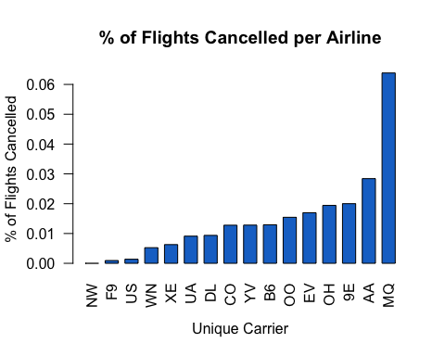 American Eagle (MQ) had the highest percentage of cancelled flights. American Airlines (AA) had the next highest percent of cancelled flights.

# Arrivals

#average arrival delay  
  
arrdelay = airlinedata[which(airlinedata[,15]>0),]  
df_arrdelay = data.frame(aggregate(arrdelay$ArrDelay ~ arrdelay$UniqueCarrier,arrdelay,mean))  
df_arrdelay = df_arrdelay[order(df_arrdelay$arrdelay.ArrDelay),]  
  
barplot(df_arrdelay$arrdelay.ArrDelay, names = df_arrdelay$arrdelay.UniqueCarrier,  
 xlab = "Unique Carrier", ylab = "Avg. Arrival Delays (minutes)",  
 main = "Avg. Arrival Delay times per Airline", las = 2, space=.5, col = 'darkseagreen')

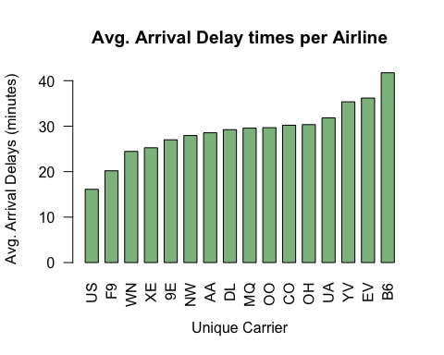 JetBlue(B6) has the longest average arrival delays, followed by ExpressJet (EV) and Mesa Airlines(YV).

#arrival delays per month  
df_arrdelaymon = data.frame(aggregate(arrdelay$ArrDelay ~ arrdelay$Month,arrdelay,length))  
plot(df_arrdelaymon$arrdelay.Month, df_arrdelaymon$arrdelay.ArrDelay,   
 xlab = "Month", ylab = "# of Arrival Delays",   
 main = "Number of Arrival delays per month", type ='o', col='lightblue',lwd=2, pch=10)

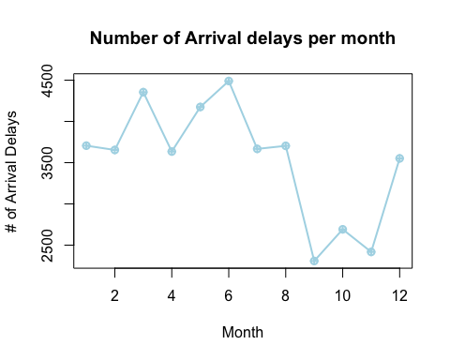 March and June had the highest number of arrival delays, while September and November had the smallest number of arrival delays.

#average arrival delays per month  
df_arrdelaymon = data.frame(aggregate(arrdelay$ArrDelay ~ arrdelay$Month,arrdelay,mean))  
plot(df_arrdelaymon$arrdelay.Month, df_arrdelaymon$arrdelay.ArrDelay,   
 xlab = "Month", ylab = "Avg. Arrival Delay (Minutes)",   
 main = "Avg. Arrival delays per month", type ='o', col='lightblue',lwd=2, pch=10)

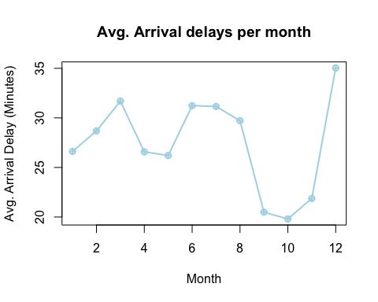 September, October and November had the shortest average arrival delays, while December had the longest.

#arrival delays by day of the week  
  
df_arrdelayday = data.frame(aggregate(arrdelay$ArrDelay ~ arrdelay$DayOfWeek,arrdelay,length))  
  
plot(df_arrdelayday$arrdelay.DayOfWeek, df_arrdelayday$arrdelay.ArrDelay,   
 xlab = "Day of Week (1-Monday - 7-Sunday)", ylab = "# of Arrival Delays",   
 main = "Number of Arrival delays by Day of Week", type ='o', col='thistle',lwd=2, pch=10)

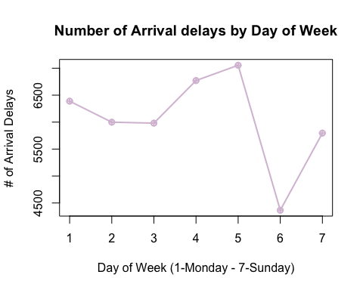 Saturdays had the lowest amount of arrival delays, while Thursdays and Fridays had the most.

#average time of arrival delays by day of the week  
  
df_arrdelayday = data.frame(aggregate(arrdelay$ArrDelay ~ arrdelay$DayOfWeek,arrdelay,mean))  
  
plot(df_arrdelayday$arrdelay.DayOfWeek, df_arrdelayday$arrdelay.ArrDelay,   
 xlab = "Day of Week (1-Monday - 7-Sunday", ylab = "Average Time of Arr Delay (minutes)",   
 main = "Avg. Time of Arrival Delay by Day of Week", type ='o', col='steelblue',lwd=2, pch=10)

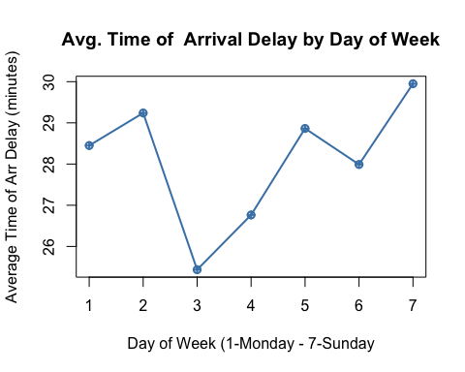 The Average time of arrival delays is the lowest on Wednesdays and highest on Sundays.

# average time of arrival delays by time of day

#average time of arrival delays by time of day  
  
df_arrdelaytime = data.frame(aggregate(arrdelay$ArrDelay ~ arrdelay$ArrTime,arrdelay,length))  
  
plot(df_arrdelaytime$arrdelay.ArrTime, df_arrdelaytime$arrdelay.ArrDelay,   
 xlab = "Time of Day (24 Hour Time)", ylab = "# of Arr. Delay ",   
 main = "Number of Arrival Delay by Time of Day", type ='o', col='slategray',lwd=2, pch=10)

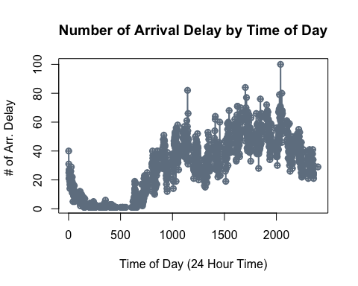 Between 1 am and 6 am there are the fewest amount of arrival delays. This is probably due to the lesser amount of flights during this time, since many airports don’t have flights bewtween 2 am and 5 am . Around 11 am and 8 pm seem to ahve the the highest number of arrival delays. The best time for arrivals seems to be from around 6 am to 8 am. The number stays pretty consistent throughout the day after 10 am.

#average time of arrival delays by time of day  
  
df_arrdelaytime = data.frame(aggregate(arrdelay$ArrDelay ~ arrdelay$ArrTime,arrdelay,mean))  
  
plot(df_arrdelaytime$arrdelay.ArrTime, df_arrdelaytime$arrdelay.ArrDelay,   
 xlab = "Time of Day (24 Hour Time)", ylab = "Average Time of Arr Delay (minutes)",   
 main = "Avg. Time of Arrival Delay by Time of Day", type ='o', col='slategray',lwd=2, pch=10)

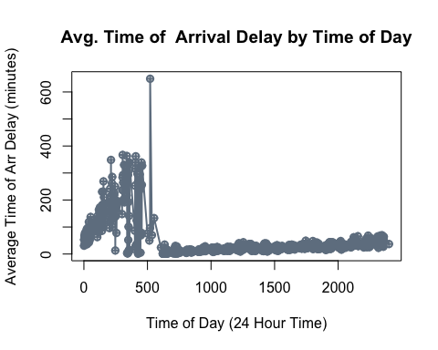 Between Midnight and 5 am the average time of arrival delay is the highest (with a peak at around 5:30am). After about 6 am, average arrival delay by time of day is pretty low.

# Departures

#average departure delay   
  
depdelay = airlinedata[which(airlinedata[,16]>0),]  
df_depdelay = data.frame(aggregate(depdelay$DepDelay ~ depdelay$UniqueCarrier,depdelay,mean))  
df_depdelay = df_depdelay[order(df_depdelay$depdelay.DepDelay),]  
  
barplot(df_depdelay$depdelay.DepDelay, names = df_depdelay$depdelay.UniqueCarrier,  
 xlab = "Unique Carrier", ylab = "Avg. Departure Delays (minutes)",  
 main = "Avg. Departure Delay times per Airline", las = 2, space=.5, col = 'orange3')

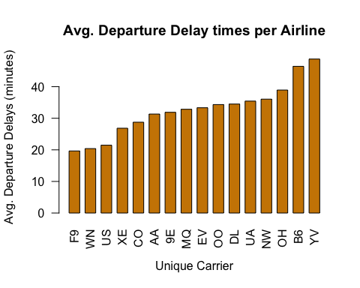 Departure delays are usually linked to arrival delays. Looking at departure delays is more important in understanding the likelihood of arriving at your destination on time/ or making conncections at another airport. The top three airlines with the longest departure delay times were Mesa Airlines (YV), PSA Airlines (OH), and Jet Blue(B6). The airlines with the longest delayed departure times is similar to the airlines with the longest avergae arrival delays.

#% of of departures delayed per airline   
  
df_delay_percent = data.frame(aggregate(depdelay$DepDelay ~ depdelay$UniqueCarrier,   
 depdelay, length))  
df_percent = data.frame(aggregate(airlinedata$FlightNum ~ airlinedata$UniqueCarrier,   
 airlinedata, length))  
  
percent_finaldf = merge(df_delay_percent, df_percent, by.x="depdelay.UniqueCarrier", by.y="airlinedata.UniqueCarrier")  
percent_finaldf = within(percent_finaldf, percent <- depdelay.DepDelay/airlinedata.FlightNum)  
percent_finaldf = percent_finaldf[order(percent_finaldf$percent),]  
barplot(percent_finaldf$percent, names = percent_finaldf$depdelay.UniqueCarrier,  
 xlab = "Unique Carrier", ylab = "% of Depatures Delayed",  
 main = "% of Departures Delayed per Airline", las=2, space=.5, col='lightcyan2')

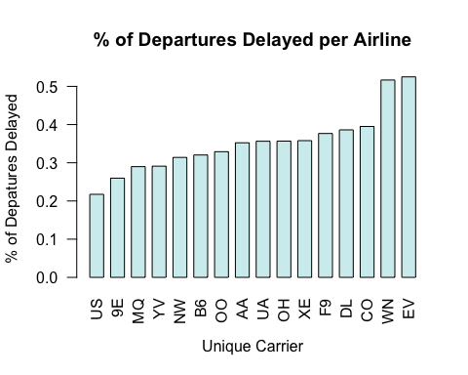 Looking at the % of Departures delayed per Airline, ExpressJet(EV) has 50% of flights delayed. Southwest (WN) also has close to 50% of flights delayed. The three airlines with the highest % of departures delayed (EpressJet, Southwest and Continential Airlines) are not the same airlines with the highest average departure delay times. This means that while one might have longer average departure delays, it does not mean they are delayed the most.

#departure delays per month  
df_depdelaymon = data.frame(aggregate(depdelay$DepDelay ~ depdelay$Month,depdelay,length))  
plot(df_depdelaymon$depdelay.Month, df_depdelaymon$depdelay.DepDelay,   
 xlab = "Month", ylab = "# of Departure Delays",   
 main = "Number of Departure delays per month", type ='o', col='sienna',lwd=2, pch=10)

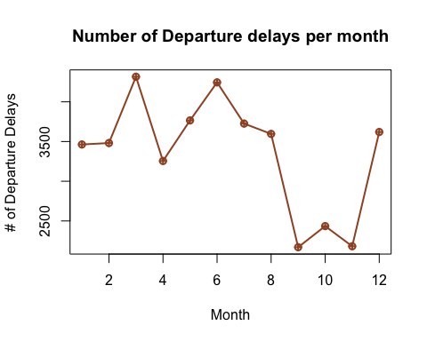 The highest number of departure delays occur in March and June. The months with the least amount of departure delays were September and November. Next, we will look at which months had the longest average delays.

#average departure delays per month  
dfmm =data.frame(aggregate(depdelay$DepDelay~depdelay$Month, depdelay,mean))  
  
plot(dfmm$depdelay.Month, dfmm$depdelay.DepDelay,   
 xlab = "Month", ylab="Avg. Departure Delays (Minutes)",   
 main = "Avg. Departure Delay times by Month", type='o',  
 col = 'palegreen',lwd=2, pch =10)

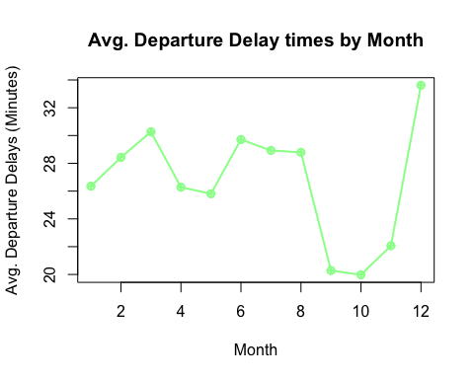 While March and June had highest number of delays. December had the longest average delays. September and October had the shortest average departure delays.

#deprture delays by day of the week  
  
df_depdelayday = data.frame(aggregate(depdelay$DepDelay ~ depdelay$DayOfWeek,depdelay,length))  
  
plot(df_depdelayday$depdelay.DayOfWeek, df_depdelayday$depdelay.DepDelay,   
 xlab = "Day of Week (1-Monday - 7-Sunday)", ylab = "# of Departure Delays",   
 main = "Number of Departure delays by Day of Week", type ='o', col='tomato',lwd=2, pch=10)

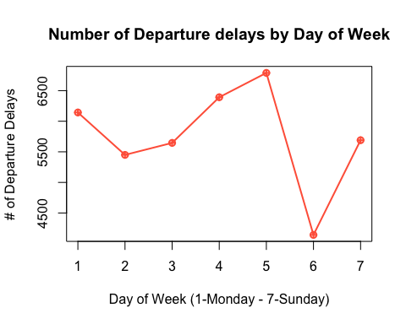 Fridays have the most number of Departure delays, followed by Thursdays. Saturdays had the lowest number of departure delays.

#average departure delays by day of the week  
  
df_depdelayday = data.frame(aggregate(depdelay$DepDelay ~ depdelay$DayOfWeek,depdelay,mean))  
  
plot(df_depdelayday$depdelay.DayOfWeek, df_depdelayday$depdelay.DepDelay,   
 xlab = "Day of Week (1-Monday - 7-Sunday)", ylab = "Avg. Departure Delays (minutes)",   
 main = "Avg. Departure delays by Day of Week", type ='o', col='royalblue',lwd=2, pch=10)

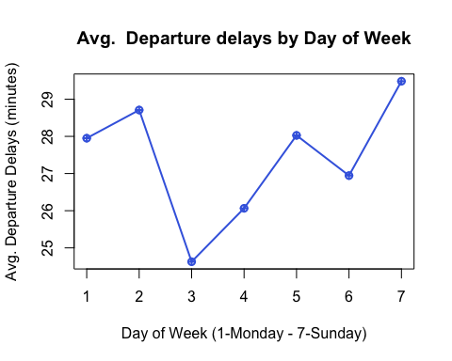 Wednesdays had the shortest average time of departure delays, while Sunday had the longest delays. Tuesdays had the second longest average departure delays.

#average time of departure delays by time of day  
  
df_depdelaytime = data.frame(aggregate(depdelay$DepDelay ~ depdelay$DepTime,depdelay,length))  
  
plot(df_depdelaytime$depdelay.DepTime, df_depdelaytime$depdelay.DepDelay,   
 xlab = "Time of Day (24 Hour Time)", ylab = "# of Dep. Delay ",   
 main = "Number of Departure Delays by Hour", type ='o', col='rosybrown',lwd=2, pch=10)

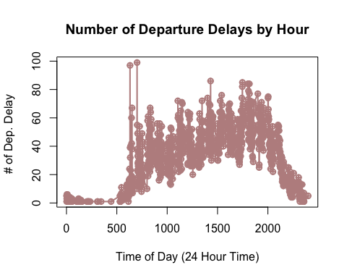 It seems like the most delayed happen in the middle of the day between 6 am and 8 pm. There a re a coupleof peaks between 6 am and 7 pm. After 8pm, there are less departure delays and between midnight and 5 am there are almost zero. But, then again there are not many departing flights between midnight and 5 am.

#average time of departure delays by time of day  
  
df_depdelaytime = data.frame(aggregate(depdelay$DepDelay ~ depdelay$DepTime,depdelay,mean))  
  
  
plot(df_depdelaytime$depdelay.DepTime, df_depdelaytime$depdelay.DepDelay,   
 xlab = "Time of Day (24 Hour Time)", ylab = "Avg. Departure Delays (Minutes) ",   
 main = "Avg. Time of Departure Delays by Hour", type ='o', col='rosybrown',lwd=2, pch=10)

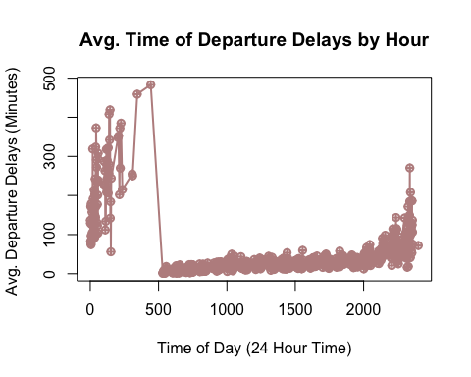 While there are not many departure delays between midnight and 5 am, the ones that do occur are long delays. In contrast the delays during the peak delay times seem to be shorts. The night delays (after 8pm) are longer, but not as long as the early morning delays.

# Destinations and Origins

departures = subset(airlinedata, Origin == 'AUS')  
  
#average departure delay by destination   
departdelay = departures[which(departures[,16]>0),]  
df_depdelays = data.frame(aggregate(departdelay$DepDelay ~ departdelay$Dest, departdelay, mean))  
df_depdelays2 = df_depdelays[order(-df_depdelays$departdelay.DepDelay),][1:15,]  
  
barplot(df_depdelays2$departdelay.DepDelay, names = df_depdelays2$departdelay.Dest,xlab = "Destination", ylab = 'Avg. Departure Delays (minutes)', main = 'Longest Avg. Departure Delay times by Destination', las =2, space=.5, col='plum2')

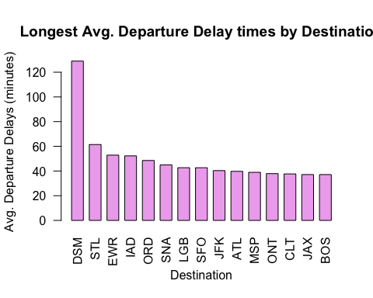 The above graph shows which airports are the destinations in which there are the longest average delays. The longest delays happen for flights headed to Des Moines, Iowa (DSM). THe second longest are for St. Louis (STL) and the third longest delays are for flights headed to Newark, NJ (EWR).

#destinations with the shortest average delays  
  
departures = subset(airlinedata, Origin == 'AUS')  
  
#average departure delay by destination   
departdelay = departures[which(departures[,16]>0),]  
df_depdelays = data.frame(aggregate(departdelay$DepDelay ~ departdelay$Dest, departdelay, mean))  
df_depdelays2 = df_depdelays[order(df_depdelays$departdelay.DepDelay),][1:15,]  
  
barplot(df_depdelays2$departdelay.DepDelay, names = df_depdelays2$departdelay.Dest,xlab = "Destination", ylab = 'Avg. Departure Delays (minutes)', main = ' Shortest Avg. Departure Delay times by Destination', las =2, space=.5, col='lavender')

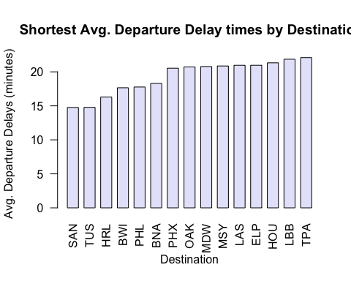 The three destinations with the shortest average departure delays are San Diego (SAN), Tucson (TUS) and Valley International Airport (HRL).

#average arrival delay by Origin  
arrivals = subset(airlinedata, Origin != 'AUS')  
arrivedelay = arrivals[which(arrivals[,15]>0),]  
df_arrdelays = data.frame(aggregate(arrivedelay$ArrDelay ~ arrivedelay$Origin, arrivedelay, mean))  
df_arrdelays2 = df_arrdelays[order(-df_arrdelays$arrivedelay.ArrDelay), ][1:15,]  
  
barplot(df_arrdelays2$arrivedelay.ArrDelay, names = df_arrdelays2$arrivedelay.Origin,xlab = "Origin", ylab = 'Avg. Arrival Delays (minutes)', main = 'Longest Avg. Arrival Delay times by Origin', las =2, space=.5, col='lightsteelblue')

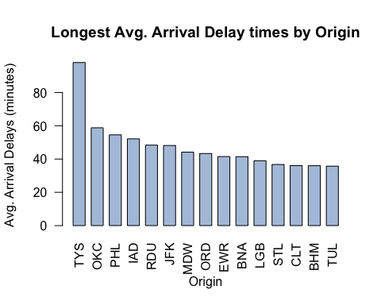 The longest average arrival delays happens with planes coming from McGhee Tyson Airport in Knoxville, TN (TYS), Will Rogers World Airport in Oklahoma City, and Philadelphia (PHL).

#average shortest arrival delay by Origin  
arrivals = subset(airlinedata, Origin != 'AUS')  
arrivedelay = arrivals[which(arrivals[,15]>0),]  
df_arrdelays = data.frame(aggregate(arrivedelay$ArrDelay ~ arrivedelay$Origin, arrivedelay, mean))  
df_arrdelays2 = df_arrdelays[order(df_arrdelays$arrivedelay.ArrDelay), ][1:15,]  
  
barplot(df_arrdelays2$arrivedelay.ArrDelay, names = df_arrdelays2$arrivedelay.Origin,xlab = "Origin", ylab = 'Avg. Arrival Delays (minutes)', main = 'Shortest Avg. Arrival Delay times by Origin', las =2, space=.5, col='lightsteelblue')

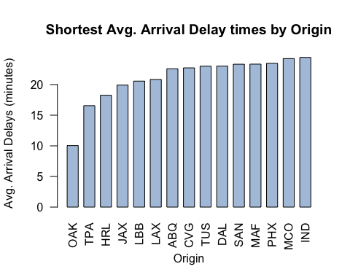

The shorest average arrival delays happen with planes coming from Oakland, California (OAK), Tampa, Florida (TPA) and Valley International (HRL).

### Author Attribution

#### Preprocessing

First we need to read in all of our data and then preprocess it to make everything lowercase, remove numbers, remove punctuation, remove excess white spaces, and remove stopwords. We then create the document term matrix for both the train and test together to address the issue of some terms appearing in the test but not train or vice versa.

library(tm)   
  
readerPlain = function(fname){  
 readPlain(elem=list(content=readLines(fname)),   
 id=fname, language='en') }  
  
authors_train <- Sys.glob('~/Documents/UT/Summer Classes/Intro to Predictive Modeling/Part 2/HW 2/ReutersC50/C50train/*')  
file_list_train = NULL  
labels_train = NULL  
authors_test = Sys.glob('~/Documents/UT/Summer Classes/Intro to Predictive Modeling/Part 2/HW 2/ReutersC50/C50test/*')  
file_list_test = NULL  
labels_test = NULL  
  
for(i in authors_train) {   
 author_name_train = substring(i, first = 84)  
 files_to_add_train = Sys.glob(paste0(i, '/*.txt'))  
 file_list_train = append(file_list_train, files_to_add_train)  
 labels_train = append(labels_train, rep(author_name_train, length(files_to_add_train)))  
}  
  
author_names = NULL  
for(i in authors_test) {   
 author_name_test = substring(i, first = 83)  
 author_names = append(author_names, author_name_test)  
 files_to_add_test = Sys.glob(paste0(i, '/*.txt'))  
 file_list_test = append(file_list_test, files_to_add_test)  
 labels_test = append(labels_test, rep(author_name_test, length(files_to_add_test)))  
}  
  
file_list <- append(file_list_train,file_list_test) #combine train and test for simplicity  
labels <- unique(append(labels_train,labels_test))  
  
all_docs = lapply(file_list, readerPlain)   
names(all_docs) = file_list  
names(all_docs) = sub('.txt', '', names(all_docs))  
all_corpus = Corpus(VectorSource(all_docs))  
#names(all_corpus) = labels  
  
all_corpus = tm_map(all_corpus, content_transformer(tolower)) # make everything lowercase

## Warning in tm_map.SimpleCorpus(all_corpus, content_transformer(tolower)):  
## transformation drops documents

all_corpus = tm_map(all_corpus, content_transformer(removeNumbers)) # remove numbers

## Warning in tm_map.SimpleCorpus(all_corpus,  
## content_transformer(removeNumbers)): transformation drops documents

all_corpus = tm_map(all_corpus, content_transformer(removePunctuation)) # remove punctuation

## Warning in tm_map.SimpleCorpus(all_corpus,  
## content_transformer(removePunctuation)): transformation drops documents

all_corpus = tm_map(all_corpus, content_transformer(stripWhitespace)) ## remove excess white-space

## Warning in tm_map.SimpleCorpus(all_corpus,  
## content_transformer(stripWhitespace)): transformation drops documents

all_corpus = tm_map(all_corpus, content_transformer(removeWords), stopwords("en")) #remove stop words

## Warning in tm_map.SimpleCorpus(all_corpus,  
## content_transformer(removeWords), : transformation drops documents

#creating a document term matrix with tf idf scores   
dtm <- DocumentTermMatrix(all_corpus,control = list(weighting = function(x) weightTfIdf(x, normalize = FALSE)))  
dtm <- removeSparseTerms(dtm, 0.95)

#### Naive Bayes

We first try the Naive Bayes model on the training data set. We find the weight vector for each author that contains the weight of each word used by that author. We smooth the data so that when words are not in an author’s bag of words, a small non-zero probability is given so that the posterior probabilities don’t become zero.

#Naive Bayes  
  
x <- as.matrix(dtm)  
x_train <- x[1:2500,]  
x_test <- x[2501:5000,]  
smooth_count = 1/nrow(x_train)   
  
author_sums <- rowsum(x_train +smooth_count, labels_train)   
wt <- rowSums(author_sums)  
author_wt <- log(author_sums/wt) # log of prob of word occuring with particular author   
  
predicted_probabilities <- x_test%*%t(author_wt) #use x_test to multiply log probabilities from weights of training set authors

predicted_authors = NULL  
for( i in 1:2500) {   
 predicted_authors = c(predicted_authors,which.max(predicted_probabilities[i,]))  
 }  
  
predicted_authors <- as.data.frame(predicted_authors)  
predicted_authors$actual <- rep(1:50,each = 50)  
  
#assign author with max sum of probabilities for each of 2500 test points in new list  
  
results_bayes=table(predicted_authors$predicted_authors, predicted_authors$actual)  
results_bayes

##   
## 1 2 3 4 5 6 7 8 9 10 11 12 13 14 15 16 17 18 19 20 21 22 23  
## 1 42 0 0 0 0 0 0 0 0 0 0 0 0 0 0 0 0 0 0 0 0 0 0  
## 2 0 30 0 0 0 0 0 0 0 0 0 0 0 0 0 0 0 0 1 0 0 0 0  
## 3 0 1 28 0 1 0 0 0 3 0 0 0 0 0 0 0 5 7 0 7 0 4 0  
## 4 0 0 0 7 0 0 0 0 0 0 0 0 2 0 7 0 0 0 0 0 1 0 0  
## 5 0 0 0 0 27 0 0 0 0 0 0 0 0 0 0 0 0 0 0 0 0 0 0  
## 6 1 0 0 0 0 36 1 7 0 2 1 0 0 0 0 0 0 0 0 0 0 0 9  
## 7 1 0 0 0 0 0 21 0 0 0 0 0 5 0 0 0 0 0 0 0 0 0 0  
## 8 0 0 0 0 0 0 0 4 0 0 0 0 0 0 0 0 0 0 0 0 0 0 0  
## 9 0 0 0 0 0 1 0 0 10 0 0 0 0 0 0 0 0 0 1 3 0 1 0  
## 10 0 0 0 0 0 0 0 0 0 26 0 0 0 0 0 0 0 0 0 0 0 0 1  
## 11 0 0 0 0 0 0 0 0 0 0 48 0 0 0 0 0 0 0 0 0 0 0 0  
## 12 0 0 0 2 0 0 1 0 0 0 0 37 0 0 0 0 0 0 0 0 0 0 0  
## 13 0 0 0 0 0 0 21 0 0 0 0 0 16 0 0 0 0 0 0 0 0 0 0  
## 14 0 0 0 15 0 0 1 1 3 0 0 3 13 0 19 1 0 0 1 0 6 1 0  
## 15 0 7 0 0 0 0 1 0 0 0 0 0 1 22 0 0 0 0 7 0 0 0 0  
## 16 0 0 0 0 0 0 0 0 0 0 0 0 0 0 0 48 0 0 0 0 0 0 0  
## 17 0 0 20 0 1 0 0 1 2 0 0 0 0 1 0 0 0 32 0 0 0 2 0  
## 18 0 12 0 0 0 0 0 0 0 0 0 0 1 25 0 0 0 0 34 0 0 0 0  
## 19 0 0 1 0 0 0 0 0 5 0 0 0 0 0 0 0 4 0 1 30 0 1 0  
## 20 0 0 0 0 0 0 0 0 3 0 0 0 0 0 0 0 30 1 0 1 0 0 0  
## 21 0 0 0 0 0 0 1 1 3 0 0 0 1 0 0 0 0 0 0 0 37 0 0  
## 22 0 0 0 0 2 0 0 0 1 3 0 0 0 0 0 0 1 0 0 1 0 30 0  
## 23 0 0 0 0 0 4 0 5 0 4 0 0 1 0 0 0 0 0 0 0 0 0 26  
## 24 0 0 0 0 6 0 2 1 0 0 0 0 1 0 0 0 0 0 0 0 0 0 1  
## 25 0 0 0 0 0 0 0 0 7 1 0 0 0 1 0 0 2 2 0 2 0 5 0  
## 26 0 0 0 0 0 0 0 0 0 0 0 0 0 0 0 0 0 0 0 0 0 0 0  
## 27 0 0 0 0 0 0 0 0 0 0 0 0 0 0 0 0 0 0 0 0 0 0 0  
## 28 0 0 0 0 0 0 0 0 0 0 0 0 0 0 0 0 0 0 0 0 0 0 0  
## 29 0 0 0 0 1 0 0 0 0 0 0 0 1 0 0 0 0 0 0 0 0 0 0  
## 30 0 0 0 0 0 0 0 0 1 0 0 0 0 0 0 0 0 0 0 0 0 0 0  
## 31 0 0 0 0 5 0 0 0 0 0 0 0 2 1 0 0 0 1 0 0 0 0 0  
## 32 1 0 0 0 0 0 0 2 0 3 0 0 0 0 0 0 0 1 0 0 0 0 1  
## 33 0 0 0 0 0 0 0 0 0 0 0 1 0 0 0 0 0 0 0 0 3 0 0  
## 34 0 0 0 0 3 0 0 1 1 0 0 0 0 0 0 0 0 0 0 0 0 0 1  
## 35 0 0 0 1 0 0 0 0 0 0 0 0 0 0 6 0 0 0 3 0 2 0 0  
## 36 0 0 0 0 0 0 0 1 0 2 0 0 0 0 0 0 0 0 0 0 0 0 3  
## 37 0 0 0 0 0 0 0 4 0 0 0 0 0 0 0 0 0 0 0 0 0 0 6  
## 38 0 0 0 3 0 0 0 0 0 0 0 0 0 0 1 0 0 0 0 0 0 0 0  
## 39 0 0 0 0 0 0 0 0 4 0 0 0 0 0 0 0 0 0 0 0 0 0 0  
## 40 0 0 0 0 0 2 0 2 0 1 0 0 0 0 0 0 0 0 0 0 0 0 0  
## 41 0 0 0 0 0 0 0 0 0 1 0 0 1 0 0 0 0 0 0 0 0 0 0  
## 42 5 0 0 0 0 1 0 0 0 4 0 0 0 0 0 0 0 0 0 0 0 0 1  
## 43 0 0 0 0 4 0 0 0 0 0 1 6 1 0 2 0 0 0 0 0 0 0 0  
## 44 0 0 0 10 0 0 0 0 0 0 0 3 2 0 10 0 0 0 2 0 1 0 0  
## 45 0 0 0 0 0 0 0 0 1 0 0 0 0 0 0 0 0 5 0 1 0 2 0  
## 46 0 0 0 1 0 0 0 0 0 0 0 0 0 0 0 0 0 0 0 0 0 0 0  
## 47 0 0 1 0 0 2 0 2 0 3 0 0 0 0 0 0 0 0 0 0 0 0 1  
## 48 0 0 0 0 0 0 0 0 5 0 0 0 0 0 0 0 8 1 0 5 0 4 0  
## 49 0 0 0 0 0 4 1 18 1 0 0 0 0 0 0 0 0 0 0 0 0 0 0  
## 50 0 0 0 11 0 0 0 0 0 0 0 0 2 0 5 1 0 0 0 0 0 0 0  
##   
## 24 25 26 27 28 29 30 31 32 33 34 35 36 37 38 39 40 41 42 43 44 45 46  
## 1 0 1 0 0 0 0 0 0 0 0 0 0 0 0 0 0 0 3 1 0 0 0 0  
## 2 0 0 0 0 0 0 0 0 0 0 0 0 0 0 0 0 0 0 0 1 0 0 0  
## 3 0 3 0 0 0 0 0 4 0 0 0 0 0 0 0 1 0 1 0 0 0 18 0  
## 4 0 0 0 0 0 0 0 0 0 0 0 0 0 0 0 0 0 0 0 0 0 0 0  
## 5 4 0 0 0 0 0 0 2 0 0 0 0 0 0 0 0 0 0 0 0 0 0 0  
## 6 0 0 1 4 0 0 2 0 6 0 0 0 1 5 0 0 2 0 0 0 0 0 0  
## 7 0 0 0 6 0 0 0 0 0 0 0 0 0 0 0 0 0 0 0 0 0 0 0  
## 8 0 0 0 1 0 0 0 0 1 0 0 0 0 0 0 0 0 0 0 0 0 0 0  
## 9 0 1 0 0 0 0 2 0 0 0 0 0 0 1 0 1 0 0 0 0 0 0 0  
## 10 0 0 11 1 0 0 0 0 4 0 0 0 2 0 0 0 0 0 4 0 0 0 0  
## 11 0 0 0 0 0 0 0 1 0 0 0 0 0 0 0 0 0 0 0 0 0 0 0  
## 12 0 0 0 0 1 0 0 0 0 0 0 2 0 0 0 0 0 0 0 0 1 0 0  
## 13 0 0 0 2 0 0 0 1 0 0 0 0 0 0 0 0 0 0 0 0 0 0 0  
## 14 0 0 0 0 4 2 0 0 0 2 0 12 0 0 1 0 0 1 0 1 23 0 0  
## 15 0 0 0 0 0 0 0 0 0 0 0 0 0 0 0 0 0 0 0 0 0 0 0  
## 16 0 0 0 0 0 0 0 0 0 0 0 0 0 0 1 0 0 0 0 0 0 0 0  
## 17 2 0 0 0 0 0 1 0 0 0 4 0 0 0 0 4 1 0 0 0 0 7 0  
## 18 0 0 0 0 0 0 0 0 0 0 0 0 0 0 0 0 0 0 0 0 0 0 0  
## 19 0 1 0 0 0 0 2 0 0 0 1 0 0 0 0 1 0 0 0 0 0 0 0  
## 20 0 0 0 0 0 0 0 0 0 0 0 0 0 0 0 0 0 0 0 0 0 0 0  
## 21 0 0 0 0 0 0 0 0 0 0 1 0 0 0 0 0 0 0 0 0 0 0 0  
## 22 1 6 0 0 0 0 3 0 1 0 0 0 0 0 0 4 0 1 0 0 0 0 0  
## 23 0 1 1 0 0 0 0 0 1 0 1 0 0 10 0 0 5 0 1 0 0 0 0  
## 24 30 0 0 0 0 0 0 11 0 0 1 0 0 0 0 0 0 0 0 1 0 0 1  
## 25 5 34 0 0 0 0 3 0 0 0 0 0 1 0 0 0 2 1 0 0 0 0 0  
## 26 0 0 28 0 0 0 0 0 1 0 0 0 0 3 0 0 0 0 0 0 0 0 0  
## 27 0 0 0 31 0 0 0 0 0 0 0 0 0 0 0 0 0 0 0 0 0 0 0  
## 28 0 0 0 0 39 0 0 0 0 0 0 1 0 0 0 0 0 0 0 0 0 0 0  
## 29 0 0 0 0 0 47 2 0 0 2 0 1 0 0 0 0 0 0 0 0 1 0 0  
## 30 0 0 0 0 0 0 24 0 0 0 0 0 0 0 0 6 1 0 0 0 0 0 0  
## 31 2 0 0 1 0 0 0 23 0 0 0 0 0 1 0 0 0 0 0 0 0 0 0  
## 32 0 0 0 0 0 0 1 0 17 0 0 0 1 0 0 0 1 0 1 0 0 0 0  
## 33 0 0 0 0 0 0 1 0 0 44 0 0 0 0 0 0 0 0 0 0 0 0 0  
## 34 1 0 0 1 0 0 0 1 0 0 36 0 0 1 0 0 1 2 0 0 0 0 0  
## 35 0 0 0 0 2 0 0 2 0 0 0 14 0 0 0 0 0 0 0 0 4 0 1  
## 36 1 0 1 0 0 0 0 0 2 1 0 0 36 3 0 1 0 4 0 0 0 0 0  
## 37 0 0 0 0 0 0 0 0 3 0 3 0 2 24 0 0 0 2 0 0 0 0 0  
## 38 0 0 0 0 0 0 0 0 0 0 0 3 0 0 27 0 0 0 0 9 4 0 12  
## 39 0 0 0 0 0 1 7 0 0 0 1 0 0 0 0 31 0 0 0 0 0 0 0  
## 40 0 0 0 0 0 0 0 0 0 0 0 0 0 0 0 0 36 0 0 0 0 0 0  
## 41 0 0 0 0 0 0 0 0 2 0 0 0 1 0 0 0 0 30 0 0 0 0 0  
## 42 0 1 3 3 0 0 0 0 8 0 1 0 4 1 0 0 0 2 34 0 0 0 0  
## 43 0 1 0 0 0 0 0 3 0 0 0 0 0 0 2 0 0 0 0 28 0 0 12  
## 44 0 0 0 0 1 0 0 2 0 1 0 9 0 0 2 0 0 2 0 2 11 0 1  
## 45 0 0 0 0 0 0 0 0 0 0 0 0 0 1 0 0 0 0 0 0 0 24 0  
## 46 0 0 0 0 1 0 0 0 0 0 0 2 0 0 17 0 0 0 0 8 0 0 22  
## 47 0 0 5 0 0 0 0 0 2 0 1 0 2 0 0 0 0 0 7 0 0 0 0  
## 48 2 1 0 0 0 0 2 0 0 0 0 0 0 0 0 1 0 0 0 0 0 1 0  
## 49 0 0 0 0 0 0 0 0 2 0 0 0 0 0 0 0 1 0 2 0 0 0 0  
## 50 2 0 0 0 2 0 0 0 0 0 0 6 0 0 0 0 0 1 0 0 6 0 1  
##   
## 47 48 49 50  
## 1 3 0 0 0  
## 2 0 0 0 0  
## 3 0 2 0 0  
## 4 0 0 0 4  
## 5 0 1 0 0  
## 6 1 0 1 0  
## 7 0 0 0 0  
## 8 0 0 13 0  
## 9 0 0 0 0  
## 10 9 0 0 0  
## 11 0 0 0 0  
## 12 0 0 0 2  
## 13 0 0 0 0  
## 14 0 0 3 7  
## 15 0 0 0 0  
## 16 0 0 0 0  
## 17 0 0 0 0  
## 18 0 0 0 0  
## 19 0 5 0 0  
## 20 0 0 0 0  
## 21 0 0 0 0  
## 22 0 3 0 0  
## 23 3 0 0 0  
## 24 0 1 0 0  
## 25 0 0 1 0  
## 26 0 0 0 0  
## 27 0 0 0 0  
## 28 0 0 0 1  
## 29 0 0 0 0  
## 30 0 0 0 0  
## 31 0 2 0 0  
## 32 0 0 1 0  
## 33 0 0 0 0  
## 34 1 0 1 0  
## 35 0 0 0 4  
## 36 1 0 2 0  
## 37 0 0 5 0  
## 38 0 0 0 1  
## 39 0 0 0 0  
## 40 0 0 1 0  
## 41 2 0 0 0  
## 42 9 0 1 0  
## 43 0 0 1 4  
## 44 0 0 0 8  
## 45 0 4 0 0  
## 46 0 0 0 3  
## 47 21 0 0 0  
## 48 0 32 0 0  
## 49 0 0 20 0  
## 50 0 0 0 16

correct = NULL  
for (i in 1:nrow(results_bayes)) {  
 correct = append(correct, results_bayes[i,i])  
}  
  
correct_by_author = data.frame(correct, row.names = author_names)  
correct_by_author

## correct  
## HW 2/ReutersC50/C50test/AaronPressman 42  
## HW 2/ReutersC50/C50test/AlanCrosby 30  
## HW 2/ReutersC50/C50test/AlexanderSmith 28  
## HW 2/ReutersC50/C50test/BenjaminKangLim 7  
## HW 2/ReutersC50/C50test/BernardHickey 27  
## HW 2/ReutersC50/C50test/BradDorfman 36  
## HW 2/ReutersC50/C50test/DarrenSchuettler 21  
## HW 2/ReutersC50/C50test/DavidLawder 4  
## HW 2/ReutersC50/C50test/EdnaFernandes 10  
## HW 2/ReutersC50/C50test/EricAuchard 26  
## HW 2/ReutersC50/C50test/FumikoFujisaki 48  
## HW 2/ReutersC50/C50test/GrahamEarnshaw 37  
## HW 2/ReutersC50/C50test/HeatherScoffield 16  
## HW 2/ReutersC50/C50test/JanLopatka 0  
## HW 2/ReutersC50/C50test/JaneMacartney 0  
## HW 2/ReutersC50/C50test/JimGilchrist 48  
## HW 2/ReutersC50/C50test/JoWinterbottom 0  
## HW 2/ReutersC50/C50test/JoeOrtiz 0  
## HW 2/ReutersC50/C50test/JohnMastrini 1  
## HW 2/ReutersC50/C50test/JonathanBirt 1  
## HW 2/ReutersC50/C50test/KarlPenhaul 37  
## HW 2/ReutersC50/C50test/KeithWeir 30  
## HW 2/ReutersC50/C50test/KevinDrawbaugh 26  
## HW 2/ReutersC50/C50test/KevinMorrison 30  
## HW 2/ReutersC50/C50test/KirstinRidley 34  
## HW 2/ReutersC50/C50test/KouroshKarimkhany 28  
## HW 2/ReutersC50/C50test/LydiaZajc 31  
## HW 2/ReutersC50/C50test/LynneO'Donnell 39  
## HW 2/ReutersC50/C50test/LynnleyBrowning 47  
## HW 2/ReutersC50/C50test/MarcelMichelson 24  
## HW 2/ReutersC50/C50test/MarkBendeich 23  
## HW 2/ReutersC50/C50test/MartinWolk 17  
## HW 2/ReutersC50/C50test/MatthewBunce 44  
## HW 2/ReutersC50/C50test/MichaelConnor 36  
## HW 2/ReutersC50/C50test/MureDickie 14  
## HW 2/ReutersC50/C50test/NickLouth 36  
## HW 2/ReutersC50/C50test/PatriciaCommins 24  
## HW 2/ReutersC50/C50test/PeterHumphrey 27  
## HW 2/ReutersC50/C50test/PierreTran 31  
## HW 2/ReutersC50/C50test/RobinSidel 36  
## HW 2/ReutersC50/C50test/RogerFillion 30  
## HW 2/ReutersC50/C50test/SamuelPerry 34  
## HW 2/ReutersC50/C50test/SarahDavison 28  
## HW 2/ReutersC50/C50test/ScottHillis 11  
## HW 2/ReutersC50/C50test/SimonCowell 24  
## HW 2/ReutersC50/C50test/TanEeLyn 22  
## HW 2/ReutersC50/C50test/TheresePoletti 21  
## HW 2/ReutersC50/C50test/TimFarrand 32  
## HW 2/ReutersC50/C50test/ToddNissen 20  
## HW 2/ReutersC50/C50test/WilliamKazer 16

sum(correct_by_author)/2500 #accuracy

## [1] 0.4936

Naive Bayes only acheives an accuracy of 49% which is not very good. Jim Gilchrist and Fumiko Fujisaki are predicted best (48 correct, 2 wrongly attributed) , while authors like John Mastrini are predicted poorly. Some of the most common misclassifications were Scott Hillis for Jane Macartney and Tan Eelyn for Peter Humphrey.

#### Random Forest

The next model we will try is Random Forest. Since our dataset is large, we specify 200 as our number of trees and limit mtry to 6.

#Random Forest  
  
library(randomForest)

## randomForest 4.6-14

## Type rfNews() to see new features/changes/bug fixes.

set.seed(11)  
  
rf.fit = randomForest(x = x_train, y = as.factor(labels_train), mtry=6, ntree=200)  
rf.pred = predict(rf.fit, data=x_test)  
rf_results = table(labels_test, rf.pred)  
rf_correct = NULL  
for (i in 1:nrow(rf_results)) {  
 rf_correct = append(rf_correct, rf_results[i, i])  
}  
  
rf_correct_by_author = data.frame(rf_correct, row.names = author_names)  
rf_correct_by_author

## rf_correct  
## HW 2/ReutersC50/C50test/AaronPressman 48  
## HW 2/ReutersC50/C50test/AlanCrosby 41  
## HW 2/ReutersC50/C50test/AlexanderSmith 30  
## HW 2/ReutersC50/C50test/BenjaminKangLim 32  
## HW 2/ReutersC50/C50test/BernardHickey 33  
## HW 2/ReutersC50/C50test/BradDorfman 29  
## HW 2/ReutersC50/C50test/DarrenSchuettler 42  
## HW 2/ReutersC50/C50test/DavidLawder 42  
## HW 2/ReutersC50/C50test/EdnaFernandes 30  
## HW 2/ReutersC50/C50test/EricAuchard 32  
## HW 2/ReutersC50/C50test/FumikoFujisaki 45  
## HW 2/ReutersC50/C50test/GrahamEarnshaw 38  
## HW 2/ReutersC50/C50test/HeatherScoffield 41  
## HW 2/ReutersC50/C50test/JanLopatka 23  
## HW 2/ReutersC50/C50test/JaneMacartney 43  
## HW 2/ReutersC50/C50test/JimGilchrist 50  
## HW 2/ReutersC50/C50test/JoWinterbottom 37  
## HW 2/ReutersC50/C50test/JoeOrtiz 33  
## HW 2/ReutersC50/C50test/JohnMastrini 34  
## HW 2/ReutersC50/C50test/JonathanBirt 45  
## HW 2/ReutersC50/C50test/KarlPenhaul 45  
## HW 2/ReutersC50/C50test/KeithWeir 37  
## HW 2/ReutersC50/C50test/KevinDrawbaugh 27  
## HW 2/ReutersC50/C50test/KevinMorrison 30  
## HW 2/ReutersC50/C50test/KirstinRidley 28  
## HW 2/ReutersC50/C50test/KouroshKarimkhany 43  
## HW 2/ReutersC50/C50test/LydiaZajc 45  
## HW 2/ReutersC50/C50test/LynneO'Donnell 49  
## HW 2/ReutersC50/C50test/LynnleyBrowning 37  
## HW 2/ReutersC50/C50test/MarcelMichelson 45  
## HW 2/ReutersC50/C50test/MarkBendeich 41  
## HW 2/ReutersC50/C50test/MartinWolk 32  
## HW 2/ReutersC50/C50test/MatthewBunce 44  
## HW 2/ReutersC50/C50test/MichaelConnor 36  
## HW 2/ReutersC50/C50test/MureDickie 24  
## HW 2/ReutersC50/C50test/NickLouth 37  
## HW 2/ReutersC50/C50test/PatriciaCommins 35  
## HW 2/ReutersC50/C50test/PeterHumphrey 36  
## HW 2/ReutersC50/C50test/PierreTran 37  
## HW 2/ReutersC50/C50test/RobinSidel 42  
## HW 2/ReutersC50/C50test/RogerFillion 47  
## HW 2/ReutersC50/C50test/SamuelPerry 29  
## HW 2/ReutersC50/C50test/SarahDavison 28  
## HW 2/ReutersC50/C50test/ScottHillis 19  
## HW 2/ReutersC50/C50test/SimonCowell 33  
## HW 2/ReutersC50/C50test/TanEeLyn 25  
## HW 2/ReutersC50/C50test/TheresePoletti 26  
## HW 2/ReutersC50/C50test/TimFarrand 36  
## HW 2/ReutersC50/C50test/ToddNissen 38  
## HW 2/ReutersC50/C50test/WilliamKazer 19

sum(rf_correct_by_author)/2500

## [1] 0.7192

Our random forest produces a higher accuracy of around 72% and is therefore my preferred model. Authors like Aaron Pressman and Jim Gilchrist are predicted well, meaning that perhaps they have strong characteristic writing styles specific to them. Other authors like Jan Lopatka and William Kazer are not well predicted, and thus potentially have less of a distinguishable vocabularly in their writing.

### Practice with Association Rule Mining

library(arules)

## Loading required package: Matrix

##   
## Attaching package: 'arules'

## The following object is masked from 'package:tm':  
##   
## inspect

## The following objects are masked from 'package:base':  
##   
## abbreviate, write

library(arulesViz)

## Loading required package: grid

groceries = read.transactions("~/Documents/UT/Summer Classes/Intro to Predictive Modeling/Part 2/HW 2/groceries.txt", format = 'basket', sep = ',')  
summary(groceries)

## transactions as itemMatrix in sparse format with  
## 9835 rows (elements/itemsets/transactions) and  
## 169 columns (items) and a density of 0.02609146   
##   
## most frequent items:  
## whole milk other vegetables rolls/buns soda   
## 2513 1903 1809 1715   
## yogurt (Other)   
## 1372 34055   
##   
## element (itemset/transaction) length distribution:  
## sizes  
## 1 2 3 4 5 6 7 8 9 10 11 12 13 14 15   
## 2159 1643 1299 1005 855 645 545 438 350 246 182 117 78 77 55   
## 16 17 18 19 20 21 22 23 24 26 27 28 29 32   
## 46 29 14 14 9 11 4 6 1 1 1 1 3 1   
##   
## Min. 1st Qu. Median Mean 3rd Qu. Max.   
## 1.000 2.000 3.000 4.409 6.000 32.000   
##   
## includes extended item information - examples:  
## labels  
## 1 abrasive cleaner  
## 2 artif. sweetener  
## 3 baby cosmetics

groceries_rules = apriori(groceries, parameter=list(support=.005, confidence=.5, maxlen=8))

## Apriori  
##   
## Parameter specification:  
## confidence minval smax arem aval originalSupport maxtime support minlen  
## 0.5 0.1 1 none FALSE TRUE 5 0.005 1  
## maxlen target ext  
## 8 rules FALSE  
##   
## Algorithmic control:  
## filter tree heap memopt load sort verbose  
## 0.1 TRUE TRUE FALSE TRUE 2 TRUE  
##   
## Absolute minimum support count: 49   
##   
## set item appearances ...[0 item(s)] done [0.00s].  
## set transactions ...[169 item(s), 9835 transaction(s)] done [0.00s].  
## sorting and recoding items ... [120 item(s)] done [0.00s].  
## creating transaction tree ... done [0.00s].  
## checking subsets of size 1 2 3 4 done [0.00s].  
## writing ... [120 rule(s)] done [0.00s].  
## creating S4 object ... done [0.00s].

inspect(groceries_rules)

## lhs rhs support confidence lift count  
## [1] {baking powder} => {whole milk} 0.009252669 0.5229885 2.046793 91  
## [2] {oil,   
## other vegetables} => {whole milk} 0.005083884 0.5102041 1.996760 50  
## [3] {onions,   
## root vegetables} => {other vegetables} 0.005693950 0.6021505 3.112008 56  
## [4] {onions,   
## whole milk} => {other vegetables} 0.006609049 0.5462185 2.822942 65  
## [5] {hygiene articles,   
## other vegetables} => {whole milk} 0.005185562 0.5425532 2.123363 51  
## [6] {other vegetables,   
## sugar} => {whole milk} 0.006304016 0.5849057 2.289115 62  
## [7] {long life bakery product,   
## other vegetables} => {whole milk} 0.005693950 0.5333333 2.087279 56  
## [8] {cream cheese,   
## yogurt} => {whole milk} 0.006609049 0.5327869 2.085141 65  
## [9] {chicken,   
## root vegetables} => {other vegetables} 0.005693950 0.5233645 2.704829 56  
## [10] {chicken,   
## root vegetables} => {whole milk} 0.005998983 0.5514019 2.157993 59  
## [11] {chicken,   
## rolls/buns} => {whole milk} 0.005287239 0.5473684 2.142208 52  
## [12] {coffee,   
## yogurt} => {whole milk} 0.005083884 0.5208333 2.038359 50  
## [13] {frozen vegetables,   
## root vegetables} => {other vegetables} 0.006100661 0.5263158 2.720082 60  
## [14] {frozen vegetables,   
## root vegetables} => {whole milk} 0.006202339 0.5350877 2.094146 61  
## [15] {frozen vegetables,   
## rolls/buns} => {whole milk} 0.005083884 0.5000000 1.956825 50  
## [16] {frozen vegetables,   
## other vegetables} => {whole milk} 0.009659380 0.5428571 2.124552 95  
## [17] {beef,   
## yogurt} => {whole milk} 0.006100661 0.5217391 2.041904 60  
## [18] {beef,   
## rolls/buns} => {whole milk} 0.006812405 0.5000000 1.956825 67  
## [19] {curd,   
## whipped/sour cream} => {whole milk} 0.005897306 0.5631068 2.203802 58  
## [20] {curd,   
## tropical fruit} => {yogurt} 0.005287239 0.5148515 3.690645 52  
## [21] {curd,   
## tropical fruit} => {other vegetables} 0.005287239 0.5148515 2.660833 52  
## [22] {curd,   
## tropical fruit} => {whole milk} 0.006507372 0.6336634 2.479936 64  
## [23] {curd,   
## root vegetables} => {other vegetables} 0.005490595 0.5046729 2.608228 54  
## [24] {curd,   
## root vegetables} => {whole milk} 0.006202339 0.5700935 2.231146 61  
## [25] {curd,   
## yogurt} => {whole milk} 0.010066090 0.5823529 2.279125 99  
## [26] {curd,   
## rolls/buns} => {whole milk} 0.005897306 0.5858586 2.292845 58  
## [27] {curd,   
## other vegetables} => {whole milk} 0.009862735 0.5739645 2.246296 97  
## [28] {pork,   
## root vegetables} => {other vegetables} 0.007015760 0.5149254 2.661214 69  
## [29] {pork,   
## root vegetables} => {whole milk} 0.006812405 0.5000000 1.956825 67  
## [30] {pork,   
## rolls/buns} => {whole milk} 0.006202339 0.5495495 2.150744 61  
## [31] {frankfurter,   
## tropical fruit} => {whole milk} 0.005185562 0.5483871 2.146195 51  
## [32] {frankfurter,   
## root vegetables} => {whole milk} 0.005083884 0.5000000 1.956825 50  
## [33] {frankfurter,   
## yogurt} => {whole milk} 0.006202339 0.5545455 2.170296 61  
## [34] {bottled beer,   
## yogurt} => {whole milk} 0.005185562 0.5604396 2.193364 51  
## [35] {brown bread,   
## tropical fruit} => {whole milk} 0.005693950 0.5333333 2.087279 56  
## [36] {brown bread,   
## root vegetables} => {whole milk} 0.005693950 0.5600000 2.191643 56  
## [37] {brown bread,   
## other vegetables} => {whole milk} 0.009354347 0.5000000 1.956825 92  
## [38] {domestic eggs,   
## margarine} => {whole milk} 0.005185562 0.6219512 2.434099 51  
## [39] {margarine,   
## root vegetables} => {other vegetables} 0.005897306 0.5321101 2.750028 58  
## [40] {margarine,   
## rolls/buns} => {whole milk} 0.007930859 0.5379310 2.105273 78  
## [41] {butter,   
## domestic eggs} => {whole milk} 0.005998983 0.6210526 2.430582 59  
## [42] {butter,   
## whipped/sour cream} => {other vegetables} 0.005795628 0.5700000 2.945849 57  
## [43] {butter,   
## whipped/sour cream} => {whole milk} 0.006710727 0.6600000 2.583008 66  
## [44] {butter,   
## citrus fruit} => {whole milk} 0.005083884 0.5555556 2.174249 50  
## [45] {bottled water,   
## butter} => {whole milk} 0.005388917 0.6022727 2.357084 53  
## [46] {butter,   
## tropical fruit} => {other vegetables} 0.005490595 0.5510204 2.847759 54  
## [47] {butter,   
## tropical fruit} => {whole milk} 0.006202339 0.6224490 2.436047 61  
## [48] {butter,   
## root vegetables} => {other vegetables} 0.006609049 0.5118110 2.645119 65  
## [49] {butter,   
## root vegetables} => {whole milk} 0.008235892 0.6377953 2.496107 81  
## [50] {butter,   
## yogurt} => {whole milk} 0.009354347 0.6388889 2.500387 92  
## [51] {butter,   
## other vegetables} => {whole milk} 0.011489578 0.5736041 2.244885 113  
## [52] {newspapers,   
## root vegetables} => {other vegetables} 0.005998983 0.5221239 2.698417 59  
## [53] {newspapers,   
## root vegetables} => {whole milk} 0.005795628 0.5044248 1.974142 57  
## [54] {domestic eggs,   
## whipped/sour cream} => {other vegetables} 0.005083884 0.5102041 2.636814 50  
## [55] {domestic eggs,   
## whipped/sour cream} => {whole milk} 0.005693950 0.5714286 2.236371 56  
## [56] {domestic eggs,   
## pip fruit} => {whole milk} 0.005388917 0.6235294 2.440275 53  
## [57] {citrus fruit,   
## domestic eggs} => {whole milk} 0.005693950 0.5490196 2.148670 56  
## [58] {domestic eggs,   
## tropical fruit} => {whole milk} 0.006914082 0.6071429 2.376144 68  
## [59] {domestic eggs,   
## root vegetables} => {other vegetables} 0.007320793 0.5106383 2.639058 72  
## [60] {domestic eggs,   
## root vegetables} => {whole milk} 0.008540925 0.5957447 2.331536 84  
## [61] {domestic eggs,   
## yogurt} => {whole milk} 0.007727504 0.5390071 2.109485 76  
## [62] {domestic eggs,   
## other vegetables} => {whole milk} 0.012302999 0.5525114 2.162336 121  
## [63] {fruit/vegetable juice,   
## root vegetables} => {other vegetables} 0.006609049 0.5508475 2.846865 65  
## [64] {fruit/vegetable juice,   
## root vegetables} => {whole milk} 0.006507372 0.5423729 2.122657 64  
## [65] {fruit/vegetable juice,   
## yogurt} => {whole milk} 0.009456024 0.5054348 1.978094 93  
## [66] {pip fruit,   
## whipped/sour cream} => {other vegetables} 0.005592272 0.6043956 3.123610 55  
## [67] {pip fruit,   
## whipped/sour cream} => {whole milk} 0.005998983 0.6483516 2.537421 59  
## [68] {citrus fruit,   
## whipped/sour cream} => {other vegetables} 0.005693950 0.5233645 2.704829 56  
## [69] {citrus fruit,   
## whipped/sour cream} => {whole milk} 0.006304016 0.5794393 2.267722 62  
## [70] {sausage,   
## whipped/sour cream} => {whole milk} 0.005083884 0.5617978 2.198679 50  
## [71] {tropical fruit,   
## whipped/sour cream} => {other vegetables} 0.007829181 0.5661765 2.926088 77  
## [72] {tropical fruit,   
## whipped/sour cream} => {whole milk} 0.007930859 0.5735294 2.244593 78  
## [73] {root vegetables,   
## whipped/sour cream} => {other vegetables} 0.008540925 0.5000000 2.584078 84  
## [74] {root vegetables,   
## whipped/sour cream} => {whole milk} 0.009456024 0.5535714 2.166484 93  
## [75] {whipped/sour cream,   
## yogurt} => {whole milk} 0.010879512 0.5245098 2.052747 107  
## [76] {rolls/buns,   
## whipped/sour cream} => {whole milk} 0.007829181 0.5347222 2.092715 77  
## [77] {other vegetables,   
## whipped/sour cream} => {whole milk} 0.014641586 0.5070423 1.984385 144  
## [78] {pip fruit,   
## sausage} => {whole milk} 0.005592272 0.5188679 2.030667 55  
## [79] {pip fruit,   
## root vegetables} => {other vegetables} 0.008134215 0.5228758 2.702304 80  
## [80] {pip fruit,   
## root vegetables} => {whole milk} 0.008947636 0.5751634 2.250988 88  
## [81] {pip fruit,   
## yogurt} => {whole milk} 0.009557702 0.5310734 2.078435 94  
## [82] {other vegetables,   
## pip fruit} => {whole milk} 0.013523132 0.5175097 2.025351 133  
## [83] {pastry,   
## tropical fruit} => {whole milk} 0.006710727 0.5076923 1.986930 66  
## [84] {pastry,   
## root vegetables} => {other vegetables} 0.005897306 0.5370370 2.775491 58  
## [85] {pastry,   
## root vegetables} => {whole milk} 0.005693950 0.5185185 2.029299 56  
## [86] {pastry,   
## yogurt} => {whole milk} 0.009150991 0.5172414 2.024301 90  
## [87] {citrus fruit,   
## root vegetables} => {other vegetables} 0.010371124 0.5862069 3.029608 102  
## [88] {citrus fruit,   
## root vegetables} => {whole milk} 0.009150991 0.5172414 2.024301 90  
## [89] {root vegetables,   
## shopping bags} => {other vegetables} 0.006609049 0.5158730 2.666112 65  
## [90] {sausage,   
## tropical fruit} => {whole milk} 0.007219115 0.5182482 2.028241 71  
## [91] {root vegetables,   
## sausage} => {whole milk} 0.007727504 0.5170068 2.023383 76  
## [92] {root vegetables,   
## tropical fruit} => {other vegetables} 0.012302999 0.5845411 3.020999 121  
## [93] {root vegetables,   
## tropical fruit} => {whole milk} 0.011997966 0.5700483 2.230969 118  
## [94] {tropical fruit,   
## yogurt} => {whole milk} 0.015149975 0.5173611 2.024770 149  
## [95] {root vegetables,   
## yogurt} => {other vegetables} 0.012913066 0.5000000 2.584078 127  
## [96] {root vegetables,   
## yogurt} => {whole milk} 0.014539908 0.5629921 2.203354 143  
## [97] {rolls/buns,   
## root vegetables} => {other vegetables} 0.012201322 0.5020921 2.594890 120  
## [98] {rolls/buns,   
## root vegetables} => {whole milk} 0.012709710 0.5230126 2.046888 125  
## [99] {other vegetables,   
## yogurt} => {whole milk} 0.022267412 0.5128806 2.007235 219  
## [100] {fruit/vegetable juice,   
## other vegetables,   
## yogurt} => {whole milk} 0.005083884 0.6172840 2.415833 50  
## [101] {fruit/vegetable juice,   
## whole milk,   
## yogurt} => {other vegetables} 0.005083884 0.5376344 2.778578 50  
## [102] {other vegetables,   
## root vegetables,   
## whipped/sour cream} => {whole milk} 0.005185562 0.6071429 2.376144 51  
## [103] {root vegetables,   
## whipped/sour cream,   
## whole milk} => {other vegetables} 0.005185562 0.5483871 2.834150 51  
## [104] {other vegetables,   
## whipped/sour cream,   
## yogurt} => {whole milk} 0.005592272 0.5500000 2.152507 55  
## [105] {whipped/sour cream,   
## whole milk,   
## yogurt} => {other vegetables} 0.005592272 0.5140187 2.656529 55  
## [106] {other vegetables,   
## pip fruit,   
## root vegetables} => {whole milk} 0.005490595 0.6750000 2.641713 54  
## [107] {pip fruit,   
## root vegetables,   
## whole milk} => {other vegetables} 0.005490595 0.6136364 3.171368 54  
## [108] {other vegetables,   
## pip fruit,   
## yogurt} => {whole milk} 0.005083884 0.6250000 2.446031 50  
## [109] {pip fruit,   
## whole milk,   
## yogurt} => {other vegetables} 0.005083884 0.5319149 2.749019 50  
## [110] {citrus fruit,   
## other vegetables,   
## root vegetables} => {whole milk} 0.005795628 0.5588235 2.187039 57  
## [111] {citrus fruit,   
## root vegetables,   
## whole milk} => {other vegetables} 0.005795628 0.6333333 3.273165 57  
## [112] {root vegetables,   
## tropical fruit,   
## yogurt} => {whole milk} 0.005693950 0.7000000 2.739554 56  
## [113] {other vegetables,   
## root vegetables,   
## tropical fruit} => {whole milk} 0.007015760 0.5702479 2.231750 69  
## [114] {root vegetables,   
## tropical fruit,   
## whole milk} => {other vegetables} 0.007015760 0.5847458 3.022057 69  
## [115] {other vegetables,   
## tropical fruit,   
## yogurt} => {whole milk} 0.007625826 0.6198347 2.425816 75  
## [116] {tropical fruit,   
## whole milk,   
## yogurt} => {other vegetables} 0.007625826 0.5033557 2.601421 75  
## [117] {other vegetables,   
## root vegetables,   
## yogurt} => {whole milk} 0.007829181 0.6062992 2.372842 77  
## [118] {root vegetables,   
## whole milk,   
## yogurt} => {other vegetables} 0.007829181 0.5384615 2.782853 77  
## [119] {other vegetables,   
## rolls/buns,   
## root vegetables} => {whole milk} 0.006202339 0.5083333 1.989438 61  
## [120] {other vegetables,   
## rolls/buns,   
## yogurt} => {whole milk} 0.005998983 0.5221239 2.043410 59

inspect(subset(groceries_rules, subset=lift > 3))

## lhs rhs support confidence lift count  
## [1] {onions,   
## root vegetables} => {other vegetables} 0.005693950 0.6021505 3.112008 56  
## [2] {curd,   
## tropical fruit} => {yogurt} 0.005287239 0.5148515 3.690645 52  
## [3] {pip fruit,   
## whipped/sour cream} => {other vegetables} 0.005592272 0.6043956 3.123610 55  
## [4] {citrus fruit,   
## root vegetables} => {other vegetables} 0.010371124 0.5862069 3.029608 102  
## [5] {root vegetables,   
## tropical fruit} => {other vegetables} 0.012302999 0.5845411 3.020999 121  
## [6] {pip fruit,   
## root vegetables,   
## whole milk} => {other vegetables} 0.005490595 0.6136364 3.171368 54  
## [7] {citrus fruit,   
## root vegetables,   
## whole milk} => {other vegetables} 0.005795628 0.6333333 3.273165 57  
## [8] {root vegetables,   
## tropical fruit,   
## whole milk} => {other vegetables} 0.007015760 0.5847458 3.022057 69

inspect(subset(groceries_rules, subset=confidence > 0.6))

## lhs rhs support confidence lift count  
## [1] {onions,   
## root vegetables} => {other vegetables} 0.005693950 0.6021505 3.112008 56  
## [2] {curd,   
## tropical fruit} => {whole milk} 0.006507372 0.6336634 2.479936 64  
## [3] {domestic eggs,   
## margarine} => {whole milk} 0.005185562 0.6219512 2.434099 51  
## [4] {butter,   
## domestic eggs} => {whole milk} 0.005998983 0.6210526 2.430582 59  
## [5] {butter,   
## whipped/sour cream} => {whole milk} 0.006710727 0.6600000 2.583008 66  
## [6] {bottled water,   
## butter} => {whole milk} 0.005388917 0.6022727 2.357084 53  
## [7] {butter,   
## tropical fruit} => {whole milk} 0.006202339 0.6224490 2.436047 61  
## [8] {butter,   
## root vegetables} => {whole milk} 0.008235892 0.6377953 2.496107 81  
## [9] {butter,   
## yogurt} => {whole milk} 0.009354347 0.6388889 2.500387 92  
## [10] {domestic eggs,   
## pip fruit} => {whole milk} 0.005388917 0.6235294 2.440275 53  
## [11] {domestic eggs,   
## tropical fruit} => {whole milk} 0.006914082 0.6071429 2.376144 68  
## [12] {pip fruit,   
## whipped/sour cream} => {other vegetables} 0.005592272 0.6043956 3.123610 55  
## [13] {pip fruit,   
## whipped/sour cream} => {whole milk} 0.005998983 0.6483516 2.537421 59  
## [14] {fruit/vegetable juice,   
## other vegetables,   
## yogurt} => {whole milk} 0.005083884 0.6172840 2.415833 50  
## [15] {other vegetables,   
## root vegetables,   
## whipped/sour cream} => {whole milk} 0.005185562 0.6071429 2.376144 51  
## [16] {other vegetables,   
## pip fruit,   
## root vegetables} => {whole milk} 0.005490595 0.6750000 2.641713 54  
## [17] {pip fruit,   
## root vegetables,   
## whole milk} => {other vegetables} 0.005490595 0.6136364 3.171368 54  
## [18] {other vegetables,   
## pip fruit,   
## yogurt} => {whole milk} 0.005083884 0.6250000 2.446031 50  
## [19] {citrus fruit,   
## root vegetables,   
## whole milk} => {other vegetables} 0.005795628 0.6333333 3.273165 57  
## [20] {root vegetables,   
## tropical fruit,   
## yogurt} => {whole milk} 0.005693950 0.7000000 2.739554 56  
## [21] {other vegetables,   
## tropical fruit,   
## yogurt} => {whole milk} 0.007625826 0.6198347 2.425816 75  
## [22] {other vegetables,   
## root vegetables,   
## yogurt} => {whole milk} 0.007829181 0.6062992 2.372842 77

inspect(subset(groceries_rules, subset=lift > 3 & confidence > 0.6))

## lhs rhs support confidence lift count  
## [1] {onions,   
## root vegetables} => {other vegetables} 0.005693950 0.6021505 3.112008 56  
## [2] {pip fruit,   
## whipped/sour cream} => {other vegetables} 0.005592272 0.6043956 3.123610 55  
## [3] {pip fruit,   
## root vegetables,   
## whole milk} => {other vegetables} 0.005490595 0.6136364 3.171368 54  
## [4] {citrus fruit,   
## root vegetables,   
## whole milk} => {other vegetables} 0.005795628 0.6333333 3.273165 57

plot(groceries_rules)

## To reduce overplotting, jitter is added! Use jitter = 0 to prevent jitter.

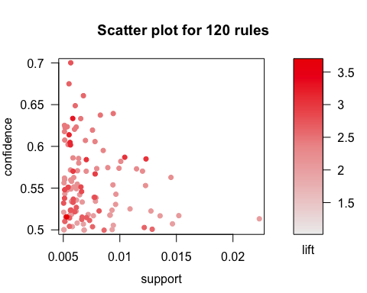

A lot of the item sets are very similar products grouped together, like citrus fruit and tropical fruit or root vegetables and other vegetables. The highest lift values were primarily sets of items that inform the purchase of ‘other vegetables.’ We chose a threshhold for lift of 3, because most of the lift values ranged from 1-3, so the values with lift >3 showed us the highly informative baskets. Most of the confidence values ranged from 0.5-0.7 so we chose a threshhold of confidence > 0.6. The rules we found made sense, and primarily tell us about what groups of items tell us about the liklihood of buying whole milk and vegetables.