Markdown Slides [EN]
Adolfo Sanz De Diego
January 2014

About

What is it? (I)
- MarkdownSlides is a Reveal.js, Deck.js and PDF slides generator from MARKDOWN files, that also generate HTML, ODT and DOCX documents.

What is it? (II)
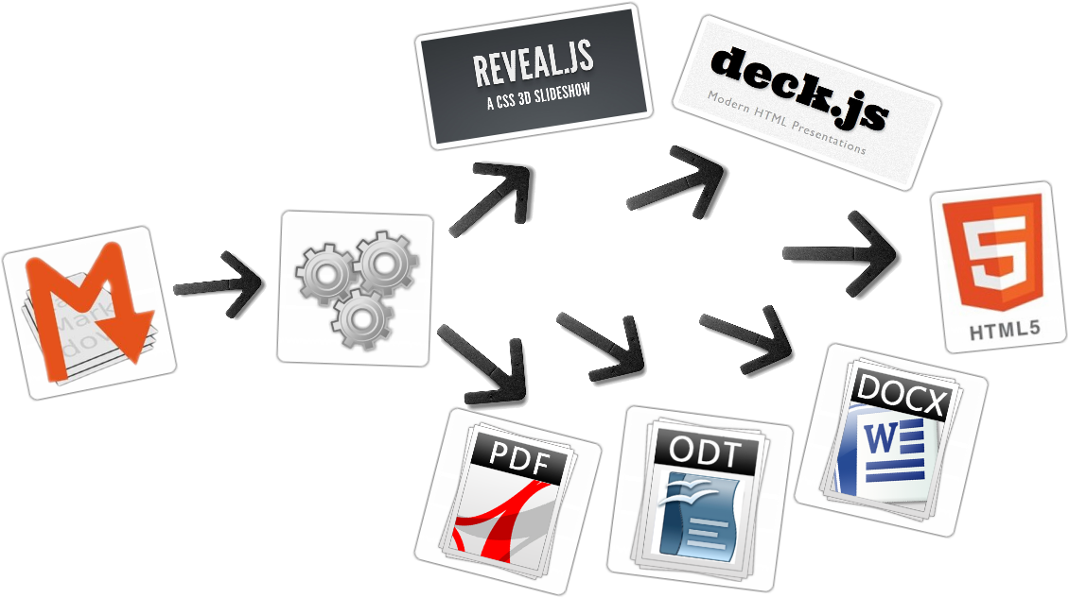

Samples
- From a MARKDOWN file generate:
  - deck-slides
  - deck-slides-alternative
  - reveal-slides
  - reveal-slides-alternative
  - reveal-pdf-slides
  - reveal-pdf-slides-alternative
  - pdf-beamer
  - pdf
  - html
  - docx
  - odt

Licence
- This work is licensed under a:
  - Creative Commons Attribution 3.0
- The program source code are licensed under a:
  - GPL 3.0

Instalation and how to use

Dependencies
- Pandoc (needs to be installed)
- Phantom.js (needs to be installed)
- Reveal.js (automaticaly downloaded)
- Deck.js (automaticaly downloaded)
- Now, only works in Linux (may be on MacOS)

Download
- https://github.com/asanzdiego/markdownslides/archive/master.zip

Creation (I)
- First copy the doc folder and rename it as you like. This is not necessary but helps you organize your documents.
- Create the md files that you want to generate in the md folder. The md files are Markdown files which are nothing more than plain text files with extension md, and a lightweight markup (we should know it but it is very simple).

Creation (II)
- Once created the md files, we can generate with an script.
  - reveal-slides
  - reveal-pdf-slides
  - deck-slides
  - pdf-beamer
  - pdf
  - html
  - docx
  - odt

Build
- In the root folder you have to execute:
./build.sh [mode] [folder]
- Where [mode] can take the next values:
  - "min": generate deck-slides and plain html.
  - "med": generate also reveal-slides, docx and odt (default value)
  - "max": generate all formats.
- And where [folder] is the name of the folder wher to find the md files. If no folder name, it will convert all md files of all the folders.

Author

Adolfo Sanz De Diego
- Old JEE web developer
- Today:
  - Computer teacher:
    - Hardware, Operating Systems
    - Networking, Programming
  - Freelance Trainer:
    - Java, Android
    - JavaScript, jQuery
    - JSF, Spring, Hibernate
    - Groovy & Grails
  - I like to develop

Hackalover

- For hackathons lovers
  - Meetup: http://www.meetup.com/Hackathon-Lovers/
  - Twitter: http://twitter.com/HackathonLovers
  - Blog: http://hackathonlovers.tumblr.com/
  - LinkedIn: http://www.linkedin.com/groups/Hackathon-Lovers-6510465
  - YouTube: http://www.youtube.com/channel/UCRwSe7jK-y62BMvIiNBV1qw

Tweets Sentiment

- Is a tweets analyzer which extracts semantic information to know if the general tweets feeling about a topic is positive or negative.
  - Web: http://tweetssentiment.com/
  - Twitter: http://twitter.com/TweetsSentiment

Where to find me?
- My nick: asanzdiego
  - AboutMe: http://about.me/asanzdiego
  - GitHub: http://github.com/asanzdiego
  - Twitter: http://twitter.com/asanzdiego
  - Blog: http://asanzdiego.blogspot.com.es
  - LinkedIn: http://www.linkedin.com/in/asanzdiego
  - Google+: http://plus.google.com/+AdolfoSanzDeDiego

