ORIE5230_FinalProject_HHL38_RR737

Main idea

Our main idea was: first, to design a pairs trading strategy with the results of Assignment 4, and then, compare the annualized returns with another pairs trading strategy returns that shares the same cointegration idea of assignment 4, but with an expanded stock universe.

First, we took assignment 4 and extend the scope as we designed a trading strategy for the top stocks pair that had the highest correlation. We defined that our data would be from

2015 to 2019, inclusive. Choosing 2015 to 2016, inclusive, as our training set. We computed the correlation among the ~500 stocks of the S&P500 index on the training set and get the stocks with the highest correlations. From these, we filtered those which had a correlation higher than 0.95, in order to avoid stocks from the same company but different class or stocks that share a common holding company. Then, as in Assignment 4, with the top pair we computed a cointegration test that returned the slope of the linear regression between the two time series and the trading signal. Once we had these values, we computed the stocks’ position to be held during the entire test set (2018-2019).

For the second part of the project, we wanted to expand the stock universe and defined a trading strategy with a little twist with respect to the previous one. Therefore, we downloaded data from all the stocks listed in NASDAQ, NYSE and AMEX. Given that ~5,000 are too many stocks to select from and it will require a lot of computational power, we narrowed down our stock universe based on the 500 stock pairs that have the highest correlation during our training set. As before, we filtered those with correlation >0.95. Now, with these pairs we implemented another trading strategy. This new strategy built a portfolio of 10 stock pairs. At the beginning of every month, we used previous 3 months data to determine top 10 correlated stock pairs. Once the recalculation was done, we followed the same steps as the previous trading strategy. Used linear regression to the determine signal and slope of each pair. Weighted each pair trade using the signal strength (absolute value of signal). Weighted each stock within a pair using Beta (the slope) such that the absolute value of the weights given to each ticker equals the weight assigned to the pair. And held the assigned weights for each stock until the next rebalancing date.

How you measure the over or underperformance with respect to the benchmark trading assignment?

The performance is measure based on the annualized returns and Sharpe ratio of each strategy. Given that these are a trading strategies and you can put money on them, we believe that these benchmarks are the most relevant.

The results are as follow:

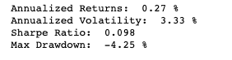**Baseline**

**Trading Strategy**

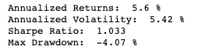

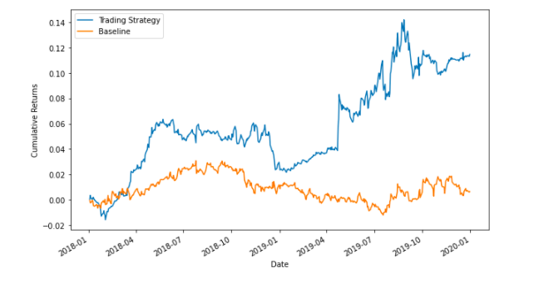

Conclusion

We believe that the strategy still has some space for improvement. For example, we can tune some parameters as recalculation window, weighting, stock pairs in the portfolio. Nevertheless, even we didn’t obtain an outstanding annual return, we had a very good Sharpe ratio, so we will certainly invest some amount of money on this strategy devising better results in the future.