# Homework1 – D

Discuss a visual effect

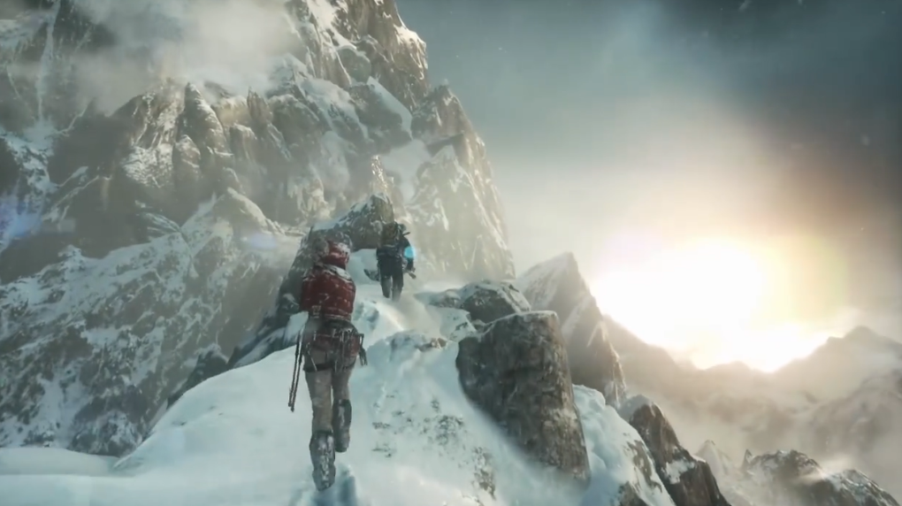

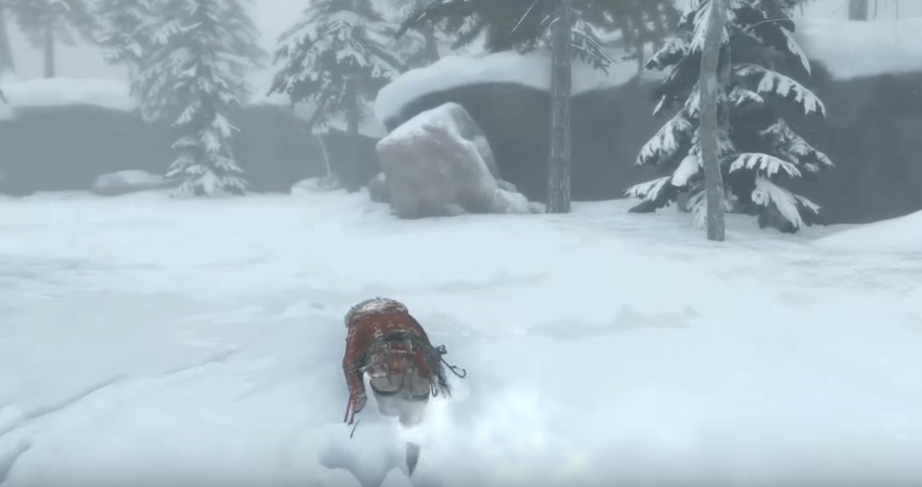

In Rise of the Tomb Raider, when the character walk through the snow, there will have trails on the ground. This kind of environment interaction effect makes the game more realistic and believable. The trails are not simply change the texture of the snow, it transformed the shape of mesh so that seems more realistic and we can feel the thickness of snow. From the pictures above, we can see the different about the thickness of snow.

For normal terrain system, the density of vertices within the terrain is too sparse or dense that unable to support this kind of change on the mash. Too sparse of vertices will make the trails too sharp and rough which tend to look fake. On the other hand, too dense means high-poly mesh which is prohibitively expensive. In the develop blog, it shows a dynamic tessellation which can automatically change the density of mesh within a given range. As the camera approach to the character, the terrain system will add more vertices to the ground which can make it more precise to generate the trails on the snow. This technique increases the density of mesh to apply the trails and limit the memory usage to create too much vertices. Also, there most have some changes in the texture to change the color of different parts of snow of the trails. What’s more, the edge of the trails is not just flat it humps because of the heaping up of the snow when the character is walking.

I think both change of geometry and texture that make the trails looks more realistic and cause less performance in calculating the trails. The more interaction with the environment the more Immersive plays will have in the game.

Reference:

[Dev Blog: Snow Tech and Houdini Simulations](http://tombraider.tumblr.com/post/131825841425/dev-blog-snow-tech-and-houdini-simulations-mike)