**Homework1-A**

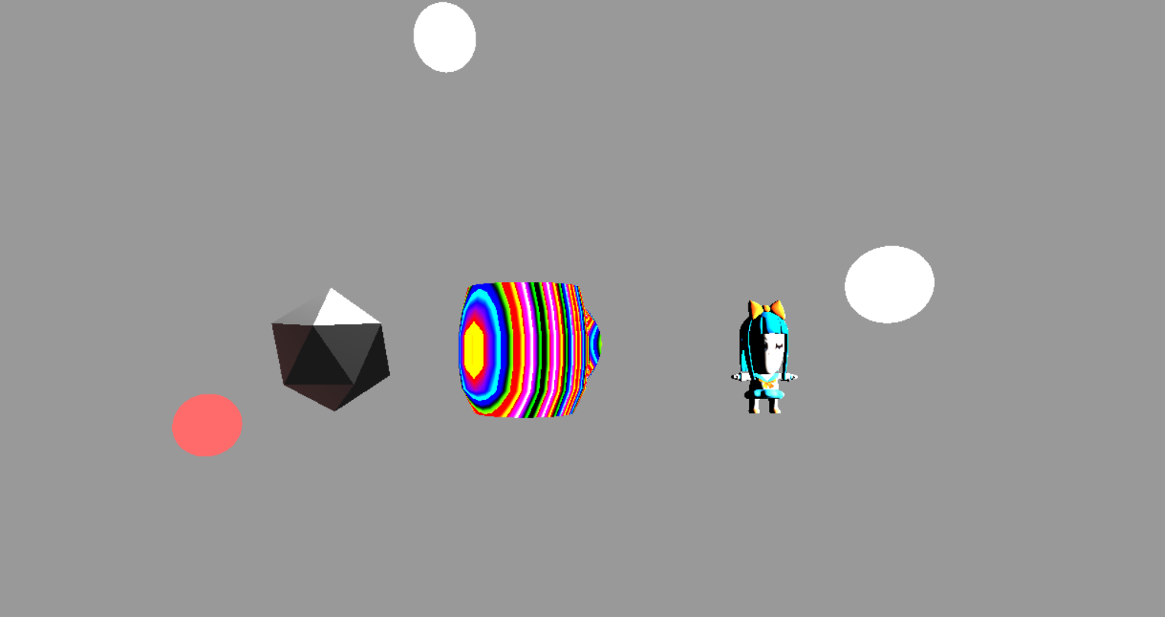

Created 3 objects.

Object 1: Created by THREE.IcosahedronGeometry(1, 0). Apply Phong shader with 2 lights.

Object 2: Created by blender. Loaded by JSONLoader. Apply dynamic color shader.

Object 3: Loaded by OBJLoader. Apply a shader with texture and 1 light.

All objects and light can move.

Added a controller to the camera to change the view.

**Homework1-B**

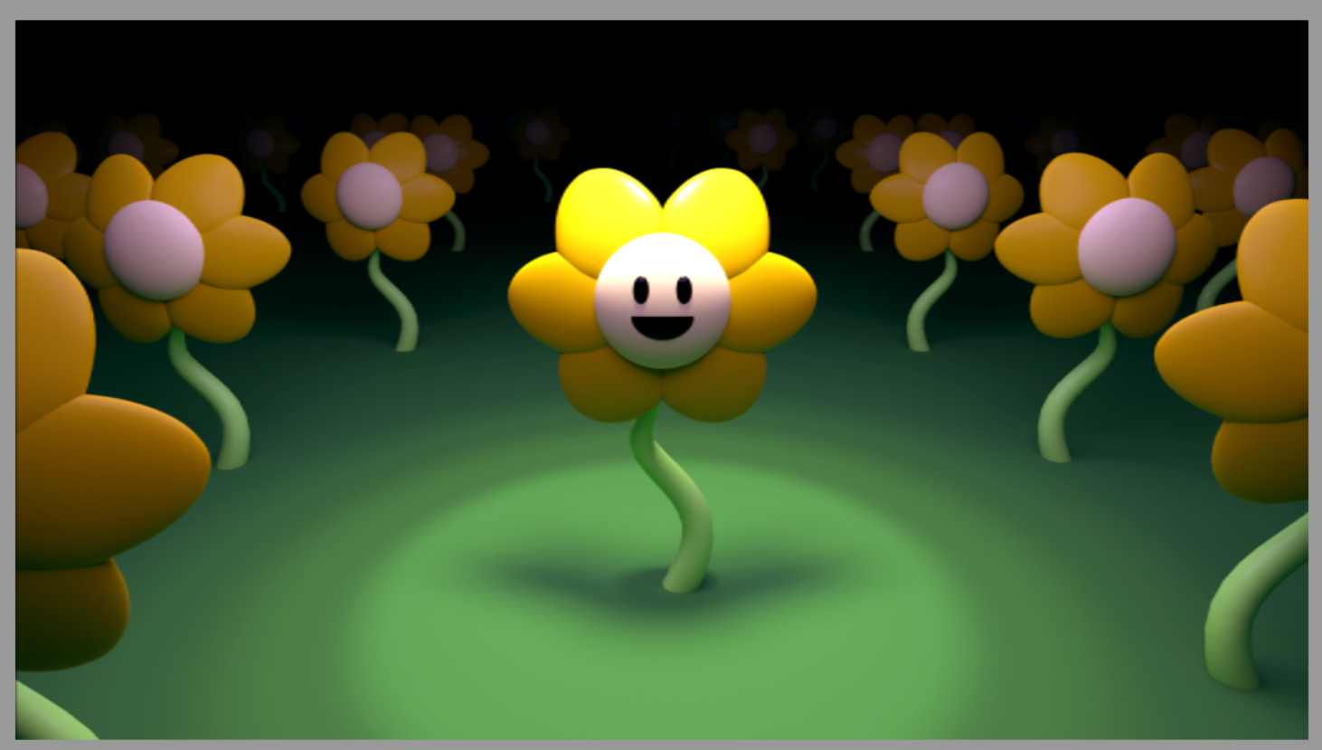 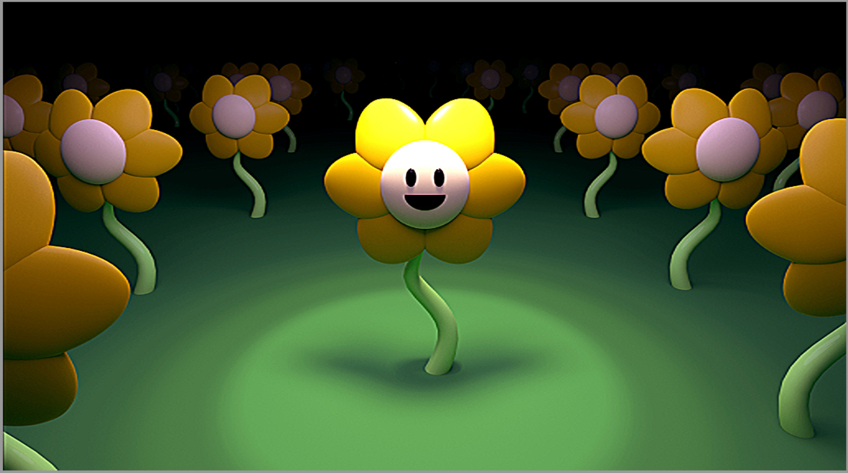

Use the Kernel (image processing) the Sharpen matrix to sharpen the image.

Move the mouse to control the effect.

**Homework1-C**

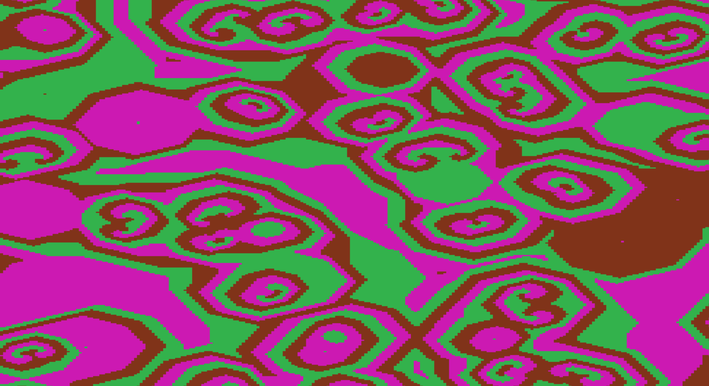

Cyclic Cellular Automata

3 states 3color and threshold = 3

Rules from the <https://softologyblog.wordpress.com/2013/08/29/cyclic-cellular-automata/>

**Homework1-D**

Discussed a visual effect in Rise of the Tomb Raider about the snow trails.