For this one, based from the previous step, we would trace where the operation information goes after it leaves the operator token.
- Last round, swapping the × token for + stopped changing the answer after about layer 8. But the model still gets the right answer, so it must still know it’s multiplying. That means the information didn’t vanish. It most likely moved to a later token before layer 8.
Calculate 6 × 7 = (space)
↑ ↑
operator final

patch position:
Take “Calculate 6 × 7 = “, which should give 42, and borrow vectors from “Calculate 6 + 7 = “, which gives 13. At each layer, replace one of these:
- The operator token only
- The final token only
- Both at once
Then check whether the model says 42 or 13.

Prediction:
Layers Patch operator Patch final Patch both
Early (0 to 7) switches to 13 still 42 switches to 13
Late (15+) still 42 switches to 13 switches to 13

It tells us the operation info doesn’t sit in one place. It gets passed along three tokens as the layers go deeper. That’s why swapping the x token stopped working around layer 8.

Calculate 6 × 7 = (space)
↑ ↑ ↑
1 2 3

1. × token: layers 0 to 7
2. 7 (b's digit): layers 8 to 14
3. final space: layers 15 and up

Where does the operation info go?
Layers 0 to 7: it’s on the ×. Swap in + there and “6 × 7” gives the addition answer, 13.
Layers 8 to 14: the × stops mattering, and the last digit of b matters most. Swapping the × and final tokens together doesn’t flip × prompts here, because neither is the main place the info sits at those layers.
Layers 15 and up: the final token controls the answer. Swapping it changes the first digit of the answer almost every time.

saved patch_positions_results.npz (772s total)

Is that the whole path?
Pretty much. Swapping all three tokens together flips the first digit at every layer (86 to 100%), so these tokens are enough to control the operation. The = token doesn’t seem to matter.

Can we reuse a stored state in a new prompt?
It depends on the token and the layer:

Token Can a generic same-op average replace it? What that suggests
× token Yes, at every layer It carries the operation, not details the answer depends on
b digit No, not until layer 17 It holds the number itself, and an average wipes that out
Final token, layers up to 16; Yes (+ prompts drop to 88% at layers 15 to 16); The model can still get the numbers from elsewhere
Final token, layers 17+; No; It probably depends on the specific numbers or answer by then

The most useful spot is the final token at layers 15 to 16. There, the same-op average works and the other-op average breaks the answer. So that’s where the final token controls the operation but can still be replaced with a generic state. It’s the closest thing we’ve found to “substitute stored information into a new query”.

Two things that change the plan
Full-answer accuracy undersells the final token. From layer 15 on, patching it flips the first digit about 89 to 100% of the time, but the full answer flips far less often on × prompts (18 to 23% at layers 15 to 18). My best explanation is that later digits re-read the unpatched operator and number tokens. So I added a first-digit metric alongside the two probabilities Andrew asked for.
There’s a possible reuse window, which is the part Andrew will care about most. Here’s what happens when you put an average vector into the final token:
Layer Same-op average, × prompts Same-op average, + prompts Other-op average
15 to 16 100% correct 88% correct about 7% correct
17+ 19 to 30% correct 41 to 51% correct 7 to 40% correct
So at layers 15 to 16, a generic state of the same operation can stand in for the final token, while the wrong operation breaks it. From layer 17 on, even the same-op average breaks it, probably because that state now depends on the specific numbers or answer.

How it works
positions: finds the four tokens by name. Counting back from the end of the prompt, the final token is the trailing space, equals is one before it, and b_last is two before it.
canonical: builds the × and + averages at all four tokens. Last round only did this for the operator token.
plan: lists every combination of source, patch set, and layer, for 576 in total per prompt.
run_all_patches: runs those combinations in batches of 64. Each row gets the same prompt, and a hook at each layer patches only the rows assigned to that layer, which is much faster than last round’s one-at-a-time approach.
Sending only the answer positions through lm_head: that fixed the slowdown from earlier, because full logits for a big batch were using a huge amount of memory.
What the output rows mean
acc orig / acc alt: whether the model gives exactly the original answer, or exactly the other operation’s answer.
P(orig) / P(alt): the probability of each of those answers, as Andrew asked.
1st=orig / 1st=alt: whether the model’s top first digit matches each answer. This only uses prompts where the two answers start with different digits, and the header prints how many that is.

saved patch_positions_results.npz (5411s total)

What the results show

The first digit flipping is the clearest measure here. This table shows how often swapping in “same numbers, other operation” flips it:

Patched token Layers 0 to 7 Layers 9 to 14 Layers 15+
Operator × 53 to 100%, + 96 to 100% × 0%, + 5 to 21% about 0%
Last digit of b about 0 to 3% × 8 to 14%, + 76 to 85% about 0 to 3%
Final about 0 to 4% × 0%, + 7 to 10% × 91 to 100%, + 99 to 100%
All three × 86 to 100%, + 100% × 95 to 97%, + 100% × 99 to 100%, + 100%

× prompts + prompts
Same-op average: original answer still correct 100% 88%
Other-op average: original answer still correct 7% 7 to 8%
Other-op average: first digit flips 78 to 80% 100%

Comparing with Julian and Tyler’s work:
Our results point to the same layers even though we patched different things. Julian and Tyler swapped KV cache entries at the operator token, and I swapped hidden states at several tokens. Together, the results suggest the operation may be handed from the operator to the final token at their block 15 (my layer 14 to 15). One difference is still unresolved: how much an operator swap hurts × prompts at layers 9 to 14.
One thing to keep in mind is that: Julian and Tyler probably started to count blocks from 1, so their block 15 reads my layer 14 hidden state. I inferred this from their plot subtitle and from where the curves line up, so we should confirm it.

Where the results agree:
- The operator token stops mattering at the same points. Their KV swaps on × prompts dip at blocks 8 to 9 and block 15. My hidden state swaps recover at layers 7 to 9 and improve again from layer 14 to 15.
- Block 15 may be the handoff to the final token. Their last operator dip is at block 15. My final-token swap has its big effect right after that: P(original answer) on × prompts falls from 0.71 at layer 14 to 0.06 at layer 15. This is a hypothesis, since neither of us has tested it directly.
- Same-operation swaps at the operator token are safe. Neither of us sees real damage at any layer.
- Losing the original answer doesn’t mean getting the other operation’s answer. Their P(other-operation answer) peaks at about 0.13, and mine stays around 0.01 at the operator from layer 9 on.
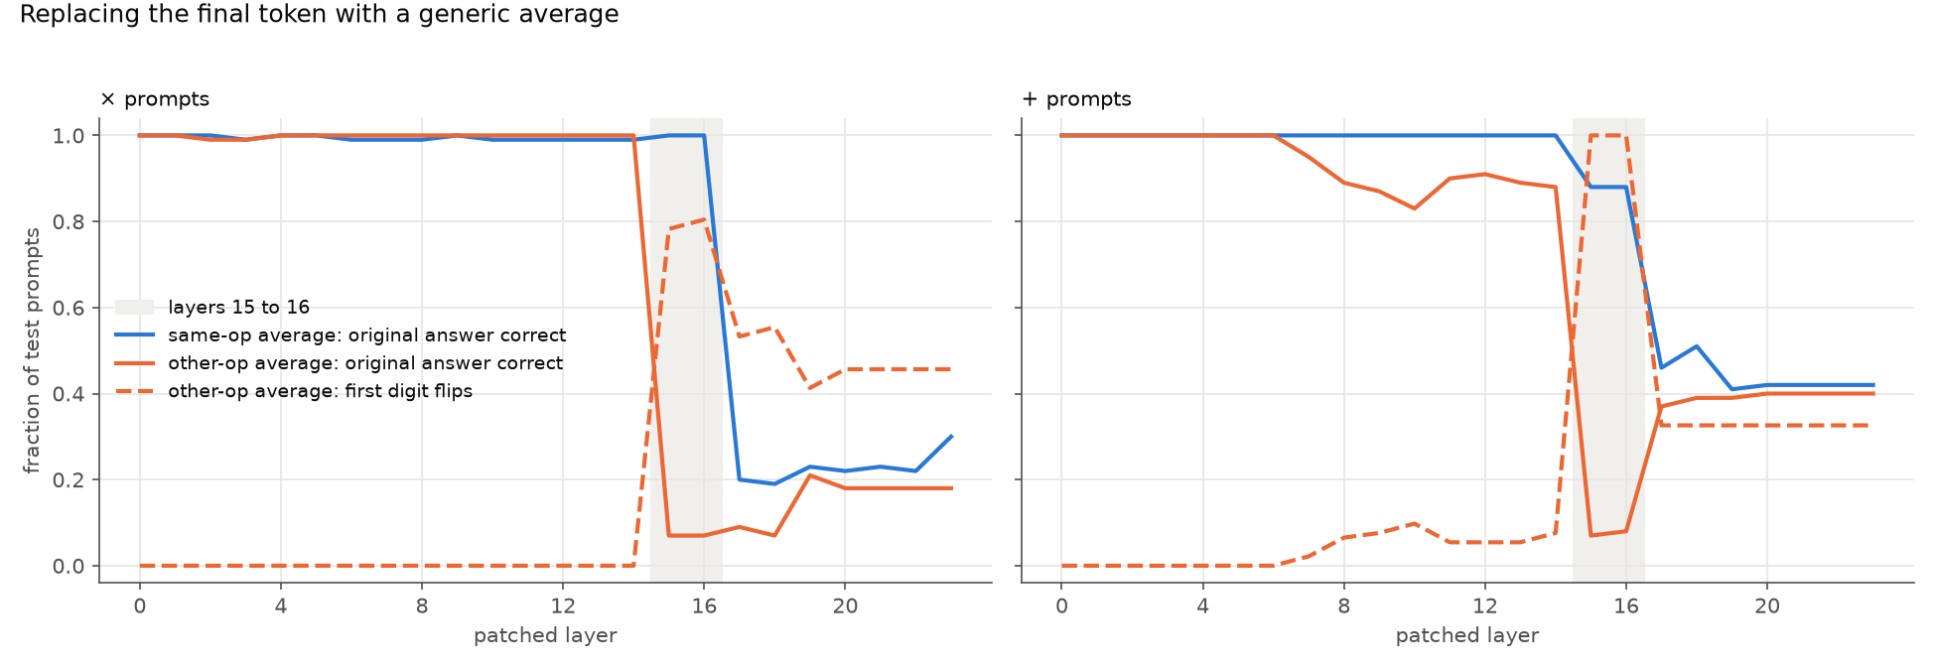
Layers 15 to 16 are a narrow reuse window. The same-operation average keeps the answer correct 100% of the time on × and 88% on +, while the other-operation average drops it to about 7 to 8%. At layer 17, same-operation accuracy falls to 20% on × and 46% on +, so the final token may hold the specific answer by then instead of the operation. This only swaps one token at one layer, so it isn’t real KV reuse yet.

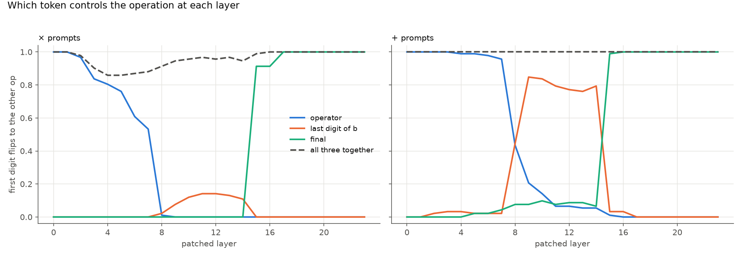
On + prompts, control of the first digit moves from the operator (through about layer 7) to the last digit of b (76 to 85% flips at layers 9 to 14), then to the final token (99% at layer 15). On × prompts, no single token controls layers 9 to 14, since the last digit of b reaches only 14%, but swapping all three tokens together flips 95 to 97%. This suggests the information is spread across tokens on × prompts.
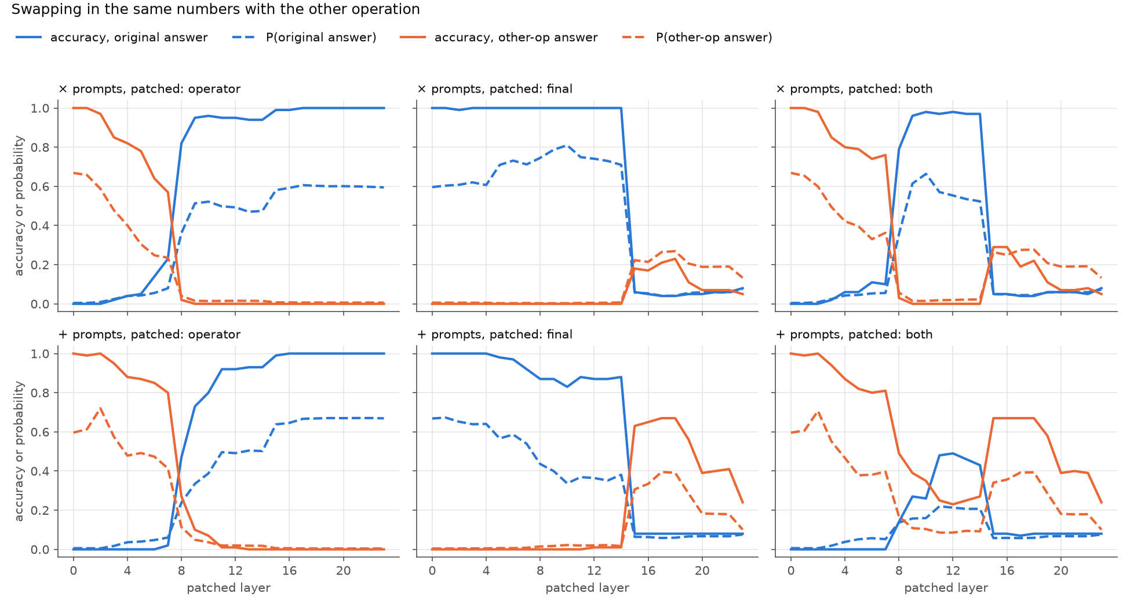
Swapping the operator switches the answer in the early layers, but this mostly stops at layer 8. Swapping the final token has a sharp edge between layers 14 and 15, where original accuracy drops from 1.00 to 0.06 on × and from 0.88 to 0.08 on +. A broken answer isn’t a clean switch, though, because from layer 15 the other-operation answer reaches only 0.05 to 0.23 on × and 0.24 to 0.67 on +.

From my experiments, it added much more insight to how KV cache and hidden states works:
- The operation appears to move between tokens: swapping the operator flips the first digit at layers 0 to 7. The last digit of b matters at layers 9 to 14 on + prompts (76 to 85% flips, vs 8 to 14% on √ó). The final token controls it from layer 15 on (91 to 100% flips).
- Those three tokens cover the path: swapping all three flips the first digit at every layer (86 to 100%).
- A possible reuse window: at layers 15 to 16, a same-operation average at the final token keeps the answer correct (100% on √ó, 88% on +). An other-operation average drops it to about 7%

Julian and Tyler swapped KV cache entries, and also tested K and V separately. They patched only the operator token, and each swap changed one block’s cache. They used 20 test prompts per operation. They also tested zeroing K/V and compared swapping during prefill with swapping after prefill.
I swapped hidden states instead. I patched the operator, the last digit of b, =, the final token, and combinations of those. Each swap happened at one layer, but the change carries into later layers. I used 100 test prompts per operation and also tracked the first-digit flip rate.

