Effective-Medium Geant4 Predicts K-Edge Nanocomposite Shielding: A Six-Material Explicit-RVE Benchmark
Hani H. Negm¹
¹ Hani Negm, Department of Physics, College of Science, Jouf University
Corresponding author: hhnegm@ju.edu.sa

Abstract
Nanoparticle-filled shielding polymers are often simulated as homogeneous materials even when experiments describe nanoscale fillers. This paper tests when that effective-medium shortcut remains valid for K-edge photon shielding.
Six HDPE composites were benchmarked: Bi₂O₃, WO₃, BaWO₄, Gd₂O₃, and PbWO₄ at φ=0.189, plus a Bi₂O₃/WO₃ ternary at φ=0.10+0.10. Geant4 11.4-beta-01 with G4EmLivermorePhysics was run from 30 keV to 1.332 MeV in three regimes: homogeneous G4Material, 1 µm G4PVParameterised explicit RVE, and 250 nm G4MultiUnion explicit RVE. The endpoint was μ/ρ(E), compared with NIST XCOM for Regime A and with matched Regime-A baselines for explicit RVEs.
All six Regime-A materials passed the XCOM gates, with mean absolute deviations of 0.339–0.793% and maximum deviations of 0.967–2.933%. For the five composition-equivalent binary materials, Regime B agreed with Regime A within the ±3% H1 gate at 30–150 keV: Bi₂O₃ (0.975–0.984), WO₃ (0.988–1.022), BaWO₄ (0.992–1.010), Gd₂O₃ (0.999–1.012), and PbWO₄ (0.976–1.010). Regime C reproduced the broad trend but showed larger finite-RVE fluctuations. The ternary explicit-RVE case failed composition equivalence because only Bi₂O₃ was spatialised, making it a negative-control stress test rather than an H1 validation.
Effective-medium Geant4 is therefore appropriate for macroscopic bulk attenuation when μr ≪ 1 and composition is represented consistently. Parameterised explicit RVEs are best reserved for validation and phase-aware scoring; G4MultiUnion should be limited to small-RVE feasibility checks.
Keywords: NIST XCOM · mass attenuation coefficient · representative volume element · photon transport · G4PVParameterised · G4MultiUnion · high-Z fillers

1. Introduction

1.1 Background
Polymer-matrix radiation-shielding composites loaded with high-Z fillers have become a sustained research focus, driven by the need for lead-free, flexible, and manufacturable alternatives in medical X-ray protection, nuclear medicine, industrial radiography, and aerospace shielding. Common filler chemistries include Bi₂O₃, WO₃, BaSO₄/BaWO₄, Gd₂O₃, PbO/PbWO₄, and related dense oxides. Many experimental papers describe these systems as nanocomposites because the filler particles are prepared or dispersed at sub-micron or nanometre length scales.
Recent shielding literature reflects this trend. Clay and polymer nanocomposites containing Cd/Pb, Cu/Fe, W, Bi, and related heavy oxides are typically characterised experimentally and then benchmarked with Geant4, XCOM, Phys-X/PSD, or equivalent photon-attenuation tools [12,13,17]. Heavy-oxide glasses follow a similar pattern, reporting mass attenuation coefficients, half-value layers, effective atomic numbers, and Geant4/XCOM agreement for dense Pb/W/Bi-containing compositions [14]. Widely used tools such as Phy-X/PSD and EpiXS have made these bulk attenuation calculations accessible and reproducible [15,16]. These studies establish material performance, but they usually validate material-level attenuation curves rather than isolating the algorithmic question addressed here: whether a composition-equivalent homogeneous Geant4 material and an explicit nanoparticle RVE give the same μ/ρ when source, density, physics list, and scoring are held fixed.
In Monte Carlo photon-transport calculations, however, these materials are usually implemented as homogeneous mixtures: elemental mass fractions are supplied to a single material definition, a bulk density is assigned, and the microscopic spatial distribution of filler particles is ignored. This modelling choice is often physically justified for macroscopic transmission because diagnostic and gamma-ray photon mean free paths are typically orders of magnitude larger than a 25–100 nm filler particle. Under that condition, photon attenuation is governed by mass-fraction additivity and the independent-atom approximation, not by the exact particle coordinates.
The difficulty is not the existence of the effective-medium rule itself. The difficulty is knowing when a shielding simulation that calls a material a nanocomposite should remain homogeneous and when explicit nanoparticle geometry is needed. The answer depends on the observable. Macroscopic transmitted fluence may be insensitive to nanoscale geometry, while phase-resolved interface dose, local energy deposition, or dose-enhancement factors may not be.

1.2 Gap
Three gaps motivate this work. First, there is no widely available Geant4 benchmark that holds composition, density, source definition, scoring, and physics list constant while varying only the geometric representation: homogeneous material, parameterised explicit RVE, and multi-union explicit RVE. Second, prior validation is often tied to one filler, whereas a robust shielding workflow should reproduce K-edge behaviour across chemically distinct absorbers, including Bi, W, Ba/W, Gd, and Pb/W systems. Third, although Geant4 provides both G4PVParameterised and G4MultiUnion, their practical scaling for shielding-relevant nanoparticle counts is rarely quantified in a way that helps users choose the correct geometry strategy.

1.3 Contribution and hypotheses
This paper contributes a controlled benchmark campaign for six K-edge filler chemistries across three modelling regimes. The core scientific question is whether macroscopic attenuation through a nanocomposite at fixed composition is changed by resolving the particles explicitly.
Hypothesis H1. For photon energies where the photon mean free path greatly exceeds the nanoparticle radius (μr ≪ 1), transmitted fluence and μ/ρ through the same composition are independent of the choice of Regime A, B, or C within the statistical uncertainty of 10⁶–10⁷-history Geant4 runs, provided composition, density, and scoring are matched.
Hypothesis H2. For photon energies E ≲ 100 keV with high-Z fillers, phase-resolved radial dose-enhancement profiles around individual particles may carry spatial structure that an effective-medium material cannot reproduce.
Only H1 is tested quantitatively in this manuscript. H2 requires phase-resolved local scoring and is treated as future work.
The novelty is methodological rather than kernel-level. G4PVParameterised, G4MultiUnion, and G4EmLivermorePhysics are standard Geant4 components; the contribution here is the controlled, reproducible, material-resolved shielding benchmark built from those components.

2. Theoretical Basis

2.1 Effective-medium attenuation
For photon attenuation under the independent-atom approximation, the mass attenuation coefficient of a mixture is
μρmix(E)=i​wiμρi(E),
where $w_{i}$ is the elemental or compound mass fraction. This relation is exact for the tabulated mixture rule used by XCOM, subject to the underlying independent-atom approximation. In Geant4, the same physical expectation should hold when the material is represented by a homogeneous G4Material with correct elemental fractions and density.
The spatial distribution of atoms becomes relevant when the heterogeneity length scale approaches the photon mean free path or when the scored observable depends on local phase boundaries rather than bulk transmission. For the present 25 nm particles and photon energies ≥30 keV, the condition μr ≪ 1 is expected to hold for macroscopic transmission.

2.2 Effective density and mass fractions
All material densities are derived from a volume-fraction rule unless otherwise noted:
ρeff=j​ϕjρj.
The corresponding mass fraction of phase $j$ is
$$w_{j}=\frac{ϕ_{j}ρ_{j}}{ρ_{\text{eff}}}.$$
This paper uses HDPE density 0.95 g cm⁻³. The binary φ=0.189 cases differ in filler density and therefore in effective density and filler weight fraction. The ternary case uses φ(Bi₂O₃)=0.10 and φ(WO₃)=0.10.

2.3 Representative volume elements
A cubic RVE is used for explicit nanoparticle simulations. For a random dispersion of monodisperse spheres of radius $r$ at volume fraction $ϕ_{f}$, the nominal number of particles in an RVE of side $L$ is
$$N≈\frac{ϕ_{f}L^{3}}{(4/3)πr^{3}}.$$
For $r=25$ nm, $L=1$ µm, and $ϕ_{f}=0.189$, this gives approximately 2,888 spheres. This count is tractable with parameterised placement but not with G4MultiUnion on the 8 GB workstation used here. A reduced $L=250$ nm RVE contains approximately 45 spheres for φ=0.189 and approximately 24 spheres for φ=0.10.

3. Geant4 Modelling Regimes

3.1 Regime A — homogeneous effective medium
Regime A defines each composite as a single G4Material using elemental mass fractions and an assigned density. Slab thickness is selected per energy to keep transmission near $T≈0.65$, which stabilises the direct estimator
$$\hat{μ}=−\frac{lnT}{t}.$$
Regime A is the production model for bulk shielding calculations and is directly benchmarked against NIST XCOM.

3.2 Regime B — explicit RVE with G4PVParameterised
Regime B resolves 25 nm filler spheres using G4PVParameterised. Particle centres are generated by random sequential addition with hard-sphere exclusion. The principal binary studies use a 1 µm RVE and 2,888 spheres at φ=0.189. The ternary explicit-RVE studies use 1,528 Bi₂O₃ spheres at φ=0.10.
This regime is the main explicit-geometry validation path because repeated sphere placement remains scalable at O(10³) particle counts.

3.3 Regime C — explicit RVE with G4MultiUnion
Regime C builds the explicit particles into a single G4MultiUnion and calls Voxelize(). This provides a useful independent geometry path, but memory use grows rapidly with sphere count. On the present workstation, 1 µm and 500 nm multi-union RVEs were infeasible; the adopted configuration is a 250 nm RVE with 45 spheres for φ=0.189 binary cases and 24 Bi₂O₃ nodes for the ternary φ=0.10 explicit case.

3.4 Ternary explicit-RVE interpretation
The ternary Regime-A material is a true HDPE/Bi₂O₃/WO₃ effective medium. The Regime-B and Regime-C ternary geometries spatialise Bi₂O₃ spheres only. Because the explicit geometry does not independently resolve the WO₃ phase as a matched spatial component, the ternary B/A and C/A ratios are not interpreted as a valid H1 pass/fail test for a fully composition-equivalent ternary RVE. They are retained as a stress test showing that composition equivalence is mandatory when comparing effective-medium and explicit-particle representations.

4. Benchmark Protocol

4.1 Materials
Table M1. Material design summary for the v10 six-chemistry benchmark.
Material | Volume fraction | $ρ_{\text{eff}}$ (g cm$​^{−3}$) | Heavy phase wt% | Principal K-edge(s) | Regimes completed
HDPE/Bi₂O₃ | φ=0.189 | 2.452 | 68.6% Bi₂O₃ | Bi K = 90.526 keV | A+B+C
HDPE/WO₃ | φ=0.189 | 2.124 | 63.72% WO₃ | W K = 69.525 keV | A+B+C
HDPE/BaWO₄ | φ=0.189 | 1.927 | 60.02% BaWO₄ | Ba K = 37.441 keV; W K = 69.525 keV | A+B+C
HDPE/Bi₂O₃/WO₃ | φ(Bi₂O₃)=0.10; φ(WO₃)=0.10 | 2.366 | 37.62% Bi₂O₃; 30.26% WO₃ | W K = 69.525 keV; Bi K = 90.526 keV | A+B+C*
HDPE/Gd₂O₃ | φ=0.189 | 2.107 | 63.42% Gd₂O₃ | Gd K = 50.239 keV | A+B+C
HDPE/PbWO₄ | φ=0.189 | 2.369 | 67.49% PbWO₄ | W K = 69.525 keV; Pb K = 88.005 keV | A+B+C
*The ternary explicit-RVE cases resolve Bi₂O₃ spheres only and are treated as a hybrid stress test rather than a composition-equivalent H1 validation.
A separate HDPE/Bi₂O₃ 30 wt% Regime-A validation study from v08 is retained as an independent emlivermore/XCOM calibration case. It is not used as the cross-regime baseline.

4.2 Source and energy grid
All runs use mono-energetic photons at 30, 50, 80, 100, 150, 356, 511, 662, 1173, and 1332 keV. The source direction is normal to the slab or RVE. Regime C uses distributed transverse sampling over the 250 nm RVE face to average over the small explicit geometry.

4.3 Physics list and software
All runs use G4EmLivermorePhysics in Geant4 11.4-beta-01. The Windows host runs Python 3.11 from d:\uv_envs; Geant4 execution is performed through WSL Ubuntu 22.04. The benchmark orchestrator is python -m shieldlab.analysis.nano_benchmark.

4.4 Histories
Regime | Geometry | Histories per energy | Purpose
A | Homogeneous slab | ${10}^{6}$ | XCOM validation and reference baseline
B | 1 µm parameterised RVE | ${10}^{7}$ | Explicit-particle H1 test
C | 250 nm multi-union RVE | ${10}^{7}$ | Independent explicit-geometry feasibility check

4.5 Artifact provenance and reproducibility matrix
All manuscript figures and tables are derived from fixed study JSON files and result directories. Table M2 is kept in the main text as a compact study-to-result provenance matrix because its scientific role is to show which comparisons are valid H1 tests. The path-level JSON and result-directory audit trail is moved to Appendix D, where it remains available for exact reruns without making the main article table unreadable. The strict H1 interpretation applies only to the five binary rows marked composition-equivalent; the ternary row is retained as a non-H1-equivalent stress test because WO₃ is included in the effective medium but not spatialised as explicit particles.
Table M2. Study-to-result provenance and H1 interpretation for the six-material campaign.
Material | Regime A baseline | Regime B explicit RVE | Regime C explicit RVE | H1 interpretation
HDPE/Bi₂O₃ | seed 13579; XCOM baseline | seed 22222; 1 µm, 2,888 Bi₂O₃ spheres | seed 33333; 250 nm, 45 Bi₂O₃ spheres | Composition-equivalent binary
HDPE/WO₃ | seed 24680; XCOM baseline | seed 44444; 1 µm, 2,888 WO₃ spheres | seed 55555; 250 nm, 45 WO₃ spheres | Composition-equivalent binary
HDPE/BaWO₄ | seed 13579; XCOM baseline | seed 11111; 1 µm, 2,888 BaWO₄ spheres | seed 66666; 250 nm, 45 BaWO₄ spheres | Composition-equivalent binary
HDPE/Bi₂O₃/WO₃ | seed 24681; XCOM baseline | seed 77777; 1 µm, 1,528 Bi₂O₃ spheres only | seed 88888; 250 nm, 24 Bi₂O₃ spheres only | Non-composition-equivalent stress test
HDPE/Gd₂O₃ | seed 35791; XCOM baseline | seed 12345; 1 µm, 2,888 Gd₂O₃ spheres | seed 98765; 250 nm, 45 Gd₂O₃ spheres | Composition-equivalent binary
HDPE/PbWO₄ | seed 46802; XCOM baseline | seed 54321; 1 µm, 2,888 PbWO₄ spheres | seed 67890; 250 nm, 45 PbWO₄ spheres | Composition-equivalent binary
The scorer records incident and transmitted counts for a narrow-beam direct estimator. For Regime A, the slab thickness is selected per energy so that the target transmission remains near 0.65. For Regimes B and C, μ/ρ is reconstructed from the RVE path length and transmitted count, then divided by the effective bulk density of the matched material. Statistical intervals use binomial counting uncertainty propagated through $\hat{μ}=−ln(T)/t$ and then through $\hat{μ}/ρ$.

4.6 Acceptance criteria
Criterion | Metric | Gate
Regime A vs XCOM | mean abs. $Δ(μ/ρ)$ over 10 energies | ≤1.5%
Regime A vs XCOM | max abs. $Δ(μ/ρ)$ over 10 energies | ≤5.0%
H1 cross-regime | abs. $(μ_{B}/μ_{A}−1)$ at 30–150 keV | ≤3%
Regime C feasibility | Reported against A with finite-RVE and count caveats | descriptive
The strict H1 gate is applied to Regime B for composition-equivalent binary materials only. Regime C is reported separately because the adopted 250 nm RVE contains only 45 particles at φ=0.189 and therefore includes larger finite-RVE fluctuations. The ternary explicit-RVE ratios are excluded from H1 pass/fail status because the explicit geometry spatialises Bi₂O₃ only and is not composition-equivalent to the full Bi₂O₃+WO₃ effective medium.

5. Results

5.1 Regime A XCOM validation across six chemistries
Figure 1 and Table 1 show that all six Regime-A materials pass the XCOM acceptance gates. The largest deviation is observed for Gd₂O₃ at 50 keV, immediately below the Gd K-edge at 50.239 keV, where small interpolation differences between EPDL97 and XCOM are expected to be amplified.
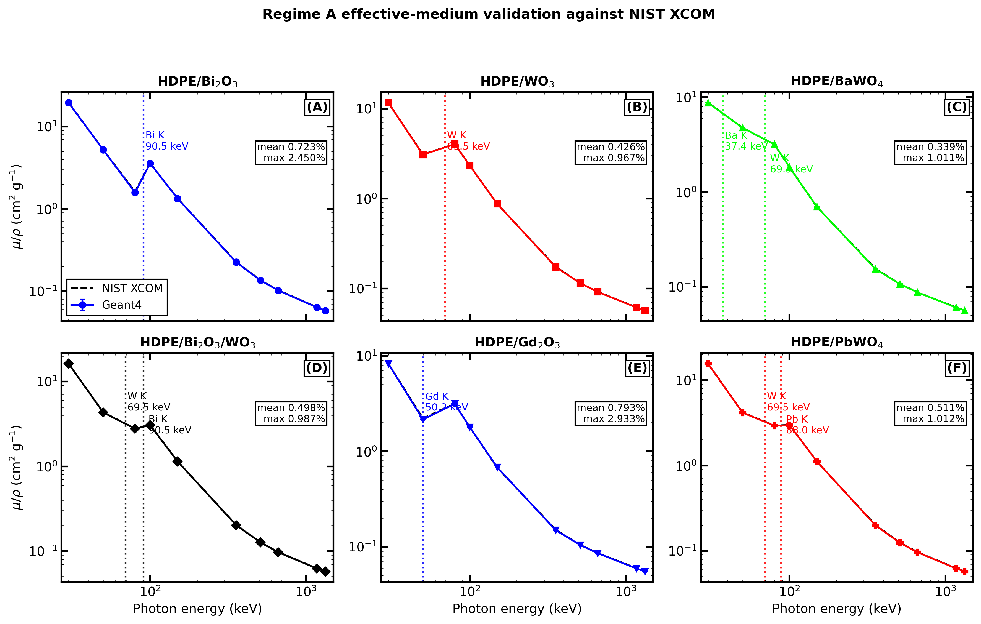
Figure 1. Six-material Regime-A validation against NIST XCOM. Panels A-F show HDPE/Bi₂O₃, HDPE/WO₃, HDPE/BaWO₄, HDPE/Bi₂O₃/WO₃, HDPE/Gd₂O₃, and HDPE/PbWO₄, respectively. Symbols are Geant4 G4EmLivermorePhysics effective-medium results with 95% statistical intervals; dashed black curves are NIST XCOM references. Dotted vertical lines mark the material-specific K-edges.
Table 1. Regime-A XCOM acceptance summary.
Material | Mean abs. Δ (%) | Max abs. Δ (%) | Max-deviation energy | Acceptance
HDPE/Bi₂O₃ | 0.723 | 2.450 | 80 keV | Pass
HDPE/WO₃ | 0.426 | 0.967 | 50 keV | Pass
HDPE/BaWO₄ | 0.339 | 1.011 | 356 keV | Pass
HDPE/Bi₂O₃/WO₃ | 0.498 | 0.987 | 356 keV | Pass
HDPE/Gd₂O₃ | 0.793 | 2.933 | 50 keV | Pass
HDPE/PbWO₄ | 0.511 | 1.012 | 356 keV | Pass
Table 2. Regime-A simulated mass attenuation coefficients, $(μ/ρ)_{\text{sim}}$, in cm$​^{2}$ g$​^{−1}$.
E (keV) | Bi₂O₃ | WO₃ | BaWO₄ | Bi₂O₃/WO₃ | Gd₂O₃ | PbWO₄
30 | 19.542 | 11.661 | 8.730 | 16.247 | 8.251 | 15.629
50 | 5.218 | 3.080 | 4.754 | 4.322 | 2.152 | 4.165
80 | 1.581 | 4.045 | 3.183 | 2.781 | 3.135 | 2.928
100 | 3.578 | 2.328 | 1.827 | 3.057 | 1.786 | 2.979
150 | 1.336 | 0.873 | 0.697 | 1.144 | 0.679 | 1.115
356 | 0.225 | 0.173 | 0.154 | 0.203 | 0.149 | 0.199
511 | 0.135 | 0.115 | 0.107 | 0.127 | 0.104 | 0.124
662 | 0.102 | 0.091 | 0.087 | 0.097 | 0.086 | 0.096
1173 | 0.064 | 0.061 | 0.060 | 0.062 | 0.059 | 0.062
1332 | 0.058 | 0.057 | 0.056 | 0.058 | 0.055 | 0.057
The K-edge signatures are visible directly in Table 2 and Figure 2. WO₃ rises from 3.080 cm² g⁻¹ at 50 keV to 4.045 cm² g⁻¹ at 80 keV after the W K-shell opens. Gd₂O₃ rises from 2.152 to 3.135 cm² g⁻¹ across the 50–80 keV interval after the Gd K-edge. PbWO₄ rises from 2.928 to 2.979 cm² g⁻¹ between 80 and 100 keV, consistent with the Pb K-edge at 88.005 keV. The ternary mixture also rises from 2.781 to 3.057 cm² g⁻¹ between 80 and 100 keV, showing the Bi K-edge contribution superposed on the W-containing baseline.
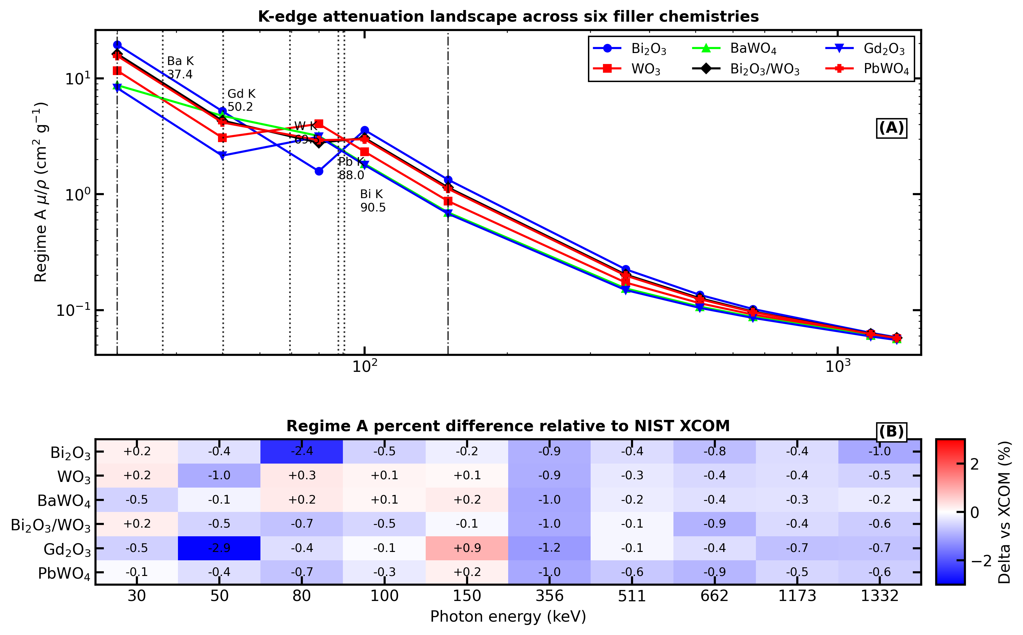
Figure 2. K-edge attenuation landscape and XCOM residual map. Panel A overlays the six Regime-A attenuation curves on a common log-energy axis; vertical guides identify the Ba, Gd, W, Pb, and Bi K-edges, and dash-dot limits mark the 30–150 keV H1 window. Panel B reports the per-energy percent difference between Geant4 and NIST XCOM for every material. The largest edge-adjacent residual is the Gd₂O₃ point at 50 keV, immediately below the 50.239 keV Gd K-edge.

5.2 Regime B explicit-RVE comparison
For composition-equivalent binary systems, Table 3 and Figure 3A show that the 1 µm G4PVParameterised RVE reproduces the Regime-A baseline at 30–150 keV within the ±3% H1 gate. This is the strongest cross-regime result because Regime B has the largest explicit RVE and the best particle-count statistics.
Table 3. Regime-B / Regime-A ratios at 30–150 keV.
Material | 30 keV | 50 keV | 80 keV | 100 keV | 150 keV | Range | Mean abs. ratio deviation
HDPE/Bi₂O₃ | 0.982 | 0.976 | 0.984 | 0.982 | 0.975 | 0.975–0.984 | 2.00%
HDPE/WO₃ | 1.000 | 0.997 | 0.988 | 1.022 | 0.997 | 0.988–1.022 | 0.82%
HDPE/BaWO₄ | 0.996 | 1.010 | 0.992 | 1.007 | 1.002 | 0.992–1.010 | 0.63%
HDPE/Gd₂O₃ | 1.007 | 0.999 | 1.007 | 1.000 | 1.012 | 0.999–1.012 | 0.54%
HDPE/PbWO₄ | 0.992 | 0.983 | 0.976 | 0.997 | 1.010 | 0.976–1.010 | 1.22%
HDPE/Bi₂O₃/WO₃* | 0.663 | 0.679 | 0.325 | 0.670 | 0.664 | 0.325–0.679 | 39.99%
*Ternary explicit-RVE ratios are not composition-equivalent to the full ternary Regime-A material and are not counted as an H1 validation pass/fail.
The binary results support H1 for macroscopic attenuation: explicitly resolving 25 nm particles does not change μ/ρ once composition and density are matched. The Bi₂O₃ case carries a small systematic downward offset of about 2%, consistent with the v08 result and RVE boundary-layer/statistical effects. The WO₃, BaWO₄, Gd₂O₃, and PbWO₄ cases show sub-1.3% mean absolute ratio deviation over 30–150 keV.

5.3 Regime C multi-union comparison
Regime C provides an independent explicit-geometry implementation, but the feasible RVE is much smaller. Table 4 and Figure 3B show that the 250 nm RVE gives useful confirmation for Bi₂O₃ and WO₃, while finite-RVE fluctuations become more visible for BaWO₄, Gd₂O₃, and PbWO₄.
Table 4. Regime-C / Regime-A ratios at 30–150 keV.
Material | 30 keV | 50 keV | 80 keV | 100 keV | 150 keV | Range | Mean abs. ratio deviation
HDPE/Bi₂O₃ | 0.984 | 1.016 | 1.014 | 0.982 | 0.984 | 0.982–1.016 | 1.59%
HDPE/WO₃ | 0.986 | 0.986 | 1.008 | 0.986 | 1.027 | 0.986–1.027 | 1.53%
HDPE/BaWO₄ | 0.992 | 0.955 | 1.001 | 1.005 | 0.926 | 0.926–1.005 | 2.66%
HDPE/Gd₂O₃ | 0.993 | 0.969 | 1.009 | 1.062 | 0.967 | 0.967–1.062 | 2.84%
HDPE/PbWO₄ | 0.996 | 1.012 | 1.056 | 0.979 | 0.982 | 0.979–1.056 | 2.22%
HDPE/Bi₂O₃/WO₃* | 0.658 | 0.680 | 0.331 | 0.634 | 0.656 | 0.331–0.680 | 40.82%
The multi-union results preserve the qualitative K-edge structure but are more sensitive to small-number RVE sampling. Because the appendices contain the full per-energy count tables, Table 5 brings the most relevant count-statistics evidence into the main text. It shows that Regime C retains hundreds to thousands of attenuated events in the 30–150 keV H1 window but falls to O(10–100) attenuated events above 300 keV for several materials. The high-energy apparent μ/ρ deviations in Figure 4 are therefore dominated by counting statistics and finite-RVE sampling and are not interpreted as physics disagreement.
Table 5. Explicit-RVE attenuated-count minima derived from Appendix B and Appendix C.
Material | Regime B min. $N_{\text{att}}$, 30–150 keV | Regime C min. $N_{\text{att}}$, 30–150 keV | Regime B min. $N_{\text{att}}$, 356–1332 keV | Regime C min. $N_{\text{att}}$, 356–1332 keV
HDPE/Bi₂O₃ | 3,193 | 810 | 124 | 30
HDPE/WO₃ | 1,850 | 480 | 130 | 30
HDPE/BaWO₄ | 1,350 | 310 | 116 | 30
HDPE/Bi₂O₃/WO₃* | 1,797 | 440 | 105 | 20
HDPE/Gd₂O₃ | 1,447 | 350 | 116 | 30
HDPE/PbWO₄ | 2,666 | 650 | 126 | 30
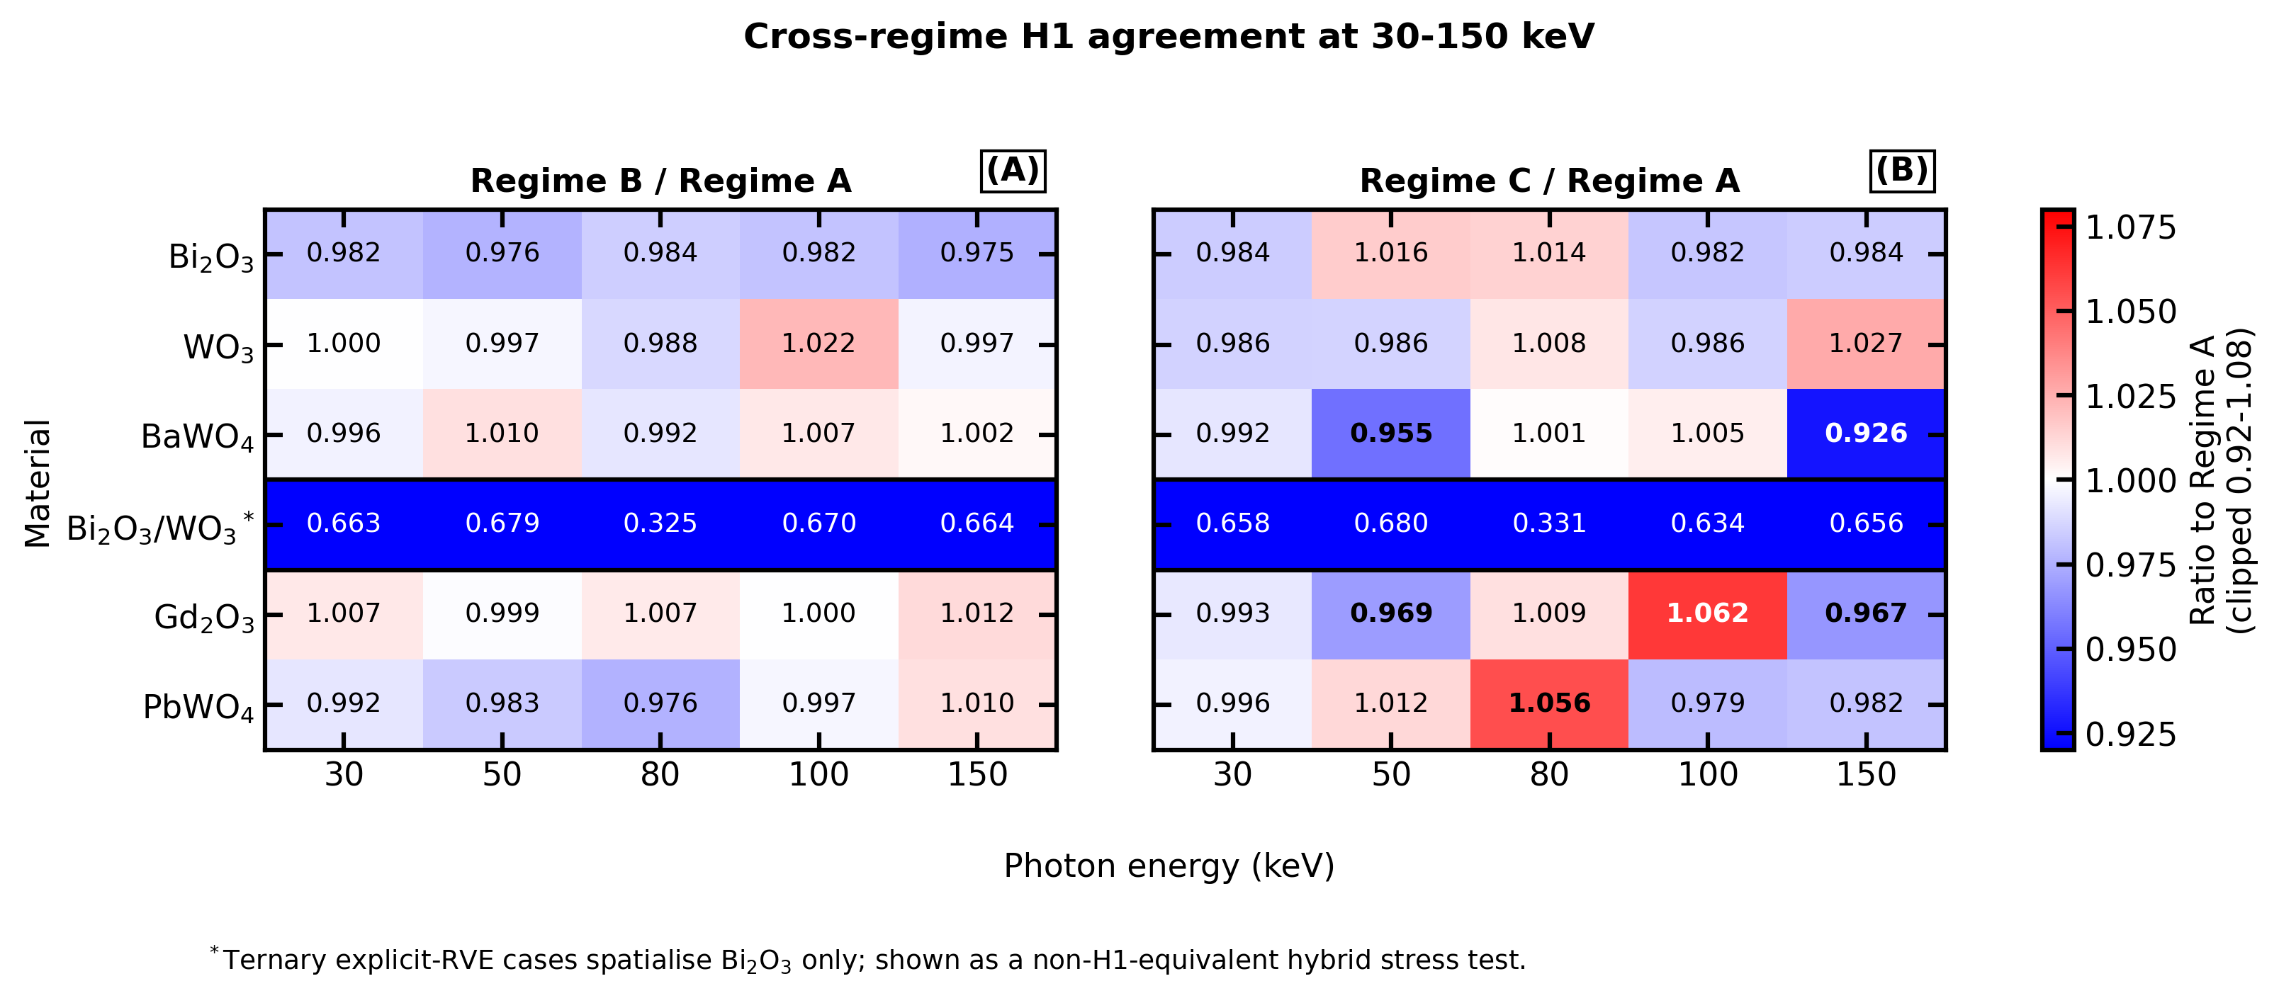
Figure 3. Cross-regime H1 ratio heatmaps at 30–150 keV. Panel A shows Regime B / Regime A ratios for the 1 µm G4PVParameterised RVE. Panel B shows Regime C / Regime A ratios for the 250 nm G4MultiUnion RVE. The ternary row is boxed and marked as a hybrid non-H1-equivalent stress test because only Bi₂O₃ is spatialised in the explicit geometry.
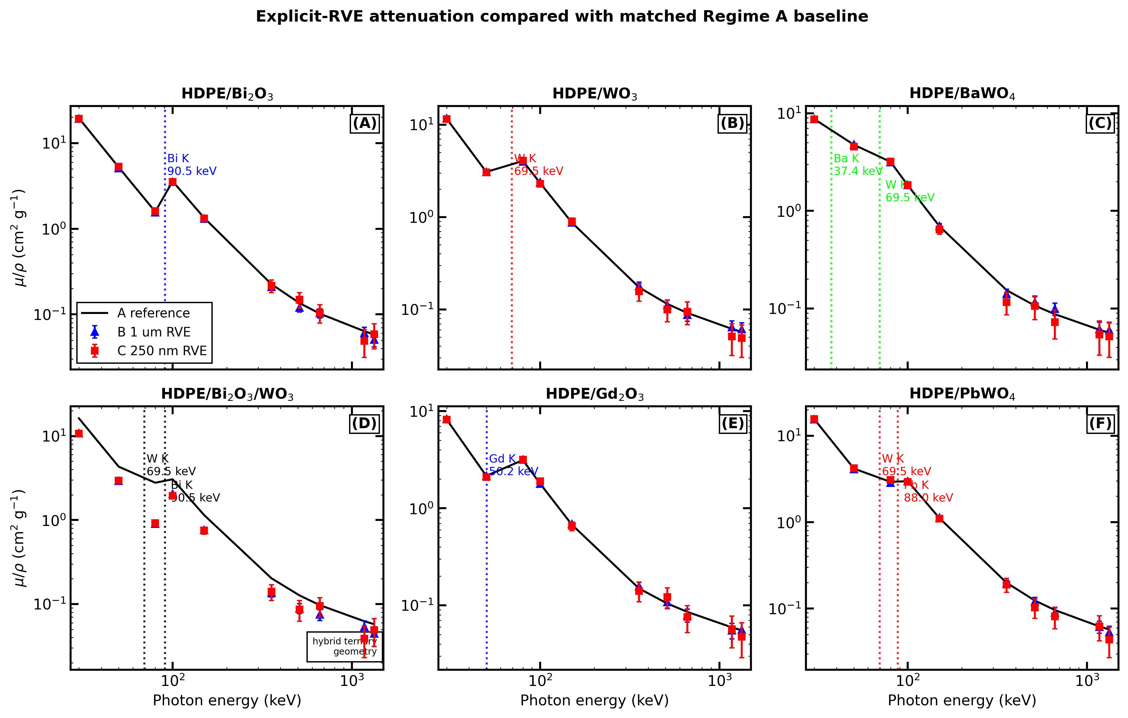
Figure 4. Explicit-RVE attenuation curves against the matched Regime-A baseline. Black curves are Regime A; blue triangles are Regime B; red squares are Regime C. The five binary systems show close agreement in the 30–150 keV H1 window, while high-energy explicit-RVE points broaden because the attenuated counts are small. The ternary panel is labelled as a hybrid explicit geometry.

5.4 Material-specific K-edge findings
HDPE/Bi₂O₃. The Bi K-edge at 90.526 keV is captured by the rise from 1.581 cm² g⁻¹ at 80 keV to 3.578 cm² g⁻¹ at 100 keV in Regime A. Regime B resolves the same trend, with μ/ρ increasing from 1.557 to 3.512 cm² g⁻¹.
HDPE/WO₃. The W K-edge at 69.525 keV produces the anti-intuitive increase from 3.080 cm² g⁻¹ at 50 keV to 4.045 cm² g⁻¹ at 80 keV, despite the normal $E^{−3}$ photoelectric falloff. Regime B and C preserve this feature.
HDPE/BaWO₄. BaWO₄ combines a Ba K-edge at 37.441 keV and a W K-edge at 69.525 keV. The 30–50 keV interval crosses the Ba K-edge but remains dominated by the large low-energy photoelectric decrease. The 50–80 keV interval crosses the W K-edge, partially offsetting the expected falloff.
HDPE/Bi₂O₃/WO₃ ternary. The Regime-A ternary mixture passes XCOM and shows additive dual-edge behaviour: the W-containing composition shapes the 50–80 keV interval, and the Bi K-edge produces a 9.9% μ/ρ increase from 80 to 100 keV. The explicit-RVE ternary implementation does not reproduce the full ternary attenuation because it spatialises only Bi₂O₃, making it a useful cautionary case rather than a validated H1 result.
HDPE/Gd₂O₃. The Gd K-edge lies at 50.239 keV, almost coincident with the 50 keV grid point. The 2.933% maximum XCOM deviation at 50 keV is therefore physically unsurprising and remains within the 5% gate. The K-edge opening is confirmed by the 45.7% μ/ρ increase from 50 to 80 keV.
HDPE/PbWO₄. PbWO₄ combines the W K-edge at 69.525 keV and Pb K-edge at 88.005 keV. The Pb K-edge is visible as a modest rise from 2.928 cm² g⁻¹ at 80 keV to 2.979 cm² g⁻¹ at 100 keV. Regime B preserves the same direction, with 2.857 to 2.970 cm² g⁻¹.

5.5 Legacy 30 wt% Bi₂O₃ validation
The v08 30 wt% HDPE/Bi₂O₃ Regime-A validation case is retained as a separate calibration run. It achieved mean |Δ|=0.549% and max |Δ|=2.013% against XCOM over 30 keV–1.332 MeV. Because its supplied density is not the volume-rule density for 30 wt% Bi₂O₃, it is not used in the cross-regime H1 comparisons.

6. Discussion

6.1 Claim hierarchy
The benchmark supports a narrow but useful conclusion: for macroscopic narrow-beam photon attenuation, a composition-correct homogeneous Geant4 material is sufficient for the HDPE/high-Z nanocomposites tested here. This conclusion rests on three evidence layers. First, all six Regime-A materials pass XCOM acceptance with sub-1% mean deviations and <3% maximum deviations (Figure 1 and Table 1). Second, the K-edge structure expected from Ba, Gd, W, Pb, and Bi is preserved without material-specific tuning (Figure 2 and Table 2). Third, the five composition-equivalent binary Regime-B RVEs agree with Regime A within the ±3% H1 gate at every 30–150 keV point (Table 3 and Figure 3A).
This claim does not say that nanoscale geometry is irrelevant for every observable. It says that the particle coordinates do not measurably change bulk μ/ρ in the tested μr ≪ 1 regime when density, composition, source, physics list, and scoring are fixed.

6.2 Relationship to current shielding practice
Recent radiation-shielding papers commonly combine experimental material preparation with Geant4, XCOM, Phys-X/PSD, EpiXS, or MCNP-style attenuation comparisons [12–17]. That literature establishes the shielding merit of specific heavy-oxide nanocomposites, glasses, and polymer fillers. The present work is complementary: it does not propose a new best absorber, but tests a modelling assumption that those workflows often rely on implicitly. By holding the material composition constant and changing only the geometric representation, the campaign separates material performance from geometry-regime validity.
The result explains why many homogeneous-mixture simulations agree well with reference attenuation tools even when the experimental material is called a nanocomposite. For transmission through millimetre- to centimetre-scale shields, XCOM and homogeneous Geant4 respond primarily to elemental composition and density. Explicit nanoparticles become scientifically necessary when the observable is local, phase-resolved, or interface-sensitive rather than a bulk attenuation coefficient.

6.3 Practical modelling workflow
The most defensible workflow is therefore tiered. Regime A should be the production model for routine macroscopic shielding calculations because it is fast, directly benchmarkable against XCOM, and avoids unnecessary geometry overhead. Regime B should be used when an explicit RVE is needed to validate homogenisation, quantify phase-specific scoring, or prepare future local-dose studies; G4PVParameterised remains scalable for O(10³) spheres. Regime C should be treated as a small-RVE feasibility and geometry-construction check, not the primary validation model, because G4MultiUnion voxelisation becomes memory-limited as particle count increases.
Figure 5 condenses this recommendation into a modelling decision workflow. The figure is included as a conceptual synthesis of the benchmark rather than as an additional simulation endpoint: it maps each geometry regime to its defensible use, evidence level, and interpretation limit.
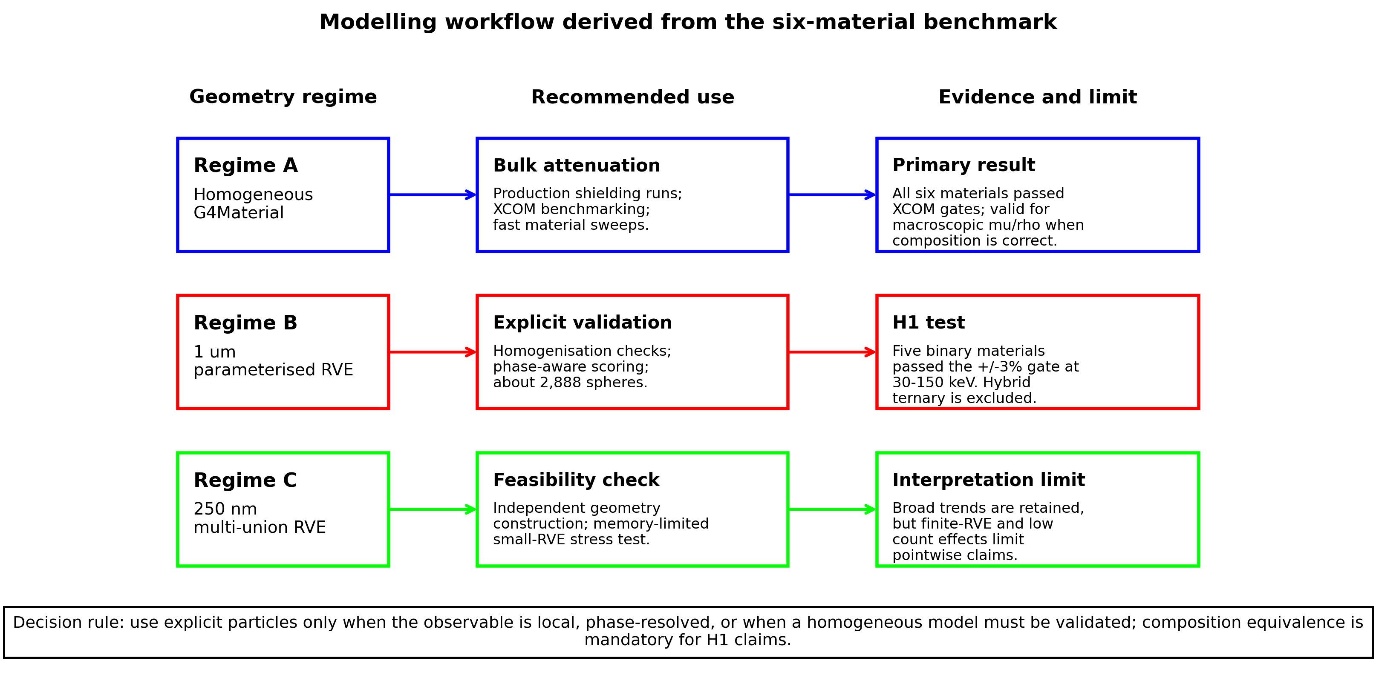
Figure 5. Modelling workflow derived from the six-material benchmark. Regime A is the recommended production path for macroscopic bulk attenuation and XCOM benchmarking. Regime B is the explicit-particle validation path for composition-equivalent RVEs and future phase-aware scoring. Regime C is retained as a memory-limited feasibility check. The decision rule emphasizes that explicit geometry is necessary only for local or phase-resolved observables, or when a homogeneous model must be validated; composition equivalence is mandatory for H1 claims.
The Regime-C results are useful in that context. They preserve the broad attenuation trends but show larger pointwise fluctuations for BaWO₄, Gd₂O₃, and PbWO₄ (Table 4 and Figure 3B). Figure 4 shows why these deviations should be interpreted cautiously: in the 250 nm geometry, high-energy attenuation events fall to O(10–100), so counting uncertainty and finite-RVE sampling can dominate pointwise ratios.

6.4 Ternary negative-control lesson
The ternary case defines the boundary of the conclusion. Regime A correctly represents HDPE/Bi₂O₃/WO₃ as a full effective medium and passes XCOM, but the explicit ternary RVEs spatialise Bi₂O₃ only. Their B/A and C/A ratios are therefore not failures of the effective-medium approximation; they are failures of composition equivalence. The large deficit near 80 keV is exactly what should occur when the W-bearing phase contributes to the reference μ/ρ but is absent from the explicit particles.
This negative control is important because it prevents an attractive but wrong generalisation. A multi-filler explicit RVE can validate a multi-filler effective medium only if every attenuation-relevant phase is represented consistently, or if any effective background replacement is independently justified. Hybrid geometries are useful for debugging and stress testing, but not for H1 pass/fail claims about the full ternary material.

6.5 Implications for future work
The next scientific step is not another bulk attenuation sweep with more fillers; the current evidence already shows the expected composition-governed behaviour for this class of observable. The higher-value extension is phase-resolved scoring: local radial dose, interfacial energy deposition, secondary electron production, and particle-size or clustering effects. Those are the observables for which explicit nanoscale geometry may become physically decisive. A composition-equivalent dual-filler ternary RVE is also required before any strong statement can be made about multi-filler explicit geometry beyond the negative-control result reported here.

7. Conclusions
This work tested whether explicit nanoparticle geometry changes macroscopic photon attenuation in HDPE/high-Z shielding nanocomposites when composition, density, physics list, source, and scoring are fixed.
Effective-medium Geant4 is quantitatively valid for the tested bulk attenuation problem: all six Regime-A materials pass XCOM with mean absolute deviations of 0.339–0.793% and maximum deviations of 0.967–2.933%. The main H1 result also holds for composition-equivalent binary explicit RVEs, because HDPE/Bi₂O₃, HDPE/WO₃, HDPE/BaWO₄, HDPE/Gd₂O₃, and HDPE/PbWO₄ all agree with matched Regime-A baselines within ±3% at 30–150 keV using the 1 µm G4PVParameterised RVE.
The benchmark reproduces Bi, W, Ba/W, Gd, and Pb/W K-edge behaviour without material-specific tuning, supporting the robustness of the Geant4/XCOM comparison for these fillers. G4MultiUnion remains useful as an independent geometry path, but the 250 nm multi-union cases are better interpreted as small-RVE feasibility checks because they show larger finite-RVE and counting fluctuations than the 1 µm parameterised geometry. The ternary explicit-RVE case defines the negative-control validity boundary: a full HDPE/Bi₂O₃/WO₃ effective medium can pass XCOM, but an explicit RVE that spatialises only Bi₂O₃ is not composition-equivalent and cannot validate the full ternary material.
The recommended workflow is Regime A for production macroscopic shielding, Regime B for explicit-particle validation or phase-aware scoring, and Regime C for small-RVE feasibility checks. Multi-filler explicit RVEs must enforce composition equivalence before any H1 validation claim is made.

8. Limitations and Validity Scope
Several limitations define the validity scope. The manuscript evaluates transmitted fluence and μ/ρ only; interface dose-enhancement factors and radial dose profiles require phase-resolved scoring and are deferred to the H2 study. The ternary Regime-B and Regime-C runs spatialise Bi₂O₃ only, so a future composition-equivalent ternary RVE must resolve both Bi₂O₃ and WO₃ phases or implement an explicitly validated effective background before any full multi-filler H1 claim is made.
The Regime-C geometry is also finite by construction. The 250 nm G4MultiUnion RVE is the largest practical configuration on the 8 GB workstation used here, and its 45-particle binary RVEs are sufficient for feasibility checks but not for high-precision convergence claims. The main benchmark is narrow-beam attenuation; broad-beam buildup observables were retained only for the legacy Bi₂O₃ validation case. Densities are volume-rule values or user-specified literature inputs, with no measured densities available for the simulated specimens. Neutron, electron, and charged-particle transport are outside the scope of this paper, and all explicit-RVE studies use 25 nm radius spheres without modelling particle-size distributions, clustering, aggregation, or imperfect dispersion.

9. Reproducibility, Code Availability, and Ethics
Software availability. ShieldLab G4 v1.1 (tag to be assigned upon paper submission) is released under the MIT licence. Source code is available at the repository root.
Data availability. Benchmark study JSON files, raw scorer outputs, derived CSV files, and figure-generation scripts for this paper are released in results/paper3/ under CC-BY 4.0.
Compute environment. The simulations used Geant4 11.4-beta-01 on WSL Ubuntu 22.04 and Python 3.11 on the Windows host through the d:\uv_envs virtual environment. The primary benchmark command was python -m shieldlab.analysis.nano_benchmark <study.json> --wsl-distro Ubuntu --geant4-setup /home/negm_/geant4-install/bin/geant4.sh --executable ./build/ShieldLabG4 --no-plots --build-dir .. Journal-ready PNG/PDF/SVG figures were generated with python scripts/generate_paper3_v10_figures.py and written to results/paper3/figures/v10/ with a manifest.
Ethics, funding, and competing interests. This study used no human participants, no animal data, and no clinical data. No external funding was received, and the author declares no conflict of interest.
AI-assisted writing disclosure. Portions of the manuscript were drafted with the assistance of GitHub Copilot in agent mode; all physics claims, results, citations, and code were independently verified by the author before submission, consistent with COPE 2023 guidance.

Appendix A. Regime-A XCOM Comparison Tables

A.1 HDPE/Bi₂O₃ φ=0.189
E (keV) | T | $(μ/ρ)_{\text{sim}}$ | $(μ/ρ)_{\text{XCOM}}$ | Δ (%)
30 | 0.649496 | 19.542 | 19.507 | +0.18
50 | 0.650992 | 5.218 | 5.236 | −0.35
80 | 0.656895 | 1.581 | 1.621 | −2.45
100 | 0.651467 | 3.578 | 3.596 | −0.52
150 | 0.650565 | 1.336 | 1.339 | −0.20
356 | 0.652574 | 0.2249 | 0.2270 | −0.92
511 | 0.651168 | 0.1353 | 0.1358 | −0.42
662 | 0.652160 | 0.1021 | 0.1029 | −0.77
1173 | 0.651123 | 0.06365 | 0.06391 | −0.40
1332 | 0.652863 | 0.05818 | 0.05878 | −1.02

A.2 HDPE/WO₃ φ=0.189
E (keV) | T | $(μ/ρ)_{\text{sim}}$ | $(μ/ρ)_{\text{XCOM}}$ | Δ (%)
30 | 0.649330 | 11.661 | 11.633 | +0.24
50 | 0.652710 | 3.080 | 3.110 | −0.97
80 | 0.649280 | 4.045 | 4.035 | +0.26
100 | 0.649630 | 2.328 | 2.325 | +0.13
150 | 0.649800 | 0.873 | 0.8725 | +0.07
356 | 0.652660 | 0.173 | 0.1746 | −0.95
511 | 0.650760 | 0.1146 | 0.1149 | −0.27
662 | 0.651250 | 0.09147 | 0.09188 | −0.45
1173 | 0.651100 | 0.06143 | 0.06167 | −0.39
1332 | 0.651500 | 0.05690 | 0.05720 | −0.53

A.3 HDPE/BaWO₄ φ=0.189
E (keV) | T | $(μ/ρ)_{\text{sim}}$ | $(μ/ρ)_{\text{XCOM}}$ | Δ (%)
30 | 0.651490 | 8.730 | 8.777 | −0.532
50 | 0.650337 | 4.754 | 4.760 | −0.120
80 | 0.649338 | 3.183 | 3.175 | +0.237
100 | 0.649725 | 1.827 | 1.826 | +0.098
150 | 0.649401 | 0.697 | 0.695 | +0.214
356 | 0.652837 | 0.154 | 0.155 | −1.011
511 | 0.650650 | 0.107 | 0.107 | −0.232
662 | 0.651028 | 0.087 | 0.088 | −0.367
1173 | 0.650962 | 0.060 | 0.061 | −0.344
1332 | 0.650663 | 0.056 | 0.056 | −0.237

A.4 HDPE/Bi₂O₃/WO₃ ternary
E (keV) | T | $(μ/ρ)_{\text{sim}}$ | $(μ/ρ)_{\text{XCOM}}$ | Δ (%)
30 | 0.649456 | 16.247 | 16.215 | +0.194
50 | 0.651407 | 4.322 | 4.343 | −0.502
80 | 0.651996 | 2.781 | 2.801 | −0.712
100 | 0.651373 | 3.057 | 3.072 | −0.490
150 | 0.650220 | 1.144 | 1.145 | −0.078
356 | 0.652769 | 0.203 | 0.205 | −0.987
511 | 0.650295 | 0.127 | 0.127 | −0.105
662 | 0.652484 | 0.097 | 0.098 | −0.886
1173 | 0.651227 | 0.062 | 0.063 | −0.438
1332 | 0.651655 | 0.058 | 0.058 | −0.591

A.5 HDPE/Gd₂O₃ φ=0.189
E (keV) | T | $(μ/ρ)_{\text{sim}}$ | $(μ/ρ)_{\text{XCOM}}$ | Δ (%)
30 | 0.651514 | 8.251 | 8.296 | −0.540
50 | 0.658265 | 2.152 | 2.217 | −2.933
80 | 0.651055 | 3.135 | 3.147 | −0.377
100 | 0.650146 | 1.786 | 1.787 | −0.052
150 | 0.647455 | 0.679 | 0.673 | +0.911
356 | 0.653293 | 0.149 | 0.151 | −1.173
511 | 0.650264 | 0.104 | 0.105 | −0.094
662 | 0.651093 | 0.086 | 0.086 | −0.390
1173 | 0.652051 | 0.059 | 0.060 | −0.731
1332 | 0.652036 | 0.055 | 0.056 | −0.726

A.6 HDPE/PbWO₄ φ=0.189
E (keV) | T | $(μ/ρ)_{\text{sim}}$ | $(μ/ρ)_{\text{XCOM}}$ | Δ (%)
30 | 0.650187 | 15.629 | 15.639 | −0.067
50 | 0.651081 | 4.165 | 4.181 | −0.386
80 | 0.651959 | 2.928 | 2.948 | −0.699
100 | 0.650701 | 2.979 | 2.986 | −0.250
150 | 0.649516 | 1.115 | 1.113 | +0.173
356 | 0.652840 | 0.199 | 0.201 | −1.012
511 | 0.651781 | 0.124 | 0.125 | −0.635
662 | 0.652389 | 0.096 | 0.097 | −0.852
1173 | 0.651323 | 0.062 | 0.062 | −0.472
1332 | 0.651589 | 0.057 | 0.058 | −0.567

Appendix B. Regime-B Explicit-RVE Numerical Results
Each table reports the 1 µm G4PVParameterised RVE result with ${10}^{7}$ histories per energy.

B.1 HDPE/Bi₂O₃
E (keV) | T | $(μ/ρ)_{\text{sim}}$ | $N_{\text{att}}$
30 | 0.995310 | 19.190 | 46,899
50 | 0.998753 | 5.095 | 12,475
80 | 0.999619 | 1.557 | 3,813
100 | 0.999140 | 3.512 | 8,601
150 | 0.999681 | 1.303 | 3,193
356 | 0.999949 | 0.2098 | 514
511 | 0.999971 | 0.1200 | 294
662 | 0.999975 | 0.1033 | 253
1173 | 0.999985 | 0.0608 | 149
1332 | 0.999988 | 0.0506 | 124

B.2 HDPE/WO₃
E (keV) | T | $(μ/ρ)_{\text{sim}}$ | $N_{\text{att}}$
30 | 0.997526 | 11.660 | 24,740
50 | 0.999348 | 3.071 | 6,520
80 | 0.999152 | 3.996 | 8,480
100 | 0.999494 | 2.381 | 5,060
150 | 0.999815 | 0.870 | 1,850
356 | 0.999962 | 0.179 | 381
511 | 0.999976 | 0.112 | 237
662 | 0.999981 | 0.087 | 185
1173 | 0.999986 | 0.064 | 136
1332 | 0.999987 | 0.061 | 130

B.3 HDPE/BaWO₄
E (keV) | T | $(μ/ρ)_{\text{sim}}$ | $N_{\text{att}}$
30 | 0.998325 | 8.697 | 16,750
50 | 0.999076 | 4.800 | 9,240
80 | 0.999392 | 3.157 | 6,080
100 | 0.999645 | 1.841 | 3,550
150 | 0.999865 | 0.699 | 1,350
356 | 0.999973 | 0.141 | 271
511 | 0.999978 | 0.116 | 224
662 | 0.999981 | 0.099 | 191
1173 | 0.999988 | 0.061 | 118
1332 | 0.999988 | 0.060 | 116

B.4 HDPE/Bi₂O₃/WO₃ ternary
E (keV) | T | $(μ/ρ)_{\text{sim}}$ | $N_{\text{att}}$
30 | 0.997455 | 10.769 | 25,477
50 | 0.999306 | 2.936 | 6,942
80 | 0.999786 | 0.904 | 2,140
100 | 0.999516 | 2.047 | 4,843
150 | 0.999820 | 0.760 | 1,797
356 | 0.999968 | 0.136 | 322
511 | 0.999979 | 0.089 | 210
662 | 0.999982 | 0.075 | 177
1173 | 0.999987 | 0.054 | 127
1332 | 0.999989 | 0.044 | 105

B.5 HDPE/Gd₂O₃
E (keV) | T | $(μ/ρ)_{\text{sim}}$ | $N_{\text{att}}$
30 | 0.998250 | 8.312 | 17,513
50 | 0.999547 | 2.150 | 4,531
80 | 0.999335 | 3.157 | 6,651
100 | 0.999624 | 1.785 | 3,761
150 | 0.999855 | 0.687 | 1,447
356 | 0.999967 | 0.157 | 330
511 | 0.999977 | 0.108 | 227
662 | 0.999983 | 0.079 | 167
1173 | 0.999988 | 0.055 | 116
1332 | 0.999988 | 0.056 | 118

B.6 HDPE/PbWO₄
E (keV) | T | $(μ/ρ)_{\text{sim}}$ | $N_{\text{att}}$
30 | 0.996333 | 15.507 | 36,735
50 | 0.999030 | 4.096 | 9,704
80 | 0.999323 | 2.857 | 6,768
100 | 0.999297 | 2.970 | 7,036
150 | 0.999733 | 1.126 | 2,666
356 | 0.999954 | 0.196 | 464
511 | 0.999971 | 0.121 | 286
662 | 0.999979 | 0.090 | 213
1173 | 0.999985 | 0.062 | 146
1332 | 0.999987 | 0.053 | 126

Appendix C. Regime-C Multi-Union Numerical Results
Each table reports the 250 nm G4MultiUnion RVE result with ${10}^{7}$ histories per energy.

C.1 HDPE/Bi₂O₃
E (keV) | T | $(μ/ρ)_{\text{sim}}$ | $N_{\text{att}}$
30 | 0.998822 | 19.230 | 11,780
50 | 0.999675 | 5.301 | 3,250
80 | 0.999902 | 1.604 | 980
100 | 0.999785 | 3.514 | 2,150
150 | 0.999919 | 1.315 | 810
356 | 0.999987 | 0.2153 | 130
511 | 0.999991 | 0.1485 | 90
662 | 0.999994 | 0.1044 | 60
1173 | 0.999997 | 0.0489 | 30
1332 | 0.999996 | 0.0587 | 40

C.2 HDPE/WO₃
E (keV) | T | $(μ/ρ)_{\text{sim}}$ | $N_{\text{att}}$
30 | 0.999390 | 11.497 | 6,100
50 | 0.999839 | 3.038 | 1,610
80 | 0.999784 | 4.078 | 2,160
100 | 0.999878 | 2.296 | 1,220
150 | 0.999952 | 0.896 | 480
356 | 0.999992 | 0.156 | 80
511 | 0.999995 | 0.100 | 50
662 | 0.999995 | 0.094 | 50
1173 | 0.999997 | 0.051 | 30
1332 | 0.999997 | 0.049 | 30

C.3 HDPE/BaWO₄
E (keV) | T | $(μ/ρ)_{\text{sim}}$ | $N_{\text{att}}$
30 | 0.999583 | 8.660 | 4,170
50 | 0.999781 | 4.542 | 2,190
80 | 0.999846 | 3.187 | 1,540
100 | 0.999911 | 1.837 | 890
150 | 0.999969 | 0.646 | 310
356 | 0.999994 | 0.116 | 60
511 | 0.999995 | 0.106 | 50
662 | 0.999996 | 0.073 | 40
1173 | 0.999997 | 0.054 | 30
1332 | 0.999997 | 0.052 | 30

C.4 HDPE/Bi₂O₃/WO₃ ternary
E (keV) | T | $(μ/ρ)_{\text{sim}}$ | $N_{\text{att}}$
30 | 0.999368 | 10.695 | 6,320
50 | 0.999826 | 2.939 | 1,740
80 | 0.999946 | 0.920 | 540
100 | 0.999885 | 1.938 | 1,150
150 | 0.999956 | 0.751 | 440
356 | 0.999992 | 0.140 | 80
511 | 0.999995 | 0.086 | 50
662 | 0.999994 | 0.095 | 60
1173 | 0.999998 | 0.039 | 20
1332 | 0.999997 | 0.049 | 30

C.5 HDPE/Gd₂O₃
E (keV) | T | $(μ/ρ)_{\text{sim}}$ | $N_{\text{att}}$
30 | 0.999569 | 8.192 | 4,310
50 | 0.999890 | 2.086 | 1,100
80 | 0.999833 | 3.165 | 1,670
100 | 0.999900 | 1.897 | 1,000
150 | 0.999965 | 0.657 | 350
356 | 0.999993 | 0.140 | 70
511 | 0.999994 | 0.122 | 60
662 | 0.999996 | 0.076 | 40
1173 | 0.999997 | 0.057 | 30
1332 | 0.999997 | 0.047 | 30

C.6 HDPE/PbWO₄
E (keV) | T | $(μ/ρ)_{\text{sim}}$ | $N_{\text{att}}$
30 | 0.999078 | 15.570 | 9,220
50 | 0.999750 | 4.217 | 2,500
80 | 0.999817 | 3.090 | 1,830
100 | 0.999827 | 2.916 | 1,730
150 | 0.999935 | 1.094 | 650
356 | 0.999989 | 0.189 | 110
511 | 0.999994 | 0.103 | 60
662 | 0.999995 | 0.081 | 50
1173 | 0.999996 | 0.062 | 40
1332 | 0.999997 | 0.044 | 30

Appendix D. Study JSON and Result-Directory Provenance
The detailed provenance table uses repository-relative paths. Regime-A seeds are run seeds; Regime-B and Regime-C seeds are RVE seeds. The ternary explicit-RVE rows are marked as hybrid because they spatialise Bi₂O₃ only.
Table D1. Full artifact provenance for the six-material benchmark campaign.
Material | Regime | Study JSON | Result directory | Seed | Nominal explicit particles
HDPE/Bi₂O₃ | A | configs/studies/paper3_hdpe_bi2o3_regime_a_phi0p189.json | results/paper3/regime_a_hdpe_bi2o3_phi0p189 | 13579 | Not applicable
HDPE/Bi₂O₃ | B | configs/studies/paper3_hdpe_bi2o3_regime_b_rve.json | results/paper3/regime_b_hdpe_bi2o3 | 22222 | 2,888 Bi₂O₃ spheres
HDPE/Bi₂O₃ | C | configs/studies/paper3_hdpe_bi2o3_regime_c_250nm.json | results/paper3/regime_c_hdpe_bi2o3 | 33333 | 45 Bi₂O₃ spheres
HDPE/WO₃ | A | configs/studies/paper3_hdpe_wo3_regime_a_phi0p189.json | results/paper3/regime_a_hdpe_wo3_phi0p189 | 24680 | Not applicable
HDPE/WO₃ | B | configs/studies/paper3_hdpe_wo3_regime_b_rve.json | results/paper3/regime_b_hdpe_wo3 | 44444 | 2,888 WO₃ spheres
HDPE/WO₃ | C | configs/studies/paper3_hdpe_wo3_regime_c_250nm.json | results/paper3/regime_c_hdpe_wo3 | 55555 | 45 WO₃ spheres
HDPE/BaWO₄ | A | configs/studies/paper3_hdpe_bawo4_regime_a_phi0p189.json | results/paper3/regime_a_hdpe_bawo4_phi0p189 | 13579 | Not applicable
HDPE/BaWO₄ | B | configs/studies/paper3_hdpe_bawo4_regime_b_rve.json | results/paper3/regime_b_hdpe_bawo4 | 11111 | 2,888 BaWO₄ spheres
HDPE/BaWO₄ | C | configs/studies/paper3_hdpe_bawo4_regime_c_250nm.json | results/paper3/regime_c_hdpe_bawo4 | 66666 | 45 BaWO₄ spheres
HDPE/Bi₂O₃/WO₃ | A | configs/studies/paper3_hdpe_bi2o3_wo3_ternary_regime_a.json | results/paper3/regime_a_hdpe_bi2o3_wo3_ternary | 24681 | Not applicable
HDPE/Bi₂O₃/WO₃ | B | configs/studies/paper3_hdpe_bi2o3_wo3_ternary_regime_b_rve.json | results/paper3/regime_b_hdpe_bi2o3_wo3_ternary | 77777 | 1,528 Bi₂O₃ spheres only
HDPE/Bi₂O₃/WO₃ | C | configs/studies/paper3_hdpe_bi2o3_wo3_ternary_regime_c_250nm.json | results/paper3/regime_c_hdpe_bi2o3_wo3_ternary | 88888 | 24 Bi₂O₃ spheres only
HDPE/Gd₂O₃ | A | configs/studies/paper3_hdpe_gd2o3_regime_a_phi0p189.json | results/paper3/regime_a_hdpe_gd2o3_phi0p189 | 35791 | Not applicable
HDPE/Gd₂O₃ | B | configs/studies/paper3_hdpe_gd2o3_regime_b_rve.json | results/paper3/regime_b_hdpe_gd2o3 | 12345 | 2,888 Gd₂O₃ spheres
HDPE/Gd₂O₃ | C | configs/studies/paper3_hdpe_gd2o3_regime_c_250nm.json | results/paper3/regime_c_hdpe_gd2o3 | 98765 | 45 Gd₂O₃ spheres
HDPE/PbWO₄ | A | configs/studies/paper3_hdpe_pbwo4_regime_a_phi0p189.json | results/paper3/regime_a_hdpe_pbwo4_phi0p189 | 46802 | Not applicable
HDPE/PbWO₄ | B | configs/studies/paper3_hdpe_pbwo4_regime_b_rve.json | results/paper3/regime_b_hdpe_pbwo4 | 54321 | 2,888 PbWO₄ spheres
HDPE/PbWO₄ | C | configs/studies/paper3_hdpe_pbwo4_regime_c_250nm.json | results/paper3/regime_c_hdpe_pbwo4 | 67890 | 45 PbWO₄ spheres

10. References
- S. Agostinelli et al., “Geant4 — a simulation toolkit,” Nucl. Instrum. Methods Phys. Res. A 506, 250–303 (2003). DOI: 10.1016/S0168-9002(03)01368-8.
- J. Allison et al., “Geant4 developments and applications,” IEEE Trans. Nucl. Sci. 53, 270–278 (2006). DOI: 10.1109/TNS.2006.869826.
- J. Allison et al., “Recent developments in Geant4,” Nucl. Instrum. Methods Phys. Res. A 835, 186–225 (2016). DOI: 10.1016/j.nima.2016.06.125.
- J. H. Hubbell, “Photon mass attenuation and energy-absorption coefficients from 1 keV to 20 MeV,” Int. J. Appl. Radiat. Isot. 33, 1269–1290 (1982). DOI: 10.1016/0020-708X(82)90248-4.
- J. H. Hubbell, “Review of photon interaction cross-section data in the medical and biological context,” Phys. Med. Biol. 44, R1–R22 (1999). DOI: 10.1088/0031-9155/44/1/001.
- M. J. Berger, J. H. Hubbell, S. M. Seltzer, J. Chang, J. S. Coursey, R. Sukumar, D. S. Zucker, K. Olsen, XCOM: Photon Cross Section Database, NIST SRD 8 (XGAM), NIST, Gaithersburg MD. URL: https://physics.nist.gov/xcom.
- J. H. Hubbell and S. M. Seltzer, Tables of X-Ray Mass Attenuation Coefficients and Mass Energy-Absorption Coefficients from 1 keV to 20 MeV for Elements Z = 1–92 and 48 Additional Substances of Dosimetric Interest, NISTIR 5632 (1995).
- S. Incerti et al., “Comparison of Geant4 very low energy cross-section models with experimental data in water,” Med. Phys. 37, 4692–4708 (2010). DOI: 10.1118/1.3476457.
- S. Incerti et al., “The Geant4-DNA project,” Int. J. Model. Simul. Sci. Comput. 1, 157–178 (2010). DOI: 10.1142/S1793962310000122.
- H. N. Tran et al., “Geant4 Monte Carlo simulation of absorbed dose and radiolysis yields enhancement from a gold nanoparticle under MeV proton irradiation,” Nucl. Instrum. Methods Phys. Res. B 373, 126–139 (2016). DOI: 10.1016/j.nimb.2016.01.017.
- D. E. Cullen, J. H. Hubbell, and L. Kissel, EPDL97: The Evaluated Photon Data Library, ’97 Version, UCRL-50400 Vol. 6 Rev. 5, Lawrence Livermore National Laboratory (1997).
- H. H. Negm, R. M. El-Sharkawy, E. Abdeltwab, M. Mostafa, M. E. Mahmoud, and A. El-Taher, “Evaluation of shielding properties of a developed nanocomposite from intercalated attapulgite clay by Cd/Pb oxides nanoparticles,” Physica Scripta 99, 055956 (2024). DOI: 10.1088/1402-4896/ad3b48.
- H. H. Negm, E. A. Allam, E. Abdeltwab, M. Mostafa, M. E. Mahmoud, and A. El-Taher, “A new nanocomposite of copper oxide and magnetite intercalated into Attapulgite clay to enhance the radiation shielding,” Radiation Physics and Chemistry 216, 111398 (2024). DOI: 10.1016/j.radphyschem.2023.111398.
- I. Boukhris, I. Kebaili, M. S. Al-Buriahi, and M. I. Sayyed, “Radiation shielding properties of tellurite-lead-tungsten glasses against gamma and beta radiations,” Journal of Non-Crystalline Solids 551, 120430 (2021). DOI: 10.1016/j.jnoncrysol.2020.120430.
- E. Şakar, Ö. F. Özpolat, B. Alım, M. I. Sayyed, and M. Kurudirek, “Phy-X/PSD: Development of a user friendly online software for calculation of parameters relevant to radiation shielding and dosimetry,” Radiation Physics and Chemistry 166, 108496 (2020). DOI: 10.1016/j.radphyschem.2019.108496.
- F. C. Hila, A. Asuncion-Astronomo, C. A. M. Dingle, J. F. M. Jecong, A. M. V. Javier-Hila, M. B. Z. Gili, C. V. Balderas, G. E. P. Lopez, N. R. D. Guillermo, and A. V. Amoroso Jr., “EpiXS: A Windows-based program for photon attenuation, dosimetry and shielding based on EPICS2017 (ENDF/B-VIII) and EPDL97 (ENDF/B-VI.8),” Radiation Physics and Chemistry 182, 109331 (2021). DOI: 10.1016/j.radphyschem.2020.109331.
- S. H. Hosseini et al., “Experimental evaluation of gamma radiation shielding characteristics of Polyvinyl Alcohol/Tungsten oxide composite: a comparison study of micro and nano sizes of the fillers,” Nuclear Instruments and Methods in Physics Research A 1026, 166214 (2022). DOI: 10.1016/j.nima.2021.166214.

