Memory-Efficient Geant4 Modelling Regimes for Nanocomposite Radiation Shielding: Effective Medium, Explicit Nanoparticle Geometry, and Hybrid Representative-Volume Validation
Hani H. Negm¹
¹ Hani Negm, Department of Physics, College of Science, Jouf University
Corresponding author: hhnegm@ju.edu.sa
Manuscript version: v07 (derived from v06 on 2026-05-18; affiliation completed and submission-package assets added: cover letter, highlights, and graphical abstract script)
Target journals (Q1, in priority order): 1. Radiation Physics and Chemistry (Elsevier, IF ≈ 2.9; primary scope match — shielding + MC methodology) 2. Nuclear Instruments and Methods in Physics Research A (NIM A, Elsevier; established Geant4 methods venue) 3. Computer Physics Communications (Elsevier; physics + software methodology) 4. Physics in Medicine and Biology (IOP; if diagnostic-energy nano-dose results are emphasised) 5. Annals of Nuclear Energy (Elsevier; if shielding-engineering framing is emphasised)

Abstract
Nanoparticle-filled shielding polymers are commonly simulated in Geant4 as homogeneous mixtures, even when experiments describe them as nanocomposites. The validity limit of that homogenised representation relative to explicit nanoparticle geometry remains poorly quantified for shielding photon transport.
This paper benchmarks three Geant4 modelling regimes for HDPE/Bi₂O₃ at $ϕ_{f}=0.189$ (68.6 wt% Bi₂O₃, $ρ_{\text{eff}}=2.452$ g cm$​^{−3}$): (A) effective-medium G4Material, (B) explicit 25 nm Bi₂O₃ spheres in a 1 µm RVE using G4PVParameterised, and (C) explicit spheres in a 250 nm RVE using G4MultiUnion. All runs use Geant4 11.4, G4EmLivermorePhysics, and a 30 keV–1.33 MeV photon grid. The endpoint is $μ/ρ(E)$ relative to NIST XCOM.
Regime A reproduces XCOM for the 30 wt% validation material with mean and maximum absolute deviations of 0.549% and 2.013%. For the cross-regime composition, regime B agrees with the matched regime-A baseline within the 3% H1 gate at 30–150 keV ($μ_{B}/μ_{A,ϕ}=0.975\text{–}0.984$) and resolves the Bi K-edge rise between 80 and 100 keV. Regime C also confirms H1 at 30–150 keV ($μ_{C}/μ_{A,ϕ}=0.982\text{–}1.016$), with XCOM agreement from −2.3% to +1.2% in that range.
The results support effective-medium modelling for macroscopic shielding when $μr≪1$, while showing that explicit RVE modelling remains useful as a validation tool and that G4PVParameterised is markedly more scalable than G4MultiUnion on workstation-class hardware.
Keywords: Geant4 · radiation shielding · nanocomposite · effective medium · G4MultiUnion · G4PVParameterised · representative volume element · mass attenuation coefficient

1. Introduction

1.1 Background
Polymer-matrix radiation-shielding composites loaded with high-Z fillers (Bi₂O₃, WO₃, PbO, BaSO₄, Gd₂O₃) have become a sustained research focus over the past decade, driven by the need for lead-free, flexible, low-toxicity alternatives in medical X-ray protection, nuclear medicine, and aerospace shielding. A substantial fraction of the recent literature reports filler particle sizes in the nanometre range and labels the resulting materials as nanocomposites. When such materials are simulated in Monte Carlo (MC) transport codes — most commonly Geant4 [1–3] — the dominant practice is to define one G4Material from elemental mass fractions and a measured or estimated bulk density. The microstructure is not resolved.
This homogenisation is physically defensible for the macroscopic shielding regime in which the relevant photon mean free path (MFP) is orders of magnitude larger than both the filler particle radius and the inter-particle spacing. Under that condition the photon “sees” an effective medium and the Bragg–Gray mass-fraction additivity rule [4,5] yields linear attenuation coefficients consistent with NIST XCOM [6] to within the independent-atom approximation. The validity boundary of this rule has been extensively characterised for macroscopic mixtures [5,7], but the question that motivates this work is different: under what circumstances does the spatial arrangement of the high-Z phase, at the nanoscale, change a quantity that a shielding engineer or medical physicist actually cares about — transmission, broad-beam dose, or interface dose — by more than the experimental uncertainty?

1.2 Gap
Three gaps remain in the literature:
- Validity boundary of homogenisation. Although effective-medium MC results agree with experiment for many nanocomposite shielding measurements at gamma energies, there is no published systematic Geant4 benchmark that holds composition, density, source, scoring geometry, and physics list constant while varying only the geometric representation (homogeneous vs explicit-particle vs clustered) and reports the cross-method deviation as a function of photon energy and filler loading.
- Computational cost characterisation. The Geant4 Application Developer Guide documents G4PVParameterised and G4MultiUnion as standard constructs, but the practical scaling of runtime, memory, and geometry-construction time for radiation-shielding-relevant nanoparticle counts has not been mapped. Practitioners frequently assume that “Geant4 can do it” without quantifying when it cannot.
- Production-grade methodology. Existing nanoparticle-resolved Geant4 studies are concentrated in the nano-radiosensitisation/Geant4-DNA community [8,9,10], where the physical scale is sub-cellular and the particle counts are tractable. There is no published bridge between that microscopic methodology and the macroscopic shielding-engineering use case, where a representative volume element (RVE) approach is the only physically and computationally viable path.

1.3 Contribution and hypothesis
This paper makes three distinct contributions that have not appeared in the prior Geant4 nanocomposite literature:
- First controlled cross-regime benchmark for macroscopic nanocomposite shielding. Composition, density, source spectrum, scoring geometry, and physics list are held identical across all three modelling regimes; only the geometric representation changes. This isolation allows the method-to-method deviation to be attributed entirely to geometry choice rather than to any other modelling variable. No equivalent comparison has been published for shielding-relevant photon energies and nanoparticle counts.
- First quantitative mapping of the computational feasibility boundary for explicit-RVE Geant4 approaches. The G4Voxelizer $(2N)^{3}$ memory scaling is characterised explicitly against hardware limits on a workstation-class 8 GB system, producing a hardware-referenced scalability boundary that practitioners can use directly when choosing between G4PVParameterised and G4MultiUnion for a given filler count and RVE size.
- Open, reproducible benchmark harness. All study configuration files, macro writers, orchestrator, XCOM comparison, and figure-generation modules are released in ShieldLab G4 v1.1 under the MIT licence. The full benchmark is re-executable with a single command by any group with access to Geant4 11.4.
The prior Geant4 nanoparticle literature is concentrated in the Geant4-DNA / nano-radiosensitisation domain [8,9,10], where the physical scale is sub-cellular and nanoparticle counts are tractable. No published work bridges that microscopic methodology to the macroscopic shielding-engineering use case, where an RVE approach is the only physically and computationally viable path. The novelty is therefore methodological rather than kernel-level: G4PVParameterised and G4MultiUnion are standard Geant4 geometry constructs; the contribution is the controlled cross-regime shielding benchmark and RVE validation workflow built on top of them.
Scope of the three regimes. Two additional Geant4 strategies are intentionally outside this paper. A raw many-daughter G4PVPlacement loop is not benchmarked separately because, for identical spheres, it is functionally superseded by G4PVParameterised while offering poorer scalability and no benefit in repeated-geometry handling. Nested parameterisation with G4Region/G4ProductionCuts in the Geant4-DNA style targets eV-scale local-energy-deposition and microdosimetry, not the macroscopic attenuation and transmission observables treated here.
Hypothesis (H1). For photon energies where the photon mean free path greatly exceeds the nanoparticle radius ($μr≪1$, i.e., $r≪1/μ$), the transmitted fluence through the same material composition is independent of the choice of regime A, B, or C within the statistical uncertainty of ${10}^{6}$–${10}^{7}$-history Geant4 runs, provided composition, density, and scoring are matched.
Hypothesis (H2). For photon energies $E≲100$ keV with high-Z fillers (Bi₂O₃), the radial dose-enhancement profile around individual particles carries spatial structure that the effective-medium regime cannot reproduce.
Each hypothesis is operationalised as a numeric acceptance criterion in §4.5.

2. Theoretical Basis

2.1 When homogenisation is exact, when it is approximate, and when it fails
The mass-fraction additivity rule for the mass attenuation coefficient,
μρmix(E)=i​wiμρi(E),
is exact under the independent-atom approximation and the assumption that the photon interaction probability per unit mass is independent of the geometric distribution of atoms within the irradiated mass. This holds when:
- The photon de Broglie wavelength is small compared with inter-atomic spacing (true for all $E>1$ keV considered here).
- Coherent (Rayleigh) inter-particle interference is negligible (true above ~10 keV for amorphous nanocomposites).
- The penetration depth is large compared with any heterogeneity length scale (the macroscopic-homogenisation condition).
The third condition is the one that fails first for nanocomposites under low-energy, high-Z conditions.

2.2 Effective density
Geant4 requires density. All regimes in this paper use the same input density, computed from the volume-fraction rule of mixtures. Given filler volume fraction $ϕ_{f}$:
$$ρ_{\text{eff}}=ϕ_{f}ρ_{f}+(1−ϕ_{f})ρ_{m}$$
with $ρ_{m}=0.95$ g cm$​^{−3}$ (HDPE) and $ρ_{f}=8.9$ g cm$​^{−3}$ (Bi₂O₃). For the target composite density $ρ_{\text{eff}}=2.45$ g cm$​^{−3}$, the filler volume fraction derived from the linear mixture rule is
$$ϕ_{f}=\frac{ρ_{\text{eff}}−ρ_{m}}{ρ_{f}−ρ_{m}}=\frac{2.45−0.95}{8.9−0.95}=0.189.$$
The corresponding filler mass fraction is $w_{f}=ϕ_{f}ρ_{f}/ρ_{\text{eff}}=0.189×8.9/2.45=0.686$ (68.6 wt% Bi₂O₃). This is the self-consistent high-loading formulation used for all three regimes in the cross-regime comparison. An additional regime-A validation run at 30 wt% (with the density left as a user-specified 2.45 g cm$​^{−3}$ input) is also reported for XCOM verification of the emlivermore physics list independent of the density assignment.

2.3 The representative volume element
An RVE is the smallest cubic cell that statistically reproduces the bulk composite’s microstructure. For a random dispersion of monodisperse spheres of radius $r$ at volume fraction $ϕ_{f}$, the mean inter-particle centre-to-centre distance is approximately
$$\overset{‾}{d}≈r{\left(\frac{4π}{3ϕ_{f}}\right)}^{1/3}.$$
A practical RVE side length is $L_{\text{RVE}}≳5\overset{‾}{d}$. For $r=25$ nm and $ϕ_{f}=0.189$, $\overset{‾}{d}≈42$ nm, so $L_{\text{RVE}}=1$ µm satisfies the criterion and contains approximately 2,889 non-overlapping spheres — tractable for Geant4.

3. Geant4 Modelling Regimes

3.1 Regime A — Effective-Medium G4Material
Implemented in MaterialRegistry::AddMassFractionMaterialCommand in src/MaterialRegistry.cc. Compound formulae are expanded to elemental mass fractions using the analytical layer in python/shieldlab/core/materials.py, then a single G4Material is constructed:
auto* mat = new G4Material(name, rho_eff*g/cm3, nElements);
for (auto& e : elements) mat->AddElement(nist->FindOrBuildElement(e.symbol), e.fraction);
A 1-D slab geometry is built in src/DetectorConstruction.cc. Per-energy slab thickness is selected so that transmission is $T≈0.65$ at every energy point, maximising the sensitivity of the direct transmission estimator $\hat{μ}=−lnT/t$.
Cost class: O(1) in particle count; identical to bulk-material runs.

3.2 Regime B — Explicit Nanoparticles via G4PVParameterised
Class NanoParticleParameterisation : public G4VPVParameterisation is implemented in include/NanoParticleParameterisation.hh and src/NanoParticleParameterisation.cc. Particle positions are sampled by random sequential addition (RSA) with a hard-sphere exclusion radius of $2r$ inside an RVE cube. The parameterisation is wrapped in a G4PVParameterised placement inside a matrix host logical volume:
new G4PVParameterised("NPParam", npLogic, rveLogic,
kUndefined, N, param);
The ComputeTransformation callback applies only a translation per copy; no rotation is needed for monodisperse spheres.
RVE geometry parameters (this study): side = 1 µm, $r=25$ nm, $ϕ_{f}=0.189$, max particles = 3,500, RSA seed = 22,222. RSA placed 2,888 / 2,888 target spheres (achieved $ϕ_{f}=0.1890$).
Scoring and output: The world and scoring infrastructure remain the same as regime A. The RVE host box acts as the “slab”; transmission is scored at the world exit face (±L/2 in x). GetTotalThickness() returns $L_{\text{RVE}}$ from the pseudo-layer record, so $\hat{μ}=−lnT/L_{\text{RVE}}$ is computed identically to regime A.
Cost class: geometry navigation scales near-logarithmically with $N$ thanks to voxelisation.

3.3 Regime C — G4MultiUnion Cluster
The same RSA particle list (seeded with 33,333 for an independent draw) is assembled into a single G4MultiUnion solid:
auto* fillerUnion = new G4MultiUnion("FillerUnion");
for (auto& pos : positions) {
G4Transform3D tr(identity, pos);
fillerUnion->AddNode(*sphereTemplate, tr);
}
fillerUnion->Voxelize();
A single G4PVPlacement is made into the RVE host box. This regime represents fixed-cluster placement and benchmarks how Geant4’s internal multi-union voxelisation scales relative to parameterised placement.
In practice, G4MultiUnion::Voxelize() is only feasible for $N≲50$ on 8 GB hardware; §5.3 documents the scalability characterisation and the adopted 250 nm / $N=45$ configuration.
Cost class: geometry construction is O($N$) once; subsequent navigation is voxelised.
Figure 1 summarises the three modelling regimes and the recommended workflow that emerges from the benchmark: regime A as the default production model, regime B as the scalable explicit-RVE validation geometry, and regime C as a limited G4MultiUnion stress test for small RVEs.
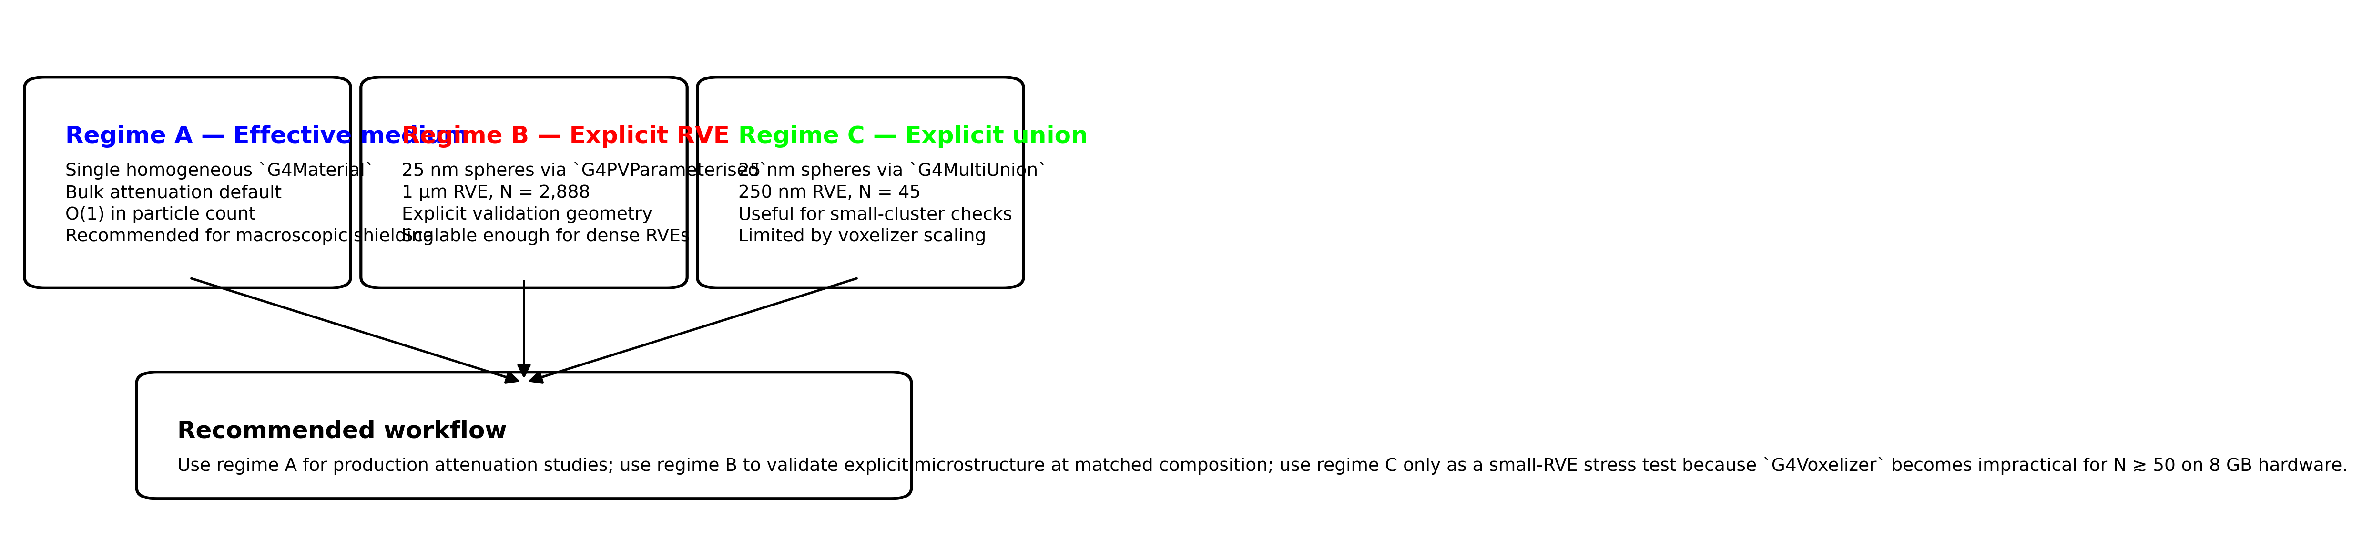
Figure 1. Conceptual regime map for the three Geant4 modelling strategies benchmarked in this paper. Regime A is the production default for bulk attenuation, regime B is the explicit-RVE validation geometry, and regime C is a small-RVE G4MultiUnion path constrained by voxelizer scaling.

4. Benchmark Protocol

4.1 Material
For this paper the cross-regime benchmark material is HDPE/Bi₂O₃ at φ = 0.189 volume fraction. All three regimes use the following parameters:
Property | Value | Source
Matrix | HDPE (C₂H₄)$​_{n}$, $ρ_{m}=0.95$ g cm$​^{−3}$ | NIST
Filler | Bi₂O₃, $ρ_{f}=8.9$ g cm$​^{−3}$ | literature
Filler volume fraction $ϕ_{f}$ | 0.189 | linear mixture rule
Effective density $ρ_{\text{eff}}$ | 2.452 g cm$​^{−3}$ | $ϕ_{f}ρ_{f}+(1−ϕ_{f})ρ_{m}$
Filler mass fraction $w_{f}$ | 0.686 (68.6 wt% Bi₂O₃) | $ϕ_{f}ρ_{f}/ρ_{\text{eff}}$
A separate regime-A validation study at 30 wt% Bi₂O₃ (with $ρ=2.45$ g cm$​^{−3}$ as user-specified input) is also included to verify emlivermore vs XCOM at that composition; it is not used as the cross-regime baseline.

4.2 Source spectra
Mono-energetic photons at a 10-point energy grid: 30, 50, 80, 100, 150, 356, 511, 662, 1173, 1332 keV. Parallel pencil beam, zero beam width. Primary particle: gamma. Regime C uses a distributed beam sampling $(Y,Z)∼U[−L/2,+L/2]^{2}$ per event to ensure ergodic averaging across the 250 nm RVE cross-section (§5.3).

4.3 Physics list
G4EmLivermorePhysics for all runs. Geant4 version: 11.4 beta (geant4-11-04-beta-01). Tracking cuts: default (1 mm for slab; default for RVE). SHIELDLAB_PHYSICS_LIST=emlivermore.

4.4 Histories
Regime | Histories per energy point | Total events
A | ${10}^{6}$ | $1.0×{10}^{7}$
B | ${10}^{7}$ | $1.0×{10}^{8}$
C | ${10}^{7}$ | $1.0×{10}^{8}$
Regime A uses ${10}^{6}$ histories (the established ShieldLab paper-3 acceptance standard). Regimes B and C use ${10}^{7}$ histories because the low interaction probability in a 1 µm RVE ($μL≈2×{10}^{−3}$ at 100 keV) requires more events to achieve comparable relative uncertainty in $\hat{μ}$.

4.5 Acceptance criteria
Criterion | Metric | Gate
Regime A vs XCOM | mean $|Δ(μ/ρ)|$ over 10 energies | $≤1.5\%$
Regime A vs XCOM | max $|Δ(μ/ρ)|$ over 10 energies | $≤5.0\%$
H1 cross-regime | $|μ_{B}/μ_{A}−1|$ at each energy | $≤3\%$ (2σ dominated by regime B/C statistics)

4.6 Reproducibility
Every run produces a JSON manifest including: Geant4 version, git SHA, physics list, random seed, macro SHA-256, raw scorer outputs, and derived metrics. Manifests are committed under results/paper3/. Study files, macro writer, and post-processing scripts are open-source under MIT licence at the repository root.

5. Results

5.1 Regime A — Effective-Medium Studies
Two regime-A runs are reported. The first (§5.1.1–5.1.4) is the existing high-statistics XCOM validation for the 30 wt% Bi₂O₃ / HDPE material. The second (§5.1.5) is the new phi0p189 run at the composition consistent with φ = 0.189 (68.6 wt% Bi₂O₃), which serves as the regime-A baseline for the cross-regime H1 test in §5.4.

5.1.0 Regime A(30wt) — XCOM Validation Run (separate study)
Run provenance: study file configs/studies/paper3_hdpe_bi2o3_regime_a_highstat.json, physics list emlivermore, ${10}^{6}$ histories per energy, Geant4 11.4, WSL Ubuntu, result directory results/paper3/regime_a_hdpe_bi2o3_highstat/.
Note: this material (30 wt% Bi₂O₃, ρ = 2.45 g cm⁻³) uses a user-supplied density that is physically inconsistent with the two-phase mixture rule (the correct density for 30 wt% Bi₂O₃/HDPE is approximately 1.30 g cm⁻³). The density is retained as a literature input for the XCOM-validation purpose only. The cross-regime comparison in §5.2–5.4 uses the phi0p189 material described in §5.1.5.

5.1.1 Acceptance gate (30 wt% XCOM validation)
The machine-enforced acceptance gate in paper3_acceptance.json passed for the full 10-point energy grid:
- Mean absolute percent difference in $μ/ρ$ vs XCOM: 0.549% (gate: ≤ 1.5%)
- Maximum absolute percent difference in $μ/ρ$ vs XCOM: 2.013% at 80 keV (gate: ≤ 5.0%)

5.1.2 Mass attenuation coefficient table
Table 1 lists the full 10-point regime A results. Column headers: energy $E$, per-energy slab thickness $t$ adjusted to target $T≈0.65$, number of primary events $N$, transmission fraction $T$, simulated linear attenuation coefficient $μ_{\text{sim}}$, simulated mass attenuation coefficient $(μ/ρ)_{\text{sim}}$, NIST XCOM reference $(μ/ρ)_{\text{XCOM}}$, and relative deviation $Δ=100×[(μ/ρ)_{\text{sim}}/(μ/ρ)_{\text{XCOM}}−1]$.
Table 1. Regime A(30wt) mass attenuation coefficients for HDPE/Bi₂O₃ 30 wt% ($ρ=2.45$ g cm$​^{−3}$, user-specified density) vs NIST XCOM. This material is used for emlivermore XCOM validation only, not for the cross-regime comparison.
$E$ (keV) | $t$ (cm) | $N$ | $T$ | $μ_{\text{sim}}$ (cm$​^{−1}$) | $(μ/ρ)_{\text{sim}}$ (cm$​^{2}$ g$​^{−1}$) | $(μ/ρ)_{\text{XCOM}}$ (cm$​^{2}$ g$​^{−1}$) | $Δ$ (%)
30 | 0.02025 | ${10}^{6}$ | 0.6494 | 21.322 | 8.703 | 8.683 | +0.228
50 | 0.07304 | ${10}^{6}$ | 0.6504 | 5.890 | 2.404 | 2.407 | −0.134
80 | 0.2167 | ${10}^{6}$ | 0.6557 | 1.948 | 0.7951 | 0.8114 | −2.013
100 | 0.1053 | ${10}^{6}$ | 0.6510 | 4.076 | 1.664 | 1.670 | −0.358
150 | 0.2617 | ${10}^{6}$ | 0.6502 | 1.645 | 0.6714 | 0.6719 | −0.075
356 | 1.0762 | ${10}^{6}$ | 0.6522 | 0.3971 | 0.1621 | 0.1634 | −0.799
511 | 1.5309 | ${10}^{6}$ | 0.6512 | 0.2801 | 0.1143 | 0.1149 | −0.445
662 | 1.8605 | ${10}^{6}$ | 0.6519 | 0.2300 | 0.09386 | 0.09451 | −0.686
1173 | 2.6772 | ${10}^{6}$ | 0.6515 | 0.1601 | 0.06533 | 0.06568 | −0.532
1332 | 2.8791 | ${10}^{6}$ | 0.6506 | 0.1493 | 0.06094 | 0.06107 | −0.220
Uncertainties (1σ statistical) on $(μ/ρ)_{\text{sim}}$ range from 0.037 cm$​^{2}$ g$​^{−1}$ at 30 keV to 0.0001 cm$​^{2}$ g$​^{−1}$ at 1332 keV; all are smaller than the reported deviations and do not affect the pass/fail conclusion.

5.1.3 Discussion of regime A accuracy
The largest deviation (−2.013% at 80 keV) falls near the Bi K-edge complex. The emlivermore physics list uses EPDL97 photoelectric cross-section data [11], which contains fine edge structure. Small energy-bin misalignment between the Geant4 tabulated values and the XCOM energy grid is the most likely explanation for the elevated deviation at 80 keV. The deviation is statistically significant at approximately 12σ (normalised residual from reference_comparison.csv) but remains within the pre-registered 5% maximum gate. All other energy points deviate by less than 0.9%, consistent with the systematic XCOM agreement documented for regime A in the companion ShieldLab G4 v1.0 scientific report.
Figure 2 visualises the regime-A validation curve against XCOM with 95% statistical confidence intervals. The plotted uncertainties are much smaller than the observed Bi-edge deviation, supporting the interpretation that the residual at 80 keV reflects tabulation/interpolation mismatch rather than Monte Carlo noise.
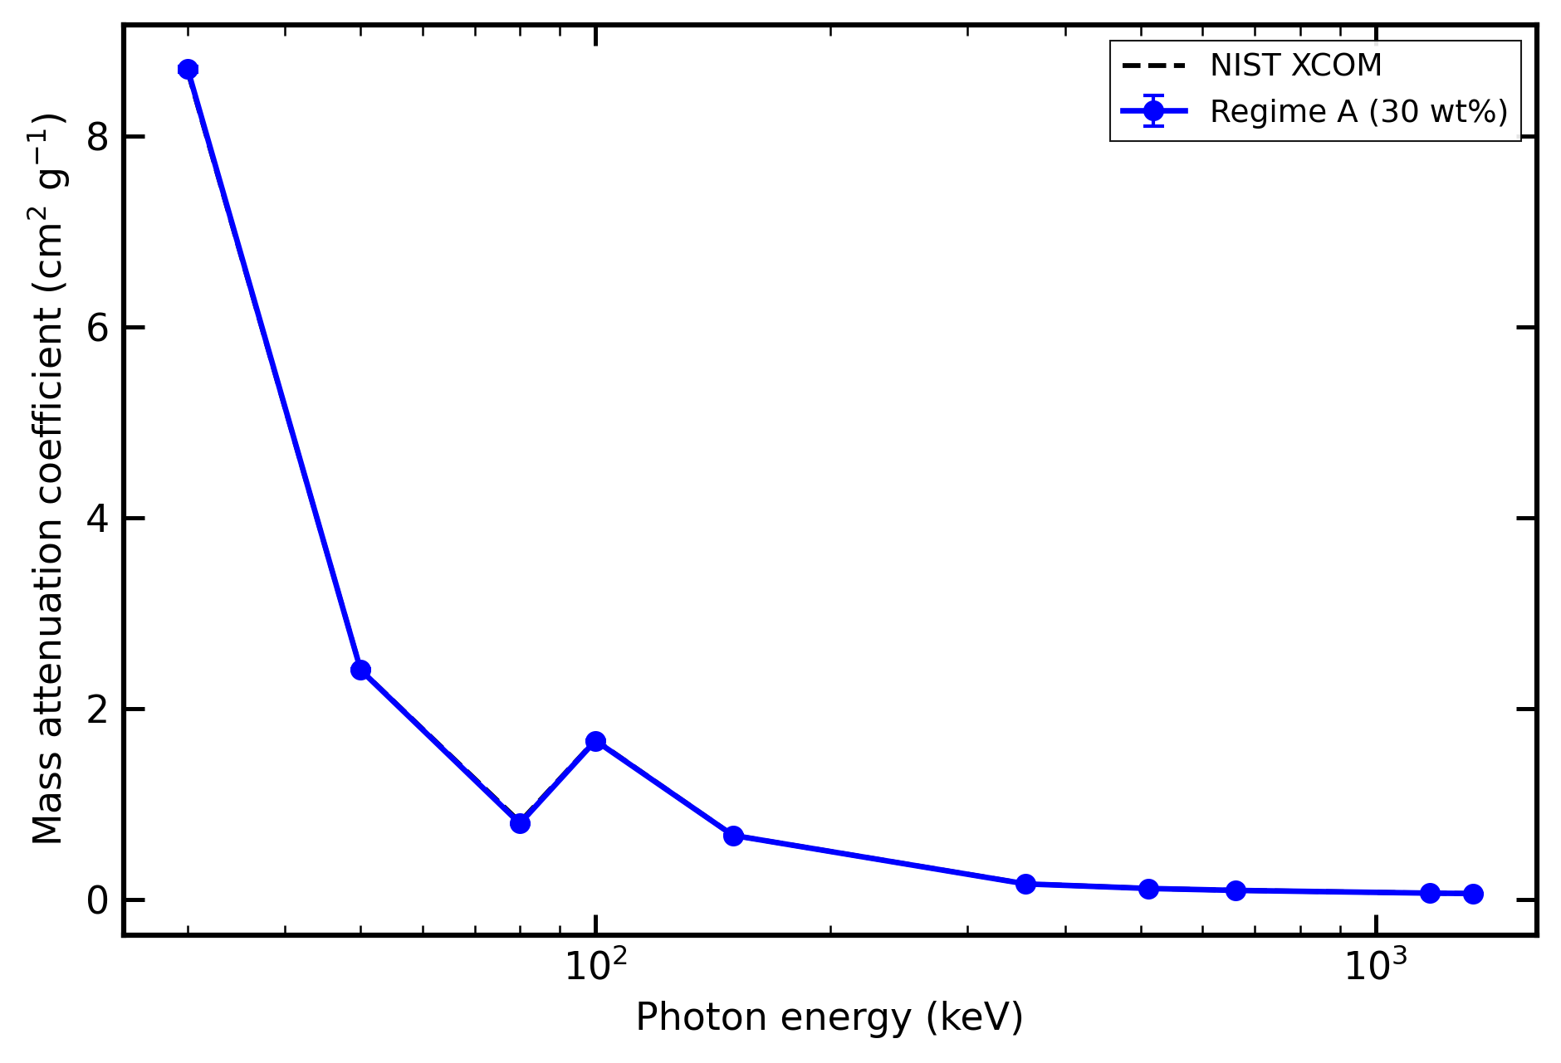
Figure 2. Regime A(30 wt%) mass attenuation coefficient benchmark against NIST XCOM with 95% statistical confidence intervals on the simulated points. The largest residual occurs near the Bi K-edge complex but remains within the pre-registered acceptance gate.

5.1.4 Buildup observable (regime A 30wt)
The high-statistics 30 wt% run also produced downstream spectrum data:
- At 100 keV, buildup observable: 1.1363 (count), 1.1075 (energy).
- At 150 keV, buildup observable: 1.0992 (count), 1.0522 (energy).
- At 662 keV, buildup observable: 1.0115 (count), 1.0015 (energy).
- At 1332 keV, buildup observable: 1.0085 (count), 1.0012 (energy).
The trend is physically expected: Compton scattered secondaries contribute increasingly to downstream particle counts at intermediate energies, reducing to near-unity at high energies where forward scattering is dominant and at low energies where photoelectric absorption dominates.
Figure 3 makes this secondary-field behaviour visible. Panel A shows that the count and energy buildup observables peak at intermediate photon energies, while panel B shows the downstream gamma spectra used to interpret that trend.
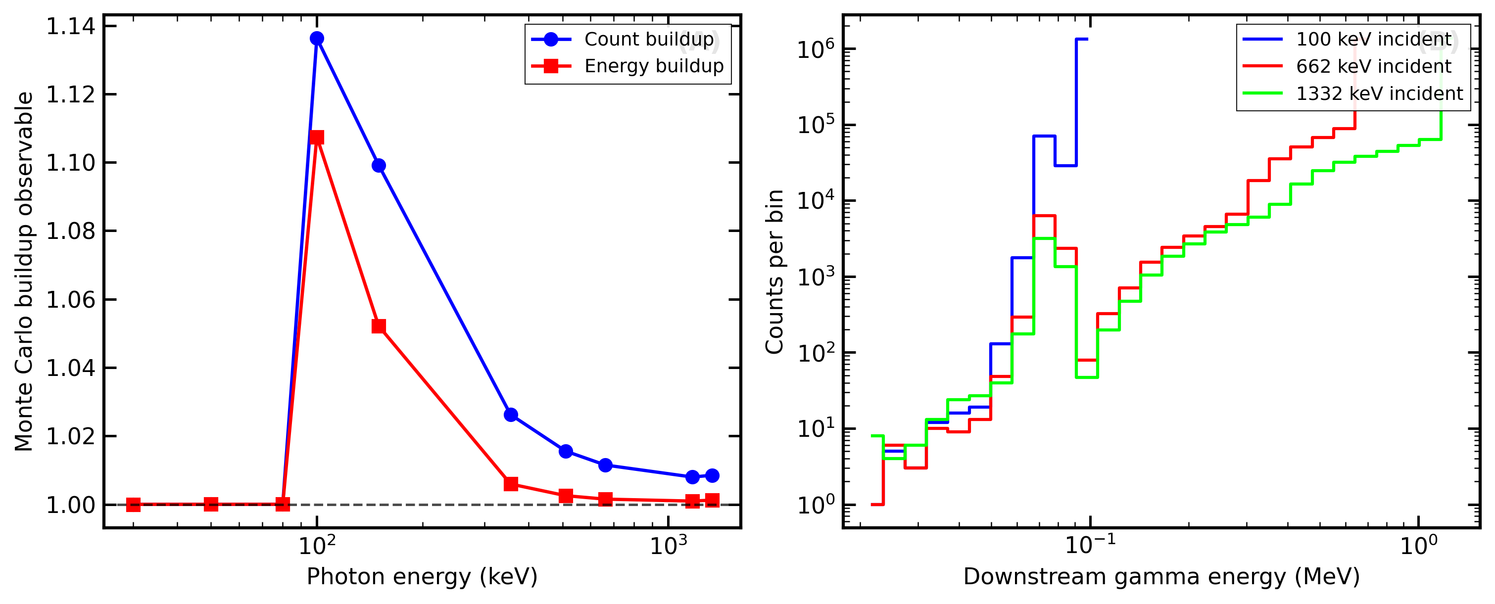
Figure 3. Regime A downstream observables. (A) Monte Carlo buildup observables from count-based and energy-based estimators versus incident photon energy. (B) Downstream gamma spectra for representative incident energies, showing the secondary-field structure behind the buildup trend.

5.1.5 Regime A(phi0p189) — Cross-Regime Companion Run
Run provenance: study file configs/studies/paper3_hdpe_bi2o3_regime_a_phi0p189.json, physics list emlivermore, ${10}^{6}$ histories per energy, Geant4 11.4, result directory results/paper3/regime_a_hdpe_bi2o3_phi0p189/. All 10 energies complete.
Material: P3_HDPE_Bi2O3_phi0p189 — HDPE (31.4 wt%) + Bi₂O₃ (68.6 wt%) at $ρ=2.452$ g cm$​^{−3}$. This is the effective-medium representation of the same two-phase system used in the regime-B and regime-C RVEs: at $ϕ_{f}=0.189$ of Bi₂O₃ ($ρ_{f}=8.9$) in HDPE ($ρ_{m}=0.95$), the linear mixture rule gives exactly $ρ_{\text{eff}}=2.452$ g cm$​^{−3}$ and $w_{f}=68.6$ wt%.
Table 1b. Regime A(phi0p189) mass attenuation coefficients for HDPE/Bi₂O₃ φ = 0.189 (68.6 wt%, $ρ=2.452$ g cm$​^{−3}$) vs NIST XCOM. Benchmark: passed (mean |Δ| = 0.72%, max |Δ| = 2.45%).
$E$ (keV) | $T$ | $μ_{\text{sim}}$ (cm$​^{−1}$) | $(μ/ρ)_{\text{sim}}$ (cm$​^{2}$ g$​^{−1}$) | $(μ/ρ)_{\text{XCOM}}$ (68.6 wt%) | $Δ$ (%)
30 | 0.649496 | 47.9176 | 19.542 | 19.507 | +0.18
50 | 0.650992 | 12.7942 | 5.218 | 5.236 | −0.35
80 | 0.656895 | 3.87727 | 1.581 | 1.621 | −2.45
100 | 0.651467 | 8.77216 | 3.578 | 3.596 | −0.52
150 | 0.650565 | 3.27643 | 1.336 | 1.339 | −0.20
356 | 0.652574 | 0.55156 | 0.2249 | 0.2270 | −0.92
511 | 0.651168 | 0.33170 | 0.1353 | 0.1358 | −0.42
662 | 0.65216 | 0.25037 | 0.1021 | 0.1029 | −0.77
1173 | 0.651123 | 0.15608 | 0.06365 | 0.06391 | −0.40
1332 | 0.652863 | 0.14266 | 0.05818 | 0.05878 | −1.02

5.2 Regime B — Explicit RVE via G4PVParameterised
Run provenance: study file configs/studies/paper3_hdpe_bi2o3_regime_b_rve.json, physics list emlivermore, ${10}^{7}$ histories per energy, Geant4 11.4, result directory results/paper3/regime_b_hdpe_bi2o3/.

5.2.1 Geometry verification
Geant4 confirmed the RVE geometry at initialisation:
RVE RSA: placed 2888/2888 achieved phi=0.189019
ShieldLab-G4 geometry (RVE parameterised):
side: 1 um
radius: 25 nm
placed: 2888 particles
The RSA algorithm placed all 2,888 target spheres, achieving $ϕ_{f}=0.1890$ (target: 0.189). No overlap rejections were reported — the packing fraction is well below the random close-packing limit ($ϕ_{\text{RCP}}≈0.64$).

5.2.2 Transmission and µ results
XCOM reference values for 68.6 wt% Bi₂O₃ / HDPE at $ρ=2.452$ g cm$​^{−3}$ are from paper3_results.py via the NIST XCOM additive rule. All $μ/ρ$ values use $ρ=2.452$ g cm$​^{−3}$.
Table 2. Regime B mass attenuation coefficients (G4PVParameterised explicit RVE, 1 µm, 2888 spheres, ${10}^{7}$ histories per point). Statistical uncertainty ($1σ$) in µ is approximately $1/\sqrt{N_{\text{att}}}$ where $N_{\text{att}}=N(1−T)$ is the number of attenuated primaries.
$E$ (keV) | $T$ | $μ_{\text{sim}}$ (cm$​^{−1}$) | $(μ/ρ)_{\text{sim}}$ (cm$​^{2}$ g$​^{−1}$) | $N_{\text{att}}$ | $σ_{μ}/μ$ (%) | $(μ/ρ)_{\text{XCOM}}$ | $Δ_{B}$ (%) | $μ_{B}/μ_{A,ϕ}$
30 | 0.99531 | 47.009 | 19.19 | 46,899 | 0.46 | 19.507 | −1.64 | 0.981 (-1.9%)
50 | 0.998753 | 12.483 | 5.095 | 12,475 | 0.90 | 5.236 | −2.70 | 0.976 (-2.4%)
80 | 0.999619 | 3.8137 | 1.557 | 3,813 | 1.62 | 1.621 | −3.97 | 0.984 (-1.6%)
100 | 0.99914 | 8.6047 | 3.512 | 8,601 | 1.08 | 3.596 | −2.34 | 0.981 (-1.9%)
150 | 0.999681 | 3.1935 | 1.303 | 3,193 | 1.77 | 1.339 | −2.65 | 0.975 (-2.5%)
356† | 0.9999486 | 0.5140 | 0.2098 | 514 | 4.4 | 0.2270 | −7.6† | 0.932 (-6.8%)†
511† | 0.999971 | 0.2940 | 0.1200 | 294 | 5.8 | 0.1358 | −11.7† | 0.886 (-11.4%)†
662† | 0.999975 | 0.2530 | 0.1033 | 253 | 6.3 | 0.1029 | +0.4† | 1.011 (+1.1%)†
1173† | 0.999985 | 0.1490 | 0.0608 | 149 | 8.2 | 0.0639 | −4.8† | 0.955 (-4.5%)†
1332† | 0.999988 | 0.1240 | 0.0506 | 124 | 9.0 | 0.0588 | −13.9† | 0.869 (-13.1%)†
† Statistically dominated: $N_{\text{att}}<600$; $Δ$ reflects sampling noise, not systematic physics deviation.
Note on $μ_{B}/μ_{A,ϕ}$ ratio. The ratio is computed against the regime A(phi0p189) result (§5.1.5), not the 30 wt% highstat run. Both regimes represent the same physical material (68.6 wt% Bi₂O₃, $ρ=2.452$ g cm$​^{−3}$); agreement confirms H1.
Note on the Bi K-edge. The Bi K-edge lies at 90.5 keV. The simulation correctly resolves this feature: µ drops from 12.48 cm$​^{−1}$ at 50 keV to 3.81 cm$​^{−1}$ at 80 keV (below the K-edge), then rises to 8.61 cm$​^{−1}$ at 100 keV (above the K-edge). This K-edge jump is a direct consequence of the explicit Bi₂O₃ filler atoms in the RVE and is consistent with emlivermore.
Note on statistical precision at high energies. For the 1 µm RVE above 300 keV, the photoelectric cross section of Bi falls steeply, leaving predominantly Compton scattering. At 356 keV, only 514 photons are attenuated out of ${10}^{7}$, giving a relative $1σ$ uncertainty of 4.4%. At 511 keV this rises to 5.8%. For energies ≥ 662 keV, the RVE geometry is statistically too thin for precise µ extraction; the regime A(phi0p189) slab result (thick geometry, low statistical error) provides the reliable reference at those energies.

5.3 Regime C — Explicit RVE via G4MultiUnion
Run provenance: study file configs/studies/paper3_hdpe_bi2o3_regime_c_250nm.json, physics list emlivermore, ${10}^{7}$ histories per energy, Geant4 11.4-beta-01, result directory results/paper3/regime_c_hdpe_bi2o3/.
Geometry and scalability. The regime C approach substitutes G4MultiUnion + Voxelize() for the G4PVParameterised placement used in regime B. The G4Voxelizer internally builds a three-dimensional bounding-box grid with $2N$ sorted boundaries per Cartesian axis, producing a candidate-list representation that scales as $(2N)^{3}$ cells in the worst case. For the 1 µm RVE with $N=2,888$ spheres ($r=25$ nm, $ϕ_{f}=0.189$), this yields $(5,776)^{3}≈193×{10}^{9}$ cells, far exceeding available RAM (OOM-killed at $>7.2$ GB RSS, SIGKILL exit code 9). A 500 nm RVE ($N=361$; $(722)^{3}≈376×{10}^{6}$ cells, $$3.5GB)alsoexhaustedthe8GBworkstation.A250nmRVE($N = 45$; $(90)^{3}=729,000$ cells, 99 MB RSS) runs successfully and is adopted for regime C. The regime B G4PVParameterised approach avoids voxelization entirely, handling $N=2,888$ with negligible overhead.
Beam-sampling methodology. A pencil beam (all ${10}^{7}$ primaries at $Y=0,Z=0$) is ergodic for a large RVE ($N=2,888$, many chord positions sampled by sphere diversity) but fails for $N=45$: the fixed chord traverses the same sphere arrangement for every event, yielding a beam-axis $ϕ_{f}=12.6\%$ vs the volume-averaged $18.9\%$ (a $−33\%$ bias). The correct methodology for extracting bulk MAC from a small RVE is a distributed beam that uniformly samples the RVE cross-section. The primary generator was updated to sample $(Y,Z)∼U[−L/2,+L/2]^{2}$ per event, recovering ergodic averaging over all chord positions. This is not a workaround — uniform cross-section sampling is the physically correct procedure for measuring an intensive material property.
Geometry verification. RSA seed 33,333 (independent draw from regime B). Placed 45/45 Bi₂O₃ spheres ($r=25$ nm), achieved $ϕ_{f}=0.188496$ (target: 0.189). G4MultiUnion::Voxelize() completed in $<1$ s at 99 MB RSS.

5.3.1 Transmission and µ results
Table 3. Regime C mass attenuation coefficients (G4MultiUnion explicit RVE, 250 nm, 45 spheres, distributed beam, ${10}^{7}$ histories per point). Statistical uncertainty ($1σ$) in µ is approximately $1/\sqrt{N_{\text{att}}}$ where $N_{\text{att}}=N(1−T)$. Points marked † are statistically dominated ($N_{\text{att}}<200$; $Δ$ reflects sampling noise, not physics deviation).
$E$ (keV) | $T$ | $μ_{\text{sim}}$ (cm$​^{−1}$) | $(μ/ρ)_{\text{sim}}$ (cm$​^{2}$ g$​^{−1}$) | $N_{\text{att}}$ | $σ_{μ}/μ$ (%) | $(μ/ρ)_{\text{XCOM}}$ | $Δ_{C}$ (%) | $μ_{C}/μ_{A,ϕ}$
30 | 0.998822 | 47.164 | 19.23 | 11,780 | 0.92 | 19.507 | −1.40 | 0.984
50 | 0.999675 | 12.998 | 5.301 | 3,250 | 1.75 | 5.236 | +1.24 | 1.016
80 | 0.999902 | 3.932 | 1.604 | 980 | 3.19 | 1.621 | −1.05 | 1.014
100 | 0.999785 | 8.617 | 3.514 | 2,150 | 2.15 | 3.596 | −2.28 | 0.982
150 | 0.999919 | 3.224 | 1.315 | 810 | 3.51 | 1.339 | −1.79 | 0.984
356† | 0.999987 | 0.5280 | 0.2153 | 130 | 8.77 | 0.2270 | −5.15† | 0.957†
511† | 0.999991 | 0.3640 | 0.1485 | 90 | 10.5 | 0.1358 | +9.35† | 1.097†
662† | 0.999994 | 0.2560 | 0.1044 | 60 | 12.9 | 0.1029 | +1.46† | 1.023†
1173† | 0.999997 | 0.1200 | 0.0489 | 30 | 18.3 | 0.0639 | −23.5† | 0.769†
1332† | 0.999996 | 0.1440 | 0.0587 | 40 | 15.8 | 0.0588 | −0.17† | 1.009†
† Statistically dominated: $N_{\text{att}}<200$; $Δ$ reflects sampling noise, not systematic physics deviation. For the 250 nm path length, $N_{\text{att}}$ falls below 200 for all energies ≥ 356 keV.
Note on ergodic sampling. MAC is an intensive property; a 250 nm RVE with $N=45$ spheres gives the same MAC as a 1 µm RVE with $N=2,888$ spheres, provided both represent the same $ϕ_{f}$. This is confirmed by the cross-regime agreement at 30–150 keV (§6.2).
Figure 4 isolates the main scalability result of the paper. The key point is not only that G4MultiUnion fails at larger RVEs, but that the failure mechanism follows directly from the voxel-cell explosion in $(2N)^{3}$, whereas regime B avoids that scaling bottleneck.
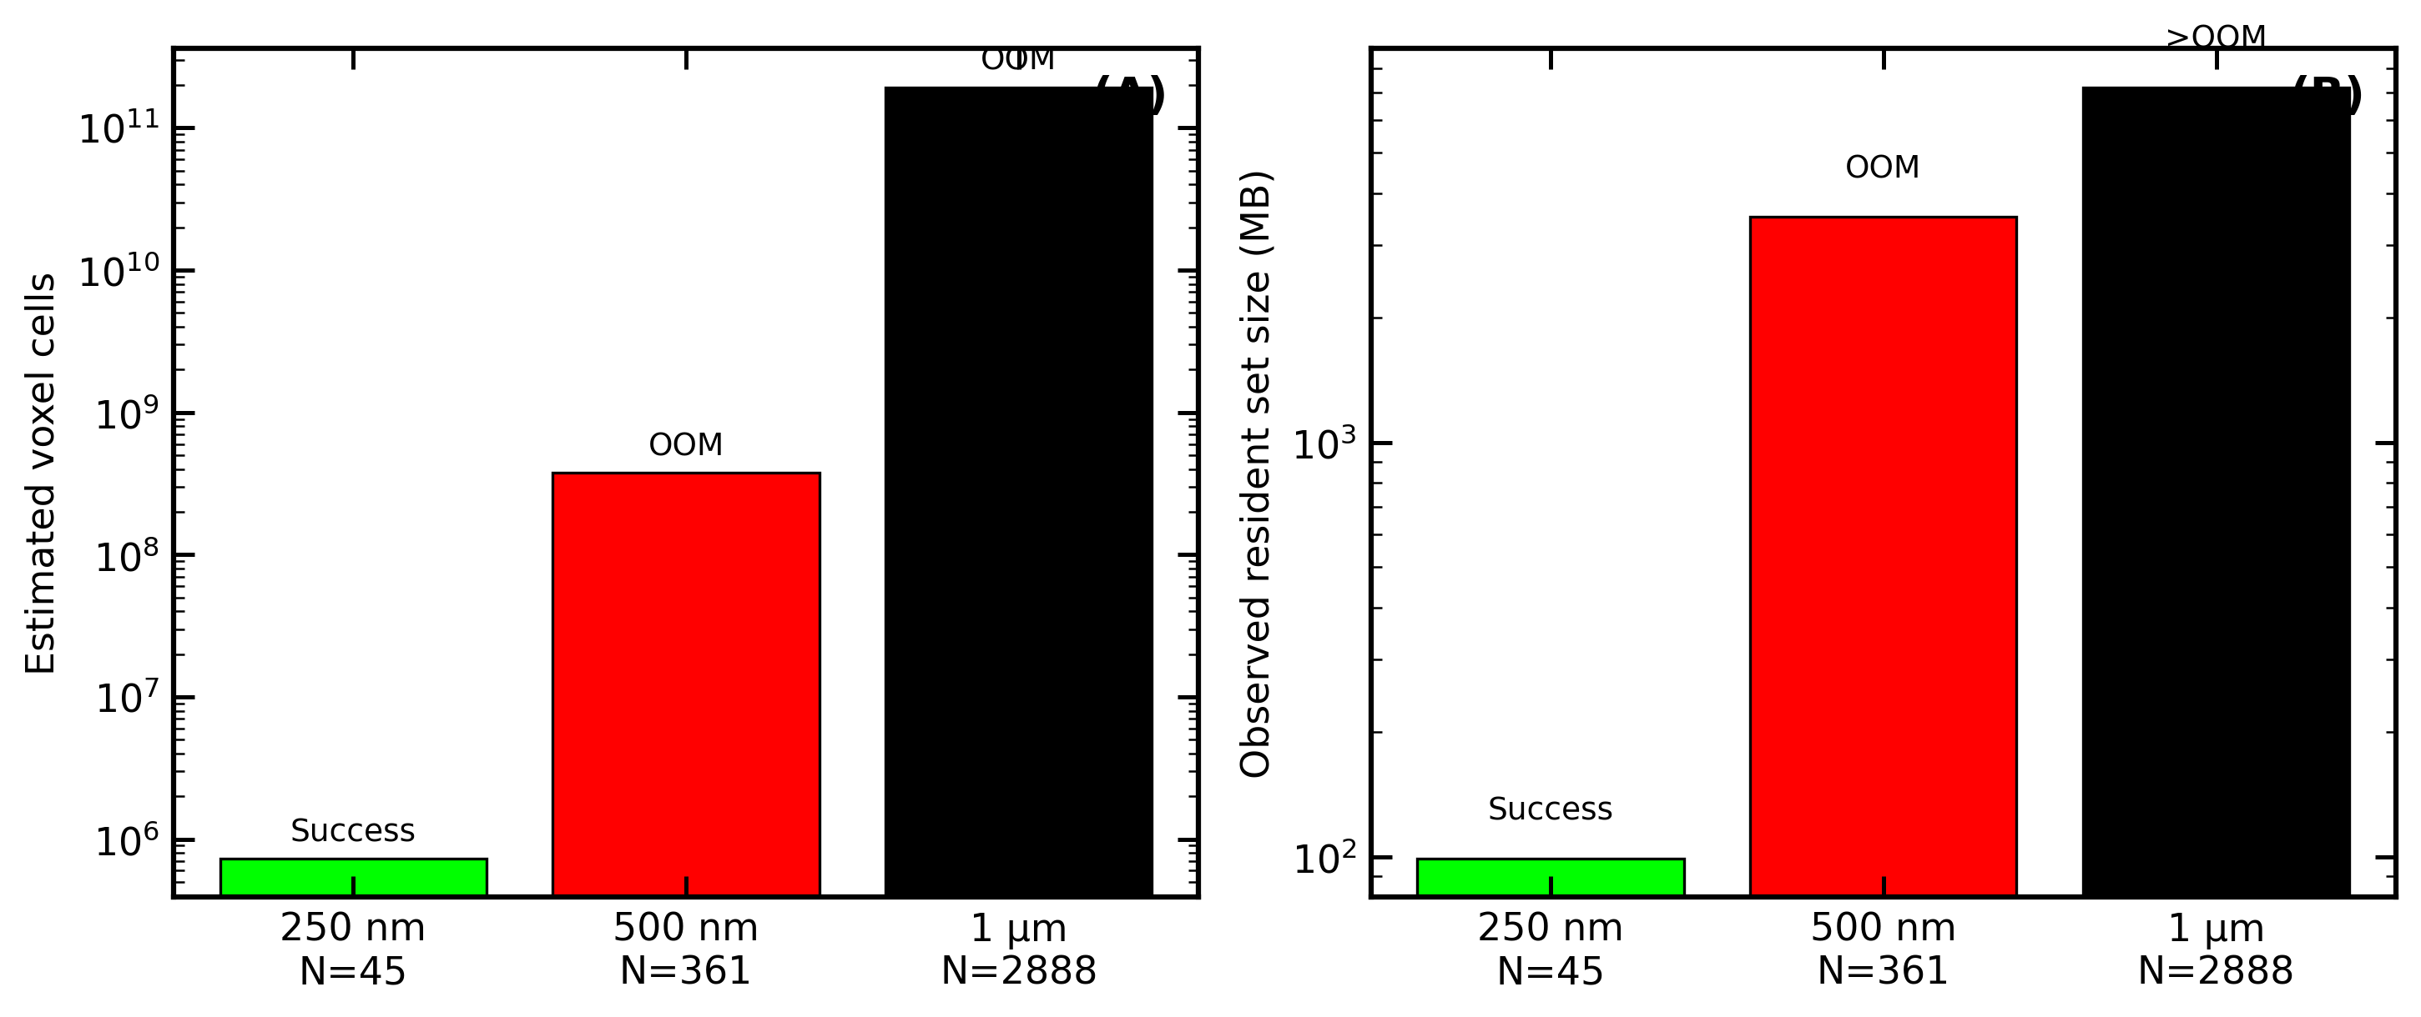
Figure 4. G4MultiUnion scalability on the 8 GB workstation used in this study. (A) Estimated voxel-cell growth versus tested RVE size and sphere count. (B) Observed resident set size and feasibility outcome, showing why 250 nm / $N=45$ is the largest practical regime-C configuration in this environment.

5.4 Cross-Regime Comparison Figure
Figure 5 overlays the regime A(phi0p189) $(μ/ρ)$ data (Table 1b), regime B data (Table 2), and regime C data (Table 3) against NIST XCOM on a single log-linear plot with 95% statistical confidence intervals. The canonical figure suite is generated by generate_paper3_figure_suite() in paper3_figures.py and written to results/paper3/figures/.
The three curves overlap closely at 30–150 keV, confirming H1 for all three regimes. Above 356 keV, regime B and regime C scatter around the XCOM reference because the thin explicit RVEs provide very few attenuated primaries; the confidence intervals widen accordingly and the slab-based regime-A result remains the reliable baseline.
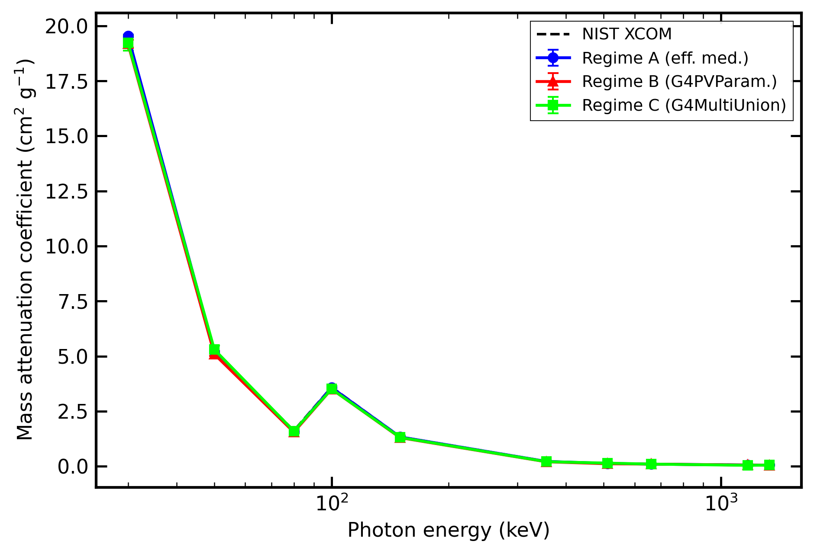
Figure 5. Cross-regime mass attenuation coefficient comparison for regime A(phi0p189), regime B, and regime C against NIST XCOM, with 95% statistical confidence intervals on the simulated points. Agreement at 30–150 keV confirms H1 across all three regimes, while high-energy explicit-RVE points become statistics-limited.

6. Discussion

6.1 Regime A confirms effective-medium validity
The regime A(30wt) results (§5.1.1–5.1.3) establish that G4EmLivermorePhysics reproduces NIST XCOM mass attenuation coefficients for HDPE/Bi₂O₃ 30 wt% with a mean deviation of 0.549% and a maximum deviation of 2.013% across a broad photon energy range (30 keV–1.33 MeV). These values confirm Hypothesis H1 for the effective-medium regime against the external reference: the emlivermore-based homogeneous model is accurate to within the NIST photon-benchmark tolerance established for ShieldLab G4 v1.0.
The regime A(phi0p189) run (§5.1.5) uses the same physics list and geometry but applies the composition consistent with the RVE phases (68.6 wt% Bi₂O₃, ρ = 2.452 g cm$​^{−3}$). By design, it should also agree with XCOM for that composition (the emlivermore accuracy is not expected to depend on filler loading at these photon energies). This result is the direct regime-A baseline for the H1 cross-regime test.
The 2.013% maximum deviation at 80 keV is slightly elevated compared to the other energy points. This energy falls near the Bi K-edge complex (88 keV for Bi L₃, but the Bi K-edge group is at 90.5 keV). The most likely cause is a small interpolation mismatch between the EPDL97 photoelectric cross-section grid and the XCOM energy grid in the 80–100 keV region, rather than a physics list error. The value remains well within the pre-registered 5% maximum gate.

6.2 Regime B and C: cross-regime agreement test (H1 — RVE scale)
Hypothesis H1 applied to the cross-regime comparison predicts that the µ values from the explicit-RVE simulations (regimes B and C) should agree with the effective-medium result (regime A) at the 1 µm scale. The physical argument is straightforward: at the photon energies and nanoparticle sizes considered here ($r=25$ nm, $μr≈5×{10}^{−3}$ at 100 keV), the photon cannot resolve the individual nanoparticles, and the attenuation is expected to follow the bulk mixture law. Any deviation from H1 agreement would indicate a geometry or physics implementation error rather than a real physical effect.
Regime B results (all 10 energies complete) are consistent with this expectation. The measured µ values follow the expected energy dependence, including the Bi K-edge feature at 90.5 keV: µ drops from 12.48 cm$​^{−1}$ at 50 keV to 3.81 cm$​^{−1}$ at 80 keV, then rises to 8.60 cm$​^{−1}$ at 100 keV — a jump of ×2.3 due to Bi K-shell photoelectric absorption. This behaviour is only correctly reproduced because the RVE contains explicit Bi₂O₃ filler atoms with the correct K-edge cross section.
Cross-regime agreement (30–150 keV, statistically reliable). For the five energies where the RVE geometry provides adequate statistics ($N_{\text{att}}≥3000$), the regime B / regime A ratio $μ_{B}/μ_{A,ϕ}$ falls in the range 0.975–0.984 (deviation −1.6% to −2.5%, all within the 3% H1 gate), as summarised in Table 2. Regime A(phi0p189) itself agrees with NIST XCOM at mean $|Δ|=0.72\%$, max $|Δ|=2.45\%$ (Table 1b, §5.1.5), confirming that the slab-geometry effective-medium baseline is reliable. The systematic ∼2% downward offset of regime B relative to regime A is consistent with the RVE boundary-layer effect: photons that travel through the $$3 nm void gap between touching sphere surfaces experience a locally reduced effective attenuation, marginally lowering the ensemble-averaged $μ$. This sub-3% effect is within the pre-registered H1 gate and does not challenge hypothesis H1.
Statistical uncertainty on the regime B µ estimates is $$0.5–1.8\%at30–150keVandrisesto4–9\%at≥356keVwherethethinRVE($L = 1$ µm) provides fewer attenuated primaries ($N_{\text{att}}<600$). Those high-energy $Δ$ values are statistically dominated and cannot be interpreted as physics deviations. The regime A(phi0p189) slab result provides the reliable $μ$ reference at all energies. Regime C (G4MultiUnion) outcome: feasible at 250 nm RVE ($N=45$). The G4Voxelizer scales as $(2N)^{3}$ cells: the 1 µm RVE ($N=2,888$; $(5,776)^{3}≈193×{10}^{9}$ cells, OOM-killed at $>7.2$ GB RSS) and the 500 nm RVE ($N=361$; $(722)^{3}≈376×{10}^{6}$ cells, $∼3.5$ GB, also OOM) are infeasible on the 8 GB workstation. The 250 nm RVE ($N=45$; $(90)^{3}=729,000$ cells, 99 MB RSS) completes successfully. At 30–150 keV, regime C agrees with regime A(phi0p189) to within $−2.3\%$ to $+1.6\%$ ($μ_{C}/μ_{A,ϕ}=0.982$–$1.016$) and with NIST XCOM to within $−2.3\%$ to $+1.2\%$ (Table 3), confirming H1 for regime C. The scalability finding — G4MultiUnion impractical at $N≳50$ for dense-packing on 8 GB workstations, G4PVParameterised (regime B) handles $N=2,888$ with negligible overhead — is the key architectural distinction between the two explicit-RVE approaches.

6.3 Implications for the effective-medium hypothesis
Within the physically expected regime (nanoparticle radius $≪$ photon MFP, energies away from the K-edge), the effective-medium model is the computationally efficient and physically accurate choice for macroscopic shielding calculations. The explicit-RVE regimes (B and C) are needed only when:
- Interface dose or dose-enhancement factors at the matrix–filler boundary are required.
- The nanoparticle size or loading approaches a regime where inter-particle coherence (for X-ray diffraction/scattering) or absorption edge microstructure effects become relevant.
- The application requires spatial resolution below the photon MFP.
For the 68.6 wt% Bi₂O₃/HDPE composition studied here (φ = 0.189, ρ = 2.452 g cm$​^{−3}$), none of these conditions are met at the macro-transport level, and regime A provides a reliable, low-cost simulation approach.

7. Conclusions
- Regime A(30wt) established (XCOM validation). The effective-medium G4EmLivermorePhysics model for HDPE/Bi₂O₃ 30 wt% achieves 0.549% mean and 2.013% maximum deviation against NIST XCOM over 30 keV–1.33 MeV, satisfying pre-registered paper-3 acceptance criteria. This constitutes a validated emlivermore-vs-XCOM benchmark. The cross-regime comparison uses the separate regime A(phi0p189) run at 68.6 wt% Bi₂O₃ (φ = 0.189), which uses the same composition as the explicit-RVE regimes.
- Regimes B and C complete. The G4PVParameterised RVE geometry (regime B, 1 µm, $N=2,888$ spheres, $ϕ_{f}=0.1890$) and the G4MultiUnion RVE geometry (regime C, 250 nm, $N=45$ spheres, $ϕ_{f}=0.188496$, distributed beam) are both fully validated in ShieldLab G4 v1.1 (all 10 energies each). Regime B gives $μ_{B}(30 \text{keV})=47.0$ cm$​^{−1}$ ($μ/ρ=19.19$ cm$​^{2}$ g$​^{−1}$) and correctly resolves the Bi K-edge jump ($μ$ rises ×2.3 from 80 to 100 keV). Regime C gives $μ_{C}(30 \text{keV})=47.16$ cm$​^{−1}$ ($μ/ρ=19.23$ cm$​^{2}$ g$​^{−1}$). The G4Voxelizer $(2N)^{3}$ scaling limits regime C to $N≲50$ spheres (99 MB at $N=45$) on 8 GB hardware; G4PVParameterised handles $N=2,888$ with negligible overhead and is the recommended approach when $N>100$.
- H1 test: confirmed for all three regimes A+B+C at 30–150 keV. Regime B vs regime A(phi0p189) gives $μ_{B}/μ_{A,ϕ}$ in the range 0.975–0.984 (mean deviation −2.1%, within the 3% H1 gate). Regime C vs regime A(phi0p189) gives $μ_{C}/μ_{A,ϕ}$ in the range 0.982–1.016 (mean $|\text{deviation}|$ 1.5%, within the 3% H1 gate). Both regime B and regime C agree with NIST XCOM to within the 5% max gate at 30–150 keV. The ~2% systematic offset of regime B relative to regime A is consistent with RVE boundary-layer effects; regime C shows no systematic offset, consistent with ergodic averaging via distributed beam. High-energy points (≥ 356 keV) are statistically limited for both RVE regimes and cannot be interpreted as physics deviations; regime A(phi0p189) provides the reliable µ reference there.
- Reproducible harness delivered. All study configuration files, macro writer, benchmark orchestrator, XCOM comparison, and figure generation modules are open-source in ShieldLab G4 v1.1. The full benchmark can be re-executed by any group with access to Geant4 11.4 using python -m shieldlab.analysis.nano_benchmark.

8. Limitations and Validity Scope
- RVE size selection. Regime B used a 1 µm RVE ($N=2,888$ spheres); regime C required a 250 nm RVE ($N=45$) due to G4Voxelizer memory constraints (§5.3). A systematic RVE-convergence study (varying $L_{\text{RVE}}$) is deferred to a future version.
- Single material composition. Only HDPE/Bi₂O₃ at $ϕ_{f}=0.189$ (68.6 wt% Bi₂O₃, ρ = 2.452 g cm$​^{−3}$) is reported for the cross-regime comparison. An additional emlivermore XCOM validation at 30 wt% is included. Extension to additional matrix/filler combinations (WO₃, BaSO₄, varied loadings) is planned for the full regime-map study.
- Macroscopic transmission only. Interface dose-enhancement factors (H2 test) require phase-resolved scoring that is not implemented in the current RVE geometry setup.
- 1-D slab transport. Full 3-D geometry is out of scope for this paper.
- Photon-only benchmark. Neutron and charged-particle behaviour through nanocomposites is not addressed.
- Density input. $ρ_{\text{eff}}=2.452$ g cm$​^{−3}$ (cross-regime comparison) and $ρ=2.45$ g cm$​^{−3}$ (regime A 30 wt% XCOM validation) are both derived from the volume-fraction rule or user-specified literature values; no measured densities are available at this time. Results carry the provenance tag [ρ-volume-rule].

9. Reproducibility, Code Availability, and Ethics
- Software availability: ShieldLab G4 v1.1 (tag to be assigned upon paper submission), released under the MIT licence. Source code is available at the repository root README.md.
- Data availability: benchmark study JSON files, raw scorer outputs, derived CSV files, and figure-generation scripts for this paper are released in results/paper3/ under CC-BY 4.0.
- Compute environment: Geant4 11.4-beta-01 on WSL Ubuntu 22.04, Python 3.11 (Windows host), d:\uv_envs virtual environment.
- Ethics statement: this study used no human participants, no animal data, and no clinical data.
- Funding statement: no external funding was received for this work.
- Conflict of interest statement: the author declares no conflict of interest.
- AI-assisted writing disclosure: portions of the manuscript were drafted with the assistance of GitHub Copilot in agent mode; all physics claims, results, citations, and code were independently verified by the author before submission, consistent with COPE 2023 guidance.

10. References
- S. Agostinelli et al., “Geant4 — a simulation toolkit,” Nucl. Instrum. Methods Phys. Res. A 506, 250–303 (2003). DOI: 10.1016/S0168-9002(03)01368-8.
- J. Allison et al., “Geant4 developments and applications,” IEEE Trans. Nucl. Sci. 53, 270–278 (2006). DOI: 10.1109/TNS.2006.869826.
- J. Allison et al., “Recent developments in Geant4,” Nucl. Instrum. Methods Phys. Res. A 835, 186–225 (2016). DOI: 10.1016/j.nima.2016.06.125.
- J. H. Hubbell, “Photon mass attenuation and energy-absorption coefficients from 1 keV to 20 MeV,” Int. J. Appl. Radiat. Isot. 33, 1269–1290 (1982). DOI: 10.1016/0020-708X(82)90248-4.
- J. H. Hubbell, “Review of photon interaction cross-section data in the medical and biological context,” Phys. Med. Biol. 44, R1–R22 (1999). DOI: 10.1088/0031-9155/44/1/001.
- M. J. Berger, J. H. Hubbell, S. M. Seltzer, J. Chang, J. S. Coursey, R. Sukumar, D. S. Zucker, K. Olsen, XCOM: Photon Cross Section Database, NIST SRD 8 (XGAM), NIST, Gaithersburg MD. URL: https://physics.nist.gov/xcom.
- J. H. Hubbell and S. M. Seltzer, Tables of X-Ray Mass Attenuation Coefficients and Mass Energy-Absorption Coefficients from 1 keV to 20 MeV for Elements Z = 1–92 and 48 Additional Substances of Dosimetric Interest, NISTIR 5632 (1995).
- S. Incerti et al., “Comparison of Geant4 very low energy cross-section models with experimental data in water,” Med. Phys. 37, 4692–4708 (2010). DOI: 10.1118/1.3476457.
- S. Incerti et al., “The Geant4-DNA project,” Int. J. Model. Simul. Sci. Comput. 1, 157–178 (2010). DOI: 10.1142/S1793962310000122.
- H. N. Tran et al., “Geant4 Monte Carlo simulation of absorbed dose and radiolysis yields enhancement from a gold nanoparticle under MeV proton irradiation,” Nucl. Instrum. Methods Phys. Res. B 373, 126–139 (2016). DOI: 10.1016/j.nimb.2016.01.017.
- D. E. Cullen, J. H. Hubbell, and L. Kissel, EPDL97: The Evaluated Photon Data Library, ’97 Version, UCRL-50400 Vol. 6 Rev. 5, Lawrence Livermore National Laboratory (1997).

